*Cultural Trends* DOI: 10.1080/09548963.2015.1135528 Published Online 28 January 2016

ISSN: 0954-8963 (Print) 1469-3690 (Online) Journal homepage: http://www.tandfonline.com/loi/ccut20

**RESEARCH ARTICLE**

**Participation and Provision in Arts & Culture – Bridging the Divide**

Graeme Evans[1]*, Middlesex University School of Art & Design, Middlesex University UK

*Successive policies and efforts to increase participation in a range of arts and cultural activities have tended to focus on the profile and attitude of individuals and target groups in order justify public - and therefore achieve more equitable - funding. Rationales for such intervention generally reflect the policy and political regime operating in different eras, but widening participation, increasing access and making the subsidised arts more inclusive have been perennial concerns. On the other hand, culture has also been the subject of a supply-led approach to facility provision, whether local amenity-based (‘Every Town Should Have One’ - Lane, 1979), civic centre or flagship, and this has also mirrored periodic growth in investment through various capital for the arts, municipal expansion, urban regeneration, European regional development and lottery programmes. Research into participation has consequently taken a macro, sociological, ‘class distinction’ approach, including longitudinal national surveys such as Taking Part, Target Group Index, Active People and Time Use Surveys, whilst actual provision is dealt with at the micro, amenity level in terms of its impact and catchment. This article therefore considers how this situation has evolved and the implications for cultural policy, planning and research by critiquing successive surveys of arts attendance and participation and associated arts policy initiatives, including the importance of local facilities such as arts centres, cinemas and libraries. A focus on cultural mapping approaches to accessible cultural amenities reveals important evidence for bridging the divide between cultural participation and provision.*

*Keywords: arts participation, accessibility, cultural mapping*

**Introduction**

A key observation from several decades of cultural activity surveys is that these have been undertaken with little or no reference to actual provision, their location or the relationship between place and participation. Factors such as time and travel are captured in participation surveys in as far as they act as limitations to more frequent activity away from home, but these questions are asked without a spatial reference, since no geographical restriction is placed on where the activity or event occurred. For example, in the ongoing national survey of participation *Taking Part*, respondents stating that they visited a museum once in the year may well have visited this museum whilst on holiday abroad as in the UK, let alone in their local town or region, whilst the qualification for visiting heritage sites can include ‘simply being in a city or town of historic character’ (Hewison, 2014, p.207). Furthermore, successive activity and attitude surveys since the 1980s have also been silent on this question: Where? Even local government quality of life/place surveys which measure satisfaction with local services do not distinguish specific cultural facilities below the level of all the theatres/concerts halls/arts venues; museums/ galleries; or libraries in the local authority area (Evans, 2008, p.65), and since culture is a mixed economy supply, users may not be aware of who the provider actually is - whether private, voluntary or public - weakening the effectiveness of these value for money studies.

**Distinctions in Place and Participation**

This disjunction between participation and provision is remarkable and is little considered in either cultural policy or management, including the lack of research on understanding the relationship between place and cultural consumption (Gilmore, 2013). There are several reasons that have conspired to perpetuate this dichotomy. Firstly, funding organisations – local and central government, Arts Councils - focus their performance measurement efforts on those cultural organisations they fund, whilst using population based surveys to support their advocacy. This has resulted in the qualitative and quantitative audience data from the former not able to be connected to the non-specific surveys which measure attitudes to and participation in a range of cultural activities. Secondly, individual arts organisations and venues produce user (but seldom ‘non-user’) information from periodic surveys and box office data that can generate useful qualitative and profile data that can also be programme/production specific and provide trend data. However, this is seldom captured at the household level and is in isolation from the relationship with other (local) providers, or how this sits with the participants’ other cultural activities - in short, place and participation is again not joined up. Thirdly, the focus on local quality of life and latterly place-making, looks to a combination of amenity values that together make up a good place to live. Culture may form part of this bundle of local assets and environmental factors, but not to the extent that specific cultural facilities or programmes can be attributed to residents ‘feel good’ response or crude satisfaction ratings. What these various cultural datasets fail to achieve is the consistent tracking of the same participants/households over time, such that we never actually know who or where this anonymous cultural exchange is. As Oakley and O’Brien observe: ‘who consumes needs be based on a sense of where consumption occurs’ (2015, p.5).

Historically, research into arts audiences, attendance and participation has focused in an unbalanced way on ‘demand’ to the exclusion of ‘supply’ and environmental accessibility factors, with a preoccupation with the sociological determinants of cultural activity. This is apparent in the reliance on socio-demographic distinctions in formal cultural engagement, from Bourdieu’s notion of cultural capital (see Bourdieu and Darbel, 1969), the work of Dimaggio in the USA (1978), drawing on earlier foundations of sociology – from Marx, Durkheim, Weber to Simmel: ‘the most influential theories that have focused on the ways in which taste-formation and cultural consumption are linked to social differentiation and stratification’ (Belfiore and Bennett, 2008, p.164). Whilst socio-economic class defined by professional/occupation group has been superseded by generic proxies such as education, income and lifestyle (including gender, ethnicity, religious) distinctions (Katz-Gerro, 1999), this ‘culturalist’ turn still looks to arts activity as individualist consumption. The dependence on market research agencies to conduct periodic arts attendance surveys on behalf of arts and other cultural agencies (e.g. BMRB – *Taking Part*; Kantar – Target Group Index, ACORN; Experian – MOSAIC) has also reinforced a socio-economic, lifestyle, consumerist perspective on culture, irrespective of production, place and programming and their inter-relationship. One particular consequence of this outsourcing of public (and publicly-funded) surveys has been the limited availability of underlying data and its dissemination, and limited access to source data/respondents. Academic attention has reinforced this tendency with further classifications of individualistic cultural consumer types (e.g. Chan & Goldthorpe, 2005, 2007a & b; Bennett et al., 2009; Gayo-Cal, Savage and Warde, 2006), in an otherwise cultural production and spatial vacuum. This is also exacerbated by the poor geographic coverage of survey data used, which has prevented disaggregation of national/regional data to the place of cultural experience.

Furthermore, the obsession with defending public service provision and arts funding in these measurement processes effectively ignores much cultural activity that occurs outside of these systems – in everyday, private, entertainment and community spheres (Paterson, 2016). As Su Braden first observed: ‘to take a particular art form and expose a community to it in the hope that it will become less mysterious and more relevant is wrong…it will succeed only when art is seen as a part of culture not the whole of it’ (in Evans, 2001, p.127). Arts and cultural consumption of course take place in the home (including TV, PC), in youth and community centres, schools, religious centres, clubs, pubs, in associations/societies and commercial venues. This is evident from a DCMS (2008) survey of amateur arts activity where the scale of engagement included 50,000 organised groups represented by nearly 6 million members and 3.5 million volunteers taking part in over 700,000 events attended by 158 million in the year. Amateur dramatics and music were the most popular, but multi-art form including ethnic and new art forms make up the largest group, suggesting that venues offering diverse programmes are particularly important.

Despite technology-driven consumption and communication which has individualised and atomised some aspects of social life, the importance of collective cultural consumption and participation that is provided by public-access spaces should not be understated therefore, since they offer the cultural content and progression through a ‘hierarchy of provision’ (Evans, 2001, 2008) that other forms of cultural exchange rely upon. The correlation between the level of public cultural funding and rates of arts attendance also appear to be positive across Europe (KEA, 2006), with the most evenly distributed facilities such as cinemas and libraries (below) achieving the highest usage across social groups (Brook, 2011). Countries with higher levels of regional cultural funding and facilities, such as federal Germany (länder ‘regions’) support higher levels of arts attendance which are often organised through local associations such as housing associations/clubs (*Besucherring*), across social ‘divides’ (Feist et al., 1998). The rising popularity and willingness-to-pay for live events, e.g. music festivals, touring venues, reflects this demand against the corollary of individual cultural engagement through mobile and other media. From the *Taking Part* survey, 30% of adults said that they attended ‘live music events’ in 2011/12 the most popular activity (DCMS, 2012). Over 2 million people attend weekly ballroom dancing – before the advent of the BBC TV’s *Strictly Come Dancing* that has therefore tapped into an already popular pastime, boosted by its combination with popular celebrity culture (Evans, 2010). The Arts Council estimated that 10% of the population regularly engages with dance as artists, audience or participants - but where, and how has arts and cultural policy sought to influence cultural engagement?

**Arts Policy**

Policy towards arts participation and provision has faced the challenge of positioning itself between supply-led and demand-led intervention in the cultural economy. Local and regional arts funding has looked to strengthening the arts infrastructure as part of social amenity provision, as well as regeneration and economic development (Evans, 2005) and therefore as a prime mechanism for attracting arts participation and investment – both consumption and capital. A more distributive model of cultural provision had developed from the 1970s with a degree of devolution to regional arts associations/boards working in collaboration with local authorities, which together were able to maintain an art form and regional distribution, including multiuse arts centres (below). A renewed opportunity to undertake regional cultural planning presented itself in the mid-2000s with the creation of regional spatial strategies (RSS) which for the first time considered culture (arts, heritage, museums/libraries, sport) within their remit and in the context of housing/population growth and demographic change. A focus on cultural planning based on the distribution of amenities in relation to population catchments was therefore enabled, however, despite initiatives such as *Living Places* and a national Cultural Planning Toolkit (Evans, 2008), this spatial approach was to be short-lived as RSS were cancelled by government, the victim of regime change and an ideological turn to ‘localism’. It is interesting to note however that one of the recent Warwick Commission’s recommendations revived this aim: ‘All residential planning proposals must provide for the cultural and heritage needs of their locality’ (2015, p.67), but without any basis on which this might be achieved and ‘supply and demand’ measured, or indeed any reference to previous guidance (Evans, 2013a).

In the context of both arts and local government spending cuts, ‘localism’ has not translated into the growth or redistribution of local cultural provision to meet expressed need or preferences. On the other hand, the principle of place-shaping was to be introduced in the Inquiry into Local Government (Lyons, 2007): ‘cover(ing) a wide range of local activity which affects the well-being of the local community. It will mean different things in different places and at different levels of local government, informed by local character and history, community needs and demands, and local politics and leadership’ (p.174). However, these needs and the listed components of place-shaping lacked any reference to arts provision, leaving culture yet again absent at a time of severe reductions in arts and leisure spending (an estimated 19% in local government spending on the arts over the previous three years - NCA, 2013), despite higher emphasis on local decision-making and vernacular provision to meet local aspirations. Recent government studies have sought to measure the social and economic effects of cultural assets (DCMS, 2011), most recently through the notion, again, of place-shaping: ‘exploring the relationship between culture, heritage and sporting infrastructure and investments on key economic and social outcomes within local economies…in shaping local place(s)’ (DCMS, 2015, p.1, and see Markusen and Gadwa, 2010). However, the emphasis here continues to be on the externalities associated with cultural amenities and investment, rather than on direct arts activity and participation itself, and where this is located - and the inter-relationship between place and engagement. Efforts here have been the focus of programmes of audience development and responses to the perceived barriers to arts attendance and participation by a significant majority of the population and specific social groups in particular.

**Audience Development and Barriers to Participation**

Data, albeit limited, on audiences and participation in the arts, and particular ‘less popular’ art forms, has therefore been used as the prime argument to invest in cultural development activity targeted at particular under-represented groups, and to fuel further research into the barriers to participation experienced by these groups. Thus pursuing the dual objectives of increasing audiences and therefore earned income offsetting reductions in grant aid (economic aim), and widening the social profile (including age, gender, ethnicity, etc.) of attenders (social aim).

Evidence-based policy research in this field has been extensive, although somewhat repetitive. An extensive review of this literature is beyond the scope here, but commissioned research has focused on diversity in arts, libraries and museums usage and participation, notably minority ethnic (Desai and Thomas, 1998; Jermyn and Desai, 2000) and young people (Harland, Kinder and Hartley, 1995) whilst this and research around inclusion (Jermyn, 2001) has concentrated on the barriers to participation, which if removed or ameliorated, would release latent demand for arts activity. As well as policy and plans on greater diversity, key surveys include ACE reports on *Ethnic Minorities and the arts* (2000); *Cultural diversity* (2003); *Arts in England* (Skelton & Bridgwood et al, 2002); and also studies on older people’s participation (Keaney and Oskala, 2007), which have collectively started to capture not just barriers, but attitudes and preferences towards cultural activity. The influence that place might have in these factors was also tested in a programme of *Placing Art in New Contexts* (Jermyn, 2000) which surveyed audiences/participants in non-traditional arts venues and ‘target communities’ that are traditionally excluded from artistic experiences through geographic, physical, social or psychological barriers’ ~~(p.1).~~ Barriers to attendance/ participation and reasons to attend the arts more range from time/cost (travel, ticket price), access/transport and distance/proximity – with these spatial access factors higher for some groups such as minority ethnic and older people. Some factors are consistent in these periodic studies and surveys, however others diverge, and they do not use common frameworks, making trend analysis difficult.

Barriers to engagement - or more engagement - in arts activity, whether as audience or active participant, are therefore prosaic and geographic, but the quality of the programme and its relevance to particular cultural groups, are also important. Here ‘performances and events closer to where I live…and about subjects I am interested in’ are cited in *Taking Part* (DCMS, 2007) and again are highly rated reasons for certain target groups non or infrequent attendance. Accessibility in terms of distance/travel, and expressed feelings such as ‘comfort’; ‘facilities for a variety of activities in one small area’; and ‘welcoming’ - as opposed to ‘feeling out of place’ (Evans, 2001) - all provide important clues, suggesting that proximity and familiarity are important, as Jermyn’s study revealed (2000, p.18) and this rises in importance for those who rely on public transport/walking (i.e. younger and older people) with associated issues of community safety (Evans, 2009) and cost:

I like an environment that is comfortable and easy-going. People of your own social economics, these are the things I look for ..For example the National Theatre, if they are on tour I would rather see them at the Hackney Empire where it is more accessible for me and friendly (Male Black African)

I like art places, but it’s a bit dull really and they’re always quiet and I am not a person for quiet places. All paintings all over, older people walking around (Female, 14).

Access is therefore spatial, environmental , and when these factors are distributed geographically, area-based in relation to the provision and access to cultural facilities at a local level.

**Access(ibility)**

In both a spatial and social-cultural sense, access to a range of arts and cultural activities and facilities is fundamental from the perspective of distributive equity and arguably (human) rights (Evans, 2013a). Notwithstanding the promotion of place shaping, the legacy of inclusion and diversity has been maintained in social, and to an to an extent cultural policy, through the principle of ‘accessibility’ which had become a more robust target through social inclusion policies which gave even greater attention to barriers to participation at a neighbourhood level (Shaw, 1999; Jermyn, 2001), and thus for maintaining the rationale for public spending on this ‘minority’ interest. This was against a backdrop of widely divergent arts attendance across different social groups. This began to be revealed statistically with annual Omnibus surveys commissioned by the Arts Council and in general social survey data from the 1980s (ACE, 2000). For instance by the mid-1990s when the New Labour government came to power, arts attendance - even infrequent (less than once a year) - by adults in professional social grades AB was two to three times that of C2 and DE groups in theatre ballet/dance, opera, classical music and jazz and this divide had not narrowed from the previous decade.

This perspective on social distinctions in recorded arts consumption draws on Bourdieu’s earlier surveys of arts attendance in France and other European countries (although not the UK), and his observations around how different social groups relate to and experience their visit to cultural venues such as museums (Bourdieu & Darbel, 1969). His conclusion that cultural capital influenced the range and frequency of arts participation also recognised that this was made up of educational and artistic capital and that national cultural capital differed across Europe: ‘a term denot(ing) the result, accumulated over successive generations, of the interaction between a supply and a demand’ (Bourdieu and Darbel, 1969, p.166). Today, despite decades of arts policy and programmes to improve accessibility and widen participation rates across the population, the divide persists. For example, those from least deprived neighbourhoods are twice as likely to attend museums as those from the most deprived (DCMS, 2010).

It is only at lower geographic levels that data reveals important spatial variations in the distribution of cultural activity. From the *Active People* survey conducted for Sport England within which an arts participation question was added between 2008 and 2010[2] (ACE, 2011), the highest rates (60% to 66%) in the country were recorded in six central and west London boroughs, whilst two London boroughs were in the lowest ten (Newham the lowest in the country at 20% against a national average of 44%). Different districts in the South East also featured in both the top and lowest ten. In London the overall attendance rate is 56% whilst in West Midlands only 42% but within London the variation is marked, between Barking 40% in the east, and Kensington 80% in the west. Over the past 20 years, cost and accessibility factors have combined with a decline in local leisure provision (e.g. closure of local swimming pools, community centres, libraries), as has been experienced in the ‘Olympic borough’ of Newham, which scores lowest on physical and cultural activity. Furthermore, ‘access’ measured through standard public transport accessibility levels (PTALs - TfL, 2010) understate mobility and perception barriers experienced by particular groups where community safety combines with time/cost/transfer factors to reduce or even prevent actual accessibility to a cultural facility (Evans, 2009), irrespective of the linear distance between home and venue.

This spatial variation within a region is illustrated visually (Fig.1) in *The* *Audience Agency’s* analysis of the concentration of audience penetration based on ticket ‘bookers’ to events and user address information from 35 participating venues. Central/inner west London dominates both in the supply of cultural venues, but also in generating demand, with outer east and west areas showing lower attendance – a combination of poorer access including public transport and much lower levels of provision. However some ‘outlying’ cultural venues also demonstrate high audience participation from their local area, particularly where offering a range of accessible cultural programming/art forms (Evans, 2008 - and see Arts Centres below).

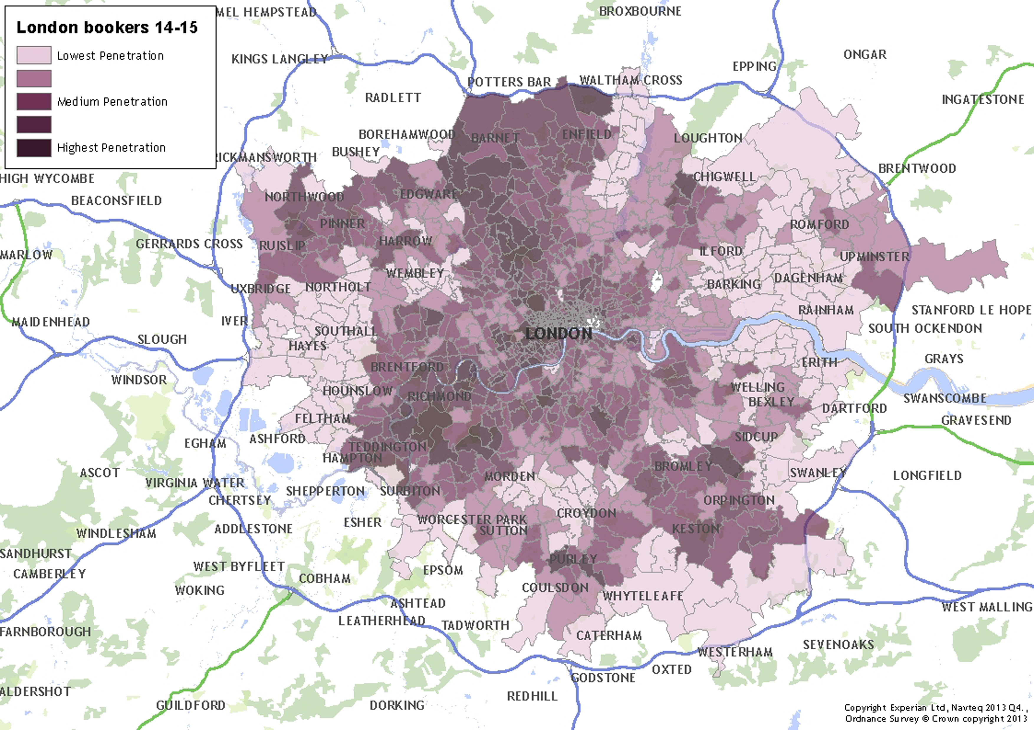

**Figure 1. London wide map showing performing arts venue distribution and audience penetration**

Extending this approach, an application of mapping cultural assets and attendance within a local catchment is provided by a study of Woolwich in the London Borough of Greenwich. *Shaping Woolwich Town Centre though Culture* (Evans, 2015) was developed under the *Living Places* initiative drawing on a detailed analysis of cultural facilities across all sectors (Table 1); the assessment of the distribution of arts attendance by borough residents (Fig.2); planned population/new housing growth; and measuring walking catchments to clusters of arts facilities (Fig.3). This classification of assets was further detailed with secondary and tertiary descriptors, catchment, status (e.g. professional, amateur), strategic significance and other capacity information (DCMS/CASE, 2010).

**Table 1. Cultural asset primary description (exc. Sport)**

|  |  |  |
| --- | --- | --- |
| **Arts** | **Museums, Libraries and Archives** | **Heritage** |
| Art Galleries and Visual Art Venues | Museums | Historic Buildings and Structures |
| Music Venues | Libraries | Historic Monuments |
| Theatres, Dance and Drama Venues | Archives | Historic Parks and Gardens/ Landscapes |
| Multi-Use Venues |  | Protected Natural Landscapes |
| Cinemas |  | Archaeological Sites |
|  |  | World/National Heritage Sites |

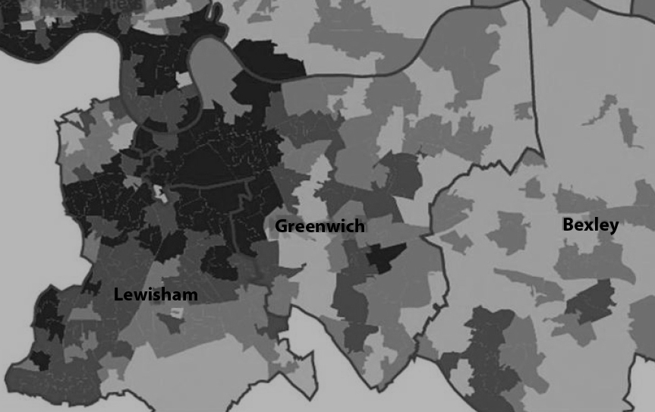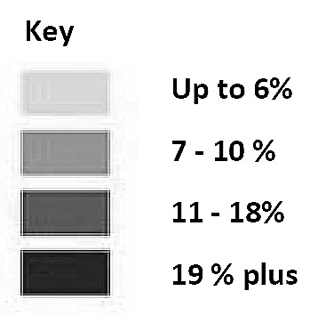

**Figure 2. Arts attendance and participation (2005/06), all art forms**

Fig.2 shows the percentage of households in each local ‘super output area’ that have attended one or more of thirty venues surveyed by Audience London in the year. This does not cover all art forms or venues (for example free events and festivals) however it provides an understanding of the differences in attendance among local neighbourhoods. Whilst levels of arts engagement were lower in this area, housing and population growth coupled with a cluster approach to the cultural facilities which could be easily accessed by foot (Fig.3), provided the basis for both investment and the development of cultural programmes and facilities. In this case the strategy was to both increase access and attendance and thus increase frequency of cultural engagement by local residents – new and established.

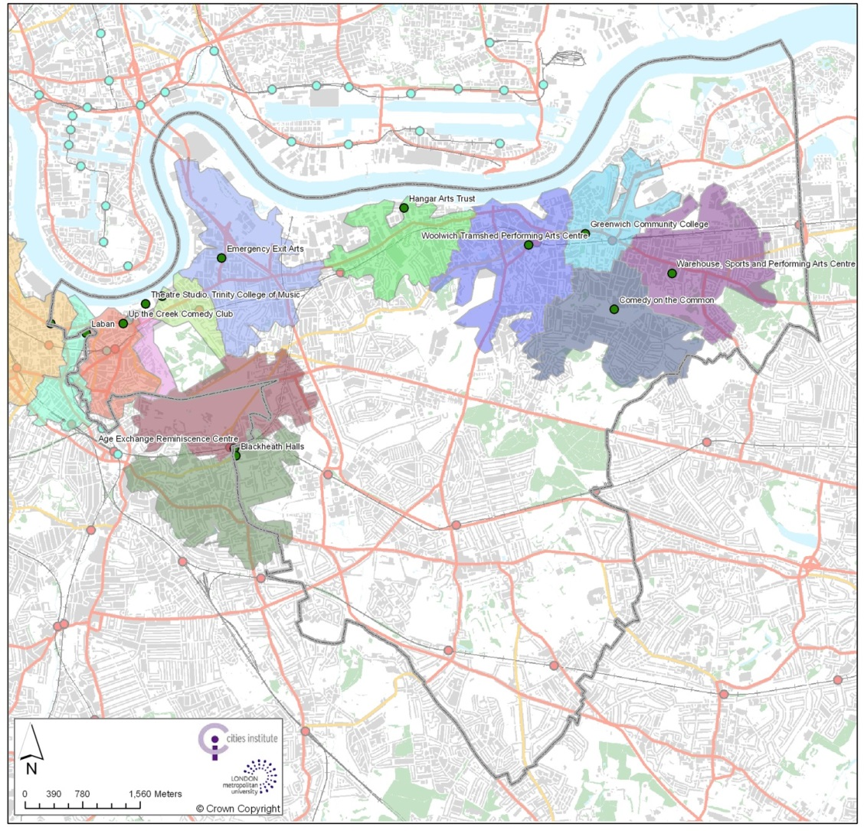

**Figure 3. Multipurpose performing arts spaces, 20 minute walking catchments**

**Frequency and Proximity**

It seems logical therefore that the influence of, and access to supply, is fundamental in considering cultural activity, particularly out of home, although even in the household, access to fast broadband, digital media and other spatial and social conditions can create distinctions in access to a range of cultural engagement. Tenants, particularly in social/council rented accommodation have less freedom to adapt their premises, whilst space standards have fallen in new housing/apartment developments in order accommodate more/higher density occupation, militating against social-cultural space-usage for these dwellers (Evans, 2013b). This means that local amenities are more important for these groups and serve dual social, cultural, as well as economic purposes. In some respects this forms part of the cultural capital which together with education, direct the trajectories that influence personal taste and attitudes towards culture. Childhood experience is of course credited with a strong influence on subsequent adult cultural appreciation and participation in the arts. Bourdieu’s early surveys indicated that the age at which the first visit to a museum took place varied from 26% of under-15 year old working class respondents, compared with 37% of middle class and 56% upper class respondents (Bourdieu and Darbel, 1969, p.133). (Bourdieu had earlier claimed that visitors to museums were also likely to overstate the frequency of their visits the less they visit - and the lower level of their education - by being seen to conform to what they perceived as the ‘norm of legitimate practice’ (ibid, p.38). However, this is not limited to formal education (curricula and extra-curricula) and training that requires expert tuition (e.g. learning a musical instrument, ballet etc.) as Dobson and West (1989) found. Their research on adult arts participation and attendance found a strong positive linkage between participatory experience in informal settings (e.g. youth, community/arts centre), as opposed to formal (‘curricula’) and passive attendance at school, theatre or museum trip (Evans, 2001, p.126). Harland and Kinder also reported that there was ‘very little evidence on the school’s contribution to encouraging applied and independent engagement with cultural venues’ (1999, p.36).

Whilst actual arts attendance and participation is seldom quantified in periodic local authority satisfaction/quality of life surveys, or is minimal in the case of *Taking Part*, TGI and cognate surveys which are satisfied with ‘once a year’ as an indicator of arts activity, the frequency of activity is obviously critical in sustaining cultural development and developing new audiences - and an important measure of success in arts programming and provision. For example across a local population sample, ‘live arts, heritage and exhibitions’ can attract over three quarters of a population, attending from 4 to 5 times a year (ACE, 2006). Sports activity on the other hand is undertaken more frequently, but by a smaller proportion of the community (Evans, 2001). This combination measures the ‘penetration rate’ based on the percentage of the area population attending multiplied by the frequency of attendance. Sports and recreation facilities tend to be more evenly spread locally, benefiting from long established standards and ‘hierarchy’ of provision based on population and facility size (e.g. swimming pools, parks, sports centres), whilst access to a range of arts facilities requires longer travel often to town/city centre and beyond. As Audience London’s Culture Map analysis found however, where good quality arts provision and programming is available to a local audience outside of the city centre, a high level of population penetration is achieved (and these levels will also be understated by frequent social usage and attendance at free events). Understanding these spatial and quality relationships is therefore vitally important, but the focus on non-place specific participation surveys is of limited help in planning and programming the arts. Three contrasting types of cultural facility are therefore considered - libraries, cinemas and arts centres - which all exhibit higher frequency of attendance as a result of their geographic availability and arguably their diversity. They also represent different models of public, private and voluntary cultural provision and operation.

Libraries

In arts and entertainment provision, (commercial) cinema and (public) libraries present the most distributed and not surprisingly most accessible in terms of attendance by a larger population group than other less available cultural facilities (Evans, 2008). Unlike cinema, where audience profiles show a rapid ‘age-decay’ between younger and older consumers, libraries also maintain a fairly even spread of age group usage and higher proportion of lower socio-economic group usage. Despite cumulative reductions in the funding and therefore opening hours of public libraries (threatening long standing minimum standards of provision - below), 39% of the adult (16+) population still use libraries and this rises to 50% in more deprived areas of the country, as the recent Independent Library Report (DCMS, 2014) observed: ‘Libraries offer more than just books, CDs and DVDs. They have become the portal to a whole range of material for education, entertainment and self-improvement’. Today, local libraries (some rebranded as *Idea Stores* or part of arts centre hubs) host young people studying and using these facilities as a buffer between home and school (it should be noted under-16 year olds are not included in government Social Trends surveys, ONS, 2011), as well as a range of classes, spaces and exhibitions - from pre-school to pensioners. The most recent standards of public library services (Table 2) include aggregate opening hours of 128 per year per 1,000 population (and this can be increased to include daily commuter and visitors flows). These targets are however consistently not met.

**Table 2. Proportion (%) of households living within specified distance of a static library**

|  |  |  |  |
| --- | --- | --- | --- |
| Authority type | Households within: | | |
| 1 mile | 2 miles | Sparse authorities/2miles |
| Inner London  Outer London  Metropolitan  Unitary  County | 100  99  95  98 | 100  100  85 | 72  72 |

Source: DCMS (2008) Sparse authorities are defined as the 10% of with highest sparsity of population indices.

Libraries also offer a good litmus test of participation of a local population through the library/swipe card with user address details. Whilst the full range of services actually used is not distinguishable (and is therefore understated) without further survey data, this does provide a clear indication of the geographic catchment in terms of households, and therefore socio-demographic analysis. An example of utilizing local data to profile library catchments is Hampshire County Council’s Public Library User (PLUS) System. This creates user profiles for each library, combining data on users/ visitor activity, behaviour and attitudes, profiled by postcode - with census, deprivation and lifestyle data (e.g. ACORN, MOSAIC). This creates user profiles, defining the demographic for each library catchment and highlighting the difference between users and the actual community through a ‘community variance index’ (Dorward, 2006). An example of catchment and population usage is illustrated through an analysis of library provision in Gateshead, north east England (Fig.4). This reveals which areas of the borough attracts comparatively higher and lower library usage in proximity to library facilities. Local provision is clearly important to actual usage, but variations are apparent between areas where library facilities are similar. This information in turn can be analysed by household and demographic profiles, and can suggest where there may be gaps in provision and where accessibility and quality issues may be constraining or encouraging usage.

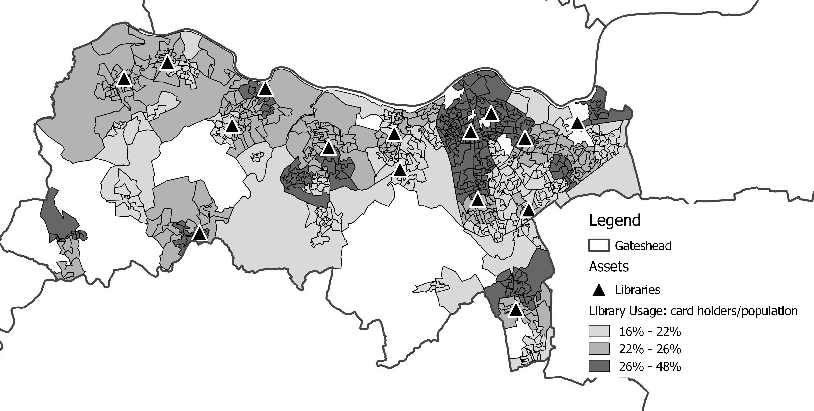

**Figure 4. Gateshead Library Usage**

Cinema

Cinema provides another locally accessible cultural facility (albeit also declining in supply) - like libraries also subject to high levels of substitution from competing forms of consumption, notably video and now digital (TV, DVD, PC, streaming, mobile/tablets etc). Despite this, cinema attendance maintains the highest level of attendance at cultural events – 67.5% of the population in England (compared with 48.2% attending “Any performance in a theatre”), the only activity where attendance actually increased between 2008/9 and 2009/10 (ACE, 2010). Black and Asian group attendance is also higher here than in other activities - proportionately higher than White audiences (ACE, 2003). Between 1995 and 2009 cinema attendance rose from 52% to 67.5% of the population. Like *Taking Part*, these surveys give no indication of the place of participation, whilst the frequency of attendance they count is low (it includes people who attend ‘less frequently than once a year’). Cinema on the other hand has the highest frequency of reported attendance with nearly four times as many people going regularly (4 times or more) than go infrequently (once or less a year).

An interesting contribution to the place-cultural experience relationship has been provided by the introduction of live theatre screenings in cinemas by the National Theatre, Metropolitan Opera (New York), Covent Garden Opera House and other larger venue organisations such as the English National Opera. For example, National Theatre broadcasts live performances simultaneously to collaborating cinemas across the country, capturing the ‘live’ experience rather than just digitally recorded for later screening. One perhaps unexpected impact has been that cinema audiences are in many cases closer to the stage/performers than most theatre-goers, with cameras allowing for close up-zooming. A NESTA survey (2010) of two NT productions *Phèdre* and *All’s Well That Ends Well* at these live/screened events produced some interesting results between the cinema and NT theatre audiences.

In terms of the experience itself, cinema audiences were more absorbed and had their expectations met moreso than the theatregoers, with a higher emotional response and an appreciation of a new way of seeing the work. The live cinema therefore provides both a substitute and complementary cultural experience to the live theatre, and provides a positive introduction to subsequent attendance at live performances (in both the cinema and theatre) with 89% of cinema audiences saying that they were more likely to attend future live broadcasts, with a large minority more likely to attend the theatre itself (34%) and other plays/venues (30%). Significantly, the live cinema screening attracted a lower income audience and many of whom had never been to the NT. What is clear is that a familiar and accessible venue is able to attract a wider audience than the original production. In the cinema case, audiences were willing to compromise factors such as ambience and some of the excitement of the face to face live event for convenience, a more intimate, shared experience and closer access to the stage/action. For most, local accessibility was an overriding factor in attendance.

Arts Centres

Community-based arts centres have been a prime distributive cultural policy in the UK and other countries in the post-War period e.g. Malraux’s *Maisons de le Arts* in France. Most arts centres in the UK have been established as the result of action by a local resident group or action by an arts, education or community organisation to establish or improve a facility; a local authority seeking to improve local provision or, more recently, to regenerate an area; or some combination of these. The geographic location of an arts centre, in relation to other provision, also appears to have a direct bearing on its programme - from performances, screening, readings and exhibitions - to classes, workshops, to advice for artists, studios and rehearsal rooms. In most cases, arts centres were opened to fill a gap in provision, including art form/special interest (e.g. ethnic arts, community arts). There is also a strong influence of the architecture of an arts centre on its programme – how ‘fit for purpose’ and whether the facilities can fulfil their ambitions (an oft-cited barrier to local provision and single-use venues such as cinemas is the standard of the facility and experience). The majority of arts centres occupy converted spaces including historic/heritage buildings, although as a result of Lottery, European and regeneration funds, there are more purpose-built cultural centres, including high profile ‘failures’ or centres that struggled to attract users (e.g. National Pop Centre, Sheffield; The Public, West Bromwich; Artezium, Luton; Centre for Visual Arts, Cardiff). Welcoming social spaces are cited as one of the selling points of arts centres and one of the prerequisites for audience development. Cafés, bars, bookshops, restaurants and accessible foyer areas have much greater value than the simple generation of income. They are key to social interaction between the people who work in, and use, the centre. The most recent survey of Arts Centres was in 2006 (ACE) but this revealed some key features that suggest this type of provision has a particular place and value in participation, cultural development and access.

In terms of the profile of users, these showed a fairly even spread across age groups (11% Under-25 and 25-34 years olds; 20% 35-44, 45-54 and 55+ age groups), with non-metropolitan centres having an older user group and metropolitan centres a much higher youth attender. Frequency of attendance, facilitated by proximity and a core local audience was as follows (Table 3), and with higher usage rates than more mainstream venues.

**Table 3. Frequency of attendance**

|  |  |
| --- | --- |
| Frequency of attendance | % |
| Once a week | 15% |
| Every couple of weeks | 11% |
| Every 1-3 months | 53% |
| Once a year | 12% |
| Less than once a year | 8% |

Arts centres also provide a diverse range of activities and facilities (e.g. studios, classes /workshops) although some may be focused towards particular arts practice, e.g. drama, dance, visual arts, media, ethnic arts. This is reflected in audience take up of more than one art form with a significant proportion experiencing three or more art form activities (Table 4).

**Table 4. % of audience attending different numbers of artforms**

|  |  |  |  |
| --- | --- | --- | --- |
| Number of art forms attended | All | Non-metropolitan | Metropolitan |
| 0 (social users only) | 3% | 4% | 1% |
| 1 – 2 | 30% | 30% | 25% |
| 3 – 5 | 38% | 35% | 42% |
| 6 – 10 | 22% | 23% | 23% |
| 11+ | 6% | 7% | 9% |

Serving a primarily local and sub-regional catchment provides an indication of the benefits from both access/proximity and continuity of supply, which are important for sustained participation and cultural development. For example, in a study of demographic indicators of cultural consumption, Boyle found that over a 5 year period from the opening of a new venue, the number of households attending from the catchment area increased by 1,101 to 2,704 and as the authors suggest: ‘the local availability of a venue can broaden the range of people attending’ (2011, p.25). Another example of the influence of a change in supply, between 2005 and 2009 attendance at museums & galleries in the North West region increased from 40% to 47% attributed to the build-up and effect of Liverpool’s European Capital of Culture in 2008, however, attendance slipped back to 45% in 2009 as the level of provision declined (DCMS, 2010).

Access to a range of arts and cultural activities and facilities within a neighbourhood locality would therefore look to provision at the same scale as, say, junior schools, not limited to town centres, but accessible at a similar level, whether formal community arts centres, or multipurpose facilities, or where professional programmed and supported cultural activities are delivered via community centres and other venues (Evans, 2008). Arts centres in various forms and scales thus represent one of the few distributed cultural facilities that combine more than one art form/cultural activity and space. Where established they can fill a particular gap in local provision (see Fig.1), although receiving less attention in arts attendance surveys (having been devolved or always funded locally).

**Conclusion**

It would be hard to suggest that the overall increases in basic attendance rates in formal arts activities has not in part been influenced by improvements in the supply of cultural facilities (of all kinds) in the past 30 year period, as well as population increases - i.e. participation rates for a larger population equates to an absolute increase in attendances, *cet par*. However, the extent to which these upgraded/extended and new cultural venues which have received the lion’s share of funding (Lottery, European, regeneration) have benefited an existing and latent arts attender rather than genuinely widened access/accessibility, is not clear, particularly with the evidence that social and geographic divides continue to persist, and much cultural activity remains ‘hidden’ (sic) in these official assessments. With local government still the highest funder of arts and community cultural provision (albeit of a reducing total budget), attention to local facilities and the relationship to cultural engagement is warranted, given the embedded barriers - such as access, arts in education, transport, time/cost, and environmental and institutional factors discussed above. However, cultural policy and funding priorities still privilege national arts institutions, predominately London-based, whilst local government funding settlements threaten further major cuts in central government support, further weakening local resources (funding, buildings) for what is a non-mandatory and therefore more vulnerable area of provision.

The focus on impacts and change effects arising from investment and provision of cultural facilities and programmes has been a continuing feature in policy initiatives and commissioned research, particularly since the advent of the National Lottery, and the imperatives to measure the externalities associated with social impacts (Reeves, 2002; Shaw, 1999); regeneration (DCMS, 2004); and cultural investment (DCMS, 2011, 2015) - rather than a clearer focus on supply-demand relationships and the implications that arise from this in terms of survey and measurement efforts and investment location and arts programming decisions. Whether this situation is a self-fulfilling reflection of the quality of research commissioning and production, or whether the ‘right’ questions are not being asked (which might lead to structural changes in cultural provision, resource allocation and distribution) - but a combination of these factors seems to be the fairest conclusion.

However, an inescapable observation is that the national data sets, commissioned surveys and local knowledge (residents, arts organisations) are not joined up, and are unable to link the supply and demand for cultural activity and required facilities in order to increase participation and representation. The model of *Culture Map* demonstrates (Brook, Boyle, Flowerdew, 2010) that when this link is made and visualised using arts venue and available demographic and related data at very localised ‘household’ levels, the propinquity of cultural amenities to communities, particularly those who do not or cannot access cultural venues and spaces further away, generates sustained participation. This also reveals fine grained distinctions in activity levels within and across different catchment areas. Evidence from particular venues located in non-central areas also show that they can maintain a large and regular population usage from their catchment, and this can also be traced to particular programming and provision through the use of venue-user-household data. We therefore need more systematic evidence of this link. This will then lead to an assessment of gaps in provision, where ‘non-users’ are concentrated geographically and socially - in short, a cultural planning approach to participation and provision (Evans, 2008, 2013a, 2015).

Strategically it may be time therefore to revisit the ‘hierarchy of provision’ model (Evans, 2001, p.123; 2008) that looks to a scale of cultural amenities from neighbourhood to town/city centre, that is not limited to the official arts and other funding systems, but in relation to population and genuine accessibility and the full range of cultural amenities in a catchment (DCMS, 2010). This represents what is currently known as the ‘cultural ecosystem’ - a term first borrowed from biology and environmental studies, then applied to economic production chain/innovation. Valorising the cultural ecosystem primarily in terms of its contribution to the economic creative industries (Warwick Commission, 2015) does however diminish the value of cultural amenities and the benefits of cultural exchange, experience and development. The latter should be the focus of rebalancing cultural provision in a socio-spatial context. As Raymond Williams argued: ‘to achieve cultural growth, varying elements must be equally available and new and unfamiliar things must be offered steadily over a long period to make general change’ (1961, p.365).

**References**

ACE (2000). *Artstat: Digest of Arts Statistics and Trends, 1986/87-1997/98*. London: Arts Council of England.

ACE (2003)*. Focus on cultural diversity: attendance, participation and attitudes*. London: Arts Council of England.

ACE (2006). *Arts Centres Research*. London: Arts Council of England.

ACE (2010). *Arts attendance in England and Great Britain 1994/95 - 2009/10*. London: Arts Council of England.

ACE (2011). *Active People Survey.* Retrieved from http://www.artscouncil.org.uk/what-we-do/research-and-data/arts-audiences/active-people-survey/

Belfiore, E. and Bennett, O. (2008). *The Social Impact of the Arts*. Basingstoke: Palgrave.

Bennett, T. et al. (2009). *Culture, Class, Distinction*. London: Routledge.

Bourdieu, P. and Darbel. A. (1969/1991). *The Love of Art*. Cambridge, Polity Press.

Boyle, P. (2008). *Demographic indicators of cultural consumption*: ESRC End of Award Report, RES-163-27-0005. Swindon: ESRC.

Brook, O. (2011). *International comparisons of public engagement in culture and sport.* London: DCMS.

Brook, O., Boyle, P. and Flowerdew, R. (2010). ‘Geographic analysis of cultural consumption’, *Spatial and Social Disparities*. Houten, Springer Netherlands, 67-82.

Chan, T. W. & Goldthorpe, J. H. (2005). The Social Stratification of Theatre, Dance and Cinema Attendance, *Cultural Trends*, 14(3), 55, 193–212.

Chan, T. W. & Goldthorpe, J. H. (2007a). The social stratiﬁcation of cultural consumption: Some policy implications of a research project. *Cultural Trends*, 16(4), 373-384.

Chan, T. W. & Goldthorpe (2007b). Social stratification and cultural consumption: The visual arts in England, Poetics, 35, 168–190

DCMS (Department for Culture, Media and Sport) (2004). *Culture at the Heart of Regeneration,* London.

DCMS (2007). T*aking Part: The National Survey of Culture, Leisure and Sport. Annual Report 2005/2006*. London.

DCMS (2008). *Public Library Service Standards*, June. London.

DCMS (2010). *Taking Part - Statistical Release. Adult and Child Report 2009/10.* London.

DCMS (2011). *The Art of the Possible. Using secondary data to detect social and economic impacts from investments in culture and sport*. London.

DCMS (2012). Taking Part 2011/12 *Adult and Child Report. Statistical Release*. London.

DCMS. (2014). *Independent Library Report for England.* London.

DCMS (2015). *The role of culture, sport and heritage in place-shaping. Invitation to Tender.* London.

DCMS/CASE (2010). Cultural Physical Asset Mapping Toolkit. Culture & Sport Evidence Programme. London. Retrieved from [www.gov.uk/government/uploads/system/uploads/attachment_data/file/71127/DCMS_Mapping_Toolkit.pdf](http://www.gov.uk/government/uploads/system/uploads/attachment_data/file/71127/DCMS_Mapping_Toolkit.pdf).

Desai, P. and Thomas, A. (1998). *Cultural Diversity: Attitudes of Ethnic Minority Populations Towards Museums & Galleries*. London: Museums & Galleries Commission.

# Dimaggio, P. and Useem, P. (1978). ‘Social class and arts consumption’, [*Theory and Society*](http://link.springer.com/journal/11186)*,* 5(2), 141-161.

Dobson, L and E. West (1989). Performing Arts Subsidies and Future Generations. In H.H. Chartrand ~~et al.,~~ (Eds), *Cultural Economics ‘88: A Canadian Perspective* (pp. 108-116). Akron: Association for Cultural Economics.

Dorward, S. (2006). *Community Profiling for Libraries - Why and How.* *Recreation & Heritage.* Winchester: Hampshire County Council.

Duxbury, N., Gareth-Potts, W.F., MacLennan, D. (Eds) (2015). *Cultural mapping as cultural inquiry*. New York: Routledge.

# Evans, G.L. (2001). *Cultural Planning: An Urban Renaissance*?. London: Routledge.

Evans, G.L. (2005). ‘Measure for Measure: Evaluating the Evidence of Culture’s Contribution to Regeneration’, *Urban Studies* 42 (5/6), 959-984.

Evans, G.L. (2008). Cultural mapping and sustainable communities: Planning for the Arts revisited, *Cultural Trends*, 17(2), 65-96.

## Evans, G.L. (2009). ‘Accessibility, Urban Design and the Whole Journey Environment’, *Built Environment*, 35(3), 366-385.

Evans, G.L. (2010). Creative Spaces and the Art of Urban Living. In Edensor, T., Millington, S., Rantisi, N. (Eds) *Spaces of Vernacular Creativity: Rethinking the Cultural Economy* (pp, 19-32). London: Routledge.

Evans, G.L. (2013a). Cultural Planning and Sustainable Development. In G.Baker and Stevenson, D. (Eds) *Handbook of Planning and Culture* (pp, 223-228). Aldershot, Ashgate.

Evans, G.L. (2013b). Living in the City: Mixed Use and Quality of Life. In: R.Cooper & E.Burton (Eds) *Wellbeing and the Environment* (pp, 119-147). Oxford*:* Wiley.

Evans, G.L. (2015).Cultural Mapping and Planning for Sustainable Communities. In: N.Duxbury, W.F.Garrett-Petts and David MacLennan (Eds) *Cultural Mapping as Cultural Inquiry* (pp 45-68). London: Routledge.

Feist, A., Fisher, R., Gordon, C. and Morgan, C. (1998). *International Data on Public Spending on the Arts in Eleven Countries*. London: Arts Council of England.

Gayo-Cal, M., Savage, M. and Warde, A. (2006). A Cultural Map of the United Kingdom, 2003. *Cultural Trends* 15(2/3), 213-237.

Gilmore, A. (2013). Cold spots, crap towns and cultural deserts: the role of place and geography in cultural participation and creative place-making, *International Journal of Cultural Policy*, 22(2), 86-96.

Harland, J. and Kinder, K. (1999). *Crossing the Line. Extending Young People’s Access to Cultural Venues.* London: C.Gulbenkian Foundation.

Harland, J., Kinder, K. and Hartley, K. (1995). *Arts in their View: A Study of Youth Participation in the Arts*. Slough: NFER.

Hewison, R. (2014). *Cultural capital: The Rise and Fall of Creative Britain*. London: Verso.

Katz-Gerro, T. (1999). Cultural Consumption and Social Stratification: Leisure Activities, Musical Tastes, and Social Location, *Sociological Perspectives*, 42(4), 627-646.

Jermyn, H. (2001). *The Arts and Social Exclusion. A review*. London: Arts Council of England.

Jermyn, J. (Ed) (2000). *Placing Art in New Contexts: summary of a report to the Arts Council of England.* ACE Research Report No.19. London: Arts Council of England.

Jermyn, H. and Desai, P. (2000). *Arts – what’s in a word? Ethnic minorities and the arts.* London: Arts Council of England.

KEA (2006). The Economy of Culture in Europe. Brussels: European Commission, D-G for Education & Culture.

Keaney, E. & Oskala, A. (2007). The Golden Age of the Arts? Taking Part Survey Findings on Older People and the Arts. *Cultural Trends* 16(4), 323-355.

Lane, J. (1979). *Arts Centres - Every Town Should Have One*. London, Paul Elek.

Lyons, M. (2007). *Place-shaping: A shared ambition for the future of local government - final report.* London: Lyons Inquiry into Local Government.

Markusen, A. and Gadwa, A. (2010*). Creative Place-Making*. Washington DC: NEA.

NCA (National Campaign for the Arts) (2013). *Arts Index - A measure of the vitality of Arts and Culture in England*. Retrieved from http://static.guim.co.uk/ni/1386244722890/The-NCA-Arts-Index-2013-ebo.pdf.

NESTA (2010). *Beyond Live: Digital Innovation in the Performing Arts*. London.

Oakley, A. and O’Brien, D. (2015). *Cultural Value and Inequality*. Swindon, AHRC.

ONS (2011). *Lifestyles and Social Participation*. Cardiff: Office for National Statistics.

Paterson, M. (2006). *Consumption and Everyday Life*. London: Routledge.

Reeves, M. (2002). *Measuring the Economic and Social Impact of the Arts: A Review*. London: Arts Council of England.

Shaw, P. (1999). *The Arts and Neighbourhood Renewal: A Research Report*. London: Department for Culture Media & Sport.

Skelton, A., Bridgwood, A., Duckworth, K., Hutton, L., Fenn, C., Creaser, C. and Babbidge, A. (2002). *Arts in England: Attendance, Participation and Attitudes in 2001*. London: Arts Council of England.

TfL (2010). *Measuring Public Transport Levels: PTALs*, London: Transport for London.

Warwick Commission (2015). *The Warwick Commission on the Future of Cultural Value*. Warwick University.

Williams, R. (1961). *The Long Revolution.* London: Pelican.

1. * Email: g.evans@mdx.ac.uk
2. **Note**

   Respondents were asked whether they had been to any creative, theatrical, artistic or musical events in the last 12 months and how often they have attended. They were also asked if they have undertaken any creative, artistic, theatrical or musical activities in the last 12 months and how often (www.artscouncil.org.uk/what-we-do/research-and-data/arts-audiences/active-people-survey).