**Does innovation-orientation lead to retail industry growth? Empirical evidence from patent analysis**

**ABSTRACT**

Competitiveness and complexity in the retail industry are increasing due to rapid technological changes and diffusion. Patent analysis is largely used in innovation studies to assess and monitor technological changes in different sectors. The aim of this paper is to provide a comprehensive view of the innovative forces affecting the retailing sector, by focusing on the evaluation of innovation levels through the classification and analysis of patented innovations. The findings show that retailers might shift to more innovation-oriented strategies in order to propose innovative consumer solutions, due to the support of the technology advancements highlighted by the strong patent track record. Our study contributes to the literature by providing empirical evidence of critical areas for innovation in retailing and by offering bibliometric and patent analytical methods measures relative to the innovative forces affecting retailing, which might push the sector to be increasingly an innovation-oriented one. Finally, the high level of property rights (defined by the huge amount of patents) pushes retailers to invest more on acquiring patented technologies to achieve advantages over competitors or to adopt novel management practices as substitutes for patents.

**Keywords**. Innovation management, Technology management, Retailing, Patent analysis

**1. Introduction**

Competitiveness and complexity in the retail industry are largely increasing due to rapid technological changes and diffusion. For example, technology-based innovation can integrate leisure and entertainment into the retail experience while also providing new shopping experiences and enhanced retail services (Arnold & Reynolds 2003; Demirkan & Spohrer, 2014; Hristov and Reynolds, 2015; Johnson et al., 2015; Poncin & Mimoun 2014). As a consequence, these innovations challenge the retail industry to find new and efficient solutions to improving the consumer experience and retail management. These innovations can dramatically modify the retail landscape (Hopping, 2000; Pantano, 2016). In fact, demand pull has been largely considered a driver of innovation (Pantano, 2014; Venugopalan and Rai, 2015). However, this increasing technological complexity, in combination with the shorter technology lifecycle, makes decisions about innovating difficult (Han and Shin, 2014).

In recent years, several researchers have tried to investigate the innovative forces affecting the industry, by focusing on the drivers (Alexander et al. 2005; Pantano, 2014; Tsai et al. 2010), process management (Evanschitzky et al. 2015; Hristov & Reynolds, 2014), and innovation outcomes of the consumer experience (Demirkan & Spohrer 2014; Pantano, 2014; Poncin & Mimoun 2014). Moreover, forecasting the success of future technology plays an important role for marketers in predicting the success of an investment in a certain technology (Altuntus et al., 2015). Similarly, a deep understanding of the innovative forces affecting the sector might provide useful insights for managers for better orienting investments and strategies (Barros, 2015).

However, while these studies provide a clear picture of the factors driving consumers’ adoption of innovation in retail settings, they do not empirically support an understanding of retailing as a high innovation or low innovation sector. Similarly, they do not attempt to classify the critical areas of development in the industry. However, some authors (Lee et al., 2011) have highlighted the extent to which the increasing complexity and availability of technological innovation requires companies to monitor technological changes in order to maintain business profitability. Therefore, there is a need for clear measurement tools to enable develop understanding of the innovative forces in retailing and provide scholars and practitioners with new ways to successfully compete in the emerging context.

Other sectors have faced the challenge of evaluating innovation, and have started using patent analysis as a reliable tool for evaluating the level of innovation and the level of technological development within a certain sector (Abraham & Moitra, 2001; Encaoua et al., 2006; Hana and Shin, 2014; Nelson et al., 2014). For instance, they base the analysis on the evaluation of the number of patents and their dynamics over a number of years (Cecere et al., 2014; Hicks et al., 2001).

Despite the benefits, this kind of analysis has not yet been fully exploited by the retail industry. Retailing (offline and online) is one of the most dynamic global economic sectors with total sales of more than $22 trillion in 2014 and sales are forecasted to reach $28.3 trillion in 2018 (emarketer.com, 2014). Beginning with patent analysis in the retail industry, the aim of this paper is to provide a clear understanding of the areas (i.e. payment systems, systems for product displays, etc.) that have witnessed the greatest changes.

The contribution of this paper is twofold. First, it attempts to fill a gap in the literature by providing empirical evidence through patent analysis on critical areas for innovation in retailing. To our knowledge this is the first study that uses patent analysis in retailing. Second, it suggests that by using bibliometric and patent analytical methods (Ma & Chang, 2014) on the innovative forces affecting retailing, the sector might become progressively innovation-oriented one. Through the proposed analysis, scholars and practitioners can be made more aware of the importance of innovation and of those specific technologies that could offer more opportunities to increase business profits. In particular, retailers could use our insights to prioritize investment in innovation by identifying some key specific areas in order to achieve a competitive advantage.

The paper is organized as follows: the first part is an analysis of current studies which focus on the forms of retailing that have evolved due to new advances in technology, and on the current measures used to evaluate levels of innovation based on patent analysis in several sectors, with an emphasis on the emerging benefits. Secondly, we analyse the patents in retailing so as to discern the most critical areas. Thirdly, we analyse the patent trends in the retail sector and make some comparisons with other sectors. Finally, we discuss the outcomes and provide indications for both scholars and practitioners on how these insights could be used to develop new and more effective management strategies for the retail industry.

**2. Theoretical background**

*2.1 Evolution of retail environments*

Past studies have investigated how advances in digital technologies prompted evolutions in retailing, in terms of store layout, service delivery, product search, etc. (Pantano & Timmermans, 2014). In fact, actual retailing is characterized by a huge focus on the development of innovative consumer solutions for creating value for clients based on technological innovation (Maglio & Spohrer, 2013; Pantano &Timmermans, 2014). Thus, there has been a shift from a traditional face-to-face service to a technology-enriched one which can improve the shopping experience and consumer satisfaction (Demirkan and Spohrer, 2014; Pantano, 2016)

In this context, Evans (2011) anticipated the increasing integration of computing in consumer shopping activities through pervasive penetration supported by ubiquitous systems. For instance, Wu and Hisa (2008) identified the main steps in the evolution of stores as I-commerce (internet-based retailing), M-commerce (mobile technologies-based retailing) and U-commerce (ubiquitous computing-based retailing); whereas Williams (2009) identified the basic steps as the creation of: department stores, mail order catalogues, discount stores and e-tailing; and Bourlakis and colleagues (2009) identified the introduction of online channels and e-commerce platforms, and metaverse environments such as Second Life. While other studies proposed the evolution of traditional points of sale towards ubiquitous stores based on a high level of connectivity and extensive usage of mobile devices (Blazquez, 2014; Kourouthanassis et al., 2007; Pantano, 2014). These studies introduce the new concept of an innovative store where boundaries are no longer physical or temporal but technological, due to how they are integrated with advanced technology. Therefore, they underline how the current trend in retailing is based on the development of innovative technological environments, where a higher integration with technology has an impact on the spatial dimensions of the store. Current studies emphasize the use of mobile and high connectivity technologies for innovation in retailing, while excluding the usage of large fixed technologies to support shopping (Pantano, 2014). In summary, these studies predict the trend in retailing without highlighting the critical areas or the critical technologies that would redefine the concepts of ‘stores’ and ‘shopping experience’, while an analysis of the actual patents granted would clearly identify the key digital technologies that could be integrated in the future and act as a driver of this change.

*2.2 Patents as measure of innovation*

Technological change is an evolutionary process that requires constant monitoring to allow firms to understand the current scenario and react accordingly so as to maintain their competitive advantage (Lee et al., 2011). In recent years there have been an increasing number of studies aimed at investigating the trends within a particular field of technology through the development of new methods and tools that can enable a better understanding of these trends (Choi & Hwang, 2014; Jun, 2014; Lapple et al., 2015; Lee et al., 2011; Venugopalan & Rai, 2015; Yoon and Park, 2004).

The need to develop a measure of the technological changes affecting a specific sector or a geographical area has attracted the attention of a number of academics over the past decades (Archibugi & Pianta 1996; Basberg 1987; Kim et al. 2015). For instance, several indexes have been applied to measure technological change as a function of patent quantity (Daim et al. 2006). In particular, patents have the ability to reflect inventive activity and innovation, and can be used to analyse the evolution of technology in a certain area (including geographical areas, particular industries, countries, etc.) (Basberg, 1987). Basically, patents consist of a document which includes the “source of technical and commercial knowledge about technical progress and innovative activity” (Park et al., 2005, p. 473), and they are the most used method for protecting firms’ inventions (Archibugi & Pianta, 1996). They provide detailed information about the technology, including the technical and market attributes, the criteria for originality, such as technical feasibility and commercial worth, and details about the inventor. (Lee et al., 2011; Park et al., 2005). Patents also cover every field of innovation across different countries and over long periods of time (Park et al. 2005) and are particularly efficient in capturing the proprietary and competitive dimensions of a technological change (Archibugi and Pianta 1996; Basberg 1987; Jun and Park, 2013; Kim et al., 2015). In fact, patents describe innovation activity at a technological and a country level, and their analysis can provide different insights across technological classes and similar insights across countries (Abraham & Moitra. 20011). Finally, patents are public documents that present information in a standardized way that can be easily accessed through public and commercial databases (Lee et al., 2011; Choi & Hwang, 2014). When considering the technology life cycle curve (TLC), patents can provide insights into the success of a technology in terms of possible future diffusion, patent power, potential investment areas, etc. (Altuntas et al., 2015). In fact, past authors have noticed that patent growth follows a trend similar to s-shaped growth, by considering that an emerging technology (early stage of s-shape) involves a very limited number of patents, while in a fast-growing period involves a huge number of patents (Daim et al., 2006).

Therefore, patent analysis is able to monitor technological change, because it (i) defines the economic indicators which synthesize the link between technological development and economic growth, (ii) estimates technological flows and their subsequent impact on productivity, (iii) evaluates the competitiveness of firms while comparing innovative performances in national and international contexts, and as well evaluating the competitiveness of firms, (iv) creates technology plans which better identify the investment required to prioritize R&D activities, because acquiring patent rights requires a lot of time and financial resources (Yoon and Park 2004; Lee et al., 2011). Hence, patent analysis provides a conceptual or qualitative measure of the technological change, while predicting future trends based on the information extracted by patents through numerical results (Lee et al., 2011; Choi & Hwang, 2014).

For these reasons, it has been successfully used in the agri-food sector to measure farm-level innovation through the development of an agricultural innovation index (Lapple et al. 2015), in nanomechanics to evaluate the innovativeness of the systems used for the mechanical characterization of materials at the micro/ and nanoscale (Alfano et al. 2011), in family businesses to evaluate the economic and technological importance of innovation for family firms (Block et al., 2013), in information and communication technologies (Choi et al., 2007), and in green energy (Jun, 2014). Since innovation patterns and the effects of innovation differ across different industrial sectors (Park et al., 2005), and there are no specific measures in the retail sector, retailing would need ad hoc analysis to investigate the innovative forces and enable a better understanding of the technological changes in order to define new response strategies.

**3. Research Methodology**

Patent analysis has largely been employed to investigate trends in technology. Using text mining (i.e. the text describing the patent) and bibliometric analysis (i.e. the number of patents in a certain period of time) (Lee et al., 2011), this kind of analysis can provide a more detailed overview of the level of innovation compared with studies which aim to highlight the constant changes in technological developments and moving targets (Ogawa and Kajikawa, 2015). Text mining enables the extraction and analysis of information from text data (i.e. patent description, etc.) (Lee et al., 2011), while bibliometrics enables this to be done using the number of patents granted. In particular, these have been employed, using different approaches, to explore, organize and analyse large amounts of historical data, and facilitate the identification of complex patterns and the prediction of future trends (Daim et al., 2006; Han and Shin, 2014): (i) statistical analyses based on time series regression (Daim et al., 2006; Jun & Park, 2013), (ii) cluster analysis (Jun and Park, 2013), and (iii) citation networks (Daim et al., 2006; Jun and Park, 2013; Ogawa and Kajikawa, 2015; Patel and Ward 2011) in order to identify current trends and predict future ones. For these reasons, we used a bibliometric approach which took the number of patents granted into account.

*3.1 Data source and procedure*

The actual classification systems do not use specific categories for retailing patents, which lie at the intersection of five broad domains (audio-visual technology, digital communication, computer technology, IT methods for management, and other consumer goods). In fact, patent selection based on classification codes limits the ability of the researcher to investigate the inventive activity in specific product or market areas (Venugopalan & Rai, 2015). To overcome this problem, we used the approached proposed by Lee and colleagues (2009), suggesting text mining to transform patent documents into structured data to identify keyword vectors. We starting from patents selection including the word “retail” in the title or in the abstract from the European Patent Office (see Espacenet). Similarly, we limited the research to patents that had been granted between 2010 and 2014. This procedure allowed us to collect 3,500 patents. Since this filter did not allow selection, it was not enough to only select the patents that were strictly related to retailing, so we further manually screened the patents and selected 1,772 patents, which consisted of the reading of each abstract and manually remove the patent which might include the word “retail” in the text without specifically referring to the retail process (i.e. a patent related to a particular packaging for better preserving a certain product).

Finally, when building the initial dataset for each patent we included the following: patent number, patent title, patent abstract, application date, acceptance date, assignees (patent owners) and country. The patents collected differ in nature, they include methods for identifying retail tire sales, new augmented reality systems for improving the shopping experience, or methodologies for recommending products based on a shopping list and budget, etc.

**4. Key findings**

The first analysis was based on the evaluation of patent numbers for retailing in terms of the total number of patents between 2010 and 2014. Since the patents collected for retailing differ in nature, for instance they might include methods for identifying retail tire sales, new systems for improving the safety of payments procedures, or methodologies for recommending products based on a shopping list and budget, etc., we distinguished five main categories: ‘payment system’ (i.e. a new system for increasing the security of mobile transactions for self-checkout), ‘info/product display’ (i.e. a system including the chance to “try” the product directly from the packaging, without actually opening it), ‘shopping experience’ (i.e. an innovative audio system able to customize the sound in a certain area of the store according to the consumers’ characteristics), ‘information search’ (i.e. a new context-aware system for supporting consumer information searches), and other (i.e. monitoring systems).

The first analysis was based on the distribution of patents across the different typologies. In particular, we identified 51 patents in 2010, 63 in 2011, 68 in 2012, 75 in 2013 and 149 in 2014 for shopping experience; 41 in 2010, 40 in 2011, 44 in 2012, 42 in 2013, and 55 in 2014 for payment systems; 44 in 2010, 52 in 2011, 64 in 2012, 43 in 2013 and 59 in 2014 for info/product display; 14 in 2010, 13 in 2011, 27 in 2012, 33 in 2013 and 27 in 2014 per information search; 98 in 2010, 112 in 2011, 143 in 2012, 176 in 2013 and 189 in 2014 for other (i.e., a method for managing web pages for an e-commerce site, a system for monitoring sales inventory, a system for handling electronic coupons, a new price management system). Figure 1 illustrates the distribution across the typologies.

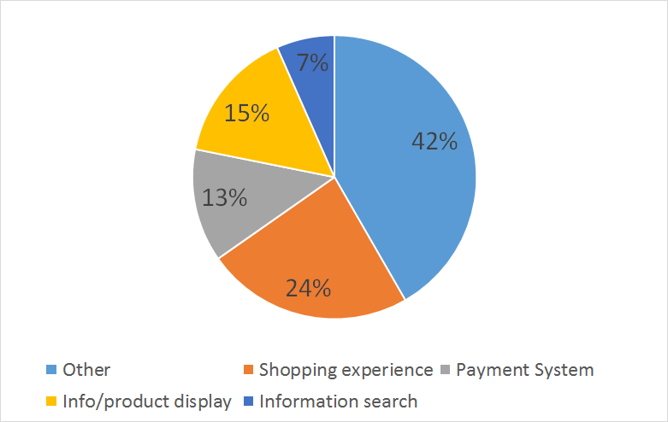

**Figure 1**. Patents distribution across typologies.

These insights provide an overview of the total number of patents granted in each typology in the referring period (five years) by highlighting the most important one as ‘shopping experience’ (upon excluding “other”). This analysis indicates that the technologies aimed at improving the shopping experience are the most popular. A subsequent analysis provides an evaluation of the trend of patents granted in each typology for each year (between 2010 and 2014) (see Table 1 and fig. 2). This comparison is based on the percentage growth per year in order to make a more accurate comparison, taking 2010 as the reference year.

**Table 1.** Number of granted patents per retail typology based on the percentage growth per year, considering 2010 as the referring year.

|  |  |  |  |  |  |
| --- | --- | --- | --- | --- | --- |
| Typologies | 2010 | 2011 | 2012 | 2013 | 2014 |
| Shopping experience | 1 | 1,235 | 1,333 | 1,470 | 2,921 |
| Payment System | 1 | 0,976 | 1,073 | 1,024 | 1,341 |
| Info/product display | 1 | 1,181 | 1,454 | 0,977 | 1,340 |
| Information search | 1 | 0,928 | 1,928 | 2,357 | 1,928 |
| Other | 1 | 1,143 | 1,459 | 1,796 | 1,928 |

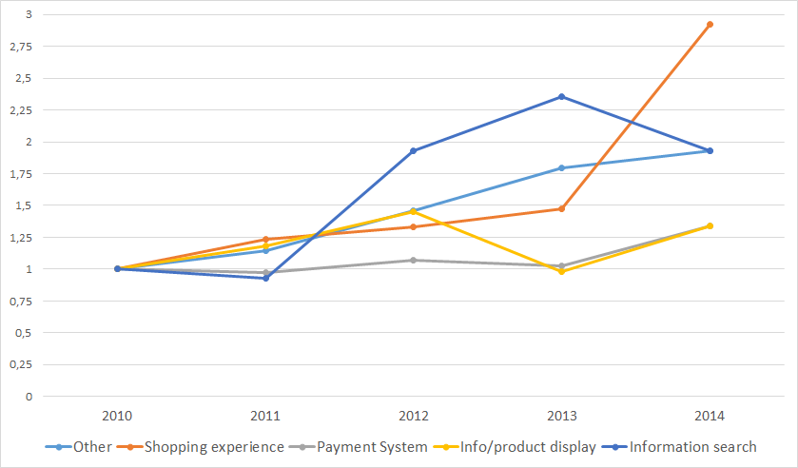

**Figure 2**. Number of granted patents per typology based on the percentage growth per year considering 2010 as the referring year.

As seen in these analyses, the number of patents describing innovation in the shopping experience gradually increased over some years and peaked in 2014 (a percentage of growth of more than 190%). While ‘information search’ increased considerably in 2013 (more than 100%) and decreased in 2014. ‘Information/product display’ increased gradually in 2012 and decreased in 2013, and it increased again in 2014. In contrast, other sectors only increased gradually in 2014. This implies that there is increasing interest in new technologies that can enhance the shopping experience, as there has been a positive trend over the past five years.

To better understand whether retailing is an innovation-oriented industry, we need further analyses comparing retailing with other sectors. Table 2 summarizes a comparison between the numbers of granted patents in retailing with the total amount of patents for the same years.

**Table 2.** Comparison between retailing patents and total patents.

|  |  |  |  |  |  |
| --- | --- | --- | --- | --- | --- |
|  | **2010** | **2011** | **2012** | **2013** | **2014** |
| Total per year | 58.144 | 62.103 | 65.654 | 66.706 | 64.584 |
| Retailing patents | 248 | 280 | 346 | 369 | 479 |
| Percentage | 0,43% | 0,45% | 0,53% | 0,55% | 0,74% |

Since this analysis is based on a comparison between two elements occurring with a different measure (the total number of patents is around 60 thousand while the number for retailing is less than five hundred), a subsequent analysis based on the percentage growth per year has been introduced in order to make a more accurate comparison, taking 2010 as the reference year (Table 3).

**Table 3.** Comparison between the percentage of growth of retailing patents and total patents

|  |  |  |  |  |  |
| --- | --- | --- | --- | --- | --- |
|  | **2010** | **2011** | **2012** | **2013** | **2014** |
| % growth Tot. Patents | 1 | 1,06809 | 1,129162 | 1,147255 | 1,110759 |
| % growth Retailing Patents | 1 | 1,129032 | 1,395161 | 1,487903 | 1,931452 |

Figure 3 graphically summarizes these results in order to clearly indicate how the trends have emerged.

**Figure 3.** Comparison between the percentage of growth of retailing patents and total patents

From this analysis, a positive trend in retail patents emerges. This suggests that there is increasing interest in innovation in retail settings. Since some of the patents that fall into the category of retailing might belong to the fields of audio-visual technology, digital communication, computer technology, IT methods for management, and other consumer goods (as classified by the European Patent Office), we removed these fields from our subsequent analysis. We then evaluated the percentage of growth that was introduced per year and compared the result with retailing, while considering 2010 as the reference year (Table 4). Figure 4 graphically summarizes these results.

**Table 4.** Percentage of growth of granted patents by field of technology.

|  |  |  |  |  |  |
| --- | --- | --- | --- | --- | --- |
| **years** | **2010** | **2011** | **2012** | **2013** | **2014** |
| Electrical machinery, apparatus, energy | 1 | 1,081019 | 1,121099 | 1,059548 | 1,144002 |
| Telecommunications | 1 | 0,961705 | 1,036715 | 0,912357 | 0,751678 |
| Basic communication processes | 1 | 1,016234 | 1,058442 | 1,079545 | 0,813312 |
| Semiconductors | 1 | 1,244838 | 1,235988 | 1,107178 | 1,023599 |
| Optics | 1 | 1,161765 | 1,26548 | 1,228328 | 1,130805 |
| Measurement | 1 | 1,051684 | 1,088489 | 1,189115 | 1,095928 |
| Analysis of biological materials | 1 | 0,963532 | 0,909789 | 1,017274 | 1,142035 |
| Control | 1 | 1,021111 | 1,135556 | 1,205556 | 0,862222 |
| Medical technology | 1 | 1,135786 | 1,190982 | 1,259912 | 1,269241 |
| Organic fine chemistry | 1 | 1,066275 | 1,127936 | 1,32047 | 1,400587 |
| Biotechnology | 1 | 0,981584 | 0,961326 | 0,964549 | 1,083333 |
| Pharmaceuticals | 1 | 0,969116 | 1,117146 | 1,142705 | 1,234824 |
| Macromolecular chemistry, polymers | 1 | 1,062213 | 1,163065 | 1,115914 | 1,204322 |
| Food chemistry | 1 | 1,172786 | 1,276458 | 1,330454 | 1,483801 |
| Basic materials chemistry | 1 | 1,164458 | 1,326578 | 1,293063 | 1,344505 |
| Materials, metallurgy | 1 | 1,098105 | 1,230769 | 1,294314 | 1,360089 |
| Surface technology, coating | 1 | 1,139723 | 1,210162 | 1,375289 | 1,218245 |
| Micro-structural and nano-technology | 1 | 2,115385 | 2,346154 | 2,461538 | 2,807692 |
| Chemical engineering | 1 | 1,008147 | 1,057705 | 1,071283 | 1,056348 |
| Environmental technology | 1 | 0,995031 | 1,147826 | 0,976398 | 0,959006 |
| Handling | 1 | 1,071066 | 1,117174 | 1,111675 | 0,992809 |
| Machine tools | 1 | 1,126652 | 1,096916 | 1,106828 | 1,02478 |
| Engines, pumps, turbines | 1 | 1,02733 | 1,084919 | 1,109322 | 1,016105 |
| Textile and paper machines | 1 | 1,026064 | 1,056915 | 0,859043 | 0,921809 |
| Other special machines | 1 | 1,19144 | 1,259688 | 1,373048 | 1,314633 |
| Thermal processes and apparatus | 1 | 1,234043 | 1,243714 | 1,350097 | 1,44294 |
| Mechanical elements | 1 | 1,19052 | 1,230483 | 1,194238 | 0,996283 |
| Transport | 1 | 0,986941 | 0,999336 | 1,039177 | 0,920983 |
| Furniture, games | 1 | 0,880694 | 0,966739 | 1,106291 | 1,135936 |
| Civil engineering | 1 | 1,008475 | 1,004237 | 1,097458 | 1,141646 |
| RETAILING | 1 | 1,129032 | 1,395161 | 1,487903 | 1,931452 |

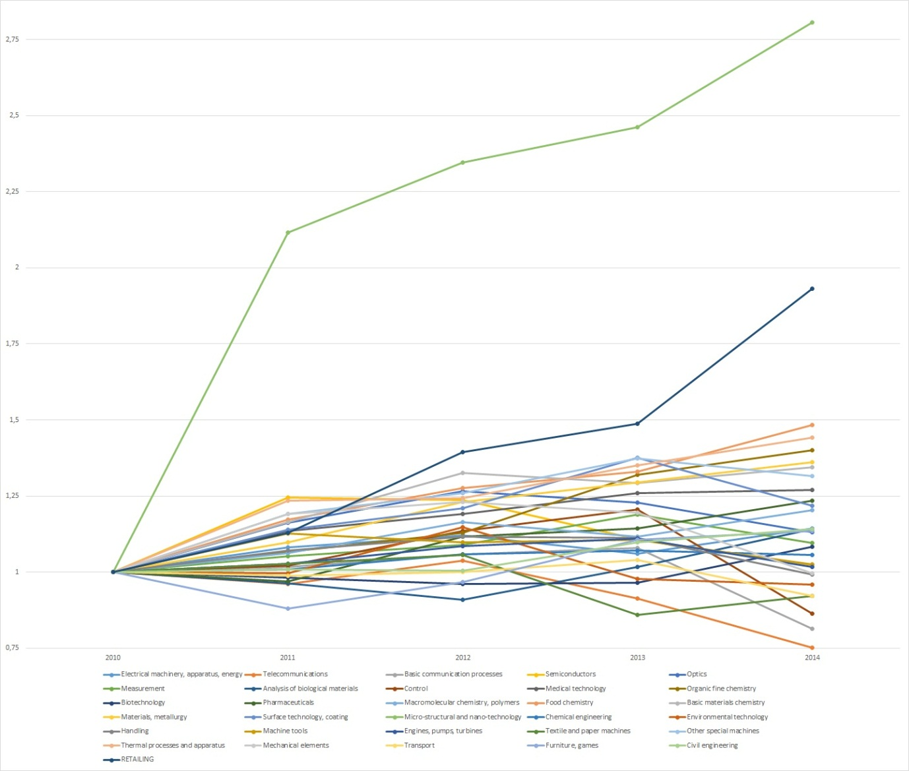

**Figure 4.** Percentage of growth of granted patents by field of technology.

Although micro-structural and nano-technology emerges as the sector with the largest investment in terms of research and development (Alfano et al. 2011), retailing follows a similar trend with a higher percentage of growth in the last year. Other sectors are showing a negative trend in terms of the number of patents per year, which suggests decreasing interest. Overall, these insights characterize retailing as an innovation-oriented sector.

**5. Discussion and conclusion**

Since the patents describe technical progress and innovation in a particular sector (Abraham and Moitra, 2001; Park et al., 2005), the present study demonstrates that there is increasing interest in innovation in retailing, while also showing the extent to which patent analysis can be used to provide a clear picture of the level of innovation in retailing. In this way, it extends the insights made by previous studies that have focused on the effects of innovation on retailing (Demirkan and Spohrer, 2014; Pantano, 2014; Poncin and Mimoun, 2014; Hristov and Reynolds, 2015; Pantano, 2016). Beginning with a patent analysis which goes beyond the patent innovation for patents selection in order to evaluate the stream of invention in the specific domain, as suggested by Venugopalan and Rai (2015) and Hand and Shin (2014), our study provides a clear view of the innovation introduction procedure into the retail process (Figure 5).

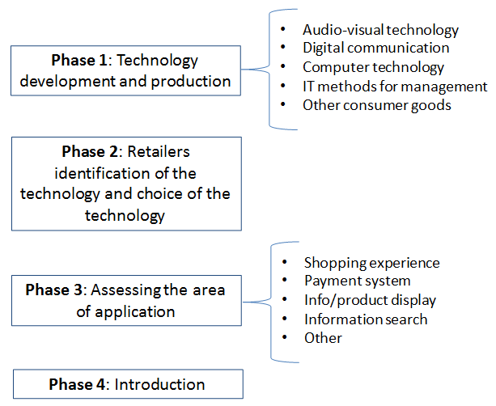

**Figure 5.** Innovations introduction process into retail settings.

Our study contributes to the existing literature in two major ways: (i) by providing empirical evidence of critical areas for innovation in retailing and (ii) by offering bibliometric and patent analytical methods measures relative to the innovative forces affecting retailing, which might push the sector to be increasingly an innovation-oriented one.

*(I) Critical areas for innovation in retailing*

Our insights provide an overview of the current competitive retail landscape while emphasizing the potential diffusion of different innovations concerning the categories of ‘shopping experience’, ‘payment systems’, ‘info/product display systems’, ‘information search systems’, and ‘others’. In particular, when considering the innovation rate among different subsectors of retailing, the highest innovation rate emerges in ‘shopping experience’, which is in line with the findings of past studies which considered the shopping experience as one of the drivers of innovation in retailing (Demirkan and Spohrer, 2014; Pantano, 2014; Poncin and Mimoun, 2014). In fact, if we refer to the technology life cycle curve and related patents analysis (Altuntas et al., 2015), our findings clearly highlight the technologies in which retailers should invest, and anticipate the possible future diffusion of technologies which will enhance the shopping experience and increase investment in this area. Therefore, the interest in consumer technology should help marketers make decisions about investing in a certain innovation, and take advantage of the predicted success of this innovation (Altuntas et al., 2015).

Since an analysis of the actual patents granted for retailing provides an overview of the innovation that could be integrated in stores in the future, our findings further extend previous studies on the evolution of points of sale (Wu and Hisa, 2008; Bourlakis et al., 2009: Williams, 2009; Evans, 201) by anticipating a scenario in which the technologies used will be most oriented to the improvement of the shopping experience. Therefore, future retail investment in innovation might be oriented towards this critical area, in order to maintain competitive advantages. A reason for this interest lies in the huge consumer demand for innovation at the point of sale, as well as on retailers awareness of the benefits emerging from the adoption of smart technologies (Demirkan and Spohrer, 2014; Pantano, 2016), which have been defined as the innovation drivers of the retail industry (Pantano 2014). Similarly, the interest in the technologies improving information searching would decrease, although a disappearance is unlikely. However, this trend might be affected by retailers’ tendency to imitate/follow market leaders innovation strategies (Pantano, 2016).

*(II) Measures relative to the innovative force affecting retailing.*

As anticipated in 2014 by Pantano, one of the innovation drivers in retailing is the technology push. The present study highlights the technology push by providing information about the number of patented innovations that have been, or that could be, integrated within the points of sale. In fact, when considering the rate of innovation in different sectors, we notice the highest innovation rate is in micro-structural and nano-technology, which is the sector with the largest investment in terms of research and development (Alfano et al. 2011). Retailing emerges as the second one, with a higher percentage of growth in 2014. In contrast, other sectors are showing a negative trend in terms of the number of patents per year, which suggests decreasing interest. If we refer to the curve in the s-shape and technology life cycle curve (Altuntas et al., 2015; Daim et al. 2006), we clearly notice a period where there is rapid growth in the number of patents, which suggests investment in innovation. This means that the retail sector is in its ascendant stage, characterized by a huge interest in innovation, in finding new solutions to improve the consumer experience and consumer satisfaction through new technology, and in improvements in the whole retail process. Therefore, these insights, by using bibliometric and patent analytical methods, measure the innovative forces affecting the sector, by pushing towards the shift to more innovation-oriented strategies to propose innovative consumers solutions, due to the support of the technology advancements highlighted by the strong patent track record.

From a practical standpoint, through our study managers can identify the current trends in R&D and thus make better innovation investment decisions with due regard to retail application areas. We provide a framework to support the innovation process portfolio in terms of technology selection among patented innovation and assessment of application areas.

**6. Future work**

Our patent analysis provides a picture of innovation in the retail sector by considering innovations that have been patented. Although we assume that these innovations might be integrated in the future retail environment, we do not know which ones will be effectively implemented. Our analysis is limited to patented innovations because some past studies (Archibugi & Pianta, 1996; Basberg, 1996) have demonstrated the extent to which not all innovations can be, or are, patented. New research could make a comparison between the patents granted and the innovations which have been effectively integrated, in order to better understand the extent to which patent analysis is a reliable measure of technological trends in retailing, and provides the starting point for better predictions of evolutions in retailing. New research in this direction might further investigate retailers’ propensity to patent, in terms of developing innovations to be patented or to buy and adopts patented innovations.

Our findings also show the high number of patents included in the typology “other” (i.e., a method of managing web pages for an e-commerce site, a system for monitoring sales inventories, a system for handling electronic coupons, a new price management system system), thus further studies might analyze these category of patents in more depth in order to distinguish more subclasses, such as systems for improving data collection for retailers (including monitoring systems), systems for ad-hoc advertising, systems improving the movement of goods, etc., in order to provide more accurate previsions of the critical areas in the retail sector. Finally, the present study only focused on five years, which represents another limitation of the present study. Future research could extend this period by considering a longer time period, in order to provide more data to better support predictions about future trends in the sector.

**References**

Abraham, B.J., Moitra S.D. (2001). Innovation assessment through patent analysis. *Technovation,* *21*(4), 245-252.

Alexander, A. (2008). Format development and retail change: supermarket retailing and the London co-operative society. *Business History, 50* (4), 489-508.

Alfano, M., Pagnotta, L., & Pantano, M.F. (2011). A review of patented works on the mechanical characterization of material at micro- and nano-scale. *Recent Patents on Nanotechnology, 5*(1), 37-45.

Altuntas S., Dereli T., & Kusiak, A. (2015). Forecasting technology success based on patent data. *Technological Forecasting and Social Change, 96,* 202-214.

Archibugi, D., & Pianta, M. (1996). Measuring technological change through patents and innovation surveys. *Technovation, 16*(9), 451-468.

Arnold, M.J., & Reynolds, K.E. (2003). Hedonic shopping motivations. *Journal of Retailing, 79*(2), 77-95.

Barros, H.M. (2015). Exploring the use of patents in a weak institutional environment: the effects of innovation partnerships, firm ownership, and new management practices. *Technovation*, *45-46*, 63-77.

Basberg B.L. (1987). Patents and the measurement of technological change: A survey of the literature. *Research Policy, 16*(2), 131-141.

Blàzquez, M. (2014). Fashion shopping in multichannel retail: the role of technology in enhancing the customer experience. *International Journal of Electronic Commerce, 18*(4), 97-116.

Block, J., Miller, D., Jaskiwicz, P., & Spiegel, F. (2013). Economic and technological importance of innovation in large family and founder firms: An analysis of patent data. *Family Business Review, 26*(2), 180-199.

Cecere, G., Corrocher, N., Gossart, C., & Ozman, M. (2014). Technological pervasiveness and variety of innovators in Green ICT: A patent-based analysis. *Research Policy, 43* (10), 1827-1839.

Choi, J., & Hwang, Y.S. (2014). Patent keyword network analysis for improving technology development efficiency. *Technological Forecasting and Social Change,* 83, 170-182.

Daim, T.U., Rueda, G., Martin, H., & Gersdri, P. (2006). Forecasting emerging technologies: use of bibliometrics and patent analysis. *Technological Forecasting and Social Change,* 73, 981-1012.

Demirkan, H., & Spohrer, J. (2014). Developing a framework to improve virtual shopping in digital malls with intelligent self-service systems. *Journal of Retailing and Consumer Services, 21*(5), 860-868.

eMarketer.com. (2014). Retail sales worldwide will top $22 trillion this year. <http://www.>

emarketer.com/Article/Retail-Sales-Worldwide-Will-Top-22-Trillion-This-Year/ 1011765#sthash.uN0EaHvF.dpuf

Encaoua, D., Guellec, D., & Martinez, C. (2006). Patent systems for encouraging innovation: lessons from economic analysis. *Research Policy, 35* (9), 1423-1440.

Evanschitzky, H., Iyer, G. R., Kenning, P., & Schutte, R. (2015). Consumer trial, continuous use, and economic benefits of a retail service innovation: The case of the personal shopping assistant. *Journal of Product Innovation Management, 31*(3), 459-475.

Evans, J.R. (2011). Retailing in perspective: the past is a prologue to the future. *The International Review of Retail, Distribution and Consumer Research*, *21*(1), 1-31.

Han, K., Shin, J. (2014). A systematic way of identifying and forecasting technological reverse salient using QFD, bibliometrics, and trend impact analysis: a carbon nanotube biosensor case. *Technovation*, *34*, 559-570.

Hicks, D., Breitzman, T., Olivastro, D., & Hamilton, K. (2001). The changing composition of innovative activity in the US- a portrait passed on patent analysis. *Research Policy, 30* (4), 681-703.

Hopping, D. (2000). Technology in retail. *Technology in Society, 22*(1), 63-74.

Hristov, L., & Reynolds, J. (2015). Perception and practices of innovation in retailing: challenges of definition and measurement. *International Journal of Retail Distribution Management, 43*(2), 126-147.

Johnson, K.K.P., Kim H.-Y., Mun J.-M., & Lee, J.Y. (2015). Keeping customers shopping in stores: interrelationships among store attributes, shopping enjoyment, and place attachment. *The International Review of Retail, Distribution and Consumer Research, 25* (1), 20-34.

Jun, S.H. (2014). Technology forecasting of green energy using patent analysis and simulation modelling. *Advanced Materials Research, 875,* 1619-1624.

Jun, S., & Sung Park, S. (2013). Examining technological innovation of Apple using patent analysis.  *Industrial Management & Data Systems, 113* (6), 890-907.

Kim, G.J., Park S.S., & Jang, D.S. (2015). Technology forecasting using topic-based patent analysis. *Journal of Scientific & Industrial Research, 74*, 265-270.

Kourouthanassis, P.E., Giaglis, G.M., & Vrechopoulos, A.P, 2007. Enhancing user experience through pervasive information systems: The case of pervasive retailing. *International Journal of Information Management, 27*(5), 319-335.

Lapple, D., Renwick, A., & Thorne, F. (2015). Measuring and understanding the drivers of agricultural innovation: Evidence from Ireland. *Food Policy, 51*, 1-8.

Lee, C., Jeon, J., & Park, Y. (2009). An approach to discovering new technology opportunities: keyword-based patent map approach. *Technovation*, *29* (6-7), 481-497.

Lee, C., Jeon, J., & Park, Y. (2011). Monitoring trends of technological changes based on the dynamic patent lattice: a modified formal concepts analysis approach. *Technological Forecasting and Social Change,* *78*(4), 690-702.

Maglio, P.P., & Spohrer, J. (2013). A service science perspective on business model innovation. *Industrial Marketing Management,* 42 (5), 665-670.

Nelson, A., Earle, A., Howard-Grenville, J., Haack, J., Young, D., 2014. Do innovation measures actually measure innovation? Obliteration, symbolic adoption, and other finicky challenges in tracking innovation diffusion. Research Policy, 43 (6), 927-940.

Ogawa, T., & Kajikawa, Y. (2015). Assessing the industrial opportunity of academic research with patent relatedness: a case study on polymer electrolyte fuel cells. *Technological Forecasting and Social Change,* *90,* 469-475.

Pantano, E. (2014). Innovation drivers in retail industry. *International Journal of Information Management, 34*(3), 344-350.

Pantano E. (2016). Engaging consumer through storefront: evidences from integrating interactive technologies. *Journal of Retailing and Consumer Services, 28*, 149-154.

Pantano, E., & Timmermans, H. (2014). What is smart for retailing?. *Procedia Environmental Sciences,* *22,* 101-107.

Park, Y., Yoon, B., & Lee, S. (2005). The idiosyncrasy and dynamism of technological innovation across industries: patent citation analysis. *Technology in Society, 27*(4), 471-485.

Patel, D., Ward, & M.R. (2011). Using patent citation patterns to infer innovation market competition. *Research Policy, 40*(6), 886-894.

Poncin, I., Mimoun, & M.S.B. (2014). The impact of “e-atmospherics” on physical stores. *Journal of Retailing and Consumer Services, 21*(5), 851-859.

Tsai, M.C., Lee, W., & Wu, H.C. (2010). Determinants of RFID adoption intention: evidence from Taiwanese retail chains. *Information & Management, 47*(5-6), 255-261.

Venugopalan, S., & Rai, V. (2015). Topic based classification and pattern identification in patents. *Technological Forecasting and Social Change,* *94,* 236-250

Williams, D.E. (2009). The evolution of e-tailing. *The International Review of Retail, Distribution and Consumer Research, 19*(3), 219-249.

Wu, J.H., & Hisa, T.L. (2008). Developing e-business dynamic capabilities: an analysis of e-commerce innovation from i-, m-, to u-commerce. *Journal of Organizational Computing and Electronic Commerce, 18* (2), 95-111.

Yoon, B., & Park, Y. (2004). A text-mining-based patent network: analytical tool for high-technology trend. *The Journal of High Technology Management Research, 15*(1), 37-50.