Trees and the Urban Environment - Weighing Risks and Benefits
David J. Ball,¹ John Watt¹ and Neville Fay²

¹ Centre for Decision Analysis and Risk Management (DARM), Middlesex University, School of Science and Technology, London NW4 4BT, UK.
email: D.Ball@mdx.ac.uk, J.Watt@mdx.ac.uk
²Treework Environmental Practice, Monarch House, 1-7 Smyth Road, Bedminster, Bristol BS3 2BX, UK.
email: nevfay@treeworks.co.uk

Abstract: The presence of mature, broad-leafed trees in urban areas is increasingly evidenced as being beneficial for public health, mental well-being and the environment. Consequently, any loss of such trees should be regarded as increasing risk, potentially with significant consequences. Currently, austerity measures and fragmented policies are tending to miss out on the opportunities presented by a greener environment, and some policies connected with, for example, road safety and highway engineering have the potential to reduce tree presence if disproportionately applied, as does fear of litigation.

Keywords: Trees, public health, cities, opportunities, threats.
1. Introduction
The presence of trees in the urban environment generates both threats and benefits for urban dwellers as well as property and infrastructure. It is clear that policy decisions relating to urban features, including trees, should consider both the threats and the benefits in an holistic an approach as possible. However, this does not always happen. Narrowly focussed interest groups may at times seize the initiative, intentionally or by default, resulting in fragmented and non-optimal decision making. In this paper we aim to promote international collaboration on the conservation and, potentially, the expansion of urban tree networks so that their benefits may be realised without unduly exposing populations to risk.

Although the presence or absence of urban trees may not at first sight appear as particularly consequential in comparison with some other hazards to which urban areas are exposed, this may be a misperception. For example, in the UK the Department for Environment, Food and Rural Affairs (DEFRA) has recently felt the need to establish a risk register specifically on hazards faced by trees (DEFRA, 2014). Moreover, the current risk register for hazards of all types for the Greater London conurbation (Figure 1) includes 'heatwave' as a medium-consequence-high-probability hazard in its high-level summary of all hazards faced by the metropolis (Greater London Authority, 2015). The likelihood rating for this hazard is given as 4 and consequence as 3, both out of a maximum score of 5. This in turn means daily maximum temperatures in excess of 32°C over most of a region for at least 5 consecutive days, which is estimated to cause up to 1000 fatalities and 5000 casualties, mainly amongst the elderly, with additional impacts on electricity generation requirements through demand for building air conditioning (the summer peak electricity demand in London is already greater than the winter peak due to air conditioning requirements). The probability rating of 4 for this hazard is equivalent to a >5% likelihood of this event occurring during the next five years. It is clearly considered a consequential hazard, and one which could increase over time if climate change occurs as has been forecast. The relevance of this for the topic of our paper is that urban green infrastructure including trees, especially broadleaf, is, inter alia, known to mitigate the urban heat island effect by between 2°C and 8°C (Doick and Hutchins, 2013).
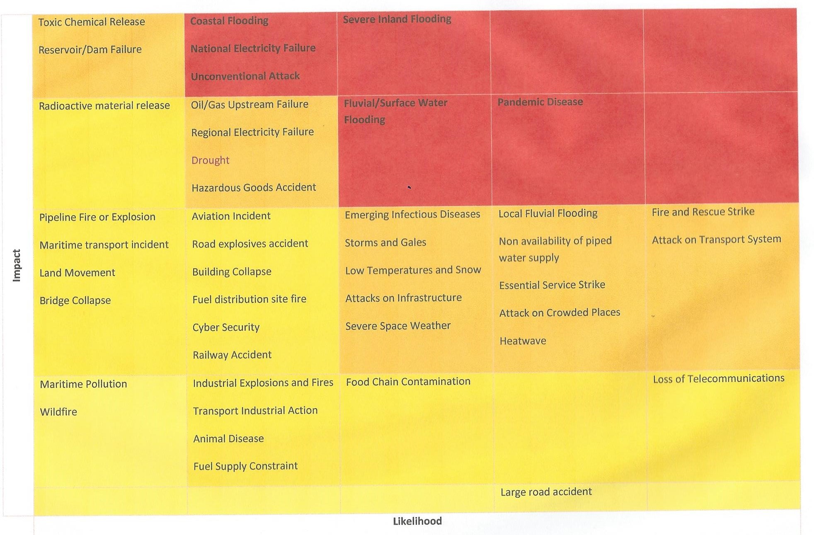
Figure 1 - London Risk Register (Version 4) High Level Summary (GLA, 2015)

As Brown et al. (2014) have expressed it:

"Our warming climate has the potential to have adverse effects on our health and wellbeing. People who live in urban environments are particularly susceptible as Urban Heat Islands (UHI) can be created in built up areas through storage and reflection of the solar radiation from building and construction materials.

The effects of UHI can be reduced by green spaces and vegetation, which can cool local environments and provide other aesthetic and environmental advantages. Trees have been shown to provide the greatest benefits to people and the environment, and international and national support for the retention and replacement of urban trees is strong." (Brown et al., 2014)

Positive health consequences through the mitigation of high temperatures is just one of numerous benefits provided by mature broadleaf trees. Urban dwellers also value them for their environmental, cultural and aesthetic benefits, whether found in private gardens, on streets, or in parks (Maller et al., 2006; Nilsson et al., 2010). More tangible benefits include protection of the land from soil erosion, reductions in storm-water run-off, provision of habitats for wildlife, absorption and filtration of air pollutants and thus additional health benefits through improvements in local air quality (Pandit et al., 2013).
2. Threats to urban trees
2.1 Highway maintenance
Despite their copious benefits, urban trees are threatened on many fronts. At a 2015 conference in Kew Gardens, London (Treework Environmental Practice, 2015), Professor Ian Rotherham described experiences with urban tree care in the city of Sheffield (Treework Environmental Practice, 2015: 22-23). According to Rotherham, the management of city trees which, he said, had long been a Cinderella of public service, faced further serious erosion through austerity cuts in public services and municipal provision, resulting in the formation of public-private partnerships for highway maintenance. Essentially, the care of street trees was being placed in the hands of highway engineering firms whose tacit, though denied, agenda was to reduce highway maintenance costs by an aggressive programme of removal of mature trees. Rotherham concluded that the focus on engineering aspects of highways had led to a reduction in quality of Sheffield's famously 'green' suburbs, and the loss of essential climate-change and flood-proofing.
2.2 Liability and litigation
On another front, and often used as a justification for tree removal, trees also shed branches as a part of their natural life cycle and ultimately fall down and this may result in death and injury of passers-by. There have been a number of criminal prosecutions in the UK of land owners by regulatory bodies. One case which, ultimately, did not go to court but which was in abeyance for several years and generated much concern, involved the death of an eight year old boy in Dunham Massey park in Cheshire in 2005 (Manchester Evening News, 2007). The fatality happened on New Year's Day and involved the collapse of a 20 metre beech tree during what might have been a strong wind. The accident was very carefully investigated by the regulator, the Health and Safety Executive (HSE). Although it was eventually decided by the HSE not to prosecute, the threat hanging over the land owner and its employees was vicariously experienced by countless other land owners around the country. This generated a deep concern amongst land owners of all denominations regarding their liability for any trees on their land, and there was a growing anxiety that this was leading to a risk-averse attitude which was resulting in premature and unnecessary tree removal.

There were a number of consequential actions. One was that the British Standards Institution (BSI) embarked in 2007 upon preparation of a British Standard addressing the risk to the public posed by falling trees (Ball and Ball-King, 2011: 12). The likely outcome of this would have been the publication of a Standard setting out the details of a 'voluntary' tree inspection regime. The fear was that this regime would have been so onerous as to put further pressure on those with trees and merely increase the concern over liability. Even though the Standard would have been voluntary, it would likely have been regarded as good practice for everyone to follow. It is relevant to note that the Chair of Britain's Risk and Regulation Advisory Council (RRAC), Rick Haythornthwaite, investigated the planned Standard and concluded that "This is a perfect example of how the pressure to regulate to minimise public risk can lead to wholly undesirable outcomes if left unchallenged" (Ball and Ball-King, 2011: 12). Consequently it was put on ice.

The concern over the Dunham Massey incident and other similar incidents also resulted in research aimed at quantifying the actual level of risk to the British public from tree fall (Ball and Watt, 2013). A decade of tree-related fatality and serious injury data were analysed, from which it was concluded that overall the fatality data pointed to around 5.4 cases per annum in the UK. Based on a population of around 60 million, this indicated an annual individual risk of below 1 in 10 million. To put this in perspective, the lead regulator
(HSE) had said that risks even as low as one in a million per year could be described as extremely small when compared with the background risks of everyday life, and that most people were prepared to accept risks of this magnitude from all manner of hazards in exchange for the associated benefits (HSE, 2001). The identified tree risk also fell in a band which HSE has termed one of ‘broadly acceptable’ risk, in which the risks are so low as to be generally regarded as insignificant and adequately controlled (HSE, 2001). In practical terms it is also true that to reduce a risk which is already as low as 1 in 10 million is both difficult and problematic because control measures themselves have consequences, sometimes introducing their own risks, which may outweigh that of the target risk (Graham and Wiener, 1995).
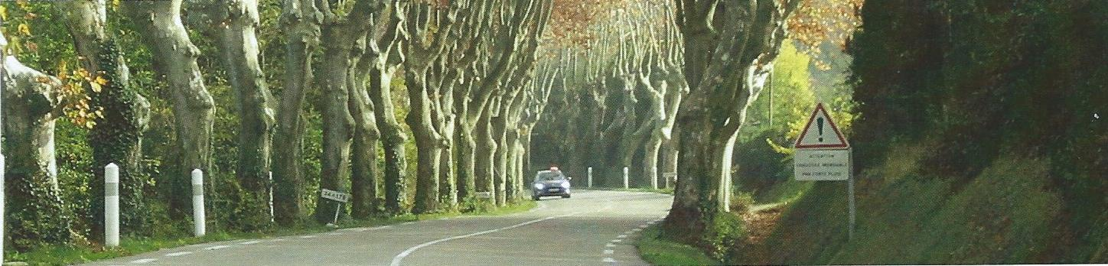

Figure 2 - Tree-lined route. How safe / unsafe in reality?

A further highly significant development was that in 2007 a sector industry group was formed representing, primarily, landowners, professional bodies and organisations with heritage and/or conservation interests. Known as the National Tree Safety Group (NTSG), this group’s primary objective was to generate a nationally recognised response on tree safety management which was proportionate to the risk posed to the public by trees and which was ‘defendable rather than defensive.’ This initiative culminated in the publication of 'Common sense risk management of trees' (NTSG, 2011) which aims to provide sensible, proportionate, reasonable and balanced advice to owners on managing the risk from trees. The guidance was subsequently endorsed by the HSE.
2.3 Conflicting agendas
Although not specifically about urban trees per se, the 2015 Treework Environmental Practice conference at Kew also highlighted another potential threat to the urban natural environment quite different from that addressed by the NTSG. In particular, Chantal Pradine described how specialised highway engineers have been seeking to reduce the risk to motorists who veer off the carriageway by designing 'forgiving roads,' that is, roads with verges that have no hard objects (Pradine, 2015). Hard objects, as described, have principally included roadside trees and Pradine remarks how, since the 1960s, this approach, bolstered by the introduction of Road Safety Inspections and Road Safety Audits, has led to the gradual disappearance of many tree avenues in Europe, one example cited being Seine-et-Marne which, between 1987 and 2012 lost 40% of its roadside trees.
Connected with this concept of 'forgiving roads' (also referred to as 'Passive Safety') is that of 'Vision Zero.' Vision Zero, introduced by Sweden and the Netherlands, is a philosophy whose ultimate goal is the elimination of all fatal and serious injuries on the roads. The problem with such philosophies is, as Pradine (2015: 16) describes, that they "explicitly rule out the trade-off of the objective of zero deaths or serious injuries against other policy objectives" and that as a consequence there is no interest in how a road safety treatment affects the environment. Essentially Vision Zero is a hazard-based approach whereas, in the UK at least, the approach adopted is normally risk-based (HSE, 2001). See also Elvik (1999) for a philosophical discussion of Vision Zero. The UK Vision Zero website (Vision Zero, 2016) does say that it does not accept the removal of roadside trees, however, it remains to be seen how this dictum is followed.
2.4 Other threats
There are other threats to established urban trees which we have not been able to discuss in this paper due to space limitations. Examples include the practice of replacing large mature trees with what some have called 'lollipop trees.' There are a number of reasons for this which include concern about root damage and also liability should a tree fail. Secondly, tree pathogens are not discussed and these also pose a real threat to the arboricultural environment.
3. Complexity and risk management
Deciding what to do when faced with some hazard is less straightforward than is often acknowledged. With regard to and in support of the forgiving roads concept, the organisation Passive Safety UK has reported that:
"Trees on British roads are statistically equally, if not more of a danger, than man-made roadside infrastructure.... In 2008, 180 people were killed and 796 people were seriously injured in single vehicle accidents with trees." (Passive Safety UK, 2010)
This led Passive Safety UK to make the following proposals:
a) All trees exceeding the 250 mm girth limit should be mapped and identified as potential risks on A and B roads
b) Accident records with trees and street furniture should be recorded on the same system
c) A programme of preventative culling should be established to maintain clear zones within 4.5 metres of the carriageway where possible
d) Boundary hedges should be cut and maintained to prevent them becoming trees

While prima facie the above advice appears logical, risk management is not always as straightforward as it might appear and can even be counterintuitive, particularly at the public policy level. The Green Book by HM Treasury, arguably the UK's most authoritative discourse on policy making, stresses that all such interventions should be subject to careful analysis prior to implementation and that this would require consideration of the benefits of the interventions, along with associated costs, uncertainties and unintended consequences (HMT, 2011).

The first problem with the above propositions by Passive Safety UK is that no attempt is made to predict the benefit of the intervention, benefit here being reduced KSI (killed and seriously injured) numbers. Of course, it is easy to envisage that the risk of a KSI following a vehicle leaving a carriageway is likely to be reduced if there are no hard objects on the verge but, as Unwin (1996) has put it, when considering the context of the British legislative system, four criteria must be met before a policy is enforced. These criteria are:

a) There must be a high level of scientific evidence that the intervention is effective in reducing the rate of injury;
b) The benefits to society and others of the intervention must be convincingly demonstrated;
c) There must be widespread agreement, ideally by a large majority, that the potential benefits outweigh any infringement of personal liberty and other disbenefits;
d) There must be good evidence to suggest that intervention would not make related public health benefits harder to obtain (adapted from Unwin, 1996)

One is left to reflect on the strength of the case for tree removal from roadsides. One of the difficulties is that engineering solutions are not passive solutions in the sense that people do not respond in entirely predictable ways to these interventions (Adams, 1995). They may modify their behaviour, as was discovered by Hans Monderman (2015) with his shared space revolution in traffic safety management. A key question in this regard would be, do motorists change their driving behaviour in the presence of tree-lined verges, just as they are known to do in other circumstances when perceiving their environment to have been made safer? Pradine (2015: 15) has concluded that the presence of trees leads to calmer and safer driving. Likewise, Rosenblatt et al. found:

"The addition of curbside trees significantly increased driver perception of spatial edge.
Rules generated from the pilot indicate that if curbside trees are present, results can include a positive effect on driver perception of safety regardless of contextual environment; a reduction in driving speed in suburban landscapes for both faster and slower drivers; and a more significant increase in driver perception of safety in urban landscapes than in suburban." (Rosenblatt et al., 2008)
The evidence that the presence of trees by the roadside has a positive impact on driver behaviour is apparently sufficiently compelling that, at the operational level, the UK Department for Transport (DfT, 2010) has reported a number of schemes aimed at using tree planting to reduce speeds and hence accidents. Thus, in Norfolk, the County Council have planted 200 trees in four villages in an effort to reduce average speeds by three mph and cut accidents by 20 per cent. Speed reductions were noted following planting but it will be some years before there is sufficient data to make a reliable determination of whether this has translated into fewer accidents. Nonetheless, there would appear to be significant doubt surrounding the scientific evidence supporting the felling of roadside trees so that Unwin's criteria a) and b) are not satified. Likewise, c) is not satisfied judging by the presentations at the Treework Environmental Practice conference, and nor is d). In fact, loss of significant numbers of mature trees in cities is forecast to increase death rates in heat waves and no doubt will do so by other more subtle mechanisms too, as well as diminishing the quality of life.
5. Conclusions
Hard evidence of the copious benefits provided to people by trees in urban environments is strengthening. The need for these benefits is also increasing as climates change and the numbers of people and hence social pressure in cities increases. What is required is policies which recognise the new era which is upon us and take steps to realise the opportunities via appropriately funded long term strategies.

Strategies such as 'forgiving roads,' 'passive safety' and 'zero harm' must recognise that when trying to optimise public affairs tradeoffs are inevitable.
References
Adams, J. (1995) Risk. University College London Press, London.
Ball, D. J. and Ball-King, L. N. (2011). Public safety and risk assessment: Improving decision making. Routledge.
Ball, D. J. and Watt. J. (2013). The risk to the public of tree fall. Journal of Risk Research 16(2): 261-269.
Brown, H., Katscherian, D., Carter, M., and Spickett, J. (2014). Cool communities: Urban trees, climate and health. School of Public Health, Curtin University: Perth, Australia. http://ehia.curtin.edu.au/local/docs/CoolCommunities.pdf, accessed 11 February 2016.
DEFRA (2014). Defra announce new tree health risk register, http://www.britishecologicalsociety.org/blog/2014/01/27/defra-announce-new-tree-health-risk-register/, accessed on 10 February, 2016.
Department for Transport (2010) Taking on the rural road safety challenge. http://webarchive.nationalarchives.gov.uk/20121107103953/http://assets.dft.gov.uk/publications/pgr-roadsafety-dpp-rural-ruralroadsafetyreport-pdf/report2.pdf , accessed 12 February 2016.
Doick and Hutchins (2013). Air temperature regulation by urban trees and green infrastructure, Forestry Commission Research Note, http://www.forestry.gov.uk/pdf/FCRN012.pdf/$FILE/FCRN012.pdf, accessed on 10 February 2016.
Elvik, R. (1999) Can injury prevention efforts go too far? Reflections on some possible implications of Vision Zero for road accident fatalities. Accident Analysis and Prevention 31: 265-286.
Fay, N. (2007) Towards reasonable tree risk decision making. The Arboricultural Journal 30(2). 143 – 161.
Graham, J. and Wiener, J. (1995). Risk versus risk: Tradeoffs in protecting health and the environment. Cambridge, Mass.: Harvard University Press.
Greater London Authority (2015). London Risk Register version 4.0. https://www.london.gov.uk/sites/default/files/gla_migrate_files_destination/London%20Risk%20Register%204.0.pdf , accessed 11 February 2016.
Health and Safety Executive (2001) Reducing risk protecting people. http://www.hse.gov.uk/risk/theory/r2p2.pdf , accessed 12 February 2016.
HM Treasury (2011) The Green Book: Appraisal and evaluation in central government. https://www.gov.uk/government/uploads/system/uploads/attachment_data/file/220541/green_book_complete.pdf , accessed 12 February 2016.

Maller, C., Townsend, M., Pryor, A., Brown, P. and St Leger, L. (2006) Healthy nature healthy people: ‘contact with nature’ as an upstream health promotion intervention for populations, Health Promotion International 21(1): 45-54.
Manchester Evening News (2007). http://www.manchestereveningnews.co.uk/news/greater-manchester-news/damage-missed-in-tragedy-tree-1036149 , accessed 11 February 2016.
Monderman, H. (2015) http://www.pps.org/reference/hans-monderman/ , accessed 12 February 2016.
National Tree Safety Group (2011). Common sense risk management of trees. Forestry Commission. http://www.forestry.gov.uk/PDF/FCMS024.pdf/$FILE/FCMS024.pdf , accessed 11 February 2016.
Nilsson, K., Sangster, M., Gallis, C., Hartig, T., de Vries, S., Seeland, K and Schipperin, J. (2010), Forests, trees and human health. Springer Press.
Pandit, R., Polyakov, M., Tapsuwan, S. and Moran, T. (2013). The effect of street trees on property value in Perth, Western Australia. Landscape and Urban Planning 110, 124-142.
Passive Safety UK (2010) Passive Safety UK guidelines for specification and use of passively safe street furniture on the UK road network. http://www.ukroads.org/webfiles/Guidelines%20Print%20ready.pdf , accessed 12 February 2016.
Pradine, T. (2015) Forgiving roads: regulations threatening tree-lined routes. See Treework Environmental Practice Seminar Proceedings No. 20 pp13-20.
Rosenblatt, J., Kweon BS. and Maghelal, P. (2008) The street tree effect and driver safety. ITE Journal on the Web, 69-73.
Treework Environmental Practice (2015). Tree-lined routes and the linear forest: A new vision of connected landscapes. Seminar Proceedings, No. 20. Treeworks Environmental Practice: Bristol.
Unwin N. (1996) Cycle helmets: When is legislation justified? Journal of Medical Ethics, 22: 41-45.
Vision Zero (2016) Vision zero charter. https://visionzerouk.wordpress.com/vision-zero-charter/ , accessed 20 February 2016.

The figure of 5.4 differs, non-significantly, from the figure of 6.4 of NTSG (2011) due to trivial classification adjustments.
See also (Fay, 2007).

