Issues Faced by Vision-Impaired Users of Interactive TV Search Facilities
Mark Springett  Interaction Design Centre, Middlesex University  Town Hall, Hendon, London, NW4 4BT, UK  m.springett@mdx.ac.uk | Richard N Griffiths  School of Computing, Mathematical & Information Sciences, University of Brighton  Watts Building, Moulsecoomb, Brighton, BN2 4GJ, UK  r.n.griffiths@brighton.ac.uk | Martin Mihajlov  Faculty of Economics, Ss. Cyril and Methodius University  Goce Delcev 9b, 1000 Skopje, Macedonia  martin@eccf.ukim.edu.mk

ABSTRACT
This paper reports two studies of digital television users. The first study investigates the behaviour of non-impaired users to understand typical usage patterns and problem-solving, attempting three representative tasks using a digital television terrestrial receiver. Videos were analysed to identify problem incidents and attempts at recovery. Patterns observed included misidentifying handset menu options leading to extended guessed action, repeated misspecification of task and repeated re-performance to confirm actions. The results show that interaction with Digital TV in its current handset-based form involves considerable reactive action specification and corrective action, suggesting that interaction endemically difficult for those with various levels of low vision. The second study, a less formal probe of users with visual impairments, suggests that even users with relatively mild visual impairments may struggle with current two-device interaction. However, suitable strategies for supporting vision impaired users may as much to do with user preferences rather than simply accessibility. We conclude by discussing the efficacy of current two-device interaction support and possible future directions.

Author Keywords
visually impaired users, studies of interaction, accessibility, user experience

ACM Classification Keywords
H.5.2. User interfaces, H.5.m. Miscellaneous

INTRODUCTION
In a 2001 survey of attitudes towards technology, amongst a representative sample of the general population digital TV was rated as harder to use than a personal computer [2]. It is not obvious that increased exposure since then has altered perceptions much; rather it has confirmed it. One reason is the continuing reliance on such a primitive interaction device as the ubiquitous infra-red coupled remote handset. It must be accurately aimed at a sensor on the TV set, and there is latency in interaction actions impose by the low band rate used. Both of these features encourage input errors. The model of interaction where dedicated buttons on the handset are used to implement individual functions, results in a dense packing of buttons onto the device with numbers in excess of fifty being common [3]. The necessarily compressed textual and iconic representations of functionality printed onto the buttons themselves and the casing are both difficult to read (particularly in the low ambient light conditions usual for TV viewing) and ambiguous, a finding supported in [8]. Guidelines for handset design have been around for some time [e.g. 7], but with little evidence of them being taken up.
The paper reports two related studies. The first involved users without visual impairments performing search using a Samsung TV remote. The second is a less formal study involving ten subjects with varying levels of visual impairment. This study involves co-evaluation combined with an informal probe of their experiences with TV equipment. Therefore we are not presenting our findings as a formal comparison of performance between the two subject groups.
We studied the non-impaired group performing three interactive tasks to gain an understanding of the nature and emergent usage habits of non-impaired TV viewers, for example, searching of the electronic programme guides (EPG). This information can be used to define what ‘equivalence’ might consist of for vision impaired users, and whether this is attainable or indeed desirable. We have previously worked with people having sensorial impairment to both examine in detail the challenges digital television presents and explore alternative interaction possibilities [9, 10]. This approach complements and strengthens our previous work.
There are significant contrasts and similarities between iTV interaction and interaction with PC and laptop facilities. On PCs the user is more or less exclusively taking visual cues to action and feedback from the screen. In iTV interaction the user may be switching attention between the handset interface and the screen, and is required to aim the handset appropriately for input actions. Both, however, involve initial specifying of action which may be altered and reactively restructured due to unexpected or unsatisfactory system responses. In the case of TV this incudes errors caused by a failure of coordination between the remote pointing device and the sensor on the set itself, a class of error that is peculiar to two-device interaction.

Study of non-impaired subjects using TV remotes
The study used 16 non-impaired subjects. The intention was both to validate the proposed model and to identify points in interaction where those with visual impairments are likely to face particular problems. The users were asked to use the Samsung LE37R87BD, a representative middle of the range HD TV with integrated terrestrial digital receiver (Freeview). They were all students or staff at Brighton University and had some exposure to the use of TV remotes and interactive facilities. The age range was 20-44, nine male seven female. They were given unlimited time to perform three tasks, namely:
- To find the programme to be shown on Channel E4 at 9pm that evening.
- To find the weather forecast for the local city that evening.
- To add a specified channel to the favourites list.
They were asked to provide think-aloud verbalisations as they performed the tasks in the manner prescribed in [1]. The sessions were recorded with a screen recording of their actions, a camera trained on the handset, and a wide angle camera to capture their body language.
Our expectation was that users would make a greater variety of errors that in equivalent studies of PC interaction. This notion emerges from previous analysis identifying two key issues. One is that of co-ordination of two devices via sensor-based technology. This demands that the user co-ordinates the two devices simultaneously to select options. This makes the incidence of slips likely to be greater. Also, users cannot fixate on screen and remote device simultaneously to monitor their actions. The second is that interaction cues and task support tend to be presented in parallel with TV content. This has a number of forms, including simultaneous sound from TV content, overlaid menus where the content is visible beneath, and interactive services that operate from specific channels. In the case of sound and overlays the possibility of disruption to the user’s auditory and visual channels is increased. In the case of channel specific services there are issues regarding user generation of task strategy. Tasks one and three did not involve first going to the channel to perform operations, but it is plausible that users may have expectations of this, particularly those with knowledge of the SKY remote, where one can get information about later broadcasts.
The examination of the input device itself was expected to contrast with typical exploratory behaviour and task performance in PC-based interaction as the users gaze is usually directed almost solely towards the screen during PC interaction. This is, therefore a significant extra cognitive and perceptual burden as the user gaze switches between handset and screen. Part of our investigation was to analyse the significance of this.
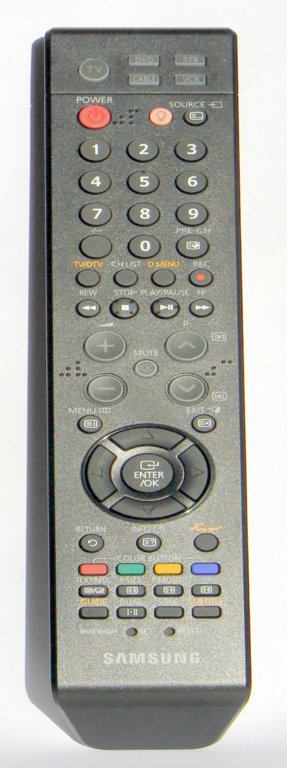
Figure 1: The Samsung LE37R87BD Remote Control

Analysis of results
Task one was completed by all but one subject. The average time taken was 4.45 minutes. The quickest was 20 seconds and the longest 10.05 minutes. Two subjects completed the task in less than one minute, 8 subjects took between 1 and 2 minutes, 4 subjects took between 3 and 4 minutes. The other two took 7.45 and 10.05 minutes. Seven subjects managed to perform this task without any problems. One subject performed the task with just one minor slip. Of the other ten all made at least one incorrect choice of button. This either led to the scanning of an irrelevant menu or the ‘now and next’ TV guide. In two cases the subjects switched to analogue mode and had problems working out how to return.
Task two was completed by all but one subject. The average time taken was 7.40 minutes. The quickest took 1 minute and the longest 10.05 minutes. Most users faced few problems except for incorrect guesses about the location of local information. This was a result of the somewhat uninformative menu with the options ‘forecast summary’ and ‘forecast maps’ representing national and local weather respectively. The subject who failed to complete the task got as far as displaying the BBC text overlay but failed to recognize it. This subject declared knowledge of teletext based on experience with the analogue version. Two others incorrectly searched for a ‘text channel’ before leaving the EPG and finding the correct button on the handset.
Nine subjects did not complete task three. The average time for those that completed was 6.05 minutes, the quest taking 1.25 minutes and the longest 10.40 minutes. The difficulty with this task was expected due to a combination of hidden functionality deep in a somewhat unintuitive menu and the misleading presence of a favourites button on the EPG that does not lead to an add function. Nearly all subjects went first to this function, some repeatedly attempting the option. Most users initially chose an incorrect strategy for finding features for adding a channel to the ‘favourites’ list. This involved in 12 cases subjects entering the EPG and going to the relevant channel in expectation of further cues. Three subjects also went to the channel itself and tried to access the feature from there. Five subjects reported problems understanding the feedback and could not reliably confirm that the channel was added.

Analysis of User Behaviour Patterns in Response to Problems
Observed incidents were further analysed to study user behaviour in response to problems encountered. Our objective was not to evaluate the handset or on-screen design per se, although usability deficiencies with the design (both as an individual design and as a genre) were obviously relevant to our findings. Our intention rather is to understand the dynamics of user interaction with DTV. In doing so we hoped to gain a better understanding of how DTV can be enhanced to be made more accessible. The most common problems and associated responses are now described in overview:

Misidentifying handset menu options (Task 1)
The commonly observed action was a long scan, generally without a declaration of a strong theory. This was diagnosed as ambiguity and a lack of clear guidance in the labelling of buttons. Ten subjects made at least one incorrect choice. Responses tended to depend on the reversibility of actions. Three subjects had prolonged difficulties after inadvertently switching to analogue mode. Prolonged difficulties came as the screen did not offer a way of recovering, leaving users with the task of pressing random buttons simply to return to a point where other buttons would be effective. Those that was able to return to the screen (effectively the home page for interactive tasks) simply guessed further buttons. Two user’s problems with the handset were compounded by the fact that two options resemble an established icon for text on other handsets. These two users bucked the general trend by making reference to iconic button labelling on previous handsets. This issue is in some sense outside the terms of the model in that user difficulties were initially observed prior to an input action being attempted. However, we take as a start point the moment at which a guessed option produces unsatisfactory feedback as a result of this inaccurate hypothesis generated about the button’s functionality.
Where an action was immediately reversible the user was able to recognise a known error. However, two subjects could not find how to reverse the action having switched out of Digital mode. This caused a prolonged sequence of guessed action.

Searching the Wrong Menu
The ‘now and next’ menu duplicates some of the EPG functions and has a similar appearance, causing some users to try to search it for later content. Three users had this problem. The failure of this action only gradually revealed itself as the menu has the appearance of supporting the task. A prolonged examination was conducted by subjects before it was accepted that the action was not possible. The partial understanding from recognition of a ‘programme guide’ resulted in one or two loops of hypothesis modification where subjects declared criteria for believing that the action was possible (the ‘modify action specification’ path in the model) resorting to guesses in two cases and rapid abandonment of the action by the third.

Misspecification of task procedure (tasks 1 and 3)
Subjects either declared no strong hypothesis when initially scanning the handset or in some cases generated a hypothesis from prior use of other handsets. This was most common in task 1, where some of the misleading and ambiguous button labels were first encountered. Eight subjects declared familiarity with teletext when embarking on Task two. In all but 2 cases prior knowledge of teletext resulted in swift task completion. However, two subjects also reported expectations of teletext based on knowledge of the analogue version. In one case the subject actually reached the overlay menu for digital BBC1 but failed to recognise it claiming ‘well I’ve managed something but it isn’t teletext’. One subject also declared and used knowledge of the red button to shortcut to the BBC text facility. Only two subjects made reference to previously used handsets pertinent to Task three. Task three typically led users to search for the relevant channel on the EPG. This model of the task was quite strong and was re-enforced by the presence of the ‘favourites’ button option.
All subjects began with a prolonged scan of the handset. This in itself was not unexpected given their lack of familiarity with it. However, the majority of first attempts at a button press proved to be incorrect. In a further six cases the subjects went to the correct menu but were unable to identify it as such. This was particularly observed in Task Three where 5 subjects were observed rejecting the correct menu containing the ‘add favourites’ feature. In these cases the subjects generated alternative (and incorrect) strategies as a result.
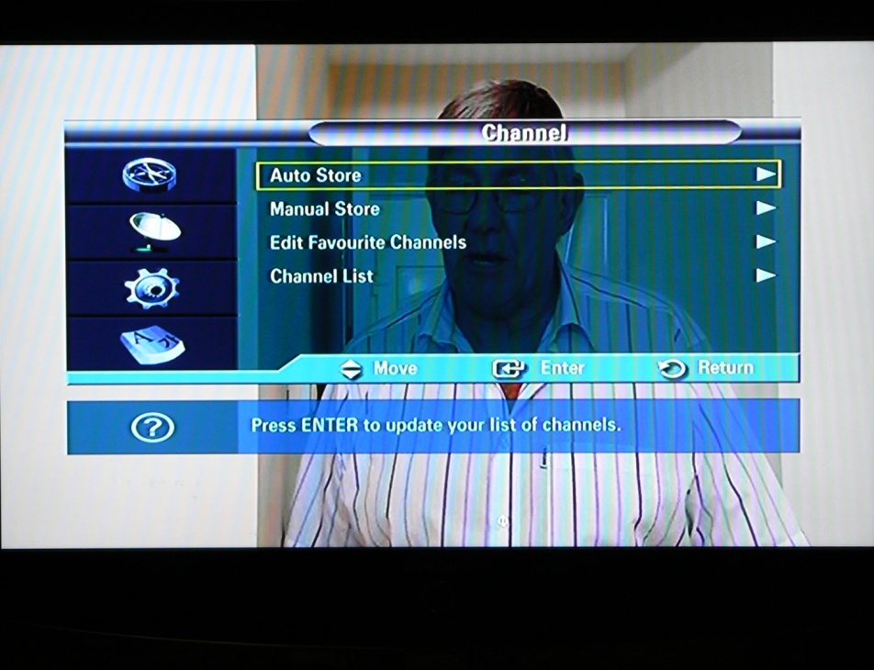
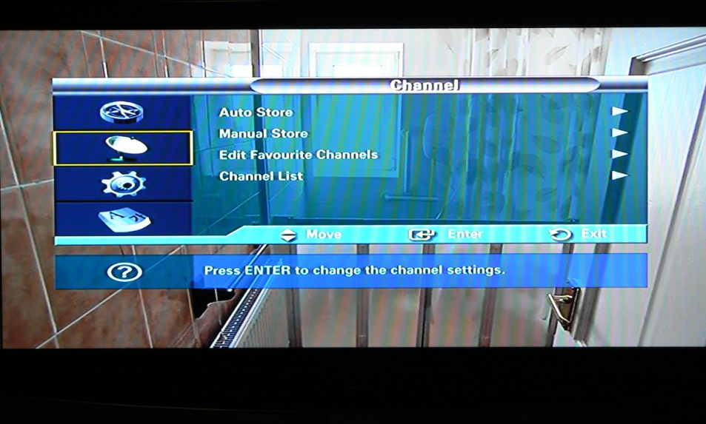
Figures 2a and 2b: The ‘Channel Menu’ Showing the satellite icon menu header which reveals the ‘edit favourite channels’ option when selected.

Users unable to find the correct feature within the Channel menu(task 3)
This menu (shown in Figures 2a and 2b) has an unusual design in that uses icons in the left-hand margin to display text options on the right-hand side. Four subjects also remarked on the correct iconic header (an image of a satellite dish) as unhelpful. Subjects were observed struggling to understand how the page operated, typically going through repeated action phases or exploratory action. In three cases the subject simply rejected the feature.

Users incorrectly drilling through the EPG to the ‘favourites’ option (task 3)
This was a particularly common problem. Twelve subjects generated the hypothesis that the feature could be accessed by first going to the channel on the EPG. Once there the system presents a ‘favourites’ option via the green handset button. On entering the menu users discovered that the add feature was not available. Four subjects retried the option at least once before abandoning and resuming by scanning the handset and guessing options. This screen is shown in Figure 3.

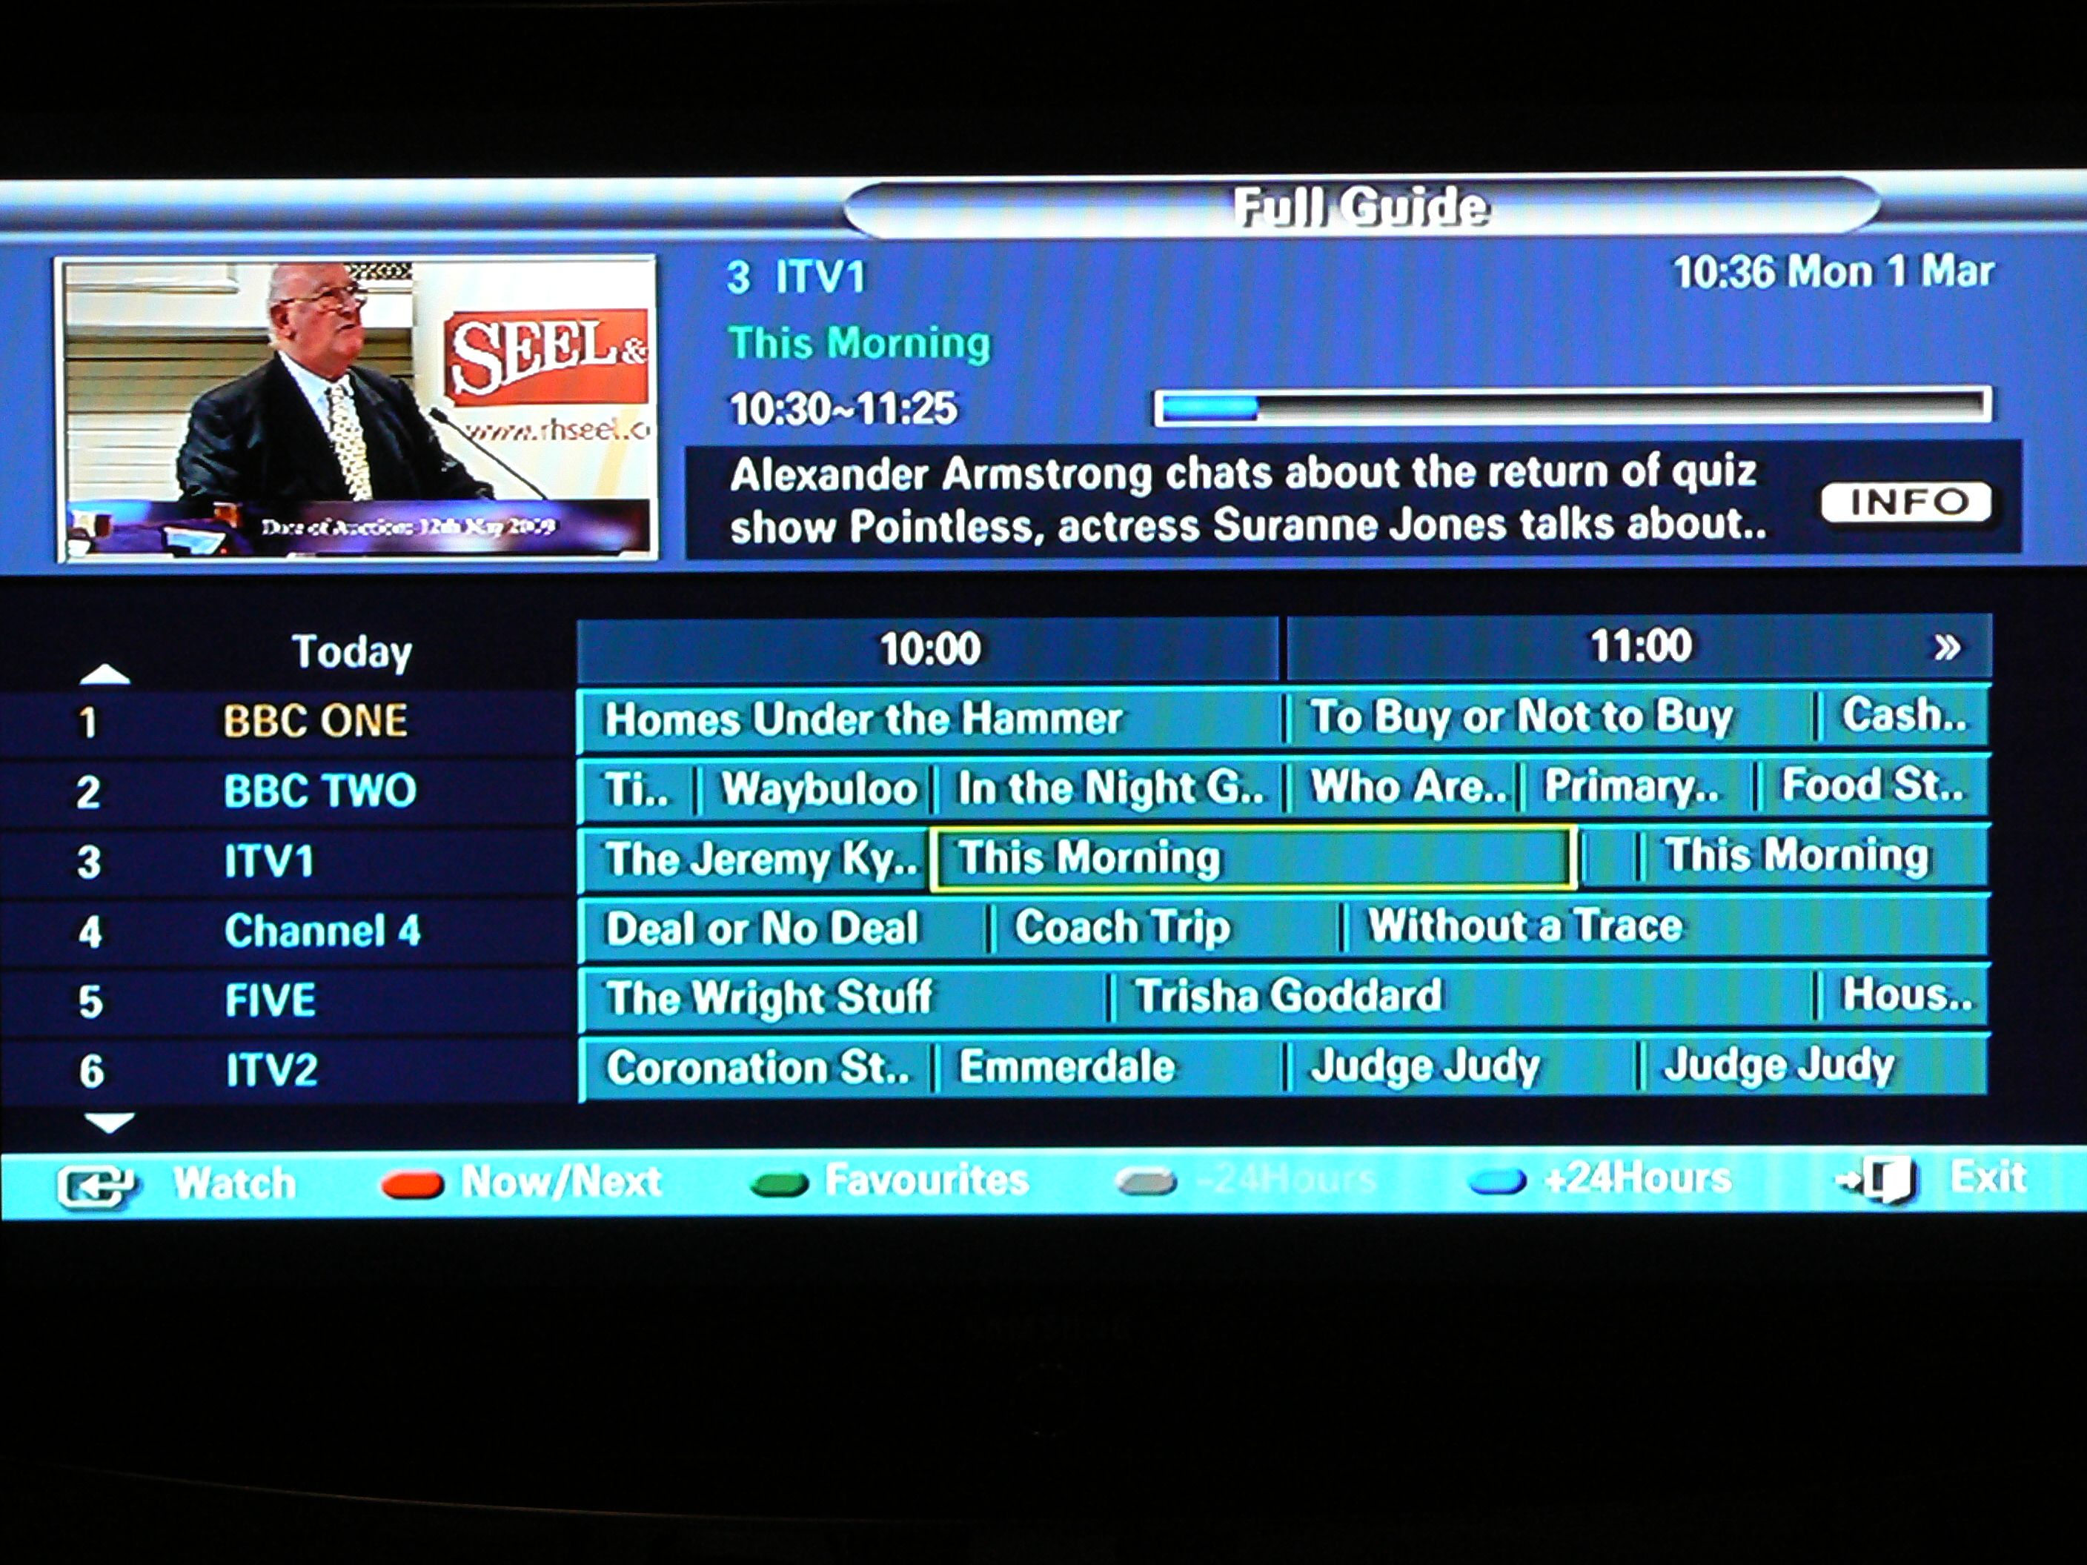
Figure 3: The Electronic Programme Guide: The green button option for the favourites menu is displayed on the lower panel

Users were not able to confirm successful saves to favourites (task 3)
Three users declared confusion over whether channels had actually been saved after (successfully) specifying the procedure. The feedback is ambiguous on atomic actions, causing significant checks and re-checks in search of confirmation. In fact there is a procedural hint at the end of the menu to press ‘enter’ confirming the save, not seen by the subjects. These subjects went through the same procedure again, and one went to the EPG and drilled through the ‘favourites’ button option to check that it was there. This was noted as examples of partially understood action resulting in a modified action specification to check progress towards a goal.

Users not noticing options on a page (tasks 1 and 3)
The EPG has four blocks of options with cursor movement available on two axes. Users can scroll down and to the right by moving through the options which remain static until this action occurs. Four users were initially unable to spot options even though they were available on the page and drilled past them.

Difficulty confirming actions (task 1 and task 3)
In a number of cases users were observed scanning pages for evidence of either successful search or successful completion of an action. The latter was observed particularly in task three, where a further sequence of action was used by five subjects in order to confirm the selection of a favourite. Subjects spent significant time reverse engineering their actions to link their actions to the feedback that was presented.
In some cases, particularly in Task Three where the design of feedback is somewhat questionable the incidence of repeated action loops is likely to be linked to poor feedback design. However, there were twelve observed examples of subjects repeating incorrect actions whilst suggesting that they didn’t know if they had performed input actions as intended. This suggests that anticipated device co-ordination issues were affecting user behaviour. These incidents would see the highest rate of gaze shift between the device and the screen.

Tendency for input actions to outpace user perception (all tasks)
Task one showed seven observed instances of subjects scanning past the required option, before returning to it, declaring that they had noticed it. This included two distinct cases where the options had disappeared from view when the subjects declared that they had seen it. In several additional cases no verbalisation accompanied the action but a similar performance was observed. This was observed mainly in continuous, repeated ‘surfing’ actions. The subjects appeared to be physically moving through the menus at too great a pace to parse a searched for an option or a satisfactory match with their goal, but were able to hold perceived information in short-term memory and re-adjust to find the option. For example, scrolling to find a channel in tasks one and three involved a repeated input action in support of search through menus that would scroll when the cursor was drilled past the option on the edge of the display. One subject manoeuvred the cursor past the desired item and scrolled so that it was temporarily off screen, whilst simultaneously declaring that he thought that he had noticed the item. However there was a noticeable delay in the cessation of the scrolling action and a slower paced reverse scroll to locate the recognised option. In performing these tasks the subjects had long sequences repeating the same scrolling action.

Users misidentified weather menu options (task 2)
This was attributed to poor onscreen labelling which meant that users could not accurately distinguish options. The three labels on candidate options ‘forecast summary’, forecast maps’ and ‘world cities’ and subjects had difficulty making a selection. This did not prove to be a serious barrier to completion although a prolonged examination of the features caused the task to take several minutes in some cases. Options were scrolled and scanned for the required option. For example, one subject went first to the ‘world cities’ menu and having scanned it thoroughly tried the ‘forecast summary’ menu declaring ‘well it must be somewhere, it could be anywhere’.

Analysis of subjects gaze
The subjects’ patterns of eye movement were observed. This was not performed with a level of precision offered by eye-trackers, but analysed the split of visual attention between screen and handset features. The intention was to pair phases of eye movement and focus with time and activity. This identifies 3 modes of gaze fixation, solely on the handset, solely on the screen and rapidly interchanging. The pattern that emerged was remarkably similar for all subjects in most aspects. All subjects spent time initially fixating solely on the handset prior to their first specification of action. This was not surprising given that it was unfamiliar to them. All subjects took between 35 seconds and 1.30 minutes scanning the remote prior to action. Once action commenced it was observed that periods of continuous fixation on-screen was almost exclusively confined to two types of activity. The first was scrolling tasks, such as scanning down menus or through the electronic programme guide. The second was during a task-action sequence where anticipated or known features were sought. The latter caused a pause in input action while a scan of the screen was undertaken. All subjects spent a large amount of time rapidly switching between screen and handset. This tended to happen at points where a speculative action such as trying a menu for search or actions involving alternative or combinations of button presses was performed. This was also common at points where users were re-trying actions in order to check their input actions.

Review of user responses after unsatisfactory action
One of the identified nuances of two-device interaction is that after a first pass it is often unclear to the user whether or not they have completed an action sequence successfully. This is in part a consequence of the two-device interaction. The space of possible slips is greater when co-ordinating two devices. The possibility of misdirecting the remote, or of failing to press buttons properly in rapid input sequences is significant. In these cases actions are repeated without modification. The two tributaries to this are checking the correctness of input action and strength of the original hypothesis directing an action. The former seems to be a consequence of two-device interaction where the strength of button presses and directionality of the inputs increase the possibility of execution error. Cases in which the original hypothesis generated remains strong may cause equivalent observed behaviour. The subjects who drilled through the EPG in Task Three and found the ‘favourites’ option, were observed repeating the action as the interface had strongly suggested the possibility of action.
Where users initial hypotheses at first seemed to be supported they tended to spend longer generating modifications to their initial action specification. This was particularly strong in Task Three where there is a visible link to the ‘Favourites’ page, but on drilling through to it there is no displayed option for adding a channel to the favourites list. The strength of expectation led subjects to a prolonged sequence of repeated and modified exploratory action. A pattern of repeated hypothesis generation/modification seems to be a key dynamic. In a number of examples the users would spend time repeating actions, trying and retrying button presses and re-examining screen feedback where actions were not successful. The number of repeats or revisited actions was much greater than anticipated. This may be a consequence of the possibility of unperceived slip errors (failure to orientate the device or press buttons effectively). This in turn means that the user has a greater diagnosis space to explore than the PC user, who typically can connect the system response to their last action, even where it is unsatisfactory. This suggests that the user’s repetition of input sequences in support of original hypothesis about system operation is a significant feature of DTV interaction.
In conclusion, significant perceptual and cognitive resources are deployed in search tasks, and in surfing. This is complex as it involves two-devices both of which contain significant functionality, such as labelled buttons and small navigation pointers. Rapid switching of attention from one device to another is a key element of this. The next sections consider how those with visual impairments (mild or severe) fare given this task complexity.

Study of Impaired Users
Eight subjects with varying degrees and types of visual impairment were tested. They were aged between 38 and 81years old. Two of these subjects had severe visual impairments. One had Retinitus Pigmentosa, tunnel vision and weak peripheral vision. The other had Retinitus Pigmentosa, no central vision at the top The other six subjects had a range of less severe impairments. One had Astigmatism, and a cataract in the right eye. Another was very long-sighted with astigmatism in the left eye. Two had cataracts and general diminished vision. Another two had diminished near vision. Two had short-sight, one with long slight cataracts in both eyes. Not all the eight subjects were able to offer precise medical descriptions of their visions problems. The remote used was not familiar to any of the subjects.
The nature of the sessions were more in the tradition of co-operative evaluation, where a combination of tasks performed with the device and verbal interaction between the subject and a moderator generated a combination of observation and verbal data, and anecdotal returns. The conditions were the same as for subject one in that the users were asked to attempt the three standard tasks whilst conversing with the moderator. Time data was not taken due to the interference effect of the conversational probing during interaction, a trade-off described by Hertzum et al [3]. This style of evaluation has two advantages; one is that it resembles the nature of use better than more formal laboratory conditions. Another is that the use of the system has the effect of prompting the subject to talk about aspects of the viewer experience that may not emerge in observable data. Also, we anticipated that some subjects would not be able to make significant progress in tasks. In such situations the elicitations became more co-operative and less based on observation of task-action. The user-experience laboratory at Brighton University was the venue for the study as in the first study.
The two severely impaired subjects were unable to make significant progress. Neither was able to make progress unaided. Both needed to be told the identity of relevant handset buttons by the facilitator in order to attempt tasks. Therefore a higher percentage of the data in their sessions was gained though verbal interaction with the facilitator, or modified tasks conditions (i.e. a greater level of guidance).
One of the severely impaired subjects began making large head movements attempting to maximise visual focus on key items, then tried to make headway in the text search tasks by moving to within a few inches of the screen. The BBC text overlay (where TV content behind the text screen was visible) was cited as particularly problematic. The text was also unreadable. Significantly, he was unable to see feedback on scanning or selection actions. The consequence was that he was not therefore able to interpret the results of button presses or even confirm that that state changes had occurred. The exception to this was changes of channel, where auditory feedback indicated the progress of an action. Whilst tactile information allowed him to find some buttons, in most cases he was unable to confirm the nature of action without examining the screen, which in turn was often not possible. The inability to read the handset options renders many button presses a guessed action, and he was therefore entirely reliant on visual feedback from the screen, much of which could not be seen.
Of the six subjects with relatively mild impairments three displayed similar interaction patterns to the non-impaired users and reported few problems. However, in three cases a number of issues emerged. The most significant of these was the difficulty in dealing with tasks that involved switching between two devices. These three subjects repeatedly switched from wearing glasses to read the remote control options to reading the screen without glasses. The subject with short and long sight in either eye reported repeated difficulty caused by a blurring effect. This subject reported difficulties in following numerous changes in the identity of on-screen buttons. This meant that she was unable use of location as an identifier for buttons, repeatedly relying on reading the option labels. As a result she repeatedly changed from wearing glasses when focused on the handset to focusing without glasses on the screen. As a result she reported numerous occasions where she had tried a button on the remote control and ‘saw a light do something on the screen’ but was unable to confirm the nature of state-change as the image on the screen was blurred. Searches through vast menus tended to be relatively fluent due to the fact that the perceptual aspect of the task focuses solely on the screen rather than being distributed between handset and screen. This subject did, however, find some difficulty in identifying relatively small navigational features on the screen and smaller text items during extended scrolling. All three of the subjects who experienced problems switching between devices made a number of selection errors attempting the ‘favourites’ task that took significant time to identify.
One subject who had astigmatism and cataracts reported problems with the size of writing on the handset buttons. This subject was also critical of the lack of tactile information on the handset. The problem of co-ordinating between two devices was also observed for this subject, who reported difficulty in confirming actions. This subject also commented that their typical strategy would be to find information about programmes from paper-based sources and that the EPG ‘doubles the work compared to paper’.

Reflection on the impaired subject sessions
The experiences of the two Retinitis Pigmentosa suffers show that, beyond a certain threshold, interaction patterns and structures similar to non-impaired users require sensory substitution. Added audio description and tactile information was argued for by both subjects in order to support searching. By contrast two of the relatively mildly impaired subjects who could (albeit with difficulty) were less interested in features supporting equivalent experience (extensive searching, exploratory action) as simplifying tasks, removing extensive search. This suggests that preference and individual perceptions of the nature of the viewing experience cut across considerations of how accessibility features can be designed. In some cases the ability to search and explore speculatively is not a part of the viewer experience.

Discussion
The study findings were used both to gain a richer understanding of typical interaction DTV features but also to help identify elements of DTV use that are likely to be especially problematic for those with visual impairments.
One consideration is that it is desirable for content rich DTV systems to be explorable. Whilst for some tasks it may be desirable simply for the system to perform tasks automatically (e.g. finding new channels) one school of thought is that ‘channel surfing’ and similar user-driven traversals of the content space as an intrinsic part of the DTV experience. If this is the case then identifying particular difficulties that user impairments cause and looking for alternative support is necessary to ensure equivalence. Another school of thought, however, is that there are endemic problems in supporting user driven experience-based learning and performance on DTV for users with impairments. In particular ‘errors’ in trial and error learning do not contribute to learning in a way that facilitates gaining of control and satisfaction. Assuming that the ideal would be to support the equivalent empowerment of users, support of the ‘surfer’ experience where possible seems desirable but alternative, more system driven alternatives may also be necessary. It is worth noting that the ‘constituency’ of impaired users includes an increasing number of older users who have no model of TV as an interactive experience and who find themselves forced to learn and understand DTV facilities purely for instrumental reasons.
At each point in any sequence of atomic actions the system may make perceptual demands that are beyond users with serious visual impairments and seriously complicating even for those with minor impairments. Our findings and previous experience show that where such features cause problems to non-impaired users they are often able to use information from the screen or handset and generate alternative theories. For those with impairments the likely demands of the task are considerably greater and in some cases render the task practically impossible. Furthermore, the demands placed on them by extended input sequences and speculative scanning renders trial-and-error based learning and performance extremely demanding. The challenge therefore is to find ways of supporting exploratory action that are sensitive to potential practical and hedonic barriers for those with different types of impairment.
In a previously reported study of visually impaired subjects [11] there was also a high incidence of subjects going deeply into menu structures and facing a significant cycles of random search. Without the ability to perceive features and system behaviour that allowed modification of unsuccessful action specification subjects became embroiled in long sequences of guessed action, and problems tended to be compounded, particularly when in deep menu structures. The solution to this problem could lie in straightforwardly better page design that allows users to acquire a model of page operation that can be re-used to predict system behaviour. Even where vision is impaired spatial memory remains an important resource for users which can be supported by consistent design. However, the possibility of slip errors by users means that simply good usability practice in screen design may not be enough. Current DTV design lacks features that are dedicated to repair of unsatisfactory action. Some users who have impairments would clearly benefit if the presence of such features was known and had a fixed procedure.
The rapid scanning in which subjects surfed and picked up options is obviously not available to low vision users. However, contemporary screen readers that are used on PCs work in a similar fashion. The options are scanned rapidly, with the user needing to hold a possible match in short-term memory and reverse back to its location. This suggests that a genuine equivalence may be possible using audio-browsing facilities.
The future of functionally rich handsets is in question. One issue is simply that they are difficult and error prone to use. Users have to learn buttons on the handset and then learn screen operations, causing a significant extra learning curve. Users need to switch attention between screen and handset to perform task. It is also difficult to confirm actions or to be sure that unexpected feedback is or is not the result of an execution error, far more so that in PC-based interaction. In more general terms current DTV support demands an exploratory learning approach from users, which on desktop computers is supported by strong visual metaphors, recognition-based action and free cursor movement. By contrast DTV does not facilitate mental model formation or example-based learning of the interaction space well.
The use of other input devices is a possible way forward. Some developments have already looked at removing functionality from the remote device, which alleviates the ‘two-interface’ issue. Furthermore, many users with impairments are familiar with input devices such as joysticks and similar personalised devices. A future DTV with a greater degree of cursor movement and less reliance on complex handsets could in turn support customised and personalised input support

Conclusion and Future Work
The use of handsets as we know them remains a significant barrier to accessible DTV. Users need to learn and retain a lot of new knowledge without the support of string metaphors to facilitate learning. Equally the limited two-axis movement of cursors mean that trial and error learning is restricted and cumbersome. Reactive action and recovery from error is a crucial part of DTV interaction but is not currently well supported.
Further experimental studies can usefully consider how different types of search can be supported for users with different abilities. The searches in tasks one and two were ‘known item’ searches where a match between the menu option name and the item referred to in the study instructions was exact. A lot of content search using TV is optimising or satisficing search where criteria such as ‘find a good comedy show’ or ‘find something light’ would be representative examples of the search heuristic used. Future studies can look at ways in which recognition of such content could be effected in rapid searches of vast data-spaces. This could be significant in optimising the presentation and interactivity of contact search support. Anecdotally, users seem to have the ability to hold a sense of a satisficing item in short-term memory after the option has disappeared from view, although this has not been empirically tested.
It is somewhat surprising that the interface to digital television set functionality continues universally to be via multiple buttons on a handset. The advent of devices such as the Nintendo Wii with its orientation sensing and tactile feedback controller demonstrate that reliable and economic consumer products that support alternate modes of interaction could supplied. Moving the interaction onto the screen, whether controlled by something as sophisticated as the Wii or a stripped down handset consisting only of cursor control quadrant and an enter/OK button, would considerably improve user experience. No longer would it be necessary to scan the miniscule and occasionally erased text on a handset, a task made more difficult in the low ambient light conditions of optimal TV viewing, and a task that for some people requires a change of glasses. There is an additional benefit from this approach in that activity on the screen may in principle be easily captured and rendered in audio mode for people with visual difficulties.
Current DTV design has some characteristics of desktop computing in that users are expected to search and explore to learn functionality. However, there are key ways in which such exploratory learning is not supported. There is no strong metaphor mapping between DTV interaction tasks and extant user knowledge. Users declared fragments of knowledge from previously used TV remotes and screen designs, but the picture is of users largely guessing from the outset. Therefore current DTV falls between instruction-based interaction (where users are guided step by step) and exploration-based interaction support. Furthermore cursor movement is restricted to incremental movement on two axes, making exploration difficult. In particular reversing and re-specifying action needs to become a swifter and easier process if support for exploratory behaviour is to be optimised. There is a lack of a dedicated reverse or undo feature that users can go to. Undo is a key feature in support of exploratory learning for desktop computing.
Given that TV remains primarily an entertainment medium, the search and exploration have hedonic as well as instrumental targets both for impaired and non-impaired users. Time spent searching should either be brief and efficient or where brief is not a realistic expectation it should be an intrinsically engaging experience. For example, content ‘surfing’, the rapid speculative scanning of content, appears to be a naturally enjoyable activity and a genuine part of the experience.
Whilst it is true that some of the problems encountered were the result of avoidable cases of poor labelling (e.g. the BBC weather menu, the Channel Menu), our position is that safeguards against such design errors are necessary in the longer term to make a genuine difference. Around three decades have passed since the first usability guidelines were published designs in both established genres and new technology paradigms still continue to contain micro-level usability faults such as poor labels and confusing feedback. It is arguable that this problem is one that is likely to continually affect interaction with software products into the foreseeable future, particularly as a larger range of content providers become involved. What we can establish are understandable ways of getting to grips with difficult design features, providing reversibility, recoverability and workarounds in the design of the platform itself.
An even more radical approach, with considerable benefit in increased accessibility, would be for manufacturers to incorporate the standard ‘ISO/IEC 24752:2008 Information technology - User interfaces - Universal remote console’ in their products. This specifies a protocol for devices to make their state and functionality available in a form independent of a particular interface design. The actual interface is realised in a ‘remote console’ device that the designer is free to implement in any style or using any interface technology that they see fit. For ‘viewers’ with acute accessibility requirements this would confer many potential benefits. For others not requiring this support, the possibility of dispensing with multiple ugly handsets in favour of controlling the TV set from a mobile phone may be attractive.

References
[1] K. A. Ericsson, H. A. Simon, Protocol analysis: Verbal reports as data. Revised edition. Cambridge, MA: The MIT Press, 1993
[2] J. Freeman, & J. Lessiter, ITC-UsE Ease of Use and Knowledge of Digital and Interactive Television: Results, 2001, http://www.ofcom.org.uk/static/archive/itc/uploads/UsE_report.pdf
[3] Hertzum, M., and Holmegaard, K.D. (2013). Thinking Aloud in the Presence of Interruptions and Time Constraints. International Journal of Human-Computer Interaction, 29(5), 351-364.
[4] D.A. Norman, Cognitive engineering. In D. A. Norman & S. W. Draper (Eds.), in User-centred design: New perspectives in human computer interaction. Hillsdale, NJ: Lawrence Erlbaum Associates, (1986).
[5] Ofcom, 2009, The Communications Market 2 Television, http://www.ofcom.org.uk/research/cm/cmr09/
[6] J. Rasmussen, Information processing and human-machine interaction: An approach to cognitive engineering. Amsterdam, The Netherlands: North-Holland, 1986.
[7] RNIB, How to make remote controls and universal remote controls more accessible, http://www.tiresias.org/research/guidelines/remote.htm
[8] J. Lessiter, J. Freeman, A. Miotto, E. Ferrari, A Comparative Study of Remote Controls for Digital TV Receivers. EuroITV 2008: Changing Television Environments, 5066 Springer (2008) 318-322
[9] M. Springett, R. Griffiths, Innovation for Inclusive Design: An Approach to Exploring the iDTV Design Space , in Proc. UXTV 08, ACM Press, (2008), 49-58
[10] M. Springett, R. Griffiths, The use of stalking-horse evaluation prototypes for probing DTV accessibility requirements, Interactive Digital Television: technologies and applications, IRM press (2007).

