**Figures**

Green reward

Green performance management

Organizational citizenship behavior for the environment

Employee in-role green performance

Culture

(Western & local)

H1c

H1d

H1a

H1b

H1e

H1f

H2c

H2d

H2a

H2b

Indirect influence

Indirect influence

**Figure 1.** Research framework and hypotheses.

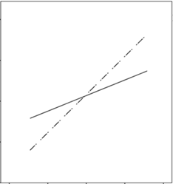

**Figure 2a.** Interactive effects of culture and REW on EIGP.

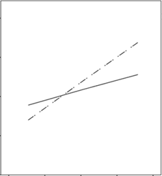

**Figure 2b.** Interactive effects of culture and REW on OCBE.

EIGP

Low-REW High-REW

**Hotel**

local

Western

4.5

3.0

3.5

2.5

4.0

**Hotel**

local

Western

4.5

3.0

3.5

2.5

4.0

OCBE

Low-REW High-REW