Validity and reliability of a light-based electronic target for testing response time in fencers

Andrea De Giorgio1, Enzo Iuliano1, Anthony Turner2, Carlo Millevolte1, Luca P. Ardigò3, Johnny Padulo1,4,5

1University eCampus, Department of Psychology, Novedrate, Italy

2London Sport Institute, Middlesex University, London, UK

3School of Exercise and Sport Science, Department of Neurosciences, Biomedicine and Movement Sciences, University of Verona, Verona, Italy

4Faculty of Kinesiology, University of Split, Split, Croatia

5Sport Performance Lab, University of Split, Split, Croatia

**Abstract**

Response time is a fencing fundamental sensorimotor skill. Therefore, the aim of the current study was to examine the efficacy of a light-based electronic target in fencers, designed to measure and train this entity. Ninety-five fencers (M=53; F=42) were tested in regard to their response time, using a light-based electronic target, for three different attack types: simple attack, the lunge, and an attack following a 1.5-m thrust. All participants were divided into elite *vs.* novice fencers. Elite fencers had national and international rankings, and were again divided with regard to used weapon: épéeists (n=32; M=19; F=13) and foilists (n=30; M=13; F=17). Measurement was evaluated for validity/reliability, sensitivity/specificity, and correlation. Reliability was high for all attack types (ICC 0.94-0.96). Lower response times were found in males for two attack types with good sensitivity (81-93%)/specificity (50-91%) for all attack types. Elite fencers responded faster than novice fencers for all attack types (*P*<0.001), whereas elite males were faster than females for two attack types (*P*<0.01). Lower response times in females correlated with level for one attack type (*r*=0.797, *P*<0.05). In conclusion, the light-based electronic target system was found to be highly reliable and therefore could be used by fencing athletes as a further measure of performance.

**Key Words:** accuracy; precision; sports technology; sports performance; reaction time.

**INTRODUCTION**

In order to achieve excellence in sport performance, it is important to develop an athlete’s sensorimotor capabilities alongside their physical capacity and motor skills. Several investigators have studied the role of sensorimotor skills in sport (23), in an attempt to better appreciate the cognitive demands and how they fluctuate based on the degree of psychological (e.g., pressure to perform and environmental demands) and physical (e.g., fatigue, and heat) stress (15). An athlete’s sensorimotor skills and their functionality in stressful conditions should be seen as highly influential on the final performance outcome, as it likely influences their ability to select only relevant information and thus the time taken to make a decision (14), before delivering the chosen motor response (28).

It is generally accepted that the ability to fix on only relevant stimuli and choose the right response is developed through extensive experience, covering a range of contexts and game scenarios (13). Therefore, competition experience and sports coaching practices are likely best at developing this and thus predominately instilled by the coach and athlete. However, it is also important to recognize how sport science practitioners can be facilitative of sensorimotor skill development in athletes (2,3,25). Normally, this will be via increasing the capacity to tolerate physiological (i.e., increases in anaerobic and aerobic fitness, sleep, and nutrition) and psychological (e.g., through mental toughness and self-talk for example) stress, and via the execution of the motor skill itself (e.g., through increases in speed, power, or the ability to cover greater distance or reach higher heights). In this paper, we focus on motor skill development, but also the capacity to affect reaction time (albeit total response time acts as the proxy for this). Reaction time is a fundamental component to sensorimotor skills and is described as the duration between the time of a stimulus and the time in which a motor response starts (24). Given reaction and movement duration have been shown to be decisive in fencing, on account of the fast-paced open skilled nature of the sport (34), researchers should continue to investigate ways in which these fundamental components can be trained and tested.

Whereas the training of fencing motor skills has been well covered (32,35), reaction time has been explored far less (36). An athlete’s reaction time is typically governed by fixed factors such as age (37), gender (1,31), height (31), and, to a lesser extent, body mass (30). However, elite fencing athletes have been found to have a quicker reaction time than their novice counterparts (19,36), suggesting it is indeed a trainable entity and potentially one that sport scientist can seek to improve as part of their provision. Given the short time frames with which reaction time occurs – in elite fencers, reaction time averages at 350 ms (36) – it is generally difficult to test it in isolation given the measuring equipment typically available to sports performance programs. Methods therefore usually involve testing both reaction time and motor skill execution as one metric (i.e., total response time, RT), and, aside from those tests that require responding to life-size opponents projected on large screens (13), require reacting to a light stimulus (36). Given the low ecological validity this may present, such methods must therefore be tested to ensure this feasibility has not overly compromised its efficacy. Therefore, the aim of this paper is to test RT in fencers using a light-based electronic target. If the instrument is found to be valid, it may offer the sport science team an opportunity to test this as part of a fencing specific battery and potentially use it to expedite the sensorimotor development of fencers, supporting that achieved via practice and games.

**METHODS**

**Experimental Approach to the Problem**

This experimental study was approached through a “cross-over” observational design, investigating the effects of gender, level, and weapon against each fencer’s RT, during three different attack types. Response time was measured using a light-based electronic target. Gender, level, and weapon were the independent variables and RT the dependent variable. Measurement was evaluated for validity/reliability, sensitivity/specificity, and correlation. The ability of the device to measure (and train) sensorimotor skills can be established when comparing a group of novice fencers to elite fencers and was therefore the research design used here. Clearly significant differences should be noted between the elite and novice fencers if the test is of suitable ecological validity and is sensitive enough to note small (and real) changes.

**Subjects**

Ninetyfive participants (M=53; F=42) were tested and their characteristics are shown in Table 1 (data in table are reported as means ± standard deviation and range). All participants were divided into elite fencers *vs.* novice fencers. Elite fencers had national and international rankings and were again divided with regard to used weapon: épéeists (n=32; M=19; F=13) and foilists (n=30; M=13; F=17). Novice fencers started to practice fencing recently, only practicing occasionally (<once *per* week), and did not have any rankings. Due to the testing instrument setup (i.e., ETF-1, from now on “target”), sabre was excluded from the study given the requirements for cutting with the sword’s edge. Used weapons were in accordance with the Federation Internationale D’Escrime regulations (<http://fie.org/fie/documents/rules>). Elite fencers were tested using the weapons they usually use, while novice fencers were tested using the foil because this weapon is lighter than the épée. For each participant of elite standard, the used weapon, years of experience, number of weekly workouts, and ranking position was also collected in addition to their anthropometrics (Table 1). All procedures performed in the present study were in accordance with the 1964 Helsinki Declaration and its later amendments or comparable ethical standards. All participants gave their signed consent to participate in the study and all families did the same to allow minors to participate in it. Local ethics committee approved the study.

Table 1 about here

**Procedures**

Testing was undertaken using the Favero Electronic Target™ (ETF-1, Favero Electronics Srl, Arcade, Italy), a programmable target designed to challenge a fencer to hit a series of randomized targets. This instrument has five target areas and nine different pre-set exercises meant for improving a fencer’s accuracy and total RT (Figure 1).

Figure 1 about here

All participants performed three types of attacks: simple attack (from now, “DIRECT-HIT”), the lunge (LUNGE), and an attack following a 1.5-m thrust (from now, “DISTANCE”). The participant was positioned in the *en garde* position such that with the arm naturally extended, the weapon touched the target with the tip (Figure 2A). In regard to the DIRECT-HIT from the *en garde* position, the participant had to hit the target with only an arm movement (i.e., without the chest and/or legs moving; Figure 2B). Regarding the LUNGE, the participant was positioned at “lunge distance” (Figure 2C), defined as the distance from which a simple arm movement would not allow the target to be reached. Finally for DISTANCE, the participant was positioned at standard distance from the target (i.e., 1.5 m), with the tip of the foot in the *en garde* position. In this case, each participant could hit the target according to their characteristics (i.e., DIRECT-HIT or LUNGE; Figure 2D). Each test was repeated fives times and response time between target stimulus (i.e., red light) and hit (i.e., green light when hit was correct) were measured. The shortest RT was used for further analysis. At the end of the three sets of attacks, a pause was administered and the exercise was proposed again in reverse order for test-retest purposes.

Figure 2 about here

***Statistical Analyses***

A one-way analysis of variance (ANOVA) was performed to evaluate whether significant differences existed between elite fencers *vs.* novice fencers, across the three test types; DIRECT-HIT, LUNGE, and DISTANCE. The same test was also used to determine whether significant differences existed between female and male participants, and again to evaluate whether differences existed between the two analysed weapons (foil and épée), but this time in the elite fencer group only. For each comparison, effect size (Cohen’s *d*) ± 95% confidence interval (CI) for the differences between means were also calculated, to provide a practical interpretation of the size of the difference and to facilitate the application of results to similar samples.

The Receiver Operating Characteristic curve (ROC curve) was used to analyse the three test scores (DIRECT-HIT, LUNGE, and DISTANCE) in order to evaluate whether they were sensitive (sensitivity=true positives/[true positives+false negatives]) and specific (specificity=true negatives/(true negatives+false positives) indicators for the detection of elite fencers *vs.* novice fencers. Here, sensitivity is defined as a measure of the test’s effectiveness at identifying a desired subject’s feature, and specificity as a measure of the test’s ability to detect a non-desirable feature of a subject. The Youden’s *J* index (39) was used to detect the cut-off value (i.e., the *criterion*). When significant differences are found between gender or weapon scores in any of the three tests, the ROC curve analyses were performed independently for male and female participants or for the two weapons, in order to obtain gender-specific or weapon-specific cut-off values. For the ROC curve analysis, the non-parametric method of DeLong et al. (12) was used.

Finally, Pearson’s correlation analysis between scores *vs*. years of experience and international rank were performed (for the elite fencers only), to verify whether test scores were related to years of practice/experience, or with the participant’s worldwide ranking position. For reliability analysis, the Intraclass Correlation Coefficient (ICC) was calculated to assess the test-retest reliability of the three tests. Specifically, the two-way consistency model ICC for single measures was performed using the two different scores obtained in the two days of test and retest. The coefficient of variation (CV) for duplicated measurements (test and retest) was also calculated. Significance level was set at *P*<0.05. All statistical analyses were performed using MedCalc Statistical Software (MedCalc Software bvba, v. 17.6, Ostend, Belgium) and Microsoft Excel software (Microsoft corporation, v. 2016, Redmond, WA, USA).

**RESULTS**

Reliability analysis revealed ICC’s of high reliability for the three tests with ICC=0.945 and CV=7.41% for DIRECT-HIT, ICC=0.954 and CV=6.14% for LUNGE, and ICC=0.965 and CV=5.59% for DISTANCE. The two groups (elite fencers *vs.* novice fencers) were not significantly different for age, body mass, and height. Significant differences were found when the group was split by gender for height and body mass, with higher values for males in elite fencers and novice fencers. Concerning the comparisons between the different weapons, significant differences appeared when analysing female participants only. In particular, the differences were: (1) higher height of épéeists *vs.* foilists, (2) higher body mass and height of épéeists *vs.* novice fencers, and (3) higher body mass of foilists *vs.* novice fencers. Male participants on the contrary did not show such differences in height and body mass. Results are reported in Table 1.

Response times from the three tests are reported in Table 2 and show that foilists and épéeists do not differ significantly and consequently no specific ROC analyses were selectively conducted for the two different weapons. In contrast, significant differences in the three tests emerged between male and female participants in DIRECT-HIT and DISTANCE, but not in LUNGE. Consequently, ROC analyses were separately performed for males and females in DIRECT-HIT and DISTANCE, whereas for LUNGE test analysis, male and female participants were considered together due to the absence of gender differences. ROC curve analysis showed that DIRECT-HIT had a moderate specificity in discriminating male elite fencers from male novice fencers. Indeed, the analysis showed a sensitivity of 81.2% (95% CI=63.6–92.8) and a specificity of 76.2% (95% CI=52.8–91.8). For both sensitivity and specificity, a cut-off of 40 cs (i.e., hundredths of one second) was used (Area under the Curve [AUC]=0.838; Standard Error [SE]=0.060; *P*<0.0001). The same analysis performed on female participants showed instead a sensitivity of 93.3% (95% CI=77.9–99.2) and a specificity of 50.0% (95% CI=21.1–78.9) with a cut-off of 45 cs (AUC=0.721; SE=0.102; *P*=0.030). ROC curve performed on LUNGE scores showed that the test (performed on male and female participants together) had a sensitivity of 88.7% (95% CI=78.1–95.3) and a specificity of 90.9% (95% CI=75.7–98.1) when a cut-off of 53 cs is used (AUC=0.935; SE=0.031; *P*<0.0001). Finally, ROC curve performed on male participants showed that DISTANCE had a sensitivity of 90.6% (95% CI=75.0–98.0) and a specificity of 81.0% (95% CI=58.1–94.6) with a cut-off of 43 cs (AUC=0.885; SE=0.047; *P*<0.0001). The output on female participants showed instead a sensitivity of 73.3% (95% CI=54.1–87.7) and a specificity of 83.3% (95% CI=51.6–97.9) with a cut-off of 45 cs (AUC= 0.854; SE=0.063; *P*<0.0001). In order to favour a better interpretation of ROC curve analysis, the relative graphics of the three tests are reported in Figure 3.

Table 2 about here

Figure 3 about here

Scores split by gender, level, sword, and strike type are presented in Table 2, where it can be noted that elite athletes respond significantly quicker than their novice counterparts across all tests. Equally, male elites are faster than female elites during DIRECT-HIT as well as during DISTANCE. However, there is no difference between swords. Pearson’s correlation analyses between tests scores (without a gender divide) and years of experience and ranking placement, revealed that when scores were split by gender, only DIRECT-HIT scores *vs.* ranking placement for female participants showed a high and significant correlation coefficient (*r*=0.797, *P*<0.05). All other comparisons showed poor-to-moderate non-significant correlations.

**DISCUSSION**

The aim of this paper was to test the total RT (i.e., reaction time plus the execution of the motor skill) in fencers using a light-based electronic target. Elite athletes respond significantly quicker than their novice counterparts (+24–34%, *P*<0.001). Male elites are faster than female elites during DIRECT-HIT (+12%, *P*=0.005) as well as during DISTANCE (+10%, *P*=0.009), but there is no difference between swords (+4%, *ns*; Table 2). Notably, the scores reported here are similar to those of Williams et al. (36).

To achieve a high performance in fencing, neuromuscular control of multi-joint movements is essential. For example, the *en garde* position requires high stability, balance, and proper muscle tension (4). To score against the opponent, a fencer must have good weapon handling coupled with an explosive extension of the trailing leg to perform a forceful forward lunge without losing balance. Furthermore, this complex movement requires forces to be asymmetrically developed across the body (29). Somatosensory and neuromuscular factors are decisive in balance control, also regarding body orientation in space, which is managed by the central processes of visual, vestibular, and peripheral afferences (i.e., from muscles and joints; 18). When many conflicting sensory inputs are present, as in an open-skill sport like fencing, balance control performance can decrease, highlighting the importance and relevance of each sensory system (21). All sensory inputs are processed by cortical and subcortical structures in the brain such as the visual cortex, somatosensory cortex, basal ganglia (9) and the cerebellum (6), and each structure affects the other (8,10). These structures organize the motor response and are very sensitive to training (26), which shows a long-lasting positive effect of sport training through sensorimotor adaptations (7,27). This likely explains the differences found herein between elite fencers and novice fencers in RT times, and why others have found likewise (19,36).

Performance in fencing can be affected by psychological (distress, environmental demands, and psychological pressure) and biomechanical (posture and kinematics, and joint and muscle coordination and synergy) demands (5), but also by weapons, which have different masses and are characterized by different rules and attack strategies. Weapons can affect biomechanics, because they vary in blade type (épée is heavier – 775 g *vs.* 350-500 g – same in blade length, 90 cm, than foil), scoring technique (e.g., thrusting for foil and épée and also cutting for saber), and valid target zones (e.g., torso without the extremities for foil, torso and superior extremities for sabre, and entire body for épée). However, these differences are either too small or not appropriately tested by the electronic device used herein, given no differences between scores were noted. This is not a surprising finding as no differences between swords have previously been reported when measuring the physical capacity of fencers (33). This is generally attributed to the high similarity each sword has from a fitness training perspective and supports the notion that fencers do not need to have a weapon-specific approach to sport science (33).

Attention is decisive in many sports (11,38) and also in the fencer’s performance (17) and it is considered to be one of the most important psychological aspects that determine better performance in fencing (17). Hijazi (17) demonstrated a substantial similarity in the attention dimensions between male and female fencers, but also noted that in terms of high scores obtained for dimensions of visual perception, in particular visual discrimination, there were differences between male and female fencers. Attention is a process related to, and basic condition for, perception to occur. Whereas attention occurs first, perception interferes with it (16). In turn, perception is closely related to reaction time (20). Lahtela et al. (22) discussed how reaction time tasks incorporating a strong semantic component (e.g., numbers as stimuli) highlight a female advantage. On the other hand, tasks characterized by spatial features (e.g., spatial location stimuli) show a male superiority. According to the literature, the shorter movement time in males compared to females could be related to a specific information processing strategy (1), and this in turn would partly explain the superior total RT of males. Furthermore, across a range of physical capacity tests (including the execution of fencing specific motor skills), male fencers have scored better than females (33), generally considered on account of increased strength, power, and reduced fat mass. Both these factors can collectively explain the better scores obtained by males.

In summary, the device was found to be highly reliable and therefore could be used by fencing athletes as an additional test with ecological validity, and by inference, as an additional training tool. Future studies should aim to investigate the use of this device as a training tool. It is likely that athletes will improve at scores through either (1) increases in strength and power and thus the execution of the motor skill, (2) improvements in reaction time, or (3) both. With regards to reaction time, it would also be interesting to determine the transfer of quicker reactions to a light stimulu*s*, to that of the human body and sword. The true efficacy of this device, from a training perspective, lies in such an analysis.

**PRACTICAL APPLICATIONS**

A new light-based electronic target provides valid/reliable and sensitive/specific results for RT across gender, level and weapon during three different fencing attacks. The device shows that elite fencers respond significantly quicker than their novice counterparts, and that male elites are faster than female elites during simple attacks as well as during attacks following a short thrust. However, there is no difference between swords. The device may therefore be a suitable testing tool for fencers.

**ACKNOWLEDGEMENTS**

We would like to thank the fencers, who voluntarily gave their best performance for this protocol, and Favero Electronics Srl for providing the light-based electronic target. The results of the present study do not constitute endorsement of the product by the authors or the NSCA.

**REFERENCES**

1. Adam, JJ, Paas, FG, Buekers, MJ, Wuyts, IJ, Spijkers, WA, and Wallmeyer, P. Gender differences in choice reaction time: evidence for differential strategies. *Ergonomics* 42: 327–335, 1999.

2. Alesi, M, Bianco, A, Padulo, J, Vella, FP, Petrucci, M, Paoli, A, et al.. Motor and cognitive development: the role of karate. *Muscles Ligaments Tendons J* 4: 114–120, 2014.

3. Ardigò, LP, Dello Iacono, A, Zagatto, AM, Bragazzi, NL, Kuvacic, G, Bellafiore, M, and et al.. Vibration effect on ball score test in international vs. national level table tennis, *Biol Sport* 35: 329–334, 2018.

4. Barth, B. The Complete Guide to Fencing. Aachen, Germany: *Meyer & Meyer Verlag*, 2006.

5. Chen, TLW, Wong, DWC, Wang, Y, Ren, S, Yan, F, and Zhang, M. Biomechanics of fencing sport: A scoping review. *PLoS One* 12: e0171578, 2017.

6. Churchill, N, Hutchison, MG, Leung, G, Graham, S, and Schweizer, TA. Changes in functional connectivity of the brain associated with a history of sport concussion: a preliminary investigation. *Brain Inj* 31: 39–48, 2017.

7. Crotts, D, Thompson, B, Nahom, M, Ryan, S, and Newton, RA. Balance abilities of professional dancers on select balance tests. *J Orthop Sports Phys Ther* 23: 12–17, 1996.

8. De Bartolo, P, Gelfo, F, Burello, L, De Giorgio, A, Petrosini, L, and Granato, A. Plastic changes in striatal fast-spiking interneurons following hemicerebellectomy and environmental enrichment. *Cerebellum* 10: 624–632, 2011.

9. De Giorgio, A. The roles of motor activity and environmental enrichment in intellectual disability. *Somatosens Mot Res* 34: 34–43, 2017.

10. De Giorgio, A., Kuvačić, G., Milić, M., and Padulo, J. The brain and movement: How physical activity affects the brain. *Monten J Sports Sci Med* 7: 63–68, 2018.

11. De Giorgio, A, Sellami, M, Kuvacic, G, Lawrence, G, Padulo, J, Mingardi, M, et al.. Enhancing motor learning of young soccer players through preventing an internal focus of attention: The effect of shoes colour. *PLoS One* 13: e0200689, 2018.

12. DeLong, ER, DeLong, DM, and Clarke-Pearson, DL. Comparing the areas under two or more correlated receiver operating characteristic curves: a nonparametric approach. *Biometrics* 44: 837–845, 1988.

13. Gabbett, TJ, and Abernethy, B. Expert–novice differences in the anticipatory skill of rugby league players. *Sport Exerc Perform Psychol* 2: 138–155, 2013.

14. Gil-Arias, A, Moreno, MP, García-Mas, A, Moreno, A, García-González, L, and del Villar, F. Reasoning and Action: Implementation of a Decision-Making Program in Sport. *Span J Psychol* 19: E60, 2016.

15. Gould, D, Jackson, S, and Finch, L. Sources of stress in national champion figure skaters. *J Sport Exerc Psychol* 15: 134–159, 1993.

16. Hagemann, N, Schorer, J, Cañal-Bruland, R, Lotz, S, and Strauss, B. Visual perception in fencing: Do the eye movements of fencers represent their information pickup?. *Atten Percept Psychophys* 72: 2204–2214, 2010.

17. Hijazi, MM. Attention, visual perception and their relationship to sport performance in fencing. *J Hum Kinet* 39: 195–201, 2013.

18. Horak, FB, Shupert, CL, Dietz, V, and Horstmann, G. Vestibular and somatosensory contributions to responses to head and body displacements in stance. *Exp Brain Res* 100: 93–106, 1994.

19. Hughes, PK, Bhundell, NL, and Waken, JM. Visual and psychomotor performance of elite, intermediate and novice table tennis competitors. *Clin Exp Optom* 76: 51–60, 1993.

20. Jaśkowski, P. Simple reaction time and perception of temporal order: Dissociations and hypotheses. *Percept Mot Skills* 82: 707–730, 1996.

21. Kuo, AD, Speers, RA, Peterka, RJ, and Horak, FB. Effect of altered sensory conditions on multivariate descriptors of human postural sway. *Exp Brain Res* 122: 185–195, 1998.

22. Lahtela, K, Niemi, P, and Kuusela, V. Adult visual choice‐reaction time, age, sex and preparedness: A test of Welford's problem in a large population sample. *Scand J Psychol* 26: 357–362, 1985.

23. Mann, DT, Williams, AM, Ward, P, and Janelle, CM. Perceptual-cognitive expertise in sport: A meta-analysis. *J Sport Exerc Psychol* 29: 457–478, 2007

24. Nuri, L, Shadmehr, A, Ghotbi, N, and Attarbashi Moghadam, B. Reaction time and anticipatory skill of athletes in open and closed skill-dominated sport. *Eur J Sport Sci* 13: 431–436, 2013.

25. Padulo, J, Pizzolato, F, Tosi Rodrigues, S, Migliaccio, GM, Attene, G, Curcio, R, and Zagatto, AM. Task complexity reveals expertise of table tennis players. *J Sports Med Phys Fitness* 56: 149–156, 2016.

26. Paillard, T. Plasticity of the postural function to sport and/or motor experience. *Neurosci Biobehav Rev* 72: 129–152, 2017.

27. Perrin, P, Deviterne, D, Hugel, F, and Perrot, C. Judo, better than dance, develops sensorimotor adaptabilities involved in balance control. *Gait Posture* 15: 187–194, 2002.

28. Savelsbergh GJ, Van der Kamp, J, Williams, AM, and Ward, P. Anticipation and visual search behaviour in expert soccer goalkeepers. *Ergonomics* 48: 1686–1697, 2005.

29. Sinclair, J, Bottoms, L, Taylor, K, and Greenhalgh, A. Tibial shock measured during the fencing lunge: the influence of footwear. *Sports Biomech* 9: 65–71, 2010.

30. Skurvydas, A, Gutnik, B, Zuoza, AK, Nash, D, Zuoziene, IJ, and Mickeviciene, D. Relationship between simple reaction time and body mass index. *Homo* 60: 77–85, 2009.

31. Tønnessen, E, Haugen, T, and Shalfawi, SA. Reaction time aspects of elite sprinters in athletic world championships. *J Strength Cond Res* 27: 885–892, 2013.

32. Turner, A, Bishop, C, Chavda, S, Edwards, M, Brazier, J, and Kilduff, LP. Physical characteristics underpinning lunging and change of direction speed in fencing. *J Strength Cond Res* 30: 2235–2241, 2016.

33. Turner, AN, Bishop, CJ, Cree, JA, Edwards, ML, Chavda, S, Read, PJ, et al.. Do fencers require a weapon-specific approach to strength and conditioning training?. *J Strength Cond Res* 31: 1662–1668, 2017.

34. Turner, A, James, N, Dimitriou, L, Greenhalgh, A, Moody, J, Fulcher, D, et al.. Determinants of Olympic fencing performance and implications for strength and conditioning training. *J Strength Cond Res* 28: 3001–3011, 2014

35. Turner, AN, Marshall, G, Noto, A, Chavda, S, Atlay, N, and Kirby, D. Staying out of range: Increasing attacking distance in fencing. *Int J Sports Physiol Perform* 12: 1319–1323, 2017.

36. Williams, LRT, and Walmsley, A. Response timing and muscular coordination in fencing: a comparison of elite and novice fencers. *J Sci Med Sport* 3: 460–475, 2000.

37. Woods, DL, Wyma, JM, Yund, EW, Herron, TJ, and Reed, B. Factors influencing the latency of simple reaction time. *Front Hum Neurosci* 9: 131, 2015.

38. Wulf, G, Shea, C, and Park, JH. Attention and motor performance: preferences for and advantages of an external focus. *Res Q Exerc Sport* 72: 335–344, 2001.

39. Youden, WJ. Index for rating diagnostic tests. *Cancer* 3: 32–35, 1950.

**Figure captions**

**Figure 1.** EFT-1. Red light indicates the cue proposed by the device. When score is confirmed, green light appears. On the top, there are three digital displays, which describe, from left to right: exercise number, remaining attacks, and time (as result).

**Figure 2.** Here it is shown the three types of attacks performed. A. *en garde* position, B. direct-hit started by *en garde* position, C. lunge, and D. lunge started from a 1.5-m distance.

**Figure 3.** ROC curve analysis relative to graphics of the three tests. C.O.=Cut-Off; Se.=Sensitivity; Sp.=Specificity; NF=Novice fencers; EF=Elite fencers.

Figure 1 (left) and Figure 2 (right)

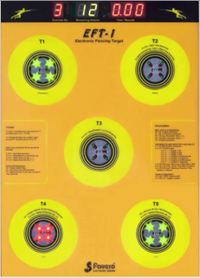 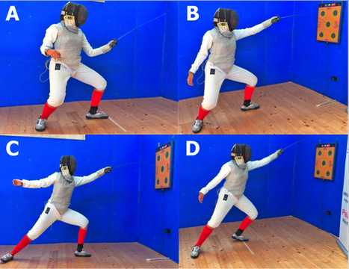

**Figure 3**

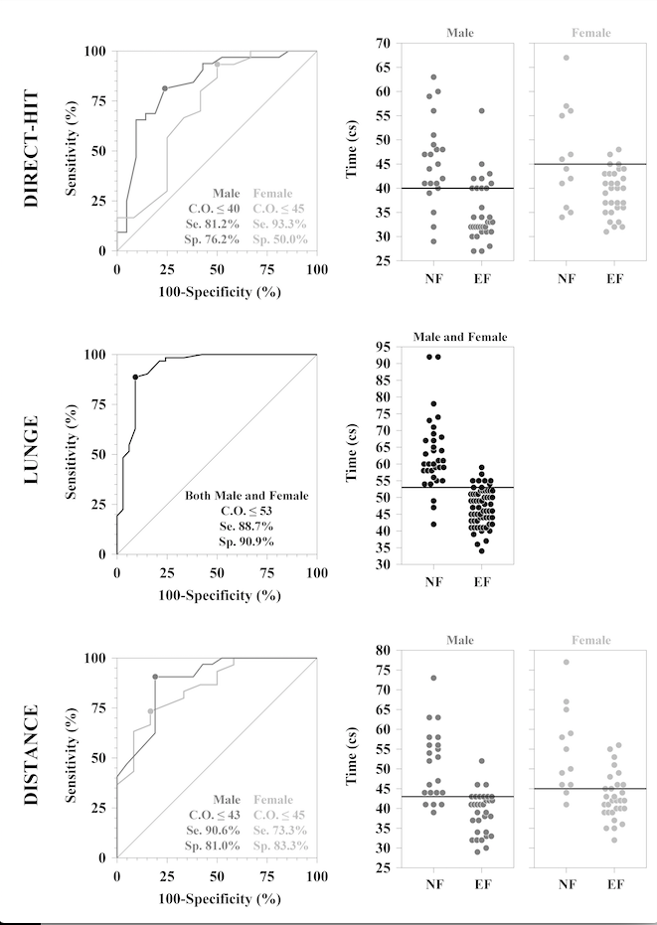

**Table 1**

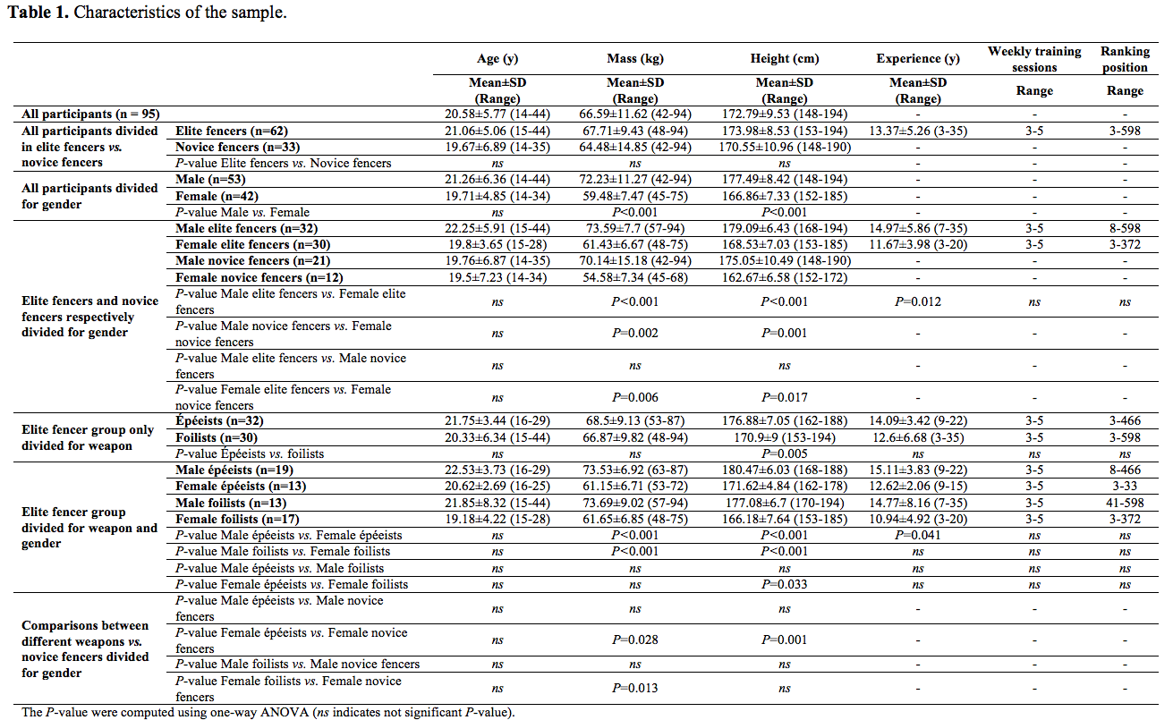

**Table 2**

