# Descriptive Geometry in England – lost in translation

Snezana Lawrence, Bath Spa University, England UK

## Abstract

This chapter looks at the history of descriptive geometry in England, and why here it had such a short, and not a very fulfilling life. Having arrived to England in the immediate aftermath of the wars between England and France, its translation and attempts to introduce it into the educational system happened only after the 1840s. The lack of direct, implicit knowledge of the original technique, and some aspects of mistranslation, meant that the technique was never properly understood. Descriptive geometry is still mainly regarded as a drawing, rather than a mathematical technique in England, and has not been practiced since the end of the 19th century. Polytechnic schools in England were another short-lived phenomena, and only of any significance and showing similarity with the French model in the second half of the 20th century.

### Key words

Descriptive geometry, Monge, Farish, Nicholson, orthographic projection, isometric perspective, parallel oblique projection, curvilinear perspective.

## Mathematics in England in the 18th and 19th centuries

### General background

English mathematics in the 18th and 19th century was vibrant and diverse, not perhaps as spectacular as that of the 17th century, but brining to the discipline some important developments and new concepts (Rice, 2011). English mathematical landscape was still under the heavy influence of Newton (1642-1726) and his work well into the 18th century. England of this time produced some mathematicians whose contributions were global, such as John Wallis (1616-1703), Edmund Halley (1656-1742), and Brook Taylor (1685-1731) to name but a few. But there was also, what Rice (2011) called a certain stagnation, a ‘lull’ in producing original mathematics in the 18th century (Guicciardini, 1989). And then suddenly the wheel turned and more mathematics was produced than at any other time.

So how did descriptive geometry fare amongst the locally made ‘Maxwell’s equations, Boolean algebra, histograms, and even the concept of standard deviation’ (Rice, 2011: 1), Venn diagrams (1880s), mechanization of mathematics in Babbage’s Difference Engine (1832), the use of mathematics to make persuasive arguments in matters of changing policies (in Florence Nightingale’s work for example 1850-1870s), to name but some of the most popular and widely known examples? This chapter will look at the place that descriptive geometry took in such a landscape of new mathematical developments.

### Practical mathematics and the practicing mathematician

In order to understand the context in which descriptive geometry was introduced in England, we will first give a short historical overview of the learning of geometry in this country. Until the 16th and 17th centuries, the learning of mathematics was confined to a small number of learning establishments to which no dissident, non-Christian (and after 1559 with the establishment of Anglican independent church) non-Anglican, or female, had access and certainly no one without the knowledge of the classics. Then, from mid-1500s, books on mathematics in vernacular English (Recorde, 1543, 1551; Blagrave, 1585) and in 1570, the first edition of Euclid’s *Elements*, was published in vernacular English (Billingsley, 1570).

Several other important aspects of this emerging learning culture developed. The networks, associations of kinds, and schools for artisans, builders, and anyone who needed to know mathematics sprang around London and other big cities (Lawrence, 2002). One such network grew into the first official mathematical society, which was formed in London in 1717, - the Spitalfields’ Mathematical Society (Cassels, 1979). The early members of this society came from the lower middle classes of artisans and majority were weavers, but there were also brewers, bakers, and braziers (Clark, 2000: 214).

Soon after the accession of George II, in 1730, a small club of local men sat drinking in the snug parlour of a Westminster alehouse, gathered together to learn mathematics, so that ‘by their mutual assistance and indefatigable industry they are now become masters… of logarithmetical arithmetic and some of them greatly advanced in algebra’ (FWJ, 1730).

The society’s aim, along with drinking and socializing, was collective improvement – for it was a ‘fundamental rule of this society not to conceal any new improvement from another member…; before tackling mathematics they had taught themselves French’ (Clark, 2000:1). One should not however make too much of this instance of learning French and mathematics together. This particular society arose in an area of London in which there was, at the time, a sizeable Huguenot population following their exodus from France more than a century earlier (Gwynn, 2001).

Nevertheless, this self-reliant at first, and then more organized movement to enlarge activities around the learning of mathematics, steadily grew and finally solidified itself in the first chairs of mathematics being established at the new modern institutions of learning, like that of the King’s College and University College, both in London in the first half of the 19th century.

The two new universities were open to non-Anglicans, dissidents (more so University College London) and, by the end of the 19th century, women. The greater movement of mathematical texts, their translations and the branching of learning of mathematics needed more specifically for the newly founded professions (such as for example engineering and architecture), all ensued (Lawrence, 2002).

## English tradition Pre-Descriptive Geometry

### Brook Taylor and his Linear Perspective

The work that had prepared the ground, or so it may seem, for the arrival of descriptive geometry to England, would have been that of Brook Taylor (1685-1731). Taylor belonged to the tradition described above in more than one way. He was an artisan, musician, and a mathematician (Jopling, 1835). He published two books on geometry which certainly paved the way to the study of graphical geometry in England before the arrival of descriptive geometry.

Having originated in a well to do family, Taylor had private tuition as a child and attended Cambridge as a young adult. By the time he graduated there in 1709, he had already written his first mathematical paper, and he published it a few years later, in the same year he was elected a Fellow of the Royal Society (Taylor, 1712). Shortly after this, Taylor became the secretary to the Royal Society in 1714. At this time he was interested in several things: magnetism, calculus, and linear perspective. He published on all three subjects in 1715 (Jopling, 1835), but the publication which we are most interested in was his *On the Principles of Linear Perspective* (Taylor, 1715).

Linear perspective is a technique which was developed fully only during the Italian Renaissance, although there are instances of its appearance in art since the classical antiquity (Damisch, 1995). The development of the technique can roughly be divided into three periods (Jones, 1950): the first during which architects and artists made re-discovery of the technique (15-16th centuries), the second in which geometrical study of the technique was presented more formally (17th century) and finally the third in which the technique was presented in a more generalized form, as an abstract theory (18th century). Taylor’s work certainly falls into the third period not only because of the timing of his two treatises (Taylor, 1715, and 1719) but because of the abstraction of thought that made this technique a mathematically sound one.

Taylor’s work attracted some attention in England and on the continent – it was translated into Italian (Taylor, 1755), and there gained important following. Cremona became interested in particular in the fundamental theorems from Taylor’s second treatise and published new proofs of the same (Cremona, 1865). This link between Cremona and Taylor remained in the Italian tradition and can be seen in the Gino Loria’s contribution to Moritz Cantor’s *Geschichte der Mathematick* (Loria, 1908; Anderson, 1992: 78).

**Mathematical catechisms**

The number of practicing mathematicians or those who needed some mathematical knowledge as described earlier grew from there on and so did the need for resources from which to learn mathematics. In 18th century a new industry of popular geometrical books aimed particularly at artisans, builders and workmen was born. The books such as these mainly resembled empirical recipes (Booker, 1963:91-111; Lawrence, 2002) like Joseph Moxon’s (1627-1691) works: *Mathematics made easie* (Moxon, 1700) and *Mechanick Exercises or Doctrine of handy-works* (Moxon, 1703) or Batty Langley’s (1696-1751) numerous books (Langley, 1727, 1735, 1736a, 1736b, 1737, 1738, 1739, 1740). These works invariably mixed the learning of geometry with freemasonic lore and mythology (Lawrence, 2002; Lawrence & McCartney, 2015).

An example is given bellow: it is a page from Langley’s book giving an introduction to the science of Geometry:

This Art was first invented by Jabal the Son of Lamech and Adam, by whom the first House with Sones and Trees was built.

Jabal was also the first that wrote on this Subject, and which he performed, with his Brethren, Jubal, Tubal Cain, and Naamah, who together wrote on two Columns the Arts of Geometry, Music, working in Brass and Weaving, which were found (after the Flood of Noah) by Hermarines, a descendent from Noah, who was afterwards called Hermes the Father of Wisdom, and who taught those Sciences to other Men (Langley, 1736b: 61).

As such, these books and manuals offered a very few underlying principles or encouraged geometrical understanding and thinking, or taught how to transfer principles from one case to another. Instead, they offered specific cases, and resembled catechism rather than an exact method. The need therefore, for a clearly defined geometrical technique to satisfy this particular application was discussed and entertained at the various levels of the engineering (both civil and military) and the architectural professions (Booker 1963; Lawrence, 2002, 2011) at the time when descriptive geometry was already taught in France.

## Descriptive Geometry in England – arrival, translations and adaptations

Descriptive geometry’s first public appearance in English language came around 1820s. Some records which we will soon explore in detail, show that some copies of Monge’s books (whether an VIII or Hachette is unclear) were circulating around London at the time (Nicholson, 1823).

When considering the reception, and the context of descriptive geometry in England in this light, one should also add that descriptive geometry was proclaimed a military secret (Booker 1963, Taton, 1951, Lawrence, 2002) when first conceived by Monge. Additionally when it was for the first time publicly taught in Paris on 20th January (1er Pluviôse III), Britain and France were at war with each other. This was of course during the War of the First Coalition (1792-1797); during the War of the Second Coalition (1798-1802), Britain led the coalition against France, and Monge was one of the savants that took part in the Egyptian Expedition where one of the biggest battles of this war took place – the battle of Alexandria (Lawrence, 2015). Indeed the Coalition Wars meant something that was more important than the boundaries of countries or the prestige of the warring sides: they were about upholding the old or inventing a new social, political, and intellectual systems and frameworks (Fisher, 2004).

In this light, it is clear that Monge’s sentiments about the need for a technique such as descriptive geometry, and the role he imagined it play in building of the French national prestige did not exactly warm the hearts of the English (Monge, 1798). Only following the death of Monge, different translations and adaptations of descriptive geometry appeared in England. There were three periods in this development, and we will examine them in chronological order.

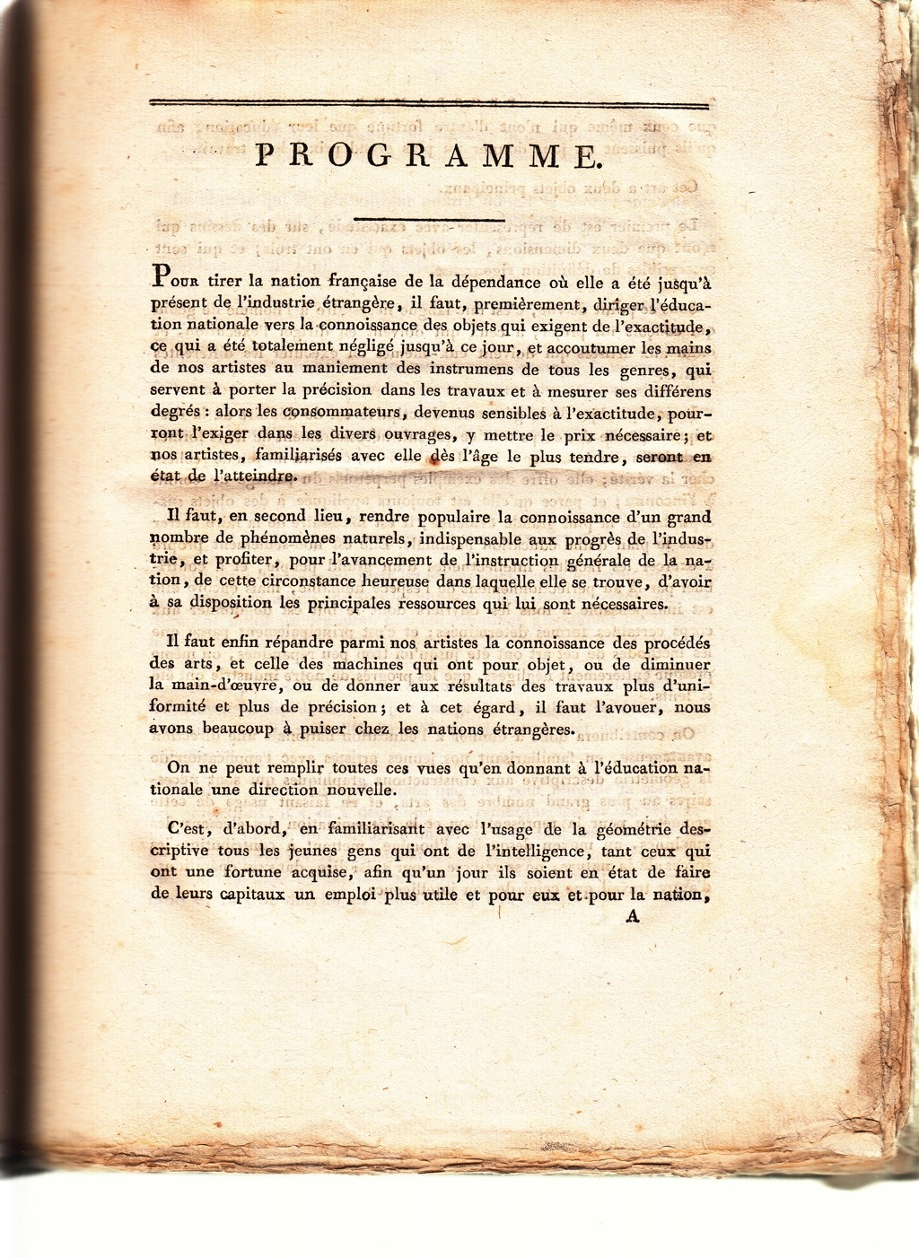

Figure 1. Introduction to *Geometrié Descriptive*, Monge (1798).

## First period, 1820-1840

**Overview**

This period saw an upsurge in publications considering techniques which would resemble descriptive geometry, all of which made references to it, but were not actually descriptive geometry. This period is defined by two publications, one from 1820 and another from 1840. It begins with the first alternative to descriptive geometry, Farish’s *Treatise on Isometrical Perspective* (Farish, 1820) and completes with Nicholsons’ *A Treatise on Projection* (Nicholson, 1840). The isometrical perspective of Farish is a system very different to that of descriptive geometry, and is *de facto* an alternative to parallel projection that was already in use and was for example described by Lambert in his *La perspective affranchie* (Lambert, 1759). However it was portrayed as an English invention (Farish, 1820) and remained to be considered as such through the 19th century (Heather, 1851).

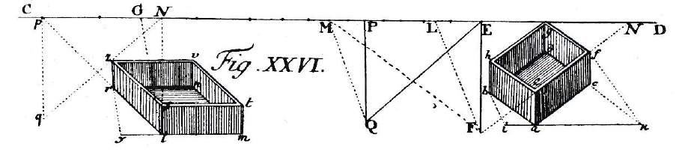

Figure 2. Oblique projection as described by Lambert (1759) prior to Farish’s invention (1820).

**Farish and his *Isometrical Perspective***

William Farish (1759-1837) was Jacksonian professor of natural and experimental philosophy at the University of Cambridge from 1813 to 1836. We know very little of him, but do have some simple facts. Farish was an influential professor, one of the founders of the Philosophical Society of the University of Cambridge, and established its publication, *The Philosophical Transactions* in 1820.

In the first issue of the *Transactions*, in 1820, Farish published a treatise on his use of a graphical representation system which he called *Isometrical Perspective* (Farish, 1820). Heather, of Royal Military Academy in Woolwich, made an interesting comparison of the Monge’s and Farish’s systems and explained the main difference between them, pointing to the reason why most British authors on the subject found descriptive geometry difficult to accept:

Descriptive Geometry would require great accuracy in the construction of the shadows, and would frequently present great difficulties in practice.... [on the other hand] a single projection, the construction of which is remarkable for its simplicity, forms a conventional picture, conveying at once to the eye the actual appearance of the objects, as in a perspective view, and also giving readily the dimensions of the objects represented, especially those dimensions which are situated in planes parallel to three principal planes at right angles to each other.... This technique is Isometrical Perspective of William Farish... (Heather, 1851:ix-x).

Farish did not have the grand ambition that Monge did some twenty years earlier, in suggesting that it should be used throughout the whole territory defined by a national education system. As professor of Natural Philosophy at the University of Cambridge, Farish held lectures on mechanical principles of machinery used in manufacturing industries, and for these he often used models which exemplified particular principles. Storage of models and their transport from the store room to the lecture theatres posed a problem, which Farish solved by making the models from elements which were then assembled by his assistants. In order to communicate with his assistants, Farish devised this system and in drawings based on it he showed how the machinery was to be re-built.

As these machines, thus constructed for a temporary purpose, have no permanent existence in themselves, it became necessary to make an accurate representation of them on paper, by which my assistants might know how to put them together, without the necessity of my continual superintendence. This might have been done by giving three orthographic plans of each; ... But such a method, though in [high] degree in use amongst artist, would be liable to great objections. It would be unintelligible to an inexperienced eye; and even to an artist, it shows but very imperfectly that which is most essential, the connection of the different parts of the engine with one another; though it has the advantage of exhibiting the lines parallel to the planes, on which the orthographic projections are taken, on a perfect scale.... (Farish, 1820: 2).

Farish then published a short treatise describing this practice: isometrical perspective, however, soon became very popular and was used in many other situations, from architecture to engineering (Sopwith, 1834, 1854).

The difference between the circumstances in which the two techniques - that of descriptive geometry and that of isometrical perspective were invented, as well as the difference between their inventors, were to have major consequences for the ways the two were later adopted at the teaching institutions of the architectural profession. Booker (Booker, 1961: 73) described these major differences between the two techniques:

... Whilst Monge had been a draughtsman and knew quite a lot about designing and manufacturing things, Farish was an academic and seems to have been concerned with assembling things which were already made or were familiar enough to be brought into existence by someone else, the craftsman.... Farish’s interests lay entirely in their mechanics, the broad scientific principles. It is doubtful whether he understood the concept of accuracy as Monge did; and of course, being only concerned with broad principles, drawing did not find a place in his engineering lectures - quite the reverse of Monge’s curriculum in which drawing was the key subject.

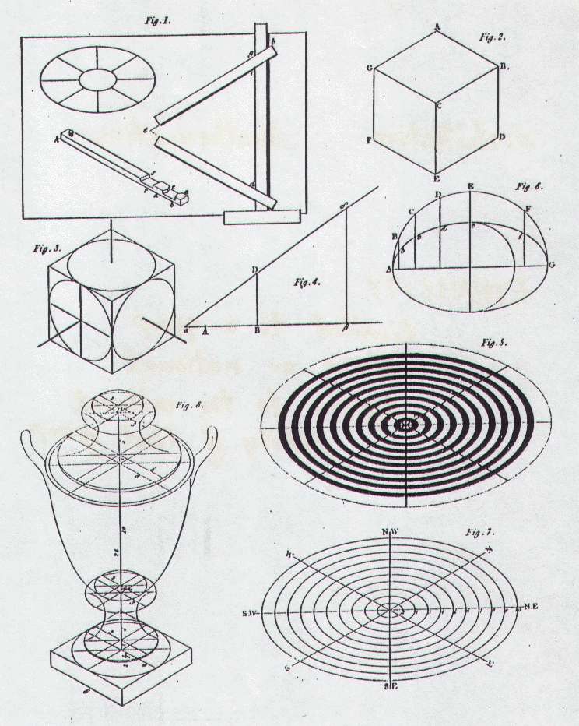

Figure 3. The first page of Farish’s treatise on *Isometrical Perspective* published in 1820.

**After Farish**

Soon after this a first edition of Descriptive Geometry in English language was published in the USA, by Claude Crozet (Crozet, 1821). And at almost the same time in England, Nicholson published his first book on perspective (Nicholson, 1822), which was followed by his *A practical treatise on the art of masonry and stonecutting* (Nicholson, 1823). In this latter book Nicholson didn’t only first time mention that he was working on descriptive geometry, but gave the first English translation of some of the basics of the technique published in England.

In 1823, Joseph Jopling, a civil engineer, published his *Septenary system of generating curves by continued motion*, which, although an interesting publication would not be of any interest to us but for the fact that it used the principle of motion for the description of geometrical objects, an underlying principle used in descriptive geometry (Lawrence, 2011). Jopling later revised Farish’s system, making it more applicable to engineering and architecture trough giving concrete examples applicable to both disciplines (Jopling, 1833). Sopwith, a friend and colleague of Jopling, a civil engineer from London, also published *A Treatise on Isometrical Drawing* (1834) but his was work aimed at mining and civil engineers. In the introduction to his book Sopwith stated that the drawback of isometrical perspective was that the real measurements could not be taken from a drawing, and suggested the method of ‘crating’ – an old technique used since the Renaissance for drawing objects by placing them in elementary reference box, from which the measurements could be extracted.

Some five years later, Thomas Bradley published a book on *Practical Geometry, Linear Perspective, and Projection* (Bradley, 1834). Although this book contains no reference to descriptive geometry ‘proper’, we have the records (Lawrence, 2002) that Bradley taught descriptive geometry at the time at the newly founded Engineering Department of King’s College in London.

In 1840, Nicholson came back with a more comprehensive work on practical geometry, his *Treatise on Projection* (Nicholson, 1840). Nicholson work transcended our two periods and is the most important contribution to the history of descriptive geometry as it lived, under an assumed name, in England.

### Peter Nicholson and his technique of *Parallel Oblique Projection*

A technique which most resembled the Monge’s original came from the work of architect and mathematician Peter Nicholson (1765-1844). Nicholson was born in Prestonkirk, East Lothian on 20th July 1765, a son of a stonemason. He became interested in geometry and its applications to architecture, where he strove to develop an efficient system of graphical communication for the use of architects and craftsmen. Because he knew about descriptive geometry and was the first to apply its principles (Nicholson, 1823), his translation of the practice of descriptive geometry for the architectural profession being founded at the time in Britain, played an important part in leading research towards the establishment of a standardized graphical communication language. The character of his work may be seen as a mediating one between an architect and a craftsmen.

Nicholson was both an author and a practitioner, and, between 1805 and 1810 worked for Robert Smirke (1780-1867), the architect of the British Museum, as a superintendent of the building of the new court-houses at Carlisle. Both men were Freemasons, and members of the same Masonic lodge (the Old Cumberland Lodge, united in 1818 with the Lodge of Fortitude, London).

Nicholson’s family background is of great importance both for his career and our story. Freemasonry in Scotland was, in the late 18th and early 19th centuries, fundamentally different to that in England. Fully operative lodges, which nevertheless practiced the ritual, or speculative Freemasonry, still persisted in Scotland up to the middle of the 19th century, although in England this ceased to be the case shortly after the founding of the Grand Lodge of England in 1717 (Lyon, 1900; Lawrence, 2002). In England, by 1717, the two concepts – that of operative masonry and speculative, or ritual, Freemasonry – were strictly defined, and masonic, or building lodges, were no longer involved with speculative, or philosophical Freemasonry (Knoop, 1935). In Scotland however, operative lodges admitted members through a variation of freemasonic rituals and customs, but maintained their status of the building trade organization into the 1800s (Lyon, 1900).

Nicholson drew upon this practical knowledge he gained while a freemason, and as an apprentice to his uncle, a stonemason in Scotland. When he moved to London, Nicholson organised lectures for craftsmen in Berwick Street, Soho, in which he taught practical stonemasonry. These lectures served to provide learning opportunities for mechanics and workmen who were facing an open, post-lodge market, but where, the lodge apprenticeship was non-existent and hence the practical instruction was lacking.

Nicholson’s knowledge of projection techniques used within the stonemasons craft and the carpenters trade proved to be unquestionably important in this context. He became a well respected and well known figure in this field, and published a number of books and treatises on practical geometry as well as on aspects of architecture (related to technical details and stonecutting). He obviously believed that his mathematics was sufficiently good, and in 1827 tried to get a professorship in mathematics at the newly established University College in London, but was of course passed over in favour of the much younger and better qualified Augustus De Morgan (1806-1871).

We can best trace the invention of Nicholson’s system of projection through his own account of events:

In 1794 I first attempted the Orthographical Projection of objects in any given position to the plane of projection; and, by means of a profile, succeeded in describing the iconography and elevation of a rectangular parallelpipedon: this was published in vol. ii of the Principles of Architecture (Nicholson, 1822: 46-7).

Nicholson also gave information on how and where he had become acquainted with descriptive geometry:

In 1812 Monge's treatise was lent to me by Mr Wilson Lowry, celebrated engraver... (Nicholson, 1822: 47).

Perhaps even more interesting is his memory from an earlier period. Nicholson said (1822), that in 1796-7 he had met Mr Webster, a drawing clerk for Mr Mitchell in Newman Street, who pointed out to him the similarity of his work with that of works from France. When in 1812 Nicholson reports to have been given Monge's treatise, he had it translated by Mr Aspin and considered publishing the major points in his Architectural Dictionary of 1813 (but in fact only mentioned it in passing). We do not unfortunately have that translation nor Nicholson’s notes for the dictionary.

Nicholson’s system undoubtedly rested on his knowledge and experience both of what was considered the necessary knowledge of builders’ craft and of what was going on in this subject on the Continent. His account of the practical need for geometrical education appearing in his *Practical Treatise on the Art of Masonry and Stone-cutting* (Nicholson, 1839) described what he believed was the most important aspect of a new language of graphical communication:

To be able to direct the operations of Stone Masonry, taken in the full extent of the Art, requires the most profound mathematical researches, and a greater combination of scientific and practical knowledge, than all the other executive branches in the range of architectural science. ... To enable the Workman to construct the plans and elevations of the various forms of arches or vaults, as much of Descriptive Geometry and Projection is introduced, as will be found necessary to conduct him through the most difficult undertaking (Nicholson, 1839: 51).

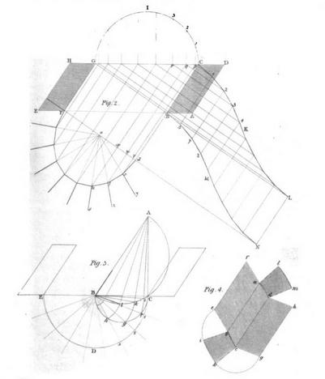

Figure 4. Illustration showing the construction of stone arch using development of a surface into the flat plane, Nicholson (1839)

Nicholson at this point called his system Parallel Oblique Projection; it was an orthographic system of projection which makes use of an oblique plane, so as to provide both the presentation of an object and the method by which such an object is to be executed at a building site. Nicholson’s treatise (1840) comes at the end of a series of his publications related to the topic that we already mentioned, and in which glimpses were given of the principles of his final technique. In this work (Nicholson, 1840), he finally explains his system elaborately, together with numerous examples and listing of possible applications. Like most of the works in this genre, this book too was written for the engineer, architect, surveyor, builder, mechanic, and the like, suggesting that the technique should be used as a universal language of graphical communication among the different parties involved in the building trade.

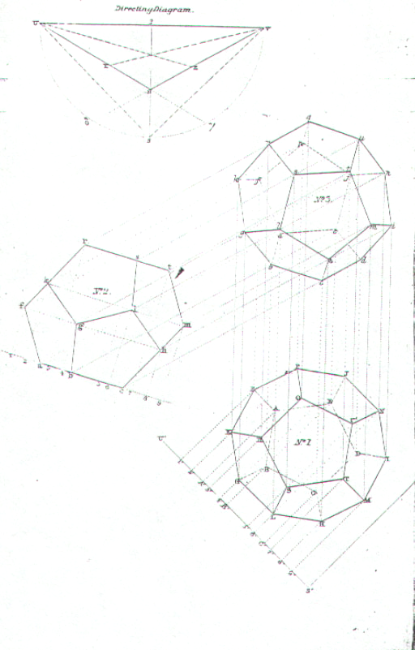

Figure 5. Plate 20 from Nicholson’s Parallel Oblique Projection (1840), showing the body in three views, the system is determined by the small diagram above, showing the position of inclined plane and offers an easy method to obtain real measurements by manipulation of the object.

The system of Parallel Oblique Projection is based on the principles of orthographic projection, and where there is a third, or oblique projection obtained through an auxiliary plane, which then enables the exhibition of a complex design. The third auxiliary plane of projection is seen in its trace through the two primary planes of projection.

## Second period, 1840-1864

Nicholson’s technique, the parallel oblique projection, although it was based on descriptive geometry, was a heavily modified system of Monge. Not having the same title as Monge’s technique should not then be surprising.

Following this book however, a couple of books on descriptive geometry, trying to introduce and present Monge’s system in a straight-forward but slightly simplified form, appeared. First was Thomas Grainger Hall’s *The elements of Descriptive Geometry: chiefly intended for Students in Engineering* (Hall, 1841). Hall’s book is very interesting for two reasons: firstly it pays homage to the inventor and the invention of descriptive geometry and secondly, it suggests that descriptive geometry should be important in education and hence should be taught in England.

The present work is intended for those students who are occupied in graphically represnting the forms of bodies, and the delineations of machines. To such a class the advantage of having general methods by which the position of points, lines, and surfaces, may be determined with exactness and precision, is very obvious. Descriptive Geometry supplies that want. Invented by the genius of Monge, and pursued with ardour and success by the most eminent French Geometricians, it is now taught in almost all the universities and in the principal schools of the continent. In England it was unknown, as a branch of instruction, until lectures were given upon it by Mr. Bradley, in the Engineering Department of King’s College; and the present work has been undertaken to supply the students with a text book, that by it they might the more profitably attend to what they heard in the lecture room: and as an elementary book was necessary for beginners, it has been thought expedient to place before the students, in an English dress, one which has stood the test of experience (Hall, 1841: i).

Hall drew upon Lefebure de Fourcy – edition unknown – for the most part for his translation. The ‘English dress’ meant mainly the introduction to it went via inductive geometry.

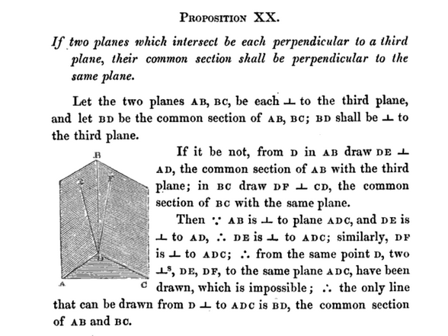

Figure 6. Proposition XX from Hall’s treatise (Hall, 1841), showing the introduction to geometry to reiterate some basics before descriptive geometry principles are given bellow.

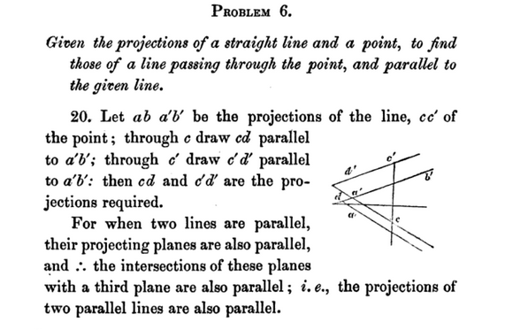

Figure 7. Problem six from Hall’s book (Hall, 1841) showing the remnants of same methodology used to teach geometry.

Hall wrote when Monge was dead for some decades, and his revolutionary demeanor was not threatening any longer. A few further treatises on descriptive geometry were published in England. They were all given in the similar manner to Hall, and were aimed mainly at the engineers. First was by Joseph Wooley, *The Elements of Descriptive Geometry; being the first part of a treatise on descriptive geometry, and its application to ship building* (Wooley, 1850), a very much simplified version of Hall. The second was by John Fry Heather, the *Elementary Treatise on Descriptive Geometry with a Theory of Shadows and Perspective* (Heather, 1849), who gives Monge’s an VII edition as the source for his book. Heather’s book is divided into two sections: text at the front, with the illustrations at the back. The illustrations are given as drawings on the board, as can be seen bellow.

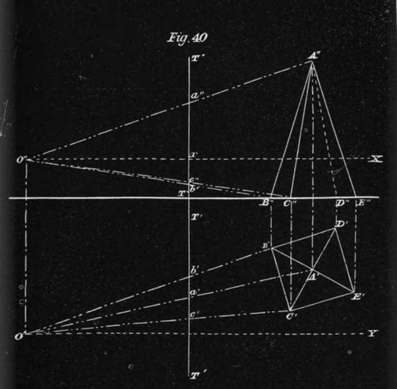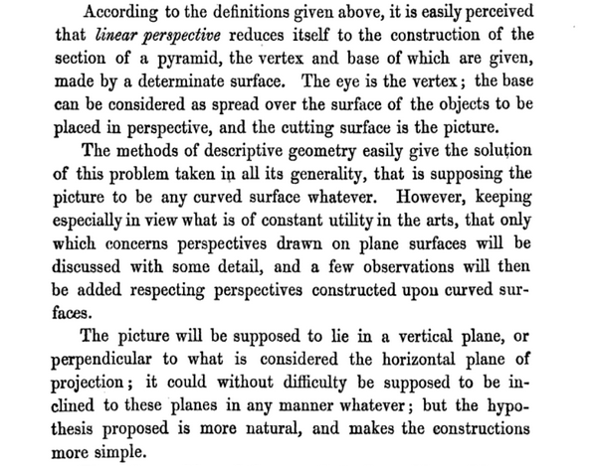

Figure 8. Heather’s illustration of problem 40, using descriptive geometry to demonstrate the principles of linear perspective.

Whilst it is interesting to see that descriptive geometry ‘proper’ did briefly made appearance in England, it soon again vanished too. But let us first see the last few attempts and variations on the theme of descriptive geometry in the programmes of study and textbooks from the final period in its English history.

## Third period: 1851-1864

In this period the interest in inventing a new system of graphical communication or graphical geometry was waning, but some alternatives were further explored. Hardman’s *A treatise on the Curvilinear Perspective of Nature* (Hardman, 1853) explained geometry behind the technique used for centuries by various artists (see for example the detail of the convex mirror in Jan van Eyck’s *Arnolfini Portrait* from 1434).

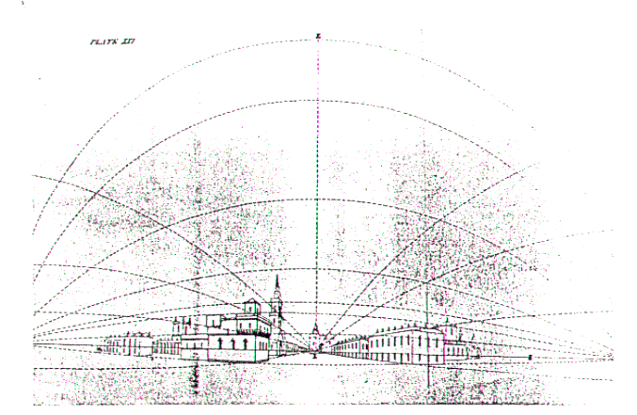

Figure 9. Hardman’s illustration of the principles behind curvilinear perspective (Hardman, 1853).

Various other treatises on descriptive geometry were published by professor of geometry William Binns, who taught at Putney College of Civil Engineers between 1846-51. Binns’ books at start have ‘descriptive geometry’ in titles, but slowly drop this in favour of ‘orthographic’ projection (Binns, 1857, 1860, 1864). His books followed Heather’s practice (Heather, 1849) of providing the illustrations in contrast (white on black), suggesting a pedagogical method, presumably to evoke images from the demonstrations on a blackboard. Further works by Bradley from this period did the same, and both incorporated Nicholson’s system as a simplified method and one which aimed to give a final picture of the object (Bradley, 1860, 1861).

### Summary of a life

Descriptive geometry had a short life in England. The simple, straightforward translations aimed at engineers, in particular those originating from Woolwich Military Academy and the King’s College London, came following the first treatises which attempted to adapt descriptive geometry, in the period between 1820 and 1840s. Whilst the Farish’s and Nicholson’s adaptations of old systems were interesting in their proposed use (and appeared throughout the 19th century as systems which were taught in engineering and art schools across England), the direct translations were more or less uninspired and not well received, and were never reprinted. From these came several further treatises by Binns and Bradley, mainly adopting Nicholson’s approach – being more orthographic projection treatises than descriptive geometry ‘proper’.

Nicholson’s system combines in a way the methods of both Monge’s and Farish’s systems. It makes use of the processes of *rabatting* (bringing a plane of interest into the plane of projection to gain the real measurements) and at the same time offers an easy way of constructing an image of the object, without necessarily referring to its construction (generation).

The system which was developed by Nicholson subsequently even gained the name of ‘British system of projection’ (Grattan-Guinness and Andersen, 1994). It became widely used in the schools of architecture and engineering that were established in the 19th century England, beginning from the ones in London at King’s (1828) and University College (1829).

## The wisdom of hindsight

### A Cunningham’s plan

William Cunningham (1868), in his paper on *Importance of Descriptive Geometry* in England did a comparison to its reception in France, Germany, and the UK. He concluded that the foci of national systems of education, and the perception of mathematics in relation to these, were most at fault for the technique never ‘catching on’ in England.

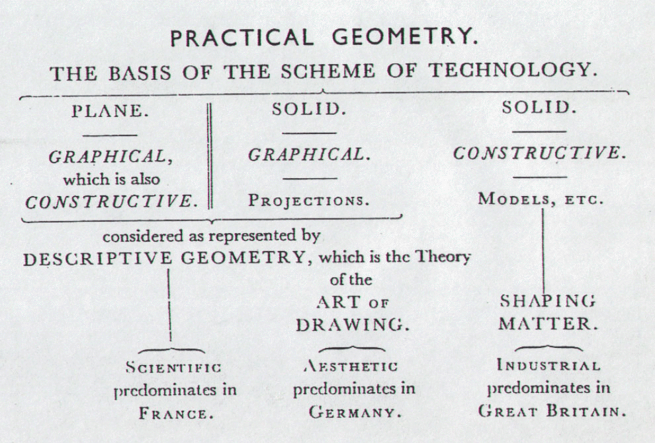

Figure 10. Plate from Cunningham’s *Notes on the History, Methods and Technological Importance of Descriptive Geometry* (1868) comparing the systems of graphical communication in France, Germany and Great Britain.

But furthermore, the author argued that not only were the teaching practices different in the three countries, but that this was a consequence of the general differing predispositions in the way that space is perceived and taught. While descriptive geometry could be used, as indeed it was in many countries and national systems as we see in this volume, for very practical purposes, its strength was in the underlying mathematical principles, and not in the way the picture of an object was presented. In England descriptive geometry had a short and not all together fulfilling life; its main mathematical features were overlooked, and its benefits for education were considered sometimes negligible and sometimes undesirable. Nicholson’s system was accepted as a method of solving practical geometrical problems in architecture and engineering, but gained no approval in relation to the fact that it can be applied to the learning and teaching of spatial mathematics, or as an introduction to projective geometry (Rogers, 1995: 401-412).

### Lost in translation

There was however, apart from the political context, another very important reason for descriptive geometry never being properly understood in England. It is the case of the lack of implicit knowledge: there was no one in England who had any personal experience of descriptive geometry as it was taught in France. The knowledge acquired seemed to have been entirely explicit, via a text or worse still, a translated text (Lawrence, 2010).

This can be shown on the example of misunderstanding the simple and important terms and translating them slightly differently from their original meaning. Cunningham (1849-1919), for example, who wrote *On the History and Importance of Descriptive Geometry* in 1868, found that the terms ‘plan and elevation’ are erroneous in the case of Descriptive Geometry. Cunningham was an economist and a churchman and is largely credited with establishing the economic history as a scholarly discipline in British universities. He was a professor of Economics from 1891 to 1897 at King's College London, where he became interested in the technique, mainly because of his interest in its application to industry. His most important and complete work is *The Growth of English Industry and Commerce* (1882).

Cunningham’s view was that

…it is impossible to express the co-ordinate relation of the two planes of projection in such terms as Plan and Elevation, which involve the special ideas - ‘horizontal’ and ‘vertical‘ (Cunningham, 1868: 25).

Instead, Cunningham suggested the use of word ‘rabatting’ which refers to pulling the plane of projection to the plane of drawing. The orientation of planes in descriptive geometry was immaterial; the mathematical task at hand was to understand the ways objects are generated, in order to enable the practitioner to execute particular graphical operations and then perhaps to discover the precise measurements of the finished object. In English texts this was never understood because the generating principle was never explained, and instead the method of rabatting was taken to be the main principle in order to gain a view of the object.

### To translate or not to translate

The word rabatting appeared for the first time in English language in Cunningham’s paper (1868). Cunningham explained what was lost in translation from the original meaning of the method of rabatting:

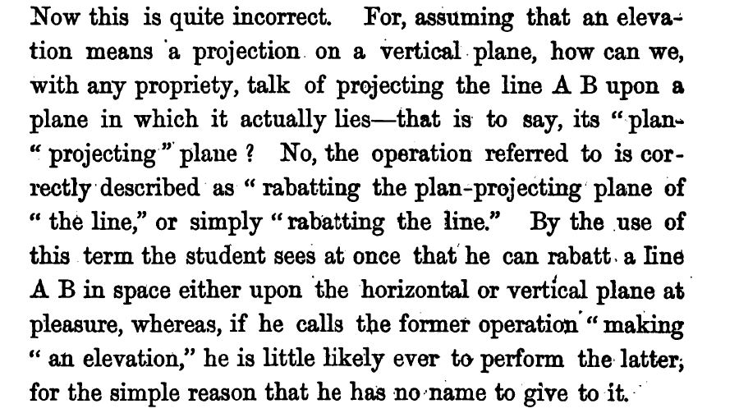

Figure 11. Cunningham’s use of the term ‘rabatting’ and phrase ‘to rabatt’ is its first occurrence in the English language and directly derived from the French.

But the term ‘rabatting’, and even the mathematical importance of descriptive geometry, had by the time Cunningham’s paper was published, become irrelevant in England. The technique had by then been cast aside as an abstract technique, the alternatives such as those of Farish and Nicholson, were much easier to use. Its purpose and real nature misunderstood, descriptive geometry waned in both importance and use, to completely disappear even as a passing reference, in the national educational system by the end of the 19th century.

The word rabatting is of little use today in English language, and if used, it is done almost exclusively in the literature relating to geometric manipulations of objects. As a curiosity, the author of this chapter noticed the first instance of the use of ‘rabatting’ in English language in Cunningham’s paper (1868) and alerted the Oxford English Dictionary to the fact.

## The missing link – the polytechnic school

The English did not follow the example of the polytechnic school either. There was an attempt to establish such institutions, one of which was partially successful – it was the London Polytechnic, founded in 1838. But this institution did not resemble the French model in any way. It was a small institution, giving evening lectures to mainly workmen who wanted to advance themselves and did not have the resources to study at the universities. There were also polytechnic societies formed around the country, of which was for example The Royal Cornwall Polytechnic Society (founded in Cornwall in 1832). The purpose of this society was to offer a place for discussion, and organize a library.

Polytechnic schools perhaps more like the original developed in England in the 1960s, with the rise of the Labour government, which supported their image and role in education. But by this time the many iterations of the polytechnic school model meant that the main similarity between the French original and the English iterations was in the title rather than any of the principles that may have been embedded as the foundation stones of Monge’s École Polytechnique. In the 1992 though, and with the Conservative government gaining a new mandate, most of the polytechnic schools in England were given university status and their names changed. With this the name polytechnic also disappeared as a school resembling the French original even in a minute detail, from the English educational landscape.

## Bibliography

Anderson, Kirsty. (1992). *Brook Taylor’s Work on Linear Perspective.* Springer.

Billingsley, William. (1570). *Euclid’s Elements. With a preface by John Dee.* London.

Binns, William. (1857). *An Elementary Treatise on Orthographic Projection; being a new method of teaching the science of mechanical and engineering drawing, etc*. E. & F. N. Spon: London.

Binns, William. (1860). *A Course of Geometrical Drawing, containing practical geometry, including the use of drawing instruments, etc*. John Weale: London.

Binns, William. (1864). *An Elementary Treatise on Orthographic Projection and Isometrical Drawing, etc*. Longman & Co.: London.

Binns, William. (1869). *A Course of Geometrical Drawing, containing practical geometry, including the use of drawing instruments, etc*. Simpkin & Marshall: London; John Heywood: Manchester.

Binns, William. (1869). *The Second Course of Orthographic Projection, etc*. E. & F. N. Spon: London.

Booker, Peter Jeffrey. (1961). Gaspard Monge, The Father of Descriptive Geometry and Founder of the Polytechnic School. Paper presented to the Newcomen Society for the Study of the History of Engineering and Technology on 1st November 1961. *The Engineering Designer*: London.

Booker, Peter Jeffrey. (1963). *A History of Engineering Drawing*. Chatto & Windus: London.

Bradley, Thomas. (1834). *Practical Geometry, Linear Perspective, and Projection, etc*. Baldwin & Cradock: London.

Bradley, Thomas. (1860). *Lecture On Practical Plane and Descriptive Geometry, mechanical and machine drawing, and building construction, etc*. G. E. Eyre & W. Spottiswoode: London.

Bradley, Thomas. (1861). *Elements of Geometrical Drawing or, Practical Geometry, Plane and Solid, including both orthographic and Perspective Projection*. Published for the Committee of Council on Education. Chapman and Hall: London.

Cassels, John William Scott. (1979). The Spitalfields Mathematical Society. Bulletin of the London Mathematical Society, 111:3, 241-258. London.

Cremona, Luigi. (1865). I principi della prospettiva lineare secondo Taylor. In *Giornale di Matematiche*, 3: 14, 338-343.

Clark, Peter. (2000). British Clubs and Societies 1580-1800: The Origins of an Associational World. Clarendon Press, Oxford.

Crozet, Claudius. (1821). *A Treatise on Descriptive Geometry, for the use of Cadets of the United States Military Academy*. A. T. Goodrich & Co.: New York.

Farish, William. (1820). Treatise on Isometrical Perspective. *The Transactions of the Cambridge Philosophical Society*, vol. i: Cambridge.

Fisher, Todd & Fremont-Barnes, Gregory. 2004. The Napoleonic Wars: The Rise and Fall of an Empire. Oxford: Osprey Publishing.

FWJ – Fog’s Weekly Journal. (1730). National Library of Scotland, Acc 7694.

Grattan-Guinness, Ivor and Andersen, Kirsty. (1994). Descriptive geometry. In Ivor Grattan-Guinness (ed.) Companion encyclopedia of the history and philosophy of the mathematical sciences , Routledge, London, New York, 887-896.

Guicciardini, Niccolo. (1989). The Development of Newtonian Calculus in Britain 1700-1900. Cambridge University Press.

Hall, Thomas Grainger. (1841). *The elements of Descriptive Geometry: chiefly intended for Students in Engineering*. J. W. Parker: London.

Hayward, James. (1829). *Elements of Geometry upon The Inductive Method to which is added An Instruction to Descriptive Geometry*. Hilliard and Brown, Cambridge.

Heather, John Fry. (1851). *Elementary Treatise on Descriptive Geometry with a Theory of Shadows and of Perspective. Extracted from the French of Gaspard Monge to which is added a description of the Principles and practice of Isometrical Projection the whole being intended as an introduction to the application of Descriptive Geometry to various branches of the Arts*. John Weale: London.

Herdman, William Gawin. (1853). *A treatise on the Curvilinear Perspective of Nature; and its applicability to art*. London, Liverpool, [printed].

Jones, P. S. (1950). *Brook Taylor and the Mathematical Theory of Linear Perspective*. Presented on 1st September, 1950 to Section VII of the International Congress of Mathematicians, Cambridge Massachusetts, US.

Jopling, Joseph. (1823). *The Septenary system of generating curves by continued motion, including sundry observations on the system, and on its application and utility in civil and naval architecture, sculpture, etc*. London.

Jopling, Joseph. (1833). *The Practice of Isometrical Perspective, etc*. London.

Jopling, Joseph. (1835). *Dr Brook Taylor’s Principles of Linear Perspective, etc.* London.

Knoop, Douglas. (1935). *On the connection between operative and speculative Freemasonry*. The Inaugural Address delivered to the Quatour Coronati Lodge, No 2076, on his Installation as Master. 8th November 1935. Sheffield.

Lambert, Johann Heinrich. (1759). *Perspective affranchie de l’embarras du plan geometrical*. Zürich.

Langley, Batty. (1727). *The Builder's Chest-Book; or, a Complete key to the five orders of columns in architecture, etc*. J. Wilcox: London.

Langley, Batty. (1735). *The Builder’s vade-mecum or a Compleat key to the Five Orders of Columns in Architecture.* London & Dublin.

Langley, Batty. (1736a). *A design for the Bridge at New Palace Yard, Westminster. ... With observations on the several designs published to this time, etc*. London.

Langley, Batty. (1736b). *Ancient Masonry, both in theory and practice ... Illustrated by ... examples engraved on ... copper plates, etc. 2 vol*. Printed for the Author: London.

Langley, Batty. (1738). *The Builder's Compleat Assistant, or a Library of Arts and Sciences, absolutely necessary to be understood by builders and workmen in general*. Richard Ware: London.

Langley, Batty. (1739). *The builder's chest-book; or, A complete key to the five orders in architecture ... The second edition, much improv'd. To which is added, Geometrical rules made easy for the use of mechanicks*. John Wilcox and James Hodges: London.

Langley, Batty. (1740). *The Builder's Complete Assistant; or, a Library of Arts and Sciences, absolutely necessary to be understood by builders and workmen in general*. 2 vol. Printed for I. and J. Taylor: London.

Langley, Batty. (1741). The Builder’s Jewel: or The Youth’s Instructor and Workman’s Rememberancer: Explaining Short and Easy Rules etc. London.

Langley, Batty. (1745). *The City and Country Builder's and Workman's Treasury of Designs: or, the Art of drawing and working the ornamental parts of architecture*. S. Harding: London.

Langley, Batty. (1747). *The Builder's Director, or Bench-Mate: being a pocket-treasury of the Grecian, Roman, and Gothic orders of architecture*. H. Piers: London.

Langley, Batty. (1748). *The London prices of Bricklayer's materials and works ... justly ascertained, etc*. London.

Langley, Batty. (1750). *The Builder's compleat Assistant; or, a Library of Arts and Sciences, ... necessary to be understood by builders and workmen in general*. 2 vols. London.

Lawrence, S. (2010) Alternatives to Teaching Space Teaching of Geometry in 19th century England and France. In Franco-British Interactions in Science Since the Seventeenth Century. R. Fox and B. Jolly (eds.) London: College Publications.

Lawrence, Snezana & McCartney, Mark. 2015. Mathematicians and Their Gods. Oxford University Press, Oxford.

Lawrence, Snezana. (2002). Geometry of Architecture and Freemasonry in 19th century Englad. PhD Thesis presented to Open University, UK.

Lawrence, Snezana. (2011). Developable surfaces, their history and application. *Nexus Network Journal*, 13 (3). pp. 701-714. Springer.

Loria, Gino. (1908). Perspektive und darstellende Geometrie. In Moritz Cantor, *Vorlesungen über Geschichte der Mathematick*. Vol 4, pp. 577-637. Leipzig.

Moxon, Joseph. (1700). Mathematicks made easie, or A mathematical dictionary explaining the tersm of art and difficult phrases used in arithmetic, geometry, astronomy, astrology, and other mathematical sciences. London.

Moxon, Joseph. (1703). Mechanick Exercises or Doctrine of handy-works (shewing how to draw a true Sun-Dyal on any given Plane, however Scituated; only with the help of a straight Ruler and a pair of Compasses, and without any Arithemtical Calculation). London, printed at St Paul’s Church Yard.

Nicholson, Peter. (1820). *A Treatise on the Construction of Staircases and Handrails, ... preceded by some necessary problems in practical geometry*. London.

Nicholson, Peter. (1795). *The student's instructor in drawing and working the five orders of architecture*. I. & J. Taylor: London.

Nicholson, Peter. (1810). *The carpenter and joiner's assistant;. containing practical rules for making all kinds of joints, and various methods of hingeing them together; .... to which are added, examples of various roofs executed ... also extracts from M. Belidor, M. du Hamel, M. de Buffon, &c. on the strength of timber, with practical observations*. J. Taylor, at the Architectural Library: London.

Nicholson, Peter. (1812). *Mechanical Exercises; or, the Elements and practice of carpentry, joinery, bricklaying, masonry, slating, plastering, painting, smithing and turning. Containing a full description of the tools belonging to each branch of business ... With an explanation of the terms used in each art; and an introduction to practical geometry*. J. Taylor: London.

Nicholson, Peter. (1815). *A Treatise on Practical Perspective, without the use of vanishing points; being an application of the Centrolinead to Perspective, with a general description of that instrument*. London.

Nicholson, Peter. (1818). *Essays on the Combinatorial Analysis; shewing its application to some of the most useful and interesting problems of Algebra, ... and clearly indicating the Law of Expansion, and the simple ... processes from which the resulting series may be obtained by finding any one term independently of the rest*. London.

Nicholson, Peter. (1819). *An Architectural Dictionary, containing a correct nomenclature and derivations of the terms employed by architects, builders and workmen ... and the lives of the principal architects, etc*. 2 vols. London.

Nicholson, Peter. (1820). *Essay on Involution and Evolution; containing a new ... method of ascertaining the numerical value of any function of an unknown quantity; particularly applied to the operation of extracting the roots of equations, pure or affected, according to a process entirely arithmetical ... Together with an Appendix, shewing the use of figurate numbers and arithmetical equivalents in the extraction of roots, etc*. London.

Nicholson, Peter. (1822). *The Rudiments of Practical Perspective, in which the representation of objects is described by two easy methods, one depending on the plan of the object, the other on its dimensions and position*. London, Oxford [printed].

Nicholson, Peter. (1823-25). *The New Practical Builder, and Workman's Companion: containing a full display ... of the ... method pursued by Architects and Artificers, in the ... departments of Carpentry, Joinery, ... Plastering, etc*. London.

Nicholson, Peter. (1823). *A practical treatise on the art of masonry and stonecutting*. M. Taylor: London.

Nicholson, Peter. (1826). *The Carpenter and Builder's Complete Measurer. Intended as a sequel to the “Carpenter's Guide.” A practical Treatise on Mensuration*. London.

Nicholson, Peter. (1828). *The School of Architecture and Engineering; illustrated by numerous copper-plate engravings, etc. [Part I.]* London.

Nicholson, Peter. (1833). *A Treatise on Dialling, comprising the delineation of sun dials in every position to the plane of the horizon, etc*. Printed for the Author: Newcastle.

Nicholson, Peter. (1840). *A Treatise on Projection*. R. Groombridge: London, [Newcastle printed].

Sakarovitch Jőel. (1997). Epures D'architecture. Birkhäuser Verlag AG.

Sopwith, T. A. (1834). *A Treatise on Isometrical Drawing as applicable to Geological and minning plans, pictoresque delineations of Ornamental Grounds Perspective Views and Working plans of Buildings and Machinery and to general purposes of Civil Engineering*. Taylor's Architectural Library; John Weale: London.

Sopwith, Thomas. (1854). *On Models and Diagrams. In London.-III.-Royal Society for the Encouragement of Arts, Manufactures and Commerce*. Lectures in connection with the Educational Exhibition of the Society of Arts, etc. London.

Taylor, Brook. (1712). De Inventione Centri Oscillationis- Per Brook Taylor Armig. Regal. Societat. Sodal. In *Phil. Trans*. 28: 11-21.

Taylor, Brook. (1715). *On the Principles of Linear Perspective*. London.

Taylor, Brook. (1719). *New Principles of Linear Perspective.* London.

Wooley, Joseph. (1850). *The Elements of Descriptive Geometry; being the first part of a treatise on descriptive geometry, and its application to ship building, etc*. London.