Airborne Particulate Matter and Diesel Vehicles in Cities - changing perspectives
David J. BALL and John WATT

Centre for Decision Analysis and Risk Management (DARM), Middlesex University, School of Science and Technology, London NW4 4BT, UK.
email: D.Ball@mdx.ac.uk, J.Watt@mdx.ac.uk

Abstract: The last half Century has seen a dramatic turnaround in attitudes to atmospheric particulate emissions including those from diesel-engined road vehicles. In the 1960s it was believed that diesel emissions, then referred to as 'smoke,' were no more than a nuisance in that they obscured visibility and / or appeared unsightly. In 2016 they are seen as contributing significantly to mortality risk in urban areas. This paper traces the evolution of thinking over that time period using London as a case study. It is apparent that there has at times, and for a variety of reasons, been resistance to new knowledge and a reluctance to move on, even though it was for the common good that that be done. Similar contests can be observed with respect to other hazards to which urban inhabitants are exposed.

Keywords: Air pollution, diesel engines, cities, particulate matter
1. Introduction
According to a February 2016 news report (British Broadcasting Corportation, 2016) from the annual meeting of the American Association for the Advancement of Science, Michael Brauer, from the University of British Columbia in Canada, has said that the statistics of the World Health Organisation's (WHO) Global Burden of Disease Project (WHO, 2016) on the health impacts of air pollution should make governments think hard about the scope of their anti-pollution policies, and spur greater ambition. According to this research more than 5.5 million people worldwide are dying prematurely every year because of air pollution, mostly in rapidly developing countries, with air pollution being the fourth greatest risk preceded only by high blood pressure, dietary risks and smoking. The main culprit is identified as the emission of small particles from power plants, factories and vehicles which accounted for 2.9 million attributable deaths in 2013 (Forouzanfar et al., 2015). As Brauer has been reported as saying (emphasis added):
"The trick here is to not take the 50 or 60 years that it took in the high income countries, and to really accelerate the process; and that's really where we think these statistics, the data, will come in handy" he told BBC News." (BBC, 2016)

This issue of fine particulate matter (PM) is not confined to rapidly developing countries. It has also existed, and continues to exist, in developed countries especially in their urban areas. For example, Figure 1 shows a map of PM₁₀ concentrations in London (GLA, 2010). Although there are few exceedances of Air Quality Guidelines for PM in London the WHO has said there is no evidence of a safe level of exposure or a threshold below which adverse health effects do not occur. Further, more than 80% of the population in the European Union live in cities with levels of PM exceeding WHO Air Quality Guidelines designed to safeguard public health. Thus, they say, pollution from PM creates a substantial burden of disease, reducing

Figure 1 - Modelled PM₁₀: annual average concentrations (μg/m³) for the year 2008 (GLA, 2010)

life expectancy by almost 9 months on average in Europe. Since even at relatively low concentrations the burden of air pollution on health is significant, WHO has concluded that effective management of air quality which aims to achieve WHO Air Quality Guidelines levels is necessary to reduce health risks to a minimum (WHO, 2013). Recent research adds that even in London, where air quality generally meets the guidelines, there were an estimated 52,630 life-years lost in 2010 due to exposure to PM_{2.5}, equivalent to over 3,500 deaths (Walton et al., 2015) and that the annual economic costs of health impacts of air pollution ranged from £1.4 billion to £3.7 billion. Walton et al. (2013) also report that road transport is the main source of PM_{2.5} emissions in London, and contributed around 80 per cent in 2008, the remaining 20 per cent coming from non-transport emissions. LGVs (light goods vehicles), cars and taxis each contributed around 20 per cent of PM_{2.5} emissions in central London in 2008, whilst buses contributed about five per cent.
Following on from Brauer's assertion that the trick is to move thIngs on quickly, a pertinent question is to ask why it has taken so long to formulate progressive policies on PM in high income countries.

2. Early history

In the beginning, which, for the purposes of this paper, we take to be the 1960s, motorists were more familiar with petrol-engined vehicles than diesels. It was nonetheless said at the time that of all the pollutants emitted by road vehicles, that which caused most public concern was smoke from diesel engines (Reed, 1966). This led then British government departments, in collaboration with the British Motor Industry Research Association (MIRA), to carry out a series of tests on diesel vehicles and from that to devise a new British Standard setting smoke emission limits.
Figure 2 shows the test actually being carried out in 1963. As described by Dodd and Reed (1964), the basis of the test was that what counted for the public was the visual appearance of the smoke at the exhaust pipe, and the panel of observers in Figure 2 were simply required to decide if the level of smoke emitted by a range of vehicles driven past them was acceptable or not to them personally.
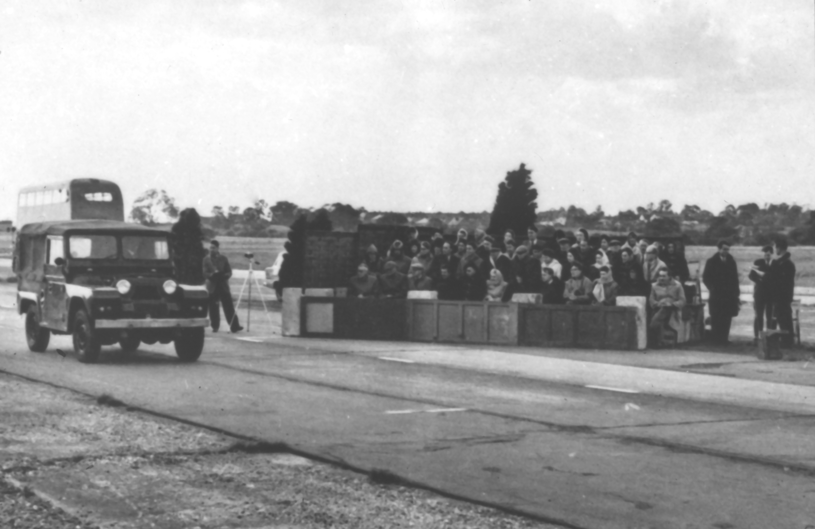

Figure 2 - Panel observing smoke emissions from a selection of diesel vehicles

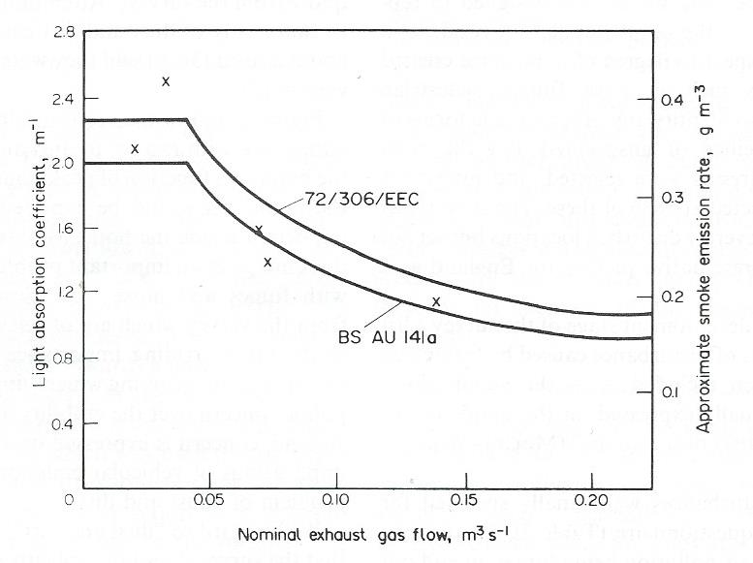
Figure 3 - British and European limit values for diesel exhaust gas opacity (circa 1971 / 1972)

Subsequently, a British Standard (BS AU 141a) was formulated for smoke emissions from diesel vehicles as shown in Figure 3 (BSI, 1971). The Standard was set at a level for which the smoke emissions were acceptable to 50% of the observers on the panel. This was soon after superceded by a European Standard (72/306/EEC) as also shown on Figure 3. The European Standard (EC, 1972) was marginally less stringent than the British one, implying that even were the basis of the test plausible, it would not even satisfy half of observers. Thus, it was the official view at that time that all that counted was visibility and that there were no significant health or environmental issues. As summarised by Vulliamy: "... visibility , rather than soot content is the criterion for the objection to smoke emission." (Vulliamy, 1973)
The foundations of this widely-held believe are barely documented and largely unknown. However, in those days air pollution control was split between different government ministries depending upon source. Road traffic emissions came under the then Ministry of Transport whose view of road traffic emissions was as follows:
"Air pollution from road traffic is important mainly in the effects (possibly temporary) it can have on the well-being of road users and in particular to its possible effects on the health and behaviour of road users." (Sherwood and Bowers, 1970)
Conversely, at that time, numerous traffic management schemes were being implemented in London and these often included public opinion surveys. A review of these surveys found that the public were unconcerned about the visibility of emissions. The two things which did concern them were perceived health effects associated with an invisible component of vehicle emissions, and secondly, the soiling of materials which was attributed by them to the deposition of PM, described as 'dust,' 'dirt,' or 'grime' (Ball and Caswell, 1983).
The public, it would seem, were ahead of the game. Why the dichotomy came about is unknown. What is known is that London's air quality had for centuries been dominated by smoke emissions from first wood and then coal burning, and that this had caused terrible smog episodes right through until the 1950s (Brimblecombe, 1987). With the dramatic improvement in air quality following the demise of the smogs (Auliciems, A. and Burton, I., 1973), there persisted a view that the problem was solved and failing that that: “pollution was considered a part of British life” (The Lancet, 2008). The latter quote originates from an eminent epidemiologist of the day, Professor Pat Lawther. Lawther was at times an advocate for further air pollution control but not always so. On occasion he apparently regarded the air quality of the 1970s as so good, presumably in comparison with the London smogs with which he was familiar, that nothing much needed further action. His influence was powerful. There was also a slowness in government to recognise the growing dominance of motor vehicles as a source of air pollution. For example, a 1977 study which found diesel-engined road vehicles to be the primary source of smoke in London's air (Ball and Hume, 1977), was initially treated with disbelief.
3. Pressure for change
During the 1950s and 60s in the USA, various federal, state and local governments conducted studies into the sources of air pollution and ultimately attributed a significant portion to the automobile. At that time, such minimal emission control regulations as existed in the USA were promulgated at the municipal or, occasionally, the state level. The ineffective local regulations were gradually supplanted by more comprehensive state and federal regulations. By 1967 the State of California created the California Air Resources Board (CARB), and in 1970, the federal US Environmental Protection Agency (EPA) was established. Both agencies, as well as other state agencies, were active in creating and enforcing emission control regulations for automobiles. Although similar agencies and regulations were contemporaneously developed and implemented in Canada, western Europe, Australia and Japan, the situation in California was likely to have been prompted by the prominent issue of photochemically generated pollution in the Los Angeles basin.
Concern in the UK, other than over the contentious issue of lead additives in petrol (Landrigen, 2002), developed more slowly. For example, the Royal Commission on Environmental Pollution (RCEP) identified the following concerns with respect to diesel emissions in its Fifteenth Report published in 1991:
human health
- carcinogenesis of chemicals associated with particulate matter in diesel exhausts;
- respiratory conditions associated with nitrogen dioxide and ozone;
- irritant effects of unburnt hydrocarbons.
natural and built environment
- the effect of the public perception of visible diesel exhausts on amenity;
- soiling and structural damage of the built environment;
- effects of ozone, nitrogen oxides, particulate matter and polycyclic aromatic hydrocarbons on vegetation and possible contamination of foodstuffs (RCEP, 1997)
Interestingly, the RCEP had pinpointed some possible health consequences of PM emissions and building damage, as well as retaining notions of the perceptual issue of visible emissions. By the time of the Eighteenth Report in 1997, however, evidence was beginning to emerge, principally from studies in the USA, about the effects of exposure to airborne particulates on incidence of illness (hospital admissions) and mortality rates from respiratory and cardiovascular diseases, and this new Report expressed concern that emissions from road vehicles might be causing serious damage to human health and concluded there was a clear case for increasing the precautionary action taken to improve air quality, especially by reducing concentrations of particulates and nitrogen oxides (RCEP, 1997).
Gradually this issue of motor vehicle emissions has been picked up in Europe. Thus, European rules affecting exhaust emissions from cars first came into force in 1970 and have been tightened up progressively ever since. After the first standard in 1970 the next big change came in 1992 with the introduction of the Euro 1 standard. This heralded the compulsory fitting of catalytic converters to petrol cars to reduce carbon monoxide emissions. So far as particulate emission limits are concerned these are set out in Table 1 (AA, 2016; DieselNet, 2016). It can be seen that emission limits are now based on mass of particulate emitted and not visibility, and that the limits are by now thirty or so times lower than they were in the early 1990s. Despite this considerable improvement health effects must still be expected as there is no known threshold for effects. As the GLA has said:

"In spite of these measures and the improvements in recent years that have already been seen, transport in London remains the most significant source of air pollutant emissions, contributing substantially to the overall concentrations of air pollution and adversely affecting public health. Consequently, further reductions in air pollutant emissions from transport are needed. While action to reduce transport emissions alone cannot remove the causes of poor air quality in London, it can play an important role in working towards the achievement of the EU limit values and delivering health benefits for Londoners." (GLA 2010: p49)

Table 1 - Euro diesel particulate emission limits
Euro Standard | Date | Diesel cars (g/km) | Heavy duty diesels (g/kWh)
1 | 1992 | 0.14 | 0.36
2 | 1996 | 0.08 | 0.25 / 0.15
3 | 2000 | 0.05 | 0.10
4 | 2005 | 0.025 | 0.02
5 | 2009 | 0.005 | 0.02
6 | 2014 | 0.005 | 0.01

4. The environmental dimension
As noted earlier, the public were also concerned about the soiling effects of diesel emissions, and again they were right. Air pollution has two main effects on materials – corrosion and soiling, and particulate matter plays a role in both. The main effects on three important urban building materials are:
Stone
- surface erosion and loss of detail
- soiling and blackening
- biological colonisation
- formation of ‘crust’
Metals
- surface corrosion
- development of a stable patina
- pitting and perforation
- deterioration / loss of coating (paint, galvanising, etc.)
Glass
- corrosion of medieval potash glass
- soiling of modern soda glass

Figure 3 Weathering and soiling of carving
As Figure 3 demonstrates, these actions can be complexly interwoven. Material is chemically attacked by reactive compounds present in the surrounding environment (or produced by biological agents, the effects of which complicate the picture as they may act synergistically with atmospheric pollution). There was a dramatic fall in sulphur dioxide and particulate matter associated with industrial and domestic coal burning following the UK Clean Air Acts in the 1950s and similar policy action throughout the world. For building damage (and acid rain damage to ecosystems) this probably contributed to the sense that the problem was solved. Indeed cities across Europe have embarked on ambitious cleaning programmes that would never have been contemplated when the pollution levels were so high.
Soiling is a visual effect - the darkening of exposed surfaces due to air pollution as a result of the deposition and accumulation of atmospheric particles (Watt, 2009). Deposition, removal and accumulation processes are numerous and complex, depending on the physical and chemical properties of the particles, the nature of the surface, the local meteorology and the pathways followed by rainwater after it hits the building surface. As a result of these complex interactions, there can be substantial variations in the level of soiling observed on building surfaces.
The extent to which soiling damage is regarded as a bad thing is in itself variable. Some people like the ‘patina of history’ on ancient monuments and dislike recently cleaned buildings, especially where poorly planned interventions cause a patchwork to develop. The nuisance caused by the soiling thus depends on the response of the observer (Grossi & Brimblecombe, 2004; Brimblecombe & Grossi, 2005), who used on-site questionnaires and found a clear relationship between opinions about the dirtiness of a building and desirability of cleaning. There was some indication that people particularly disliked streaky patterns of soiling (which is relatively common on limestones, since flowing acid water will continuously expose a fresh white surface in marked contrast with the soiled building in more sheltered areas (Figure 3).
Estimating the effect of PM on soiling is not easy (Watt et al, 2008) since the black crusts are both a chemical corrosion effect and a blackening effect. The term ‘soiling’ can be used to describe the accumulation of particulate matter on a non-reactive surface and this accumulation can be re-moved by washing; crusts are taken to mean a compact surface layer with different chemical composition from the original material, formed by chemical weathering. Gypsum crusts are the most common type of growth found on building surfaces and are formed on calcareous stones following SO₂ deposition to the surface in the presence of moisture, followed by the dissolution of calcite and the precipitation of gypsum. The black colour of gypsum crusts is the result of the accumulation of particulate matter within the crust (Del Monte et al., 1981, Saiz Jiminez, 1993). They periodically fall off, which makes modelling difficult. Scientific study of soiling rates on inert materials have shown that soiling continues to be a problem in heavily trafficked cities and that diesel emissions are largely to blame. Such modern emissions are actually darker than the original ‘black smoke’ that was used in the original measurement of atmospheric particulate.
5. Conclusions
There has been a background of public concern about diesel particulate emissions since the 1960s and possibly earlier still. It has taken half a century or more to get to grips with this problem, as noted by Brauer (BBC, 2016). The length of time taken to bring about change, even in regard to health issues, has been noted by other authors. Wilson and Horrocks (2008) report how it took over two decades to achieve the removal of leaded gasoline in New Zealand despite international evidence and original research conducted in New Zealand itself on the harm to child cognitive function and behaviour from lead exposure. They posit a number of reasons including: industry power and lobbying; failure to apply the precautionary principle; and weak policymaking machinery based on poor use of health research evidence, lack of competent personnel, and separation of responsibility among government departments.
We believe that several of these reasons also applied in the UK situation. However, the UK also got off to a bad start with its notion that there were no health effects attributable to PM and that all that mattered to the public was the visual impact of unsightly smoke. The apparent lack of concern about health may have been because of residual ideas about the inevitability of pollution in an industrial society as exemplified by “pollution was considered a part of British life,” and by the fact that for centuries London and other cities had been shrouded in smog which had finally been eliminated. Nonetheless, there was certainly a slowness of response during the 1970s to 1990s to scientific evidence on sources and effects of pollution, and some of this was likely down to entrenched ways of thinking and a failure to look at the situation in a holistic way.

References

Automobile Association (2016) Euro emissions standards - Progressively tighter exhaust emissions limits to improve air quality and health, https://www.theaa.com/motoring_advice/fuels-and-environment/euro-emissions-standards.html , accessed 16 February 2016.
Auliciems, A. and Burton, I. (1973) Trends in smoke concentrations before and after the Clean Air Act of 1956. Atmospheric Environment, 7(11), 1063-70.
Ball, D. J. and Hume, R. (1977) The relative importance of vehicular and domestic emissions of dark smoke in Greater london in the mid-1970s. Atmospheric Environment, 11, 1063-1073.
Ball, D. J. and Caswell, R. (1983) Smoke from diesel-engined road vehicles: An investigation into the basis of British and European emission standards. Atmospheric Environment, 17(1), 169-181.
Brimblecombe, P. (1987). The big smoke: A history of air pollution since medieval times. Routledge.
Brimblecombe, P. and Grossi, C. M. (2005) Aesthetic thresholds and blackening os stone buildings. Sci. Total Env. 349, 175 – 198.
British Broadcasting Corporation (2016). http://www.bbc.co.uk/news/science-environment-35568249
British Standards Institution (1971). The performance of diesel engines for road vehicles. BS AU 141a, BSI, London.
Del Monte, M., Sabbioni, C. and Vittori, O. (1981). Airborne carbon particles and marble deterioration, Atmos. Env. 16, 2253 - 2257.
DieselNet (2016). Heavy-duty truck and bus engines - regulatory framework. https://www.dieselnet.com/standards/eu/hd.php , accessed 16 February 2016.
Dodd, A. E. and Reed, L. E. (1964). The relationship between subjective assessment and objective measurement of exhaust smoke from diesel-engined road vehicles. MIRA report No. 1964/12.

Dockery, D. W., Arden Pope, C., Xu, X., Spengler, J. D., Ware, J. H., Fay, M. E., Ferris, B. G. and Speizer, F. E. (1993) An Association between Air Pollution and Mortality in Six U.S. Cities, N. Engl. J. Med. 1993; 329: 1753-1759. DOI: 10.1056/NEJM199312093292401
European Community (1972). Council Directive No. 72/306/EEC relating to measures to be taken against the emission of pollutants from diesel engines for use in vehicles. J. Eur. Communities, L42, 889-909.
Forouzanfar, M. H. et al. (2015). Global burden of disease study. The Lancet, 386, No. 10010, 2287-2323.
Greater London Authority (2010). Clearing the air, https://www.london.gov.uk/sites/default/files/air_quality_strategy_v3.pdf , accessed 13 February 2016.
Grossi, C. M. and Brimblecombe, P. (2004). Aesthetics of simulated soiling patters on architecture. Environ. Sci. Technol. 3971 – 3976.
Landrigen, P. J. (2002). The worldwide problem of lead in petrol. Bulletin of the World Health Organization 2002, 80 (10) 768.
Sherwood, P. T. and Bowers, P. H. (1970). Air pollution from road traffic - a review of the present position. Ministry of Transport Report No. LR352.
Reed, L. E. (1966). Vehicle exhausts in relation to public health. Paper to Royal Society of Health, London.
Royal Commission on Environmental Pollution (1997) Memorandum by the Royal Commission on Environmental Pollution (AQ 01), http://www.publications.parliament.uk/pa/cm199798/cmselect/cmenvtra/356-i-ii/356i02.htm , accessed 15 February 2016.
Saiz Jiminez, C. (1993). Deposition of airborne organic pollutants on historic buildings, Atmos. Env. 27B, 239 - 251
The Lancet (2008). Patrick Lawther obituary. The Lancet, 372, p624.
Vulliamy, N. M. F. (1973). Why diesels smoke - how may it be abated? Clean Air Spring seminar. National Society for Clean Air, Brighton.
Walton, H., Dajnak, D., Beevers, S., Williams, M., Watkiss, P. and Hunt, A. (2015). Understanding the health impacts of air pollution in London. Environmental research Group, King's College London. https://www.london.gov.uk/sites/default/files/HIAinLondon_KingsReport_14072015_final_0.pdf , accessed 13 February 2016.
Watt, J., Hamilton, R., Lefèvre, R-A. and Ionescu, A. (2009) Soiling. In Watt, J., Tidblad, J., Kucera, V. and Hamilton, R. (2009) The Effects of Air Pollution on Cultural Heritage, Springer pp105-126.
Watt. J., Jarrett, D. and Hamilton, R. (2008) Dose-Response functions for the soiling of materials due to air pollution exposure. Sci. Total. Env. 400.
Wilson, N. and Horrocks, J. (2008) Lessons from the removal of lead from gasoline for controlling other environmental pollutants: A case study from New Zealand. Environmental Health, 7:1. DOI: 10.1186/1476-069X-7-1 http://ehjournal.biomedcentral.com/articles/10.1186/1476-069X-7-1 , accessed 16 February 2016.
WHO (2016). Global Burden of Disease Project, http://www.who.int/topics/global_burden_of_disease/en/ , accessed 13 February 2016.

PM₁₀ refers to particles with a median of 10 micrometers in aerodynamic diameter, which are so small that they can penetrate into the lungs, potentially causing health problems. PM2.5 likewise refers to even smaller and more damaging particles of < 2.5 micrometers.
In those days PM was referred to as 'smoke.'
Especially the Harvard six cities study which found associations between particulate air pollution and daily mortality rates (Dockery et al., 1993).

