Supporting the Externalisation of Thinking in Criminal Intelligence Analysis

Peter J. Passmore, Simon Attfield, Neesha Kodagoda, Celeste Groenewald, B.L. William Wong
Interaction Design Centre
Middlesex University
London UK
{p.passmore|s.attfield| n.kodagoda|c.groenewald|w.wong}@mdx.ac.uk

Abstract— At the end of the criminal intelligence analysis process there are relatively well established and understood approaches to explicit externalisation and representation of thought that include theories of argumentation, narrative and hybrid approaches that include both of these. However the focus of this paper is on the little understood area of how to support users in the process of arriving at such representations from an initial starting point where little is given. The work is based on theoretical considerations and some initial studies with end users. In focusing on process we discuss the requirements of fluidity and rigor and how to gain traction in investigations, the processes of thinking involved including abductive, deductive and inductive reasoning, how users may use thematic sorting in early stages of investigation and how tactile reasoning may be used to externalize and facilitate reasoning in a productive way. In the conclusion section we discuss the issues raised in this work and directions for future work.

Keywords—externalisation of thinking; argument; narrative; thematic sorting; criminal intelligence

Context
VALCRI (Visual AnaLytics for sensemaking in Criminal Intelligence Analysis) is a large scale integrating project funded by the European Community under the FP7 Security Programme. The project spans forty-four months with a budget of ~€13M and the consortium comprises seventeen partners from the EU and one from the US. The project aims to create an advanced visual analytics reasoning and sensemaking system to support criminal intelligence analysis. This involves the development and integration of state-of-the-art technology that will include sophisticated user interfaces for techniques such as spatio-temporal analysis and semi-automated semantic knowledge extraction. The project will develop an analyst user interface that allows direct manipulation of information objects in an intuitive way, coupled with a reasoning workspace that allows analysts to exploit data in large data sets. The reasoning workspace is broken down into a data space that allows the analyst to see and understand the data they have, an analysis space that provides direct manipulation functions to act on the data, and a hypothesis space to provide an area to develop and assemble chains of evidence into narratives and arguments. Thus central to the VALCRI system is the need to represent and externalise the analyst’s thinking, from initial stages where there is little information available and the way forward unclear, to the final stages of investigations where there may be much clearer understanding of emerging narrative and supporting argument. In this paper we begin by considering the state-of-the-art in the representation of ‘well-formed’ criminal investigations, by which we mean investigations in their later stages, and then consider the issue of supporting investigators in moving towards these.

Support for the later stages of analytic reasoning
In this section we consider literature related to evidential structuring and reasoning. We focus in particular on two kinds of structuring which we expect will provide value to VALCRI: argumentation and narrative. We see these two kinds of information structuring as particularly relevant to investigations at an operation level, and it is here that we intend to have our primary focus. This is not to exclude narrative as a consideration for volume crime analysis, particularly when narrative is taken as a coherent model or explanation. We will review the application of this context as well.
Argumentation and narrative represent different ways of structuring information, which may be helpful and important for users. There are other kinds of structuring which may also be important, but for reasons of scope we limit our interest to these for the time being. This may be developed subject to the needs and direction of the project.
Information structuring involves the segmentation of information into more or less well specified units (e.g. propositions, event descriptions, pages, documents) and linking them in terms of more or less well-specified relations (e.g. is_related_to, implies, happened_after, happened_before etc). All external representations necessarily adopt some representational convention, however loosely considered or defined. There are however many conventions for the kinds of entities and relations that may be adopted for external representational languages. For example, Blandford, Faisal and Attfield 2013 [1] propose six types: spatial, sequential (including temporal sequence), networks, hierarchical, argumentation structures and faceted. To this list we might add classification, the principle underpinning thematic sorting.
Looking at research into different representational conventions one might be forgiven for thinking that for a given user task only one form is useful. Perhaps for reasons of focus, researchers tend to consider a single convention in isolation. To anticipate our conclusions slightly, it is unlikely that this represents the optimal approach. Tools which focus on one kind of relation may be less useful than tools that take a more hybrid approach. Nevertheless, the research context invites us to consider different approaches separately, at least at the outset, and so we begin by considering argumentation and narrative separately, and ultimately hybrid schemes which may combine representational forms.

Argumentation
Argumentation is a form of structuring that relates propositions or ideas through operators that make inferential relationships explicit. Although the propositions reference the domain under investigation, the relations reference the implications that an investigator may believe can be sustained concerning that domain. Hence, argumentation references both the domain under investigation and the logic underlying the investigator’s reasoning.
The visual representation of argument has a long history and a number of schemes have been offered. In the early twentieth century, Wigmore developed a visual language for representing arguments in legal cases [2]. Wigmore’s diagrammatic convention represents competing arguments within an adversarial legal setting. It uses a graph-style notation known as Wigmore Charts in which the lowest-level primitive is the evidential proposition or statement. These are laid out in relations indicating inferential support. Wigmore diagrams include conventions for visually encoding aspects of competing arguments which may be important to a legal mind trying to evaluate their relative merit. For example, evidence is coded as to whether it is testimonial (stated by a witness), circumstantial (requires inference), explanatory (reduces impact of evidence) or corroborative (supports evidence). The side who offers the evidence (prosecution or defence) is also encoded. Wigmore Charts also represent the perceived strength of argument premises and of the argument as a whole.
Toulmin presented a general purpose diagrammatic convention for the representation of everyday arguments [3]. Toulmin’s starting point was the idea that everyday persuasive arguments rarely correspond to classical models of inference, such as the syllogism. In Toulmin’s scheme there are three main parts: a claim (i.e. the conclusion); data (evidential support for the claim); and a warrant (a generalised rule on which a link between claim and evidence depends). There are also three supporting elements: backing (providing support for the warrant); a rebuttal (challenging the generalizability of the warrant); and a qualifier (e.g. ‘definitely’, ‘probably’ or ‘presumably’ which, expresses a level of confidence in the claim mainly as a result of the rebuttal. In complex arguments, there may be several layers like this connected together.
Notably, in everyday arguments warrants (and also backing for the warrant) are essential and yet are frequently implicit. For example, DNA evidence (data) and a conclusion drawn from that evidence (claim) necessarily depends upon a generalised rule about how evidence of that kind can be interpreted. Such rules are essential to arguments and yet are often not stated. The fact that they are not stated, may be a question of assumed common ground, but an advantage of making them explicit, of course, is that they are then more open to considerations of accuracy, relevance and support for the inferential move.
Allen [4] offers a direct and modern implementation of Wigmore Charts, by concentrating on the foundational elements of logical evidence as used in a Court of Law. Like Wigmore, evidence is divided into testimonies (verbal or written accounts reported by a witness), and real evidence. The approach also represents generalizations which play the role or warrants. Real evidence is those items that are physical and that can be seen and handled by the jury, such as a piece of cloth or the alleged murder weapon. Generalizations are the considerations we have about the way things are in life - this can be either an understanding or a belief.
These elements are represented in a hierarchical chart similar to that of Wigmore, culminating in the main argument, which is a classification of guilty or not guilty. This in itself, however, does not easily represent the impact of each element on the totality of the argument. The likelihood of a premise (as logical evidence) is therefore further expressed on a separate relevance scale of 1 to -1. The evidence gathered from each side (prosecution and defence) is plotted against this scale according to how relevant it is to an argument. If it supports the argument, then the evidence is plotted on the positive axis of the scale. If it contradicts or weakens the argument, then it is plotted on the negative axis. This makes it easy to spot which pieces of evidence can enhance an argument overall and which pieces of evidence may be helpful to opposing side.
Allen also argues for considering the weight of evidence alongside relevance. The foundational evidence (testimonies, real evidence and generalizations) are weighted differently e.g. a testimony from a witness is regarded as having less weight than the testimony of an expert witness. Weights and relevance then combine to indicate how strong an argument may appear to a jury. However, this is further influenced with how well the prosecution or defence can present the “story” that the evidence is conveying (a point we return to later). Wigmore therefore still has a strong presence within the legal domain as seen within Allen’s representation.
We end this section with a point about representational schemes in general and choices that there may be between usability, utility and scope. This is not specific to argumentation, although argumentation does provides case in point. Different authors, such as Wigmore and Toulmin offer different argumentation schemes based on different taxonomies of primitives and relations. The question arises, for any tool designer, of how to choose between them, or at least, how to choose between their parts in deciding upon the representational scheme of a tool. In relation to the three factors:
Usability: One answer to this question of what makes a tool more usable is in the distinction between parsimony and expressiveness. We might expect that a tool which uses fewer primitive types and fewer relations necessarily will enforce fewer decisions on the user and so will be easier to learn and easier to use. However, this has to be qualified against the intuitiveness of the particular primitives and relations being used. Here, questions revolve around whether the distinctions made by the representational scheme are distinctions that the user naturally makes in the task context.
Utility: The utility question relates to whether a representational scheme makes explicit those distinctions which it is helpful to make in the task domain. For example, Wigmore and Allen make a similar distinction between testimonial or circumstantial evidence. But this is only worth doing if it buys leverage in using the representation in the context for which it is intended. Utility no doubt relates to intuitiveness since experienced users will probably already be thinking in ways which have utility for the task domain. However, a representational scheme may force a user to think in non-intuitive but useful ways.
Scope: Finally, the question of scope relates to the range of task domains for which a tool is intended. A tool which is used in a more limited set of task domains can be more tailored and specific. It may use a smaller set of primitive and relation types to greater effect.

Narrative
A narrative is a spoken or written account of connected events organised temporally. Narratives represent a story or a chronicle. Implicit in this is the idea of events connected according to temporal ordering. But in narratives events are also connected through the involvement of common entities, characters or themes and events are often linked through some form of causation. As such, early events provide part explanation of later events. Narratives are not the same as evidence but are inferred from a combination of evidence and background general knowledge. Hence, they act as a form of situation reconstruction and explanation of evidence.
Narrative representations are common in evidential reasoning. This is evidenced in part by the prominence temporal sequencing in the external representations created and used during legal investigations and court cases, such as time-series representations in LexisNexis CaseMap (www.casesoft.com) and IBM I2 (http://www-03.ibm.com/software/products/en/intelligence-analysis-platform). Storytelling, is frequently advocated as an important part of legal professional practice [5].
Bruner [6] presented a constructivist account of the making of meaning. He emphasised the centrality of stories in sensemaking and to human experience in general. He argued that stories are instinctual and that they impact areas such as law that we may take for granted as being rather rooted in logic and reason. In fact, Bruner sees stories as central to the building blocks of human experience and to the construction of self. He asserts that narrative plays as central a role as logic, reason and science in explaining human experience. Even law proceedings, though peppered with logic and reason, are often concerned with the use of narrative to make progress. Rao [7] considers that an important contribution of Bruner’s is the observation that stories can be gateways to truths that are hidden behind a veil of facts, which we will miss if we only consider the facts. Thus narrative should be central to the process of sensemaking in evidential reasoning.
The significance of narrative for investigatory sensemaking was demonstrated strongly by Pennington and Hastie [8], who were interested in developing a scientific description of the mind of the trial juror as revealed through the legal decision-making process. They conducted studies using a simulated murder trial which was judged as representative by attorneys and trial judges. We focus here on one such study in which they presented evidence to participants in one of two orders: story order, in which evidence was presented in a temporal, causal sequence; and witness order, in which evidence was presented as it was by witnesses in the original trial. This manipulation was applied independently to statements for the defence and statements for the prosecution. A hundred and thirty college students listened to the statements after which they were asked to give a verdict on the accused. Of the mock jurors who heard the prosecution evidence in story order and the defence evidence in witness order, 78% chose guilty. Of the mock jurors who heard the defence evidence in story order and the prosecution evidence in witness order, 31% chose guilty. Hearing evidence presented in a story form seemingly biased participants towards that evidence. The explanation offered was that the information was just easier to understand when it was presented as a narrative.
Studies like this provided the basis for Pennington and Hastie’s Story Model, according to which jurors make sense of trial information by constructing a narrative, which accounts for and explains the evidence. The narrative is created by reasoning from the evidence and also from general beliefs and expectations about the world. And since all jurors see the same evidence, one source of difference can be differences in general beliefs and expectations of the world.
Further support for the significance of narrative in investigations was provided by Attfield and Blanford [9] in a study of regulatory e-discovery investigations. They observed that chronologies, painstakingly constructed by large teams of lawyers, provided central representations for sensemaking which investigation teams reviewed and collaborated around in depth. They reported that legal investigations can involve many people, extend over time, are resource intensive, and require the sifting and re-representation of very large collections of electronic evidence. Using the chronologies that were created, teams of lawyers were able to construct an underlying narrative of their investigated domain, identify periods of key concern or activities of protagonists that seemed odd and potentially suspicious, and using this knowledge, refine their investigation questions and searches in ways that were more focused and tractable—what Attfield and Blandford referred to as issue focusing.
In discussing the application of predictive coding technology to legal investigations in practice, Chapin, Attfield and Okoro [5] argue that sensemaking in this context involves synthesising and testing narratives that are generated to take account of facts that emerge. Thus story-telling is seen as at the heart of evidential sensemaking. They make a case for structuring the process of e-discovery around narrative representations of evidence, and offer five guidelines. The first recommends narrative frame-working be used at all levels in the e-discovery process, for providing a heightened level of cognitive engagement and speeding up the process. Secondly, emerging subplots and episodes can allow the division of labour for both reviewer activity and predictive coding and supports cognition through decomposition and chunking. Designating a chief storyteller allows one person to get a unique overview of what is happening and facilitates the cross-fertilisation of information between subgroups. A fourth guideline is to use tools that externalise representations of stories, often as timelines. A final guideline is that no reviewer be left behind, there must be provision to allow all reviewers to catch up, explore and understand stories, but also to question and shape stories as they emerge.
In recent years, questions of the significance of narrative for analysis in general have become prominent in the visual analytics literature. Segal and Heer [10] address the recent phenomenon of visualisations that attempt to combine narrative with interactive visualisation and note that crafting successful narratives requires skills more familiar to film directors for example than data scientists. The authors investigated a large set of visualisations (58 in total) in various domains (such as online journalism, blogs, instructional videos and visualisation research) to identify techniques for telling stories with data graphics.
Their analysis shows how visualisation techniques and interactivity can enforce structure and narrative flow from forced linear narrative sequences to much more open ended user exploration, which may be less successful in engendering narrative. They produce a design space that has three dimensions of features: genre (magazine, annotated chart, partitioned poster, flow chart, comic strip, slide show and video); visual narrative tactics (such as visual structuring, highlighting and transition guidance); and narrative structure (including ordering the path the user takes, how the user can interact with the visualisation and messaging: the way the visualisation communicates observations and commentary).
Segal and Heer [10] identified three main patterns within their design space. The first was clustering in how users are guided through the visualisation, which led to the identification of genres. The second was interaction design consistency. Across the examples, the same interactive techniques were used such as hover, highlighting, details on demand, limited interactivity, explicit instructions, and navigation buttons for multi-frame visualisations. There was also a consistency in the under-utilisation of tacit tutorial and default views that can aid narrative flow. The third pattern showed under-utilisation of common narrative messaging techniques, like key point repetition. The use of messaging and interaction with genre produce systems that trade off presenting the authors intended narrative with story discovery by the reader. This study is a useful analysis of narrative in visualisation but as the authors acknowledge the focus on graphical and interactive elements of narrative and they give less attention to the cognitive and emotional experience of the reader.
Narrative seemingly plays an important role in the way that we make sense of evidence. Creating narratives is a constructive process, which rests as much on background knowledge and expectations as it does on the evidence itself. We expect that the generation, representation and review of narratives should play an important role in successful police investigation.

Hybrid schemes
Most research based on legal theory uses argumentation to structure and analyse evidence, whilst theories from a more psychological perspective have focused on stories. In a story-based approach, evidence is evaluated and interpreted from the holistic perspective of the stories constructed around events as they occurred, whereas with the argument-based approach, the reasons for and against a proposition are central. Bex et al. [11] argue that both arguments and narrative are relevant and useful for reasoning with and for the interpretation of evidence. They propose a hybrid theory that encompasses both and formalise their theory and associated graphical notations as the basis for design of software to reason about evidence in complex cases.
Bex et al. [12] cite Anchored Narrative Theory [13] as an important influence. Anchored Narrative Theory is a normative model motivated by studies of how judges in Dutch criminal cases decide on facts. Part of the theory is that story plausibility is evaluated with reference to how well it is anchored in common sense knowledge of the world. There are two kinds of anchoring: internal and external. Internal anchoring relates to the causal links within the story and the extent to which these are justified by plausible causal generalizations, such as, “If someone fires a gun, people nearby will hear the sound”. External anchoring concerns the extent to which the story is linked to available evidence–links which are necessarily reliant on generalizations such as “Witnesses usually speak the truth”.
Bex et al.’s framework involves the construction of stories around facts in a case and supporting arguments, which are constructed based on evidence and common sense to support or challenge such stories, and comprises a method for making sense of evidence that allows reasoning about evidence and stories based on a sound underlying theory. The formal theory served as a basis for the sensemaking and visualisation tool AVERS which models reasoning with arguments as defeasible argumentation and reasoning with stories as abductive inference to the best explanation. The model of causal stories combined with evidential arguments is implemented in the system and the authors claim that informal contact with Dutch Police has strengthened the claim that the theory is close to actual reasoning with evidence. Two weaknesses that the authors note with their theory are that it doesn’t tell the user when a particular standard of truth has been met, and that the model does not currently support choice between rebutting arguments e.g. where there are two or more conflicting evidential sources.
Bex et al.’s work makes a case for combining argumentational and narrative representations within a single, practical framework for supporting evidential reasoning in legal investigations, with the claim that this is based on both theoretical foundations and the way that people evaluating cases think. We have found evidence that users find hybrid approaches natural and helpful from an early study in which participants were asked to investigate a terrorist event using fictional news stories [14] and to externally represent their findings as either narrative, argumentation or as they wished. Analysis of the structures that they produced showed that in all conditions participants actually used combinations of narrative, argument and thematic sorting in varying proportions [15].

Supporting the early stages of analytic reasoning

A central concept in VALCRI has been the idea of supporting fluidity and rigour in analytic interaction. This is the idea that “The tools [we build] should fluidly link the generative, creative, playful and tentative exploration … that encourage exploration of alternatives, appreciation of the context, and the avoidance of premature commitment … [with] the more evaluative, critical inquiry that leads to a deliberate, final and rigorous explanation.” [16] In addition to the construction of meaning we intend that the VALCRI user interface and visualisation design will “… support and encourage self-checking – not simply reminding the person whether they are biased, but for example, facilitating the identification and easy removal of dubious or low reliability pieces of information in the data set to test for mutability and propensity.” [16].
To achieve this, the user interface and visualization design should “… facilitate the discovery of meaningfulness of the situation … not as a property of the mind, but rather as a property of the situation or functional problems that operators are trying to solve …” [17]. Our aim in designing the user interface for VALCRI will be to support the representation of the invisible, such as the logical relationships between entities, and to support the process of creatively and playfully constructing assemblies of possible relationships between pieces or sets of information and turning them into unique chronological sequences or structures that enable one to articulate and explain the unknown. We therefore need to understand and define the nature of the thinking process that occurs in criminal intelligence analysis, and then design the visual representations that correspond and are compatible with the way the person deals with the assembly and structuring of information, and to construct meaning. We can then create views or externalizations of the thinking process in ways that can help analysts reason. When presented with a set of information that can be freely moved, manipulated, grouped and re-arranged in a visuospatial manner, the interaction can help discover meanings or relationships. Such actions have been described as epistemic actions [18][19][20]. The analyst benefits from such externalization by being able to engage in a reflective conversation with the situation [21] mitigating limitations in working memory; increasing rigor; reducing bias; supporting collaboration and supporting audit. For example, the simple act of writing – putting our ideas on paper where the drafting helps to establish our understanding of the topic being written [22][23].
We have implemented an epistemic action we called tactile reasoning to support analytical reasoning by the direct manipulation of information objects in a graphical user interface or GUI. Takken and Wong [24] found that when people are able to directly manipulate data by moving and re-arranging individual pieces of information to create temporary groups or sequences, or by eliminating pieces of information from a group, this can enhance their sensemaking ability. Participants who were allowed to physically re-arrange the information provided 99 sets of explanations of what their re-arranged information could mean. In comparison, participants who were not allowed to re-arrange the data, were only able to provide 50 sets of explanations for the same data.
Similarly, in a study that compared a user interface that allowed the user to freely move and re-arrange data with a traditional web-styled user interface, Kodagoda et al [25] found that the search performance of low literacy users using a free-form user interface improved to almost that of high literacy users.

How Analysts Think
To devise external representations, we need to have some idea of the process we would like to represent externally. In this section we briefly describe our proposition of how analysts think [26]. This proposition is based on a set of focus group studies with 20 analysts, cognitive task analysis studies using think aloud protocols with 6 analysts, and another 6 librarians working on intelligence analysis type tasks. The study of thinking has been defined as including the study of a number of sub-fields: reasoning, judgment and decision making, and problem solving [27].
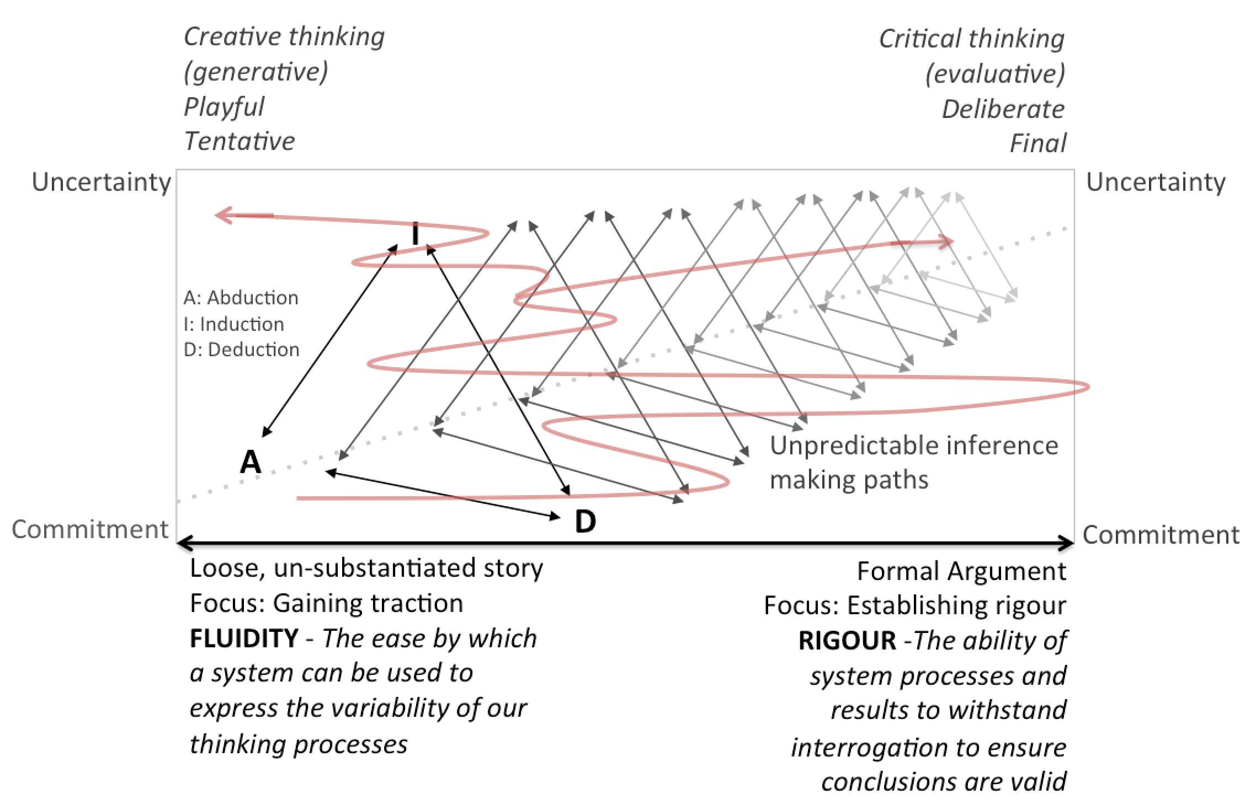
Fig 1. The thinking terrain [16]

In our studies we focused on identifying and describing the nature of thinking as applied to the intelligence analysis task–reasoning, problem-solving, inference making, sensemaking, and decision making (see Fig. 1). We then attempted to describe the thinking space for the purpose of guiding the design of user interfaces. The thinking space or terrain, can be described as a continuum. At one end, thinking is characterized by high uncertainty with a lot of unknowns. Here, the analyst’s focus is on gaining traction or starting a line of inquiry. At this point the problem may have something in common with so ‘wicked problems’ insofar as they are ill-defined [28] and in need of formulation. We observed analysts engage in playful generation of tentative ideas and possibilities—plausible hypotheses—that could account for the data they have about a case, and in view of their professional goals and expertise. At this stage they rarely fully commit to one idea, but instead are checking out and testing whether ideas or hypotheses are worthy of further investigation, assessed in terms of their goals and constraints. The sensemaking at this time is based on a combination of abductive, inductive and deductive inference strategies. They do not have all the data and are therefore required to infer outcomes that they then use to guide the search for relevant and supporting data. They also frequently re-organise and re-structure their data to create stories that afford explanation that provides the understanding that drives their reasoning, sensemaking, search and eventually the construction of a strong and rigorous argument.
In criminal intelligence analysis, the final argument that concludes with a recommendation of the perpetrators must eventually be robust enough to withstand interrogation in the court of law. At this ‘formal’ end of the thinking space continuum, there will be less uncertainty, and strong commitment to the final recommendation. The process of moving from the generative end to the formal end of the continuum is not a linear process. It is unpredictable, depending on what is discovered and how the investigation evolves. It follows a zig-zag path where as one line of inquiry becomes strong, it may discover data that negates the claims that that line of inquiry makes, having to re-start or pick up the investigation from another point. Some of the more significant difficulties center around the generation of insight—the realization of what has happened or what needs to be done; and the formulation of hypotheses—the initial explanatory stories that are uncertain and based on limited data, which need to be tested but also drive and guide the investigation.
Tools and methods have been developed to address the problems of critically evaluating those hypotheses once they have been derived (e.g. ACH, lynchpin analysis), but fewer tools have been developed to support the generative and tentative thinking at the early stages of the analysis. Kodagoda et. al. [25] present early observations of seven criminal intelligence analysts’ thinking and inference making process on how they structure, organize, assemble information and attempt to unpack arguments (claims and premises) they make. We show relationships between claims and associated premises and how induction, deduction or abduction inferences are intertwined in the analysis process while some inference making takes place concurrently rather than sequentially. During the early stages of the analysis, analysts create plausible explanations while assembling, combining data and also anchoring on previous claims made. The claims encourage looking for new data (evidence) with much rigor at the latter stages, while the early stages of the analysis was observed to be much more fluid and playful. This process depended on the availability of data, the situation and the analyst’s experience. Inference making also was observed to converge or diverge the analysis creating new understanding.

Supporting the Thinking Process: Thematic sorting
In section II we discussed the significance of argumentation and narrative for constructing evidence-based representations in crime analysis. In section III we focused on the process of investigation and how this develops from more fluid but uncertain beginnings to an account which is more formal and supported. Within this model, the creation of strong arguments and defensible narratives represents the end-game. A third kinds of structuring which we have found to be significant and also applicable to earlier stages, is thematic sorting.
Thematic sorting involves classifying information objects (documents usually) into thematic groups. A theme may be a more or less well defined topic relevant to a sensemaking task. The themes, which emerge can provide an early organising principle. Where documents are drawn from a larger set, analysts often sort or ‘triage’ them for relevance against evolving investigation themes as a precursor to deeper analysis. Triage is often being an intermediate step between automated search and deeper analysis.
Thematic sorting as an analytic step is illustrated, for example, in Pirolli and Card’s (2005) model of intelligence analysis [29]. Pirolli and Card reported a process model (shown in Fig. 2) based on cognitive task analysis with intelligence analysts. The model shows transformations that analysts perform in the process of conducting analysis. Boxes represent approximate data-flows and circles represent process flow. These are set out over two axes intended to indicate the extent of information structuring achieved (vertical) and effort expended (horizontal).
The model has two major activity loops: a foraging loop (lower-left) and a sensemaking loop (upper-right). Foraging involves seeking information, searching and filtering it, and reading and extracting information. The sensemaking loop involves structuring information in terms of come schema and the iterative development of a “mental model” or “conceptualisation” from the schema that best fits the evidence.

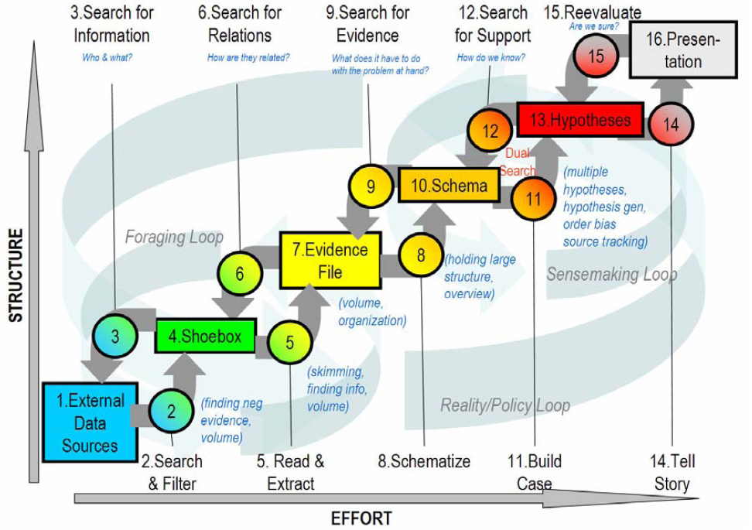
Fig. 2. Pirolli and Card’s notional model of intelligence analysis (re-produced from Pirolli & Card, 2005) Thematic sorting forms an early part of the Pirolli and Card model when structuring is low, appearing as ‘filter’ within the ‘search and filter’ process (i.e. information triage).

The Pirolli and Card model shows how thematic sorting forms an early stage to analysis, although the model says nothing about how these themes come to exist and how they may be affected by developing understanding. Thematic sorting may involve making binary choices (e.g. relevant or irrelevant) or it may involve grouping by multiple themes. In e-discovery investigations, for example, lawyers conducting manual reviews often ‘code’ or tag documents against a series of current investigation issues [9].
Typically, during extended sensemaking tasks, themes evolve. Further, early stages of sensemaking and search may be beset with uncertainty. As far back as 1968, Taylor’s analysis of questions and negotiations at the library reference desk showed that information service users often begin with unclear ideas of what it is that they are looking for [30]. Belkin, Oddy and Brooks (1982) [31] offered their ASK hypothesis which stated that “…. an information need arises from a recognized anomaly in the user’s state of knowledge concerning some topic or situation and that, in general, the user is unable to specify precisely what is needed to resolve that anomaly” (Belkin, Oddy, & Brooks, 1982, p.62). An anomaly, in their sense, was recognition of some inadequacy in a conceptual state of knowledge with respect to some aim.
Attfield and Blandford [9], [32] examined how large regulatory investigations are gradually decomposed into multiple lower-level lines of enquiry (themes). This led to their line-of-enquiry framework. Knowledge associated with a given line of enquiry can give rise to any number of more focused problems (or sub-lines of enquiry) with lines of enquiry at any level having a relatively consistent set of elements, which are tracked by investigators. These elements include: theories, questions, information seeking strategies, evidence collections, knowledge representations, assigned investigators and lower-level lines of enquiry. Hence the framework is hierarchical and recursive. Evolution and the reduction of uncertainty are embodied in lower-level and more specific lines of enquiry whose findings propagate up to inform the investigation as a whole.
In another study involving thematic sorting, Rooney et al. (2014) [33] observed a group of civil servants involved in intelligence analysis perform a simulated intelligence analysis task using the 2011 VAST dataset[14]. Participants used a tool called INVISQUE. An aim of the study was to observe how they would use the tool’s interaction capabilities to address the task. INVISQUE uses a visual metaphor that combines searching, clustering and sorting of document surrogates with free-form manipulation on an infinite canvas. In the study, participants initially sorted documents (news articles) into thematic groupings, which they then explored whilst constructing explanatory narratives. The narratives sought to explain the events reported in the news reports and were represented at the interface by chronological sequences of news report document.
Notably, during thematic sorting, participants used both breadth-first and depth-first strategies. In the breadth-first strategy case, anything that looked relevant to a potential narrative was set aside for later examination. In the depth-first strategy case, each article that was suggestive of an explanatory narrative was explored in detail before selecting the next and so on.
Hence thematic sorting can form an initial step in an analytic workflow, interleaved in different ways with more careful examination, structuring, and narrative or theory construction.

Conclusion

In this paper we have reviewed the support for representation and externalization and in criminal intelligence analysis. The review of models of argumentation and narrative demonstrates that much attention has been given to the later stages of reasoning, where thinking is more concrete and representation techniques quite well developed, allowing for the quite explicit externalization and analysis of thought. In some sense this is easier to address than the earlier stages of reasoning which may be dogged by paucity of information and uncertainty. Consideration has then been given to the need for support for representation and externalization of thought in the early stages of investigation where the analysts may need to be tentative and imaginative to generate lines of enquiry which will give the traction necessary to ultimately lead to more defined results. This is described in a context where the investigation by necessity goes from being fluid and more wide-ranging to more focused and concrete where the representation of arguments and narratives can come into play. A focus on thematic analysis shows how important this process can be in supporting reasoning in the early stages of analysis. Future work will continue to look at how we can support representation and externalization of thought throughout the process of criminal intelligence analysis.

Acknowledgments
The research reported here has received funding from the European Union Seventh Framework Programme (FP7/2007-2013) through Project VALCRI, European Commission Grant Agreement N° FP7-IP-608142, awarded to Middlesex University and partners.

References
[1] Blandord, A., Faisal, S., Attfield, S., Conceptual Design for Sense-making. In: Handbook of Human Centric Visualization. New York, NY: Springer New York, 2014.
[2] W. A. Bowman, “Book Review : Principles of Judicial Proof by John Henry Wigmore,” vol. 16, no. 1, 1931.
[3] S. E. Toulmin, The Uses of Argument. Cambridge University Press, 1958.
[4] C. Allen, Practical Guide to Evidence. Taylor & Francis, 2008.
[5] L. Chapin, S. Attfield, and E. M. Okoro, “Predictive Coding, Storytelling and God: Narrative Understanding in e-Discovery,” pp. 1–15, 2012.
[6] J. Bruner, “making stories law literature life,” The Guardian, 2004.
[7] S. Rao, “Review Essay Making Sense of Making Stories : Law , Literature , Life *,” Law Libr. J., pp. 455–462, 2003.
[8] N. Pennington and R. Hastie, “Explaining the Evidence: Tests of the Story Model for Juror Decision Making,” ournal Personal. Soc. Psychol., vol. 62, no. 2, pp. 189–206, 1992.
[9] S. Attfield and a Blandford, “Making sense of digital footprints in team-based legal investigations: the acquisition of focus,” vol. 26, no. April 2010, pp. 1–40, 2011.
[10] E. Segel and J. Heer, “Narrative visualization: Telling stories with data,” IEEE Trans. Vis. Comput. Graph., vol. 16, no. 6, pp. 1139–1148, 2010.
[11] F. J. Bex, P. J. Van Koppen, H. Prakken, and B. Verheij, “A hybrid formal theory of arguments, stories and criminal evidence,” Artif. Intell. Law, vol. 18, no. 2, pp. 123–152, 2010.
[12] F. Bex, H. Prakken, and B. Verhey, “Anchored Narratives in Reasoning about Evidence,” Jurix, vol. 152, pp. 11–20, 2006.
[13] W. A. Wagenaar and H. F. M. Crombag, Anchored Narratives: The Psychology of Criminal Evidence. Harvester Wheatsheaf, 1993.
[14] D. Grinstein, G., Whiting, M. A., Liggett, K., & Nebesh, “IEEE VAST Challenge 2011,” Retrieved October 19, 2014, from http://hcil.cs.umd.edu/localphp/hcil/vast11/index.php/taskdesc/. [Online]. Available: https://www.google.co.uk/webhp?sourceid=chrome-instant&ion=1&espv=2&ie=UTF-8#q=ieee vast challenge 2011. [Accessed: 10-Apr-2015].
[15] E. M. Okoro, “A study of different representation conventions during investigatory sensemaking,” Masters thesis, Middlesex University, 30-Jan-2014.
[16] B. L. W. Wong, “Fluidity and Rigour - Designing Visual Analytics for the Demands of Intelligence Analysis.,” NATO IST-116 Symp. Vis. Anal., vol. Defence Ac, 2013.
[17] F. J. M. Bennett B., “Display and Interface Design: Subtle Science, Exact Art.,” CRC Press, 2011. [Online]. Available: http://www.amazon.co.uk/Display-Interface-Design-Subtle-Science/dp/142006438X. [Accessed: 01-May-2015].
[18] D. Kirsh and P. Maglio, “On Distinguishing Epistemic from Pragmatic Action,” Cogn. Sci., vol. 18, no. 4, pp. 513–549, 1994.
[19] D. Kirsh, “Complementary Strategies : Why we use our hands when we think,” in Seventeenth Annual Conference of the Cognitive Science Society, 1995, pp. 212–217.
[20] D. Kirsh, “Thinking with external representations,” AI Soc., vol. 25, no. 4, pp. 441–454, 2010.
[21] D. A. Schon, The Reflective Practitioner: How Professionals Think in Action. .
[22] D. A., “Externalisation – how writing changes thinking,” Interfaces (Providence)., vol. 76, pp. 18–19, 2008.
[23] A. Kidd, “The marks are on the knowledge worker,” in Conference companion on Human factors in computing systems CHI 94, 1994, vol. Boston, MA, pp. 186–191.
[24] S. Takken and B. L. W. Wong, “Tactile reasoning: hands-on versus hands-off—What is the difference?,” Cogn. Technol. Work, Mar. 2015.
[25] N. Kodagoda, B. L. W. Wong, C. Rooney, and N. Khan, “Interactive visualization for low literacy users,” in Proceedings of the 2012 ACM annual conference on Human Factors in Computing Systems - CHI ’12, 2012, p. 1159.
[26] B. L. W. Wong, “How Analysts Think (?): Early Observations,” in 2014 IEEE Joint Intelligence and Security Informatics Conference, 2014, pp. 296–299.
[27] Holyoak K. and R. G. J.H.Morrison, The Oxford Handbook of Thinking and Reasoning: OUP USA, 2012.
[28] H. W. J. Rittel and M. M. Webber, “Dilemmas in a general theory of planning,” Policy Sci., vol. 4, no. 2, pp. 155–169, Jun. 1973.
[29] P. Pirolli and S. Card, “The sensemaking process and leverage points for analyst technology as identified through cognitive task analysis,” Proc. Int. Conf. Intell. Anal., vol. 2005, pp. 2–4, 2005.
[30] R. S. Taylor, “Question-Negotiation and Information Seeking in Libraries,” May 1968.
[31] N. J. Belkin, R. N. Oddy, and H. M. Brooks, “ASK FOR INFORMATION RETRIEVAL: PART I. BACKGROUND AND THEORY,” J. Doc., vol. 38, no. 2, pp. 61–71, Apr. 1982.
[32] A. Blandford and S. Attfield, “Interacting with Information,” Synth. Lect. Human-Centered Informatics, vol. 3, no. 1, pp. 1–99, Jan. 2010.
[33] C. Rooney, S. Attfield, B. L. W. Wong, and S. Choudhury, “INVISQUE as a Tool for Intelligence Analysis: The Construction of Explanatory Narratives,” Int. J. Hum. Comput. Interact., vol. 30, no. 9, pp. 703–717, Jul. 2014.

