**Cite as:** Forster B, Tziraki M, Jones A. (2016). The attentive homunculus: ERP evidence for somatotopic allocation of attention in tactile search. *Neuropsychologia* 84: 158-66. doi: 10.1016/j.neuropsychologia.2016.02.009.

**The attentive homunculus: ERP evidence for somatotopic allocation of attention in tactile search**

**Bettina Forster1, Maria Tziraki2**, & **Alexander Jones3**

Department of Psychology, Cognitive Neuroscience Research Unit, City University London, London, UK

# 1Corresponding author:

Department of Psychology

Cognitive Neuroscience Research Unit City University London

Northampton Square London EC1 0HB UK

Telephone: (+44) 2070404553 Email: [b.forster@city.ac.uk](mailto:b.forster@city.ac.uk)

# 2Present Address:

Institute of Brain, Behaviour and Mental Health, University of Manchester, Manchester, UK

# 3Present Address:

Department of Psychology, Middlesex University, London, UK

Our brain constantly receives tactile information from the body’s surface. We often only become aware of this information when directing our attention towards the body. Here, we report a study investigating the behavioural and neural response when selecting a target amongst distractor vibrations presented simultaneously to several locations either across the hands or body. Comparable visual search studies have revealed the N2pc as the neural correlate of visual selective attention. Analogously, we describe an enhanced negativity contralateral to the tactile target side. This effect is strongest over somatosensory areas and lasts approximately 200 ms from the onset of the somatosensory N140 ERP component. Based on these characteristics we named this electrophysiological signature of attentional tactile target selection during tactile search the N140-central-contralateral (N140cc). Furthermore, we present supporting evince that the N140cc reflects attentional enhancement of target rather than suppression of distractor locations; the component was not reliably altered by distractor but rather by target location changes. Taken together, our findings present a novel electrophysiological marker of tactile search and show how attentional selection of touch operates by mainly enhancing task relevant locations within the somatosensory homunculus.

Key words: Somatosensory system, tactile attention, tactile search, attentional selection, body.

# INTRODUCTION

Attention mechanisms allow our brain to prioritise information from the incoming stream(s) of sensory information (e.g. Carrasco, 2011 for review). Visual search tasks are a popular tool to study the selection of information from multiple simultaneous inputs on a behavioural as well as a neural level (see Eimer, 2014 for review). Event-related potentials (ERPs) allow studying neural processes over time and have been successfully employing in visual search tasks revealing the functional and temporal organisation of visual spatial attention mechanisms. In particular, the N2pc (N2-posterior-contralateral) component was identified when visual attention is focused on one item amongst one or more simultaneously presented distractor items. The N2pc reflects the focusing of attention on a visual target amongst distractors (Luck and Hillyard, 1994) and neuroimaging studies have identified the locus of this modulation in visual extrastriate areas (e.g., Hopf et al., 2000). Studies investigating the N2pc revealed diverse aspects of visual spatial attention including attentional capture, top-down and bottom-up influences on attentional selection and the timing of attentional allocation (see Luck, 2011 and Eimer, 2014 for reviews).

The N2pc is stronger negative amplitude over the hemisphere contralateral to the visual field containing the target compared to the ipsilateral hemisphere at parietal-occipital electrode sites (e.g. Eimer, 1996). This lateralized ERP component is typically present after the visual N2 component, around 220 ms post target onset. The N2pc has been suggested to reflect distractor suppression increasing the number of distractors correlates with a larger N2pc and longer response times (Luck et al., 1997) while it was absent when no simultaneous distractors are present with the targets (Luck and Hillyard, 1994). On the contrary, other research found no influence of the amount of distractors on the N2pc (Eimer, 1996), suggesting the N2pc is an index of target enhancement rather than distractor suppression (Hickey et al., 2006; Mazza et al., 2009). More recently an analogous component, the N2ac (N2-anterior-contralateral) has been observed when selecting an auditory target amongst distractors with an enhanced contralateral negativity at anterior electrode sites a similar but modality specific mechanism when searching an auditory scene (Gamble and Luck, 2011; Gamble and Woldorff, 2014). While some studies have investigated tactile search on a behavioural level (e.g. Overvliet, Smeets and Brenner, 2008), the neural correlates of tactile search (when a tactile target needs to be identified amongst tactile distractor items) remain unexplored.

A growing number of behavioural and brain imaging studies have investigated attention mechanisms in touch (for review see Spence and Gallace, 2007 for behavioural, and Sambo and Forster, 2011 for electrophysiological studies). These studies have shown that attention to touch

enhances performance at attended over unattended locations. Tactile attention studies to date have typically studied attention mechanisms at single locations (but see Adler, Giabbiconi and Müller, 2009; Forster and Gillmeister, 2011; Giabbiconi et al., 2004). That is, attention is prior to tactile target onset directed to one tactile location. Therefore, inferences were made regarding enhancement and suppression of neural processing of sequentially presented stimuli at the attended or at another ignored location (e.g., Forster and Eimer, 2005; Forster and Gillmeister, 2011) rather than investigating how we process simultaneously presented stimuli at multiple locations. Furthermore, the vast majority of tactile attention studies have examined attention to the hands (but see Heed and Roeder, 2010). Differences between the hands compared to when the whole body is relevant have been reported for tactile memory (Auvray, Gallace and Spence, 2011). However, direct comparison between tactile attentional selection of stimuli presented to hands compared to multiple locations across the body is lacking. Such a comparison can shed light on the effects of distractor distance on tactile attentional target selection and the effect of somatotopy on tactile attentional selection.

The present study was designed to investigate the electrophysiological signature of tactile stimulus selection during tactile search in a task requiring detection of a tactile target stimulus amongst several competing tactile distractors. Such multi stimuli presentations closely represent the challenges our brain faces, as it receives input from receptors across the body surface; our body is frequently in contact with more than one item at a time. For example, putting on a new shirt and scanning the body surface to evaluate its fit. Moreover, we further aimed to explore whether attention mechanisms differ when only the hands or the whole body needs to be searched. Therefore, tactile vibrations were presented simultaneously to six locations across the hands (left and right index, middle and ring fingers) and in a separate task, across the body (left and right index fingers, shoulders and big toes). In half of the trials all of the vibrations were the same, and in the other half a target was presented at a randomly selected location. Participants’ task was to indicate on each trial whether a target vibration was present or not. Importantly, tactile target and distractor frequency characteristics were counterbalanced across participants to control for any frequency effects. This paradigm is comparable to visual search studies that analogously present several objects across the visual field with one or more objects differing in one or more features.

Based on analogous studies in other modalities, showing an N2pc (vision - Eimer, 1996) and N2ac (auditory - Gamble and Luck, 2011), we expected to find a comparable electrophysiological marker of attentional selection during tactile search. However, we expected characteristics of this component to reflect tactile attentional selection; that is, we did expect to find an enhanced negativity contralateral to the target side centred over central electrodes where somatosensory

ERPs and tactile attention effects are observed (e.g. Jones and Forster, 2014). Further, our paradigm allowed us to explore if tactile attentional selection is due to enhancements of targets at attended locations, or suppression of distractors. If an electrophysiological marker of tactile attentional selection mainly reflects selection of attended locations we expected a similar contralateral negativity to be elicited for targets presented to the index fingers regardless of distractor locations, namely distractors on the neighbouring fingers (hand task) or spatially and somatotopically distant locations across the body (body task). Furthermore, we explored whether attention is allocated in a more general fashion or to in different areas of the somatosensory map. That is, somatosensory cortex extends across each hemisphere, with the hand representation area being lateral while the toe representation is medial (Penfield and Boldrey, 1937). In the body task, the shoulders, toes and fingers were all stimulated simultaneously on each trial. We can therefore compare the effects of allocating attention to a target at the hands compared to the feet - two locations that are distant in somatotopic space. Differences in ERP waveforms elicited by simultaneous stimulation of the same locations (i.e. fingers, toes and shoulders) when directing attention to a finger compared to a toe would suggest that attention operates by modulating specific parts of the somatotopic map. In contrast, similar ERP waveforms would suggest a more general lateralized effect of tactile selective attention.

Taken together, this study aimed to describe the electrophysiological marker of tactile search. Our first aim was to establish whether attentional selection operates in touch in a similar way as in vision and audition, and to establish whether it differs when selecting from simultaneous multi stimulus presentations across the hands and the whole body. Secondly, we aimed to understand the underlying mechanisms of attentional selection in touch. We sought to investigate whether this attentional selection was due to enhancement of processing at attended locations or suppression of distractor information and whether attention is allocated in a more general fashion across the somatosensory map.

# MATERIAL and METHOD

*Participants*

20 paid, healthy volunteers took part in the experiment. One participant’s data was excluded from analysis due to technical problems during recording and three participants due to excess of muscle, and alpha-wave activity leading to low trial numbers in at least one of the conditions after ERP artefact rejection. Thus, 16 participants (10 females), aged 18-36 years (average age: 27 years) remained in the sample. All but two participants were right-handed by self-report. The experiment was approved by the local Ethics Committee, City University London; and all participants gave written informed consent prior to participation.

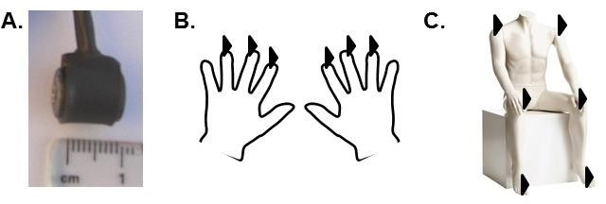

**Figure 1.** Panel A shows a photograph of a tactile stimulator next to a ruler to give an indication of size. Panel B shows a schematic drawing of hands with the location of the tactile stimulators in the hand task indicated by triangles. Panel C shows a schematic drawing of a body with the location of the tactile stimulators in the body task indicated by triangles.

*Stimuli and Procedure*

Participants were seated in a dimly lit, acoustically and electrically shielded chamber. Tactile stimulators (see Figure 1) were attached to their left and right index, middle and ring fingers (hand task) and, in a separate part of the experiment, their left and right big toes, index fingers and shoulders (body task). All participants performed both tasks. Tactile stimulators were small 12V solenoids (me-solve.co.uk) driving a metal rod with a blunt conical tip to the skin whenever a current was passed through the solenoid. Solenoids were held in place by medical tape. Participants’’ hands and feet were place at a comfortable distance of approximately 20 cm apart. Their hands and body were covered by a black cloth.

On each trial tactile vibrations were presented simultaneously by the six stimulators. Tactile vibrations were either ‘tap’ or ‘buzz’ stimuli. Taps were generated by 2 cycles of switching the solenoids ON for 20 ms and OFF for 280 ms. Buzz vibrations were generated by 30 cycles of switching the solenoids ON for 3 ms and OFF for 17 ms. Each type of vibration was followed by 3 ms ON activation of the solenoids and the total duration of each vibration type was 603 ms. For half of the participants the tap stimuli, and for the other half buzz vibrations, were assigned as targets. On target absent trials, same vibrations were presented at all 6 stimulators. On target present trials, one randomly assigned stimulator presented as the target (either tap or buzz) while the remaining 5 stimulators presented non-target vibrations (buzz or tap, respectively). Targets were presented in total 66 times at each of the 6 stimulation sites. There were 6 blocks of 132 trials each, and target present and absent trials were equiprobable and randomly intermixed. Participants’ task was to vocally state on each trial whether a target was present (yes/no). A

microphone recorded response onset and the experimenter, who was outside the testing room, registered the yes/no responses. Trials with vocal responses faster than 200 ms and slower than 1300 ms were treated as outliers and not further analysed.

Participants were instructed to focus their eyes on a fixation cross that was placed at the top edge of the computer screen, located about 60 cm in front of the participant. Compliance was monitored via a video camera by the experimenter. The computer screen was black throughout the experiment except when displaying instructions at the start of the experiment and giving performance feedback (percentage of correct responses and average response time) at the end of each block. 300 ms after the start of a trial the tactile stimuli (603 ms) were presented and once the experimenter had recorded the participants’ vocal response the next trial started. Therefore, trial and inter stimulus interval length was dependent on participants’ vocal response time and the experimenters speed of response registration (overall average trial length was 1573ms). Prior to starting the experiment, participants were presented with 12 trials to familiarize them with the tactile stimulation; six of these trials were one of each possible target trial type while the remaining trials were non target trials. During each of these tactile presentations, the trial type (target or non- target) was displayed on the screen. This was followed by 12 practise trials (as in the familiarization trials 6 target and 6 non target trials). On these trials participants responded yes or no to indicate whether a target was present or not. They were given feedback on their performance at the end of the practice block. Participants performed the familiarization task once at the start of the study (either hand or body task) and completed a practice session before each task. White noise (65 dB) was played throughout the familiarization, practise and experimental trials to mask any sounds made by the tactile stimulators.

*EEG recording and data analysis*

EEG was recorded with active electrodes from 60 scalp electrodes mounted equidistantly on an elastic electrode cap (M10 montage; EasyCap GmbH, Herrsching, Germany). All electrodes were referenced to the right earlobe and re-referenced to the average reference off-line. Bipolar horizontal electrooculogram (HEOG) was recorded from the outer chanti of the eyes. The EEG and HEOG signal were amplified, band-pass filtered at 0.01 – 100 Hz, digitised at 500 Hz, and filtered off-line with a low pass filter of 30 Hz. EEG and HEOG were epoched for a period from 100ms before to 400ms after the onset of the tactile stimulus. Trials with eye movements (HEOG exceeding ± 60 µV relative to the 100-ms pre-stimulus baseline), eye blinks or other artifacts (voltage exceeding ± 80 µV at any electrode relative to baseline) measured in this interval were excluded from analysis. ERPs on correctly detected target trials were averaged separately for targets on the left and right body side for the different locations in the body (finger, shoulder, toe)

and hand task (index, middle and ring finger). ERPs elicited on non-target trials were not further analysed as no lateralized targets were presented.

In line with previous research on visual and auditory search (e.g. Eimer, 1996 and Gamble and Luck, 2011) we expected enhanced amplitudes over electrodes contralateral in comparison to ipsilateral to the target side on target present trials. In contrast to previous research, we expected this difference to be present at central electrodes confirming a modality (somatosensory) specific attention effect (Figure 2). For the statistical analysis electrodes C3 and C4 (of the 10/20 system equalling electrodes 11/17 of the M10 montage used in this study) were chosen, as these are lateral electrodes over somatosensory areas where early somatosensory ERP components (P45, N80, P100, N140) are largest and tactile attention effects have commonly been reported (e.g., Jones and Forster, 2014). As expected, somatosensory ERPs on target trials showed to a clear hemispheric difference in relation to task and target location (Figures 2 – 4). To analyze whether a reliable difference in ERP activity over somatosensory cortex ipsilateral versus contralateral to the target side was present, ERP mean amplitudes were computed within two successive 100ms measurement windows from the N140 component (140ms post-stimulus onset) for correctly identified target-present trials. Repeated measures ANOVAs were conducted on ERP mean amplitude values for the factors Task (hand vs. body), Target location (Finger/Shoulder/Toe vs. Index/Middle/Ring Finger), Target side (left vs. right) and hemisphere (electrode C3/4 contralateral vs. ipsilateral to the target side). A significant Target side by Hemisphere interaction would indicate a reliable difference over somatosensory areas contra- compared to ipsilateral to the target side. Where appropriate, Greenhouse-Geisser adjusted p-values are reported and follow-up analyses were Bonferroni corrected. For simplicity only significant main effects and interactions are reported. None significant effects are reported in full for factors of interest to the research questions posed (that is; Task and Target side x Hemisphere and their interaction). Moreover, non-significant effects that formed part of the conclusion were additionally subjected to a Bayes Factor (BF) analysis [(http://www.lifesci.sussex.ac.uk/home/Zoltan_Dienes/inference/bayes_factor.swf).](http://www.lifesci.sussex.ac.uk/home/Zoltan_Dienes/inference/bayes_factor.swf)) This analysis was used to determine whether data supported the particular null-hypothesis or was insensitive. For all BF calculations presented the standard error was adjusted as sample size was smaller than 30 (SE*(1 + 20/df*df). Estimated effect sizes were set at SD=mean/2, and based on a normal distribution. BF conclusions are based on conventions that BF smaller than 1/3 and greater than 3 represents substantial evidence for the null-hypothesis or alternative hypothesis respectively, and anything in between suggests data are insensitive (Dienes, 2014).

# RESULTS

*Behavioural analyses*

Response speed for correct responses and accuracy on target-present trials were analysed separately with repeated measures ANOVAs for the between subject factor Target type (buzz vs. tap) and within-subject factors Task (hand vs. body), Target location (Finger/Shoulder/Toe vs. Index/Middle/Ring Finger) and Target side (left vs. right). These analyses showed no reliable difference in response speed between Target type (tap target = 695 ms vs. buzz target = 612 ms; F(1,14) = 1.67, n.s., η2 =.10) or Tasks (body task = 682 ms vs. hand task = 624 ms; F(1,14) = 2.87, n.s., η2 =.17)1 and no interaction between Task and Target location (F(2,28) = .89, n.s., η2 =.06). Participants performed better in the hand (96% correct) than in the body task (91% correct; F(1,14)=5.52, p=.034, η2 =.28) but there was no interaction between Task and Target location (F(2, 28)=.02, n.s., η2 =.12). There was no difference in accuracy between Target type (F(1, 14) = 2.37, n.s., η2 =.14) and there were no other main effects or interactions.

p

p

p

p

p p

1 Further analysis of the non-significant result between responses to targets in the hand and body task showed a Bayes Factor = 1.24 indicating that the data are insensitive (see methods). A predicted effect was estimated at 100 ms.

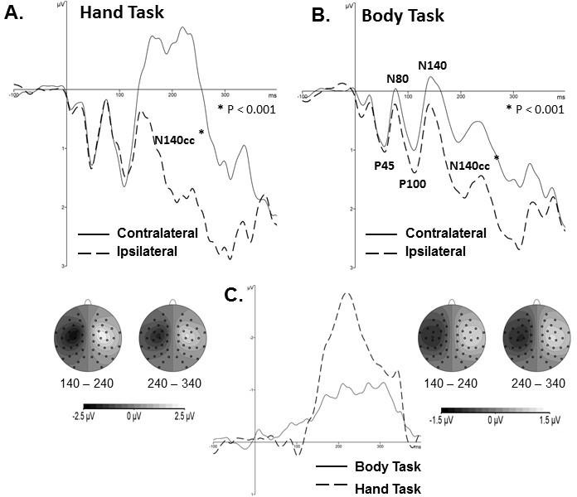

**Figure 2**. Panel A and B show grand-averaged target trial ERP waveforms (left and right top graphs) contrasting activity over the hemisphere contralateral (solid lines) and ipsilateral (dashed lines) to the target side with distractors presented at the remaining five locations of the hand (A) and body (B) tasks and corresponding topographic maps (below each graph) of the N140cc for the two analysis windrows (140 – 240ms and 240 – 340ms after stimuli onset). Topographic maps were derived by first subtracting ERPs at electrodes ipsilateral to the target side from homologous contralateral electrodes and then mirroring these difference waveforms with inverse polarity to the other hemisphere to generate symmetrical whole head maps. Figure 2 C shows the difference waveforms in order to contrast the timing and absolute amplitude of the lateralized N140cc component in the hand (dashed line) and body (solid line) tasks.

*ERP analyses*

Figure 2 A and B top panels show somatosensory ERP waveforms in response to target trials elicited over the hemisphere ipsilateral and contralateral to the target side, separate for the hand and body task. These graphs show a lateralized attention effect with more negative ERP amplitudes elicited over the hemisphere contralateral compared to ipsilateral to the target side, and this effect was present from around 140ms until around 340ms after stimuli onset. Furthermore, the difference waveform graph (Figure 2 C) contrasts the amplitude difference in response to targets over the hemisphere contralateral minus ipsilateral to the target side in the two tasks showing that a maximum difference is reached by 220ms and an overall smaller amplitude difference is present in the body task. In addition, the topographic maps (Figure 2 A and B bottom panels) show a

central distribution of this hemispheric amplitude difference in both tasks. Taken together, when selecting a target presented amongst distractors on the hands or across the body a strong and prolonged enhanced negativity is present over the hemisphere contralateral to the target side, starting from around 140 ms after stimuli onset which we named N140 central-contralateral (N140cc).

These informal observations were further substantiated by statistical analyses. Of specific interest were any Target side x Hemisphere interactions indicating the presence of amplitude differences between the hemisphere ipsi- and contralateral to the target side, that is the N140cc. For both analysis windows there was a Target side x Hemisphere (140 – 240 ms: F(1,15)=68.53, p<.001, η2p=.82; 240 – 340 ms: F(1,15)=49.73, p<.001, η2p=.77) and a Target side x Hemisphere x Task (140 – 240 ms: F(1,15)=44.96, p<.001, η2p=.75; 240 – 340 ms: F(1,15)=15.20, p<.001, η2p=.50)

interaction (Figure 2 C). Follow up analyses separately for the hand and body task confirmed the presence of a significant Target side x Hemisphere interaction in both tasks with a larger N140cc in the hand task (140 – 240 ms: F(1,15)=70.44, p<.001, η2p=.82; 240 – 340 ms: F(1,15)=44.48,

p<.001, η2p=.75) (Figure 2 A) than in the body task (140 – 240 ms: F(1,15)=39.70, p<.001,

η2p=.73; 240 – 340 ms: F(1,15)=38.97, p<.001, η2p=.72) (Figure 2 B). In addition, only in the body task for the first analysis window a Target side x Hemisphere x Target location interaction was present (F(2,30)=4.62, p=.026, η2p=.24). Separate follow up analyses for each target location confirmed the presence of significant Target side x Hemisphere interactions for each target location with a larger N140cc when targets were presented to the index fingers (F(1,15)=18.45, p<.001, η2p=.77), than the shoulders (F(1,15)=5.76, p<.005, η2p=.42) and toes (F(1,15)=5.76, p=.028, η2p=.28). It is important to note that in the body task on all trials the same locations (left and right index fingers, shoulders and big toes) were stimulated simultaneously. Targets and distractors differed in their frequency characteristics and the target – distractor frequency assignment was reversed for half of the participants to control for any effects due to stimulus characteristics. Therefore, the differences in the N140cc due to target location reported here reflect differences in the spatial allocation of attention when tactile targets are presented to different body parts. To further substantiate this claim we directly compared conditions where the stimulation locations were the same but the target locations differed. Figure 3 A and B (top panels) contrast ERPs elicited contra- versus ipsilateral to targets on the left or right index fingers or left or right toes in the body task. Furthermore, the difference waveforms (Figure 3C) of the contra-ipsilateral difference in the two task conditions clearly show differences in amplitude of the N140cc elicited in the two conditions. Repeated measures ANOVA was conducted for trials of the body task when targets were presented to the fingers or toes with the factors Target location (finger vs. toe), Target side (left vs. right) and Hemisphere (left vs. right). This analysis confirmed that in the body task finger and toe target trials elicited a N140cc (Target side x Hemisphere interactions at the 140 – 240 ms (F(1,15)=31.23, p<.001, η2p=.68) and 240 – 340 ms (F(1,15)=6.60, p<.001, η2p=.64)

analysis windows) which interacted with target location for the early analysis window (140 – 240 ms: F(1,15)=5.93, p=.028, η2p=.28; 240 – 340 ms: F(1,15)=2.42, n.s., η2 =.14). Taken together,

p

these more detailed analyses demonstrated that, at least, the early part of the N140cc is sensitive

to the somatotopy of attentional allocation to the target site and provided further support that the N140cc mainly reflects enhancement of target processing2.

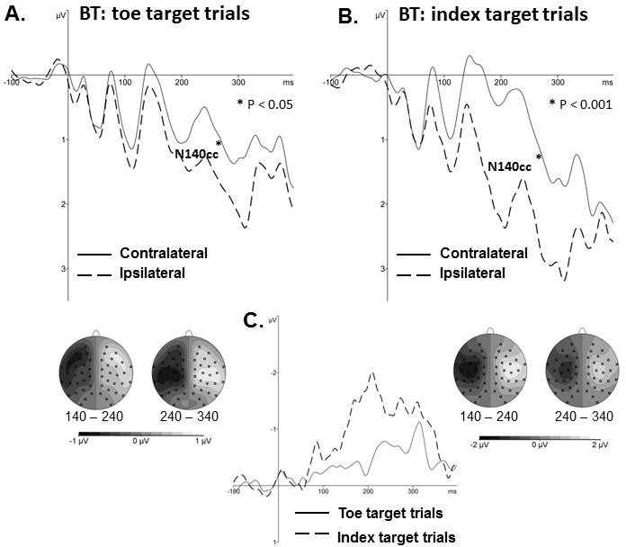

**Figure 3.** Panel A and B show grand-averaged ERP waveforms for toe (left top graph) and index finger (right top graph) target trials of the body task (BT) contrasting activity over the hemisphere contralateral (solid lines) and ipsilateral (dashed lines) to the target side and corresponding topographic maps (left and right maps below graphs) of the N140cc for the two analysis windrows (140 – 240ms and 240 – 340ms after stimuli onset). Topographic maps were derived by first subtracting ERPs at electrodes ipsilateral to the target side from homologous contralateral electrodes and then mirroring these difference waveforms with inverse polarity to the other hemisphere to generate symmetrical whole head maps. Panel C shows difference waveforms contrasting the timing and absolute amplitude of the lateralized N140cc component on toe (solid line) and index finger (dashed line) target trials.

2 An alternative interpretation of the N140cc is that it reflects the speed with which attention is allocated. This speeded attention hypothesis also predicts faster response times to targets to which attention is directed more rapidly. To test this hypothesis we compared the cumulative response time distribution on finger and toe target trials. We found an almost identical distribution making the speeded attention hypothesis unlikely.

To further investigate whether the N140cc reflects mainly target selection or distractor suppression, we contrasted the N140cc when the target location was the same but the distractor location differed (targets on index fingers and distractors on the neighbouring fingers in the hand task versus target on the index fingers and distractors on different body parts; that is, toes and shoulders in the body task). Figure 4 A and B (top panels) contrast ERPs elicited contra- versus ipsilateral to targets on the left or right index finger in the hand and body task. The difference waveforms (Figure 4C) of the contra-ipsilateral difference in the two tasks show a similar timing and strength of this hemispheric difference suggesting that distractor location and distance from the target location has little impact. Repeated measures ANOVA was conducted on trials when the target was presented to the index fingers with the factors Task (hand vs. body task), Tactile side (left vs. right), Hemisphere (left vs. right) showing a significant Tactile side x hemisphere interaction for both analysis windows (140 – 240 ms: F(1,15)=7.50, p<.001, η2 =.71; 240 – 340 ms: F(1,15)=28.65, p<.001, η2 =.66) but no interaction with Task (140 – 240 ms: F(1,15)=2.25, n.s., η2 =.13; 240 – 340 ms: F(1,15)=2.15, n.s., η2 =.13)3.

p

p

p p

3 For each of the two time intervals a BF analysis was conducted to further investigate the non-significant interaction with task. The 140 – 240 ms and 240 – 340 ms intervals showed a BF=1.05 and 1.03 respectively. Thus, the data are insensitive to draw conclusions regarding the null effects of task interaction. The estimated effect size was based upon observed effect in the 140-240 ms interval comparing finger vs toe in the BT (1.05uV) (Figure 3C).

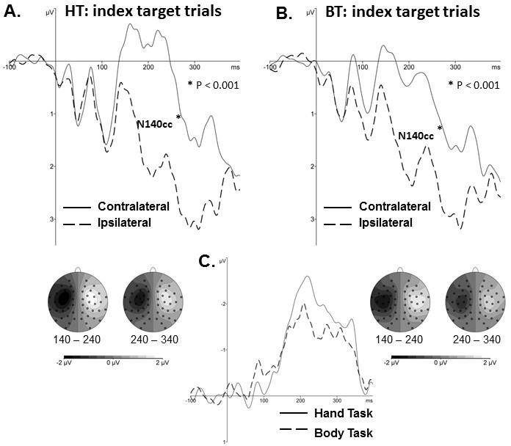

**Figure 4.** Panel A and B show grand-averaged ERP waveforms (left and right top graphs) on index finger target trials contrasting activity over the hemisphere contralateral (solid lines) and ipsilateral (dashed lines) to the target side and corresponding topographic maps (left and right maps below graphs) of the N140cc for the two analysis windows (140 – 240ms and 240 – 340ms after stimuli onset) in the hand (HT; panel A) and body task (BT; panel B). Topographic maps were derived by first subtracting ERPs at electrodes ipsilateral to the target side from homologous contralateral electrodes and then mirroring these difference waveforms with inverse polarity to the other hemisphere to generate symmetrical whole head maps. Panel C shows difference waveforms contrasting the timing and absolute amplitude of the lateralized N140cc component on index finger target trials in the hand (solid line) and body (dashed line) tasks.

# DISCUSSION

This study investigated the electrocortical response when selecting a tactile target amongst distractors. Participants either searched six locations on the fingers or, in a separate task, searched for a target amongst distractors on the body. In both tasks an enhanced negativity over the hemisphere contralateral to the target side compared to ipsilateral was demonstrated. This effect lasted from 140 ms until 340 ms after stimuli onset reflecting attentional selection of target location. We named this lateralized component the N140cc. This component was clearly strongest over central electrode sites, reflecting modality specific allocation of attention and was stronger in the hand than in the body task. This task difference suggests an effect of somatotopy on attentional selection, which was further supported by analyses contrasting conditions when all

stimulation locations were the same but allocation of attention differed (i.e. comparison of body tasks conditions when attention was focused on the finger versus on the toe). In addition, analyses contrasting conditions in which the target location was the same but distractor locations differed (i.e. comparison of conditions when attentional selection of the index fingers was required with distractors on other fingers as in the hand task or on other body parts as in the body task) showed no significant difference between the N140cc. Together these findings suggest that the N140cc represents a modality specific, attentional selection mechanism that mainly enhances processing at target locations rather than suppression of distractor information.

To our knowledge, this is the first study to describe the electrocortical response of tactile attentional selection of targets amongst distractors – the neural correlate of tactile search. More specifically, when selecting a target presented amongst distractors on the hands or across the body a strong and prolonged enhanced negativity is present over the hemisphere contralateral to the target side. In contrast to tactile search, the neural basis of attentional selection within visual scenes has been intensely studied (see Luck, 2011 for review). In line with visual search tasks, participants in the present experiment were presented with six simultaneous, identical events (i.e. vibrations) while on half of the trials one event (target) differed. Analogous to visual search tasks, electrocortical responses in our experiment showed enhanced negative amplitude values over the hemisphere contralateral to target side on target present trials. Similar to the visual N2pc (Eimer, 1996) and auditory N2ac (Gamble and Luck, 2011), the present experiment showed a prolonged negativity starting around the second negative component – N2, or N140 as it is known in touch. This attentional hemispheric difference was clearly centred over central electrodes close to and over somatosensory cortex (see topographic maps Figures 2 – 4) suggesting a topographically distinct component similar to that found in other modalities. As target and distractor characteristics were counterbalanced across participants this hemispheric difference does not reflect target characteristics, but can rather be attributed to the allocation of attention to target locations. Our findings, along with previous research in other modalities, show that attentional selection mechanisms employed during search tasks operate by modulating sensory processing within relevant modality specific areas. This notion is in line with a recent study investigating tactile working memory (Katus et al., 2014). Katus and colleagues (2014) reported enhanced negativity at central electrodes contralateral to the hand of the tactile stimulus that needed to be memorized suggesting that not only attentional selection mechanisms but also short term memory processes are modality specific. Future research may directly compare the neural mechanisms employed during tactile search and memory tasks to shed light on any overlap.

Interestingly, while we replicated an overall similar ERP pattern in the hand and body task we also found differences between the two tasks. We found a stronger N140cc in the hand than the body task (Figure 2). This indicates that somatotopy may affect attentional selection as the distribution of stimulus locations differed between the two tasks. In the hand task all stimulation locations were within close proximity and represented within the hand area located lateral in the somaotosensory cortex of each hemisphere. In contrast, in the body task the cortical representation of stimulation locations (toes, fingers and shoulders) stretched from lateral locations to the central sulcus where neurons representing touch receptors in the toes are located (Penfield and Boldrey, 1937). To further explore whether the N140cc hand and body task difference was due to a somatotopic allocation of attention we compared conditions with identical stimulation locations but differences in attentional allocation. In particular, we found differences in the N140cc amplitudes between finger and toe target trials in the body task (Figure 3) with larger N140cc amplitudes when targets were located on one of the index fingers while comparatively smaller when located on one of the toes. It is important to note that in the body task, tactile stimulation locations were the same in all conditions. The only difference between conditions is how attention was allocated to the different target locations. The larger N140cc for index finger compared to toe target trials can tentatively be linked to what has been found in vision. The N2pc has been observed to decrease with increased eccentricity (Shaffer et al., 2011), in other words, the closer the targets to the fovea, the larger the N2pc effect. This has been suggested to reflect a foveal bias in allocation of attention (Wolfe et al., 1998). In the somatosensory homunculus the hand representation is relatively larger than other body parts with tactile acuity being greatest at the fingertips (Sato et al., 1999), the hands being a “fovea of touch”. Our results are therefore consistent with the idea that the lateralized attention effect is larger where spatial acuity is best. While there are clear parallels between the different senses in the electrophysiological marker of searching for a target amongst distractors, each component - N2pc, N2ac, and N140cc - also shows different and sensory specific characteristics suggesting allocation of attentional selection is modality specific.

To further explore whether the N140cc mainly reflected enhanced processing of target locations, rather than suppression of distractors, we compared conditions where targets were presented to one of the index fingers (Figure 3). The only difference was the location of distractors (hand task: middle and ring fingers vs body task: shoulders and toes). Research employing visual search tasks has suggested the N2pc to reflect target enhancement instead of distractor suppression (e.g., Eimer, 1996; Hickey et al., 2006; Mazza et al., 2009). Moreover, the suppression hypothesis would predict increased response times for increase distractor suppression (Luck et al., 1997). We found no significant effect between RTs in the hand and body task. Similarly, no significant difference between the N140cc for target selection at the index fingers in both tasks even though the distractor locations varied. However, further Bayes Factor analysis of these non-significant effects

(Dienes, 2014) suggested the conclusions that can be drawn are limited. That is, our data do not contradict a suppression hypothesis but on the other hand cannot support it either based on non- significant results. It may intuitively make sense in a real world environment to assume that it would require a lot of resources to constantly suppress irrelevant tactile information such as the chair we sit on, or the sensation from our clothes. Instead, when we are actively searching for something touching our hands or body, we use attention mechanisms to enhance processing of this stimulus. However, more research using multiple tactile location displays would be needed to establish contributions of target enhancement and distractor suppression, for instance, by varying the number of distractors.

# CONCLUSION

The present study investigated electrophysiological correlates of tactile search. We demonstrated attention negativity over electrodes close to and over somatosensory areas contralateral to the target side (N140cc) that resembles findings in other modalities (N2pc and N2ac) but with a modality specific topography. The N140cc was present both when searching for a target at the finger tips as well as across the whole body. Importantly, we showed that the N140cc differed for attentional allocation to the fingers compared to the toes and that the N140cc may represent enhancement of target location rather than distractor suppression. Therefore, in line with visual attention studies showing a retinotopic allocation of attention (e.g. Somer and Sheremata, 2013 for review) our results suggest somatotopic allocation of tactile attention. Since the N140cc differs with somatotopically distant target locations it may be used as a valuable tool to track attention allocation and selection of different limbs in multi-stimulus arrays.

# Acknowledgement

This research was funded by City University pump priming money to BF.

# References

Adler, J., Giabbiconi, C.-M., & Müller, M. M. (2009). Shift of attention to the body location of distracters is mediated by perceptual load in sustained somatosensory attention. Biological Psychology, 81(2), 77–85. doi:10.1016/j.biopsycho.2009.02.001

Auvray, M., Gallace, A., & Spence, C. (2011). Tactile short-term memory for stimuli presented on the fingertips and across the rest of the body surface. Attention, Perception & Psychophysics, 73(4), 1227–41. doi:10.3758/s13414-011-0098-6

Carrasco, M. (2011). Visual attention: the past 25 years. Vision Research, 51, 1484-1525. doi:10.1016/j.visres.2011.04.012

Dienes, Z. (2014). Using Bayes to get the most out of non-significant results. *Frontiers in psychology*, *5*.

Eimer, M. (1996). The N2pc component as an indicator of attentional selectivity. Electroencephalography and Clinical Neurophysiology, 99(3), 225–234. doi:10.1016/S0921-884X(96)95711-2

Eimer, M. (2014). The neural basis of attentional control in visual search. Trends in Cognitive Science, 18(10),526-35. doi: 10.1016/j.tics.2014.05.005

Forster, B., & Eimer, M. (2005). Vision and gaze direction modulate tactile processing in somatosensory cortex: evidence from event-related brain potentials. Experimental Brain Research, 165(1), 8–18. doi:10.1007/s00221-005-2274-1

Forster, B., & Gillmeister, H. (2011). ERP investigation of transient attentional selection of single and multiple locations within touch. Psychophysiology, 48(6), 788–96. doi:10.1111/j.1469- 8986.2010.01147.x

Gallace, A., & Spence, C. (2009). The cognitive and neural correlates of tactile memory.

Psychological Bulletin, 135(3), 380–406. doi:10.1037/a0015325

Gamble, M. L., & Luck, S. J. (2011). N2ac: an ERP component associated with the focusing of attention within an auditory scene. Psychophysiology, 48(8), 1057–68. doi:10.1111/j.1469- 8986.2010.01172.x

Gamble, M. L., & Woldorff, M. G. (2014). The temporal cascade of neural processes underlying target detection and attentional processing during auditory search. Cerebral Cortex, (2011). doi:10.1093/cercor/bhu047

Giabbiconi, C. M., Dancer, C., Zopf, R., Gruber, T., & Müller, M. M. (2004). Selective spatial attention to left or right hand flutter sensation modulates the steady-state somatosensory evoked potential. Cognitive Brain Research, 20(1), 58–66. doi:10.1016/j.cogbrainres.2004.01.004

Heed, T., & Roder, B. (2008). Common anatomical and external coding for hands and feet in tactile attention: evidence from event-related potentials. Journal of Cognitive Neuroscience, 22(1), 184–202.

Hickey, C., McDonald, J. J., & Theeuwes, J. (2006). Electrophysiological evidence of the capture of visual attention. Journal of Cognitive Neuroscience, 18(4), 604–13. doi:10.1162/jocn.2006.18.4.604

Hopf, J., Luck, S., & Girelli, M. (2000). Neural sources of focused attention in visual search.

Cerebral Cortex, 10(12), 1233–1241.

Jones, A., & Forster, B. (2014). Neural correlates of endogenous attention, exogenous attention and inhibition of return in touch. The European Journal of Neuroscience, 40(2), 2389–98. doi:10.1111/ejn.12583

Katus, T., Grubert, A., & Eimer, M. (2014). Electrophysiological Evidence for a Sensory Recruitment Model of Somatosensory Working Memory. Cerebral Cortex. doi:10.1093/cercor/bhu153

Luck, S. J. (2011). Electrophysiological correlates of the focusing of attention within cmplex visual scenes: N2pc and related ERP components. In S. J. Luck & E. S. Kappenman (Eds.), The Oxford Handbook of Event-Related Potential Components. USA: Oxford University Press.

Luck, S. J., Girelli, M., McDermott, M. T., & Ford, M. a. (1997). Bridging the gap between monkey neurophysiology and human perception: an ambiguity resolution theory of visual selective attention. Cognitive Psychology, 33(1), 64–87. doi:10.1006/cogp.1997.0660

Luck, S. J., & Hillyard, S. A. (1994). Spatial filtering during visual search: Evidence from human electrophysiology. Journal of Experimental Psychology: Human Perception and Performance, 20(5), 1000–1014. doi:10.1037/0096-1523.20.5.1000

Mazza, V., Turatto, M., & Caramazza, A. (2009). Attention selection, distractor suppression and N2pc. Cortex; a Journal Devoted to the Study of the Nervous System and Behavior, 45(7), 879–90. doi:10.1016/j.cortex.2008.10.009

Overvliet, K. E., Smeets, J. B. J., & Brenner, E. (2008). The use of proprioception and tactile information in haptic search. Acta Psychologica, 129(1), 83–90. doi:10.1016/j.actpsy.2008.04.011

Penfield, W., & Boldrey, E. (1937). Somatic motor and sensory representation in the cerebral cortex of man as studied by electrical stimulation. Brain, 60(4), 389–443. doi:10.1093/brain/60.4.389

Sambo, C. F., & Forster, B. (2011). Sustained spatial attention in touch: modality-specific and multimodal mechanisms. The Scientific World Journal, 11, 199–213. doi:10.1100/tsw.2011.34

Sambo, C. F., Gillmeister, H., & Forster, B. (2009). Viewing the body modulates neural mechanisms underlying sustained spatial attention in touch. The European Journal of Neuroscience, 30(1), 143–50. doi:10.1111/j.1460-9568.2009.06791.x

Sato, T., Okada, Y., Miyamoto, T., & Fujiyama, R. (1999). Distributions of sensory spots in the hand and two-point discrimination thresholds in the hand, face and mouth in dental students. Journal of Physiology-Paris, 93(3), 245–250. doi:10.1016/S0928-4257(99)80158- 2

Schaffer, S., Schubö, A., & Meinecke, C. (2011). Electrophysiological correlates of target eccentricity in texture segmentation. International Journal of Psychophysiology, 80, 198– 209. doi:10.1016/j.ijpsycho.2011.03.003

Somers, D.C., & Sheremata, S.L. (2013). Attention maps in the brain. Wiley Interdisciplinary Review Cognitive Science, 4(4): 327-340. doi:10.1002/wcs.1230

Spence, C., & Gallace, A. (2007). Recent developments in the study of tactile attention. Canadian Journal of Experimental Psychology, 61(3), 196–207. doi:10.1037/cjep2007021

Wolfe, J. M., O’Neill, P., & Bennett, S. C. (1998). Why are there eccentricity effects in visual search? Visual and attentional hypotheses. Perception & Psychophysics, 60(1), 140–156. doi:10.3758/BF03211924