Managing complex fires in urban environments: A tale of two cultures
Justin OKOLI¹, John WATT¹ and Gordon WELLER²
¹ Centre for Decision Analysis and Risk Management, School of Science and Technology, Middlesex University, The Burroughs, Hendon, London NW44BT, UK. j.okoli@mdx.ac.uk; j.watt@mdx.ac.uk
² Department of Mental Health, Social Work and Inter-professional Learning, School of Health and Education, Middlesex University, Room F606, Town Hall, The Burrough, Hendon, London NW4 4BT, UK. g.weller@mdx.ac.uk

Abstract: Prior research has examined how experienced fireground commanders make task related decisions under a range of unfavourable conditions, however gaps still exist in the literature when there is need to evaluate the coping strategies of incident commanders across different urban environments. There was rarely any study found to have explored cross-cultural differences that exist between two or more fire services with distinct cultural orientations. This paper reports findings from a study that compared firefighting approaches used by the UK and Nigerian firefighters. Thirty experienced officers were interviewed (UK=15, Nigeria =15) using the critical decision method, and retrospective incident reports were collected and analysed. As expected, results revealed that the UK fire service are significantly better equipped with advanced equipment compared to their Nigerian counterparts who often make improvisations using relatively unsafe methods. However, evidence was found to suggest that the Nigerian officers are culturally biased towards the use of certain firefighting equipment. The implications of these cultural differences for practice are discussed.
Keywords: Firefighting, culture, decision making, training, critical decision method

1. Introduction
Fire is a complex object in itself that often times require a complex method of inquiry. In very threatening contexts such as the massive engulfment of an inhabited building, it can create a complex environment that makes response effort extremely difficult. Prior research (Burke and Hendry, 1997; Klein et al. 2010; Lipschitz et al., 2007) has shown that urban firefighters typically operate in an environment that is characterized by a number of task constraints such as uncertainty, ambiguity and missing data; dynamic and continually changing conditions; time pressure. However, despite these task constraints, civilians whose lives and properties are at stake often expect a lot from fire crews. In fact, members of the public often judge the effectiveness of any response effort in terms the extent to which response crews are able to salvage valuable properties (Tissington and Flin, 2005; Okoli et al., 2014). Considering the crucial role that the fire and rescue service (FRS) play in any society, it therefore appears even more needful to prepare firefighters for the unexpected and to equip the organization with relevant, up-to-date equipment so that they are able to cope with the demands of the present day fire incidents.
Prior research has examined different aspects of firefighting. Scholars have examined the decision making strategies used by expert urban fireground commanders in solving difficult fireground tasks (Burke and Hendry, 1997; Okoli et al., 2013); compared the cognitive architecture of expert and novice firefighters (Calderwood, Crandall and Baynes, 1990); assessed the mode of communication either between incident commanders and fire crews at the operational level or between personnel at the control room and on-scene firefighters (Klein et al. 2010; McLennan et al., 2006); and examined how fireground commanders coped with and managed various types of uncertainties on the incident ground (Lipshitz et al., 2007). However, all of these studies have been conducted either within a particular geographical region or across different countries with similar cultural characteristics. Rarely was any study found that compared the firefighting strategies across two or more fire services with distinct cultural orientations. Following the dearth of knowledge in this area, this paper aims to report a study that explored how expert firefighters (both in the UK and Nigeria) made difficult decisions while managing complex fireground tasks, with particular focus on the fire-fighting resources available to both services and how response efforts were shaped by these resources.
2. The role of culture in understanding task performance within a community of practice
Research on national culture and its impact on organizational performance is not new, but can be dated back to the work of Hofstede who examined the cultural differences of individuals across over forty countries between 1967 and 1978 (Hofstede, 1983). Hofstede’s main proposition was that the way people think is often conditioned by the core values underpinning their national culture, suggesting that the subject of culture can no longer be relegated to the rear when it comes to understanding how people behave within their community of practice. On this note, Hofstede (1983) defined culture as the collective programming of the mind that is taught to other members of the group as the right way of doing things. He provided some useful analogies regarding how difficult it is to change people’s existing cultural mind-set, unless one first detaches them from their culture.
Culture within the context of this study is understood as the symbolic and learned social processes that generate and sustain shared norms and values between members of a social group. It represents not only national or ethnic cultures, but also the easily “taken for granted” procedures that have become part of an organization’s daily routines. As noted by Nonaka (1994), individuals often internalize the moral values of their organizations as they undergo socialization with other members within a community of practice (Lave and Wenger, 1991). Ample evidence exists to suggest that knowledge in itself, and therefore shared cognition within a group, cannot be separated from the context in which it was created (Maqsood, Finegan and Walker, 2004; Nonaka and von Krogh, 2009). This implies that both the creation and sharing of knowledge is often deeply embedded in temporal contexts, which include the environmental conditions, cultural overtones, and social circumstances that underpin people’s actions (or inaction). In knowledge creation theory the term “context” is often referred to as “ba” — a shared space where knowledge is created based on the interactions and relationships that exist in a group, often between actors, agents and structures. Ba, which is similar to the concept of “community of practice” (Lave and Wenger, 1991), can be physical, virtual, mental or any combination of these. An attempt to measure knowledge between two or more groups is therefore likely to pose some challenges, since knowledge in itself is strongly bound to culture. It can therefore be implied that different “bas” exist for both the UK and the Nigerian firefighters.
The initial assumptions that drive this study are that the difference between the two groups would predominantly lie in the quality of firefighting technology and the response resources available to each group.
3. Methodology
This study explored “cognition in the wild”, for which scholars are particularly interested in studying what experts know and do in the real world, and how they use their experience to solve difficult domain tasks (Klein 2003; Okoli et al., 2016a). The phrase “naturalistic decision making” (NDM) is widely used to describe this body of research and mainly involves studies conducted in valid environments where tasks are “real” and “natural”.
3.1 Knowledge elicitation tool
In order to enhance the process of knowledge elicitation and contribute to existing knowledge on fire-ground decision making, the current study employed a formal knowledge elicitation tool known as the critical decision method (CDM). The CDM method makes it possible to elicit in-depth information about the strategies used by experts to manage critical domain tasks. CDM uses a set of opening queries to stimulate the recall of salient fire cases i.e. incident where firefighters made important decisions that stretched their knowledge and skills beyond the “comfort zones” (see Okoli et al. 2016b for details).
3.2 Selection of Participants
Thirty experienced fire-fighters who currently serve in relatively busy fire stations were recruited for the study across both study areas (UK=15, Nigeria=15). The participants were carefully selected on the basis of their rank/position and also through peer nomination; this was to ensure that expertise is verified and not assumed (see Table 1 and 2). Since the study aims to better understand how the two groups of experts coped with the task constraints associated with managing complex fire incidents, care was taken that all the participants had personally served as the overall incident commander in managing a real-life incident.
3.3 Procedure
Participants were first asked to recall and ‘walk-through’ a memorable fire incident that particularly challenged their expertise. They were informed in advance either through an email or a phone call about the nature of the interview, and were told the type of incidents that were of interest to the study i.e. non-routine or atypical incidents, which would normally command the use of advanced firefighting equipment as opposed to routine incidents. After narrating the incident from start to finish, participants were asked to go over the incident again, but this time with the intention of constructing a timeline (i.e. making a summary of key decisions made from the start of the incident to when events were brought under control). During timeline construction, decision points were identified, which represented the point where participants admitted choosing a specific course of action even though other potential alternatives were available. Some examples of decision points from the study include: ‘I committed my crews into the building with breathing apparatus’, ‘I requested additional fire engines because I thought we didn’t have enough on ground’, ‘I divided the lines of hose into two streams’. The timeline construction and decision point identification phases were then followed by probing each decision point using a set of CDM cognitive probes (see Hoffman, Crandall, and Shadbolt, 1998 for details of the CDM procedure). Each interview lasted between 1hr-2.5hr and was tape recorded using an MP3 recorder. A total of 134 decision points were obtained from the thirty incidents. The interviews were transcribed verbatim and analysed using a combination of a qualitative coding process and the emergent themes analytical method developed by Wong (2004).
4. Results
In our wider study, a range of cultural differences emerged between the UK and Nigerian firefighters, including insights about the contextual factors that drive the development of these differences. This discussion was structured into four themes: cultural context of the firefighting equipment and resourcing, cultural context of the approaches to training and perceived training needs, cultural context of the firefighting tactics, and cultural differences in governmental and environmental influences. However, the current paper will only focus on the cultural differences relating to firefighting equipment and tactics between the two groups of firefighters.
4.1 Cultural differences in firefighting equipment and resourcing
Analysis of the incident reports in respect of the firefighting technology available to both groups of firefighters show that the UK group have access to sophisticated firefighting equipment that are completely beyond the reach of their Nigerian counterparts (Table 1). For instance, most of the incidents reported by the UK firefighters were managed using one or more sets of advanced firefighting appliances such as high volume pumps, computerized breathing apparatus and hydraulic platforms.

Table 1 ─ Analysis of firefighting resources used on the incident ground by the UK and Nigeria firefighters
Fireground practices | Modes of operation
 | UK | Nigeria
Protecting officers from inhaling smokes, toxic and poisonous substances | - The use of computerized breathing apparatus set | - Use of handkerchiefs (face towels)
Committing crews into a well alight building (offensive firefighting) | - Breathing apparatus sets  - Entry control board and identification tallies | - Use of face masks  - Spraying water on firefighters to cool the heat around them
Protecting officers against excessive heat and physical injuries | - Fully kitted PPEs (helmet, fire-boots, touch lights, fire-jackets, and whistles).  - Fire breaks (excessive release of water to unaffected areas) | - Spraying water through the hose to reduce the amount of heat around the fireground
Gaining access to high rise buildings | - Hydraulic platforms  - Fire helicopters  - Dry riser systems | - Use of ladders and hook ladders
Ensuring constant supply of water | - Fire engines are connected to hydrants  - High volume pumps (HVPs) | - The use of two or more fire engines to secure more water  - Going back to stations to replenish fire trucks
Communication between incident commanders and control department | - Wireless radio communication | - Mobile phones
Managing crowd and creating hazard zones | - Use of inner/outer cordons  - Use of hazard tapes | - Reliance on security agencies to help control crowd

The Nigerian firefighters, like their UK counterparts, believe they have a duty of care to members of public to save lives and valuable properties. They strive to mitigate and prevent the escalation of fire incidents as much as they possibly can and with the resources available to them. But a major concern that was raised by all the Nigerian participants relates to the poor condition of the equipment available to them. They claimed that the fire crews are most times limited in their operational performance due to lack of modern infrastructure that is able to match the challenges of the 21st century fires. In a bid to avoid shying away from their responsibilities as firefighters, these officers resort to using improvised measures, some of which appeared highly risky when compared to their UK counterparts (see Table 1). For example, entering a well-alight building burning of combustible substances without proper personal protective equipment, or fighting chemical fires without breathing apparatus sets seem to defy any reasonable logic of safety for the Nigerian firefighters, yet they frequently reported undertaking these acts as part of their response strategies.
Also, the Nigerian firefighters often arrive at fire scenes relying solely on water carried in the fire trucks as hydrants do not currently work in the country unlike in the UK. They either do not exist at all, or unable to run where available due to poor water networks (see excerpts below). Hence within the Nigerian context where water availability is quite challenging, securing and managing water effectively during response operations appear to be one of the main goals pursued by incident commanders. In coping with this crucial challenge, the Nigerian officers often deploy more than one vehicle at a time to fire scenes. Once water in one fire engine is exhausted, it goes back to the nearest fire station for replenishing while another fire engine is engaged.
The excerpts below illustrate the above points more clearly:
“We come for replenishing, that is one of the problems around here. But if there are water hydrants around there, the best thing is just to couple our hose and other equipment into the hydrant and start to fight fire. What we do here for now is that if there is fire incident, there is more than one vehicle that will attend, and they noticed that the water is not enough, they will come back to the station to replenish the tank, and go back. That is the system we are using” (Adam, CFS, 30, Nigeria)
“No hydrants available, if water finishes we have to come back to the station and then fire cannot wait for you. The tanker can only take 15,000liters of water. Look at Ilorin we have only 2 stations, if fire happens in like Oloje, do you think the house will not burn down before we get there? That is why when we get there we face problem, people will be stoning us. They will be fighting us” (Kevin, 8, Watch Commander, Nigeria).
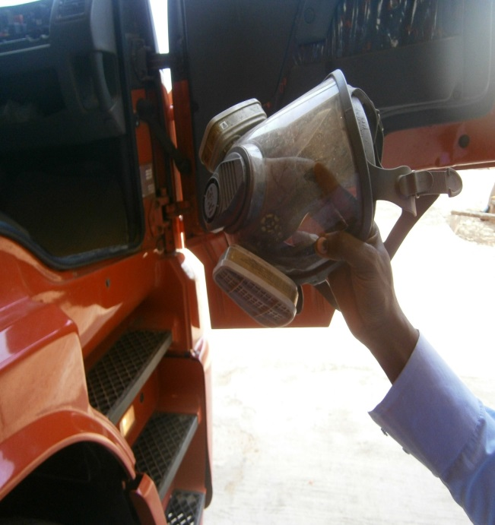  Figure 1 – A face mask used by the Nigerian firefighters in place of breathing apparatus sets | 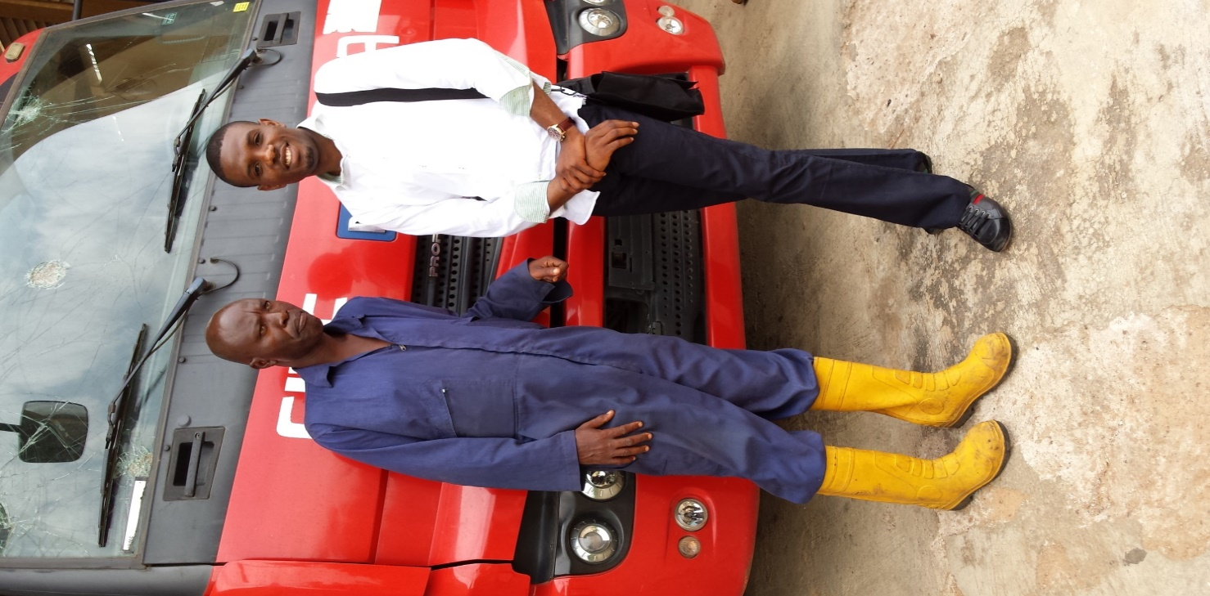  Figure 2 – A rubber boot used by the Nigerian firefighters in place of safety boots

4.2 Cultural bias towards the use of certain technology
Although a significant difference in the level of firefighting equipment and resource capabilities between both countries exist (see Table 3, Fig 1 & Fig 2), an interesting finding emerged from the analysis of the transcripts that seemed to provide further explanation to the differences that exist between the two groups of firefighters. A cultural bias against the use of breathing apparatus was identified amongst some of the Nigerian firefighters, which was traceable to the information they received in their training school. One of the officers reported that although they were told the importance of using breathing apparatus sets when fighting massive fires, they were also advised on the need to constantly breathe in “natural” air. In other words, these officers believe that since breathing apparatus sets do not supply natural oxygen then constantly relying on “artificial” oxygen from the appliance will eventually prove detrimental to their health in the long run.
“Sometimes you may not have BA; you have one handkerchief [face towel] to cover your nose…..You see in any fire we are always advised to use BA; but what we learnt is that to use BA, you will not feel comfortably or enjoy free air like this” (Sammy, 8, FSO, Nigeria)
In contrast, in none of the UK incidents did any of the officers enter a well-alight building without their breathing apparatus sets. One of the UK officers when asked about their entry procedure into a well-alight building reported thus:
“It was very much a rule that we have a person and another person with an electronic board and they monitor the firefighters that are deployed to the building, it’s a very safe system and we wouldn’t deviate from that at this fire because there was no need to” (Jade, Crew commander, 15, UK)
5. Discussion and implications for practice
The current study compared the firefighting strategies of the UK and Nigerian firefighters and particularly examined how technology affects task performance between the two groups. A number of scholars have accused the Nigerian fire service of being highly disorganized, judging from their work ethics and the way they generally respond to fire calls (Esinwoke 2011; Dare, Oke and Olanrewaju, 2009). For example, in a study that examined the economic implications of fire incidents in Lagos state (the largest commercial city in Nigeria), Cobin (2013) noted that serious gaps exist in the operational procedures and approaches to firefighting across some major cities in Nigeria. It has also been reported that most of the cities in the country often lose properties worth millions of dollars (and sometimes human lives) to serious fire outbreaks due to negligence on the part of the fire service (Dare, Oke and Olanrewaju, 2009). The saddest part of the story relates to the helplessness surrounding these Nigerian firefighters when managing major fire incidents. But as revealed in the current study, and in fairness to the firefighters, the moribund state of the fire service in the country is perhaps mainly due to the gross neglect of the institution by the Nigerian government. The lackadaisical attitude of the firemen, including their late arrival to fire scenes is best attributed to the weak infrastructural and technological development in the fire service. Although these conditions did not necessarily affect the overall performance of the Nigerian firefighters from the point of view of the incidents they reported in the study, the participants emphasized the massive holes that exist in the fire service ─ which they claimed is currently under-resourced. The drive in the firefighters and their awareness of the need to improve response efforts is probably an indicator of their willingness to learn when equipped with better equipment. Their counterpart, the UK firefighters, are much better equipped with advanced firefighting appliances that effectively enhanced task performance. This ranged from well-equipped personal protective equipment (PPE) to modern fire engines with automatic coupled hose to specialist appliances such as foam tender and aerial fire helicopters. Nonetheless, this study acknowledged the potential difficulty in comparing the effectiveness of task performance between the two groups of firefighters. The two groups of experts approached their firefighting duties uniquely as they differed in their organizational, environmental and operational setup. Cultural theorists have explained the importance of context in explaining people’s culture (way of doing things) and how meaning could easily be lost by attempting to understand internalized behaviour outside of the environment where such behaviour was developed (Hofstede, 1983; Schein, 2004). Gigerenzer used the term ecological rationality to demonstrate that rationality and behaviour are not only bounded, but also ecological (Gigerenzer, 2008). The term ecological suggests that performance is context-based and driven by the features of a particular environment. At best, one can be tempted to say that the UK firefighters managed the complex fire incidents extremely well with the support of high firefighting technology coupled with the advanced firefighting training they have acquired, while their Nigerian counterparts can be said to have coped extremely well with the task constraints despite being under-resourced.
Findings from the study also suggest that more need to be done in addition to providing better firefighting appliances for the Nigerian firefighters ─ their cultural orientations must also be redressed. Culture is one element that shapes people’s beliefs, values, attitudes and work ethics according to Hofstede (1983), and this statement was found to be true with both groups of firefighters. For example, even though the Nigerian firefighters acknowledged that breathing apparatus sets are designed to supply oxygen to operators while performing tasks under stringent conditions (excessive heat, smoke-log, combustible flames), most of the officers often fail to “trust” this equipment and rather prefer inhaling natural air by using water from the hosereels to support breath. This notion was thought to them as the best way to improvise in the absence of breathing apparatus sets, but however seems to exceed the limits of safety from all indications.
Perhaps one of the main cultural differences between the two groups lies with the way the use of certain technology and procedures on the fire ground have been instilled on officers as an acceptable way of doing things. The UK firefighters tend to see the use of breathing apparatus sets or PPEs as a moral as well as a legal requirement in the work domain, whereas such rigid complaint measures seem to be lacking in the Nigerian fire service
6. Conclusion
The notable differences that were found to exist between the two groups related mainly to non-cognitive factors such as (equipment and training), although it is important to note that the experts across both groups made fireground decisions that were appropriate to their respective task environments (context-based decisions) using the resources available to them. The Nigerian firefighters also provided evidence that suggests the need for reinforcement in the aspect of modern and up-to-date firefighting facilities. Would the Nigerian fire service become more effective if it were to be provided with better equipment? Would they be better-off if provided with more advanced training? Would the UK firefighters be able to cope if placed under the same conditions as their Nigerian counterparts? What cultural differences exist from the cognitive aspects of fire-fighting between the UK and the Nigerian fire service? What can the two groups learn from each other, if anything? These questions require further investigation and research is ongoing in these areas.
References
Burke, E., Hendry, C. (1997). Decision making on the London incident ground: an exploratory study. Journal of Managerial Psychology., 12(1), 40-47.
Calderwood, R., Crandall, B. W., Baynes, T. H. (1990). Protocol analysis of expert/novice command decision making during simulated fire ground incidents. Klein Associates, Yellow Springs OH.
Cobin, J. M. (2013). The Enterprise of Fire Safety Services in Lagos, Nigeria. The Independent Review, 17(3), 379-414.
Dare, A. A., Oke, S. A., Olanrewaju, K. L. (2009). Incidents of fire outbreaks during fuel truck accidents in Oyo State. Disaster Prevention and Management: An International Journal, 18(4), 443-450.
Gigerenzer, G. (2008). Why heuristics work. Perspectives on Psychological Science, 3 (1), 20–29.
Hoffman, R.R., Crandall, B., Shadbolt, N.R. (1998). Use of the Critical Decision Method to elicit expert knowledge: A case study in the Methodology of Cognitive Task Analysis. Journal of Human Factors and Ergonomics Society, 40(2), 254-276
Hofstede, G. (1983). The cultural relativity of organizational practices and theories. Journal of international business studies, 14 (2), 75-89.
Klein, G (2003). The power of Intuition: How to use your gut feelings to make better decisions at Work. New York: Doubleday
Klein, G., Calderwood, R., Clinton-Cirocco, A. (2010). Rapid decision making on the fire ground: The original study plus a postscript. Journal of Cognitive Engineering and Decision Making, 4 (3), 186-209.
Lave, J., Wenger, E. (1991) Situated learning: Legitimate peripheral participation. UK: Cambridge university press.
Lipshitz, R., Omodei, M., McLennan, J., Wearing, A. (2007). What’s burning? The RAWFS heuristic on the fire ground’, in Expertise out of context: Proceedings of the sixth international conference on naturalistic decision making, 97-111.
Maqsood, T., Finegan, A., Walker, D. (2004). Biases and heuristics in judgment and decision making: The dark side of tacit knowledge. Issues in Informing Science and Information Technology, 1, 295-301.
McLennan, J., Holgate, A. M., Omodei, M. M., Wearing, A. J. (2006). Decision making effectiveness in wildfire incident management teams. Journal of Contingencies and Crisis Management, 14(1), 27-37.
Nonaka, I. (1994). A dynamic theory of organizational knowledge creation. Organization science, 5 (1), 14-37.
Nonaka, I., Von Krogh, G. (2009). Perspective —Tacit knowledge and knowledge conversion: Controversy and advancement in organizational knowledge creation theory. Organization science, 20 (3), 635-652.
Okoli, J. O., Weller, G., Watt, J., Wong, B. L. W. (2013). Decision making strategies used by experts and the potential for training intuitive skills: A preliminary study. In H. Chaudet, L. Pellegrin, & N. Bonnardel (Eds.), Proceedings of the 11th international conference on naturalistic decision making, Marseille, France, 21-24 May 2013 (pp. 227-232).
Okoli, J.O., Weller, G., Watt, J. (2014). Eliciting Experts' Knowledge in Emergency Response Organizations. International Journal of Emergency Services, 3(2), 118-130
Okoli, J., Watt, J., Weller, G., Wong, W. B. L. (2016a). The role of expertise in dynamic risk assessment: A reflection of the problem-solving strategies used by experienced fireground commanders. Risk Management. doi:10.1057/rm.2015.20
Okoli, J.O., Weller, G., Watt, J. (2016b). Information filtering and intuitive decision making model: Towards a model of expert intuition. Journal of Cognition, Technology and Work, 18 (1), 89-103
Schein, E.H. (2004). Organizational Culture and Leadership. New York: John Wiley and sons
Tissington, P.A., Flin, R. (2005). Assessing risk in dynamic situations: Lessons from fire service operations. Risk Management, 7(4), 42-51
Wong, B. L. W. (2004). Data analysis for the Critical Decision Method, in D. Diaper & N. Stanton (ed.) Task Analysis for Human-Computer Interaction. Mahwah, NJ: Lawrence Erlbaum Associates, pp. 327-346

