**Bird communities in the buffer lands of Epping Forest**

Thomas E. Dickins

Faculty of Science and Technology

Middlesex University

London NW4 4BT

t.dickins@mdx.ac.uk

Andrew Froud

City of London Corporation

Epping Forest

The Warren

Essex IG10 4RW

**Abstract**

A farmland site in the green-belt buffer lands to the north of Epping Forest was surveyed for bird species across one calendar year. This is the first known effort in this area. The principal focus was upon birds listed on the Farmland Bird Index, but all species encountered were recorded, giving 41 species in total. Diversity and dominance data is presented for the whole year and across seasons. Eleven of the 19 indicator species were registered, and ten of those were present during breeding season. The majority of the missing eight species are red listed and in population decline, but so are some of those recorded. Generalist species were more readily registered. Woodpigeon is the dominant species, from two forms of analysis. The limitations of this survey and next steps are discussed.

**Introduction**

The Royal Society for the Protection of Birds (RSPB) and the British Trust for Ornithology (BTO) developed the Farmland Bird Index (FBI) in the 1990s (Gregory et al. 2004). The farmland guild that was originally created included 28 species that fed in open farmland during the breeding season. Six of these species were very rare, and hard to survey, two were introduced species, and one was nocturnal and again hard to survey. The remaining 19 species (Table 1) were more easily surveyed and already well monitored through the Common Bird Census and then the Breeding Bird Survey. These species became the indexical birds used to assay population trends and inform conservation measures (Aebischer et al. 2015; Wilson et al. 2009).

**Table 1:** Nineteen species of farmland birds used in the Farmland Bird Index.

|  |  |
| --- | --- |
| Common name | Species |
| Tree Sparrow | *Passer montanus* |
| Corn Bunting | *Emberiza calandra* |
| Turtle Dove | *Streptopelia turtur* |
| Grey Partridge | *Perdix perdix* |
| Yellow Wagtail | *Motacilla flava* |
| Starling | *Sturnus vulgaris* |
| Linnet | *Carduelis cannabina* |
| Lapwing | *Vanellus vanellus* |
| Yellowhammer | *Emberiza citrinella* |
| Skylark | *Alauda arvensis* |
| Kestrel | *Falco tinnunculus* |
| Reed Bunting | *Emberiza schoeniclus* |
| Whitethroat | *Sylvia communis* |
| Greenfinch | *Carduelis chloris* |
| Rook | *Corvus frugilegus* |
| Stock Dove | *Columba oenas* |
| Goldfinch | *Carduelis carduelis* |
| Woodpigeon | *Columba palumbus* |
| Jackdaw | *Corvus monedula* |

Epping Forest is managed by the City of London Corporation and extends from the town of Epping (Essex) to Wanstead Flats (London). It is approximately 19km long and 4km at its widest point. The forest consists of mixed deciduous woodland and open grasslands, with some heath and bog. There are ponds and ephemeral streams that drain through the forest. More than two thirds of the forest is a Site of Special Scientific Interest. A similar sized area is designated a Special Area of Conservation. The forest is protected by a buffer zone of farmland to the north. This farmland has not been surveyed for bird species presence and diversity. In order to rectify this omission, and assay the health of this area, a transect survey was conducted in a region of this buffer land for one calendar year. The main objective was to gain a sense of the farmland birds present at the site in order to develop some kind of baseline measure for future surveying and possible conservation initiatives. The results of this survey are reported here. The principal interest is the presence or possible absence of FBI listed species.

**Methods**

**Site:** A set of three fields and some marginal land along a track were chosen in the greenbelt buffer land of Epping Forest near to Copped Hall, just north of the M25 (see Figure 1). The area is dominated by arable farming, with patches of deciduous woodland, coniferous plantation, and some hedgerow along field boundaries. Some field margins have been left to seed and support wildlife. To the north of the site is the Cobbin’s Brook. A number of ditches run across the site, carrying water for most of the year. To the south of the site are a hamlet, some outlying properties, and Copped Hall, which is currently under renovation.

**Method:** The survey lasted for a calendar year (March 2016 to February 2017). Data was collected once each month (other than July 2016) at approximately the same time of day (see Table 2).

**Table 2:** Survey dates (2016-2017) and start-stop times for each transect. Transect 2 has no data on 16 November 2016 as surveying was stopped due to shooting near to that transect.

|  |  |  |  |  |
| --- | --- | --- | --- | --- |
|  | Transect 1 |  | Transect 2 |  |
|  | Start | Stop | Start | Stop |
| 23 March | 10:35 | 10:55 | 11:12 | 11:40 |
| 13 April | 09:42 | 10:15 | 10:17 | 10:50 |
| 16 May | 10:05 | 10:45 | 10:50 | 11:30 |
| 28 June | 09:55 | 10:28 | 10:31 | 11:04 |
| 4 August | 09:40 | 10:15 | 10:20 | 11:50 |
| 8 September | 09:45 | 10:30 | 10:34 | 11:11 |
| 3 October | 09:32 | 10:34 | 10:45 | 11:47 |
| 16 November | 10:55 | 11:36 | - | - |
| 14 December | 09:35 | 10:13 | 10:18 | 10:52 |
| 12 January | 09:40 | 10:11 | 10:15 | 10:58 |
| 8 February | 09:55 | 10:35 | 10:38 | 11:13 |

Two transects were established (Figure 1) and a GIS map produced, dividing the survey area into 50x50m grid squares (see Map 1). Transects were not straight lines, due to the nature of the terrain and the need to avoid disrupting farming activities. Each transect was walked at a slow pace and all bird species seen were registered and marked upon the map in order to estimate distribution across the site. Registration included species (using BTO codes), number, and basic behavioural categories (foraging, flight etc.). All registrations were made of birds orthogonal to or in front of the observer. No backward observations were registered. Any mammals encountered were noted (data available upon request). The same observer (TD) collected all data on dry days (weather data available upon request).

Transect 1 (0.92km) began at a cattle grid at the south of the site (51o 41.837’ N, 0o 4.255’ E), following a central track for farm vehicles through two fields. At the north west of the second field is a patch of set aside field margin, bounded by a ditch to the south and a hedgerow to the north, and consisting mainly of grasses, sedges and thistle. The transect turned west at the north of this patch and continued to the end where surveying stopped (51o 42.155’ N, 0o 4.14’ E). Prior to this patch both sides of each field were surveyed up to the ditch, including low-lying scrub along the track. Once at the ditch surveying was paused until just north of the patch, then data collection resumed for the patch only. Birds in the hedgerow to the north were not included. The area mapped using this transect was 17.96 hectares.

Transect 2 (1.25km) began in the south west corner of the most northerly field (51o 42.167’ N, 0o 4.161’ E) and ran along the edge of the woodland. Birds within the woodland were not surveyed, such that only birds that emerged from the woods, or were already on or over the field were included. Similarly as the transect turned east at the north end, and ran along the Cobbin’s Brook, birds on the brook and surrounding hedgerow were not recorded. At the eastern edge of this field the transect crossed a hedgerow through an access gap and re-joined the original farm track. The transect then turned south along this track and surveying of the field margin along the western edge of this track and the hedgerow was conducted. The survey ended at a pylon abutting the track (51o 42.389’ N, 0o 4.484’ E see Map 1). The area mapped using this transect was 23.3 hectares.

**Figure 1:** Aerial view of the field site compiled using Google Earth Pro. The blue transect (1) is 0.92km and the red transect (2) is 1.25km in length. Fields either side of transect 1 were surveyed. The field bounded by transect 2 was surveyed. The two polygons, denoting field margins were only surveyed when walking along the length. Thus the larger of the polygons was surveyed from transect 1, to the north; and the smaller from transect 2, along its eastern edge. See text for details.

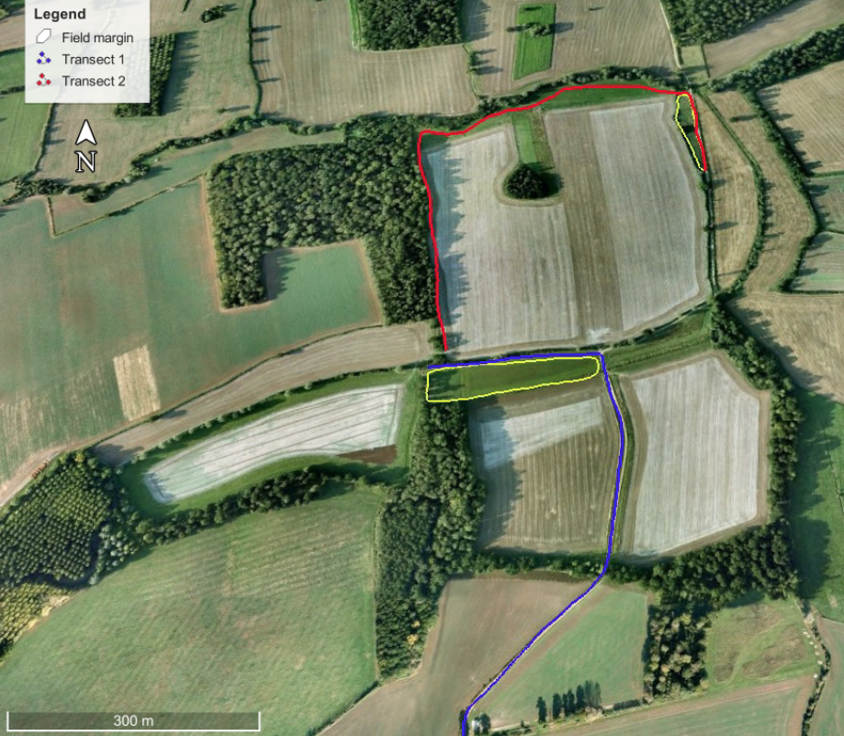

**Map 1:** Map of the entire field site with overlaid 50x50m grids (scale 1:5000). Map data from Ordnance Survey Open Source (TL40) and compiled using QGIS. Larger versions of this map were used in the field to record data.

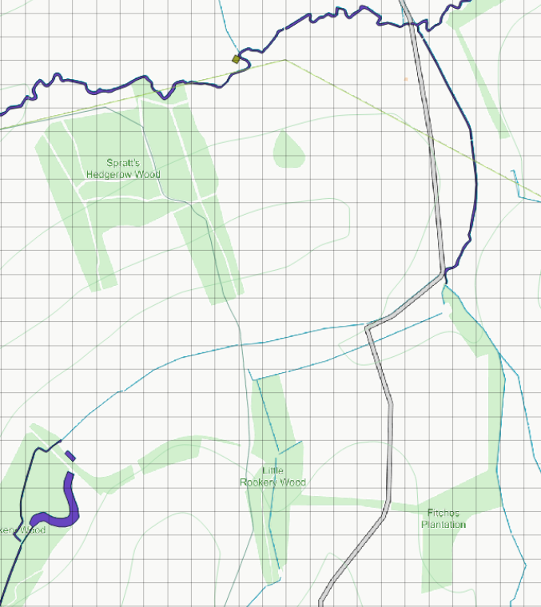

**Results**

Table 3 displays all of the 41 bird species registered and their rank abundance for the entire year, and then by season. The mean number of species recorded for each season was 22, with a standard deviation of 3.16.

Shannon biodiversity (H) and Simpson dominance (D) indices were calculated. As Bibby et al. (2000) note, diversity indices are difficult to interpret as they increase with increasing species richness. In order to counter this issue we have calculated the exponential of the diversity index (Exp-H) as well as the inverse of the dominance index (1/D) (Jost 2006). These calculations yield the effective number of species (Figure 2). We have not calculated a statistical species richness value, but instead simply reported the number of species observed across the year and in each season.

**Table 3:** Species registered (name, BTO code) and rank abundance for the whole year and each season (March 2016 to February 2017)

|  |  |  |  |  |  |  |  |
| --- | --- | --- | --- | --- | --- | --- | --- |
| SPECIES |  | CODE | RANK ABUNDANCE | | | | |
|  |  |  | Year | Spr. | Sum. | Aut. | Win. |
| Woodpigeon | *Columba palumbus* | WP | 1 | 1 | 1 | 1 | 1 |
| Canada Goose | *Branta canadensis* | CG | 2 | - | - | 2 | - |
| Carrion Crow | *Corvus corone* | C. | 3 | 3 | 2 | 11 | 2 |
| Jackdaw | *Corvus monedula* | JD | 4 | 2 | - | 5 | 3 |
| Grey Partridge | *Perdix perdix* | P. | 5 | 6 | 9 | 3 | 4 |
| Pheasant | *Phasianus colchicus* | PH | 6 | 4 | 9 | 4 | 7 |
| Ring-necked Parakeet | *Psittacula krameri* | RI | 7 | 5 | - | - | 6 |
| Buzzard | *Buteo buteo* | BZ | 8 | 12 | 9 | 11 | 7 |
| Reed Bunting | *Emberiza schoeniclus* | RB | 9 | 12 | - | - | 5 |
| Magpie | *Pica pica* | MG | 10 | 12 | 9 | 8 | 11 |
| Skylark | *Alauda arvensis* | S. | 10 | 7 | 9 | 7 | - |
| Yellowhammer | *Emberiza citrinella* | Y. | 10 | 9 | 4 | 16 | 16 |
| Blackbird | *Turdus merula* | B. | 13 | 9 | 9 | - | 10 |
| Goldfinch | *Carduelis carduelis* | GO | 13 | - | - | 5 | 16 |
| Robin | *Erithacus rubecula* | R. | 13 | 9 | - | 15 | 11 |
| Whitethroat | *Sylvia communis* | WH. | 16 | 18 | 3 | - | - |
| Blue Tit | *Cyanistes caeruleus* | BT | 17 | 7 | - | 16 | 16 |
| Kestrel | *Falco tinnunculus* | K. | 17 | 18 | 6 | 11 | - |
| Red Kite | *Milvus milvus* | KT | 17 | - | - | - | 7 |
| Rook | *Corvus frugilegus* | RO | 17 | - | 6 | 8 | - |
| Wren | *Troglodytes troglodytes* | WR | 17 | - | 6 | 16 | 11 |
| Starling | *Sturnus vulgaris* | SG. | 22 | - | 9 | 8 | - |
| Great Tit | *Parus major* | GT | 23 | - | - | 16 | 16 |
| Chaffinch | *Fringilla coelebs* | CH | 24 | 18 | - | 16 | 16 |
| Green Woodpecker | *Picus viridis* | G. | 24 | 12 | 9 | - | - |
| Mistle Thrush | *Turdus viscivorus* | M. | 24 | - | 5 | - | - |
| Swallow | *Hirundo rustica* | SL | 24 | - | - | 11 | - |
| Cuckoo | *Cuculus canorus* | CK | 28 | 12 | - | - | - |
| Goshawk | *Accipiter gentilis* | GI | 28 | - | - | - | 14 |
| Jay | *Garrulus glandarius* | J. | 28 | - | 9 | - | 16 |
| Mallard | *Anas platyrhynchos* | MA | 28 | - | - | - | 14 |
| Brambling | *Fringilla montifringilla* | BL | 32 | - | - | - | 16 |
| Chiffchaff | *Phylloscopus collybita* | CC | 32 | 18 | - | - | - |
| Collared Dove | *Streptopelia decaocto* | CD | 32 | - | 9 | - | - |
| Dunnock | *Prunella modularis* | D. | 32 | 18 | - | - | - |
| Great Spotted Woodpecker | *Dendrocopus major* | GS | 32 | 18 | - | - | - |
| Grey Heron | *Ardea cinerea* | H. | 32 | - | - | - | 16 |
| Long-tailed Tit | *Aegithalos caudatus* | LT | 32 | 18 | - | - | - |
| Song Thrush | *Turdus philomelos* | ST | 32 | - | - | - | 16 |
| Woodcock | *Scolopax rusticola* | WK | 32 | 18 | - | - | - |
| Willow Warbler | *Phylloscopus trochilus* | WW | 32 | - | - | 16 | - |
|  | ***TOTAL SPECIES*** |  | **41** | **25** | **18** | **21** | **24** |

**Figure 2:** Species richness (number of species seen; right hand y-axis), diversity (Exp H) and dominance (1/D; both on left hand y-axis) for each season and the entire year (March 2016 to February 2017). See text for details.

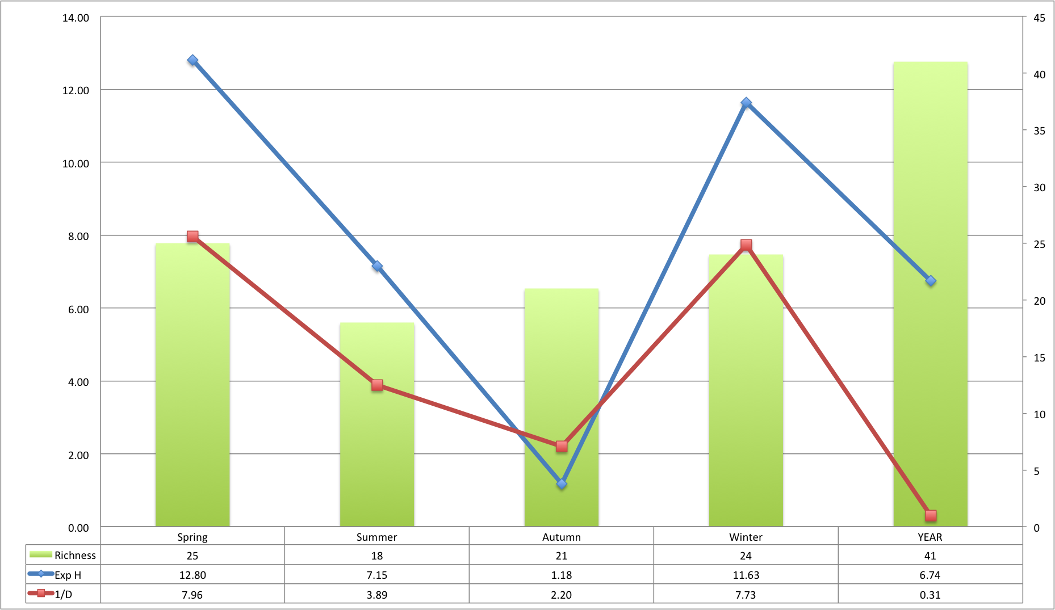

An effective number of species value equates to the number of equally common species within a population. From Figure 2, we can see that the effective number of species calculated as Exp-H is approximately 13 in the spring of 2016, seven in the summer, one in the autumn and 12 in the winter. The dominance index (1/D) tells us how many species are equally dominant across seasons: approximately eight in spring and winter, four in summer and two in autumn.

Rank abundance may mask issues of detectability (Bibby et al. 2000) such that harder to detect birds are registered less frequently. In order to investigate this issue Pareto charts were constructed for the whole year, and then for each season (Figures 3 and 4). The Pareto Principle, applied to ornithological surveys, assumes that 80% of the birds seen in a survey belong to 20% of the species registered (Rispoli et al. 2014). It is worth noting that the dominance values (1/D) approximately correspond to the number of species that make up circa 80% of the registrations in each season.

**Figure 3:** Pareto chart for the whole year. The chart gives total count (left-hand y-axis) for each species and their rank order of abundance from left to right on the x-axis. The cumulative percentage gain in species counts is also given (right hand y-axis). The Pareto Principle would predict that approximately 80% of the registrations come from 20% of the total species. This chart can be treated as a rank-abundance diagram, such that the steeper the count slope, the less diverse the community. See text and Table 3 for details.

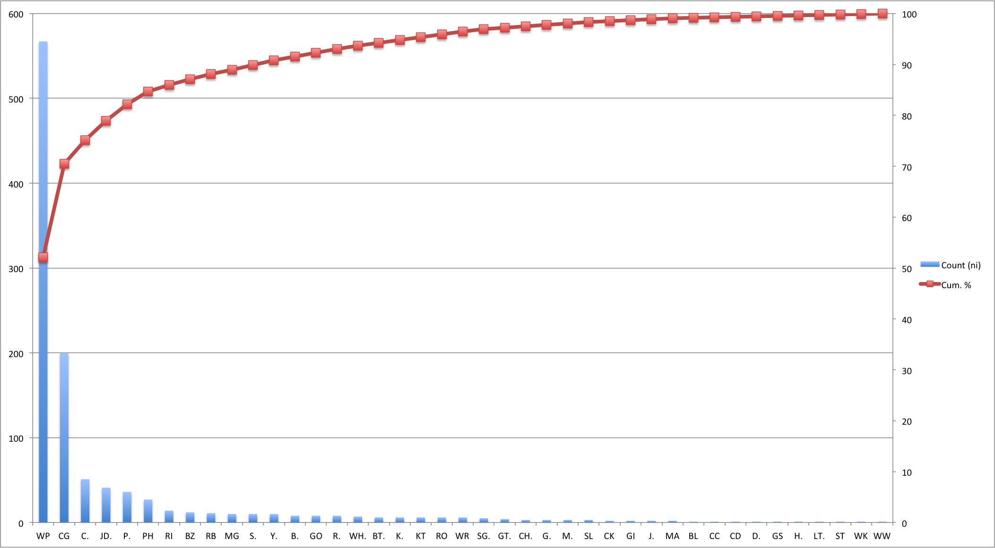

The Pareto charts produced from this survey indicate that the precise 80:20 formulation of the Pareto Principle has not been upheld, but the general principle of a small number of species dominating the observations does stand. Detectability issues are caused by the physical and behavioural phenotype of the bird but also by seasonal variation in distribution of birds. None the less, the consistent occurrence of particular species within 80% of registrations will give some indication of community structure, as will shifts in the 20% tail. Furthermore, the steeper the count curves on the Pareto charts, the less diverse the community structure.

Spring and Winter periods are more diverse than summer and autumn (Figure 4). Autumn has a particularly steep count curve, caused by a large number of Woodpigeons (WP) and Canada Geese (CG). The latter were the result of a one-off sighting during migration; the former, the cumulative count across the season as Woodpigeons moved about in search of berries and other food. It is noteworthy that following the autumn increase in Woodpigeon, Goshawk (GI) sightings were registered during the winter surveys. A number of likely Goshawk kills were found at this time. Red Kite (KT) were also registered during the winter season, for the first time in the year, and at one point seen near to a Goshawk with what looked to be a kill. Red Kites will often take food from other birds. Predators will track changes in community structure via abundance of prey items (Beckerman et al. 2006; Charnov 1976), and so this apparent shift in the registrations across seasons has partial support.

It is clear from the Pareto charts, and the data in Table 3, is that 11 of the 19 key indicator farmland birds have been registered (Gregory et al. 2004). This means that eight key indicator species have not been registered at all throughout the calendar year (Tables 1 and 5). The predominant indicator species is the Woodpigeon (WP), with good showings from Carrion Crow (C.), Jackdaw (JD), and Grey Partridge (P.) in the top 80% of registrations across seasons and the year.

**Figure 4:** Pareto charts for spring, summer, autumn and winter. Each chart gives total count (left-hand y-axis) for each species and their rank order of abundance from left to right on the x-axis. The cumulative percentage gain in species counts is also given (right hand y-axis). The Pareto Principle would predict that approximately 80% of the registrations would come from 20% of the total species. These charts can be treated as rank-abundance diagrams. See text and Table x for details.

*Spring 2016 Summer 2016*

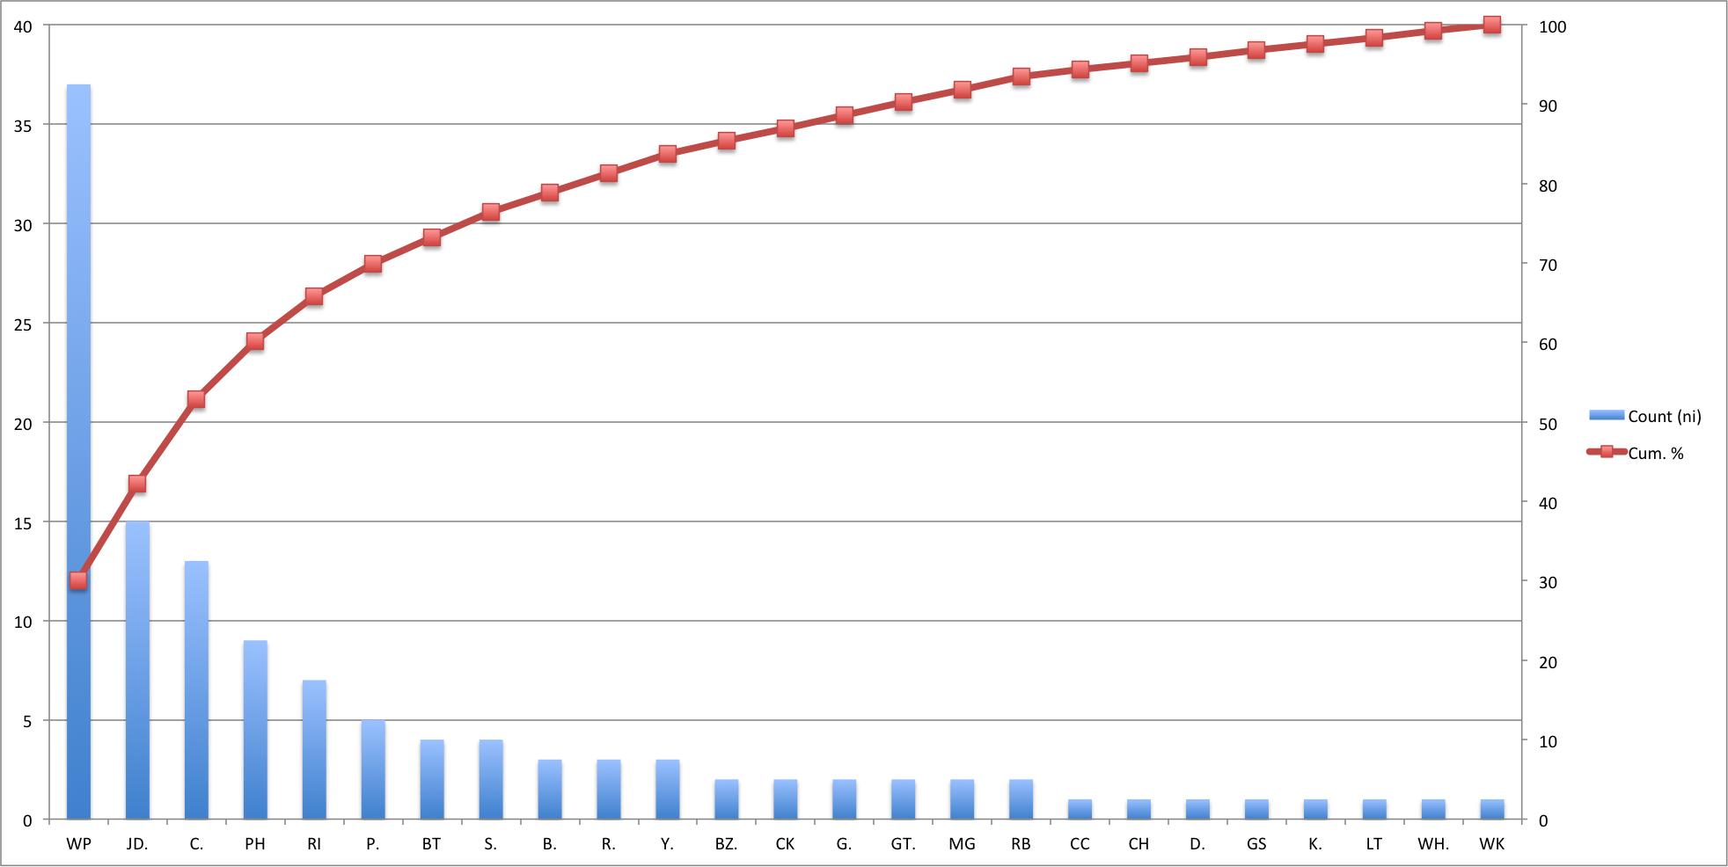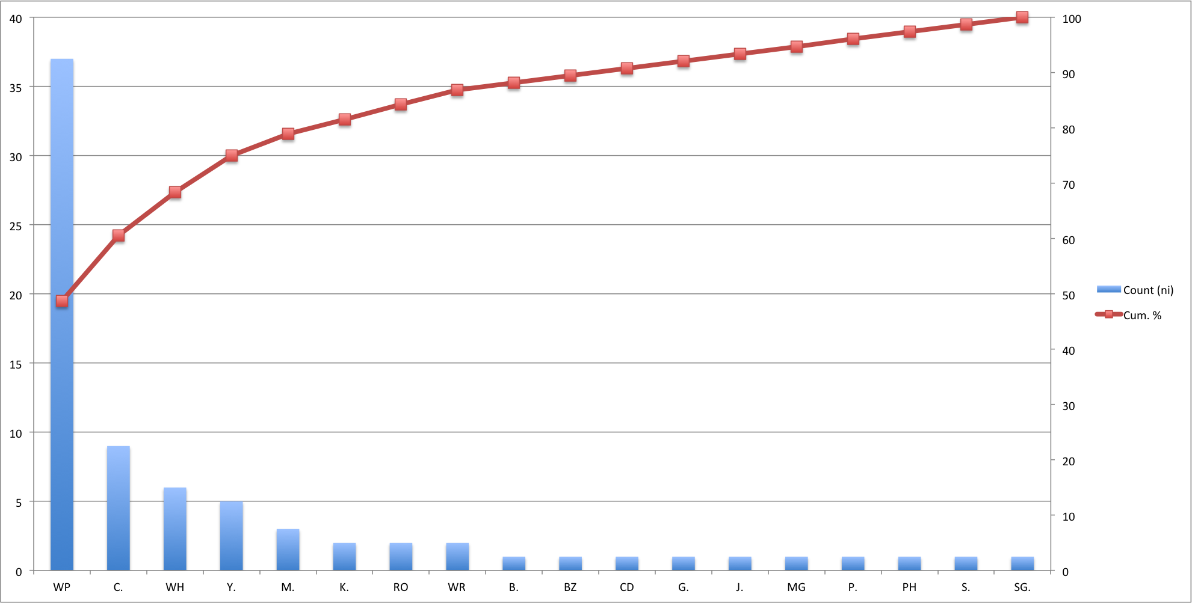

*Autumn 2016 Winter 2016/7*

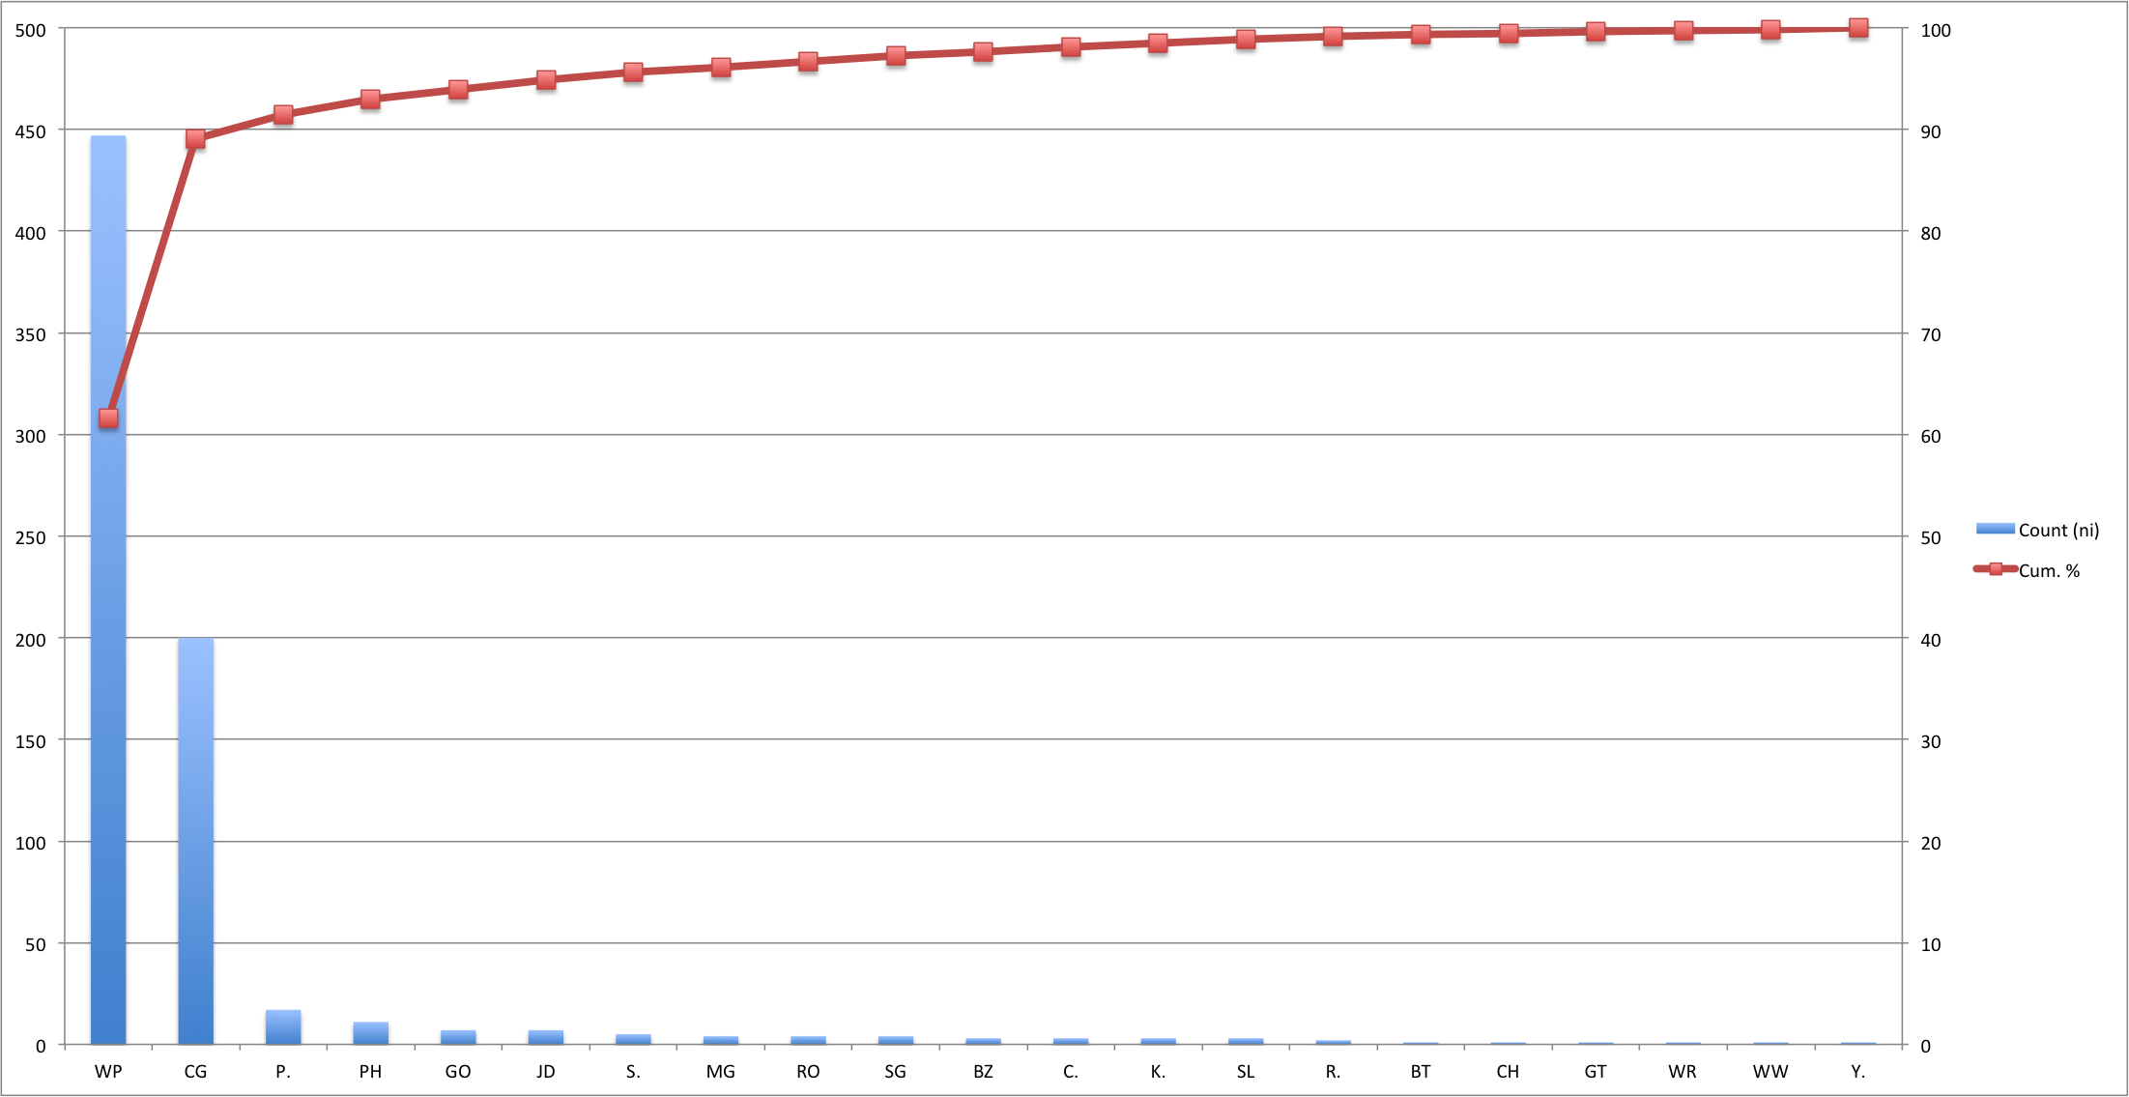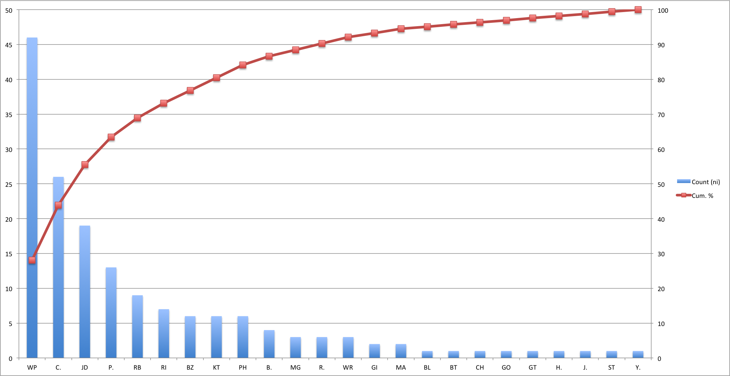

All observed species were divided into guilds dependent upon feeding ecology, habitat use and other behavioural aspects (James et al. 2010; Table 4). This guild structure was adopted as clearly not all birds registered conformed to the farmland bird guild of the FBI and this method gives greater information about other requirements of the species registered. This division demonstrates that the guild with the largest representation is that of the generalists.

**Table 4:** Species guilds for birds registered in the reported survey (James et al. 2010) and the number of species seen in each guild. Species have been allocated to one guild only in the table. Buzzards could also be seen as woodland specialists; Long-tailed Tits as feeding on invertebrates; and Grey Herons as waterbirds. The generalist guild is determined by the exploitation of a wide range of environments by the species.

|  |  |  |
| --- | --- | --- |
| Guild | Member Species | Number of Species |
| Waterbirds | Canada Goose; Reed Bunting; Mallard | 3 |
| Feeding on invertebrates | Whitethroat; Blue Tit; Great Tit; Chiffchaff | 4 |
| Woodland specialists | Green Woodpecker; Jay; Great Spotted Woodpecker; Willow Warbler | 4 |
| Nest built with lichens | Chaffinch; Long-tailed Tit | 2 |
| Raptors | Buzzard; Kestrel; Red Kite; Goshawk | 4 |
| Farmland seedeaters | Grey Partridge; Pheasant; Skylark; Yellowhammer; Goldfinch | 5 |
| Aerial insectivores | Swallow | 1 |
| Generalists | Woodpigeon; Carrion Crow; Magpie; Blackbird; Robin; Wren; Starling; Mistle Thrush; Collared Dove; Dunnock; Song Thrush | 11 |
| Locally distributed colonial birds | Jackdaw; Rook; Grey Heron | 3 |
| Waders | Woodcock | 1 |
| Other | Ring-necked Parakeet; Cuckoo; Brambling | 3 |

Two of the species not registered in the present survey might be seen as generalists also (Table 5), though the breadth of ecological niches occupied by Linnets is narrower than that of Greenfinches. All but two of the eight non-registered farmland birds are red-listed in the fourth Birds of Conservation Concern report (Eaton et al. 2015). The population decline of these six species might account for their non-appearance. This does not mean that these species are not present at the site, but perhaps the detectability of some is lower. However, Lapwings are usually fairly easy to detect as larger birds with distinctive flight, call and display behaviours. Tree Sparrows may have been missed as little of the hedgerow was directly surveyed. As this species is notoriously shy of human presence individuals may have taken cover in advance of the surveyor. Of those eleven FBI species that were registered, only four were red-listed, two were amber and five were green.

**Table 5:** Indicator farmland bird species not registered during the reported survey, with Birds of Conservation Concern 4 status (Eaton et al. 2015), 2016 population trend ([www.bto.org/birdtrends](http://www.bto.org/birdtrends)) and guild memberships (James et al., 2010). Note that some species are given more than one guild, depicting a shift in behaviour across seasons. All species are found on farmland, but some are also found in a variety of other environments.

|  |  |  |  |
| --- | --- | --- | --- |
| Common name | List status | >50% population decline over 31-47 years | Guild |
| Tree Sparrow | Red | Yes | Farmland seedeaters |
| Corn Bunting | Red | Yes | Farmland seedeaters & feeding on invertebrates (summer) |
| Turtle Dove | Red and Globally Threatened | Yes | Farmland seedeaters |
| Yellow Wagtail | Red | Yes | Feeding on invertebrates |
| Linnet | Red | Yes | Generalists |
| Lapwing | Red | Yes | Waterbirds |
| Greenfinch | Green | No | Generalist |
| Stock Dove | Amber | No | Woodland specialists & farmland seedeaters |

**Discussion**

Eleven of the 19 indicator species from the FBI were registered across the year at the Copped Hall field site. That is a 42% shortfall in FBI species. A further 30 species, not designated as farmland birds by the FBI, were also registered. Of these 30 species, ten are noted as having a greater than 50% population decline over the last 31-47 years ([www.bto.org/birdtrends](http://www.bto.org/birdtrends)).

The dominant species, determined using a Pareto chart, for the whole year were Woodpigeon, Carrion Crow, Jackdaw and Grey Partridge, and also an influx of Canada Geese during migration (Figure 3). Grey Partridge have had a greater than 50% population decline and are red-listed. All but Canada Geese and Carrion Crow appear on the FBI. Carrion Crow might best be described as a generalist species. A generalist and invasive species, Ring-necked Parakeets also had a good presence. Similar patterns are observed across the seasons (Figure 4). Simpson’s Dominance Index (1/D) gives Woodpigeons pole position as the most dominant species across the year.

Species diversity fluctuated across the seasons, with a large dip during autumn. Much of this is due to skew from influxes of Woodpigeons and migrating Canada Geese, but also low counts of other species. The blank entries in Table 3 give the pattern to absences, or rather non-registrations, across seasons. Looking at the 11 recorded FBI birds, only Goldfinches were not registered during a part of the breeding season. The remaining ten species were present in spring, summer or both seasons. More generally, patterns of non-registration might be attributed to seasonal changes in foraging, local migrations and territory changes.

One calendar year of data is not sufficient to draw detailed conclusions. The data reported will increase in value with continued and improved survey effort, enabling trends to be noted and related to changes in the overall habitat. However, the shortfall in FBI birds may well be due to the usual reasons associated with recent historical changes in agricultural practices, including intensification (Wilson et al. 2009). The habitat of the field site has not been surveyed in detail and this would be an obvious next step, in concert with continued bird surveying. Things to note will be the opportunity for breeding within the site, and the nature and extent of field margins, to give some idea of the amount of foraging opportunity. A neighbouring 17 hectare field, under watch for a different study, had four definite breeding territories for Skylarks. Informal conversation with local farmers yielded information about further Skylark nesting in adjacent farmland not belonging to Epping Forest. These areas may well provide different data. Indeed, it would be wise to investigate any gradients in diversity and dominance as farmland extends away from the M25 and forest margin.

Another pressure on farmland birds is predation. The presence of Carrion Crows poses a threat for nesting birds, as they will predate eggs and chicks. Magpies will behave similarly, and their numbers have probably been underestimated, as they will have kept to woodland and parkland areas not surveyed. Apex predatory birds were represented by the raptor guild. Buzzards and Kestrels (the latter on the FBI) were present throughout most of the year, but Goshawks and Red Kites appeared in the winter, notably after a spike in Woodpigeon registrations. This spike was probably due to Woodpigeons foraging for winter berries on the woodland and hedgerow margins of the fields. Red Kites eat a large variety of prey and are known kleptoparasites. They were seen monitoring Goshawk behaviour. There were low counts for raptors, which conforms to expectations given the size of site. It would be instructive to do a focused predator survey in order to calculate density, as this would provide an index of prey abundance.

The survey method adopted in this study has its limitations. Given the nature of the terrain, and access restrictions, the transects chosen did not enable a standard approach, with set widths of observation either side of the line (Bibby et al. 2000). It was decided to add a mapping technique more often used for territory mapping, in order to capture the activity within farmland fields. It is likely that this technique will have depressed any population estimates that might be drawn from count data due to detectability limitations that cannot be computed; but we are confident that our treatment of the data collected gives a good sense of species dominance and community structure. A point-survey method at key areas across the site might enable more detailed registration data and the using of density measures; a version of this method is at the core of the Game and Wildlife Conservation Trust Big Farmland Bird Count. Woodland and hedgerow surveying could more readily be incorporated also, as point surveys are designed to deal with more complex environments. With sufficient resource both methods might be adopted.

In summary, this field site conformed to national trends in the decline of key FBI bird species and is not therefore unusual. Continued monitoring may help in the design of conservation initiatives to protect existing species, but also to encourage the presence of others. This should be done in the context of mapping adjacent farmland and modelling of diversity gradients.

**References**

AEBISCHER, N.J. et al. (2015) Twenty years of local farmland bird conservation: the effects of management on avian abundance at two UK demonstration sites. *Bird Study*, 3657(October), pp.1–21. Available at: http://www.tandfonline.com/doi/full/10.1080/00063657.2015.1090391.

Beckerman, A.P., Petchey, O.L. & Warren, P.H. (2006) Foraging biology predicts food web complexity. *Proceedings of the National Academy of Sciences of the United States of America*, 103(37), pp.13745–13749.

BIBBY, C.J. et al. (2000) *Bird Census Techniques* 2nd ed., London: Academic Press.

CHARNOV, E.L. (1976) Optimal Foraging : Attack Strategy of a Mantid. *The American Naturalist*, 110(971), pp.141–151.

EATON, M.A. et al. (2015) Birds of conservation concern 4: The population status of birds in the United Kingdom, Channel Islands and Isle of Man. *British Birds*, 102(6), pp.296–341.

Gregory, R.D., Noble, G. & Custance, J. (2004) The state of play of farmland birds: population trends and conservation status of lowland farmland birds in the United Kingdom. *Ibis*, 146(Suppl. 2), pp.1–13.

James, P., Norman, D. & Clarke, J.J. (2010) Avian population dynamics and human induced change in an urban environment. *Urban Ecosystems*, 13(4), pp.499–515.

JOST, L. (2006) Entropy and diversity. *Oikos*, 113(2), pp.363–375.

RISPOLI, F.J. et al. (2014) Even birds follow Pareto’s 80-20 rule. *Significance*, 11(1), pp.37–38.

Wilson, J.D., Evans, A.D. & Grice, P. V. (2009) *Bird Conservation and Agriculture*, Cambridge: Cambridge University Press.