**Compensatory approaches and engagement techniques to gain flood storage in England and Wales.**

Simon McCarthy1, Christophe Viavattene1, John Sheehan2, Colin Green1

1Middlesex University London, Flood Hazard Research Centre, The Burroughs, London, UK.

2University of Technology Sydney, New South Wales, Australia and Faculty of Society and Design, Bond University, Australia

**Abstract**

Flood storage involves creating sacrificial land for water to purposefully inundate protect land downstream. Obtaining the right or co-operation to flood on private property remains a challenge. This paper based on empirical qualitative research with 14 key stakeholders involved in the practice of gaining land to flood in England and Wales the different forms of financial and economic approach that might be used to facilitate this right. Expropriation of land, one off-payment, annual single payment and flood event losses compensation were explored. Availability of funding as compensation is the main driver for landowner adoption of flood storage schemes. Three funding approaches were revealed; flowage easement, full land purchase and Agricultural Schemes funding diffuse storage. Rather than attempting to gain partnerships between spatially dislocated stakeholders in upper storage and lower impacted catchments success resides on the storage land and persuading landowner co-operation. A clear enforced legal framework of ownership of land and funding mechanisms is also viewed as essential.

Key words: Compensation, farmers, flood, flood storage, flood risk management, risk, flowage easement, water economics.

**Introduction**

Natural disasters are acutely experienced at a local level requiring approaches specific to the local circumstances where sustainable land management is an effective disaster risk reduction tool (Cambell et al., 2012). The spatial and temporal variability of flooding overlay socially and economically disparate populations and stakeholders (Howe & White, 2001). Policy drivers for inclusion of such stakeholders in decisions is informed by formal legislative requirements such as the Water Framework Directive (European Union 2000) the Aarhus Convention on stakeholder engagement and the EU Habitats and Birds directive (European Communities ECC 1992) translated into the Government Making Space for Water implementation (Defra 2005). The later document perhaps finds greatest resonance with flood storage approaches the focus of this paper.

This paper outlines the financial mechanisms and stakeholder management approaches that have been employed in England and Wales in order to secure land for the purpose of temporary upstream flood retention otherwise termed flood storage. Contributing to the continuing UK debate on upstream storage the paper pulls together the range of financial mechanisms and implementation techniques revealed from empirical social research. The paper does not set out the current context as the research was undertaken a number of years ago (2013) but presents in the absence of similar review literature conveniently summarised approaches for further discussion and future reference. In addition the focus is on the implementation techniques, a revealed gap in the literature, for encouraging landowner participation as seen through the eyes of those who regularly have to negotiate the terms for acquiring the land. The paper provides a policy and flood risk management context for flood storage before introducing the empirical research and key findings concluding with a brief discussion.

Flood storage can be defined as the temporary detention of floodwater. By capturing and storing the flood water peak flow the extreme volume is not passed downstream to cause flood inundation but gradually released when water levels have fallen. Flood storage is one of the many options used in flood risk management and has recently received greater interest at the European scale in response to the aforementioned challenges in sustainable flood risk management it’s associated policy and at a national UK scale in response to large scale flood events. Flood risk and the management of that risk is well established in the UK utilising a range of physical and behavioural mitigation approaches facilitated by economic and financial incentives (Environment Agency, 2009).

**Environmental Change and Property Rights**

Where the principle of flooding areas with expected lower losses (farmland) instead of high values areas (urban) is acceptable, obtaining the right to flood on private property remains a challenge. The role of flood risk management is to in part attend to managing injustices and minimising such inequalities. Johnson et al. (2007) highlighted the challenges of implementing flood risk management policy strategies in England in relation to ‘just, fair and equitable’ decisions in the allocation of restricted national funds sourced from tax payers’ money. While introducing a Partnership Funding mechanism provides the potential additional private, commercial and local authority resources the control of planning and implementation in relation to flood storage schemes remains within the governing and managing organisations and influenced by their particular agendas. Flood mitigation that challenges property rights in the form of flood storage creation and the economic mechanisms to facilitate resolution to such challenges becomes an issue.

In common law countries such as the UK, the clash between the expectations of holders of property rights in land and the disrespect of environmental changes for such rights is particularly evident (Resource Assessment Commission, 1993; Watson, 2015). When private property rights in land are commuted by current and climate-driven flooding on a much more frequent basis, the UK statutory protections of property (Bell, 2014) are drawn into question – who should pay to protect the private property or whom should compensation be sought for destruction of the land lying at the heart of the devalued property right.

Before addressing the impact of such an environmental change upon property rights it is necessary to further unpack flood storage, which can be succinctly described as the temporary detention on land of water derived from flood events. For fluvial storage by capturing and storing the flood water peak flow the extreme volume is not passed downstream to cause initial or further flood inundation but gradually released when water levels have fallen. Flood storage has been used in England as part of a land management strategy for many centuries. In UK flood risk management it is typically used as one of a number of approaches on a catchment and achieves a reduction rather removal of the risk of flooding altogether. Storage can be combined with approaches that include physical and behavioural resistance and resilience measures.

A flood storage scheme is composed of an area of land to hold water and structures to regulate the input and output of that water. The regulatory structures can be overspill banks and manual / automatic gates. There are two types of flood storage.’ On-line storage’ refers to where the river is not disconnected with the storage area but a damming structure or restriction causes water to back up to be stored upstream. ‘Offline flood storage’ is disconnected from the river either via flow structures or embankments that overspill purposefully (Hall et al.,1993). Also at a smaller scale natural flood infiltration and water flow reducing measures can be implemented and enhanced which collectively contribute to slowing the flow into watercourses.

**Approaches in implementation**

Dislocation between the upstream storage area and the downstream benefiting land or communities that means it is often difficult to justify to the upstream landowners to relinquish part or all of their property to participate in a storage scheme. That is a scheme that would involve the flooding of their land for beneficiaries they may feel little attachment to.

While the Water Framework Directive falls short of addressing spatial planning and flood issues the specifics in developing arrangements between source and recipients with the inclusion of incentivisation has been highlighted. Haupter et al., (2005) develop a formula of compensation for burden sharing of the disadvantage upstream advantaging the downstream stakeholders. Further research has broadened exploration of the challenges involving upstream and downstream partnerships and revealed the complexities and limitations of developing such an approach (Thaler et al., 2015; Thaler, 2014). In fact such approaches are found to be difficult to fully achieve and relied on ‘forced’ co-operation between stakeholders.

Programs resulting from the Floods Directive such as the Strategic Alliance for Water Management Actions provide guidance and tools for implementation and research further guidance in the physical assessment of water bodies including flood storage (water retention basins) (Yang et al 2012, Scholz and Yang, 2010). But little in the assessment of capabilities or approaches to engage stakeholders to implement approaches. There is recognition of the complexity and uncertainty surrounding this scale of implementation (Collins et al., 2007).

It will be shown that the main form of compensation for upstream land owners, mainly farming landlords, is dependent on forecasting the likely impact on the current management of the land. The highly dynamic (seasonality, crop use, climate change, land drainage) and local nature (weather forecast uncertainty) of agricultural flood impacts introduces uncertainty in forecast compensation (O’Connell et al., 2007). A formula for estimating costs can be deduced but some losses such as environmental stewardship may be revealed outside the assessment period (Morris and Brewin, 2014).

At the smaller scale off-line storage Farm Integrated Runoff Management Plans (Quinn et al 2007) utilise storage, infiltration, slowing and filtering of runoff on farms. Such features require maintenance to avoid reduced storage capacity (Verstraeten and Poesen, 1999). Approaches may slow the flow to downstream receptors enabling enhanced event responses thus reducing damages (Parrot et al. 2009). Wilkinson (2010) was unable to show a fixed amount of risk reduction but supported the approach to small rural and larger catchment flood management reducing downstream required standards of protection.

For large scale flood storage the focus has been given primarily to the upstream stakeholders but invariably partnerships need to have formed or require development between them in order to come to agreements for the implementation of storage. While Frey, (2001) provides a strategic characterisation of approaches to engaging stakeholders in negotiation specific implementation guidance is found wanting. Partnership is ‘not just about managing resources but it is also fundamentally about managing relationships’ (Graham & Ernstson, 2012, p3). It is the successful financial processes and management of such relationships in implementing flood storage that is the focus of this paper. Even further the research reveals practical techniques for implementing such financial mechanisms. Different forms of financial mechanisms are found to be required including expropriation of land, one off-payment, annual single payments, flood event losses compensation. The UK contexts may not be directly transferable to other governance contexts but aspects of learning and considerations revealed from this research could be instructive elsewhere.

**Methodology**

In the absence of literature at the scale of detailing actual implementation practices of financial compensation approaches and in the development of negotiation relationships social research undertaken in February 2013 among relevant practitioners was utilised. The research involved initial exploratory discussions with practitioners already known to the researchers identifying relevant stakeholder organisations that represented the majority of schemes, different approaches to funding and development of flood storage in England and Wales. 13 qualitative semi-structured telephone interviews each lasting up to an hour were undertaken with representatives. This in-depth approach allowed for flexibility in questioning and probing of answers where exploration of issues was required (Gilbert, 2008). Key organisations identified were the Environment Agency (EA) England and EA Wales (now known as Natural Resources Wales), the Royal Society for the Protection of Birds (RSPB), the Staffordshire Wildlife Trust and Doncaster Metropolitan Borough Council. At least two representatives were chosen from each organisation to explore credibility of comments. Selection of individuals was based on both their connection with specific flood storage projects and their differing insights at the policy, management and land negotiation levels of projects. With the respondents permission each interview was audio recorded and transcribed for later analysis where, descriptive themes were identified and explored. Where possible, as promised before interview, the anonymity of respondents has been maintained. A final interview was undertaken in May 2013 with the EA where the key findings were presented to gain further insights, clarifications and as a final test of balance for future reporting.

**Interview Findings**

Key financial mechanisms were identified but a common response from all the respondents was that the availability of compensatory funding was the main driver for landowner adoption of flood storage schemes in England and Wales. While for some private landowners there may be interest in the environmental, ecological and social issues still the key motivation was considered to be financial. Three funding mechanisms were revealed in interviews; flowage easement, full land purchase and Agricultural Schemes funding diffuse storage. Underlying these arrangements a clear enforced legal framework of ownership of land and funding mechanisms was also viewed as key. The paper will now explain and explore each of these facilitation mechanisms in turn revealed from the interviews.

## The Flowage Easement Mechanism

Flowage easement is the right of government to use the land of another for the purpose of overflow, flood and submerge (Strain, 1981). This is usually in perpetuity and the landowner retains rights and privileges provided they do not interfere with that flowage. Flowage easement was reported by EA respondents to be the primary mechanism of the EA.

In England theEA does not have a legal duty to protect people from flooding but holds permissive powers. However, if deemed a regulator then they do have a responsibility. The UK Floods and Water Management Act sets a safety regime of standards and inspection for any storage capacity over 10,000m³ in Wales and 25,000m³ in England above natural ground level. This classifies the structure as a reservoir with regulatory responsibilities undertaken by the EA. Flood storage areas below this capacity do not need to be registered or regulated to mitigate structural failure.

Fig 1. Distribution of flood storage areas in England and Wales in 2013

Fig. 2. Distribution of flood storage capacities in England and Wales in 2013

Figures 1 illustrates the wide distribution of flood storage schemes in England and Wales with the EA the biggest owner of regulated flood storage reservoirs. Analysis of the EA scheme data (Figure 2) revealed197 regulated Flood Storage Areas (FSAs) split equally between online and offline designs amounting to a total of just over 317million m³ storage capacity above natural ground. 114 of these regulated areas are each between 25,000 m³ and 200,001 m³ and 15 FSAs are over 3 million m³ capacity. The largest is the Ouse Washes at a capacity of 90 million m³. Rather than focused on a few very large storage areas this analysis illustrates how the approach is adopted at differing scales and geographic spread.

### The funding approach

Until May 2011 with the introduction of the Flood and Coastal Erosion Resilience Partnership Funding (Environment Agency, 2012) the dominant resource for flood defence capital scheme funding was from central government. An economic cost / benefit appraisal informed a decision if to undertake a scheme. If the forecast economic benefits were sufficiently high when set against the economic cost of construction and maintenance for the scheme (ratio set by the Treasury) then the scheme could be considered to be funded (Penning-Rowsell et al. 2013). From 2011 policy now encourages additional funding contributions from stakeholders with central government only providing sufficient capped funds related to the benefits the scheme will bring in relation to the social and economic characteristics of the communities benefited. This enables schemes falling below the set cast/benefit ratio to still progress provided funds are available from sources other than central government. However, it was often reported by the respondents that even before the introduction of partnership funding a form of the partnership approach was already in practice in some flood storage schemes without which they would not have been implemented. The EA usually leads the approach with schemes negotiated and implemented organisationally at a local level. A local scale because each storage area is unique in terms of the stakeholders, including landowners, at risk; the frequency of flooding and the consequences. This means specific national guidance is not possible. However, it is clear from EA respondents’ accounts a general negotiated approach with a single compensation payment to gain property rights was followed nationally.

### Negotiated Approach

It was reported that once it is established from hydrological studies that flood storage is a suitable approach for the catchment and following an initial hydrological assessment to define the land area affected then the landowners were identified. The amount of water that can be released and the capacity downstream dictates the flooded or impounded area of land. Invariably flood storage schemes involve a number of landowners; farmers, private landowners, local authorities and organisations. Tenant farmers, are not directly affected by the land changes and the actual landowners need to be identified and contacted for negotiations. There might be wider stakeholder interest in the scheme other than the landowners. Local authority interest could be in relation to their flood at-risk communities. Environmental interest groups such as the RSPB might see relevant conservation land use change opportunities. There may even be commercial interest of being associated with the scheme. It was reported that all of these stakeholders can possibly provide partnership funding contributions for a scheme. In special cases there may be further legal and political requirements as in the case for large land purchases where river navigation is affected such as the Leigh Barrier FSA. Here an Act of Parliament was required before work could start (Private Bill River Medway Flood Relief Act 1976).

It was revealed that an option open to the EA is a Compulsory Purchase Order (CPO) which legally enables enforced purchase and development of the land against the wishes of the landowners. Public betterment as a result of the scheme is required to be legally proven. This would also mean owning the impounded land which the EA respondents explained their organisation wished to avoid as an organisational liability. It was commented that a CPO immediately adopts a conflictual approach with uncertain outcomes and the possibility of a decision being made against the scheme resulting in wasted transaction costs and so public money. The EA respondents often highlighted their concern for responsible spending of public money. As a consequence, it was reported, the primary mechanism to gain property rights is by means of negotiation with the landowners via a combination of limited land purchase and mainly flowage easement agreements. This was viewed by respondents as a more constructive approach encouraging long term relationships with stakeholders and sustainable participation in the scheme. But the CPO remained an option if required because every landowner has to participate in order for the required area of land to be secured and a scheme to progress. It was commented that the CPO option was made clear to landowners and could act to encourage negotiations to come to a conclusion. It was reported negotiations can last many months and sometimes years. In one FSA it was commented that a CPO option was explored separately and in parallel to negotiations just in case this more aggressive action was required.

In England and Wales the process of negotiation was organisationally structured. It was found that negotiations were undertaken by a specialist EA estates team. Regional Estates Leadership Teams were made up of estates managers most of whom had operational surveying experience. They were also supported by legal and environmental advisors. This organisational arrangement was felt to ensure a consistent approach nationally and enable expertise to be built up within the organisation.

A typical negotiation process reported involved the local area EA staff making first contact with landowners individually. The staff might already know the landowners and have knowledge of the local context. It was considered by respondents advantageous that landowners were met individually rather than as a group because the focus and direction of discussions could be changed by a single landowner this not being to the advantage of all the individual landowners. Each landowner will have land with different impounding characteristics so the basis of negotiation will be different for each. It was advised that the hydrological modelling options should be forecast before meeting the landowners because in the respondent’s experience there will be an immediate need in initial meetings to understand the detail of what is being proposed. Depending on the landowner concerned the modelling consultants were sometimes taken to the meetings because iterations to the hydrological forecast models might be required based on new information gained in the meeting. This was also thought to communicate a responsive and transparent discussion.

For the financial negotiations the EA encouraged all the landowners to use a single land agent who acts on the landowners behalf interacting with the EA Estates Leadership Team. This it was thought reduces the transaction costs for the negotiating parties. The basis of negotiations depended on the characteristics of the scheme and stakeholders involved. It was reported that for farmers conversations might start on the basis of irrigation rather than flood management. This was driven by usually the farmers disinterest in flood mitigation per se and particularly when benefiting communities may be many kilometres from their property. For landowners the proposed land might already be at flood risk and so the scheme could also be negotiated on the basis of bringing flood predictability but with compensation. However, it was the EA respondents’ opinion that there is no hiding that flood storage would additionally blight their land and the landowners should get a reflection of that in compensation.

### Event Payment vs Single Payment Compensation

Where individual landowners’ flood risk was increased it was reported that a single compensatory payment is made at the time of the flood storage scheme construction. It was reported that event compensation payments is avoided and very rarely agreed. It was proposed by respondents that event compensation is too unpredictable to forecast and negotiate, time consuming and expensive to administer, difficult to quality check and the government compensatory funding for future events could not be guaranteed into the future. Event compensation does not fit well with the costing for the value for money economic analysis and could mean that over time the government paying more than the initial value of the land. It was also suggested that event compensation dripping down to landowners over long periods of time would not provide an opportunity for the landowner to fund a change in their practices or acquire new land that an upfront lump sum of money might give.

It was identified that two forms of land use payment could be negotiated and based on the open market land value. This value is driven by local supply and demand based on the agricultural land values informed by the land characteristics eg: arable is more valuable than pastureland in England. As a principle it was stated that the EA do not pay more than the capital value of the land. It was reported that for some landowners a small portion of their land is bought outright. This is the footprint of proposed scheme embankments, sluices, gates, intakes and outfalls that regulate the use of the flood storage area. It also includes land that allows access by the maintenance organisation to these structures. It was reported that the EA accepted liability for these structures as the regulator inspecting and maintaining them. As guidance to appraise the whole life cost of a scheme the maintenance cost was suggested to be three times the construction cost over 100 years. The construction costs included designed in climate change. Another approach suggested was to calculate the cost as including a mid-life rebuild and two refurbishments during a 50 year life of the asset.

For the rest of the land which would form the majority of the impounded storage area flowage easements were negotiated with the relevant landowners. It was reported that the negotiated price was based on the possible frequency of flooding and proportion of land affected. This can be calculated based on flood return periods of one in 2, 5, 10, 25, 50, 75, 100, 200 year flood events. For most catchments an average over the year was calculated because the flooding could occur at any time of year. The amount paid for the easement was based on a negotiated diminution in the value of the land normally as a percentage of the market value varying by the frequency of flooding. The less frequent the flooding the lower the diminution in market value. An example is provided in Table 1.

*Table 1 Example of the diminution in land value (Lincoln Flood Alleviation Scheme 1998)*

It was reported that the rates are not set nationally and vary according to the region, type of scheme, topography, predominant land use (arable or pasture), estimated duration of flooding etc. Observed by one EA respondent, a large number of diminutions can potentially cause confusion for some landowners during the negotiation. So another approach that was suggested would model just two scenarios. A 1 in 5 year return period negotiated at 25% of the land value (as in Table 1) and any less frequent flood frequencies negotiating at 10% of the land value. For annual inundation it was thought the EA would probably pay the full market value but not above that value.

It was apparent from respondents’ discourse that negotiations are based on hydrological forecasts which are uncertain (Beven et al. 2014). But asked if uncertainty entered negotiations it was commented by the EA respondents that forecasts are made conservatively in the landowners favour and the offers were felt to be generous. However, in the very few cases where the forecasts were fundamentally wrong the EA would renegotiate but not paying more than the capital value of the land. It was pointed out that sometimes land agents would like to include a clause for smaller variations in the forecast that inconvenienced their clients but when challenged with counter clauses for variations in favour of the EA this course of negotiation was abandoned by the agents. Overall it was stated that there was little option for recourse to negotiated compensation unless circumstances were exceptionally different from forecast and the emphasis would be for the landowner to prove that difference.

### Negotiated Agreements

Agreements were reported to be structured around the characteristics of the local stakeholders (past relationship, ownership, negotiating manner), their requirements and flood experience. In one FSA the local authority agreed to pay for a community swimming pool to compensate the community for lost historic bathing amenity within the flood storage area. But in that case the cost was not included as part of the project cost. ‘Accommodation works’ or supplementary work as it is termed by respondents might be offered to the landowner as compensation in kind which include the improvement of farm roads, the development of irrigation ponds from construction borrow pits or undertaking grass cutting and planting maintenance. The project cost might be supplemented by other stakeholders such as the RSPB to develop some wetland in the storage area. It was reported the EA also attempted to build environmental amenity into their schemes to meet their environmental goals. It was suggested by most respondents that a comprehensive record of agreements and meeting minutes is kept because there are often enquiries from landowners regarding the details sometime well after the FSA was built. The EA interest in the FSA following completion was with regard to their regulatory responsibilities, agreements to maintenance and the operation of gates if they were not automated. As part of the flowage easement the EA would be required to be consulted by the landowner if restrictions on land use change are considered and might interfere with impounding . The EA undertakes event related Project Appraisal Reports following construction to evaluate the initial cost benefit assessment. It was commented that overall the outcomes had been very good and as predicted if not better. In terms of organising negotiations the sequencing and grouping of stakeholders was important. It was also thought that where whole livelihoods could be disrupted by storage then outright purchase of the land or land swaps was preferable to a negotiated or event driven compensation approach.

## 

## *Where Purchase of the Land Outright was Preferred*

By this mechanism of gaining property rights the whole FSA was purchased included the impounded land. Apart from the CPO approach in negotiation already described this approach was adopted where far greater control of the land use was required and accepting liability of the land was viewed as an advantage. It was reported by the RSPB respondents that land use change was the key driver in their organisational interest of restoring habitat. So the main mechanism undertaken by that particular organisation. The drivers to influence outcomes in land use and in addition to being an influential partner in flood storage scheme planning. It was reported that the RSPB actively looked for opportunities to return wildlife to areas where it had been lost. Washland, wet grassland, water meadows, marshes and fens were reported as key habitats which are in short supply in the UK and so if there was a requirement to create wetland hence the association with flood storage. The organisation viewed flood risk as an opportunity to develop habitat.

It was reported that the RSPB managed at the time of research some 130,000 hectors of land as the land owner or lease holders where the previous owner or new tenant had an interest in the land. The organisation had 2000 staff and a large volunteer workforce. The RSPB was structured so that there was a Reserves Team who attempted to identify suitable land. To do this they were in close contact with local organisations to reveal opportunities as well as scanning catchment flood management plans, shoreline management plans and flood defence asset maintenance. Their Regional Teams took an overview of activities. Similar to the EA the RSPB also had a ‘land agency team’ who undertook negotiations and their environmental services could sometimes be offered as part of negotiated flood storage deals based on market values.

It was commented that a key driver for land sale was often that the landowner already expended money on flood defence or the management of flooding of their inundated wet land. Some landowners still wished to manage the land and so maintain an interest as tenants but used the capital from the sale of their land to buy more suitable farmland. The organisation had an annual land acquisition budget but did not undertake cost benefit assessments of a scheme. They instead drew on expert opinion of the wildlife contribution set against annual plans. Alternatively to land purchase the RSPB could also be partners in an EA scheme and explored smaller opportunities within the schemes. Such opportunities could include landscaping to improve habitats that avoided impact on storage capacity. The RSPB respondents reported their increasing awareness of the conflict between habitat creation and the functionality of flood storage. There had been an increase in the frequency of summer as well as winter flooding which could coincide with ground nesting birds like the lapwing. Flood water destroys the nests endangering the next generation of birds. However, localised landscaping raising possible nest sites within the inundation area was suggested as a possible mitigation measure with little impact to the storage capacity.

## *Compensating for new land management practices*

The third mechanism does not involve land purchase or flowage easement agreements but encouraging landowners to undertake their own ideas for flood storage activities. These are smaller scale approaches than those already described each falling well below the 10,000 m³ capacity reservoir registration and regulation. The largest of these schemes was reported to be a capacity of 6,500 m³. However, landowners could undertake a number of mixed approaches spread across their land and across a number of stakeholders’ land resulting in a cumulative effect on storage and flow slowing in the catchment. Compared to the previous approaches where the whole storage land was impounded here patches of the land was affected which we have termed diffuse storage.

A comprehensive description of a project by the Staffordshire Wildlife Trust that trialled this approach is Farming Floodplains for the Future (Jones, 2010). Interviews with respondents involved in this project revealed again that landowner participation was driven by compensatory payments to recover financial costs incurred excluding volunteered time. Payments covered the single capital cost of the asset, its maintenance and additional small compensation payments. The approaches were mostly sluices, scrapes, spillways, flap valves, ponds and woodland operating at low exceedance probabilities requiring very little maintenance. It was reported that guidance was provided to the landowners and project team by the RSPB. However, it was commented that the wildlife restoration value was not very great because the patch size (wildlife restored area) was small for each application which increased edge effects and so reduced conservation restoration.

Funding was sourced from securing additional farming subsidy payments (Entry and Higher Level Stewardship schemes). The landowners involved were already part of subsidy schemes and so familiar with the process. It was thought that the life of a scheme could be dependent on the life of the subsidy. Without any legal agreements and with the potential loss of funding there were concerns that maintenance would cease reintroducing the previous level of flood risk. It was thought that using flowage easements as a solution to the loss of funding would not be appropriate proving too expensive for the low capacity of storage in each section of land requiring an agreement.

Rather than being driven by achieving a defined capacity of storage linked to acquiring particular property rights in this approach a catchment of landowners were encouraged or pulled into the scheme through building awareness and trust. It was reported that not all the possible landowners participated in this project. But based on the Trust’s experience they achieved a good level of attendance at local Landowner Day events (supported by the National Farmers Union and the Country Land and Business Association) of 10% of those invited. Over the three project years around eight schemes were delivered the majority of which were suggested early in the project by the landowners themselves. The local media was used but word of mouth and landowners who championed the project helped. A guided walk around a scheme already in operation was found to be an effective recruitment mechanism of prospective landowners. This approach provided time for discussion with the landowners about the benefits of participating.

Due to resource restrictions the strategy for this project was to work with those landowners who were interested to get involved. The project officer needed the hydrological modelling, negotiation and construction skills to design and help the landowner realise their plans. Also the total flood storage capacity was dependent upon landowner participation and the level of mitigation strategies employed. The ‘right catchment’ was reported to be required where conventional flood storage costs were too expensive but a range of solutions could be employed to generate sufficient capacity to have an impact. It was also suggested that getting landowners engaged was sometimes more important than their individual storage contribution because their involvement could generate further landowner interest. Although financially less demanding the approach required time, particular skills and was less predictable in storage capacity outcome or sustainability.

# **Discussion**

The paper has focused on flood mitigation that challenges property rights in the form of flood storage creation with the economic and financial mechanisms to facilitate resolution. It is certainly the case that England and Wales have had a successful campaign of implementing flood storage with a focus on the upstream affected stakeholders rather than upstream downstream stakeholder relationship building. Rather, as suggested in the literature, organisations take on the role of bridging the divide between upstream and downstream source and receptors allocation of funding and management. However, those organisations are driven by their own organisational agendas.

The key driver for private landowner involvement in flood storage approaches was reported to be predominantly financial.

Compulsory purchase can be employed but a ‘negotiated’ process was reportedly preferred. Recognising that financial incentives are the key drivers these are combined with negotiation within a framework of scientific and financial discourse. This is undertaken while attempting to establish and maintain relationships between the organisations and the landowners required to ensure implementation of future and perhaps differing land management issues. This appears to be a valued balance by those responsible organisations reflected in their commitment to the transaction costs required. Equally for landowners fairness through the reduction of uncertainty via the negotiation process also appears valued.

As an alternative approach in Australian flood mitigation strategies has been the development of using mechanisms in the urban setting of inverse leasehold. This approach attempts to link upstream mitigation and downstream transferable development rights. In a similar way to the main approach revealed in this research landowner rights and privileges are preserved only deferred for the period the land is physically required for inundation. However, in downstream localities often inchoate development rights imbedded in land are preserved through the transfer of development rights to other less-impacted properties in adjacent or nearby low risk zones.

The paper highlights the important role of private landowners in successful implementation of storing water in the headwaters. Success depends on understanding the best approaches from a landowners’ perspective to motivate initial and continued cooperation. Further research is required to explore the interaction between the hydrological issues, governance arrangements, legal and stakeholder contexts at different catchment scales to clarify both opportunities and challenges for successful flood storage implementation. By way of example the main approach applied in England and Wales requires relational strategies with private landowners at the local scale in a context of clear and enforced property rights and funding. This may not be the case in all countries and different approaches need to be explored.

**Word Count: 6,001**

**Acknowledgement**

The research for the case study received funding from the European Union’s Seventh Framework Programme (FP7/2007-2013) under grant agreement no. 265213 (EPI-WATER – Evaluating Economic Policy Instruments for Sustainable Water Management in Europe).

# **References**

Aarhus Convention (1999) United Nations Economic Commission for Europe (UNECE) (1999) 2161 UNTS 447; 38 ILM 517

Bell, J. (2014). *Coastal Change and Coastal Development Law in Australia.* The Federation Press, Sydney.

Beven, K, Leedal, D, McCarthy, S (2014). Framework for assessing uncertainty in fluvial flood risk mapping. CIRIA: London

Cambell, J., Cheong, S., McCormick, S., Pulwarty, R., Supratid, S., Ziervogel, G. (2012) Managing the risks from climate extremes at the local level. Chapter 5. In (2012) IPCC Special Report Managing the rsikd of extreme events and disasters to advance climate change adaptation. Cambridge University Press

Collins, K., Blackmore, C. Morris, D. Watson, D. (2007). A systemic approach to managing multiple perspectives and stakeholding in water catchments: some findings from three UK case studies. Environmental science & policy.10; (6); 564-574

Defra (2005) Making space for water: taking forward a new government stratey for flodd and coastal erosion risk management in England. Delivery plan Defra, London.

European Communities EEC (1992) Council directive 1992/43/EC Conservation of natural habitats and of wild fauna and flora Official Journal Of European Communities L 206 7-50

Environment Agency (2009). Flooding in England: A national assessment of flood risk. Bristol, UK.

Environment Agency (2012). *Principles for implementing flood and coastal resilience funding partnerships.* Environment Agency, Bristol, UK.

European Union (2000) Council Directive 2000/60 EC of the European Parliament and of the Council of 23 October 2000 establishing a framework for community action in the field of water policy Official Journal of European Communities L 206 7-50.

Frey, B.S. (2001). Inspiring economics: human motivation in political economy. P.4 Edward Elgar: Cheltenham UK

Gilbert, N. (ed) (2008). Researching social life. Third edition. Sage: London

Graham, M., & Ernstson, H. (2012). Comanagement at the fringes: Examining stakeholder perspectives at Macassar Dunes, Cape Town, Soth Africa – at the intersection of high bbiodiversity, urban poverty, and inequality. Ecology and Society, 17 (3) art.34

Hall, M. J., Hockin, D. L., & Ellis, J. B. (1993). Design of flood storage reservoirs. *Butterworth-Heinemann Ltd and CIRIA. Oxford, 1993, 187*.

Haupter, B., Heiland, P. and Neumuller, J. (2005): Interregional and Transnational Co-operation in River Basins – Chances to Improve Flood Risk Management? Chapter 26 in Begum, S. Stive, M.J.F. and Hall, J.W. (2007). Flood risk management in Europe. Innovation in Policy and Practice. Springer, Netherlands.

Howe, J. and White, I. (2001) Flooding: are we ignoring the real problem and solution? Regional studies 35 p.368-71.

Johnson, C. L., Penning-Rowsell, E., & Parker, D. (2007). Natural and imposed injustices: the challenges in implementing ‘fair’ flood risk management policy in England. The Geographical Journal, 173,(4) 374-390.

Jones, M. (2010). *Farming Floodplains for the Future.* Report by the Staffordshire Wildlife Trust, UK.Leonhardt, J. (2013) *Latin: Story of a World Language,* The Belknap Press of Harvard University Press, Cambridge, Mass.

Morris, J., & Brewin, P. (2014). The impact of seasonal flooding on agriculture: the spring 2012 floods in Somerset, England. Journal of Flood Risk Management, 7, 128-140.

O’Connell, P.E., Ewen, J., O’Donnell, G., & Quinn, P.F. (2007). Is there a link between agricultural land-use management and flooding? Hydrol Earth Syst Science, 11 (1), 96-107.

Parrott, A., Brooks, W., Harmar, O., and Pygott, K. (2009). Role of rural land use management in flood and coastal risk management Journal of flood risk management 2 (4), 272-284

Penning-Rowsell, E.C., Priest, S., Parker, D., Morris, J., Tunstall, S., Viavattene, C., Chatterton, J., and Owen, D. (2013) **Flood and Coastal Erosion Risk Management – A Manual for Economic Appraisal’***,*  Routledge:Oxon.

Quinn, P.J., Hewett, C.J.M., Jonczyk, J., & Glenis, V. (2007). The proactive approach to Farm Integrated Runoff Management (FIRM) plans: Flood storage on farms. Newcastle: Newcastle University.

Resource Assessment Commission (1993) Coastal Zone Inquiry: Final Report. Canberra: Australian Government Publishing Service.

Royal Institute of Chartered Surveyors (RICS) (2012). In DairyCo/Market Information/ Farm expenses/ land prices – RICS 19th February 2013.

Sayers, P.B; Horritt, M; Penning-Rowsell, E; McKenzie, A. (2015) *Climate Change Risk Assessment 2017: Projections of future flood risk in the UK.* Research undertaken by Sayers and Partners on behalf of the Committee on Climate Change. London:Committee on Climate Change..

Scholz, M.; Yang, Q.(2010) Guidance on variables characterising water bodies including sustainable flood retention basins Landscape and urban planning. 98 (3-4): 190-199

Strain, J.A. (1981). Appraisal of flowage easements – another look. *Appraisal Journal*, 49: (**4**) p. 580.

Thaler, T (2014). Developing partnership approaches for flood risk management: implementation of inter-local co-operations in Austria. Water International, 39 (7), 1018-1029.

Thaler, T.A., Priest, S.J., Fuchs, S. (2015). Evolving interregional co-operation in flood risk management: distances and types of partnership approaches in Austria. Regional Envrionmental Change, 16, 841-853

Verstraeten, G. and Poesen, J. (1999). The nature of small-scale flooding, muddy floods and retention pond sedimentation in central Belgium. Geomorphology 29, 275-292.

Watson, J. (2015) Practical precautions, reasonable response: How South Australia’s planning regime adapts to the coastal impacts of climate change. *Environmental and Planning Law Journal*, 32(3) p.256-277.

Wilkinson, M.E. (2010). Runoff management during the September 2008 floods in the Belford catchment, Northumberland. Journal of Flood Risk Management, 3, 285-295.

Yang, Q.; Scholz, M.; Shao, J. (2012). Application of spatial statistics as a screening tool for sustainable flood retention basin management Water and Environment Journal : journal of the Chartered Institution of Water and Environmental Management 26 (2): 155-164

**Tables and Figures**

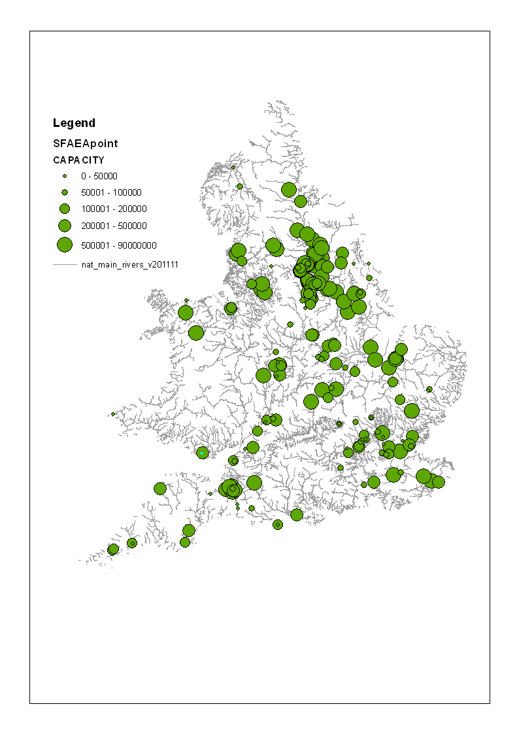

Fig 1. Distribution of flood storage areas in England and Wales in 2013

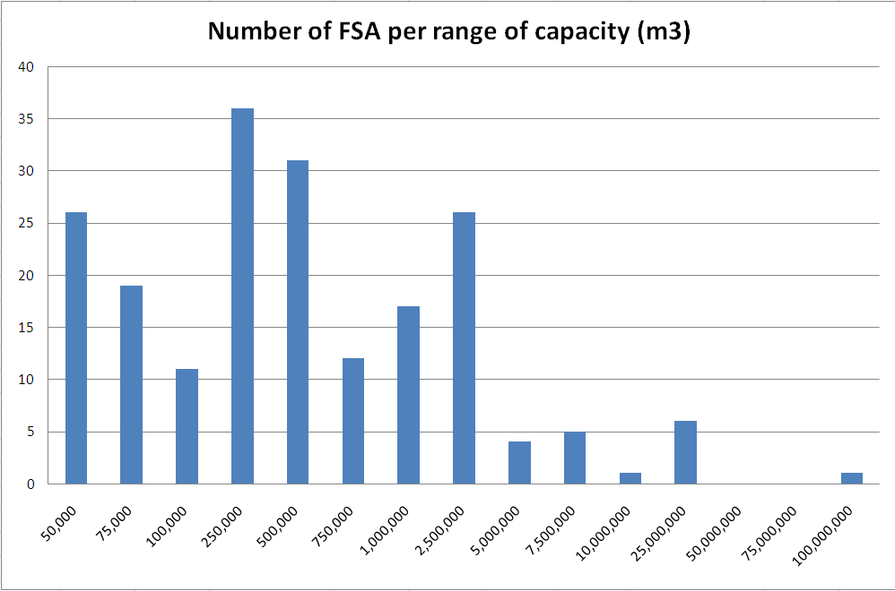

Fig. 2. Distribution of flood storage capacities in England and Wales in 2013

Flood Return Period Diminution in capital value

1 in 2 years 100%

1 in 5 years 75%

1 in 10 years 60%

1 in 25 years 35%

1 in 50 years 20%

1 in 75 years 15%

1 in 100 years 10%

Table 1 Example of the diminution in land value (Lincoln Flood Alleviation Scheme 1998)