Measures of financial risk

S.Y. Novak

MDX University London

In: Extreme Events in Finance (F. Longin, ed.), 215–237. Handbook Series in Financial Engineering and Econometrics. J. Wiley, 2016.
ISBN-13: 978-1118650196 ISBN-10: 1118650190
https://extreme-events-finance.net/wiley-handbook/contributions/novak-measures-financial-risk/
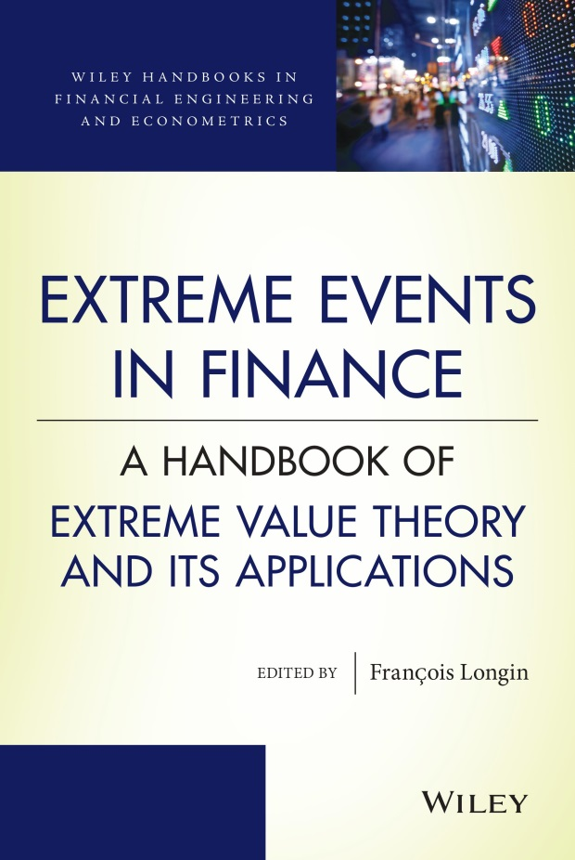

How to measure risk dynamically?
Traditional measures of risk are static: they barely change with the inflow of new information. The use of conditional measures involving recent prices only partially answers the question as the estimates of coefficients before the terms involving recent prices are typically small, making the corresponding conditional measures rather static.
This chapter presents a truly dynamic risk measure m_{TA} .
We overview its properties and discuss pros and contras. We introduce also a new risk measure that combines a static and a dynamic ones, and discuss the advantages of using a combined measure.
The arguments are illustrated on real life examples involving data available on the eve of the “Black Monday” crash in 1987 and on the eve of the financial crisis in 2007-08. We find that dynamic measures signalled increased level of risk on the eve of the crises sending a clear warning signal to investors.

