The Influence of Ethical Practice on Sustainable Supplier Selection in the Furniture Industry

Abstract

This study was carried out with an objective to investigate the sustainable supplier selection and ethics influence within the furniture industry. Literature has shown that corporates have increasingly adopted the ethical standards provided they also achieve economic sustainability.
The current study carried out in the furniture industry aimed to achieve the following objectives: 1) to appreciate the role of ethics in selection of a sustainable supplier, 2) evaluate and assess different methods used in the selection of suppliers, 3) appreciate the role of ethical practices in supply chain management 4) explore the important ethical practices within the furniture industry.
In the furniture industry, organizations are keen to involve top management in pushing for ethical practices that enhance sustainability within supply chain management. This includes presence of environmental policies for sustainability and carrying outcorporate social responsibility activities in order to boost it.
Despite the cost still being a major factor for corporates, understanding the importance of ethical practice in such an industry is becoming appreciated as more rules and standards become standard in these corporate sectors.

A total of 31 participants were interviewed in four groups. The major conclusions supported the appreciation of the role of ethics in influencing sustainable supplier selection and cite the significance of adopting ethical practices in the furniture industry. The study found out that the process of selecting suppliers is flexible and that supplier selection is integrated with ethical practices. It boosts the organization’s image, reputation and competitiveness.
Keywords: Supplier Selection, Sustainability, Sustainable Supplier, Ethics Influence in Furniture Industry.

Introduction
Corporates have progressively allied their functions with the ethical principles, and the purpose of this intensification is to attain economic sustainability (Goebel, et al., 2012; Kleindorfer et al, 2005). For most of the organizations, it becomes an obligation to maintain their existencebecause the traditional concept of such business has now changed. The organizations have comprehended a modern concept for their business which considers the overall development of the business and the society. In traditional business, there was no consideration of the ethical issues for business, employees, environment, and society. In modern business, such considerations become their prime concern (Molamohamadi et al., 2013). Thus, sustainability and ethical practices have become increasingly significant for many organizations (Marc & Hossam, 2012) and organizations are now trying to practice codes of conduct such as safety and health of employees, legal and regulatory policies, restricting under-age workers, environmental protection, ethical standards, right and respect for employees, etc. and these are practiced not only within theorganization, but also within partner organizations and stakeholders (Koplin, et al., 2007). In selecting a sustainable supplier, a company can evaluate the suppliers through their environment costs, green design, pollution control, recycling, resource consumption, etc. The furniture industry is always more concerned with ethical and environmental issues. They practice sustainable manufacturing, carbon management, eco-design, ethical timber, etc. as their ethical responsibility (Molamohamadi et al., 2013). Though the furniture industry is now trying to minimize the environmental costs, it should be more concerned about the environment and sustainability as a whole.

Background of the Sustainability in the Furniture Industry
The furniture industry encompasses all the activities and companies involved in manufacturing, designing, distributing and selling furniture and household equipment. The furniture industry has rapidly grown in a few decades all over the world. Ethical consideration and sustainability play crucial roles in the furniture industry. They restrict unethical practices in procurement, manufacturing and distributing by the suppliers. Sustainability ensures a suitable and friendly work environment for the workers and improvement in the business process. It restricts the suppliers from any activities that may have an adverse effect on business reputation. Thus, the business can get standard raw materials for manufacturing. Sustainability encourages the furniture industry to recycle and incorporate green design which minimizes wastage and secures proper utilization of resources. Now furniture businesses design the furniture in such a way that is alternative to the traditional business and process. The modern furniture business reduces the environmental costs, increases employment ethics, secures social development and also increases the profit for the business (Wiśniewska-Sałek, 2018).
Suppliers are an inseparable part of any industry. Without them, an industry can't run their businesses. To maintain the sustainability policy in any business, there is a need to build a supplier group. If the suppliers are unethical and ignore the environmental issues it becomes a curse for the industry. Ethical and legal restrictions over the suppliers help in building a sustainable industry. The furniture industry has rapidly grown in a few decades all over the world. If the industry ignores the ethical and environmental issues, there is incremental negative environmental impact for society. In almost every country, this industry has followed the legal rules and regulations regarding its business operations. Procurement processes have also been monitored and controlled by the business organizations. Such steps taken by the furniture businesses are blessings for the industry, economy, society, and environment.

Though ethical consideration and sustainability have a great impact on the environment and society as well (De George, 2014),there is still a lack of insight on the significance and role of ethics in the selection of sustainable suppliers, and also no previous studies have clearly discussed the appraisal methods used in the selection of suppliers and the importance of ethical practices in the furniture industry. In this research, the researcher has tried to examine the impact of different ethical practices on sustainable supplier selection in the furniture industry. This research will also help to address many important issues that influence the selection of sustainable suppliers, identification of the methods used to select sustainable suppliers, assessment of the roles of sustainability and ethical practices in supplier selection, and finding some of the ethics used in practice within the furniture industry. In order to do this the remainder of the paper has been divided as follows: Section 2 presents the research objectives, section 3 describes the related literature regarding the assessment of the roles of sustainability and ethical practices in supplier selection, section 4 covers research methodology, section 5 discusses the research findings and analysis and research limitations and section 6 concludes and highlights our research findings and also makes some recommendations for future research.

2.Research objectives
The key aim of this study is to define how sustainable suppliers are chosen in the furniture industry and the role performed by ethical exercises in this procedure. However, the other objectives of the research are:

To evaluate the impacts of ethics in the selection of sustainable suppliers.
- To assess the different methods used in selection of the suppliers.
- To examine the function of sustainability and ethical practices in supply chain management.
- To study the significance of ethical practices in the furniture industry.

3.Literature Review

3.1. Sustainable Supplier selection
To select the right supplier is very crucial for any company and organizations need to follow some specific standard procedures or protocols whilst selecting the suppliers (Goebel, et al, 2012). And it is very important for any organizations to affiliate their jobs with business ethics and sustainability standards (Goebel, et al, 2012; Kovacs, 2009). Without practising the particular standard method, the company would not be able to select the right suppliers for them (Meera 2014, Kovacs, 2009). Previously, the purchasing managers used certain criteria such as quality, cost and on-time delivery in appraising the appropriate supplier (Schiele, 2007). But these conventional features will not explicate the ethical exercises of such suppliers, and this needs to be examined further by a well-defined code of conduct and policies, like: - did they break any set principles within the corporation? (Blowfield, 2000).

3.2. Sustainable Supplier Selection methods
A direct correlation has been found between the selection of sustainable suppliers and the success of the supply chain in several past papers. There are three main decision-making methods for sustainable supplier selection that have been recommended since the 1980s to solve the issues regarding the selection of a supplier. These methods are Analytical network process (ANP), Analytical Hierarchy Process (AHP), and Technique for Order Preference by Similarity to Ideal Solutions (TOPSIS). Saaty (1980) pointed out that AHP is considered as a useful method used to solve the issues regarding the selection of suppliers. The AHP method helps to identify the weights of every criterion and their sub-criterion through which more precision can be ensured in ranking the suppliers of a company.
ANP is the next supplier selection method that is used as an additional approach to the AHP method. Multi-Criteria Decision Making (MCDM) is affected a lot by the ANP method. This method helps to categorize the record of probable risks in accordance with their relative significance of a company. Saaty (2005) maintained that the ANP network framework was constructed on the judgment of some experts that demands an intrinsic perception of the decision problem. On the basis of this, specific knowledge and skills were required to establish the scope of the problems;a fundamental building block to effect expected outcomes. Hwang and Yoon constructed the TOPSIS method in 1981 that is considered as the third method. Sen and Yang (1998) pointed out that this method is used to gain scores of ranking and position for the different options in order of their appropriateness. According to Singh and Benyoucef (2011), it is considered as standard approach to examine different options at a time on the basis of cost and benefit criteria. This method is preferred by the practitioners bringing the best outcomes.
These approaches are very important in the supplier selection procedures as explained above. The consideration of sustainability must be incorporated into every method in order toselect suitable suppliers with environmental and social sustainability aspects in mind.

3.3. Sustainability and Ethical Practices
The compulsion to integrate social and environmental aspects in supply chain management has increased. These two issues have been considered as principles in choosing a supplier. The components believed to best describe ethical practice in corporate businesses have changed significantly over time. Previously, compliance with the conventional guidelines was perceived as an ethical practice but this concept has altered due to diverse ecological changes and apprehensions in business. For this research paper the idea of Svensson (2009), has been implemented which described that sustainability and ethical practices are closely related (Svensson, 2009) to each other and sustainability not only maximizes the profit for business but also ensures a green environment by managing financial, environmental and social risk (De George, 2014). This notion has been accredited to the principle of the triple bottom line which incorporates the three elements of sustainability. These include social, economy and environment (Molamohamadi, 2013).

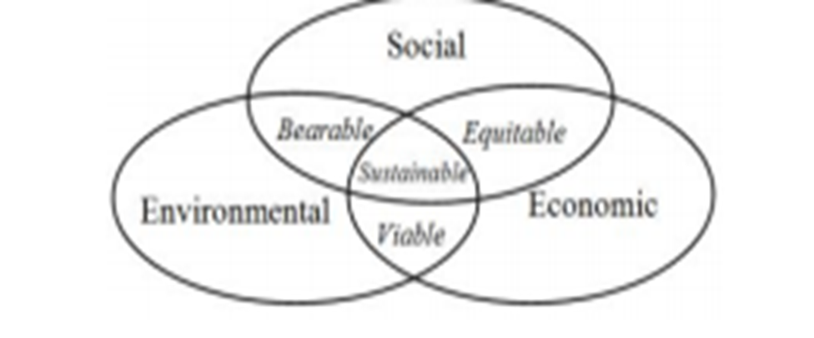
Figure 1: Elements of Sustainability: Source: (Journal of Advanced Management, 2013)

It is the duty of the procurement department of an organization to make effective decisions about the process of choosing a sustainable and reliable supplier who will help to maintain good quality and timely delivery of the materials by maintaining ethical practices. This process allows an organization to reduce manufacturing costs, enhance the quality of production, and increase the level of customer satisfaction.

3.4. Ethics in the Furniture Industry
The furniture industry is one of the most profitable, and a broad reformed code of ethics for this sector is badly needed in the 21st century. Currently, green supply chain management has emerged and subsidized to environmental sustainability. Green Supply Chain Management is outlined as an exercise of managing raw material elements from the supplier and manufacturer to the consumers by safeguarding that this practice does not deplete the atmosphere (Hu, 2010). This involves devotion, training, and responsiveness from both the top management and suppliers to grasp, realize, and approve a firm code of ethics to certify this can be attained.
Governments executed rules and regulation through diverse associations maintaining the ecosystem by supporting the latest law act that tightens the contamination and demolition of natural resources. Suppliers understand the impact of not conforming with such laws and therefore they have devised a certain code of ethics that ought to be respected by all shareholders in the business. In their study, Baird and Rowen (2010) described that application of ethics has made the furniture industry very reliable for the usage of raw materials and coupled with directorial prevention of the dumping of by-products,has nurtured the sustainability effort.

3.5 Research hypothesis
The researcher has identified the following hypotheses in this research:
H1a. Sustainable supplier selection is mostly related to the compliance level along with the ethical codes
H1b. The sustainable supplier selection is persistent with the requirements of the sustainable environment authority to which the top management level comply
H2a. The sustainable supplier selection practices are fundamentally connected to the level of incentive and and their adherement to principles and practices
H2b. Incentives escalate the level of compliance to business codes and sustainable environment exercises.

4.Research Methodology

4.1. Research Design
A qualitative research approach has been chosen for the study. A qualitative method concentrates on socially constructed reality where it is believing that the experience, knowledge and expertise of the researcher is crucial to generate more plausible and generalizable research outcome (Amaratunga and Baldry, 2001). Further, a qualitative study is more imperative and effective in providing more in-depth results than the quantitative method of the study (Adamides et al., 2012). A randomization technique has been applied in the interview segment. In total 31 mid-level managerial staff were selected from each involved section. The nclusion principles were: 1) the participant must have the experience of working with the firm for over two years, and 2) participants must have knowledge of the supplier selection procedures.

4.2. Data Collection
In this research, the data collection has been conducted by using face to face and telecommunication interviews based on the semi-structured model. The interview issues were concentrated on: a) supplier selection, b) sustainability and c) ethical practices. The research is conducted with a furniture firm in the United Kingdom. Interviews were carried out across all management levels.
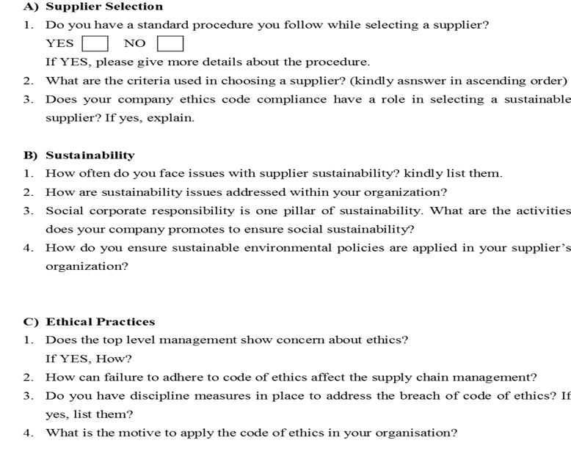

Figure 2: The interview form questions.

4.3. Data Analysis
The descriptive analysis technique has been adopted for this research. all of the interview questions have been examined thoroughly in order to extract the impact of principles in the furniture industry and in the selection of sustainable suppliers. A descriptive analysis tool SPSS has been used to observe the subsequent questions: A2, A3, and C4. Irreversibly, the study concentrates on the impact of ethics on supplier selection in the furniture industry how, where and when ethical exercise is being functional during these complicated course.

4.4. Ethics
Whilst carrying out this analysis, the examiner has confirmed that all information
will be executed with dignity and confidentiality Bell & Bryman (2007). However, a consent form has been signed by each of the participants, prior to conducting the data collection process making sure they have their conscious participation in the interview and no concern of confidentiality breach

4.5. Background of the main case study:
A medium sized furniture company founded in March 2004 with 94 employees has been chosen for this study. The company has planned to expand its operation worldwide and is investing outside the UK, China, Poland, and India.

5.0. Research Findings and Analysis
From different management levels, around 31 employees were interviewed. Employees of the company were divided into four groups which were dispersed into diverse areas, globally where the business works. The following table shows the details of the group of employees; the number of interviewees and their responses: -

Group Number | Number of Interviewees | Responses Gathered
Group 1 | 6 | 6/6
Group 2 | 7 | 7/7
Group 3 | 8 | 8/8
Group 4 | 10 | 10/10

Table1: Group and the number of group subjects

5.1. Research Findings
Interviews were grouped into three themes as shown below:-

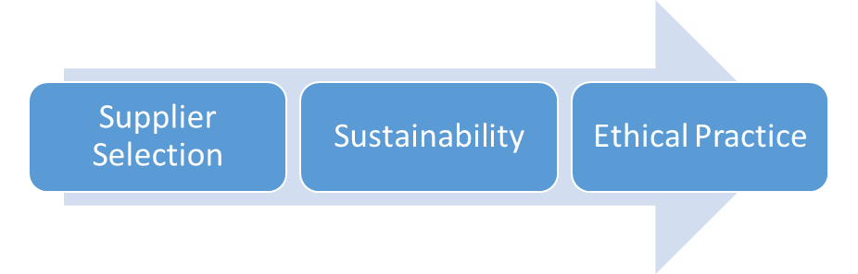
Figure 3: interview categories

5.1.1 Supplier Selection
Do you follow any standard procedure while selecting a supplier? If the answer is yes, kindly briefly explain the procedure.
Each interviewee was asked whether there is any standard procedure present and followed whilst selecting the supplier. After collecting all the responses, it has found that almost all of the 31 respondents confirmed that there is no standard way to select the suppliers.
Should there be any criteria while selecting a supplier?
The interviews responded in a different way to answer this particular question. Based on the responses of the interviewees, these include the following variables such as reputation, product characteristics, deliverability, cost, product sustainability, reliability, and quality. The criterion of reputation and sustainability incorporate ethics and raw materials, correspondingly. The variables to select the supplier are ranked as follows:

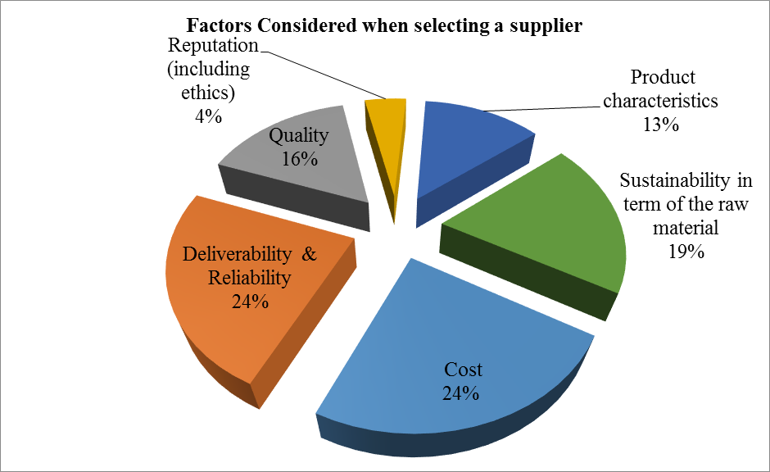
Figure 4: Criteria Considered when selecting a supplier.
The most important variables for selecting the suppliers in furniture industries are cost, deliverability and reliability responded by 24% of the interviewees, 19% of respondents said sustainability of raw materials is very important to them, 16% of the respondent answered that they will not negotiate in terms of the quality, 13% of the respondent said product characteristics are important to them and the remaining 4% respondent said suppliers reputation is very important to them to select the supplier they want.
Does the company’s code of ethics comply in selecting a sustainable supplier? If the answer is yes, explain.
To facilitate the selection of a sustainable supplier a company’s code of ethics has a very vital role which was agreed by 77.42% respondents. The remaining 22.58% respondent said ethics has no role in selecting the supplier. The furniture companies evaluated the scenario by conducting a questionnaire named, “Professional Quality Questionnaire” (PQQ) to cover the ethical issues such as employees' rights, salary, health, and safety.

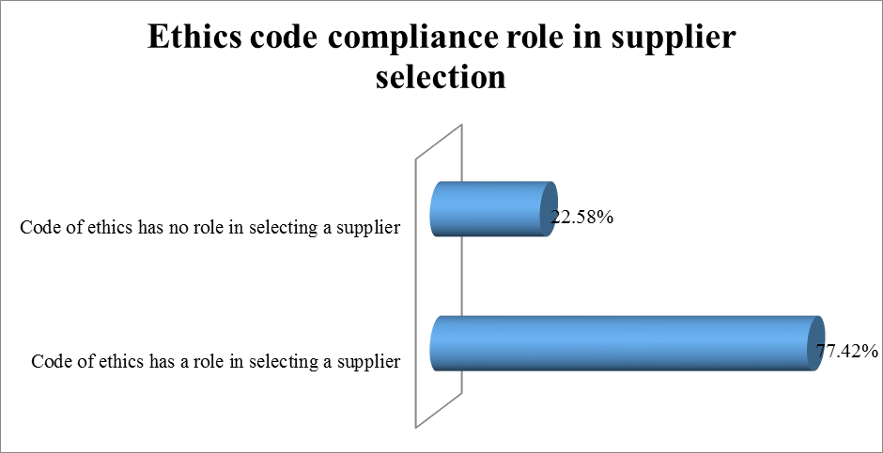
Figure 5: - Ethics code compliance role in supplier selection.
The ethical standards described in the code of ethics covers the issues such as health and safety, the security of employment rights, equality, corruption and fair trade in the developing countries.

5.1.2 Sustainability
How often issues like supplier sustainability faced by the companies? Kindly explain.
Group members of the groups 1, 3 and 4 have reported issues that they have faced because of the sustainability. But the members of group 2 argued that the issues related to supplier sustainability are country specific.
Do the issues like sustainability ever addressed within the organizations? If the answer is yes, explain?
The group members from group 1, 2 and 3 said that they have not faced any issues regarding sustainability in their organizations. Adding to that, they also said that the key method to handle sustainability is by retaining a decent correlation with the providers. Group members form group four believe that the issues related to sustainability can be addressed if the organization maintain the same values, beliefs, fairness, and equality within the ethical environment with the supplier.
What are the activities does your company is taking to promote and ensure social sustainability?
By offering placement programs, a job opportunity to local peoples, subsidising donations, volunteering program supporting the young individuals, coaching the young generation and resourcing the merchandises form a sustainable provider the company safeguards sustainability.
Adding to that, appreciably the company keeps interacting with the local agencies and offers them internships across the trade functions. It is important for the company to keep a very good tie with the local schools for establishing the “inspirational mentoring” programs" which will contribute to the employment of new generations.
For instances, as per the Group 4 respondents, the firm managing 3.5-tonne vehicle that creates the least possible Green House Gas (GHG). One of the most important policies of the company is to ensure that their suppliers maintain the highest exercises such as reprocessing the leftovers and controlling landfill waste. Group 2 interviewees explained that the company demands sustainability certification from their suppliers. Group 3 and Group 1 interviewee also described that the company instruct the new staffs on the subjects of bio-health and safety to endorse enhanced sustainability in their operation.
5.1.3 Ethical Practice
Does the top-level management show interest in terms of ethics? If the answer is yes, explain?
The research also revealed that the top level management such as the board of directors and the senior managers are cautious about ethical issues. All the interviewees responded positively for the senior level management commitment to ethical practice in the company.
From the analysis it has found that the ethical practice can be used to guide organizations relations with customers, dealers and personnel.
How does a failure to adhere to the code of ethics affect supply chain management?
As said by the Group 1 interviewee, the failure of the suppliers to follow the code of ethics leads to adversarial consequences of the firm status and the product in turn. Group 2,3, and 4 interviewees agreed with this result adding that the organization can lose confidence in its provider and in turn this might affect the trustworthiness and interactions with providers.
Do the companies have disciplinary measures to address the breaching of ethical terms? If yes, list them?
Members of all groups confirmed that there are disciplinary assessments to handle any breach of ethical terms. They also added that the organization has a written warning approach to address issues of breaching the code of ethics.
What are the motives of an organization to apply the code of ethics?
The rationale behind the code of ethics is the image enhancement and humanitarian perspective.

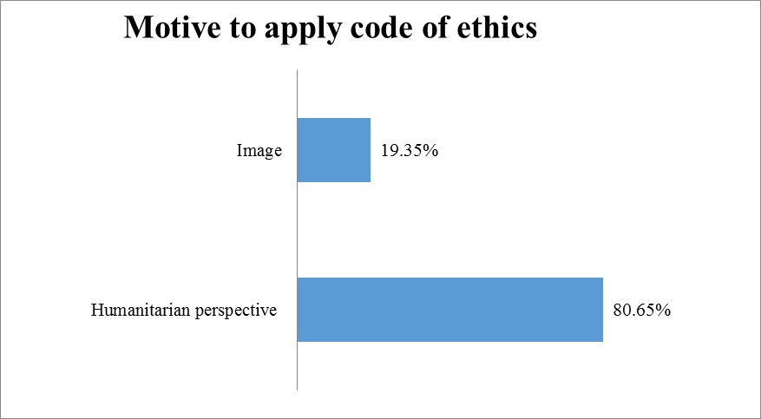
Figure 6: Motive to apply code of ethics.
This finding represents the grounds on which the corporate image stands and its ethical presence in the behaviour of the employees in any organization. About 80.65% of the respondents agreed that the purpose of the organization in applying the code of ethics is to gain a humanitarian perspective while the remaining 19.35% supported the image enhancement.
5.2 Research Analysis (RA)
Research analysis has been divided into three parts such as supplier selection, sustainability, and ethical practices. These are described as follows: -
5.2.1. Supplier Selection
The finding of the research revealed that there was no specific standard procedure or/ protocol confirmed when choosing the providers in the firm which varies notably from the outcome stated by Goebel, et al (2012). They claimed that companies are progressively developing benchmarks to affiliate their tasks to principles and sustainability. Conversely, the current study supports the outcomes identified by Meera (2014), that Supplier assortment is a chronological method of assessment and identification through which an association can choose the best supplier for their raw ingredients. Consequently, there is no need for a specific standard or process to implement, but use of varying techniques. Lack of a particular standard procedure in choosing suppliers does not prohibit the company in executing an ethical standard to assess the suppliers (Kovacs, 2009).
The outcome on the criteria to select suppliers comprises: cost, deliverability and dependability, excellence, reputation, product characteristics and sustainability (Schiele,2007). This report confirmed the cost was considered the substantial feature and diminishing the cost in suppliers leads to the competitive advantage (Hu, 2010). Reliability was also found to be a significant factor, Svensson (2009) argues, it leads to the expansion of sustainable exercises.
5.2.2 Sustainability
The research shows that a company with a code of ethics hardly encounters any issues regarding sustainability (Hu 2010). The research finds that sustainability issues are incorporated by the suppliers who maintain some level of relationship with the company. Adding to that if the company can guarantee that the suppliers follow the identical ethical practices the company follows, it leads to sustainability. Code of ethics attended by a firm ensures supplier relationships and compliance with the set of ethical standards (Kovacs, 2009).
The study recommends that the company considers that social corporate responsibility is a pillar to secure the sustainability. The activities such as internship programmes, job opportunities to local people, sponsorship and apprenticeships are the example of social sustainability. The findings of this research are similar to the research by Manufacturing Skills of Australia (2012) on social responsibility.
All the companies that participated in the study assured that they agreed with all the policies in terms of environment safety. The environmental issues that are noticed throughout the research are recycling aspects, reduction of GHG emissions, ensuring employees safety and health as well as reduction of the waste. The findings support the report by Darnall (2008) that environmental issues affect the sustainability of furniture firms. The study also supports Jennings (2005) findings. Jennings asserted that the company must ensure that the suppliers are environmentally sustainable.
5.2.3 Ethical Practice
The study has shown that top-level management is involved in confirming the ethical practice in a company (Weaver, et al., 2005). The senior level management is also responsible for regulating the ethical behaviour that needs to be used in the organization (Weaver, et al., 2005, Goebel, et al., 2012). The senior level management and the procurement manager are able to select a supplier who conforms to the code of business conduct in the industry (Moore, 2004). The study also revealed that organizational culture is needed in order to encourage ethical behaviour and guides the supplier selection and sustainability.
As stated by Darnall (2008), the point that explains the sustainability concerns in a company has shifted from brand image to competitive advantage. This research has found out that failure to maintain the code of ethics affects the supply chain management in terms of organization image, reputation, and brand. Unethical practices in the business can harm the good reputation and value of the firm (Carter & Jennings 2004, Handfield, et al. ,2002). Daniels (2006) highlighted that the purpose of having the ethics and sustainability focus has shifted from corporate image to achieving the competitive edge. This research, however, maintains that the company's biggest aim to apply the code of ethics is to gain a humanitarian perspective followed by image enhancements.
When there is any contravention of the code of ethics there are certain measures and practices that will be taken in agreement with the findings which are very similar to the findings by Green (1996). Existing written notices and removal are good practices to establish the code of ethics even further.

5.3. Summary of Findings
In light of the above-mentioned outcomes and evaluation, the study has found that the sustainability in the supplier selection has an undeviating link to the subsistence and enactment of ethics code and has proved theresearch hypothesis. Additionally, the research has shown that most of the top level management has a high level of responsiveness and training about code ethics implementation and they also believe that it is important to gain a competitive advantage in the market. New paradigm shifts in companies’ cultures happen though designing more eco-friendly strategies, offering internship programs and job opportunities to local people, sponsoring charities, introducing volunteering programmes helping young people, training the young generation and resourcing the products from a sustainable supplier, ensuring the organizations sustainability.

This finding supports the second part of the hypothesis H1b. The level of top management compliance with the sustainable environmentalism expert requirements regulates the choice of the sustainable supplier.
The principles for choosing the providers consider the following features such as expenditure, trustworthiness, deliverability, and excellence of the providers. It indicates that the choice to attain sustainable providers is associated with some objects and it supports the hypotheses H2a. The method of choosing sustainable providers has openly connected to the degree of enticements and their acknowledgement to morals exercises.
Moreover, the existence of motives in subsequent ethical exercises and environmental exertions upturns compliance and sustainable plans adherence. This is demonstrated the H2b hypotheses.

5.4 Research Limitations
The limitations of this study are: -
- Ethical practice and sustainable supplier selection in the furniture industry is a quite new addition which will take some time for the company to embrace, put in action, and launch in their policies.
- Due to not having any dedicated department to handle the sustainability issues in the company, the researcher finds some difficulties in collecting data from a consolidated platform.
- Further multi-layered research withcompanies from small-to-large size, locally and internationally is required to develop further insight on gaps in the code of ethics identifying where development should focus in the future.

6.0. Conclusions and Recommendations

To conclude, the company needs to carry out ethical exercises in their organisation,as these activities assist the organization to select environmentally sustainable suppliers, to shrink their manufacturing costs, enhance the quality of production, and increase the level of customer satisfaction. The researchhas found that there is no standard way to select the suppliers but rather it is dependant on the supplier requirements (Meera,2014). The research has also shown that different variables such as reputation, product characteristics, deliverability, cost, product sustainability, reliability, and quality are important criteria while selecting a supplier. There were mixed views with regard to the level of importance given to a company’s code of ethics in the selection of a sustainable supplier. 77.42% of the respondents agreed with this issue and the remaining 22.58% respondent said ethics has no role in selecting the supplier. There were also mixed outcomes on the matter of suppliers’ sustainability where the members of groups 1, 3 and 4 have reported that they have faced issues because of the sustainability. But group 4 argued that the issues related to supplier sustainability are country specific. All the interviewees responded positively on the issue that top-level management such as the board of directors and the senior managers are concerned about ethics. After analyzing all the outcomes of this research, the researcher identified some room for taking actions on some specific issues. The following recommendations are made by the researcher:
Recommendations:
- In the furniture businesses, the supplier’s evaluation process should be flexible enough to make it simple and straightforward to accept the ethical considerations in different scenarios while trading with the suppliers. Moreover, an organization, operating business in multiple geographical places, should develop efficient measures to achieve the existing conditions without compromising the supplier selection and sustainability.
- The failure of the suppliers to comply with the code of ethics could lead to an adverse effect to the company reputation and the brand and in turn, may affect the reliability and relationships with suppliers. Hence, there should be disciplinary measures like written warning and dismissal to handle any breach of ethical terms.
- The business organizations should assimilate the CSR (Corporate Social Responsibility) actions with the issues and problems regarding sustainability. Arranging social companions to sustainability issues helps the various parties to build collectively in an accord to gain sustainability and maintain the organization.
- Finally, ongoing and thorough training and development programmesare needed for executives, personnel, and stakeholders as part of regularization and setting behaviour to achieve sustainability in the organization.

7.References
Adamides, E.D., Papachristos, G. and Pomonis, N. (2012), “Critical realism in supply chain research: understanding the dynamics of a seasonal goods supply chain”, International Journal of Physical Distribution and Logistics Management, 42(10), pp906-930
Amaratunga, D. and Baldry, D. (2001), “Case study methodology as a means of theory building: performance measurement in facilities management organisations”, Work Study, 50(3), pp95-104
Baird, N. & Rowen, S., 2010. Lean and Green: How Sustainable Practices Are Changing Retail, Retail Systems Research.
Blowfield, M., 2000. Ethical sourcing: a contribution to sustainability or a diversion? Sustainable Development, 8(1), pp. 191-200.
Braglia, M. & Petroni, A. 2000, "Towards a taxonomy of search patterns of manufacturing flexibility in small and medium-sized firms", Omega, vol. 28, no. 2, pp. 195-213.
Carter, C. & Jennings, M., 2004. The role of purchasing in corporate social responsibility: a structural equation analysis. Journal of Business Logistics, Volume 25, pp. 145-186.
Collier, J. & Esteban, R., 2007. Corporate social responsibility and employee commitment. Business Ethics. A European Review, Volume 16, pp. 19-33.
Creswell, J.W., 2013. Research Design: Qualitative, quantitative and mixed methods approaches. Sage Publications.
Daniels, C. (2006, 16 January). Companies Coy on Eco-Management. The New Zealand Herald.
Darnall, N., 2008. Environmental Management Systems and Green Supply Chain Management: Complements for Sustainability? Business Strategy and the Environment, 5(1), pp. 30-45.
David, R.B., 2011. What is ethics in research & why is it important. Journal of Business Ethics, 1(1), pp.34-56.
Goebel, P., Carsten, R., Richard, P. & Christina, S., 2012. The influence of ethical culture on supplier selection in the context of sustainable sourcing. Int. Production Economics, 6(140), pp. 7-17.
Green, K., 1996. Purchasing and environmental management: interactions, Policies and opportunities. Business Strategy and the Environment, 5(3), pp. 188-197.
Handfield, R., Walton, S., Sroufe, R. & Melnyk, S., 2002. Applying environmental criteria to supplier assessment: a study in the application of the analytical hierarchy process. European Journal of Operational Research, Volume 141, pp. 70-87.
Hu, A. H., 2010. Critical factors for implementing green supply chain management practice. Management Research Review, 10(1), pp. 1-10.
IKEA, 2011. The IKEA Group approach to sustainability: How we manage sustainability in our business. [Online]
Available at: http://www.ikea.com/ms/zh_TW/pdf/sustainability_report/group_approach_sustainability_fy11.pdf
[Accessed 26 09 2016].
Jennings, C., 2005. The role of purchasing incorporate social responsibility. Journal of Business Logistics, 2(1), pp. 145-156.
Kaptein, M., 2004. Business codes of multinational firm. Journal of Business Ethics, 50(7), pp. 13-33.
Kleindorfer, P., Singhal, K. & van Wassenhove, L., 2005. Sustainable operations management. Production and Operations Management, Volume 14, p. 482–492.
Koplin, J., Seuring, S. & Mesterharm, M., 2007. Incorporating sustainability into supply management in the automotive industry—the case of the Volkswagen AG. Journal of Cleaner Production, Volume 15, p. 1053–1062.
Kovacs, G., 2009. Corporate environmental responsibility in the supply chain management. Journal of Cleaner Production, 4(3), p. 571–1578.
Maignan, I., Hillebrand, B. & McAlister, D., 2002. Managing socially-responsible buying: how to integrate non-economic criteria into the purchasing process. European Management Journal, Volume 20, p. 641–648.
Manufacturing Skills Australia, 2012. Sustainabilities Issues in Furniture. [Online]
Available at: http://sustainabilityskills.net.au/wp-content/uploads/2012/07/Sustainability-issues-in-furniture_June12.pdf
[Accessed 26 09 2016].
Marc, A. R. & Hossam, A. K., 2012. Sustainable Manufacturing and Design: Concepts, Practices and Needs. Sustainability, Volume 4, pp. 154-174.
Meera, B., 2014. Environmental Sustainability through Green Supply chain management practices among Indian Manufacturing Firms. International Journal of Scientific and Research Publications, 5(1), pp. 1-8.
Molamohamadi, Z., 2013. Supplier Selection in a Sustainable Supply Chain. Journal of Advanced Management Science, 6(1), pp. 271-281.
Moore, R., 2004. The methods used to implement an ethical code of conduct and employee attitudes. Journal of Business Ethics, 4(3), pp. 244-255.
Nazeri, A., Meftahi, H., Shaharoun, A.M.: Supplier evaluation and selection in SCM using Fuzzy AHP. In: 2011 3rd International Conference on Advanced Management Science IPEDR, vol. 19. IACSIT Press, Singapore (2011)
Peffers, K., 2007. A design science research methodology for information systems research. Journal of management information systems, 24(3), pp.45-77.
Saaty, T.L., 1980. “The Analytic Hierarchy Process.” McGraw-Hill, New York.
Saaty, T.L., 2005. The analytic hierarchy and analytic network processes for the measurement of intangible criteria and for decision-making.
Schiele, H., 2007. Supply-management maturity, cost savings and purchasing absorptive capacity. Journal of Purchasing and Supply Chain Management, 5(3), p. 274–293.
Sharan, M.B., 1998. Qualitative research and case study applications in education. 1st ed. San Francisco: Jossey-Bass Publishers.
Svensson, G., 2009. A corporate model of sustainable business practices: an ethical perspective. Journal of World Business, 6(2), pp. 1-10.
Trevino, 1990. Bad apples in bad barrels: a causal analysis of ethical decision-making behavior. Journal of Applied Psychology, 42(8), pp. 378-380.
Trevino, L. K., Hartman, L. P., & Brown, M. (2000). Moral person and moral manager: How executives develop a reputation for ethical leadership. California Management Review.
United Nations, 2016. The Paris Agreement. [online] Unfccc.int. Available at: http://unfccc.int/paris_agreement/items/9485.php [Accessed 14 Oct. 2016].
Upadhyay, A. (2012). Sustainability: Overview and Concepts. International Journal of Innovations in Business, 4, 268-273.
Weaver, G., Trevinio, L. & Agle, B., 2005. Ethical role models in organisations. Organisational Dynamics, Volume 34, p. 313–330.
Welford, R., 1995. Environmental Strategy and Sustainable Development. 1 ed. London: Routledge.
Williams, E.A., 2000. Research methodology in management: Current practices, trends, and implications for future research. Academy of Management Journal, 43(6), pp.1248-1264.
Wu, T. & Blackhurst, J. 2009, "Supplier evaluation and selection: an augmented DEA approach", International Journal of Production Research, vol. 47, no. 16, pp. 4593-4608.

