Arts-based Creativity
Facilitating
Organisational Innovation

By Jolanta Jagiello
Middlesex University Business School
The Burroughs
London NW4 4BT
E-mail: j.jagiello@mdx.ac.uk

ABSTRACT

Arts-based creativity has a role to play in bringing innovation to the workplace in the world of organisational life. The application of artistic practices and techniques drawn from the visual arts and performing arts are particularly suited to releasing individual creativity, the foundation in which organisations can innovate their business processes to produce new products and services.

This paper will draw upon a final year undergraduate module at Middlesex University Business School, London, UK, entitled ‘Facilitating Creativity in Business’ using the arts to encourage creative thinking leading to developing organisational brainstorming and problem solving. And the analysis of management elective titled ‘Developing Creativity in Business’ offered at the School of Business Administration, Portland State University, USA, conducted by Ellen West. The paper will examine the artistic techniques and processes used by individuals to embed creativity right into the centre of their working practices, making them an integral part of the business culture rather than just a process to add on, and the links that have been made.

CREATIVITY IN BUSINESS

As businesses enter the 21st Century they are confronted with the question of how to introduce more creativity and innovation in the workplace, and yet as Edwards [1] put it:

“What on earth is creativity? How can a concept be so important in human thinking, so crucial to human history, so dearly valued by nearly everyone, yet be so elusive?”

A survey [2] conducted on behalf of Canon and the Arts Council in 2006 of over 1,800 UK bosses and workers revealed only 4% of managers said that the first thing they look for is artistic flair or creativity in a prospective employee despite the fact that 36% believed that creativity is very important for the future of their business. In large corporations, 2% of bosses placed creativity at the top of their skills checklist when recruiting, whilst in smaller businesses 15% stated creativity as the most important quality in a new employee, recognising that originality and innovation are key factors in today’s competitive business environment. Businesses in sales and marketing (12%) placed the most value in creativity when considering new recruits, followed by retail (9%). In addition, 64% of workers saw themselves as ‘functional’ rather than ‘creative’, and 18% of employees felt that original thinking was not encouraged in the workplace. Creativity also seems to be misunderstood – one in five managers shared the view that being creative means dressing unconventionally, participating in wacky stunts and even go as far as saying that it is ‘unnecessary’ in the workplace.

Partly, the reason why I believe creativity is so elusive to business is that although, as the businesses above demonstrate, they are clear which activities, and what are the key components of creativity and innovation, they are limiting their views to problem-solving [3] the main creative skill needed to achieve this. Yet, they acknowledge that ‘newness’ i.e. thinking of something no-one has thought of before is the key component of creativity. The business challenge seems to be according to Nancy Alder [4] escaping societal conformity which artists are well suited to, especially as 20th Century managers stressed conformity above unique perception or vision.

CREATIVITY IN UNIVERSITY

Is conformity the norm with undergraduates, when applying the Experiential Socialization Index based on Schein’s model of socialization? [5], only one student scored ‘Rebellion’ and the rest all scored ‘Conformity’. No one scored ‘Creative Individualism’, a mature form of rebellion, when applied to experiential learning, Bowen [6], this entails the: locus of responsibility for learning being shared between student and lecturer; affective as well cognitive processes involved in learning; learning goals including transference of knowledge as well as development of skills and attitudes; the student being an active participant in the learning process, as well as having the ability to challenge authority (of lecturer). West [7] also adopted an experiential/active learning strategy to enable students to use a variety of ways of knowing, Lazear [8], to achieve her objectives. To develop skills which enhance students’ capacity to be creative; for students to gain knowledge of methods to foster creativity within an organization as well as various organizational characteristics that contribute to a creative culture; and finally analyse and evaluate aspects of their own creativity in the workplace.

Challenging authority is supported by Rosabeth Moss Kanter’s [9] as she observed, if you have to seek the approval of several layers of authority before any decisions can be made or ideas implemented then all you will certainly stifle innovation in organisations. The core of creativity and productivity, Barron [10], lies in creating a learning environment, where the intermix of affective and cognitive abilities includes: challenging assumptions; taking risks; making connections; taking advantage of chance; recognising patterns; and seeing in new ways. Arts-based learning based on improvisational acting, reflective writing, drawing, visual arts, music, poetry, film, is ideally suited to meeting the challenge of providing ideas that businesses are looking for in their search for ‘newness’.

CREATIVE INDIVIDUALISM

Mark Fox has spent his career working as a Chief Engineer for the NASA Space Shuttle Program and now runs his creative thinking training company ‘Sly as a Fox’ which offers creativity training both for the individual and the organisation. Fox [11] draws attention to 10 attitudes towards creativity which when not addressed by the individual in his or her education can in my opinion manifest into 10 rules to stifle innovation in an organisation, identified by Rosabeth Moss Kanter [9], when these individuals became managers.

Fox states that every one of us is born with creativity but the school system, socialization, and our parents take it away from us with the insistence over the one “Right Answer” (Attitude 1). Without developing the skills to creatively problem-solve in an organisation this insistence could manifest itself by treating the identification of problems as signs of failure (Rule 5) by discouraging people from letting managers know when something in their area isn’t working.

Logic Can Kill Creativity (Attitude 2) as it can stifle the creative flow of new ideas in brainstorming sessions. Fox as part of his brainstorming rules, always tells his participants to “leave their logic at the door, there is no room for logic in these sessions.” In an organisation, which wishes to encourage innovation, it is impossible to control everything carefully and make sure people count everything that can be counted (Rule 6).

To be creative you must break some rules (Attitude 3 - Be Creative – Break Some Rules). According to Fox this is a risky especially if you go around breaking all the rules as you may find yourself unemployed. However if management hold the attitude that they already know everything (Rule 10) then they will not understand that rules are made to get broken. It is important to challenge the rules with simply questions such as: “What rules are currently in place that are stopping me from bringing in more revenue or being more productive?”
Fox acknowledges that being both practical and logical during the creative process will not lead to any breakthrough thinking (Attitude 4 - Be Creative – Is That Practical?). To get another creative angle on the problem is to ask: How others would solve it? What if? Questions; Can I role-play the product or the idea? to get you to think outside the box. This will be impossible to do according to Moss Kanter if lower-level managers are given the responsibility for figuring out how to cut back, lay off, move people around, or otherwise implement (speedily) threatening decisions you have made (Rule 9) – rather than encouraging innovation in the organisation.

When do you come up with great ideas? When you are playing? (Attitude 5 - Play Is Creative). When the mind is allowed to break its normal patterns of processing by taking time out to entertain new information, ideas, and concepts that have nothing to do with any of the problems you had been solving. However, another way to stifle innovation is to make sure requests for information (especially new information) are fully justified, and that the information is not given out freely (Rule 8).
It is so important, according to Fox (Attitude 6 - Make Time To Think Creatively) to schedule “time to think” into your weekly work schedule, beginning with two, 2-hour sessions per week to meet yourself, planned out six months in advance. It will be very difficult to treat that “meeting” as the most important meeting you have all week, if managers are made to make decisions to change policies in secret and spring them on people unexpectedly (Rule 7).

As the survey acknowledged most business seem to think that creativity is the purgative of the marketing and the R&D departments. Creativity is needed in every business function and discipline, and can be applied to all types of process and procedures (Attitude 7 - Being Creative Is “Not My Job”) as well as marketing campaigns and product designs. Creative ideas are needed in purchase order processing, accounts, procurement, and sales forecasting to name a few examples. Creative ideas can come out of any department at any level. One of the major ways to stifle innovation is for management to regard any new idea from below with suspicion, simply because it’s new and comes from levels below management (Rule 1).

Most individuals fear looking foolish in a group setting, which is one of the biggest hindrances to creative thinking (Attitude 8 – Don’t Be Afraid To Be Creative). They hesitate to speak up in meetings about the great idea that just popped into your head for fear of criticism. It’s not an irrational or unjustified fear. It’s real if as part of stifling innovation, if managers ask departments or individuals to criticise each other’s ideas or proposals and then just pick the survivor (Rule 3).

Fox describes this attitude as driving engineers crazy, similar to acting foolish, the ability to be ambiguous (Attitude 9 - Creativity…How Ambiguous). It typically causes communication problems and has no place in certain circumstances, however it is important to the creative thinking process to act and see what ideas comes from it. To insist that people need your approval to act by first going through several other levels of management to get their signatures (Rule 2) stifles ambiguity.

Another big obstacle to generating new ideas is the fear of being wrong (Attitude 10 – Is Creativity Wrong?) by spending endless amounts of energy trying to always be right. This gives the appearance that we know what we are doing otherwise we could lose our jobs. However to make mistakes is to learn risk and create something new. By managers’ expressing their criticism freely, and withholding their praise (by keeping staff on their toes and letting them know they can be fired at any time) (Rule 4) they are clearly signally that mistakes will not tolerated.

Mark Fox’s advice on creative individualism expressed on his web-site www.slyasafox.com is: “Don’t ever think you’re not creative, you are. If you tell yourself you’re not, then you won’t be. State of mind plays a key role. Keep telling yourself you are creative and you will be. Keep your head high, remain optimistic, and let yourself discover something new.” This supports the starting point of the module by introducing students to the 4 P’s of Creative Individualism defined as Positivity, Playfulness, Passion, and Persistence.

ARTS-BASED CREATIVITY

The Arts-based curriculum to facilitate creative individualism can be delivered by adopting ‘The Artist’s Way: A Course in Discovering and Recovering your Creative Self’ by Julia Cameron [12] which is based on her workshops aimed at freeing individual creativity. Ellen West selected for her students ‘The Artist’s Way at Work’ by Bryan, Cameron, and Allen [13], to enable her students to reconnect to their own creative juices as well as make them aware of strategies they might use in their own organisations to develop an atmosphere that fosters creativity. The class has been offered three times in the last three years and a total of 72 students have taken it. The author’s aim is to release her students’ individual creativity to create a foundation for them facilitating organisational innovation [14]. Cameron’s 12 week creativity course is undertaken within a 24 week module, in which the students are asked to complete a chapter every 2 weeks. In the first year of the module run, 43 students completed the module. This year 50 students are undertaking the module. By linking Cameron’s weekly chapters to each of Fox’s Attitudes provides a mechanism of exercise and tasks which counter-act the negative effect of stifling organisational innovation into the positive effect of enabling organisational innovation.

How can the creative individualism proposed by Fox be achieved? Let us turn to Attitude 1 – One Right Answer, this is tackled in Week 7: Recovering a Sense of Connection where Cameron challenges ‘Getting it Right’ and describes it as perfectionism - an obsessive, debilitating closed system. She goes on further to say the perfectionist fixes one line of poem over and over until no other lines are written, or writes so many versions of one scene that the rest of the play never gets the written. She opens up the exploration with the question: ‘What would I do if I didn’t have to do it perfectly? – take more risks in being creative.

Attitude 2 – Logic Can Kill Creativity this Cameron takes very seriously with the insistence on the practice of Morning Pages – three pages of written stream of consciousness. There is no wrong way to do them challenging Attitude 1. They are designed to get to know our Censor, an internal critic who can criticise us mercilessly. Censor resides in our Logic Brain. Artist Brain is our inventor allowing us to be associative, freewheeling, making new connections. Morning Pages allows Logic Brain to stand aside and lets the Artist Brain play. The value of Morning Pages is reinforced in Week 4: Recovering a Sense of Integrity.

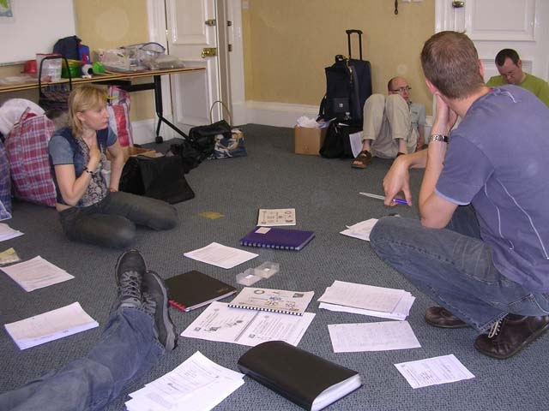 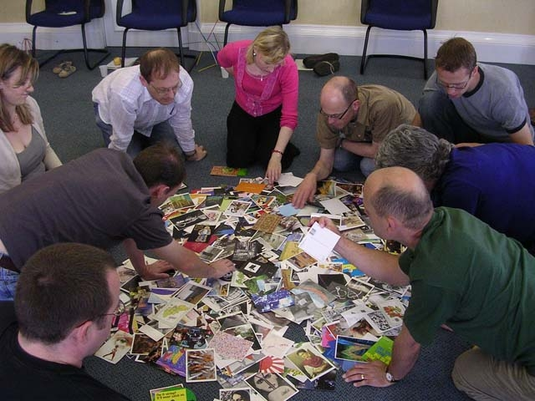 Figure 1: Logic Brain vs Artist Brain

The next attitude is a tricky one i.e. Attitude 3 - Be Creative - Break Some Rules. What rules need to be broken? Cameron concentrates on those connected to Core Negative Beliefs which are beliefs not the facts, and encourages you to counteract them with positive alternatives by developing your ally within Week 1: Recovering a Sense of Safety. This is followed in Week 2: Recovering a Sense of Identity by eliminating poisonous playmates like crazymakers, and our deeply held scepticism or secret doubts.

In Week 8: Recovering a Sense of Strength of Cameron’s book the author tackles Attitude 4 – Be Creative – Is that Practical? by acknowledging that leading a creative life does not have to involve abandoning the whole of your life as you know it. Although looking at the big picture is a valuable exercise, a creative career is best thought of as art-as-process, and is grounded in as Cameron puts: “many small steps and very, very few large leaps”. Creativity requires activity, small daily actions instead of setting big questions: ‘How can I be a writer and stay in this marriage? How can I pursue my painting and stay in this dull job?. This all-or-nothing thinking of pursuing it full-time will stop us pursuing it part-time or not at all.

Play is at the heart of all creativity (Attitude 5 – Play is Creative) whether it with ideas, paint and paintbrushes, characters, lines of a script. It’s something that children do natural, to them it is never time wasted. However, as we grow older ‘time is money’ attitude permeates our thinking. It’s a matter of where our priorities lie - I need to create what needs to be created. Creativity is its own reward, and playing is at the heart of it. In Week 11 – Recovering a Sense of Autonomy Cameron introduces her readers to the concept of allowing a sense of play to our relationship to accepted standards whether they be: money, property, nine-to-five, marriage, children. This flexibility allows us to introduce play into our lives. Week 6: Recovering a Sense of Abundance is a very valuable chapter in this context as it explores our attitudes to money.

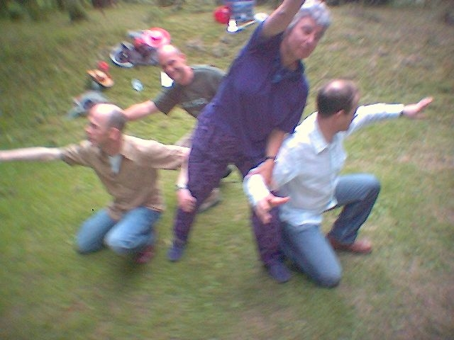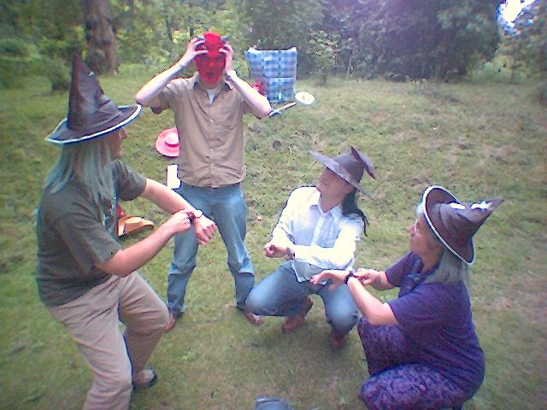
Figure 2: Playing: Improvisational acting

Part of playing is the ability to set time aside to play (Attitude 6 – Make Time To Think Creatively). Cameron’s Artist Date is centrally to this process – a date with the artist child inside you. Cameron lists a number of suggestions costing time, but not money: a trip to a jumble sale, a walk on the beach solo, watching a DVD alone, a visit to an art gallery. These dates are meant to be fun, making your work feel more like play. It is important to engage all the senses in order to feed the artist brain with images, so that it can work with them to create new ideas, forms, or scripts. Brenda Ueland on page 23 of Cameron’s book captures the value of the artist date: “So you see, imagination needs – long, inefficient, happy idling, dawdling and puttering”. In ‘The Artist’s Way at Work’ artist dates are described as Time Outs. Some examples of West’s students Time Outs [7] include: walking, bicycle riding, running, scrapbooking, strolling through the Rose Gardens (a local tourist attraction, with a stunning view of a nearby mountain if the day is clear), visiting the Japanese Garden (another local tourist attraction), sketching in the park, painting, playing guitar, writing, camping, gardening, star-gazing, and taking a long walk in the park.

Cameron believes we are all creative, challenging the Attitude 7 – Being Creative is “Not My Job”. In Week 10: Recovering of a Sense of Self-protection, she explores workaholics, who block creative energy under the guise of being busy at work. It stops us having fun, so we can avoid our creativity, and feeling our own power. Doubts or Droughts as Cameron refers to it also block our creative energy. As well as success (I may never come up with another idea as successful as this one), and competition (I never have as good ideas or come up with so many ideas as so and so). All of these blocks to our creative energy, can be neatly packaged up into being creative is not my job.

This leads us neatly into Attitude 8 – Don’t be Afraid to be Creative. Susan Jeffers in her book [15] of the same title says “Feel the fear, and do it anyway”. In Week 9: Recovering a Sense of Compassion the emphasis is on blasting the blocks whether this is fear of failure or fear of success, laziness or procrastination. At its root is fear. Let’s look at some examples from Cameron’s book on the fear of success, and how we can sabotage ourselves with what Cameron calls Creative U-turns: “A painter is invited into a group show, his first, but picks a fight with the gallery owner”; “An actress-producer with a solid script is offered a studio deal to further develop her project. She finds fault with the deal and then shelves the project entirely.” It is important to remember that a successful creative career is built on successful creative failures. The trick as Cameron puts it is to survive them.

The last Attitude 9 – Creativity … How Ambiguous refers to the demands that the creative process places in terms of going into the unknown, facing vagueness, uncertainty, ambiguity, and confusion, and yet eventually trusting that everything will just fall into place. Synchronicity plays a part in this process, as we start changing any number of unforeseen events, incidents, meetings and materials appear to assist us on our way. Cameron gives the following examples in her book: “A woman admits to a buried dream of acting. At dinner the next night, she sits beside a man who teaches beginning actors”; “A woman wonders how to rent a rare film she has never seen. She finds it at her neighbourhood bookstore two days later.” The key to synchronicity is to unearth our buried dreams (Week 4: Recovering a Sense of Integrity), without bringing these to our consciousness you will not even notice the moments of synchronicity, this requires faith (Week 12: Recovering a Sense of Faith) and relinquishing control.

We can question Is Creativity Wrong? (Attitude 10) Cameron sets a number of exercises that encourage students to look at their Imaginary Lives, Forbidden Joys, and Wish Lists in Week 5: Recovering a Sense of Possibility which focuses on things we love, and would love to do, but are not allowed to do. This is until the Virtue Trap kicks in – powerful payoffs constituting powerful reasons for non-action. Cameron sites the following example to illustrate her point: “A woman with two small children wants to take a pottery class. It conflicts with some of her son’s Little League practices, and she wouldn’t be able to attend as faithful audience. She cancels pottery and plays the good mother – seething on the side-lines with resentments”. Virtue Trap relies on being good to the world and meeting worldly approval, at the expense of your true self, which cannot be shown for fear of dreading the world’s continued disapproval. Week 3: Recovering a Sense of Power gives some guidelines on how to deal with criticism - creativity is the only cure to criticism.

ORGANISATIONAL INNOVATION

Peter Cook [16] in his book ‘Best Practice Creativity’, identifies models and concepts for organizational creativity, suggests how a creative strategy can be implemented through paying attention to: culture, leadership style and values; structure and systems, skills and resources. The 10 workshops on the module focus on organisational innovation whose foundation is creative individualism developed through completing the exercises in Julia Cameron’s book. And engaging in what Carl Rodgers describes as a psychologically safe environment where creativity flourishes [17], which is flexible, receptive, open to new experiences together with a willingness to play with ideas, and to experiment with new possibilities. Ekvall [18] too recognised the importance of identifying dimensions enabling a creative organisational climate to flourish. These have been modelled in the workshops in the following way, by presenting: challenges which are both enjoyable and energetic; freedom to be independent and take initiatives; a liveliness which leads to feeling excitedly busy in the workshop; an openness to trust each other and accept failure; a time to generate ideas. Above to create mood settings in which happiness and humour can be expressed; conflicts can be handled constructively; support can be given where students listen helpfully; debates involving contentious ideas are voiced; and risk-taking on new ideas is encouraged.

The 10 workshops draw upon the author’s training in the theatre arts, performing arts, and art and design, and combines the very best that right-brain approaches has to offer, from the arts, such as: image-work; guided imagery; relaxation; film-sequencing; story-boarding; drawing; devising and improvising; creative writing; storytelling; theatre games; physical warm-ups. The students in two of the workshops are absorbed into an open space with no tables, but with access to toys, masks, postcard images, objects, musical instruments, and materials, which facilitate their engagement with symbols, visual imagery, metaphor, association, emotional connections and intuitions to creatively problem-solve. The creativity kit of resources includes toys, images, masks, bendy toys. This kit once unpacked can transform any room into a creative space and is also very effectively used to transform rooms at residential schools on B822 Creative Management courses run at the Open University.

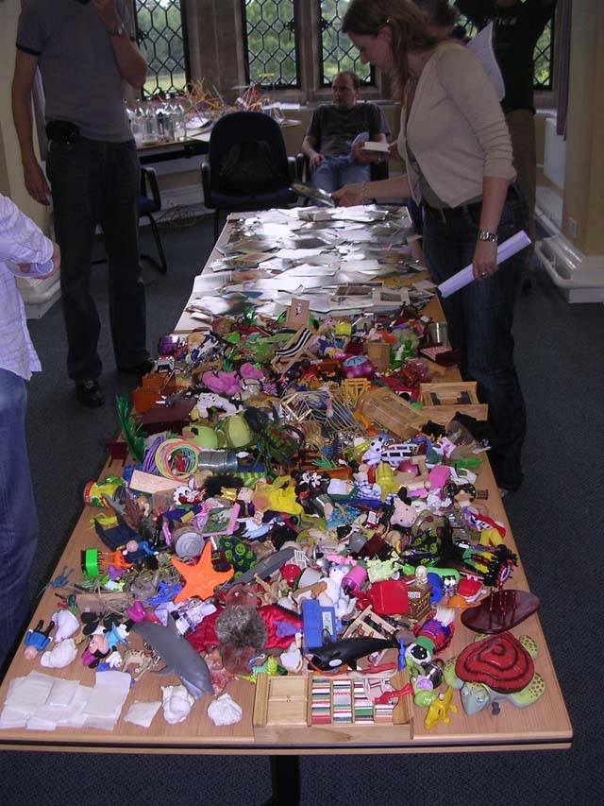
Figure 3: Creativity Kit

Workshop 1: ‘Being’ Creative to be Innovative
This workshop introduces the students to two cycles of thinking: Creative Thinking and Operational Thinking, Von Stamm [19], and dispels Attitude 7 - Being Creative is “Not My Job”. It is every ones job to ensure that the company is competitive in today’s climate. Kodak found that out to its cost by over concentrating on its operational thinking in terms of its expertise in film, without embracing creative thinking by understanding the impact that digital technologies would have on both the consumer, and its business. Entrepreneurs are ideally suited to embracing creative thinking, with their preference for spotting opportunities, marshalling resources, and then building capacity, Hall [20]. They can build a business practically out of nothing by solving customer’s problems, at a price that the customer is willing to pay, which still leaves the business enough profits. Whether it’s to make the product: faster; easier to use; more attractive; more functional; smaller. The creative thinking involved has a number of preferred roles each with 16 characteristics, Von Oech [21]. The Explorer role: a person who comes up with the stimulus and the resources in which to generate the ideas; Artist role: who generates the ideas; Judge role: who selects the ideas for implementation; Warrior role: who ensures that the ideas are implemented. Each student has a preference as to which role they would like to play in groups.

Workshop 2: Innovative Strategies & Creativity Inventories
This workshop raises the students’ awareness, by challenging Attitude 10 – Is Creativity Wrong?, to the five steps in the creative process Clemen [22]: preparation which involves looking for the ‘real’ problem; incubation a period of preconscious, fringe-conscious, off-conscious, mental activity that takes us a away from the problem; unconscious incubation, a series of unconscious and involuntary mental events in the period of abstention from the problem; illumination, the ‘Aha!’ or ‘Eureka’ experience leading to a change in perception or a new idea combination; verification, the checking out of the solution, in case the ‘Aha!’ turns out to be a vacuous idea. Austin [23] believes chance plays a role in creativity and is not immune from human intervention, and it plays a distinct role when humans react creatively with one another and their environment. He divides chance up into 5 varieties: Chance I - ‘blind luck’; Chance II - The Kettering Principle where chance favours those in motion and is reliant on curiosity, experimentation, and exploration; Chance III - The Pasteur Principle where chance favours the prepared mind, is based on abilities in observation, memorisation, and formation of significant associations; Chance IV - The Disraeli Principle where chance favours individualised action and is driven by operating in domains seemingly far removed from the area of discovery based on distinctive hobbies, and personal lifestyle. Students are introduced to a number of creative inventories Von Stamm [19], which help them assess their creativity in more depth, setting the scene for organisational innovation.

Workshop 3: FISH! Philosophy
This workshop highlights Attitude 4 – Be Creative – Is it Practical? by showing how practical it is to apply the Fish! Philosophy to the workplace by examining 4 Case Studies: Ford Toyota Rochester; Global Sprint Connection; Baptist Ministry Medical Centre; Technology Roofing Company. The Fish! Philosophy has four principles: Play; Choose your Attitude; Make Their Day; Be There after studying the behaviour of fishmongers in a fish market in Seattle [24]. The students as part of their assessment have to think up a number of strategies of how to apply the Fish! Philosophy in their workplaces. This can be done by introducing Play amongst staff through games, competitions and quiz’s, to encourage staff to choose a positive attitude to their work through positive affirmations, inspirational posters, sayings and quotations. Make Their Day refers to small acts of kindness that the staff can perform which makes the experience memorable in the customer’s eyes, whether its offering discounts, free gifts, a cup of tea, a seat, a place to change a child’s nappy, or to look after the child for a short period of time. Be There is to be fully present for the customer without being distracted by internal thoughts or external commotion it involves the ability to concentrate, listen, be emphatic, and understanding.

Workshop 4: IDEO methodology
Tom Kelley the CEO of USA- based company IDEO [25] – a creative design and ad agency that works with companies to reinvigorate their brands and services is an excellent example of Attitude 6 – Make Time To Think Creatively, which the company does for their clients, i.e. it makes time to think creatively for them. The whole company is geared up to think creatively from its workspaces, to its creative business strategy, to its staff and processes. When challenged by ABC on Nightline in the 1990 to re-design the shopping trolley, the company had the time (they only had 5 days) to not only re-think the design of the shopping trolley, but the shopping experience itself. Centrally to their processes is the identification of the CBI: Creative Business Idea for the business from which hangs their advertising and marketing campaigns. So when working with Intel in the 1990s they identified their CBI, as branding what’s inside the computer, what had never been seen before - the micro-processor. Then IDEO created a number of advertising strategies to bring this concept to the consumer. The first being the Intel Inside Logo, followed by a innovative TV commercial using fly-on-wall camera technique to travel inside a computer, the launch of the BunnyPeople during SuperBowl, and free bicycle reflectors with the Intel logo to raise awareness of the brand in China. The students are asked to identify the CBI’s in the four case studies that are set in class: MTV, Yahoo, Guinness, and Hallmark cards.

Workshop 5: Synectics: Creative Problem-solving
The Synectics approach [26] in Workshop 5 does not employ logic, but excursions and springboards to tackle Attitude 2 – Logic Can Kill Creativity. Excursions are simply exercises that drive up side-roads using different techniques to find ideas off the beaten track that can be brought back and used like any other ideas. Excursions can be divided into: excursion worlds e.g. theatre, cartoons, victoriana; story excursions - where a story is started; physical excursion - which involves a physical activity; outside excursions - collecting an object from outside; descriptive excursions – accessing something within your own experiences. Synectics draws individuals into creative states by making the familiar strange and making the strange familiar. This is achieved by facilitating artificial vacations which allow participants to take an ‘excursion’ that puts distance between themselves and their problem or opportunity or in this case subject of study. Synectics makes particular use of analogies and metaphors, as these give you access to whole new worlds which tend to be very rich in the subject-matter areas which leads to many new ideas and ways of thinking. The students participate in brainstorming exercises where they have to come up with: 50 uses for…; 25 improvements to …; identifying positives for a list of whacky ideas, as warm-up exercises before they enter into the Synectics brainstorming session.

Workshop 6: ?What if! Innovation Process
The ?What if! Innovation Company founded in 1992 has developed an Innovation Process founded on the 4R’s [27] to invigorate brands and services for major UK brands for Unilever, Tesco and Sainsbury to name a few. It’s a shinning example of Attitude 3 – Be Creative – Break Some Rules. In fact the 4R’s of its process is designed to break the rules: firstly in how the problem is expressed, through Re-expression in the wording, or in acting the problem out, to expressing it as a visual or in sound. The next R engages the student in a Related Worlds exercise similar to Synectics excursions, where the problem is related to other worlds such as pottery class for styling clay to find new techniques to style hair to help develop new hair styling products. The next R: Revolution challenges all the rules with What If? Questions: What if the product did not come as a powder? (Could it be a liquid, tablet, sachet, or handkerchief); What if the product could be used throughout the day? (Could be used in the morning, lunchtime, at night, all day long); What if the product did not exist?; What if the product was twice the price?. The next R: Random Links, forces free associations between two items. The technique has only two rules: the random item must be truly random, and you must find a connection. So for example: if you are in the business of carpets, and the random item was an orange, by forcing a connection you could sell your carpet in segments, or as a scented carpet, or a carpet that has a hard-wearing surface but which allows liquids to soak through without staining and then wiped off the back of the carpet. All of these 4 Rs create a 1.5 - 2 hour facilitated session which the students in groups of 4 engage with a group role-playing one of the Fish! Philosophy case studies in order to re-invigorate their products and services. The session is then written up in a report where they identify the CBI’s for the business to further implement. This gives the students a practical application of the: Explorer role with the group that is facilitating; the Artist role with the group who is generating ideas; Judge role with the group selecting the CBI’s, and finally the Warrior role for the group who would need to think of how to implement these ideas.

Workshop 7: Six Creative Competencies Part 1
This workshop deals with creative competencies C1 to C3, addressing Attitude 9 - Creativity … How Ambiguous can we be to enable new ways of seeing. The Six Creative Competencies [28] is used as the framework, and a creative pack is prepared to facilitate each Creative Competence from C1 to C6. The creative pack is given out to each of the groups of students with materials that can be linked to each Creative Competencies designed to navigate complex challenges, a hallmark of creative leadership in action. The packs contained: Flexi-straws to build a 3D model to illustrate C1 Paying Attention to what is ‘seen’ and ‘unseen’ in the gaps and intersections; masks to explore C2 Personalising in terms of the Ten Faces of Innovation [29] and its relationship to ten roles of the Corporate Fool [30]; and postcard images to enable group visual brainstorming in C3 Imagining. Each group member in the visual brainstorming exercise is asked to choose an image and pass it onto the group member on the right whilst receiving an image from the group member on the left, they then place an image on top and carry on passing the packs of images around the group, until it reaches them again, and then they place the last image on top. Each image that is placed on top is a visual application of Parnes/Osborn SCAMPER model [31] of generating new ideas. In this case, the use of the image is not restricted to the problem definition but to the problem re-framing stages of the creative problem-solving cycle, and can in fact be used in ideas-generation stage as well.

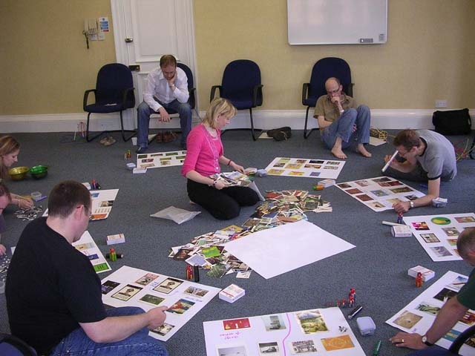
Figure 4: Visual Brainstorming: application of SCAMPER model

Visual Brainstorming using images fits neatly with the thinking of Eisner [32] who has always believed in ‘new’ forms of representation as encouraging new ways of seeing. He lists five ways in which alternative forms of representation hold out a promise to get in touch with the bedrock upon which meaning is constructed:

- They encourage ‘empathy’ with the internal thoughts and feelings being expressed.
- They vividly express the ‘particularity’ of the moment, experience.
- They evoke what he calls ‘productive ambiguity’ in stimulating multiple perspectives around a single experience.
- This leads to an increase in the questions we can use to inquire further into the nature of the experience.
- They reveal ‘individual aptitudes’ that might otherwise have been hidden.” (p.8)

Facilitating with the arts opens up the imagination, but as far as businesses are concerned this must lead to some action. Eisner believes this is possible:

‘Our conceptual life, shaped by the imagination and the qualities of the world experienced, gives rise to the intentions that direct our activities. Intentions are rooted in the imagination. Intentions depend upon our ability to recognise what is and yet to imagine what might be.’ (p.7)

Workshop 8: Six Creative Competencies Part 2
This workshop covers the next 3 competencies: C4: Serious Play; C5: Co-Inquire; C6: Crafting. They all involve an element letting student’s experience Attitude 5 – Play is Creative. A series of prompt cards is used to encourage story-telling in metaphor around C4 Serious Play drawing upon the Magic of Metaphor [33]. Six DeBono Thinking Hats [34] are used to facilitate C5 Co-Inquiry in groups. The hats are colour-coded, the DeBono green hat (represents creativity), yellow hat (positivity), and red hat (emotion) these are the least familiar hats to wear in education. Most education is based on the students wearing the black hat (critical), and allowing the facilitator to wear the blue hat (principles and philosophies), whilst requesting the white hat (data) so they can complete their assignments. Concentrating on wearing the first three hats in the workshops creates a free, supportive self-regulating environment that values all ideas. There are no ‘put-downs’, no rejections, no competitiveness, and no personal judgements. Once these attitudes are inherent in the way the group begins to work, it is easy to maintain this way of working - if the group runs into any problems, then the participants can be reminded to take off their DeBono’s black critical hats and to put their green creativity hat back on. Toys can be used to create organisational landscape in C6 Crafting – this involves synthesizing all the parts of the organisation represented as objects, by following the 5 stages of Symbolic Modelling [35]:
- Stage 1: Entering the Symbolic Domain
(Choosing the objects from the table)
- Stage 2: Developing Symbolic Perceptions
(Attributing meanings to the objects you are choosing)
- Stage 3: Modelling Symbolic Patterns
(Laying the objects out)
- Stage 4: Encouraging Conditions for Transformation
(Enabling a dialogue about their meanings, relationships and groupings of images)
- Stage 5: Maturing the Evolved Landscape
(Facilitating a change through the movement/replacement of objects

Objects are a great way to illustrate the power of Symbolic Modelling and explore the inherent logic of what is termed as the Evolved (Metaphor) Landscape. This can enable individuals to reach a deeper understand of their issues through the introduction of new objects finding a solution to their problem, which:
- Concentrates attention on lower, more fundamental levels of organisation
- Attends to higher, more significant patterns of patterns
- Broadens attention to outside or beyond existing spatial boundaries
- Lengthens attention to before or after a sequence of events
- Identifies the logical conditions necessary for change
- Introduces one symbol to another so that information or resources can be transferred or exchanged

The application of these Creative Competencies seeks to improve creativity, teamwork, and innovative problem solving for business leaders constantly seeking new ways to inspire, motivate and improve performance.

Workshop 9: NLP – Neuro-linguistic Programming
NLP is the new technology of achievement [36], which allows us to be the best we can possibly be by studying people of excellence. It embraces hypnotherapy, and its ability to tackle and remove fears and phobias through visualisations. It challenges us to overcome Attitude 8 – Don’t Be Afraid To Be Creative through self-knowledge as to whether we are a visual, auditory or kinaesthetic person. Students through story-telling and a questionnaire will be given an insight into their preferred style of communication and how they and others ‘see’, ‘hear’, and ‘feel’ them in the world. Developing good rapport skills is essential, as well as being clear of the outcome you desire, and displaying enough behavioural flexibility to notice when you get the response you want – this requires creativity. How to influence people effectively through the chucking of information and using meta-programmes is also covered. This is vital in creatively championing projects, and motivating staff to get involved.

Workshop 10: Forum Theatre Technique
The challenge to Attitude 1 – One Right Answer is presented in the last Workshop 10 on the Forum Theatre Technique. This allows us to examine a number of multiple perspectives on the problem, and look at it from several angles before deciding the next course of action. Forum Theatre developed by Augusto Boal allows the participants to ‘act’ out problems between the problem-owner and the problem-person, and is written up in more detail in the paper The Organisational Theatre of Learning [37]. The students encapsulate in a written scenario the characters, personalities and issues involved in the problems their organisations are facing. These are then 'acted' out by small groups of students to the other students who attempt to make interventions to alter the course of the dramatic action by proposing solutions using the Forum Theatre technique. Through reflection students have the opportunity to experiment with a number of conflict resolution techniques live; improve the quality of relationships, communication and problem-solving skills; and stimulate reflection, argument, counter-argument, and action. By playing the problem-owner, observing first-person perspective, or the problem-person, observing second-person perspective, or neither, observing system perspective – dynamics of the interaction.

When respondents on the Diploma of Management Studies [38] were asked to identify whether their organisation would be open to using Forum Theatre technique in their training, the following is a list of areas they identified as potential places for using this technique:

Sales - ‘motivating their sales force...’
Customer Services - ‘...would relish it’
Marketing - ‘... (but only if they could dress up too!)’
Social Services - ‘we work in a role bound way often this is prescribed in legislation - might be helpful to experiment playfully how changes of style effect these roles.’
Senior Management Training - ‘very senior mangers in health care’
Staff Development - ‘watching videos and finding the ‘right & wrong way’ way to address the situation.’
Continuous Improvement - ‘Yes, I think they would be open to new techniques, it would interest the workforce encouraging them to participate in a non-threatening environment.”

As we can see from the above responses the Forum Theatre Technique is ideally suited to addressing the three most important activities of creativity and innovation i.e. Sales, Customer Services, New product development. The exercise shows the power of following ‘right-brain’ approaches which rely on symbols, imagery, metaphor, association, emotions and intuitions, with ‘left-brain’ approaches which depend on verbal expression, rational and sequential thought, in challenging assumptions; making connections; recognising patterns; and seeing in new ways.

SUMMARY

Fritz [39] describes this three-stage creative process as: conceiving what you want by knowing what you want; knowing what currently exists by developing an accurate perception; taking action by inventing, learning and adjusting. The summary table conceives the attitudes towards creativity that need to be encouraged and those that need to be challenged, if not they can stifle innovation in an organisation as expressed by Moss Kanter’s 10 Rules. Through developing an accurate perception of creativity by the undertaking the tasks and exercises in Julia Cameron’s The Artist’s Way on a weekly basis to recover and discover our creative selves this will counteract the attitudes that stifle organisational innovation by equipping the students with the knowledge, skills, processes, and techniques in the workshops to positively encourage innovation.

Challenging Attitude | Stifling Rule | Recovering Week | Innovation Workshop
Attitude 1 - One Right Answer | Rule 5 – identify problems as signs of failure | Week 7: Recovering a Sense of Connection | Workshop 10: Forum Theatre Technique
Attitude 2 - Logic Can Kill Creativity | Rule 6 – control everything carefully | Morning Pages | Workshop 5: Synectics Creative Problem-Solving
Attitude 3 - Be Creative – Break Some Rules | Rule 10 – management hold the attitude that they know everything | Week 1: Recovering a Sense of Safety & Week 2: Recovering a Sense of Identity | Workshop 6: ?What If! Innovation Process
Attitude 4 – Be Creative – Is That Practical? | Rule 9 – lower managers are given responsibility for cut backs etc | Week 8: Recovering a Sense of Strength | Workshop 3: Fish! Philosophy
Attitude 5 – Play is Creative | Rule 8 – requests for information are not freely given out | Week 11: Recovering a Sense of Autonomy & Week 6: Recovering a Sense of Abundance | Workshop 8: Six Creative Competencies Part 2
Attitude 6 – Make time To Think Creatively | Rule 7 – managers make decisions in to change policies | Artist Dates / Time Outs | Workshop 4: IDEO Methodology
Attitude 7 – Being Creative Is “Not My Job” | Rule 1 – management regard new ideas with suspension | Week 10: Recovering a Sense of Self-Protection | Workshop 1: ‘Being’ Creative to be Innovative
Attitude 8 – Don’t be Afraid To Be Creative | Rule 3 – managers ask individuals to criticise each other’s ideas | Week 9: Recovering a Sense of Compassion | Workshop 9: NLP
Attitude 9 – Creativity … How Ambiguous | Rule 2 – people can only act with managements approval | Synchronity & Week 12: Recovering a Sense of Faith & Week 4: Recovering a Sense of Integrity | Workshop 7: Six Creative Competencies Part 2
Attitude 10 – Is Creativity Wrong? | Rule 4 – managers express their criticism freely and withhold praise | Week 5 : Recovering a Sense of Possibility & Week 3: Recovering a Sense of Power | Workshop 2: Innovative Strategies & Creativity Inventories
Figure 5: Summary Table linking Creative Individualism with Organisational Innovation (source Jolanta Jagiello)
CONCLUSION

To embed the arts-based approach in the culture of the organisation or business you are working for takes great skill, both in facilitation and in the arts themselves. The students studying on the module ‘Facilitating Creativity in Business’ will gain the expertise to facilitate arts-based approaches to enable organisational innovation that is more than a one-off workshop. Their intention, as A&B [40] puts it, will be: “to embed the arts right into the centre of business culture, making them an integral part of business process rather than a bolt on accessory.” (p.7). They will not limit creativity just to creative problem-solving, but aim to provide sustainable resource of creativity leading to organisational innovation as expressed by Holden (a freelance trainer) in his article for artsbusiness [40]:

“To many people in the commercial world, the word ‘creativity’ is a synonym for ‘problem-solving’. In business jargon, managers try to ‘get out of the box’ in order to ‘think laterally’ and ‘provide creative solutions to problems’. Increasingly however, businesses are realising that creativity is not just the activity of brainstorming in hotel room (after which everyone can conveniently get back in the ‘office’ box) but something new - the promotion of change and experimentation which is vital to growth, healthy development, and survival. In addition, they are being forced, by the pace of social and technological change to unleash all the creative resources of their employees to stay abreast of the game.” (p.10)

REFERENCES
[1] Edwards, B. Drawing on the artist within: A guide to innovation, invention,
imagination and creativity, Collins, 1987.
[2] www.creativematch.co.uk, Creativity viewed negatively by UK bosses a new survey
reveals, On behalf of Canon and Arts Council, 2006.
[3] Ackoff, R. The Art of Problem-Solving, John Wiley & Sons Inc, 1978.
[4] Alder, N. The Arts & Leadership: Now That We Can Do Anything, What Will We Do?,
Academy of Management Learning and Education Journal, vol. 5 (no. 4) 2006,
pp. 486-499.
[5] Schein, E. Organisational socialisation and the profession of management, Industrial
Management Review, Vol. 9, 1968, pp.1-16.
[6] Bowen, D. B. Experiential and traditional teaching of OB: A dubious distinction.
Exchange, The Organizational Behavior Teaching Journal, vol. 5 (no. 2)
1980, pp. 7-12.
[7] West, E. L. Unlocking the Force: Nurturing Creativity in the Classroom, The Fourth of
Art of Management and Organisation Conference, The Banff Centre, Alberta,
Canada, 9th -12th Sep 2008, Conference papers pp. 1500-1512.
[8] Lazear, D. Pathways of Learning, Zephyr Press, 2000.
[9] Moss Kanter, R. The Change Masters, Simon & Schuster, 1983.
[10] Barron, F. Putting creativity to work. In R.J. Sternberg (Ed), The nature of
Creativity, pp. 76-98, Cambridge University Press, 1988.
[11] Fox M. L. Da Vinci and the 40 Answers: A Playbook for Creativity and Fresh Ideas,
Wizard Academy Press, 2008.
[12] Cameron, J. The Artist’s Way, Pan Books, 1995.
[13] Byran, M. Cameron, J. & Allen, C. The Artist’s Way at Work, Quill, 1998.
[14] Jagiello, J. The Art of Creativity, The Fourth of Art of Management and Organisation
Conference, The Banff Centre, Alberta, Canada, 9th -12th Sep 2008,
Conference papers pp. 827-845.

[15] Jeffers, S. Feel the Fear And Do It Anyway, Ballentine Books, 2006.
[16] Cook, P. Best Practice Creativity, Gower, 2002.
[17] Rodgers, C. Toward a theory of creativity. In S.J. Parners & H.F. Harding (eds).
A source book for creative thinking. New York: Scribner’s, 1962.
[18] Ekvall, G. ‘Climate’, in D. Walker and J. Henry (ed.) Managing Innovation, Sage,
London, 1991.
[19] Von Stamm, B. Managing Innovation, Design & Creativity, Wiley, 2003.
[20] Hall, D. In The Company Of Heroes - An insider's guide to entrepreneurs at work,
Kogan Page, 2001.
[21] Von Oech R. A Whack Pack on the Side of the Head, Warner Books, 1998.
[22] Clemen, R.T. Making Hard Decisions: An Introduction to Decision Analysis, Duxbury
Press, 1999.
[23] Austin, J.H. ‘Serendipity: the varieties of chance’, B882 Creative Management
Readings, The Open University Press, pp.62-64, 1998.
[24] Lundin, S. Christensen, P. Fish for Life!, London, Hodder & Stoughton, 2004.
[25] Schmetterer, B. Leap: A Revolution in Creative Business Strategy, Wiley 2003.
[26] Prince, G. The operational mechanism of Synectics, Journal of Creative Behaviour, No.
2, pp.1-13, 1968.

[27] Kingdom, M. (ed.) Sticky Wisdom: How to Start a Creative Revolution at Work,
West Sussex, Capstone, 2002.
[28] Horth, D. & Palus, C. The Leader’s Edge: Six Creative Competencies for Navigating
Complex Challenges, Jossey-Bass, 2002.
[29] Kelley, T. & Littman, J. The Ten Faces of Innovation: IDEO’s strategy for beating the
Devil’s Advocate and driving Creativity through your
organisation, DoubleDay, 2005.
[30] Firth, D. & Leigh, A. The Corporate Fool, Capstone, 1998.
[31] Parnes, S.J. Magic of your mind, Buffalo, NY: Bearly Limited, 1981.
[32] Owen, N. The Magic of Metaphor, Crown House Publishing, 2001.
[33] Eisner, E.W. ‘Forms of Understanding and the Future of Educational Research’,
Educational Researcher, September 1993, pp. 5-11.
[34] De Bono, E. Six Thinking Hats, Penguin, London, 1985.
[35] Lawley, J. and Tompkin, P. Metaphors in Mind, Developing Company Press, 2000.
[36] Faulkner, C. & Andreas, S. NLP: The New Technology of Achievement, Nicholas
Brealey Publishing Ltd, 1996.
[37] Jagiello, J. Organisational Theatre of Learning, 1st Northumbria Creativity Conference:
‘Enhancing Students Creativity - Creating the Creative University’,
forthcoming Conference Proceedings, University of Northumbria ,
30th August-1st September 2000.
[38] Jagiello, J. Organisational Theatre of Continuous Learning: The Application of the
Forum Theatre Technique to Continuous Improvement, 2nd EuroCINET
Conference Proceedings, University of Twente, 14th-15th September 1998.
[39] Fritz, R. The path of least resistance: Learning to become a creative force in your
own life, Ballantine Books, 1989.
[40] Stockil. T. Unlocking business creativity, artsbusiness, 26th October 1998.

