**Twiplomacy in the age of Donald Trump: Is the diplomatic code changing?**

Maja Šimunjak and Alessandro Caliandro

Department of Media, Middlesex University London, London, United Kingdom

CONTACT INFORMATION

Maja Šimunjak, Department of Media, Middlesex University London, The Burroughs, Hendon, London NW4 4BT, United Kingdom, EMAIL: M.Simunjak@mdx.ac.uk

ABTRACT

This study employs digital methods in conjunction with traditional content and discourse analyses to explore how the US President Donald Trump conducts diplomacy on Twitter and how, if at all, diplomatic entities around the world engage in diplomatic exchanges with him. The results confirm speculations that Trump’s diplomatic communication on Twitter disrupts traditional codes of diplomatic language but show little evidence that new codes of diplomatic interactions on social media are being constructed, given that other diplomatic entities around the world mostly remain within the confines of traditional notions of diplomacy in (not) communicating with Trump on Twitter.

Keywords: Twitter; social media; diplomacy; digital methods; United States; Donald Trump.

The US President Donald Trump’s naming and shaming of several world leaders and countries on Twitter as soon as he took office in January 2017 received considerable media attention (Apps 2016; Crowley, McCaskill, and Nelson 2017; Dejevsky 2017; Huang 2017; Tremonti 2016), with a wide range of commentators expressing concern over newly elected president’s diplomatic practices on social media. Commenting on Trump’s “Twitter diplomacy,” Dejevsky (2017, n.p.) claims that Trump “has earned almost universal disapproval from the political and especially the diplomatic establishments, which regard such heedless commentary as, first, ill-advised in the extreme and, second, plain crass.” Indeed, his diplomatic practices on Twitter have been criticised by political actors at home (Crowley, McCaskill, and Nelson 2017) and abroad (Huang 2017). Most notably, China reacted to Trump’s negative comments on Twitter in an article published by the Chinese state news agency Xinhua titled “Addiction to Twitter diplomacy is unwise,” in which it emphasised that tweeting is not a suitable way for conducting diplomacy (Huang 2017). According to Tremonti (2016), with Trump’s Twitter practices, diplomacy is “entering an unprecedented, unpredictable, and extremely high-stakes era” (n.p.; see also Apps 2016).

While these are valuable observations, Trump’s diplomatic practices on social media have not been systematically studied; hence many assessments are based on anecdotal evidence. Consequently, to what extent is Trump using social media for diplomatic purposes, how is he conducting diplomacy on social media, and who, if at all, is engaging him on social media, remains largely speculative. We empirically address these questions in this article and also the more fundamental question whether or not Twitter practices are catalysing the development of a new code for diplomatic communication on social media.

The article proceeds as follows. We first discuss existing literature on diplomacy as communication and studies focusing specifically on social media and Trump’s Twitter use. We thereafter describe our methodology, which combines Digital Methods (DM) approach with traditional techniques of analysis, such as content analysis and discourse analysis. Lastly, we present our findings, analysis, and conclusions.

**Diplomacy as communication**

Broadly, diplomacy can be conceptualised as an instrument of policy or a means of communication (Sharp 2001). We look at diplomacy as a means of communication. From this perspective, language is considered to be the dominant medium of diplomacy (Rana 2001), and diplomats’ words are often seen as their actions (Pascual 2001). Also, following Wong (2016) and Poguntke and Webb (2005), we consider “diplomats” as not only those who have been formally delegated the duties of diplomacy (e.g. foreign ministers, ambassadors), but also political leaders who are increasingly important as representatives and negotiators in the international arena.

While a comprehensive overview of main characteristics of diplomatic language is lacking in the literature, scholars have emphasized following characteristics of diplomatic language:

1. Diplomatic language should be courteous, marked by respect for and consideration of others (Jönsson and Hall 2005). In effect, there is no space for insults, uncivil wording, naming, and shaming.
2. Diplomatic language should be constructive and positive. Diplomats in their communication should be careful not to appear superior, indifferent, controlling or offensive towards other actors in international relations (Jönsson and Hall 2005; Park and Lim 2014; Strauss, Kruikemeier, Meulen, and Noort 2015).
3. Diplomatic communication should be balanced and moderate. It should not be dramatic, especially in high stake situations (Nick 2001).
4. Diplomatic language should be ambiguous. It is often indirect and uses hedges, which makes it appear vague and open to interpretations. Such ambiguity serves several purposes in diplomacy, e.g. retaining flexibility in negotiations, making claims deniable, and being able to speak to multiple audiences (Jönsson and Hall 2005).

These characteristics are considered part of the diplomatic *code,* which guides interactions between diplomats. Given the importance and delicateness of interactions between diplomats, great deal of thought goes into crafting diplomatic language. According to Pascual (2001), diplomatic communications need to be “deliberate, masterful, carefully and prudently drawn up” (230-31).

While the ways in which diplomats communicate and engage in dialogue with other actors is considered crucial in diplomacy, scholars and practitioners alike emphasize that what is said in diplomatic communication is as important as what is left unsaid (Jönsson and Hall 2005; Pascual 2001). In other words, omission of information in a diplomatic dialogue is an action in itself, which sends messages to other actors in the same way as information that has been communicated. The same can be said for a lack of response and engagement in a dialogue. In other words, if one party in a diplomatic relation does not engage in a dialogue initiated by another party, this lack of response is interpreted as deliberate and strategic, and an action in itself. Hence, in diplomatic communication, both behaviour and non-behaviour are seen to constitute messages.

***Social media diplomacy***

Writing at the beginning of the 2010s, Stein (2011, 114) declared: “all governments are facing an urgent need, partly driven by the emergence of new technologies and social media, to update their diplomatic instruments.” Several years later, Twitter positioned itself as the “ultimate channel for digital diplomacy for world leaders and governments.” Reportedly almost 180 world leaders and governments are using it for communicating with their peers and publics (Lüfkens 2017).

Existing research on the use of social media in diplomacy has mostly focused on how social media is used for public diplomacy (i.e., relationships between nation-states and foreign publics), and on the practices of diplomatic institutions such as ministries for foreign affairs and embassies (Bjola and Holmes 2015; Cassidy and Manor 2016; Cull 2011; Zhong and Lu 2013; Strauss et al. 2015). Here social media is often seen as allowing for the development of a more open and collaborative model of diplomacy. Correspondingly, it is often said that social media requires diplomats to engage in a more personalised and interactive way with their audiences. However, there is debate on both the extent of influence of social media on diplomatic communication and the extent of influence that the social media is having on developments in diplomatic practice (Bjola and Holmes 2015; Hocking and Mellisen 2015; Zhong and Lu 2013). In fact, there is research showing that diplomatic entities on social media rarely meet expectations of social media diplomacy, i.e., they tend not to focus on interaction, networking, and openness (Cassidy and Manor 2016; Strauss et al. 2015).

Overall, existing research in social media diplomacy has two important limitations. First, it overly focuses on public diplomacy, almost completely ignoring government-to-government social media diplomacy (G-2-G). A rare exception is Cassidy and Manor (2016), which debunks social media diplomacy myths, but even here, G-2-G is barely discussed. Second, while questions concerning agenda setting, reach, and engagement have been generally explored, the issue of style as a possible source of influence on diplomatic communication has been neglected.

Consequently, existing studies provide a glimpse into the effective strategies that diplomatic institutions can use in conducting public diplomacy over social media, but there is hardly anything known about how world leaders use social media to engage with their diplomatic counterparts. According to Lüfkens (2017), world leaders extensively use social media for various purposes, including fostering relationships with other world leaders and foreign publics. According to many indicators, the most popular social network world leaders use is Twitter. Data from 2018 shows that the US President Donald Trump is the most-followed world leader on Twitter, with Pope Francis close behind. Trump is also considered to be the most influential world leader on Twitter based on number of interactions with followers, and the second most effective leader on Twitter based on number of retweets per tweet. In May of 2017 Trump’s followers on Twitter included 137 world leaders (Lüfkens 2017).

***Trump’s social media communication***

There is a growing body of research looking into Trump’s social media communication style. Existing research, which primarily examines his social media communication in primaries and 2016 US presidential elections, suggests Trump’s social media communication has following characteristics:

1. Trump’s social media communication tends to be simple. The analysis of more than 2000 tweets Trump posted in 2015 and 2016 shows that his language on Twitter is characterised by frequent use of monosyllabic words (Crockett 2016; Ott 2017).
2. Trump’s communication tends to be personalised and grandiose. Trump has been found to often use the first person and informal language, commonly using personal pronouns such as I, me, mine, myself, and frequently using social media to boast about himself (Ahmadian, Azarshahi, and Paulhus 2017; Merrill 2015; Shafer 2015).
3. Trump's social media communication during primaries and presidential campaign tended to be characterised by negativity (Gross and Johnson 2016). His tweets were often impolite and politically incorrect (Crockett 2016; Enli 2017), with one in four tweets attacking someone or something, and one in 10 containing “uncivil wording” (Lee and Lim 2017).
4. Trump’s social media communication during the 2016 campaign tended to be emotional and impulsive. He often used capital letters and exclamation marks (Crockett 2016); practices which “reinforce the negative sentiment of his Tweets and heighten their emotional impact” (Ott 2017, 64). Also, Trump’s tweets are often impulsive and lacking “forethought, reflection, or consideration of consequences” (Ott 2017, 61).

Overall, Trump deviated from practices which have been previously established as effective in social media campaigning and utilised a different communication style which Enli (2017, 54) describes as “more amateurish yet authentic.”

Shortly after Trump took office, Dejevsky (2017, n.p.) wrote in *The Guardian*: “There was a widespread belief that once Donald Trump was president, his mode of communication would change. He would think first, speak later. And if he could not bring himself to do that, his wiser aides (or his son-in-law) would ensure that whatever device he used for his quickfire utterances was safely locked up.” However, Trump continued with his communication style on social media even as he took the position of the president of the United States (Apps 2016; Dejevsky 2017). This has raised concerns, as Trump’s tweets are now presidential communications, which can be considered as diplomatic actions of the chief diplomat of the United States.

When it comes to Donald Trump’s diplomatic communication on social media, there are several permissive and restraining factors that might influence the extent to which it follows diplomatic norms.

On the permissive side, American diplomats are known to be often too direct and harsh in diplomatic exchanges (Sharp 2001). For instance, the US diplomats displayed an uncivil and tactless communication style in diplomatic exchanges with both American allies and enemies in the period before the Iraq war (Wiseman 2005). Also, Twitter privileges discourse that is simple, impulsive, and uncivil, which seems the complete opposite of the language that is said should be used in diplomatic interactions (Ott 2016). On the restraining side, the need for cooperation from other countries creates pressure to follow the universally expected diplomatic codes of behaviour in international relations. In the case of the Iraq war, when the US realised it needed international support for its actions, it changed tack and reverted to the diplomatic code of behaviour (Wiseman 2005).

If Trump’s diplomatic communications on social media are indeed consistently at odds with traditional conventions of diplomatic language, there are two possibilities. One, his style of social media diplomacy might disrupt traditional diplomatic practices and potentially cause conflicts in international relations. Two, it may lead to the construction of new conventions in (digital) diplomacy. This could take a form of “gradual change and adaptation within the existing frameworks and principles,” or it could represent “a fundamental break with accepted patterns of behaviour, norms and rules so that diplomacy starts to look fundamentally different” (Hocking and Mellisen 2015, 21).

**Methodology**

We combine Digital Methods (DM) approach (Caliandro and Gandini 2017; Rogers 2013) with traditional techniques of analysis, such as content analysis (Krippendorff 2012) and discourse analysis (Johnston 2008).

Specifically, we follow the approach proposed by Lewis, Zamith, and Hermida (2013), who fruitfully combine DM and traditional techniques for analysis of social media texts. In their seminal article entitled “Content analysis in an era of big data,” they urge researchers conducting content and/or discourse analysis of Twitter messages to use a hybrid approach blending “computational and manual methods throughout the content analysis process.” (39)

We use DM for managing as well as mapping the social and semantic structure of our dataset (119,229 tweets), i.e., for: (a) sampling the database, (b) extracting Twitter users of interest (e.g. Twitter users mentioned by Trump), and (c) tracking the interactions among users (e.g. reciprocal mentioning) (Marres 2015). Subsequently, we conduct a traditional content and discourse analysis of Trump’s Tweets.

***Data collection***

We gathered the tweets posted by the Donald Trump’s official Twitter account (@realDonaldTrump) by using custom-built software ­– a Python script programmed for interrogating the Twitter REST API[1] (Russell 2013). Specifically, we implemented a method called “GET statuses/user_timeline.” This method “returns up to 3,200 of a user’s most recent Tweets” (Twitter Developer Documentation[2]). Since we were interested in following Trump’s tweets production during his first month of the presidency, we launched the script on the 21st of February 2017. Through this procedure, we were able to retrieve 3,247 tweets posted by Trump from the March 17, 2016 to the February, 21, 2017, where 192 of them fell into our target time period (January 20, 2017 – February 20, 2017).

Once this subset was extracted from the whole dataset, we searched it in order to detect the diplomatic entities,world leaders, and foreign countries mentioned by Trump, either with or without the mention function (@). After this search, we discovered that Trump mentioned diplomatic entities in 34 tweets. Through this procedure, we identified 25 diplomatic entities mentioned by Trump. For each country mentioned by Trump, we identified three diplomatic entities – official country accounts, heads of governments, foreign ministers and their offices – that may be in a position to reply to his remarks, focusing on those diplomatic entities who have Twitter accounts. Once the list of the official accounts of the 41 entities[3] was constructed, we again launched our Python script in order to collect all the tweets posted by each of the aforementioned accounts. Specifically, the script retrieved 115,982 tweets, 57 of which contained messages where users engaged in real or imagined conversation with Trump during the first month of his presidency. Therefore, we narrowed our analysis to a database composed of 91 tweets (that is, 34 tweets posted by Trump plus 57 tweets posted by other diplomatic entities)[4]. We are aware that our analysis focused on a small set of data, which limits the generalizability of our results. Nevertheless, given our research project is qualitative and exploratory, the statistical generalizability of results was not among its primary aims (Lincoln and Guba 1985). Instead, our intention was to explore certain cultural processes emerging within a specific digital environment (Caliandro 2018), i.e., the fluxes of communication as well as communicative interactions (Larsson and Moe 2012) generated by Trump and other diplomatic actors on Twitter. Furthermore, we sought to obtain a pool of deep qualitative insights useful to establish a solid base to support further studies on Trump’s diplomatic strategies on Twitter as well as digital diplomatic communication in the age of Trump.

We submitted the afore-mentioned dataset to two kinds of textual analysis: content analysis and discourse analysis. In addition, we took advantage of Gephi, an open-source software for social network visualization (Bastian, Heymann, and Jacomy 2009), to make the structure of the communicative interactions between Trump and other diplomatic entities (e.g. who tweets about whom and with what frequency) visible and thus easier to describe.

***Data analysis***

We conducted the content analysis on the dataset composed only of diplomatic tweets posted by @realDonaldTrump (34 tweets). We conducted our content analysis using a set of a priori coding categories, which were inspired by the existing literature on diplomatic language (Nick 2001; Jönsson and Hall 2005; Park and Lim 2014; Strauss et al. 2015). The categories we used are as follows: Qualifying, Hedging, Polite, Positive, *and* Non-dramatic (see Table 2 for further details). Our analysis focused more on the *intentions of the communicator* (@realDonaldTrump) (Berelson 1952), rather than on recurrent themes appearing in the units of communication (tweets) (Smith 1992). This analysis helps us understand if and to what extent Trump embraces or disrupts the traditional diplomatic linguistic code.

**Table 1. Coding book with illustrative tweets**

|  |  |  |
| --- | --- | --- |
| **Coding Category** | **Description** | **Illustrative tweet** |
| Qualifying | Does the tweet use qualifiers which are words or phrases that minimize the certainty of a statement? | None found. |
| Hedging | Does the tweet use hedges which are word or phrases that lessen the impact of a statement, or express uncertainty? | ‘The real story here is why are there so many illegal leaks coming out of Washington? Will these leaks be happening as I deal on N.Koreaetc?’ |
| Polite | Does the tweet contain polite phrases? | ‘Thank you to Prime Minister of Australia for telling the truth about our very civil conversation that FAKE NEWS media lied about. Very nice!’ |
| Positive | Does the tweet express a positive evaluation of a country/leader? | ‘Melania and I are hosting Japanese Prime Minister Shinzo Abe and Mrs. Abe at Mar-a-Lago in Palm Beach, Fla. They are a wonderful couple!’ |
| Non-dramatic | Is the language used in the tweet non-dramatic? | ‘Today I will meet with Canadian PM Trudeau and a group of leading business women to discuss women in the workforce.‘ |

We also analysed his diplomatic tweets by using the lexicalisation technique of discourse analysis (Deacon 2007). Examination of Trump’s lexical choices allowed us to identify potential ideological beliefs and values that underpin his diplomatic messages (Deacon 2007), and uncover their “inherent assumptions and prejudices” (Kogen 2015, 8). In doing so, we were guided by the codes of diplomatic language and dialogue identified in the relevant literature. On occasion sentence and phrase structure were also analyzed, as they reflect speaker’s presentation of action, patterns of ascription, and value judgements (Smith and Bell 2007).

We used Gephi mainly for mapping the structure of interactions between Trump and other diplomatic entities. In order to do this, we employed some basic network analysis techniques (Gruzd, Wellman, and Takhteyev 2011). It was based on both the *in-link* and *out-link* technique, i.e., we analysed the mentions received and given by each user (Hanneman and Riddle 2005). It focused on both direct (e.g. @realDonaldTrump, @AbeShinzo) and indirect mentions (e.g. Trump, Abe) among users.

**Findings**

Within the first month of his presidency, Donald Trump posted 192 tweets, in which he mentioned 6 foreign political leaders and 19 foreign countries. In contrast, in their first month in office, British Prime Minister Theresa May posted 16 tweets mentioning one foreign leader and one foreign country and Australian Prime Minister Malcolm Turnbull posted 44 tweets mentioning also one foreign leader and one foreign country. This comparison shows how extraordinary is Trump’s engagement on Twitter and the extent to which he uses it for communicating to and about foreign leaders and countries.

***Conversations with leaders***

It perhaps is not surprising Trump mentioned six foreign political leaders in his tweets as four visited him in the first month of his presidency. He tweeted about three of them – Canadian Prime Minister Justin Trudeau, Japanese Prime Minister Shinzo Abe, and Israeli Prime Minister Benjamin Netanyahu, but there was no mention of the first state visit, that of Theresa May. While May was mentioned by the official presidential Twitter account, @potus, Trump did not mentioned May on his private Twitter account. Similarly, while the British media put a major emphasis on May's visit to the US, it was not a lead story on American media (Baker-Jordan 2017). Trump not tweeting about May’s visit brings into question how special really is the “special” relationship between the US and the UK, at least as far as Trump is concerned (see also Wilson 2017).

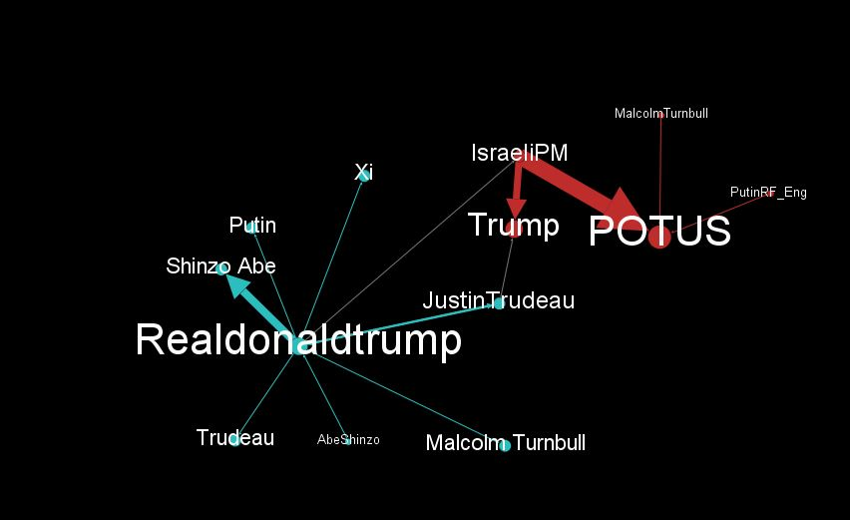

**Figure 1.** Network analysis of tweets posted by Trump and world leaders he mentions. *Note:* The size of the nodes indicates the *in-degree* of users (i.e., the number of mentions received: the bigger the node, the higher the number of mentioned received). The arrows indicate the direction of the relation. The thickness of the lines indicates the frequency of the interaction between the nodes they connect (thicker the line connecting two nodes, the higher the number of interactions among them).

Trump posted only one tweet mentioning Netanyahu during his visit. Netanyahu, on the other hand, mentioned Trump in 23 of his tweets in the first month of Trump’s presidency, tweeting extensively during his visit to the US. Hence this diplomatic dialogue on Twitter was quite one-sided. Given that US-Israeli relationship deteriorated during the Obama administration, and that Obama was openly critical of some of Netanyahu’s actions (Freedman 2017), his tweets might have been directed at portraying a stronger and better relationship with the new US president. On the other hand, Trump’s single tweet could be seen as reflecting his reluctance to position himself strongly alongside Israel at that time (Freedman 2017).

While somewhat ignoring May and Netanyahu in his diplomatic communication on Twitter, Trump tweeted extensively about Japanese Prime Minister Shinzo Abe, posting seven tweets about him during his three-day visit. Given that Trump has been attacking Japan on trade and defence issues throughout his campaign (Smith and McClean 2017), the burst of positive tweets about the meeting with Abe suggested a change in his attitude towards Japan. Abe reportedly went on a “charm offensive” as soon as Trump was elected in November 2016 (Nakamura and Fifield 2017), trying to build a “relationship of trust” with the new US president and further Japanese interests (Smith and McClean 2017). Trump’s tweets suggest that Abe succeeded in developing a constructive and positive relationship with him. It should be noted, though, that the Trump-Abe exchange on Twitter was an almost one-way diplomatic exchange, as Abe replied to Trump only once – on his departure from the US. Abe rarely uses Twitter and the tweet to Trump was the only one he posted during the examined period. Here Abe seems to have made a conscious effort to engage with Trump on Twitter.

Trudeau, Turnbull, and Putin engaged with Trump on Twitter in a similar manner to how Trump engaged with them. The only foreign leader who did not at all interact with Trump on Twitter even though he was mention in his tweets is the Chinese President Xi, who does not have a Twitter account.

Overall, it seems that neither Trump disrupted traditional notions of diplomatic communication on social media at the beginning of his presidency nor any new conventions of diplomatic code were being constructed at the time.

***Conversations with countries***

As mentioned earlier, Trump made reference to 19 foreign countries on Twitter in his first month of the presidency, a varied mix of America's allies and enemies.

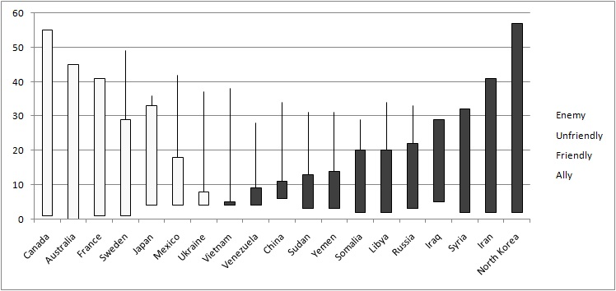

**Figure 2.** List of countries Trump mentions in his tweets presented on a scale “enemy to ally’ according to YouGov analysis of who is considered America’s ally, friendly, unfriendly and enemy (Data from Yougov.com, 2017). Each bar presents a percentage of survey participants who consider a listed country in a particular light. Bars do not stack up to 100% as the ‘not sure’ response hasn’t been presented in the figure. Graph should be interpreted as: 1% of Americans consider Canada to be an enemy country, 3% see it as unfriendly, 32% as friendly, and 55% consider it an ally.

Analysis of the Twitter interactions between Trump and diplomatic representatives of countries he mentions in his tweets reveal several interesting patterns. These Twitter interactions could be categorised as follows: friendlies who converse, provoked friendlies who converse, provoked friendlies who do not converse, unfriendlies who converse, and unfriendlies who do not converse.

Japan, Canada, and Ukraine fall in the “friendlies who converse” category, as their diplomatic representatives engaged with Trump on Twitter, with all sides talking about the same or similar issues from a shared perspective.

Mexico falls in the “provoked friends who converse” category, as its diplomatic representatives have engaged extensively with Trump on Twitter on topics of shared interest, but they and Trump can be seen as speaking from different perspectives. Mexico initiated the dialogue by congratulating Trump on becoming president and talking of a “respectful dialogue,” but after several tweets from Trump in which he attacked Mexico, its representatives took a more distant stance and did not engage in a confrontation with him.

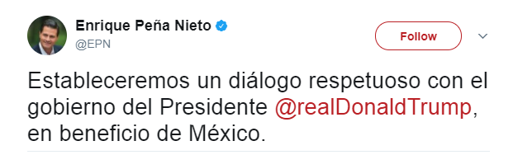

**Figure 3.** Tweet by Mexican President Enrique Peña Nieto posted on January 20, 2017. (Translation: “We will establish a respectful dialogue with the government of the President @realDonaldTrump, for the benefit of Mexico.”)

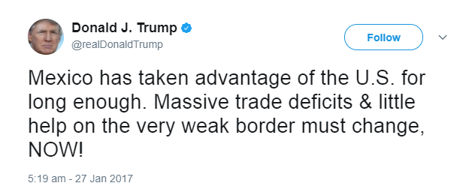

**Figure 4.** Tweet by US President Donald Trump posted on January 27, 2017.

Countries such as Australia, France, Sweden, and Vietnam fall in the “provoked friendlies who do not converse” category. Trump made negative remarks about them on Twitter (e.g. Sweden and France are unsafe countries with immigration problems), but diplomatic representatives of these countries did not engage in a rebuttal or any discussion on the issue raised in Trump’s tweet.

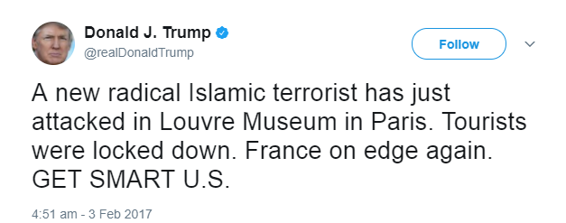

**Figure 5.** Tweet by US President Donald Trump posted on February 3, 2017.

Russia, Syria, and Venezuela fall in the “unfriendlies who converse” category. They were mentioned in a negative light by Trump and their diplomatic representatives engaged him on Twitter. However, each country engaged in a different type of interaction. Russia initiated the interaction by congratulating Trump on taking office but restrained from further interactions once he started intensely tweeting about it, mostly with negative connotations. This might be indicative of its decision not to conduct diplomacy over Twitter. On the other hand, Venezuela reacted strongly to Trump’s “command” to release Leopoldo Lopez from prison. Venezuela’s Minister for Foreign Affairs Delcy Rodriguez posted a series of tweets directly aimed at Trump via @ function in which she attacked him for what she considered was interference in Venezuelan affairs. Obviously, Venezuela was comfortable with engaging in these diplomatic interactions on Twitter and deliberately used tweets as vehicles of diplomatic exchanges.

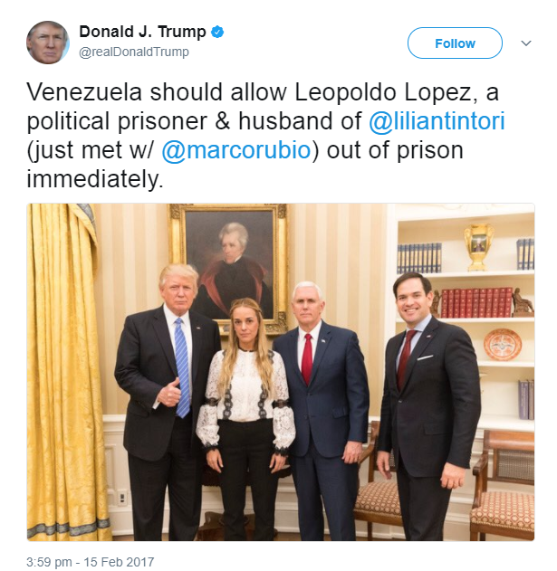

**Figure 6.** Tweet by US President Donald Trump posted on February 15, 2017.

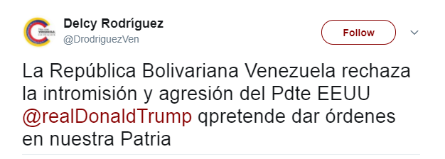

**Figure 7.** Tweet by Venezuelan Minister of Foreign Affairs Delcy Rodríguez posted on February 15, 2017. (Translation: “The Bolivarian Republic [of] Venezuela rejects the intrusion and aggression of [US President] @realDonaldTrump [who intends] to give orders to our homeland.”)

Syria has initiated the dialogue with Trump by posting two tweets (one of them was in Arabic) in which it quoted its President Bashar al-Assad “agreeing” with Trump on the fight against terrorism. Trump then posted a tweet naming Syria as a country from where refugees were coming into the US during “COURT BREAKDOWN” with regard to his travel ban. Syria replied with a tweet in English in which it appeared to change tactics by “asking” Trump to “stop supporting the terrorists,” insinuating that the US President is on the side of terrorists. In another tweet posted on the Syrian Presidency account in Arabic, al-Assad is quoted as saying that the ban is “not targeting Syrians, but rather terrorists”. It seems to have been created to further Syria’s diplomatic message about the differenting between Syrians and terrorists. Given that Trump was never mentioned using the @ function, and some tweets were in Arabic, it is questionable whether Syria actually wanted to engage with Trump, but the fact remains that it did engage in diplomatic exchanges with him on Twitter and it did so by seemingly avoiding confrontation, although using provocative messages in later stages of interaction.

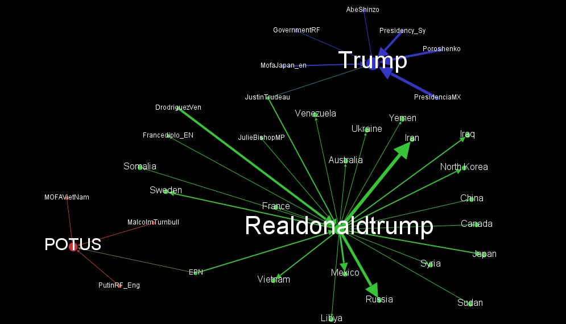

**Figure 8.** Network analysis of tweets posted by Trump in which he mentions another country and those posted by diplomatic entities from countries he mentions. *Note:* The size of the nodes indicates the *in-degree* of users (i.e., the number of mentions received: the bigger the node, the higher the number of mentioned received). The arrows indicate the direction of the relation. The thickness of the lines indicates the frequency of the interaction between the nodes they connect (thicker the line connecting two nodes, the higher the number of interactions among them).

Iran, Somalia, Sudan, Libya, Iraq, Yemen, North Korea, and China fall in the “unfriendlies who do not converse” category. Their diplomats did not engage Trump on Twitter even though he mentioned them, all in negative light except for China. The diplomatic representatives in China, Yemen, Iraq, and North Korea had no official Twitter accounts. The diplomatic representatives of Iran, Somalia, Sudan and Libya had Twitter accounts but did not engage Trump on Twitter.

***Analysis of Trump’s diplomatic language on Twitter***

A simple content analysis was conducted to gage the extent to which Trump’s language in his tweets accords with the traditional codes and conventions of diplomatic language. This analysis indicates that Trump’s language in tweets does not display most characteristics of diplomatic language. It is, however, quite moderate in a sense that it is more often than not non-dramatic. In sum, this style of communication can be seen as disruptive of traditional diplomacy, as it does not conform to its established codes.

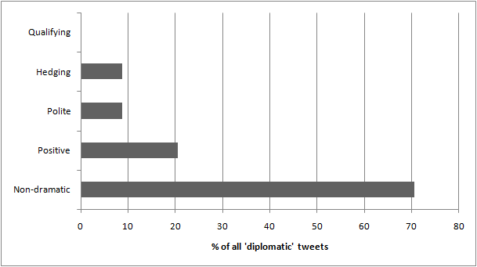

**Figure 9.** Analysis of language used in Donald Trump’s diplomatic tweets.

Trump tends to use courteous language only with leaders of America’s allies. He writes “Thank you” in a tweet to Turnbull, and “Welcome” to Trudeau and Netanyahu. There are no similar extensions of respect, i.e., use of polite phrases, found in tweets mentioning foreign countries, these being friendly or unfriendly.

The positive and constructive language also seems to be reserved solely for leaders of allies. To illustrate, when writing about Turnbull, Trump uses words such as “civil” and “nice,” underscoring them with the adverb “very” which he uses often. Similarly, writing about Abe, Trump uses words such as “wonderful,” “good,” and “productive,” again underscoring them with adverbs such as very and great.

Except for mentioning Japan as being “very well represented,” Trump does not use positive and constructive language in tweets about any other country, both friendly and unfriendly alike. Particularly negative language is used in tweets about Iran and Mexico. Trump’s tweets on Iran carry negative characterizations such as “terror,” “terrible,” “collapse,” and “last legs.” Writing about Iran as “formally PUT ON NOTICE” and “Should have been thankful,” and the US as “giving” Iran a “life-line,” Trump positioned the US as superior to Iran. Such lexical choices as “should” and “giving,” as well as the phrase structures that were used, indicate that Trump gave himself the authority to judge other countries, which can easily cause offense in international relations. Similarly, other Middle Eastern countries were mentioned with reference to “refugees” and “breakdown,” again portraying them in a negative way.

Mexico, a friendly country, is similarly portrayed in a negative and unconstructive manner. Trump tweeted about it using words such as “deficit,” “one-sided,” “lost,” “unwilling,” “badly needed,” “little help,” and “very weak,” casting the US as “taken advantage of” by Mexico. Given all the negative connotations of words used by Trump, his language does not help create a positive and constructive relationship between the two countries. Surprisingly perhaps, Trump tweeted about other friendly countries in a negative context as well. For example, he used words such as “illegal” and “dumb” when mentioning Australia; “terrorist,” “attacked,” “locked down,” and “on edge,” underscored by the adverb “again” when writing about France. Similarly, in his tweet on immigration into Sweden he used the phrase “working out just beautifully. NOT!” By using this vocabulary and phrase structure Trump insinuates that these countries have persistent problems and are unsafe, and positions himself as an authority that can judge other countries and their policies, which does not accord with the positive and constructive language traditionally used in diplomatic interactions. Finally, the case of Russia is interesting as Trump frequently mentioned it, but rarely wrote about the country itself, talking mainly about his relationships with Russia. However, Russia can still be seen as negatively portrayed as Trump’s tweets on it often carried words with negative connotations, such as “non-sense,” “illegally,” “cover up,” and “made up.”

While the content analysis suggests that Trump’s language in his tweets is often moderate, he can still be seen as using emotional and dramatic language in almost every third tweet. Most frequently, this is observed through his use of capital letters, which are seen as a graphical representation of yelling. For example, Trump wrote that Crimea was “TAKEN by Russia,” emphasizing the word “taken,” which implies intentional and hostile takeover. Similarly, when writing about the US relationship with Mexico, Trump wrote that it “must change, NOW!” His tweets on Middle Eastern countries, France and Sweden had similar tone. This detracts from the balanced and moderate language usually used in diplomatic exchanges, and particularly those between friendly countries.

Finally, Trump tended to not use ambiguous language, which is a characteristic of diplomatic communication. His language tended to not carry qualifiers that allow for flexibility in the meaning of the statement, as he was often direct and specific in his statements. For example, writing about Middle Eastern countries, Trump specified that “72% of refugees admitted into U.S. (2/3 -2/11) during COURT BREAKDOWN are from 7 countries,” leaving little to interpretation, while also opening himself to criticism if any information is incorrect. Similarly, he strongly declared that “Crimea was TAKEN by Russia,” an unambiguous statement about his perception of Russia’s role in the Ukrainian conflict. He was similarly direct in stating: “I don't know Putin.” But then, Putin had tweeted that he had talked to Trump, mentioning him with the @ function. Hence, while Trump unambiguously states he does not know Putin, Putin had already mentioned that the two have talked. This opens up space for challenging Trump's statement about not knowing Putin and opening questions about his truthfulness and transparency.

**Conclusions**

Our analysis shows that the ways in which Trump uses Twitter can be seen as quite disruptive to traditional diplomatic communication. His language does not accord with the codes and conventions of diplomatic language. While the codes and conventions of diplomatic language call for language that is courteous, constructive and positive, moderate, and ambiguous (Jönsson and Hall 2002, 2005; Nick 2001; Park and Lim 2014; Strauss et al. 2015), Trump’s language on Twitter is not polite, not constructive and positive, and not ambiguous, albeit it is mostly non-dramatic. His communication style on Twitter as president remains fairly similar to his communication style during the 2016 presidential elections (Gross and Johnson 2016; Lee and Lim 2017; Ahmadian et al. 2017; Ott 2017; Gabler 2016), as it continues to be characterised by negativity, grandiosity, and impulsiveness, all of which are not considered suitable characteristics for diplomatic language. Given that this kind of language is well suited for Twitter (Ott 2017), it opens the question whether Twitter is a suitable platform for conducting diplomacy, or whether diplomatic practices and codes should be adapted to better suit the digital environment in which diplomacy is nowadays conducted.

While Trump posted negative comments on Twitter about a number of friendly and unfriendly countries, the only diplomatic entity that responded in a similar manner was Venezuelan. Both friendly and unfriendly countries that were criticized by Trump and decided to engage him on Twitter remained within constraints of the diplomatic codes and conventions. They did not use impolite, negative, and unconstructive language and remained to an extent vague and ambiguous in their responses. This is in line with how global diplomatic counterparts reacted in some of the previous cases when the US diplomats were seen as transgressing diplomatic norms, such as during the period before the Iraq war. ‘Even countries that supported the invasion of Iraq (for example, the U.K., the East Europeans) manifested in their pronouncements a healthier respect for diplomatic civility than did the United States,” observed Wiseman (2005, 425). Here the US diplomats’ behavior, deemed by many to be disruptive of diplomatic relations, was not mirrored around the world, and the US diplomats shortly afterwards returned to the traditional codes of diplomatic behaviour (Wiseman 2005). Our analysis suggests that diplomatic counterparts around the world may be again making a stand against the dilution of the normative underpinning of diplomatic communication, although further research is needed for confirming this preliminary and tentative finding. What is clear, though, is that there is very little evidence that new conventions of diplomatic communication are in the making, given the consistency with which the diplomats have been following traditional diplomatic conventions.

The extent to which diplomats and diplomatic services of countries Trump mentioned in his tweets engaged in interactions with him on Twitter varied greatly. Some quite actively engaged Trump, from both friendly and unfriendly countries. It is perhaps not surprising that the diplomats and services that were most active in engaging with Trump on Twitter were ones that are usually very active on Twitter, such as those from Mexico and Venezuela (Lüfkens 2017). Hence, it appears that diplomats and diplomatic services that are comfortable in using Twitter and have been using it strategically and purposefully in the past, do not hesitate to engage in diplomatic exchanges on Twitter, even if they are responding to an attack by a world leader.

However, it is important to note that the majority of diplomats and diplomatic services of countries Trump mentioned did not engage with him on Twitter. Friendly countries such as Australia, Sweden, and France did not provide any response to Trump’s attacks on Twitter. They either refused to interact about diplomatic matters on Twitter, or they decided not to act at all to what could be considered an unusual provocation by a leader of an ally state. Given that a lack of response in diplomacy is considered intentional and strategic (Jönsson and Hall 2005; Pascual 2001), these provoked friendly countries might have been sending the message that Trump’s tweets are irrelevant and unworthy of responding to, or perhaps they wanted to send the message that diplomatic dialogue should not be conducted over Twitter. In either case, Trump did not find an interlocutor in diplomats of friendly countries he attacked on Twitter, except for Mexico which had been already using Twitter for political purposes consistently and extensively. Overall, Trump's diplomatic communication on Twitter seems quite unique and, in that sense, he could be seen as an outlier while other diplomats and diplomatic services around the world appear to continue to follow traditional conventions of diplomatic communication. Consequently, based on the sample examined in this study, there is no real evidence that new codes are being constructed for diplomatic communications on social media, at least for the time being.

Although based on a large dataset (119,229 tweets), our study has the limitation of having been focused on a small subset of data (91 tweets); therefore, its results have to be considered preliminary and tentative, rather than definitive and generalizable. Nevertheless, we deem our small sample large enough for an exploratory qualitative research on a quite new and understudied topic. We believe we have made a contribution by bringing together a set of concepts and establishing a set of systematic and repeatable methodological procedures that could inform further research on diplomacy on Twitter. With regard to the specific case of Trump, we envisage two kinds of big data research that could be developed in the future: a longitudinal and a cross-sectional one. The former could take into consideration Trump’s Twitter production over a longer period of time; this could be useful for validating (or invalidating) our findings on Trump’s diplomatic strategies on Twitter. The latter could consist of a comparison between Trump and other heads of government, in order to observe with more reliability if and to what extent Trump’s communications on Twitter deviate from those of other world leaders and whether there may be a new diplomatic code developing for diplomatic communications on social media. Finally, further research should also address the issue of Twitter diplomacy from the perspective of diplomats themselves, i.e. in order to fully understand why diplomatic entities engage on Twitter in particular ways, it is important to understand their views on the appropriate code for diplomatic communication on social media.

**References**

Ahmadian, S., Azarshahi, S., and D. L. Paulhus. 2017. Explaining Donald Trump via communication style: Grandiosity, informality, and dynamism. *Personality and Individual Differences* 107(1): 49–53.

Apps, P. 2016. Commentary: Trump’s brave new world of Twitter diplomacy. *Reuters*, December 5, n.p. Retrieved on June 10, 2017 from [www.reuters.com/article/us-apps-twitter-commentary-idUSKBN13U2VX](http://www.reuters.com/article/us-apps-twitter-commentary-idUSKBN13U2VX)

Baker-Jordan, S. 2017. None of the US papers put Theresa May's visit to the White House on their front page. It's time to face our insignificance. *The Independent*, January 28, n.p. Retrieved on July 27, 2017 from <http://www.independent.co.uk/voices/theresa-may-trump-visit-newspapers-american-press-insignificance-a7550686.html>.

Bastian, M., Heymann, S., and M. Jacomy. 2009. Gephi: An open source software for exploring and manipulating networks. In *Proceedings of the Third International Conference on Weblogs and Social Media,* 361-362. Palo Alto, CA: Association for the Advancement of Artificial Intelligence. Retrieved on September 21, 2018 from: <https://www.aaai.org/Library/ICWSM/icwsm09contents.php>

Berelson, B. 1952. *Content analysis in communication research*. New York: Free Press.

Bjola, C., and M. Holmes. 2015. *Digital diplomacy: Theory and practice*. Oxford, UK: Routledge.

Caliandro, A. 2018. Digital methods for ethnography: Analytical concepts for ethnographers exploring social media environments. *Journal of Contemporary Ethnography* 47(5): 551-578. DOI: 10.1177/0891241617702960.

Caliandro, A., and A. Gandini. 2017. *Qualitative research in digital environments: A research toolkit*. London: Routledge.

Cassidy, J., and I. Manor. 2016. Crafting strategic MFA communication policies during times of political crisis: A note to MFA policy makers. *Global Affairs* 2(3): 331-343.

Crockett, Z. 2016. What I learned analyzing 7 months of Donald Trump’s tweets. *Vox.com,* May 16, n.p. Retrieved on June 10, 2017 from <https://www.vox.com/2016/5/16/11603854/donald-trump-twitter>

Crowley, M., McCaskill, N., and L. Nelson. 2017. Trump picks up the phone, sets off diplomatic chaos. *Politico*.*com,* February 2, n.p. Retrieved on June 10, 2017, from <http://www.politico.com/story/2017/02/trump-foreign-policy-rhetoric-iran-australia-mexico-234531>

Cull, N. J. 2011. Wikileaks, public diplomacy 2.0 and the state of digital public diplomacy. *Place Branding and Public Diplomacy* 7(1): 1–8.

Deacon, D. 2007. *Researching communications: A practical guide to methods in media and cultural analysis.* London: Hodder Arnold.

Dejevsky, M. 2017. In defence of Donald Trump’s Twitter diplomacy. *The Guardian*, February 5, n.p. Retrieved on June 10, 2017, from <https://www.theguardian.com/commentisfree/2017/feb/05/in?defence?of?twitter?diplomacy>

Enli, G. 2017. Twitter as arena for the authentic outsider: exploring the social media campaigns of Trump and Clinton in the 2016 US presidential election. *European Journal of Communication* 32(1): 50–61.

Freedman, R.O. 2017. The Obama legacy in the Middle East and the Trump challenge. *India Quarterly* 73(2): 241-250.

Gabler, N. 2016. Donald Trump, the emperor of social media. *CommonDreams.org*, April 30, n.p.. Retrieved on June 10, 2017, from <https://www.commondreams.org/views/2016/04/30/donald-trump-emperor-social-media>

Gross, J. H., and K.T. Johnson. 2016. Twitter taunts and tirades: Negative campaigning in the age of Trump. *Political Science and Politics* 49(4): 748–754.

Gruzd, A., Wellman, B., and Y. Takhteyev. 2011. Imagining Twitter as an imagined community. *American Behavioral Scientist* 55(10): 1294–1318.

Hanneman, R.A., and M. Riddle. 2005. *Introduction to social network methods*. Riverside CA: University of California.

Hocking, B., and J. Melissen. 2015. *Diplomacy in the digital age*. Clingendael, The Netherlands: Institute of International Relations.

Huang, K. 2017. State media criticism of Trump’s “addiction to Twitter diplomacy” signals China’s frustration. *South China Morning Post*, January 4, n.p. Retrieved on June 10, 2017, from <http://www.scmp.com/news/china/diplomacy-defence/article/2059200/chinas-state-media-slams-trump-conducting-twitter>

Jönsson, C., and M. Hall. 2005. *Essence of diplomacy.* Basingstoke, UK: Palgrave Macmillan.

Krippendorff, K. 2012. *Content analysis: An introduction to its methodology*. London: Sage.

Kogen, L. 2015. Not up for debate: U.S. news coverage of hunger in Africa. *The International Communication Gazette* 77(1): 3–23.

Larsson, A. O., and H. Moe. 2012. Studying political microblogging: Twitter users in the 2010 Swedish election campaign. *New Media & Society* 14(5): 729-747.

Lee, J., and Y. Lim. 2016. Gendered campaign tweets: The cases of Hillary Clinton and Donald Trump. *Public Relations Review* 42(5): 849–855.

Lewis, S.C., Zamith R., and A. Hermida. 2013. Content analysis in an era of big data: A hybrid approach to computational and manual methods. *Journal of Broadcasting & Electronic Media* 57(1): 34-52.

Lincoln, Y.S., and E.G. Guba. 1985. *Naturalistic inquiry*. Beverly Hills, CA: Sage.

Lüfkens, M. 2016. Twiplomacy study 2016. *Twiplomacy*. Retrieved on June 10, 2017, from <http://twiplomacy.com/blog/twiplomacy-study-2016/>

Lüfkens, M. 2017. Twiplomacy Study 2017. Retrieved June 10, 2017 from <http://twiplomacy.com/blog/twiplomacy-study-2017/>

Marres, N. 2015. Why map issues? On controversy analysis as a digital method. *Science, Technology & Human Values* 40(5): 655–686.

Merrill, J. B. 2015. How Donald Trump talks. *New York Times*, December 5, n.p. Retrieved on July 10, 2017 from <https://www.nytimes.com/interactive/2015/12/05/us/politics/donald-trump-talk.html>

Nakamura, D., and A. Fifield. 2017. Trump targeted Japan during the campaign. Now its prime minister is embracing the new president. *Washington Post*, February 9, n.p. Retrieved on July 27, 2017 from <https://www.washingtonpost.com/politics/trump-targeted-japan-during-the-campaign-now-its-prime-minister-is-embracing-the-new-president/2017/02/09/66656864-ee36-11e6-9973-c5efb7ccfb0d_story.html?utm_term=.d57341dc727d>.

Nick, S. 2001. Use of language in diplomacy. In *Language and diplomacy,* eds. J. Kurbalija and H. Slavik, 39–47. Malta: University of Malta.

Ott, B. L. 2017. The age of Twitter: Donald J. Trump and the politics of debasement. *Critical Studies in Media Communication* 34(1): 59–68.

Park, S. J., and Y. Lim. 2014. Information networks and social media use in public diplomacy: a comparative analysis of South Korea and Japan. *Asian Journal of Communication* 24(1): 79–98.

Pascual, E. 2001. Pragmatics in diplomatic exchanges. In *Language and diplomacy,* eds.J. Kurbalija and H. Slavik, 225–232. Malta: University of Malta.

Poguntke, T. and P. Webb (eds.). 2005. *The presidentialization of politics: A comparative study of modern democracies.* Oxford: Oxford University Press.

Rana, K. S. 2001. Language, signalling and diplomacy. In *Language and diplomacy,* eds. J. Kurbalija and H. Slavik, 107–116. Malta: University of Malta.

Rogers, R. 2013. *Digital methods*. Cambridge: The MIT Press.

Shafer, J. 2015. Donald Trump talks like a third-grader. *Politico.com*, August 13, 2015. Retrieved on June 10, 2017 from <http://www.politico.com/magazine/story/2015/08/donald-trump-talks-like-a-third-grader-121340>

Sharp, P. 2001. Talking to Americans: problems of language and diplomacy. In *Language and diplomacy,* eds.J. Kurbalija and H. Slavik, 93–106. Malta: University of Malta.

Smith, P., and A. Bell. 2007. Unravelling the web of discourse analysis. In *Key issues and debates in media studie*s, ed. E. Devereu, 78-100. London: Sage.

Smith, S. and C. McClean. 2017. US-Japan Relations: US-Japan Relations and the Trump Effect, *Comparative Connections* 18(3): 9-16.

Smith, C.P. 1992. *Motivation and personality: Handbook of thematic content analysis*. Cambridge: Cambridge University Press.

Stein, J. (ed.). 2011. *Diplomacy in the digital age*. Toronto: McClelland & Stewart.

Strauss, N., Kruikemeier, S., Meulen, H. van der, and G. Noort. 2015. Digital diplomacy in GCC countries: Strategic communication of Western embassies on Twitter. *Government Information Quarterly* 32(4): 369–379.

Tremonti, A. M. 2016. *Diplomacy in the Trump era poses challenges for world leaders*. Retrieved on June 10, 2017 from <http://www.cbc.ca/radio/thecurrent/the-current-for-november-18-2016-1.3855509/diplomacy-in-the-trump-era-poses-challenge-to-world-leaders-1.3855645>

Wilson, G.K. 2017. Brexit, Trump and the special relationship. *The British Journal of Politics and International Relations* 19(3): 543-557.

Wong, S. S. 2016. Emotions and the communication of intentions in face-to-face diplomacy. *European Journal of International Relations* 22(1): 144–167.

Wiseman, G. 2005. Pax Americana: Bumping Into diplomatic culture. *International Studies Perspectives* 6(4): 409-430.

Zhong, X., and J. Lu. 2013. Public diplomacy meets social media: A study of the U.S. Embassy’s blogs and micro-blogs. *Public Relations Review* 39(5): 542–548.

Yougov. 2017. *America's friends and enemies*. Retrieved on July 11, 2017 from <https://today.yougov.com/news/2017/02/02/americas-friends-and-enemies/>

1. **Notes**

   See [https://dev.Twitter.com/rest/public](https://dev.twitter.com/rest/public) for further information, accessed on July 15, 2017.
2. See [https://dev.Twitter.com/rest/reference/get/statuses/user_timeline](https://dev.twitter.com/rest/reference/get/statuses/user_timeline), accessed on July 15, 2017.
3. Mentioned leaders and analysed accounts: Benjamin Netanyahu (@IsraeliPM), Justin Trudeau (@JustinTrudeau), Abe Shinzo (@AbeShinzo), Vladimir Putin (@PutinRF_Eng), Malcolm Turnbull (@TurnbullMalcolm), Xi Jinping (no account). Mentioned countries and analysed accounts: Australia (@TurnbullMalcolm, @dfat, @JulieBishopMP), Canada (@JustinTrudeau, @Canada, @cafreeland), France (@French_Gov, @BCazeneuve, @fhollande, @francediplo_EN, @jeanmarcayault), Japan (@AbeShinzo, @JapanGov, @MofaJapan_en), Iran (@IranMFA, @HassanRouhani, @JZarif), Libya (@GovernmentLY), Mexico (@EPN, @PresidenciaMDX, @LVidegaray), Russia (@GovernmentRF, @mfa_russia, @PutinRF_Eng), Somalia (@MofaSomalia, @HEhassansheikh, @SomaliPM), Sudan (@Mofasudan), Sweden (@swedense, @SwedishPM, @margotwallstrom), Syria (@Presidency_Sy), Ukraine (@poroshenko, @Kabmin_UA_e, @PavloKlimkin), Venezuela (@gobenlineave, @NicolasMaduro, @DrodriguezVen), Vietnam (@MOFAVietNam, @FMPhamBinhMinh), North Korea (no accounts), Iraq (no accounts), Yemen (no accounts), China (no accounts).
4. In sampling diplomats and diplomatic services’ Twitter accounts, preference was given to accounts in English, but in several cases only accounts in native languages were available. Tweets in non-Latin languages were sourced manually (not through software). Tweets in non-English languages were first translated by software to identify tweets mentioning Trump, which were then translated by native speakers.