## Flood insurance in Scotland: A cause for serious concern

Edmund C. Penning-Rowsell

Flood Hazard Research Centre,

Middlesex University,

The Burroughs,

London NW4 4BT

## Abstract

*The availability of flood insurance to compensate victims for the financial losses they incur from flooding is fundamental to flood risk management in UK in underpinning government risk management measures. Yet in Scotland, insurance penetration rates in the population are low for those in the lower deciles of gross weekly income, and for those living in rented accommodation. The subsidised affordable policies available under Flood Re are not available to this fraction of the population, as they do not insure now and therefore are not eligible. The rented segment of the housing market is expanding, leaving an increasingly large number of people likely not to insure against flood damage although many will hopefully have damage to the structure of their houses covered by landlords’ insurance policies. The vulnerability to flooding of Scottish households with low incomes in rented accommodation is a most unsatisfactory situation, particularly as climate change appears to have greatest impact in increasing flood severity in such deprived and disadvantaged neighbourhoods.*

## Introduction

Insurance underpins all other flood risk management (FRM) policies in the UK, and indeed this is one of the few FRM policies where measures are universally applied across the UK (National Flood Forum, 2012). Thus whilst flood risk management is a responsibility devolved to the Scottish Parliament, flood insurance is deemed to be a financial issue and a reserved power retained by the Westminster Parliament.

The availability of flood insurance, firstly, relieves the government of the possible obligation to pay compensation for the damage caused by flooding as is common practice in many other countries (Lamond and Penning-Rowsell, 2014). Secondly, flood insurance also provides the individual householder with a means for spreading risk over a period of time, through a series of annual premiums to compensate for the occasional flood damage that may occur. The risk is also spread geographically across many at-risk properties, with compensation to those occasionally flooded being funded by those paying premiums in any particular year when there is no flood and the damage that this causes. This form of cross-subsidy appears to be essential for flood insurance to operate profitably. For those receiving compensation via flood insurance the evidence suggests that recovery is more rapid (Twigger-Ross *et al.* 2014), albeit the claiming of such compensation can be a tortuous process and not free from its own anxiety and complications.

This paper examines flood insurance in Scotland in terms of its penetration throughout communities at risk from flooding there and looks at some current trends and future prospects in this respect. It uses secondary source data, principality from the Office of National Statistics, to quantify this penetration in different communities as reflected in the tenure of the properties in which they live and their assets in terms of income. The objective is to examine deficiencies in penetration. These make the relevant communities and properties more vulnerable to the kind of flood risk experienced in storm Desmond in 2015/16 by not being insured and therefore not receiving compensation for the losses incurred. The issues of the non-insurance or under-insurance (the latter not considered here owing to lack of data) have been researched before in the UK (e.g. Priest *et al*. 2005), and the problem remains largely unsolved. Indeed, it is probably endemic within insurance arrangements where participation is voluntary and income-constrained.

## Flood insurance: its character and issues

The availability of flood insurance in Scotland (Ball *et al*., 2012) and indeed across the whole of the UK is almost unique internationally (Lamond and Penning-Rowsell, 2014). It is purchased voluntarily by householders and cover is provided by private insurance companies, seeking a profit thereby. The system has arisen through a series of negotiations and agreements between the insurance industry and the government, over many years, starting with the “Gentleman’s Agreement” in the 1960s and progressing through a series of versions of the Statement of Principles (Penning-Rowsell *et al.*, 2014).

Each of these declarations modified those agreements between government and the insurance industry whereby the latter seeks to reduce its liabilities (for example when the government is required to increase its investment in flood risk management measures) and the former seeks to maximise coverage of flood insurance by making it affordable and widely available to those at risk (Penning-Rowsell and Priest, 2015). The latest of these arrangements, termed Flood Re, seeks to buffer those taking out insurance and who are at greatest risk – and thereby potentially incurring the greatest losses - from the high premiums that would otherwise be required by insurance companies (Defra, 2014). This Flood Re scheme is discussed further, below.

Insurance, however, is not unproblematic and four conditions have to be met for it to be successful, and this equally applies to flood insurance as to other perils. Thus for Arnell (2000):

1. It must be possible to estimate the likelihood of loss: this is necessary to assess risk and set premiums;
2. Losses from individual properties should be independent, and no single event should affect a large proportion of the properties insured;
3. The occurrence of a loss should be fortuitous, and not capable of bring predicted specifically;
4. The size of the premium should be acceptable to the insured.

The reality concerning flood insurance is that the second of these criteria is not met because it is perfectly possible for large numbers of properties to be affected by a single flood event, for example the widespread flooding caused by Storm Desmond in Scotland in 2015/16 (Marsh *et al.*, 2016). Without careful management of flood insurance portfolios the scale of resulting claims could cover a large proportion of insured properties. The failure regarding this criterion is at least mitigated if a large proportion of the potential insurers are covered, and of course if insurance companies provide cover across a range of different perils (motor; life; etc). In general this is the case in the UK, with regards to both penetration levels and diverse portfolios, such that the arrangements can be seen as resilient and the likelihood of insolvency is extremely low (Lamond and Penning-Rowsell, 2014). This should give householders the confidence that claims will be met but it should be noted that none of the agreements between insurance industry and government concern the prices charged for cover either in the form of annual premiums or “Deductibles”, the latter usually referred to in the UK to as ‘Excesses’.

As indicated above, domestic insurance and hence flood insurance is widely available in the UK. Scotland has a long and distinguished insurance history (Haynes, 1948) focusing largely on life insurance but also covering other perils; the poor penetration of flood insurance today, described below, cannot be ascribed to a lack of experience of insurance generally, as is the case in many other countries (Lamond and Penning-Rowsell, 2014). The Caledonian Insurance Company was founded in Edinburgh in 1805, such that on the 3rd May 1805 a meeting was held “of the Friends to a New Insurance Company under the denomination of the Caledonian Insurance Company” (Caledonian Insurance Company, 2017). Its business was first confined to fire insurance but in 1833 it was extended to cover life assurance, commencing business in London in 1840. It amalgamated with Edinburgh Fire, Scottish Fire and Scottish Metropolitan Fire in the late 19th century and became a subsidiary of Guardian Assurance Company in 1957. In February 1999 the Guardian Royal Exchange was purchased by AXA who remain a major insurer of domestic property in the UK, universally including flood insurance within its bundled policies[1].

## Flood risk and flood vulnerability in Scotland: an overview

Until recently it was considered that Scotland had a lesser flood risk than other parts of UK (Evans *et al.*, 2004). However, the coming of storm Desmond in 2015/16 showed that losses could be considerable across a large geographical area (Marsh *et al.*, 2016). The vulnerability of the Scottish population to this flooding is therefore a matter of considerable significance.

Recent research for the Joseph Rowntree Foundation (JRF) has begun to quantify the vulnerability of communities in Scotland to flooding as part of a UK-wide project (Sayers *et al.*, 2017a, b). A new metric termed the Neighbourhood Flood Vulnerability Index (NFVI) has quantified the level of risk and the vulnerability of communities at risk in each of the 6,976 2011 census Data Zones (DZs) in Scotland. There are 42,619 such neighbourhoods in the UK and the average population in each of these areas varies by country: 1600 in England, 1600 in Wales, 2000 in Northern Ireland and 760 in Scotland. This means, usefully, that the data zones in Scotland are smaller than elsewhere in terms of the number of households included and thus the granularity is proportionately greater. This maintains the resolution of previous complementary studies in Scotland (Kazmierczak *et al.,* 2015).

The NFVI is used to compare risks between the more and the less flood vulnerable neighbourhoods (where vulnerability is characterised in terms of communities experiencing a loss in wellbeing when floods occur) (Sayers *et al.*, 2017a). This understanding reflects previous studies of the impacts and societal responses to flooding (e.g. Tapsell *et al.*, 2002; Lindley *et al*., 2011; Twigger‐Ross *et al.*, 2014; Kazmierczak *et al.*, 2015). The NFVI combines five domains of vulnerability based upon a subset of twelve ‘vulnerability indicators’ such as age, housing tenure, direct experience of flooding and social networks (Sayers *et al.*, 2017a, Figure 3‐6). The five domains include: susceptibility, as the predisposition of an individual to experience a loss of well‐being when exposed to a flood; the ability of an individual to prepare for a flood; the ability of an individual to respond to a flood; the ability of an individual to recover from a flood; and the ability of the community to support flood-affected individuals.

One metric exposing the extent of risk explored in the JRF project is the number of people exposed to ‘frequent flooding’, that frequency being expressed as a flood return period of less than or equal to 1:75 years (i.e. an annual probability of 1.3%). The pattern across the UK is given in Figure 1, showing that Scotland has at least its fair share of such exposure, and probably greater than many areas elsewhere in the UK.

As a result of this exposure to this relatively frequent flooding the potential losses on an annual average basis are modelled in the JRF project to be large in Scotland, in terms of the metric Estimated Annual Damages (EAD) which integrates losses from all events with the full range of annual probabilities. The results show that those living in flood prone areas in Scotland currently experience – or suffer from – the highest EAD per person in the UK (on average, £113 per person); this is over double that of England (on average, £50 per person).

In looking to a future with climate change induced increased flooding the JRF project suggests that by the 2080s (assuming a +4oC climate future and high population growth) the EAD per person in Scotland could increase to £183 per person (compared to £95 per person in England) with the risk in the most vulnerable neighbourhoods (the top 20% by NFVI) increasing twice as quickly as elsewhere (EAD increasing from £93 to £206 per person) (Sayers *et al.*, 2017 a, b). This is not the case in England, Wales and Northern Ireland where the more and the less vulnerable neighbourhoods experience a similar rate of increase in EAD per person (Sayers *et al.*, 2017a, b).

This brief snapshot thereby indicates that Scotland is at risk of serious flooding, both now and in possible future situations. We now turn to the extent to which insurance is available in Scotland to mitigate the adverse consequences of such risk.

## Flood insurance in Scotland

### The overall extent of flood insurance

The data used here comes from the Office of National Statistics’ annual *Living Costs and Food Survey* (ONS, 2016). The publication date for the data used here is 2016 but the survey is dated 2014.

The survey is a sample of 5,133 properties across the UK and, of these, a total of 434 are sampled in Scotland (8.45% of the UK total). In some cases the sub-samples in Scotland that relate to particular survey questions are small such that, for example, 98 properties in Scotland are recorded as paying no household insurance premium at all, giving a total of 22.6% without this cover. This compares with a sample size for the rest of the UK of 4,699, of which 1,122 properties (21.8%) had purchased no household insurance cover (Table 1). Nevertheless what this shows, albeit with a small sample, is that the situation in Scotland is marginally worse than that in England, Wales and Northern Ireland, taken together. However the situation is surely not satisfactory in any of the countries involved, with over one fifth of the population not protected by purchasing flood insurance to compensate them for future flood losses.

With regard to the type of insurance, the situation appears to be slightly more favourable in Scotland with regard to insurance of the structure of the building (Table 2). Here those surveyed who are recorded as without structural insurance against flooding amount to 33.2% of households in Scotland but a much larger 37.6% in the rest of the UK. However it should be noted that these figures are distorted by the fact that structural insurance is not purchased by the tenant in a rented property, but by the landlord, and this needs to be considered when evaluating these percentages. The situation is clearer with regard to contents insurance where there are virtually identical levels of penetration in Scotland and in the rest of the UK, at 23.7% and 23.6% respectively. These figures are likely to be more accurate as a gauge of insurance penetration for the households affected, since it is those households who purchase contents insurance (and are interviewed in the ONS survey), whereas many who are tenants, as indicated above, will have the structure of their dwelling insured by their landlord. Nevertheless it is worrying that nearly one quarter of all households both in Scotland and in the rest of the UK do not have insurance to compensate for the losses incurred to the contents of their dwellings as a result of flooding.

Table 2 shows a distinct income driver to insurance penetration. Whilst only a very small percentage of the richest 10% of households by weekly gross income have no household insurance premium paid (4.7% across the UK as a whole) in Scotland the figure is as low as 2.5%: the richest Scottish households almost invariably purchase flood insurance via their general household policies. In Scotland, however, more than half of the poorest 10% of households fail to make this purchase (54.2%), a situation not dissimilar to the rest of the UK (53.3%). It is not the situation, however, that average annual incomes in Scotland are significantly different to those in the rest of the UK; indeed, they are almost identical at £27,710 for Scotland and £27,645 for the UK as a whole (Aiton, 2016). The insurance situation of the poorest 10% of households means that those who can least afford to suffer the losses incurred during flood events are the least likely to be insured and thereby receive compensation for those losses via insurance claims.

### Flood insurance and household tenure

The propensity to purchase domestic household insurance, with its flood insurance component, is related to the tenure or housing type affected. Thus those in Scotland living in local authority or housing association properties are unlikely to purchase flood insurance, given that the average level of deciding not to purchase this cover is over 66.7% (Table 3). This is marginally worse than the rest of the UK, but the situation in Scottish private rented furnished accommodation is even more disappointing. Here 80% of tenants made no purchase of insurance for their properties, as reported in the ONS survey, either for the contents or for the structure (although the latter is not surprising given that their landlord is responsible for that structure). In contrast, those owners of domestic properties have very low levels of non-insurance, especially those owning the property and paying currently for a mortgage.

The above situation is exacerbated by the fact that some parts of the rented accommodation sector in Scotland are more prevalent than that south of the border (Table 4). This particularly applies to local authority property, as in Scotland the rate of occupation of such property is c. 50% greater than that in the rest of the UK (i.e. 12.4% compared with 8.5%). However, at least with this property type it is clear that the local authorities are responsible for and are likely to undertake repairs after a flood to the structure of the building whereas the private landlords provide perhaps no such guarantee. That situation is not helped by the reputation Scottish landlords have from their tenants: according to research reported by *Scottish Housing News* (2016, 1) Scotland has the highest extent of tenants in conflict with their landlord for poor quality housing, with a quarter of renters in Scotland saying they have “a slum landlord”.

What we are seeing here, of course, is a correlation between tenure, income and the propensity to take out insurance. Those with low gross weekly incomes tend to live in rented accommodation, particularly local authority rented accommodation, and at the same time often fail to purchase flood insurance for the contents of their properties. One cannot but conclude that to them it is unaffordable. Table 5 provides evidence for this correlation between tenure and income, such that 66.2% of the poorest households in Scotland live in rented accommodation, whereas 88.9% of the richest 10% of households own their own property, that percentage including both those owning their houses outright and those currently paying for a mortgage.

The situation with regard to rented accommodation and home ownership appears to be getting worse not better. Figure 2 gives the changes in in housing tenure between 1981 and 2014 in Scotland, and shows the increasing fraction of the population in either housing association or private rented accommodation and the consequential relative decline in owner occupation and local authority housing. Given the situation shown in Table 3, where the non-purchase of insurance peaks with the housing association tenants (at 78.1%), the trend shown in Figure 2 is not encouraging. Scottish families, as in the rest of the UK, are now more likely to be renting their accommodation than they were at the peak of owner occupation in 2009, and given the rate of real rises of house prices in the last decade or so – and continuing - one is not inclined to conclude that this trend is temporary.

### Cities in decline and their influence on flood disadvantage

The relationship between relative affluence and the propensity to purchase flood insurance is clear from the above. It is also clear from the research for the Joseph Rowntree Foundation that city regions in relative economic decline tend to experience levels of flood disadvantage above the UK average (Sayers *et al.*, 2017a, 7). That research categorised as flood disadvantaged those places where many socially vulnerable people are exposed to flooding.

Sixteen of the 24 cities classed as in relative decline by Pike *et al.* (2016) experience levels of flood disadvantage above the UK average. Glasgow is one of the examples of these struggling cities where this is the case; another is Dundee. This reflects a combination of influences but is driven by higher than average levels of vulnerability (as shown by the NFVI) and a greater than average number of people exposed to frequent flooding. In Glasgow, for example, those living in the floodplain are almost twice as likely to experience frequent flooding than the UK average (Figure 1).

When income and insurance penetration are considered, the vulnerability associated with flooding is significantly higher in these Scottish cities than elsewhere (Sayers *et al.*, 2017a, 7), as it is south of the border, reflecting the lower levels of income (on average) and lower levels of insurance in relation to the rest of Scotland and indeed to the rest of the UK.

## Flood Re: Possible assistance for flood victims in Scotland

In April 2016 a new time-limited insurance scheme was launched to help homeowners and tenants in flood-affected areas obtain insurance for their homes (Defra, 2014). Called ‘Flood Re’, it is a reinsurance pool and provides a safety net for insurers, enabling them to insure themselves against losses caused by flooding (in effect, addressing Arnell’s (2000) criteria Nos. 2 and 3). It is a publically accountable, not-for-profit fund, owned and managed by the insurance industry. It is the first scheme of its kind anywhere in the world (ABI, 2016).

Not all households are eligible, however, for inclusion in Flood Re.Properties in Scotland will be eligible only if they meet all of the following criteria (Flood Re, 2018):

* They are covered by an insurance contract which is held in the name of, or on trust for, one or more individuals or by the personal representative of an individual;
* The holder of the policy, or their immediate family, must live in the property for some or all of the time (whether or not with others) or the property must be unoccupied;
* They have a domestic Council Tax band A to H (or equivalent);
* They are used for private, residential purposes;
* They are a single residential unit or a building comprising of two or three residential units;
* They are insured on an individual basis or have an individual premium;
* They were built before 1st January 2009 (if a home is built before 1stJanuary 2009 but then demolished and rebuilt, the new home is still eligible).

As is clear, rented properties where a landlord owns more than two or three dwellings are not directly eligible, although tenants can be eligible for inclusion in Flood Re for insuring the contents of their properties. The landlord is not generally covered under Flood Re for flood damage to their property.

Obviously, Flood Re’s implementation is at an early stage, but initial results are not encouraging for Scotland. Table 6 the shows that the penetration of Flood Re into Scotland appears to lag significantly behind other countries in the UK. This may reflect a lesser flooding risk in Scotland, although to suggest that the overall flood risk in Scotland is only some two-thirds that in the rest of the UK looks unlikely to be true (see Figure 1). As indicated above, those householders who are without a flood insurance policy cannot be eligible for Flood Re’s subsidy. The Scottish Flood Forum has suggested that for householders who have not purchased insurance for a number of years it is not something they are any longer considering, and therefore FloodRe also will not be perceived as helping (Scottish Flood Forum, 2018), indicating the scale of the problem of increasing flood insurance penetration, even if affordable cover is available.

Clearly the situation needs monitoring closely, but it may be the case that the larger proportion of tenanted properties in Scotland means that Flood Re is less help for householders there than elsewhere. Also, of course we have seen that the penetration of flood insurance in Scotland is less than elsewhere, and if a property has no insurance policy – because its occupants are relatively deprived, financially - then Flood Re cannot help at all: the scheme only helps those to find affordable flood insurance if they perceive can afford it in the first place.

## Conclusions

This paper has presented a summary of the relationship between communities and flood insurance in Scotland, indicating that the penetration of this insurance for domestic properties into certain parts the population is unfortunately very low. The least protected of the population in this way is also the poorest.

Returning to Arnell’s (2000) four criteria for the viability and hence the solvency of insurance schemes, we can see that the affordability criteria is not met for a large number of the potential insurers in Scotland. But, somewhat contradicting Arnell’s suggestion to the contrary, this does not necessarily threatened the solvency of the entire flood insurance programme. This is because there is a very substantial cross-subsidy in UK flood insurance (Penning-Rowsell, 2015), including in Scotland, between those not at risk, who pay the bundled policy premiums, to those at risk who make claims (Penning-Rowsell *et al.*, 2014).

This cross subsidy means that the portfolio as a whole is likely to remain profitable and the companies solvent despite more than one fifth of the target population not participating. We therefore might add a caveat to Arnell’s criterion concerning affordability to include the possibility of such a such cross-subsidy ensuring the viability of the scheme as a whole, notwithstanding that his criterion No. 2, above, concerning the simultaneous arrival of claims, remains unmet and a threat to the viability of all flood insurance programs. It is only mitigated, as is generally the case in the UK, when insurance companies such as the old Caledonian Insurance Company and their portfolio of perils policy ensures that profits in one area of insurance (e.g. life; fire) can be there to counterbalance if necessary any major losses on the flood component and ensure the viability of the whole portfolio through time.

Notwithstanding the above point about viability and solvency, the current situation with regard to flood insurance in Scotland leaves a large segment of the Scottish population particularly vulnerable to current levels of flood risk and the damage that it causes, without the protection of the compensation from insurance that can lead to speedy recovery, other things being equal. That accelerated recovery, other research shows (Twigger-Ross, *et al.*, 2014), helps not only to compensate those suffering financial losses but also acts to mitigate the anxieties and trauma caused by flooding that affects domestic properties and the families concerned.

Very few interventions to correct this situation of serious vulnerability will happen without local community involvement and support. The Scottish Flood Forum has a role in speaking for victims of flooding, at a community level, and accelerating their recovery to some pre-existing state of normality. With that experience, and drawing on the National Flood Forum (NFF) operating south of the border, some suggestions have been made (National Flood Forum, 2018) as to what might be done to increase insurance penetration, enhance the performance of other aspects of flood risk management in Scotland (and elsewhere), and thereby help the communities affected to avoid the perils that can affect and damage their properties.

The possibilities have been listed as follows:

* Targeting particular areas with advice and support – something the NFF/SFF are exploring
* More group insurance schemes for social housing tenants
* Tailored insurance schemes for low incomes
* Use of non-parametric insurance (insurance that does not indemnify the **pure** loss, but *ex ante* agrees to make a payment upon the occurrence of a triggering event)
* Use of local intermediaries for specific cultural groups
* Multi-annual agreements
* Better targeting of FRM interventions, drainage management and highways, linked to better data provision to the insurance industry (i.e. that includes non-capital schemes and descriptors of residual risk). This is especially an issue around surface water risk
* Better and more strategic local coordination of FRM
* Better sharing of data between the insurance industry and the public sector in ways that encourage strategic collaboration

Clearly this involves major tasks, and will not be accomplished quickly; many barriers are in the way of significant progress. For example, the sharing of data by insurance companies is beset with problems of commercial sensitivity, real or imagined. Nevertheless, those responsible for managing flood risk in Scotland need to consider these and their alternatives. The role of government is crucial here, because much cannot be done without state cooperation or involvement so that the population that it serves is better protected from current flood risks. This is particularly the case as this risk of flooding is likely to rise with climate change, and the at-risk’s vulnerability is heightened as Flood Re discontinues its time-limited subsidy for the most vulnerable properties when flood insurance moves towards full risk-reflective pricing after 2039. But even before such increases in risk and vulnerability the status quo in Scotland is surely a cause for serious concern.

## References

|  |
| --- |
| 1. ABI (Association of British Insurers) (2016) https://www.abi.org.uk/Insurance-and-savings/Topics-and-issues/Flood-Re/Flood-Re-explained |
| 1. Aiton, A. (2015). *Earnings in Scotland 2015*. Edinburgh, SPICe The Information Centre. |
| 1. Arnell, N. 2000. ‘Flood Insurance’, In: Parker D J (ed.) *Floods*, Chapter 27, 412-424, Routledge, London. |
| 1. Ball T., Werritty, A. and Geddes, A. (2013). Insurance and sustainability in flood risk management: the UK in a transitional state, *Area* 45(3) 266-272. 2. Caledonian Insurance Company (2017). *History of a Hundred years 1805 to 1905*. London: Forgotten Books. |
| 1. Department for Environment, Food and Rural Affairs (Defra) (2013b) Securing the future of flood insurance: an introductory guide. Defra, London. |
| 1. Department for Environment, Food and Rural Affairs (Defra, 2014*). A Short Guide to Flood Re*. London: Defra. 2. Evans, E.P., Ashley, R., Hall, J.W., Penning-Rowsell, E.C., Saul, A., Sayers, P.B., Thorne, C.R., Watkinson, A. (2004). *Foresight Future Flooding, Scientific Summary: vol. 1: Future risks and Their Drivers.* London, Office of Science and Technology. |
| 1. Flood Re (2018). *Flood Re – How it works.* <https://www.floodre.co.uk/industry/how-it-works/eligibility/> Accessed 31.1.2018 |
| 1. Kazmierczak, A., Cavan, G., Connelly, A. and Lindley, S. (2015). *Mapping Flood Disadvantage in Scotland 2015*. Edinburgh, The Scottish Government. |
| 1. Kehoe, D. (2017)  *Flood Re after one year.* Presentation to the Scottish Flood Forum, August 5th 2017. |
| 1. Lamond, J. and Penning-Rowsell, E.C. (2014) The robustness of flood insurance regimes given changing risk resulting from climate change, *Climate Risk Management* 2 ,1–10. |
| 1. Lindley, S., O’Neill, J., Kandeh, J., Lawson, N., Christian, R. and O’Neill, M. (2011*). Climate change, justice and vulnerability. A report published by Joseph Rowntree Foundation*. JRF, York. |
| 1. Marsh, T.J., Kirby, C., Muchan, K., Barker, L., Henderson, E. and Hannaford, J. (2016). *The winter floods of 2015/2016 in the UK - a review*. Centre for Ecology & Hydrology, Wallingford, UK. |
| 1. National Flood Forum (2012). Evaluation of the Defra Property‐level Flood Protection Scheme. JBA Consulting. March 2012. [Available at: <http://nationalfloodforum.org.uk/wp‐content/uploads/Evaluation‐of‐the‐Defra‐PL‐Flood‐protection‐> Scheme‐25918.pdf] |
| 1. National Flood Forum (2018), Paul Cobbing personal communication. |
| 1. ONS (Office for National Statistics, Department for Environment, Food and Rural Affairs (2016). *Living costs and food survey, 2014 [data collection]. 2nd Edition.* UK Data Service, SN: 7992. Http://doi.org/10.5255/UKDA-SN-7992-3. |
| 1. Penning-Rowsell, E.C (2015): Flood insurance in the UK: a critical perspective*. Wiley Interdisciplinary Reviews: Water,* [Volume 2, Issue 6,](http://onlinelibrary.wiley.com/doi/10.1002/wat2.2015.2.issue-6/issuetoc) pages 601–608, November/December 2015. 08/2015; DOI:10.1002/wat2.1104 |
| 1. Penning-Rowsell, E.C. and Priest, S. (2015). Sharing the burden of increasing flood risk: who pays for flood insurance and flood risk management in the United Kingdom*, Mitigation and Adaptation Strategies for Global Change*, 20(6), 991-1009, DOI 10.1007/s11027-014-9622-z |
| 1. Penning-Rowsell, E.C., Priest, S. & Johnson, C. (2014). The evolution of UK flood insurance: incremental change over six decades, *International Journal of Water Resources Development,* DOI: 10.1080/07900627.2014.903166 |
| 1. Pike, A., MacKinnon, D., Coombes, M., Champion, T., Bradley, D., Cumbers, A., Robson, L. and Wymer, C. (2016). *Uneven growth: tackling city decline. A report published by the Joseph Rowntree Foundation.* JRF, York. |
| 1. Priest, S.J., Clark, M.J. and Treby, E.J. (2005) Flood insurance: the challenge of the uninsured. *Area*, 37, 295-302. |
| 1. Raynes, H.E. (1948) *A History of British Insurance* (1948). London: Isaac Pitman. |
| 1. Sayers, P., Penning-Rowsell, E.C., and Horritt, M. (2017b) Flood vulnerability, risk and social disadvantage: current and future patterns in the UK. *Regional Environmental Change*. DOI: 10.1007/s10113-017-1252-z |
| 1. Sayers, P.B., Horritt, M., Penning Rowsell, E., and Fieth, J. (2017a). *Present and future flood vulnerability, risk and disadvantage: A UK scale assessment. A report for the Joseph Rowntree Foundation* Watlington, Oxon, Sayers and Partners LLP. |
| 1. Scottish Flood Forum (2018). Kirsty MacRea, personal communication. |
| 1. Scottish Housing News (2016). 28.11.16. http://www.scottishhousingnews.com/12618/a-quarter-of-renters-in-scotland-say-they-have-a-slum-landlord/ |
| 1. Tapsell, S. M., Penning‐Rowsell, E. C., Tunstall, S. M. and Wilson, T. L. (2002) Vulnerability to flooding: health and social dimensions, Flood risk in a changing climate. Papers of a Discussion Meeting organized and edited by D. Cox, J. Hunt, P. Mason, H. Wheater and P. Wolf. 15 July 2002,Vol 360, No. 1796, *Philosophical Transactions of The Royal Society, Mathematical, Physical and Engineering Sciences* pp. 1511‐1525 ‐ ISSN: 1364503X |
| 1. Twigger‐Ross, C., Kashefi, E., Weldon, S., Brooks, K., Deeming, H., Forrest, S., Fielding, J., Gomersall, A., Harries, T., McCarthy, S., Orr, P., Parker, D., and Tapsell, S (2014). *Flood Resilience Community Pathfinder Evaluation: Rapid Evidence Assessment*. London: Defra |

Table 1

The lack of take-up of flood insurance (and structural and contents insurance policies)

(Source: ONS *Living Costs and Food Survey* 2014; ‘n’ = sample size)



Table 2

The lack of take-up of flood insurance by householders in different income groups (Source: ONS *Living Costs and Food Survey* 2014; ‘n’ = sample size)

|  |  |  |  |
| --- | --- | --- | --- |
| Income deciles | Scotland (n=434) | Rest of UK (n=4699) | All UK (n=5133) |
|  | Households not purchasing domestic property insurance | | |
| Poorest 10% | 54.2% | 53.3% | 53.4% |
| Middle income (6th decile) | 20.3% | 18.9% | 19.1% |
| Richest 10% | 2.5% | 4.9% | 4.7% |

Table 3

The lack of take-up of flood insurance by householders in different tenure/housing types (Source: ONS *Living Costs and Food Survey* 2014; ‘n’ = sample size)

|  |  |  |
| --- | --- | --- |
| Households not purchasing domestic insurance (tenure type) | Scotland (n=434) | Rest of UK (n=4699) |
| Local authority | 66.7% | 63.3% |
| Housing Association | 78.1% | 64.4% |
| Private rental unfurnished | 64.5% | 60.5% |
| Private rental furnished | 80.0% | 78.6% |
| Owner with mortgage | 0.0% | 2.1% |
| Owner outright | 1.6% | 2.9% |
| All tenures | 22.6% | 21.8% |

Table 4

Tenure type differences between Scotland and the rest of the UK

(Source: ONS *Living Costs and Food Survey* 2014; ‘n’ = sample size)

|  |  |  |
| --- | --- | --- |
| Tenure type | Scotland (n=434) | Rest of UK (n=4699) |
| Local authority | 12.4% | 8.5% |
| Housing Association | 7.4% | 8.0% |
| Private rental unfurnished | 7.1% | 12.3% |
| Private rental furnished | 2.3% | 2.2% |
| Owner with mortgage | 26.3% | 31.1% |
| Owner outright | 42.6% | 36.6% |

**Table 5**

**The income and tenure correlation in Scotland (%)**

(Source: ONS *Living Costs and Food Survey* 2014; ‘n’ = sample size)

|  |  |  |
| --- | --- | --- |
| Income group | Rented  (all types: n = 1625) | Owned  (all, including with  mortgage: n=3519) |
| Poorest 10% | 66.2 | 31.9 |
| Middle income (6th decile) | 24.1 | 75.8 |
| Richest 10% | 10.2 | 88.9 |

Table 6

The ceding of flood insurance policies to Flood Re in Scotland

|  |  |  |  |
| --- | --- | --- | --- |
|  | Population (millions, 2017) | | Flood Re policies (2017) (Kehoe, 2017) |
| UNITED KINGDOM | 65.65 | 100.0% | 100.0% |
| ENGLAND | 55.27 | 84.2% | 85.9% |
| WALES | 3.11 | 4.7% | 6.7% |
| SCOTLAND | 5.40 | 8.2% | 5.8% |
| NORTHERN IRELAND | 1.86 | 2.8% | 1.6% |

**F**igure 1

Frequent flood exposure in the UK (top 5% of neighbourhoods

by the Neighbourhood Flood Vulnerability Index – see text)

Source: Sayers et al. (2017a)

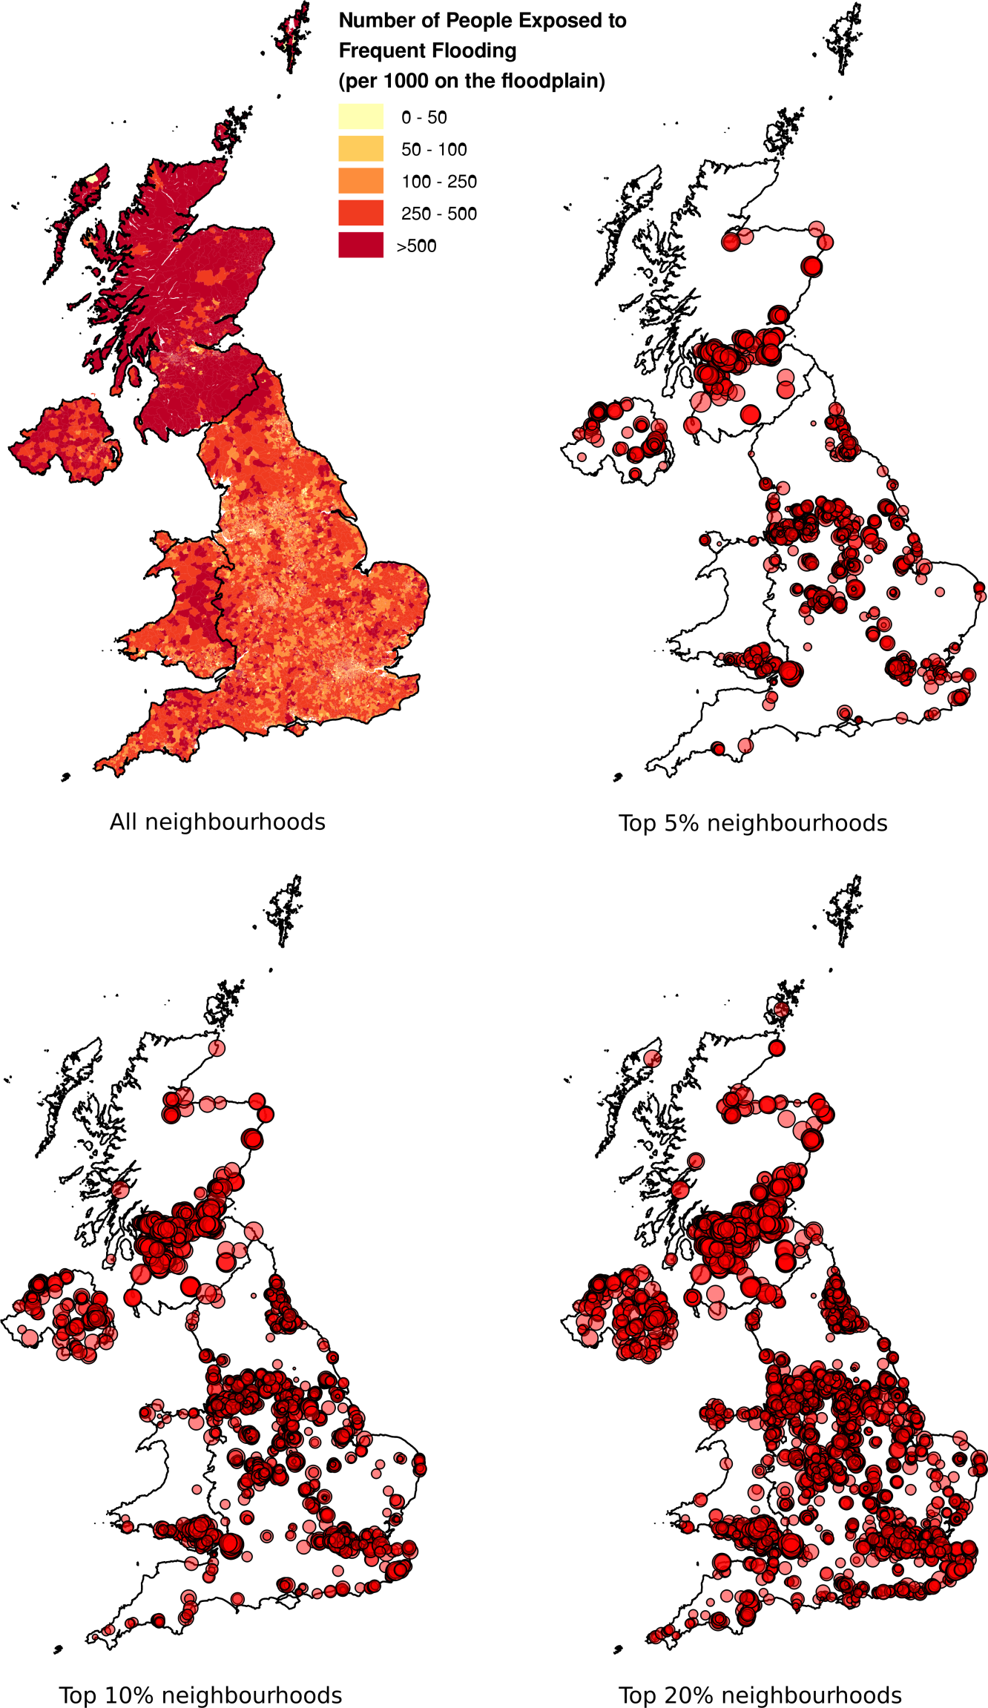

Figure 2

The trends in housing tenure in Scotland, 1981 to 2014

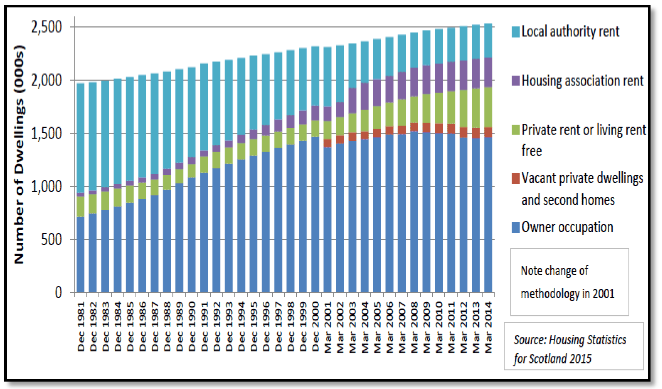

1. <https://www.axa.co.uk/auk-2016-h2-home02/>