Integrating the Strengths of Cognitive Emotion Models with Traditional HCI Interaction Analysis Tools

|  |  |  |
| --- | --- | --- |
| Mark Springett  Faculty of Science and Technology  Middlesex University, UK  [m.springett@mdx.ac.uk](mailto:m.springett@mdx.ac.uk) | Effie Lai-Chong Law  Department of Computer Science  University of Leicester, UK  elaw@mcs.le.ac.uk | Mark Coulson  Department of Psychology  Middlesex University, UK  m.coulson@mdx.ac.uk |

# ABSTRACT

## This paper reports an attempt to integrate key concepts from cognitive models of emotion, to cognitive models of interaction established in HCI literature. The aim is to transfer the strengths of interaction models to analysis of affect-critical systems in games, e-commerce, and education, thereby increasing their usefulness in these systems where affect is increasingly recognized as a key success factor. Concepts from Scherer’s Appraisal model and Stimulation evaluation checks, along with a framework of emotion contexts proposed by Coulson (2004) are integrated into the cycle of display-based action proposed by Norman (1988). Norman’s Action Cycle has commonly been applied as an interaction analysis tool in the field of HCI. In wake of the recent shift of emphasis to user experience (UX), the cognition-based Action Cycle is deemed inadequate to explicate affective experiences such as happiness, joy and surprise. Models based on Appraisal theories, focusing on cognitive accounts of emotion, are more relevant to understanding the causes and effects of feelings arising from interacting with digital artefacts. We explore the compatibility between these two genres of model, and future development of integrated analysis tools.

## Keywords

Cognition; Emotion; Appraisal; Action; Design; User experience; Withdrawal

# INTRODUCTION

This paper reports work towards integrating models of emotional factors from the psychology literature with applied models of cognition used in HCI design and evaluation. In particular it analyses the compatibility between cognitive accounts of emotion emerging from, among others, the work of Scherer (2002), Ortony et al (1988), Coulson (2004), and established approaches, particularly Norman’s (1988) model of display-based action, used to understand goal-based cognition in interaction and formative evaluation of usability factors, characterising reactions to interaction events, their causes and their effects.

The motivation for this work is to find useful theoretical tools that accommodate both analysis of traditional usability concerns such as comprehensibility of feature cues and feedback, and what are typically referred to as ‘experience’ factors, where an affective response emanates from encounters with technology. The intention is to better explain the relationship between usability and user experience factors in design, and provide for integrated analysis of these factors. We identify games, education, and e-commerce as areas in which traditional interaction models for analysis of usability remain relevant, but for which affective factors are equally critical. The integration of insights from emotion models strengthens the applicability of interaction models in these sectors.

User experience research does not yet provide fine-grained diagnostic tools capable of pinpointing and understanding elements of designed systems that may undermine positive user experience. Typically UX evaluation tends to deal with overall reactions to the interactive experience. More fine-grained analysis may give designers a better insight for design iteration where a feature or an interaction event has had a pivotal effect on user experience or behaviour. In turn this may help designers refine systems at the feature level, and repair what can be termed ‘UX bugs’ at the interface.

Few methods currently exist that support a cognitive account of the emotion through analysis of interactive sequences. Van Schaik and Ling (2012) argue that some stages of Norman’s action cycle could be mapped to pre-conditions for flow, a psychological concept posited by Csikszentmihalyi (1990); for instance, mapping gulf of evaluation onto feedback and gulf of executive onto challenge/skill balance. Such mappings are typically evaluated with self-reported questionnaires. Other approaches try to trace critical incidents by measuring physiological changes in subjects through heart monitors and galvanic skin monitors. However, these provide no more than markers showing where something (in the design or otherwise) affected interaction. Our work aims to provide a framework for analysing interaction, and linking observed (critical) incidents with antecedents and consequences, to understand truly the role of affect in user reactions to systems. It works on the assumption that a fine-grained causal account of design features’ influence on users is required to inform iterative design for optimised user experience.

1. **Complementarity between two genres of models on cognition and emotion**

The exercise reported here is the exploratory integration of cognitive accounts of emotion with theoretical and practical tools for analysing cognition during interaction. The two genres of model have complementary strengths that can usefully be integrated to produce effective user experience evaluation tools. To explain this notion we look in turn at the strengths of each genre.

**2.1 Strengths of HCI Interaction Models**

A key strength of interaction models such as the one described in Norman (1988) is that they facilitate an analysis of causal relationships when applied to interaction events, providing a baseline for understanding antecedents and consequences of system appearance and behaviour. In usability evaluation this contextualises the influence both of prior dispositions (user state of knowledge, background, expertise level, etc) as tributaries of user behaviour. It also facilitates the investigation of problem genotypes (root causes of user problems) emanating from error phenotypes (overt symptoms of a problem detected during interaction). The expression of user and system actions as a connected sequence provides a dynamic mechanism for this. Existing models in the literature add accounts of key catalytic elements in this process. These include accounts of the nature of user mental processing, levels of expertise and experience and the knowledge resources recruited during interaction. Critically, this includes internal and external resources. A prima facie match between the projects of understanding instrumental usability factors in evaluations and affective episodes at the interface lies in this synthesis of internal and external factors (e.g. Blandford et al 2008). Just as usability problems can frequently be explained with reference to mismatches between the external (the image and behaviour of the machine) and the internal (the users cognitive) resources, a cognitive account of positively and, more critically, negatively valenced encounters can be understood in terms of a similar synthesis of the internal and the external.

**2.2 Appraisal Theories of Emotion**

There are two key elements of the class of emotion theories known as appraisal theories. One is that they reject the conventional taxonomy of distinct emotional states (Ortony et al 1988). Natural language tends to embed a naive theory of emotion as falling into distinct categories represented by linguistic tokens such as happy or angry. These are seen as being of little use in understanding the underlying causes and effects of emotion (see Boehner et al 2007). The second element is the general belief that the emergent process, the genesis and consequences of emotional experiences are of interest, rather than the qualitative, experienced episode. Emotion is modelled in terms of contextual factors that determine action. The genesis, expression and time-course of emotion arise from a multiplicity of factors or contexts (Coulson 2004). We argue that useful accounts of experience in human computer interaction are more a matter of understanding the concept of appraisal than the nature of emotion experience. It is accepted that emotion is felt, experienced and expressed by the individual. These feelings are the result of a complex series of appraisals which are not necessarily conscious (and indeed are more often rapid and unconscious), and it is these appraisals which are the prime drivers of behaviour. While certain patterns of appraisal may give rise to states we might label ‘happy’ or ‘angry’, these labels do not in themselves provide any useful degree of explanatory or predictive power. This is a key consideration when applied to some phenomena of interest in UX research, e.g. a sudden event in a video game for emergency response training to an accumulation of ‘concerning’ events in a social network encounter. In the former case the sudden onset produces a quick and compelling emotional reaction. By contrast, weakening trust in the identity and integrity of a chat room correspondent could emanate from gradual accumulation of appraisals. Both states might be accurately identified as ‘fear’ by the user, but the causal factors and adaptive behaviours are quite distinct. While ‘fear’ might broadly suggest a ‘fight or flight’ response, an analysis of the underlying appraisals crucially determines *which* behavioural outcome is adaptive.

1. **OVERVIEW OF NORMAN’S AND SCHERER’S MODELS**

The aforementioned two genres of model are exemplified by Norman’s (1988) action cycle (a.k.a. “model of action” or “seven stages of action”) and Scherer’s (2001) multi-level sequential check model. Both models have frequently been cited in the field of HCI and in the psychological research on emotion, respectively. In the following sub-sections, we present an overview of the key concepts of the two models.

**3.1 Norman’s Model of Action**

In Norman’s original model execution has three phases, goal generation, intention forming and translation into a sequence of actions (Figure 1; Norman 1988). The forming of an intention implies generating expectancy of the features that will be encountered. This is characterised as a matching process between internal representations and interface features. These include container metaphors and individual feature representations. A visual scan takes place involving a search for the best match between interface features and the user’s goals (Howes & Payne, 1990). The three stages of execution are: perceiving and understanding the state of the world, comparing the state of the world to the intention, and assessing progress towards a goal.

The use of the action cycle as a tool for identifying and characterising usability bugs is established in HCI literature (e.g. Hartson et al., 1999; Springett, 1998). Typical usability problem phenotypes are associated with individual phases in execution specification, physical performance of action, and evaluation. As such these serve as key staples in establishing the ‘story’ of a critical incident. The establishing of links between phenotype and genotype (root causes), or the tracing of ‘critical threads’, is key to gaining a deep understanding of usability problems. This trace of critical threads is central to error analysis both in contrived evaluation studies (e.g. think-aloud protocols) and in error studies in the field.

Where a system is ‘affect-critical’ the cycle of action described by Norman (1988) can be seen as a legitimate, but incomplete account of cognition. The account of ‘mental actions’ has been used in accounts of HCI usability for several types of system. However, it requires a richer explanation of how the mechanics of goal-directed cognition combine with affective reactions to interface phenomena and events.

Events in the context of this analysis could be events occurring as system feedback in response to user action and interface events that isn’t directly a response to user action. An event can also be an appraisal as a result of the user scanning a visual image. Therefore we can think of appraisals as occurring at key points in this cycle, including visual scanning in early stages of the execution phase.

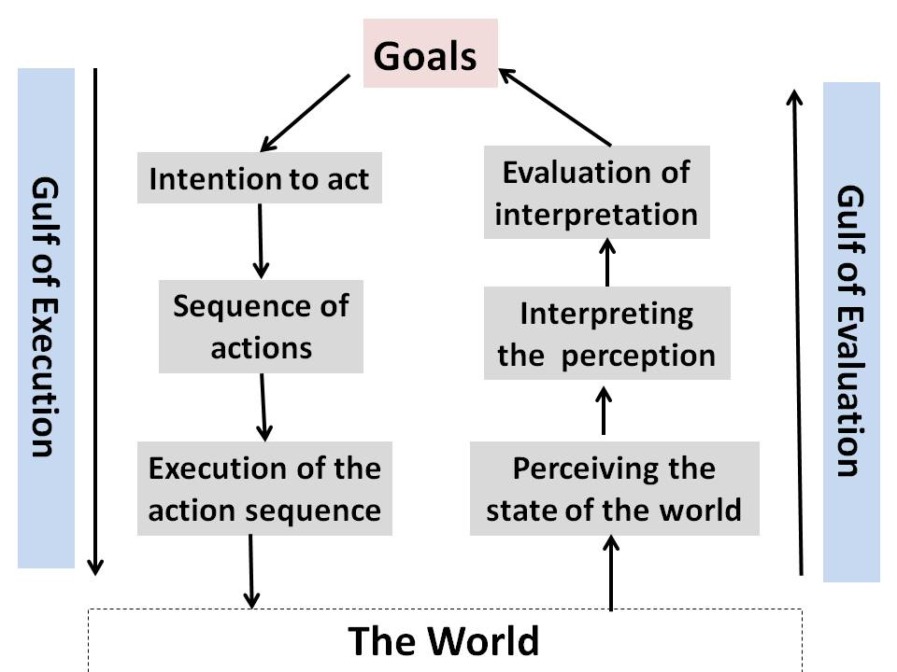

**Figure 1: Norman’s action cycle (1988)**

* 1. **Scherer’s Multi-level Sequential Check Model**

Scherer (1984) proposes a taxonomy of ways in which individuals appraise information and events. These are:

*Novelty check*: This is a check to see if the external or internal environment has changed. Internal change could be a triggered memory for a future event (e.g. an appointment). External change may include a match between expectations of system behaviour and new system behaviour.

*Intrinsic pleasantness check*: This classifies an ongoing event as positive or negative, determining approach behaviour or withdrawal/avoidance.

*Goal conduciveness*: This is composed of evaluations of relevance, expectation, conduciveness and urgency. Assessment of relevance relates to the selection of features in action execution, and match to goals in the evaluation phase of Norman’s model. Expectation and conduciveness equally seem to express the phases of interpreting and matching to goals expressed in Norman’s model.

*Coping potential*: This evaluates causality, the level of control the individual has over its consequences, and the ability to adapt to cope with it.

*Norm/self compatibility check*: This involves normative judgments about the event. This may be a match between an internal standard (i.e. personal internalized value) and a norm (i.e. external socially negotiated standard). In e-service use for example it may be a comparison of system design of behaviour to expectations of service or quality of design. It also has a socio-cultural dimension where the norms of others and accepted cultural norms are brought to bear.

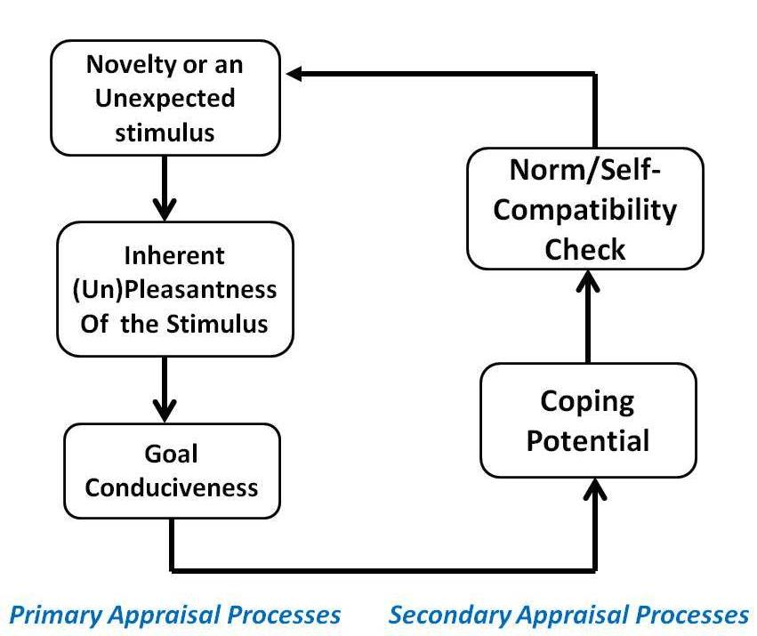

**Figure 2: Overview of Scherer’s Appraisal Model**

1. **TRANSFERRING THE MODELS**

In this section we describe first the inherent inadequacy of Norman’s model of action for explicating the emotional aspect of interaction. We then explain how this weakness can be addressed by integrating appraisal theories of emotion into the original model. Figure 3 depicts a simplified view of the attempted integration and transfer.

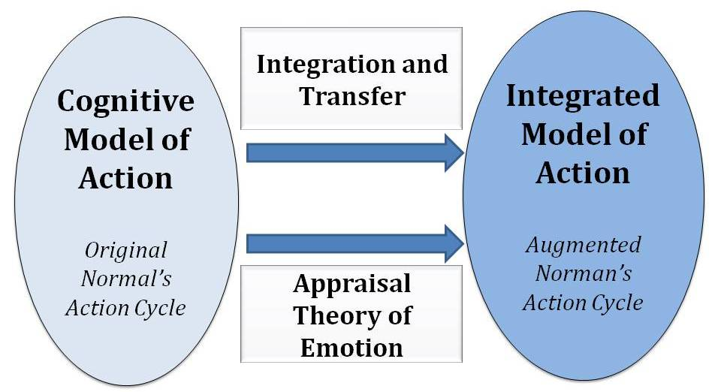

**Figure 3: An overview of model integration and transfer**

**4.1 Missing UX Elements in Norman’s Model of Action**

The transfer goal is to modify Norman’s theory of action (Figure 2) in a way that retains its power in interpreting evaluation data but also makes it fit for purpose in analysing affect-critical systems, such as games and education systems. These are systems in which affective factors such as aesthetics, experience (e.g. feeling competent when advancing to a new level of a game) and motivation (e.g. stimulation to learn) are intertwined with usability and the cognitive information processing expressed in traditional models. Norman’s action cycle describes goal-directed action, but conspicuously isolates cognitive processing from affective factors. The motivation for user action is assumed to be persistent. Our belief is that this approach can be applied to systems in which users engage in goal-directed action, but where positive/negative emotional reactions may have a decisive effect on behaviour.

Many systems are designed for strongly goal-directed interaction. In gaming the nature of action is goal-directed, even if the motivation for using the system is recreational. In serious games the game-goals are coupled with other goals such as learning or training. Systems such as business to customer websites support goal-directed action and the satisfaction of instrumental goals. Therefore a theoretical construct facilitating analysis of goals, sub-goals and decision-making provides for insightful analysis of interaction. However, in these and many other systems affective factors (e.g. attractiveness/dullness, un/pleasantness) may have a critical influence on user decision-making and behaviour. For instance, if a player is captivated by the game narrative (i.e. enchantment; McCarthy et al., 2006) this motivates them to tackle challenges in a game quest perceived as cognitive demanding in order to move to the next level (i.e. the goal). Therefore our aim is to provide an enriched model that combines the strengths of Norman but is also able to account for the influence of affect. An enriched model is intended to facilitate an integrated understanding of cognitive processing and affect when applied in these sectors.

**4.2 Injecting Emotion into the Action Cycle**

The process of transfer of action models to sectors such as gaming involves importing constructs from accounts of emotion into the cycle of action. The most suitable accounts are from appraisal theories of emotion. In appraisal theories emotions are characterised as reactions to events in which assessment of stimulus or evaluation checks such as coping potential, and intrinsic pleasantness are combined with assessment of goal/need significance. The assessment of goal/need significance seems to have a significant overlap with accounts of matching system state changes to goals in Norman’s Theory of Action. Norman’s theory describes a series of critical points within the cycle, such as an initial translation of intentions into a sequence of actions, and perceptions and analysis of feedback. These can also be interpreted as points at which appraisals occur. This increases the applicability of the Appraisal Model to interpretation of user behaviour (e.g. in think-aloud protocols) where a negative emotional reaction may be traced to the behaviour of features, interface tokens such as feature labels or reactions to system feedback. The integration of concepts referring to the influence of felt states and normative judgments can further enrich such analyses, as it provides a language for analysing these concepts in the context of interaction sequences.

Intrinsic pleasantness or unpleasantness has relevance to decision-making on motivation to continue with an interactive session, and is potentially key to acceptance or rejection of the product. Coping potential also has a link to perceptions of the interface, and to situations within interaction in which key decisions are made. This could manifest as a reluctance to engage in reactive planning and repair behaviour, avoidance of certain features, or a risk assessment resulting in reluctance to trust a third party (e.g. an e-commerce provider). Similarly, the ‘Norm/self compatibility check’ refers to a process in which normative judgments impact on user responses and choices (Figure 3).

* 1. **A Reinterpretation Of The Basic Model Of Action**

Below we revisit key phases in Norman’s model of action, adding concepts referred to in the theories considered above.

*Goal formation*: Goal formation implies the generation of satisfaction criteria. These could be criteria such as safety/security that are not explicitly part of the task model.

*Intention Forming*: Implicitly involves expectations of system features and behaviour.

*Scan matching feature/operation* (Appraise image): The scan of the interface to find features must simultaneously imply appraisals that assess match with expectations, opportunities for action, and also assessment of ‘‘attractive/dull’ and other terms often referred to in UX taxonomy. Positive valence emanates from detection of such positive qualities and negative from those suggesting boredom, disturbance or disappointment. The former is likely to reinforce **approach** behaviour the latter **withdrawal**, depending on the strength. A slight concern that the system image is not conveying excitement, reliability or stimulation may not itself be sufficient to cause withdrawal, but may be an input into appraisal of future events.

*Perceive feedback/ primary appraisal*: At this level of immediacy, primal cognitive functions are likely to be most influential, whether a sudden and high impact evaluation (e.g. a shock reaction such as a loud noise) or a low impact evaluation (e.g. a transient awkwardness on completing a manipulation).

*Understand/interpret/appraise change*: Assessment and appraisal of the event is linked to Norman’s concept of understanding and interpreting feedback from the system as a result of user action. Again there may be affect with significant force that causes withdrawal (perhaps abandonment) or simply a re-evaluation of approach and the necessary conditions for continued action.

*Match to current/overall goals*: In strict terms the satisfaction of a goal is the completion of a recognised sequence of task-steps. However, if experience factors are an additional feature of this account, then it can be argued that this extends to a wider consideration of the overall conditions for proceeding with goal-directed action. From the ‘pure’ usability standpoint goals may be supported, as progress towards them is satisfactorily supported through action cures and feedback. However, appraisals potentially lead to re-evaluation of user motivation and acceptance of the system. If a sequence of appraisals, for example, has the effect of reducing trust in the system and those perceived as being personified by it, the likelihood of withdrawal increases. It may also lead to reappraisals of goal/need states and compatibility checks, resulting in, for example, feelings about the usefulness of the system, or its suitability.

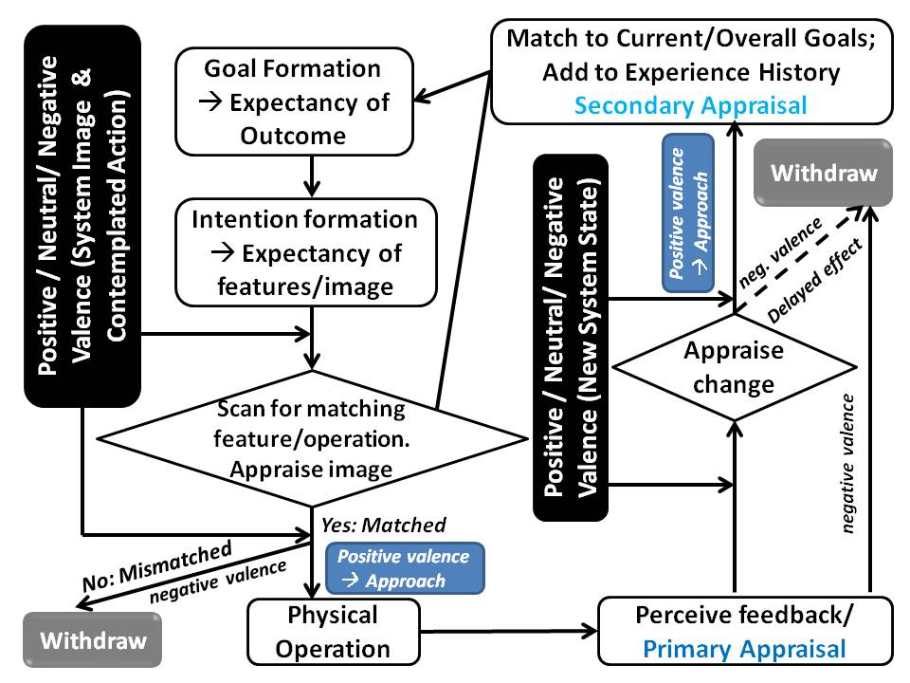

**Figure 4: Integrated models of Norman’s action cycle and Scherer’s appraisal model**

**Note: Some appraisals have a relatively high impact and others have a more slow-burning one; the dash line indicates the propagating effect of appraisals, which can be immediate or delayed.**

**4.4 Application of the Integrated Action Model to Understanding UX Problems**

In this subsection we explore the possibility of including the cultural dimension into the integrated action model depicted in Figure 4. Specifically, we argue that it can be augmented by Coulson’s (2004) framework on emotion and evaluate its relevance for understanding UX problems.

The character and dynamics of the UX problem differs dependent on how affect is generated, how actual and perceived participants are involved and the context of interaction. The model described in Figure 4 can be interpreted as involving a variety of personal, interpersonal, cultural and physical nuances dependent on the specific aspects of the UX design problem under consideration. These aspects can usefully be described in terms of a contextual framework, to emphasise the specific character of particular UX problems.

Coulson (2004) proposes a six-context framework for describing emotion. The intention is to characterize emotional episodes in terms of cause, effect and relevant conceptual entities. Our interpretation of these as applied in UX problems is listed below. We also propose an additional seventh context, the ‘cultural context’. Culture and language are seen as having a significant bearing on individual responses to events. Social norms are culturally situated and embedded in language. A personal experience of the violation of norms and expectations can be understood only with respect to the patterns of cultural interpretation that give social actions meaning (Boehner et al 2007).

* *Event*: Distinct from ‘stimulus’ possibly resulting from several stimuli, such as system feedback, non-user initiated state-changes, or non-immediate internal events in reaction to a computer-mediated *encounter*.
* *Agent*: The individual to whom the event has happened; i.e. ‘user’ (personality, goals, location etc).
* *Interpersonal*: Who else is involved: Perceptions of other agents: e.g. other game players, e-commerce providers, remote presence in co-operative systems or a virtual or ‘assumed’ presence.
* *Topographical*: Where it takes place, including virtual environments, ubiquitous environments, the desktop etc and the parameters thereby imposed.
* *Historical*: What has gone before/may come after: The dynamic nature of emotion, event persistence, antecedents and consequences of affective episodes, a record of previous instances of an event, including the likely success of possible courses of actions (e.g. repair action strategies).
* *Embodied*: Physical limitations and the scope of possible responses (e.g. the means to respond or express reaction afforded by the system and the individual’s physicality).
* *Cultural*: This is related to but extends beyond the interpersonal context. It refers to the cultural norms and norms embedded in linguistic conventions by which the individual interprets an event.

Events are specifically a user’s representation of external or internal stimuli. This may be simply may be a system’s reaction to an input (perception of feedback in Norman’s model), an intervention from another agent (perhaps directly in a virtual reality (VR) game), or may be a response to perceptions of static images (impacting on the execution phase). This is particularly relevant for understanding user behaviour in response to new systems in early interaction. For example, the immediate reaction users give to web home pages (sometimes referred to as the blink test) is a rapid reaction to an image, thought to be around 3-4 seconds. This is thought to determine whether the user will approach or withdraw. Nielsen (1993) speculates that users will decide in around 10 seconds whether or not they can proceed with interaction on a site. The former case seems to be characterized as a primary appraisal of characteristics such as warmth, or friendliness that reflect affect, whereas the 10 second rule reflects more pragmatic appraisal of likely success using the site. The latter therefore reflects the historical context in which the presented image stimulates an internal event in the user whereby the user uses their internal awareness of previous responses and the likelihood of success.

The criticality of the user’s appraisal of initial encounters with the homepage image seems to be similar in structure to repeated appraisals during cycles of task action. Each external state-change or presented system image may be evaluated as, for example, novel, intrinsically pleasant, repellent or goal-relevant with varying degrees of force or impact. A single powerful and unexpected interface state-change could cause a significant change in the user, (e.g. calculatedly shocking events in an interactive emergency response training game). However, the onset and force may be slower and the effect more cumulative. A number of repeat task-action cycles may reinforce expectations about the system, but be subtly undermined over time. For example, a change in navigation support, or the increased presence of secondary advertising may be negatively appraised but not have a high enough immediate impact to make the user withdraw, particularly where the user has established a positive history of interaction with a system. However, the cumulative affect of negative appraisals could significantly change the historical context, and effect user behaviour and interpretation of events further down the line.

The power of a ‘confounding’ negative event appears significantly strong where the interpersonal context is a high impact factor. In e-commerce encounters as suggested in the example above, the system acquires a human-like presence for the user, in which its appearance and behaviour may be appraised in terms of the intentions of the organisation that it represents. Trust and risk are significant in business to customer systems, and appraisals within interactive sessions represent positive or potentially negative reinforcements of the trust relationship. A system behaviour that is strikingly ‘out of character’ may trigger a high impact event, in which the historical and interpersonal contexts are relevant. The historical context, i.e. memory of previous encounters with the brand, likelihood of success, safety, repetition of events is a staple of the ‘interpersonal’ relationship. An event such as the sudden deletion of data, or changes to the interactive dialogue that obscure established feedback channels, or even changes to the look and feel of the site that alter the aesthetic, potentially impact on the power and duty relationships as perceived by the user.

1. **CASE STUDIES**

This section reports three case studies to illustrate the potential application of the Integrated Action Model we proposed above. Empirical studies in three affect-critical contexts, namely, ameliorating older citizens’ attitudes towards new technologies, establishing trust in e-commerce and educating children through games,

* 1. **Case Study 1: Technology Acceptance By Older Citizens**

The increasingly diverse user population implies that a vast spectrum of attitudes, dispositions and expectations are inputs to any model that seeks to explain user decision-making, affective reactions, and behaviour. Hence, we argue that our proposed integrated action model can help us understand the phenomena observed in this case study.

The interpersonal, historical and cultural contexts have a crucial relevance in contemporary UX analysis. User perception of products, whether in contemplation or exploratory use, seems to be conditioned by established beliefs and attitudes that are brought to bear to appraise new technology. This bears a close structural relation to the match between task structures and real-world objects and interface particulars that characterizes usability interaction models. In ‘affect-free’ accounts of this process the user looks for semantic attachments between task concepts and interface particulars, to assess likely satisfaction of a goal. In an integrated account factors such as fear, trust, cultural acceptability, and power relations that affect motivation and acceptance must be accounted for. Two case examples are described that focus on the relationship between instrumental learning aspects of digital technology adoption and affective issues.

In case example one; interviews were carried out with older users who had been forced to adopt new digital TV technology due to the ‘digital switchover’ that took place in the UK between 2008 and 2012. This is reported in (Keith 2010). A number of interviewees contrasted their relationship with the analogue technology previously used, and the digital technology that had replaced it. Several interviewees reported attempts to get to grips with the digital equivalent of analogue ‘teletext’ tasks, whilst others had reported simply a refusal to engage with the digital interactive services, giving up the text services when the analogue system was shut down. Two interviewees cited a list of specific services that they routinely accessed on analogue teletext, including weather and travel updates. These services are also available on digital TV services, accessed through a menu structure. Despite the availability of these digital versions of familiar analogue services these interviewees had not adopted them and had simply stopped using those services. The tasks were in essence the same, serving the same user goals. In Norman’s model this would simply be a matter of users exploring and getting to grips with re-structured tasks, to serve familiar goals. However, the influence of factors expressed in the Appraisal model seems to have a decisive influence in this example, as the changes to task-structures and system behaviour in response to inputs (e.g. less than instant feedback) cause withdrawal and avoidance behaviour.

What is interesting about the TV interaction example is that the application of digital technology to an established analogue task changes the relationship between the user and the task, and the user and the host technology. Policy makers have seen television as a useful breakthrough technology for addressing the digital divide and increasing the penetration of broadband technologies. Indeed, the argument from the UK office of the E-Envoy in 2001 was that TV was the medium used by the ‘disenfranchised’ population who did not have access to PCs. However, a major barrier to this is a combination of a greater technological complexity, and in tandem, a sense that the device was no longer ‘their’ technology, beyond a few familiar controls. This appears similar to the interpersonal dimension in the framework proposed by Coulson (2004) where the perception of power relations between the individual and an assumed community of practice had become decisive in the decision whether to pursue or avoid using digital services.

In the case example two (Springett et al., in prep) studies were carried out with senior citizens using touch-table games. In initial interviews participants expressed either diffidence or reluctance towards digital technology. Similar to the respondents in the study one there was an emergent sense that those interviewed regarded the technology as the preserve of other, younger social groups. They saw themselves as existing outside the perceived ‘digital community’. Allied to this was a declared reluctance to approach technology, simply because they didn’t understand the possible consequences of actions. These initial reactions bore a significant resemblance to the issues cited in the first study. There is a sense of ‘unfriendly’ and ‘alien’ technology that seems to link partly to perceived incompetence, but also a negative social attitude, where the individual perceives themselves as outside the social group at whom the technology is aimed.

The same individuals interviewed in study two were then invited to their local community centre to try playing some simpledigital games on a Smart Table(TM). The motivation behind the study was the belief that cognitive and affective barriers to learning could be overcome using reality-based interaction (Jacob 2008), and familiar metaphors in a gaming context. The study used 60 subjects, 20 individuals and 20 pairs. The full study data is under analysis (Springett et al in prep). The effect sought was that the users would become increasingly confident and display a willingness to explore, and increasing approach behaviour. It was found that subjects were able, through game play, to exhibit the compiled motor skills and trail-and-error learning that are characteristic of exploratory learning. This was particularly true in two-player sessions were collaborative early problem-solving correlated with quicker learning performance. Key examples include experimental manipulations where the metaphor was imprecise. The use of playing card images provided a visual mapping to the users’ mental models, but the principle behind the manipulation involved tapping and dragging actions was unfamiliar. Rapid progress was observed in learning and in approach behaviour. There was a rapid decrease in pauses or expressions of negativity when the first attempted action did not succeed, and an increase in experimental action.

In this example, the remarkably willing engagement in exploratory task-action goes beyond simply the ability to match features to goals and intentions and perform sequences of action. Initial positive valence from a pleasantly ‘familiar’ system image seem to have the effect of weakening negative attitudes, attitudes that are linked to the norm/self compatibility check (i.e. that digital technology is not ‘their’ technology) and coping potential,

The positive effect of a combination of natural reality-based interaction, the sociability of games, and the use of familiar analogue object metaphors appears to be important in two ways. They have a persuasive role, engendering positive attitudes and approach behaviour as well as purely instrumental aspects of learning support. This is similar to concepts from the Theory of Reasoned Action (Ajzen & Fishbein 1980), from which UX researchers have derived approaches to designing persuasive elements into technology. For example, Romero et al (2010) used persuasive ‘activators’ to motivate members of senior citizens communities to engage in social activities. Strategies based on this theory involve the reinforcement of positive attitudes and the weakening of negative attitudes that may influence behaviour. Interactive products can embody these principles in a non-explicit form, by simply presenting concepts in a way that facilitates the weakening of negative attitudes.

**5.2 Case Study 2: E-Commerce Trust Propagation**

In an analysis using Norman’s original model, the reasons why negative propagations of trust are not explicitly describable. For example, a user may encounter something that does not obstruct the process of task-action, such as an advertisement, a policy statement or even a graphic image that subtracts credibility from a candidate e-service provider in the eyes of the user. A straightforward application of Norman’s theory could at a stretch handle exit behaviour from the task as a mismatch between an emergent system state and the user’s goals. However, this needs a richer description of the nature of user goals and in turn reaction and behaviour. The user goals in e-commerce will include safety (from fraud identity theft etc), and there will be awareness of risk in such transactions. One of the implicit goals in interaction will be to establish and maintain trust conditions sufficient to do business.

In this example, we consider the influence of the novelty, intrinsic pleasantness and norm/self compatibility checks. Several studies (Riegelsberger et al, 2005; French et al, 2006; Sillence et al 2007) suggest that display factors have a significant influence on trust-related judgements. E-Commerce encounters involve the perception of signs (interface appearance) and events that may ether positively or negatively reinforce trust in the competence of the system and the identity/integrity of the organisation it represents. Trust propagation in e-commerce is seen as a journey from initial expectations of the organisation and encounter, through the first encounter with the website and the completion of service transactions (French et al 2006). Critical phases in which the e-customer’s relation is mediated through interface features and behaviour, including overt tangible trust signs, and sundry aspects of the interactive session that could potentially affect attitudes and behaviour.

The match between expectations and what is encountered (novelty check) may be pleasing revelation of positive trust re-enforcers such as trust seals or third-party associations. The ‘warmth’ of this re-assurance (intrinsic pleasantness) fortifies the relationship between individual and organisation. However, this could also emanate from aesthetic factors such as a pleasing colour scheme or familiar cultural references. In the negative case an event that infuriates, such as the deletion of input data, or unexpected task steps, may confound positive expectations of the organisation. This may also include the norm/self compatibility check, where the user matches the demands made by the system to their general perceptions of what is reasonable. Similarly, requests for personal information may cause a negative reaction when compared to culturally-mediated perceptions of the limits to invasion of personal privacy.

**5.3 Case Study 3: Digital Educational Games**

Games provide fertile contexts to explore and investigate the nature of user experience, as gamers typically elicit a range of affect, emotion and feeling in gamers (Law & Springett, 2013). In this case study, we report the evaluation of a digital educational game (DEG) called 80Days, which developed in the context of an R&D project with the same name. The learning domain of the game was geography. The game story was about an alien scout called Feon (non-player character) which kidnaps a Boy (play character) and travelled with him around the world in a spaceship. Feon introduced to the boy the notion of terra-forming simulation: by manipulating certain intervention measures, the risk and extent of damage of flooding varies. In short, the gamers were to achieve two tasks: locating and flying to the flooding site; experimenting with the flood simulation (Figure 5).

Two types of adaptivity are implemented in the game, namely micro and macro (Kickmeier-Rust et al., 2008; Peirce, Conlan & Wade, 2008). Micro-adaptivity was to provide motivational encouragements and cognitive hints by the non-player character Feon, whereas macro-adaptivity was to adjust the story pace. Based on the gamer’s current skill and motivational state assessed by in-game tasks, specific storyline and feedback would be delivered.

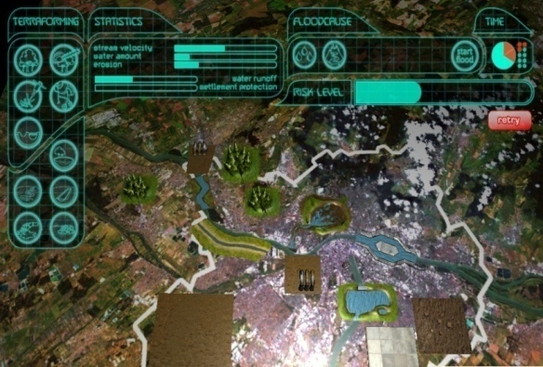

**Figure 5**: **Terra-forming simulation of flooding**

**Note: The upper right long bar indicates the risk level, which can be changed as a result of putting an intervention icon (e.g. dyke) from the left panel to an appropriate place in the central pane**

Here we focus on the qualitative data from semi-structured interviews and in situ observations, and report how our integrated Action-Appraisal model (Figure 4) is instantiated by our empirical data. The analysis presented in Table 1 illustrates a pattern of emotional and cognitive behaviours commonly exhibited by several of the gamers. Specifically, they appraised and re-appraised the feedback from the environment, including the adaptive hints and encouragements delivered by non-player character Feon and the researcher (who was also an observer). The gamers manifested a range of feelings or affective responses such as disappointment, frustration, bewilderment, fun, challenge and pride. As an ongoing feedback loop, the gamers adapted their gaming behaviours, which in turn shaped their emotion experiences. Overall, the gamers continuously updated their evaluation of the gaming process and the game itself as a whole.

**Table 1**: **Analysis of emotional and cognitive behavioural with the integrated Action-Appraisal model**

|  |  |  |
| --- | --- | --- |
| Stages | Description | Post-game interview/In-game observation |
| Goal Formation | The two main goals and success criteria were predefined by the game. First, reaching the destination with UFO was a goal explicitly specified by the game and deriving pleasure from flying the UFO was a goal implicitly formed by the gamer in anticipation of action. Second, using the features of the simulation to learn about risk factors of flooding was an explicit goal and deriving sense of achievement was an implicit one. | *“I had high expectations and was intrigued at first. I knew I had to fly the UFO to Budapest. I want to have fun.”*  The gamer leaned forward towards the screen to improve his view. When flying, he stared at the screen, totally absorbed. |
| Intention Formation | The gamer intended to make sense of the simulation by dragging the icons from the left hand “Terra-forming” and dropping them onto the landscape to see the effect. He also intended to understand adaptive hint/encouragement given by the non-player character Feon to understand better his action. | *“The simulation part was difficult. I was given a task, but I did not get it first. No clue what I was supposed to do. Then you [the researcher] explained to me… Feon also said something.”*  The gamer looked lost and sought help |
| Scan for matching (Appraise image) | The gamer was supposed to see the effect of his manipulating the icons on the change in the risk bar level. Otherwise, the drag-and-drop actions would appear random and meaningless. Such mismatches between the system’s features and operations undermined the gamer’s motivation to play, resulting in some withdrawal behaviour. | *“Looking at those buttons, bars and geographical stuff did not give me any clue. Yes, Feon did say something, not much help… I was disappointed; the game was not to do with the title [80days he wanted to fly to and see many different cities].”*  The gamer signed and leaned back. |
| Perceived feedback/ Primary Appraisal | The gamer was hinted by the researcher to look at the relationship between the icons and the change of risk bar. This feedback was perceived as useful; it revived the gamer’s motivation to continue playing the game. | ”*It took me quite a while to understand what was going on. After that, I could finish next round much quicker and had some fun.”* |
| Appraise change: *Positive* | With the understanding of the logic behind the gameplay, the gamer attempted the subsequent task with ease. He re-appraised the feedback from Feon, which he had regarded as excessive earlier, as helpful and motivating. | “*Feon still talked too much. But he praised me when I could control the risk bar. It’s helpful. I like it*.”  The gamer smiled and pointed to the risk bar. |
| Match to current goals | The gamer could accomplish all the three subtasks with the simulation and felt satisfied. | “*I had some fun and learned something about geography by playing the game. It’s not bad after all*” |
| Appraise change: *Negative* | In the post-game test, the gamer was asked to complete a domain-specific questionnaire to assess how much they had learned from the game. However, he could not respond to some of the questions that were related to the game content. That reminded him of his ‘withdraw’ (or avoidance) behaviour with respect to reading the text inside those pop-up windows. | “*I should have paid more attention to those pop-up windows. They explained this stuff, but they were not easy to read; fuzzy text on fuzzy background. I just closed them right away without looking at it*.” |

1. **DISCUSSION: EMOTION OR APPRAISAL-BASED ACTION?**

The indications both from literature studies and from the application of merged models to affect-critical systems are that emotion, as a series of lexically distinct categories, is something of a redundant notion in studies of experience within interaction. What is of greater interest is the series of cognitive appraisals that are applied to phenomena and events during interaction and the consequences that this has in terms of user behaviour and summative evaluation of experience. Norman’s action model was a baseline description of action which analysts and researchers could apply to assess gulfs of execution and evaluation (Figure 1) in the usage of a number of products. Likewise a model that combines the key elements of this model with accounts of appraisal provide a baseline for understanding affect in the context of goal-directed user action. Immediate factors such as positive or negative valance and approach or withdrawal (if the stimulus has high intensity) are accounted for within the cycle of task-action. Also, accounts of learning by exploration and synthesis of examples accommodates key appraisals with less high intensity that contributes to a relatively slow affective onset.

The six contexts described in Coulson (2004) (i.e. Event, Agent, Interpersonal, Topographical, Historical and Embodied) emphasise the factors that become particularly relevant dependent on the type of design problem considered. For example, the interpersonal context explains appraisals in which the intentionality of e-commerce organisations is deconstructed and interpreted through encounters at the interface. The same context characterises the sense of self that emanates from assumed characters in game play.

A caveat should be mentioned that emotions of all sorts are not the sole determinant of our behaviours or actions. On the contrary, the age-old James-Lange theory posits that actions precede emotions (cf. the causal chain of seeing a bear, running away, and then feeling scared). Damasio (1999), a contemporary neuroscientist, has expanded the argument by including a cognitive component, namely, the role of memory in determining our behavioural response to an external stimulus. This idea is compatible with Suchman’s (2007) notion that plans, as contextual resources, do not determine our situated actions. Instead, plans are adapted in the course of performing an action, based on various contextual factors and feedback.

**CONCLUSIONS AND FUTURE WORK**

Formative design and evaluation benefit from having runnable models that can be used, either in the form of an explicit procedure, or as a tool for thought. Theoretical tools that integrate actions of display-based cognition and appraisal can analyse both the pragmatic aspects of usability and the affective factors that influence user behaviour and judgement.

Interaction Models such as Norman’s have key characteristics that apply in modern UX critical design problems. Usability remains a key element of user experience. Positive experience, experience that gives a sense of comfort and pleasure, or positively re-enforces trust, does in many (but not all) cases emanate from good usability as it has been understood in three decades of research. Often is it the full nature of the implications of good or bad usability that extensions to interaction models are useful in explaining. UX evaluation tools aim to capture concurrent, post hoc and longitudinal aspects of experience. Theoretical tools that can establish threads from that which individuals bring to interaction (e.g. personality, culture norms, and history), the nuances of the interaction context, interaction events and their consequences, can have a significant role. A holistic understanding of UX problems implies the ability to pull together and interpret data from current and retrospective instruments as well as inspection tools, requirements gathering and user profiles. The basic nature of interaction, how the repeated sequences of action are processed, provides a usefully stable foundation for an integrated theory.

The integration of Norman’s theory of action with constructs from appraisal theories has the potential to produce useful and usable tools for understanding user experience factors during interaction. Questions relating to the true nature of the relationship between usability and user experience remain, but there is clearly value in understanding these factors in an integrated way. Future research can usefully be directed towards developing analysis tools that can facilitate the application of this in design and evaluation.

The current work proposes a tool-for-thought to help designers and evaluators interpret key concepts and understand the varying emphasis and nature of UX phenomena applied in different contexts. Future work will investigate its applications to more prescriptive and procedural tools that can be applied to different types of UX problem. The model lends itself to the development of coding and analysis for user observation and think-protocol evaluations. Possible extensions to walkthrough protocols and other methods where the dynamics of interaction are subject to fine-grained analysis are also a future area of enquiry.

**ACKNOWLEDGEMENT**

The authors are grateful to Suzette Keith for her assistance in preparation of this paper

# REFERENCES

1. Ajzen, I., & Fishbein, M. (1980). *Understanding attitudes and predicting social behavior*. Englewood Cliffs, NJ: Prentice-Hall
2. Blandford, A., Green, T. R. G., Furniss, D. & Makri, S. (2008) [Evaluating system utility and conceptual fit using CASSM](http://www.uclic.ucl.ac.uk/annb/docs/abtgdfsmIJHCSpreprint.pdf). International Journal of Human–Computer Studies. 66. 393-409. DOI http://dx.doi.org/10.1016/j.ijhcs.2007.11.005
3. Boehner, K., Depaula, R., Dourish, P., and Sengers, P. (2007). How emotion is made and measured *Int. J. Human-Computer Studies, 65*, 275–291.
4. Cannon, W. B. (1927). "The James-Lange Theory of Emotions: A Critical Examination and an Alternative Theory". *The American Journal of Psychology, 39*, 106–124.
5. Coulson, M. (2004). An ‘Everything But’ Framework for Modelling Emotion. In *Proc, AAAI Spring Symposium on "Architectures for Emotion*”
6. Csikszentmihalyi, Mihaly (1990). *Flow: The Psychology of Optimal Experience*. New York: Harper and Row. [ISBN 0-06-092043-2](http://en.wikipedia.org/wiki/Special:BookSources/0060920432)
7. Damasio, A. R. (1999). *The feeling of what happens: Body and emotion in the making of consciousness*. New York: Harcourt Brace and Co.
8. French, T., Springett, M., and Liu, K. (2006) .Towards an E-Service Semiotic Trust Framework’ In *Proc. 4th Int. ALOIS Conference* ((pp. 175-196)., Boras, Sweden.
9. Hartson, H. R., Andre, T.S., Williges, R.C., van Rens, L. (1999). The User Action Framework: A Theory-Based Foundation for Inspection and Classification of Usability Problems. *HCI (1) 1999*: 1058-1062
10. Howes, A. & Payne, S.J. (1990). Semantic analysis during exploratory learning. In J.C. Chew & J. Whiteside (Eds.) Empowering People - CHI'90 Conference Proceedings: Human Factors in Computing Systems (Special Issue of the SIGCHI bulletin). Seattle, WA: ACM. 399-406.
11. Jacob, R.J.K., Girouard, A., Hirshfield, L.M., Horn, M.S., Shaer, O., Treacy, E.S., and Zigelbaum, J. (2008). Reality-Based Interaction: A Framework for Post-WIMP Interfaces. In Proc. ACM Conference on Human Factors in Computing Systems CHI’08, ACM Press, 201-210.
12. Keith, S., (2010) Diversity in age: the challenges of reaching the ‘hard to reach'. Diversity in age: the challenges of reaching the ‘hard to reach'. In: UNITECH 2010: International Conference on Universal Technology: proceedings. Tapir Academic Press, Trondheim, Norway, pp. 34-45. ISBN 9788251925464
13. Kickmeier-Rust. M. D., Hockemeyer, C., Albert, D., and Augustin, T. (2008). Micro adaptive, non-invasive assessment in educational games. In Proc. of Digital Game and Intelligent Toy Enhanced Learning (pp. 135-138) November 17-19, Banff, Canada.
14. Law, E. L-C., Springett, M. (2013). Towards a Tripartite Theoretical Framework for the Sociality of Digital Games: Psycho-Social-Biological. In *Proc. of CHI13 Workshop Design and Evaluation of Sociability in Online Games*.
15. McCarthy, J.C., [Wright](http://www.informatik.uni-trier.de/%7Eley/pers/hd/w/Wright:Peter_C=.html), P.C., [Wallace](http://www.informatik.uni-trier.de/%7Eley/pers/hd/w/Wallace:Jayne.html) ,J. and  [Dearden](http://www.informatik.uni-trier.de/%7Eley/pers/hd/d/Dearden:Andrew_M=.html), A. : The experience of enchantment in human-computer interaction. [Personal and Ubiquitous Computing 10](http://www.informatik.uni-trier.de/%7Eley/db/journals/puc/puc10.html#McCarthyWWD06)(6): 369-378 (2006)
16. Nielsen, J., (1993). Response times: the three important limits. http://www.useit.com/papers/responsetime.html Excerpt from Chapter 5 of Usability Engineering by Jakob Nielsen, Academic Press.
17. Norman,D.A., (1988), *The Design of Everyday Things*, Basic Books
18. Ortony, A., Clore, G., and Collins, A. 1988. *The cognitive structure of emotions.* Cambridge: Cambridge University Press.
19. Peirce N., Conlan O., & Wade V. (2008). Adaptive Educational Games: Providing Non-invasive Personalised Learning Experiences. In *Proc.* *Digital Games and Intelligent Toys Based Education,* 28-35
20. Riegelsberger, J., Sasse, M.A., and McCarthy, J.D., The mechanics of trust: A framework for research and design: *International Journal of Human-Computer Studies 62* (3), 381-422
21. Romero, N.A., Sturm, J., Bekker, M.M., Valk, L. de and Kruitwagen, S, (2010) Playful Persuasion to support older adults’ social and physical activities, Special Issue on Inclusive Design, *Interacting with Computers, 22(6): 485-495*
22. Scherer, K.R. (1984). On the nature and function of emotion: a component process approach.  In K.R. Scherer & P. Ekman (Eds.), Approaches to emotion, (pp. 293-317). Hillsdale, NJ: Erlbaum.
23. [Scherer, K. R.](http://www.affective-sciences.org/publications/author/2) (2001).  [Appraisal considered as a process of multi-level sequential checking](http://www.affective-sciences.org/publication/648). ([Scherer, K. R.](http://www.affective-sciences.org/publications/author/2), [Schorr, A.](http://www.affective-sciences.org/publications/author/555), [Johnstone, T.](http://www.affective-sciences.org/publications/author/203), Ed.).Appraisal processes in emotion: Theory, Methods, Research. 92-120.
24. van Schaik, P., and Ling, J.(2012) 'A cognitive-experiential approach to modelling web navigation', International Journal of Human-Computer Studies, 70 (9), pp.630-651.
25. **Sillence, E.,** Briggs, P. Harris, P, Fishwick, L. (2007).  How do patients evaluate and make use of online health information*?  Social Science & Medicine, 64(9*): 1853-1862
26. Springett, M., Linking surface error characteristics to root problems in user-based evaluation studies. Proc. AVI 1998: ACM Press 102-113
27. Springett,M., Mihajlov,M., Whitney,G., and Murad,S., (in Prep). A study of older user performance and experience playing touch table games.
28. Suchman, L. (2007). *Human-machine reconfigurations: plans and situated actions*. Cambridge: Cambridge University Press.