The Evocation and Expression of Emotion through Documentary Animation
Abstract:
How might an animator distil and study emotion? Could animation itself be a means to unlock meaning that previous experiments have not been able to access? Animation has the power to both highlight and conceal emotions as expressed through body movement and gesture. When we view live action (human interview) documentary footage, we are exposed not just to the spoken words, but the subtle nuances of body movements. How much might be lost when documentary footage is transposed into animation, or indeed, what might be gained, translated through the personal and artistic view of the animator?
Drawing on my own previous experience as a games animator, now using research through practice methodology, this paper explores the results of the first of a series of animations created to explore the more subtle nuances of gesture. Though the medium of a documentary style interview, opposing topics are used to evoke strong emotions; firstly of happiness, then of sadness, with a view to accessing real rather than acted (simulated) emotions and their associated body movements.

Introduction

“the fleeting nature of some expressions, (the changes of the features being often extremely slight); our sympathy being easily aroused when we behold any strong emotion, and our attention thus distracted; our imagination deceiving us, from knowing in a vague manner what to expect...from these causes combined, the observation of expression is by no means easy...Hence it is difficult to determine, with certainty, what are the movements and features of the body, which commonly characterise certain states of the mind.”(Darwin 1875)

How might an animator distil and study emotion? Could animation itself be a means to unlock meaning that previous experiments have not been able to access? We try to understand gestures and body language in our everyday lives, not always successfully. This research analyses the same moment and emotion in time across multiple animation solutions, questioning life quality across motion capture and into hand drawn animation. It asks if the difference between realistic movement and convincing movement can be quantified or at least perceived by observers. It explores whether animation, where gesture is often exaggerated (for comic effect or to impart explicit meaning directly) can be used as a means to unravel and study more subtle, indirect motions and gesture at a deeper level. Can something based upon an almost “gut reaction” of a viewer actually be quantifiable? In this paper I set out the first stage of this ongoing research.

The study of body language and facial expression has long fascinated us, and (as Darwin observed) the difficulty of pairing an expression to an emotion or state of mind is fraught with confusion. We have learned to associate certain expressions with certain states of mind, a smile means happiness, a frown is anger, and animators have taken up this challenge, building up a repertoire of symbolic facial and body gestures to act out the drive of their characters, but perhaps sometimes at the expense of unconscious and more subtle real play of emotions to which we are exposed every day (Buchanan 2007). As animators, we can learn a set of postures and expressions, almost by rote, piecing together an emotional scene with our alphabet of symbols, almost as if spelling out a word. However, the difficulty is that the viewer of an animation is perceiving emotion through the filter of the animator.

It is unusual for animators; practitioners in the art of animating, to have the time in between their intensive work to delve into the theory and scientific research behind what might count for expression, and yet, with a marked push for realism, (particularly in 3D animation and gaming) an interdisciplinary approach may be called for. (Power 2008) This research hopes to interlink theory into animation practice as research, in the hope that any potentially useful findings might be made easily accessible to fellow animators as well as theorists.

Within my own experience as a games animator, I often struggled to articulate a character convincingly. Frequently working under tight deadlines or within heavy constraints or playable cycles that could be passed through a games engine, my own frustration at the often wooden movements of games characters was palpable, yet games animators rarely receive much coaching in animation and considerably less in the nuances of gesture. In particular, I was fascinated by the less obvious methods of expressing an emotion or state of mind, something which as a games animator, we rarely had the opportunity to address. Ask an animation student to indicate that their character is cold, and they might animate that character shivering, or even draw icicles hanging off their nose, but what do people normally do when they are cold? They rarely shiver, instead, they might pull their clothes round themselves, hunch their shoulders. Resorting to the symbol of coldness (teeth chattering, shivering) might not always be the appropriate approach. (Hooks 2003).

However, further investigation into the psychology behind gesture and expression threw up more questions than it answered, most people have come across Mehrabian’s research, with the often (mis)quotation that 93% of human communication is non-verbal, with 38% being tone of voice, 55% body language and only 7% your actual words. In Mehrabian’s original context of inconsistent and contradictory messages, this breakdown makes sense, we have all heard people say one thing but from their tone of voice or posture, they clearly mean the opposite. (Mehrabian 1981) but these percentages do not hold true for everyday communication, otherwise there would be no need to learn foreign languages or sign language. Clearly, we need words to make ourselves understood, (including gestural languages such as BSL and ASL, specifically evolved to bridge this gap in meaning when hearing the spoken word is not an option) and we attempt to interpret body language and gesture as a bonus meaning to our communications, sometimes to read contradictory messages, but also to reinforce a message. However, the confusion deepens, with most of us, as observers, making interpretations of the facial expression and gestures of others based upon the context of the situation or even projecting our own emotions onto the other person, thus subconsciously misinterpreting meaning based on our own hopes, fears or desires, for example, thinking that you have upset a friend or colleague, when their distant body language might be deriving from them struggling with internal aches and pains, and nothing to do with anything that you might have said. “As observers, we consider the available information and form a hypothesis...sometimes, we accurately detect the emotion of another, and, sometimes, we project an emotion onto the face of another. But in most cases we are between these extremes, making a reasonable guess.”(Russell 1997)

These subtleties can be at work in even the simplest of animations. Psychology professors Fritz Heider and Mary-Ann Simmel showed three groups of observers (female undergraduates in groups of 34, 36 and 44 respectively) a simple animation, and asked them to describe what they saw. Only one of the observers described the movements almost entirely in geometric terms, the rest resorted to describing the movements in terms of a narrative, assigning purpose and intension to these highly minimal moving shapes (Heider, Simmel 1944). The animation itself is quite simply made and basic, involving dots and triangles moving around a box, using cardboard cut-outs animated using cut-out stop-motion techniques. The dots and triangles simply move, they do not change shape, gesture, speak or otherwise exhibit any form of animated personality beyond following a path of movement. Yet they seem to have purpose and appear to be acting out a narrative (Heider 1967).
I posted this animation on my personal blog, and as might be expected, the classic “love story” interpretation was construed by two of the commenters, where the circle and triangle are interpreted as a couple being bullied by the big triangle...

Commenter K: “The little triangle is Popeye, the circle is Olive Oyl and the big triangle in the Flatland house is Bluto...”

However, one commenter came up with an interpretation I had never read of in relation to this animation, with the big triangle (almost always interpreted as the villain of the piece) being seen as the victim...

Commenter P: “The little triangle and circle are bullies. They come to Big Triangle's house and torment him until he comes outside, then little triangle distracts him while circle breaks in to the house to steal shit.

Big triangle catches circle in the house, and tries to trap him, but little circle comes back and they escape, then they lock Big Triangle in the house, and stand outside gloating. He gets so mad at them he smashes up his own house in an impotent rage.

Oh my God, I'm so obviously from Liverpool...”

While in some ways the comments are quite funny, this does demonstrate the problem faced by animators trying to express emotion, in that while we may try our best to understand gesture in order to express it, we might still be at the mercy of the interpretation of the viewer, based on their own context and background.

In writing on her own research into facial displays Chovil noted that much psychological research in the subject revolved around stills, photos of expressions, shown to people in a lab, rather than observed in the field, in motion (1997). Where there seems to be an opportunity to approach this subject with an experiment that focuses on movement and not stills, on real emotions and not manufactured ones, animation could be one (out of many) ways of expressing, exploring and disseminating research (Finley, 2005).
As an animator and a practitioner, I wanted to find a way to dig deeper into these micro expressions, unravel more subtle gestures, and perhaps see further into contradictory or hidden expressions. Taking live action documentary footage, and re-envisioning it through the medium of animation could be considered a way of removing the footage from its original context and meaning, perhaps on the surface watering it down, but also potentially raising to the surface details that were hitherto unseen, in an approach to observing gesture uniquely accessible through animation. As observed by Ruddell,

“In such films as Waking Life and A Scanner Darkly where, as we will see, the visuals are disrupted and ‘heightened’, gestures become markedly more noticeable and skewed. Through overlaying the actors gestures with animation, movement in the films is energized and literally marked out.” (Ruddell 2012)

In these films, Ruddell notes how gesture and expression can become become distorted through the rotoshop process; a graphics editing program developed by Bob Saviston based on a method of interpolated rotoscoping. Saviston developed and refined this software in the course of making his own films, and it was later used in Richard Linklater’s Waking Life (2001) and Scanner Darkly (2006). This technique has the potential to open up new, though albeit, potentially strange and stylized visions and interpretations of gesture and facial expressions, drawn heavily, (and often quite literally over) live action documentary footage. When Beckman questions Kota Ezawa on his animated documentary, The Simpson Verdict, he responds on the paradox of stylizing characters over footage, in effect both disembodying the characters from their original live footage but at the same time “distilling information” to the point where it becomes “more vibrant and more visceral.” (Beckman 2011)

In this, the intensity and idiosyncratic vision, is accessible through animation as a method of analysing and interpreting, (through a highly visual medium,) gesture and expression. The work of Bob Sabiston provided me with inspiration, notably, his talking heads, where he interviewed various people from Austin, Texas. (Sabiston 1998) An early example of Sabiston’s Rotoshop software, the animation bears the touch of the many animators who worked over each interview, influencing and “tainting” the live action footage while at the same time inextricably linked to it. “doubly indexed, pointing to the presence of the interviewee in front of the camera, and the presence of the artist in the process of translating the video language to animation” (Honess Roe 2012)

It seemed to me that an animated documentary could be a way for me to dig deeply into gesture and expression, in an intense and more fluid and expressive way than might be available to more conventional, psychological approaches to gesture and expression. Furthermore, I was struck by an experiment described by MacGillivray where she refers to an experiment conducted by student, Grant Garvin.
“Garvin drew a stick figure over some live footage of a man lifting and throwing a heavy weight to simulate motion capture. He then overworked the footage using animation principles such as Squash and Stretch and Follow Through.
Garvin made a series of these simple, quick-sketched animations of stickmen performing various tasks and without exception the animated version looks more ‘real’ than the motion capture: There is a better sense of weight and movement, and both animators and non-animators alike agree that the second version has a better ‘Life Quality’ than the one merely drawn over live footage.” (MacGillivray 2007)
This particular experiment struck a chord with me, as a 3D animator who had myself struggled to create characters containing a measure of this impression of “Life Quality,” often overworking motion capture footage with many hours of overlaid hand animation and tweaking in the hopes of capturing a better feel in the character and its movement, with varying levels (or lack of) success. Geller (2008) and Pollick (2009), comment on the shortcomings of motion captured animation (its lack of life quality) citing the examples of motion captured films including Beowulf (Zemeckis 2007) and Polar Express. (Zemeckis 2004) They point out that these films, by virtue of the high reliance on motion capture footage can trigger disquiet in their viewers, who perceive motion captured characters moving on screen with an uncanny and undead quality reminiscent of Mori’s (Mori 1970) discussion on the Uncanny Valley effect. Originally written in regard to the creation of automation, Mori’s paper has since been extrapolated into motion captured 3D animation. While motion capture technology has undoubtedly improved since 2007, with James Cameron’s highly successful film Avatar (Cameron 2009) managing to skirt around the Uncanny Valley (possibly due to a combination of non-human characters and animators “overworking” the motion capture data by adjusting and adding animated flourishes and tweaks, much as Garvin “overworked” his stick figures based on live action footage, (by adding animation conventions such as anticipation, which does not necessarily exist in pure motion captured footage) there remains scope for developing Garvin’s experiment further and in greater detail in regards to my own research into body language and non-verbal communication within animation.
This connects with MacGillivray’s concept of “life quality,” particularly in regard to hand animated work seeming to be more real than the real “pure” movements captured with film footage, and by extension, motion captured footage. I am hesitant to use the term “real” in the context of animation, given that realism and verisimilitude are a huge study in themselves, with plenty of examples of realistic animation (VFX) within the advertising and film industry that fool us into thinking we are watching live or “real” action every day. I prefer to use the term “convincing.” In that an animation, albeit obviously stylized, perhaps set in an unreal world of livid colours, somehow manages, through carefully observed movement, weight and gesture, to “convince” us that we are watching an alive creature with a personality. For a few moments, we suspend disbelief, against all the odds of the very unbelievable character we might be viewing. To give an example, Walt Disney was always asking his animators to make their work more “realistic” and yet when they did this, he complained and asked them to exaggerate the movements, again and again. One confused artist commented, “I don’t think he meant ‘realism’ I think he meant something that was more convincing.” (Thomas & Johnson, 1981) The animator does not strive to be realistic, or even necessarily truthful, the animator strives to be convincing. When Garvin overworked his footage, he went beyond realistic movements, the raw truth of real motion, into convincing movements.

Having worked myself on motion captured footage in the games industry, often with considerable frustration and with a need to overwork the footage myself, I found myself questioning the nature of real and animated – the difference between straight motion capture, straight rotoscoping or when live action or motion captured footage is overworked by animators. I intend to expand on this, in a self-exploratory documentary process worked on in stages similar to Haseman’s Enquiry Cycle. Haseman (2007) articulated a methodology particularly suited to practice-based research. Taking this cycle into the context of my own research, this methodology would entail research into non-verbal communication, leading to an animated artefact, which would be then reflected upon within the context of the making and process of the animation as a means of expressing data, which then leads on to the creation of the next artefact, it’s reflection, and thus a continued cycle, building, reflecting and expanding before building, reflecting and expanding again.

An in-depth practical based research project, using live action documentary style footage and motion-capture data to analyse motion and non-verbal communication through the medium of animation

I aimed with my own experiment to use documentary as a base. Inspired in particular by Sabiston’s talking-head documentary interview based films, I wanted to make an in-depth study of 2 opposing emotions. Happy and sad. The important thing was that these should be real, not acted emotions. The base, live action footage needed to be of a person experiencing genuine happiness, and genuine distress, not acting these emotions, or even method acting into them, actually feeling them. In this, the documentary format seemed ideal. Furthermore, it was important that the emotions were real, with questions raised as to the ethics of deliberately inducing a subject to be actually distressed in order to film them. For this reason, I decided to film myself, and thus not only start with a documentary-style interview, but render the entire artefact and reflection into a personal documentary piece, exploring and documenting not just animation and gesture but also through these mediums, exploring potentially difficult personal subjects. The camera within documentary is often a medium for revealing what might otherwise be hidden, or even, helping to induce the interviewee into revealing the hidden, “a psychoanalytic stimulant.” (Renov 2004)

A performance piece, created as a foundation for the animated artefacts
This would be very much a self-figurative piece, beginning in a literal and obvious way, with the final artefact to evolve into something more abstract and symbolic, an animation tradition with roots in the earliest films. (Crafton 1984) Furthermore, the aim would be to explore, in sequence, the three animated documentary functions described by Honess Roe:

- Mimetic substitution: animation replacing footage that cannot be otherwise filmed such as unfilmed historic events or natural history or scientific documentary. These generally aim to be as realistic as the current technology allows. Such as 3D computer generated and composited with puppetry and real film footage of environments “Walking with Dinosaurs” (James, Haines 1999) or the fully 2D animated “The Sinking of the Lusitania” (McCay 1918).
- Non-mimetic substitution: Animation replacing real footage or accompanying voiceovers, but retaining a more animated, stylized or artistic touch. An example being “Wonderland - The Trouble with Love and Sex” (Beatie 2011) where real people were recorded talking about sensitive personal issues. To preserve anonymity, stylised 2D animated characters (deliberately bearing no resemblance to the original participants) acted out to the recorded documentary footage.
- Evocation: evoking concepts otherwise difficult to visualise or express in live action film. Samantha Moore’s Eyeful of Sound (2010) attempts to capture an essence of how a person with synaesthesia might “see” sound.
(Honess Roe 2011)

The experiment began with myself being filmed and simultaneously motion captured while talking about two subjects...

1) A “happy” subject. Here I was prompted to talk about a subject I find interesting, enjoyable and easy to talk about. For example, a recent trip to India.
2) A “sad” or even distressing subject. Here I was prompted to talk about my father’s recent diagnosis and treatment of bowel cancer, his operations, his recovery followed by a possible relapse and how this has distressed me.
“Prompting” in this case being a list of key words given to my interviewer to keep me talking on these pre-arranged subjects.

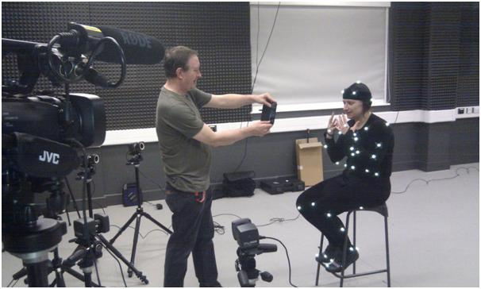

Figure 1. Myself in the motion capture suit with my interviewer-prompter, Dr Magnus Moar.

The aim was to document more closely the subtleties of body movement across two diverse emotive states. I am aware that talking of travelling (something I greatly enjoy) makes me happy, while talking about my father’s illness causes me considerable distress, however, while I feel the emotions, enough that I could begin to animate this monologue, I cannot see the emotions, the better to break down and fully analyse the movements.

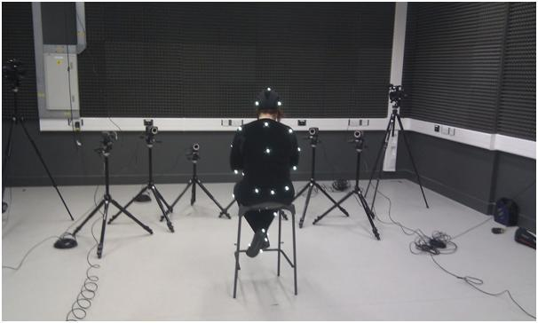

Figure 2. Myself in the motion capture suit, with the motion capture cameras.

The artefact aims to tie together 4 sequences into one piece, in that all the parts come from one performance or point in time, moving to the same dialogue and expressing the same emotions.

Stage 1: Filmed footage - the live action footage of the dialogue as it occurs. [Mimetic.]

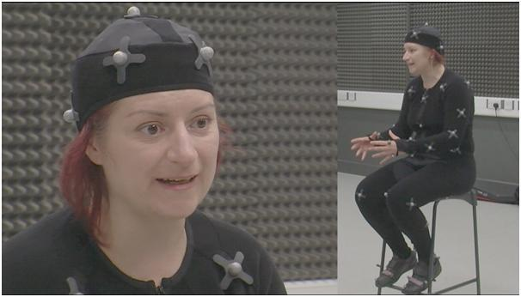

Figure 3. Still from the first part of live action footage, “happy” part of the interview.
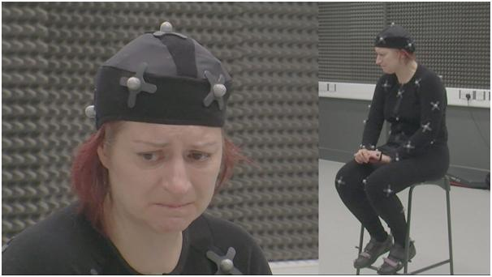

Figure 4. Still from the second part of the live action footage, “sad/upset” part of the interview.

Stage 2: Motion Capture - the movements and actions as they occur, captured and brought into an animated (not necessarily human) 3D character. This is the first step away from the “purity” of the footage, while still adhering extremely closely to the actual movements as they occur, yet brought into an animation context. [Semi-mimetic.]

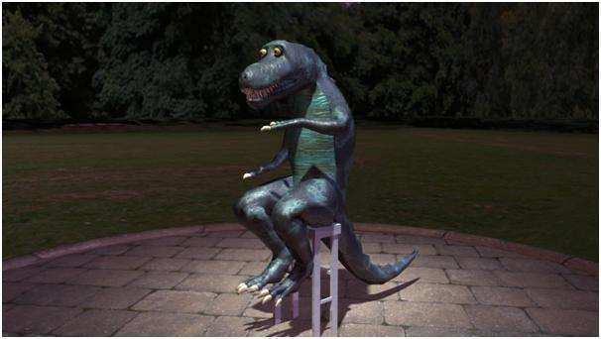

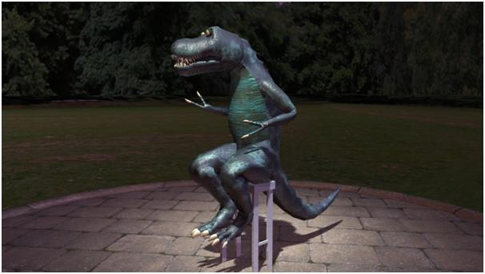

Figure 5 and 6. Stills from the motion capture footage, animated and rendered using Maya software.

Stage 3: Rotoscoped animation [Non-Mimetic substitution.]

At a basic level, rotoscoping involves tracing over live action, however, the level of stylisation and abstraction can vary according to the artist involved.
“With motion capture and the like, you are having the machine record something that becomes the spine, even the heart, of the animation derived from it. With Rotoshop, you are hand drawing the expressions and forms that you see. It is usually traced, yes, but even then you are starting with something hand drawn. There cannot help but be the smallest stamp of the artist in every line. From the very beginning, before it even enters the computer, the artwork is coming from someone’s head. The computer assistance happens afterward, and it springs from your artwork. That’s very different in my eyes.” (Sabiston, 2012)
By rotoscoping from my own film footage, I hope to stylize and hone down the expressions and emotions, while still keeping closely to the actual movements of my original performance. It is in some ways, a halfway house between motion capture and free-form animation.
“the visuals are disrupted and ‘heightened’, gestures become markedly more noticeable and skewed. Through overlaying the actors gestures with animation, movement in the films is energized and literally marked out.” (Ruddell, 2012)

Stage 4: Final animation [Evocative.]
Hand-drawn (on computer, using Flash or TV paint) this piece is the culmination of what has been learned and observed in the previous iterations. This piece may well deviate from the original footage, with animated flights of fantasy illustrating scenes from my trip to India, or my internal turmoil on seeing my father in hospital after his operation.
The final artefact will be presented in its 5 iterations (as detailed above) reflected upon, studied and presented to viewers for feedback.

Stage 5: A written reflection - documentation of what cannot be seen or drawn, internal thoughts, reflection and thoughtful reaction. [Concurrent.]

Haseman’s cycle is in operation, as I work on each part in order to inform the next, the film footage informs the motion capture, which informs the rotoscoping, which informs the final animation. The whole reflected upon in written form.
Stage 2: Animating the Motion Captured Footage

My initial idea for the character design for the 3D motion captured part of the artefact was to have a non-human 3D mesh. I specifically wanted to draw the viewer (and myself) away from making assumptions or becoming distracted by a semi-realistic human mesh. The motion capture would be focusing on the movements of the body specifically, not facial movements, and any attempt to realise a realistic 3D Human character would inevitably risk falling into the Uncanny Valley (Mori 1970) as the face would be mask-like and immobile (though the head might well move.)
There would be a risk that I and my viewers would become too distracted by the mask-like, static face to the detriment of observing the body movements, and so it would be better to move down Mori’s continuum into the realm of anthropomorphic or stylised characters.
My initial thought was to use a crocodile or lizard character design, reptiles having a solid skull and jaw that would not be expected or capable of facial expression, but would emphasise head movements and tilts with a long snout.
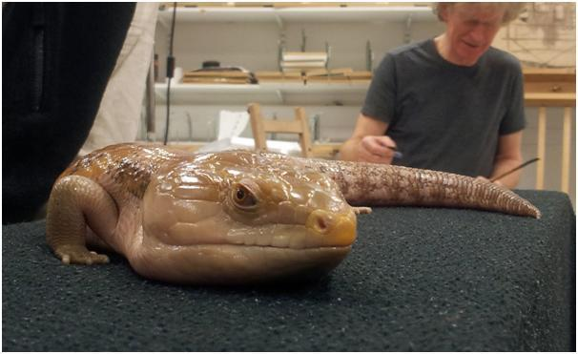
Figure 7. Blue-tongued skink. (Writers own photography.) Animals supplied by http://michaelsmobilemenagerie.co.uk/ )
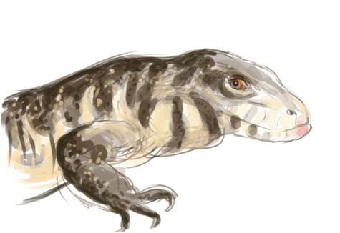
Figure 8. Sketch study of an Argentinian Tegu. (Writers own artwork.) Animals supplied by http://michaelsmobilemenagerie.co.uk/ )
I resolved to animate the motion capture footage using a character design of a T-Rex type dinosaur, but with human length arms. This is because (particularly later in the footage) I touch my face with my hands, and the character needs to be able to reach its own face.
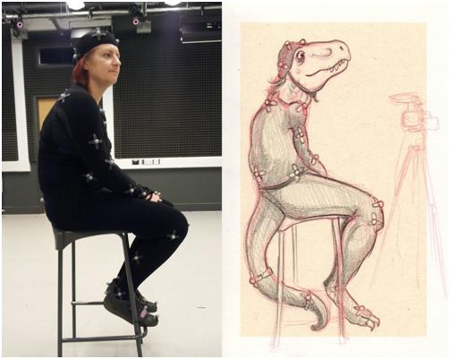
Figure 9. Sketch study of T-Rex character next to a photograph taken from the motion capture studio session.

A T-Rex character would still have a solid skull, thus not requiring or demanding facial expression but through its large skull emphasising head movements and hopefully compensating for the lack of facial expression. I aimed to design my T-Rex in the old fashioned upright pose (modern palaeontology tends to reconstruct T-Rex dinosaurs with their bodies projected forwards) but as I wished to anthropomorphize my character to better fit the captured data, I would need to have my character in a more upright, human pose. For this initial pass of animation, it was important to leave the motion captured data as untouched and “pure” as possible. For this reason too, the proportions of the character had to be close to my own captured proportions, at least in the initial animated pass. (Though proportions may be adjusted slightly for the final, evolved artefact.)

The original bone structure as imported from the motion capture software did not involve tail bones (since I do not have a tail) so these had to be added. I also added a jaw bone and finger bones - these were not present on the original motion captured data and would have to be hand animated. The motion capture suit involved sensors only attached to the body and head, but none on the jaw or fingers, so mouth movements or finger movements were not captured. Attaching these extra bones (such as tail, fingers and jaw) proved to be easy enough. As these were extremities, adding the extra bones did not impact on the motion captured movement. Rather, by parenting them to the animated bones (for example, the new un-animated fingers were parented to the animated existing hand bones) the extra bones followed the movement of their “parents” (fingers following hands) but had no movement of their own. This would have to be animated optionally.

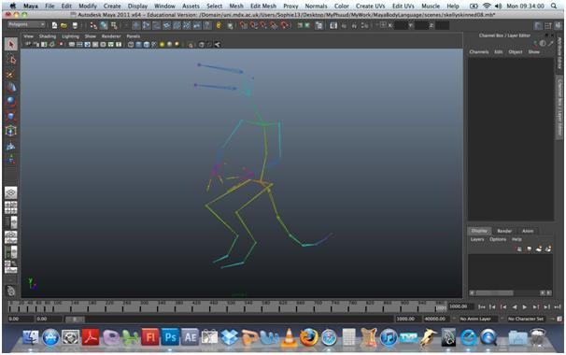

Figure 10. Raw motion captured data imported into Maya, with added tail, finger and jaw-bones.

While I am deliberately aiming for a stylized, non-human character in order to prevent distraction from the fundamental movements and postures, I feel it is important that the character have some sort of visual personality and be engaging. Hence applying a texture, and hand animating the jaw and eyelids. Without the mouth moving with the speech the character feels too distracting and odd. Even simple open and closed mouth movements help to make the character more believable as actually talking.

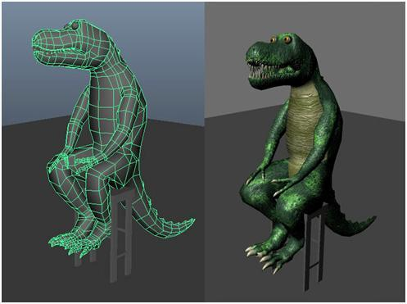

Figure 11. Wireframe mesh and textured version of the dinosaur character.

Initial viewer reactions

Test video of textured dinosaur: Introduction, (with sound.)

https://docs.google.com/open?id=0B4In3Q7aRQ_nUndqZFVBaExBQ00

On showing this piece to J and R, two professional animators who both animate and direct their own shorts in the British animation industry, the first thing they picked up on was the lack of movement. In animation, one is always encouraged to emphasise the emotion with more exaggerated or expressive movements. As one director explained, animated characters tend to be simplistic and lacking in the full range of expression of a human, so the acting has to be emphasised to compensate. It was suggested that I should have hired actors to do this piece, in particular, actors who specialize in motion capture who (so they told me) will emphasise and over-act movements, in a way that would not be expected of live action actors. Or to put it another way, deliberately tailoring an acting style to be appropriate to a specific subject or audience – in this case, animation. Since I have made an artistic choice to depict myself as a stylised, rather than a fully realistic character, the expectation was that my acting should have been more exaggerated. I had not heard of this before, a type of deliberately super-emphasized acting specifically for motion capture, and these comments threw up intriguing questions. By combining a stylized design with realistic movements, would I be introducing confusion into my audience? Not simply that by imposing motion capture onto stylized characters and thus losing gestural and facial information that live-action footage might have captured, but by also thwarting expectations in the viewer, that the viewer expects an animated character to behave in a more exaggerated way and finds themselves almost disappointed or cheated.

However, I used myself as I wanted (as far as possible) to draw upon real experiences of my own to express real (not-exaggerated) body movements, as the differences between “real” and “animated” motion is something I particularly wanted to investigate. As J and R work with me and know me quite well, they commented that my body movements were more restrained than they might have expected of me, since they associate me with using more hand gestures when I am talking. It is possible that as this is the intro, I may be acting in a more restrained manner as I get used to the odd situation I am in (sitting on a stool in a studio, wearing a cat suit covered in shiny balls.) Indeed, on further viewing of the live action footage, I do appear to relax more and become more myself, with more expansive gestures, though as with any laboratory experiment, full natural reactions might not always be achievable. In this case, my decision to use myself as symbolic lab-rat was that I would have access to my own emotional state on this experiment, and while self-confusion and self-misinterpretation is always a danger, after completing the filming I immediately sat down and wrote out my thoughts in a self-reflection of the process I had just endured, in summary...

- The situation was initially a little self-conscious, in that I had to wear odd clothes and was nervous at the prospect of revealing distressed emotions in front of people I did not know well.
- However, the technicians and assistants retreated behind a sound-proof booth. I was unable to see them, and knowing that they could not hear me and were busy with the dry, technical aspects of the experiment was reassuring. In fact, I quickly forgot all about them.
- My interviewer is someone I know well, and who has an easy-going manner. I am used to talking to him conversationally, thus it seemed easier to slip into a more conversational mode, particularly during the “happy” interlude.
- I was aware of having some restraint while talking during the “sad” interlude, though this would be normal behaviour for me in general, as I am very uncomfortable showing extreme emotions (such as tears) in front of people.
- While the situation was unnatural and strange, I was able to absorb myself in my subject, and I feel I spoke reasonably freely and honestly. The footage gained seemed a good starting point for the full piece. Even the fact that the distressed points were “restrained” was interesting for its own sake, particularly as the experiment as a whole was all about subtle emotional cues.
I posted up my preliminary animated piece on my private blog, without any explanation as to what I was intending or expecting, only that the piece was a motion captured version of myself. At this early stage, I simply wanted gut reactions from viewers. Viewers would be able to leave comments for me, but these comments were screened and viewable only to the commenter and myself, to prevent any group-think reactions or commentators reacting or being influenced by other viewers opinions.

Eleven viewers left comments. These viewers ranged from people of both genders, four of whom know me, two of whom I have met only once or twice, two I have not physically seen for years and three who have never met me and only know me through my blog, they are all technically “friends” in that they are allowed access to my private blog and presumably like me enough to read it. So it might be expected that they might be more complementary, with those who dislike the piece perhaps preferring not to comment.

As a preliminary, quick reaction feedback the replies are still interesting, particularly through their diversity and sometimes contradictory feedback. Some liked the jaw and thought it worked convincingly, others thought the jaw didn’t work, likewise the tail.

“I think it’s the subtle mismatches between the monstrous dinosaur and the very human gestures – it creates a chimera-esque frission, particularly around the arm gestures and shoulders.” (Commenter J)

Small movements become more fascinating, such as when the dinosaur settles herself down onto the stool before speaking, a natural and realistic movement that would have drawn no comment from live action footage, and yet, as an animated character, suddenly becomes heightened and more noticeable, just as Ruddell (2012) had observed in the case of Waking Life and Scanner Darkly, and even provoking wonder and surprise.

Conclusion

For the final artefact, I intend to have evolved a more abstracted piece from the cycle similar to the methodology put forward by Haseman (2007) but in this case a cycle derived from a step by step animation of the footage made, each iteration and animation informing the next into a final completed artefact. The final artefact may involve footage from the live action filming, the 3D animated character (motion captured,) the rotoscoped footage and the more abstracted “freeform” animation all cut together, which will then be shown to viewers and a more rigorous feedback session initiated and recorded. In particular, the marked reaction of viewers to seemingly insignificant movements (such as a dinosaur settling onto a stool) is an interesting reaction that bears further exploration.
To return to MacGillivray’s original observation. What can be gained from this in depth study of non-verbal communication through animation, is there a discernible “life quality” between the pieces? How will this process, in some ways, a very personal journey on the part of the animator, inform the final artefact? Will the different presentations of the same core performance elicit different reactions from viewers?

This research, working as it does as a self-exploratory and at some points highly personal interview documentary, transposed from which into animation that will delve from the mimetic through to the evocative, hopes to draw from the animated documentary tradition, self-figurative, reflective, transposed into an academic slant through the medium of the academic as practitioner.

Acknowledgements
This article is based on a paper delivered at Redefining Animation. The 25th Society for Animation Studies Annual Conference, USC, Los Angeles, 23-27 June 2013.
I want to express my acknowledgement to Prof Suzanne Buchan, Dr Magnus Moar, Dr Luke White and the anonymous reviewers at the Animation Studies Online Journal who read the subsequent version of this paper, for their constructive comments which led to this current form.

References
Beatie, Z, 2011, Wonderland - The Trouble with Love and Sex, Sherbert.
Beckman, K. 2011, "Animation on Trial", Animation: An Interdisciplinary Journal, vol. 6, pp. 259.
Buchanan, A. 2007, "Facial Expressions for Empathic Communication of Emotion in Animated Characters", Online Journal for Animation History and Theory, vol. Animated Dialogues, pp. 22nd February 2011.
Cameron, J. 2009, Avatar, 20th Century Fox.
Chovil, N. 1997, "Faces in Dialogue" in The Psychology of Facial Expression (Studies in Emotion and Social Interaction), eds. J.M. Fernández-Dols & J.A. Russell, Cambridge University Press, Cambridge, pp. 321.
Crafton, D. 1984, Before Mickey: The Animated Film 1898-1928, The MIT Press, Cambridge, Massachusetts.
Darwin, C. 1875, The Expression of the Emotions in Man and Animals, John Murray, Albemarle Street, London.
Finley, S. (2005). Arts-Based Inquiry: Performing Revolutionary Pedagogy. In N.K.Denzin and Y.S. Lincoln (Eds.), Handbook of Qualitative research (3rd ed., pp. 681-694). London:Sage Publications.
Geller, T. 2008, "Overcoming the Uncanny Valley", Computer Graphics and Applications, IEEE, vol. 28, no. 4, pp. 11.
Haseman, B. 2007, "Rupture and recognition : identifying the performative research paradigm" in Practice As Research : Approaches to Creative Arts Enquiry, eds. E. Barrett & B. Bolt, I.B. Tauris, United Kingdom, London, pp. 147-157.
Heider, F. 1967, "On Social Cognition", The American Psychologist, vol. 22, no. 1, pp. 25.
Heider, F., Simmel, M. 1944, "An Experimental Study of Apparent Behaviour", American Journal of Psychology, Vol. 57, No. 2, pp.243-259
Honess Roe, A. 2012, "Uncanny Indexes: Rotoshopped Interviews as Documentary", Animation: An Interdisciplinary Journal, vol. 7, no. 1, pp. 25-37.
Honess Roe, A. 2011, "Absence, Excess and Epistemological Expansion: Towards a Framework for the Study of Animated Documentary", Animation: An Interdisciplinary Journal, vol. 6, pp. 215.
Hooks, E. 2003, Acting for Animators, Heinemann Drama; Revised edition, Portsmouth.
James, J. Haines, T. 1999, Walking with Dinosaurs, 2 Entertain Video.
Linklater, R. 2006, A Scanner Darkly, Warner Independant Pictures.
Linklater, R. 2001, Waking Life, Fox Searchlight Pictures.

MacGillivray, C. 2007, "How Psychophysical Perception of Motion and Image relates to Animation Practice", Computer Graphics, Imaging and Visualisation, 2007. CGIV '07, , no. 14-17 Aug. 2007, pp. 81.
McCay, W. 1918, The Sinking of the Lusitania, McCay.

Mehrabian, A. 1981, Silent Messages: Implicit Communication of Emotions and Attitudes, Wadsworth Publishing Company, USA.
Moore, S. 2010, An Eyeful of Sound, Welcome Trust.
Mori, M. 1970, "The Uncanny Valley", Energy, vol. 7, no. 4, pp. 33-35.
Pollick, F. 2009, "In Search of the Uncanny Valley", The Vienna Series in Theoretical Biology, .
Power, P. 2008, "Character Animation and the Embodied Mind-Brain", Animation: An Interdisciplinary Journal, vol. 3, no. 1, pp. 25.
Renov, M. 2004, The Subject of Documentary, University of Minnesota Press, Minneapolis.
Ruddell, C. 2012, "'Don't Box Me In': Blurred Lines in Waking Life and A Scanner Darkly", Animation: An Interdisciplinary Journal, [Online], vol. 7, no. 1, pp. 7-23.
Russell, J.A. 1997, "Reading emotions from and into faces: Resurrecting a dimensional-contextual perspective" in The Psychology of Facial Expression (Studies in Emotion and Social Interaction), eds. J.M. Fernández-Dols & J.A. Russell, Cambridge University Press, Cambridge, pp. 295.
Sabiston, B. 1998, Roadhead, Flat Back Films;, USA.
Sabiston, B. 2012, "Bob Sabiston in Conversation with Paul Ward", Animation: An Interdisciplinary Journal, [Online], vol. 7, no. 1, pp. 73-82.
Thomas, F., & Johnson, O. (1981). Disney Animation: The Illusion of Life. New York: Abbeville Press.
Zemeckis, R. 2007, Beowulf, Warner Bros.
Zemeckis, R. 2004, Polar Express, Warner Bros.

