**Making sense of consumers’ tweets: sentiment outcomes for fast fashion retailers through big data analytics**

**Abstract**

**Purpose-** Consumers online interactions, posts, rating and ranking, reviews of products/attractions/restaurants and so on lead to a massive amount of data that marketers might access to improve the decision-making process, by impacting the competitive and marketing intelligence. The aim of this research is to help to develop understanding of consumers online generated contents in terms of positive or negative comments to increase marketing intelligence.

**Design/Methodology/Approach**- The research focuses on the collection of 9,652 tweets referring to three fast fashion retailers of different sizes operating in the UK market, which have been shared among consumers and between consumer and firm, and subsequently evaluated through a sentiment analysis based on machine learning.

**Findings**- Findings provide the comparison and contrast of consumers’ response towards the different retailers, while providing useful guidelines to systematically making sense of consumers’ tweets and enhancing marketing intelligence.

**Practical Implications**- Our research provides an effective and systemic approach to (i) accessing the rich data set on consumers’ experiences based the massive number of contents that consumers generate and share online, and (ii) investigating this massive amount of data to achieve insights able to impact on retailers’ marketing intelligence.

**Originality/Value**- To best of our knowledge, while other authors tried to identify the effect of positive or negative online comments/posts/reviews, the present study is the first one to show how to systematically detect the positive or negative sentiments of shared tweets for improving the marketing intelligence of fast fashion retailers.

**Keywords**: fast fashion retailing; big data analytics; consumer generated contents; user generate contents; e-word of mouth communication; online consumers behavior.

**1. Introduction**

The fast fashion industry continuously faces challenges in satisfying consumers’ desire for new products faster (Cook and Yurchisin, 2017), which results in the need to continuously investigate the market to quickly understand the demand and to respond accordingly.

Past studies investigate the role of online consumers’ generated contents, in terms of ratings, photographs, reviews that includes personal opinions and recommendations spread throughout social media, online platforms for e-commerce, bookings and products/activities reviews lead to a massive amount of data that marketers might access to improve decision making processes (Chong *et al*., 2017; Fan *et al*., 2015; Gensler *et al*., 2015; Halvorsen et al., 2013; Pantano *et al*., 2017), by impacting competitive and marketing intelligence (Fleisher, 2008; Xu et al., 2011). Social networks such as Pinterest, Twitter, Facebook, etc. are becoming very popular among customers as channels where consumers freely share their voice about their past experiences and their expectations about a certain product, emerging as the new shopping companion for young people (Pantano and Gandini, 2017, 2018). On one hand, the emerging big data and open data can serve as a rich data set on consumers experience with a certain brand/product/service and even destination; on the other hand, their analytics provide a systematic knowledge of consumers’ evaluations of the most or least appealing elements of a certain retailer (Fan *et al*., 2015; Gensler *et al*., 2015; Pantano *et al*., 2017), towards the development of a sort of “social intelligence” (Lau *et al*., 2014; Dindar and Yaman, 2018). Thus, such data can also be useful in examining how they influence other’s opinion online. When the number of followers is low (which implies a limited number of tweets per day), retailers might still manage the data manually. When the number increases resulting in big data, the process requires more complex analytics.

Therefore, the ability to analyze the massive amount of data emerging from online consumer behavior is a promising challenge and opportunities for marketing managers (Bradlow *et al*., 2017). For this reason, many IT companies are providing services related to the big data analytics and intelligent techniques applications in order to extract the essential consumers’ insights useful to support certain management decisions (i.e. Google Cloud and Microsoft Azure, from Google and Microsoft respectively). However, literature still provides only few attempts to investigate the phenomenon from a marketing perspective, in order to support marketing intelligence.

The aim of this research is to help understanding consumers online generated contents in terms of positive or negative comments to increase marketing intelligence, through a sentiment analysis based on machine learning for big data analytics. To achieve this goal, we collected and evaluated 9,652 tweets of three fast fashion retailers of different sizes operating in the UK market.

The paper is organized as follows: the next section provides an overview of the fast fashion sector and related consumer behavior to highlight the need for fast fashion to respond to rapidly changing consumers’ preferences, while the subsequent part provides a discussion of the current literature on consumers’ generated contents and the role of e-word of mouth communication in the online spread of opinions and comments. Then, the paper describes the methodology of research and main findings. Finally, the results and implications for scholars and practitioners are discussed.

**2. Theoretical background**

**2.1 Fast fashion and consumer behavior**

Due to the need to introduce new products quickly (products to be sold while the styles are in vogue), fast fashion retailers need to adopt quick response systems and flexible supply chain management (Cook and Yurchisin, 2017). Similarly, fast fashion retailers shorten periods of each season, by quickly changing the offer in order to influence consumers to frequently visit the store. This in turn reduces the life cycle of those products (limited time from introduction to decline) (Barnes and Lea-Greenwood, 2010), and pushes consumers to perceive the fast fashion products as available only in limited quantity (Cook and Yurchisin, 2017). In other words, fast fashion retailers provide the most updated high-end fashion products (collections that mimic current luxury fashion trends) at low prices available for consumers every few weeks, instead of every season as for the luxury brands (Joung, 2014; Zhang *et al*., 2017), while trying to reduce the time between the product concept and product delivery to the final consumers (Barnes and Lea-Greenwood, 2010). Therefore, the competitive scenario is characterized by ever-changing fashion trends and highly volatile demand patterns, which require fast fashion retailers be equipped with superior decision support systems for fast responses (Choi *et al*., 2014). Summarizing, the challenges of fast fashion retailers are: (i) efficient just-in-time models (the delivery of goods to meet consumers demand with minimal inventory at the store), (ii) agile supply chains (shorter and more flexible demand driven supply chains), (iii) quick response (to consumer needs with new and fast available products), and (iv) demand chains (supply chains focused on customers’ requirements) (Barnes and Lea-Grenwood, 2010; Zhang *et al*., 2017).

Moreover, word-of-mouth communication (with emphasis on e- word-of-mouth), celebrity endorsement, new forms of advertising, with emphasis on social media like Facebook can positively influence the building and maintenance of brand-customer relationships for fast fashion brands, due to the positive effect of engagement and affective commitment facilitated by the social media (Barnes and Lea-Greenwood, 2010; Chang and Fan, 2017; Halvorsen et al., 2013). In particular, those two factors are considered as determinants of long-lasting relationships between consumers and fast fashion brands (Chang and Fan, 2017). Similarly, brand awareness, brand uniqueness and perceived value are determinants of building consumers’ brand loyalties to fashion retailers (Su and Chang, 2018). To increase brand loyalty, some fast fashion retailers even started some forms of collaboration with luxury retailers for short periods to benefit from their brand image (Shen *et al*., 2017). For instance, H&M started in 2014 to collaborate with luxury brands to provide limited edition collection, by proposing a collection designed by Karl Lagerfeld in 2004, one designed by Moschino for Winter 2018, etc.

However, there may well be a need to further explore online information systems in order to understand how to systematically detect and respond to the fast trends in the fast fashion industry to boost marketing intelligence.

**2.2 Online consumer-generated contents**

Electronic word of mouth communication (eWOM), which consists of the evolution of word of mouth communication in the online channel, is recognized as a useful marketing tool for building relationships with consumers, generating awareness and interest in certain products, and influencing consumer purchase behaviour (Lee *et al*., 2012; Vazquez *et al*., 2017). eWOM is based on consumers’ online information generation (UGC), distribution and retrieval (Hornik *et al*., 2015). Since this information is generated by other consumers, it is considered more trustworthy than the information created by managers (Tran *et al*., 2012). Social media has further enhanced this information sharing process by giving to consumers the possibility to chat in real time with each other, for instance through the creation of microblogging word of mouth (MWOM) that increases the velocity with which data could be exchanged (Hennig-Thurau *et al*., 2015). The actual communication technologies support eWOM as one of the preferred methods for information search online (King *et al*., 2014), which is continuously prompted by the growing importance of social media as a channel where consumers can easily share opinions and experiences about products and brands (Hennig-Thurau *et al*., 2015). Therefore, eWOM and user-generated contents (UGC) emerge as key drivers for consumers’ buying decisions (Gensler *et al*., 2015; Lee *et al*., 2012). For these reasons, a large body of literature investigates the effect of eWOM on sales (King *et al*., 2014), other authors tried to identify the effect of positive or negative online comments/posts/reviews (Hornik *et al*., 2015; Li *et al*., 2013; Pang and Qiu, 2016; Yang *et al*., 2015), the best strategy to influence consumers’ positive eWOM (Erkan and Evans, 2016; Reamer *et al*., 2016), consumers sentiments towards a certain brand (Mostafa, 2013); and consumers’ reactions towards the firm’s participation in their online conversations (Homburg *et al*., 2015), while other studies have further considered using online consumers’ rates of tourism attractions as predictors of their future behaviour (Pantano *et al*., 2017).

Thus, the online contents generated by consumers in terms of reviews, ranking and ratings largely convey more information than reputation, in other words they reflect the product quality and popularity of a certain product, brand or service (Li *et al*., 2013; Liang *et al*., 2015; Tsekouras, 2017). Consumers are more willing to voluntarily evaluate products online across a wide variety of industry (i.e. tourism and hospitality, food, etc.). A large amount of these consumer-generated product evaluations can be found on online retailers website (i.e. Amazon), product review website (i.e. yelp.com), hotel/restaurant/attraction review website (i.e. TripAdvisor), etc. (Pantano *et al*., 2017). For this reason, many online retailers and vendors incorporate rating and reviewing systems in order to identify consumers attitude and support their purchase decision (Tsekouras, 2017). Moreover, firms use social network sites to reach out to consumers and proactively intervene with observed messages (contents), i.e. by replying to their requests or thanking when noticing a positive comment related to a certain product, etc. (Demmers *et al*., 2018). However, consumers consider more trustable online information provided by other consumers than by the vendor (Li *et al*., 2013; Tsekouras, 2017).

If comparing reviews and ratings, reviews might be considered more in-depth and insightful by providing additional information about a certain good (Tsekouras, 2017), however they require more effort to be processed (Tsekouras, 2017).

Thus, retailers might support online consumers purchase decision by providing recommendations generated by both previous consumers and recommender systems (Baum and Spann, 2014). For instance, Amazon suggests new books to buy based on the past purchases of consumers with similar characteristics or on sophisticated algorithm (recommender systems) that try to match consumer interest with product offer. Indeed, providing positive consumers’ opinions in addition to a recommender system’s suggestions might have a positive effect on consumers’ purchase decisions (Baum and Spann, 2014; Pang and Qiu, 2016). This leads online marketers to even group the reviews based on different criteria to help consumers to enhance finding the most helpful reviews (Pang and Qiu, 2016). For instance, in tourism industry, TripAdvisor is largely accessed by tourists to choose the restaurant/attraction, while the rating and ranking generated online might be accessed by tourism managers to achieve insights in the actual tourists behavior and make more accurate prediction of their future behaviors (Pantano *et al*., 2017).

However, those studies investigate the fast fashion industry by mainly focusing on supply chain and consumers’ behavioural models tested with traditional surveys limited to a particular sample of population (i.e. college students), without effectively investigating the online consumers’ behavior towards those retailers in terms of user generated contents and e-word of mouth communications.

**3. Methodology of research**

**3.1 Research design**

Given our objective to explore consumers’ online generated contents in terms of positive or negative comments to increase marketing intelligence, we chose a multiple-case study as research design. As a multiple-case research retains only relationships that are replicated across the cases, outcomes are more robust and generalizable when compared to single-case studies (Ellonen et al., 2009).

Similarly, multiple-case studies are based on the replication logic, thus each case is investigated as an independent experiment standing on its own as an analytical unit (Ellonen et al., 2009). Following the replication strategy suggested by Yin (2003), we chose three information-rich cases that show similar characteristics in our initial evaluation: the cases are from the same industry (fast fashion specialized in accessories), performing in the same market (UK), with similar size (large companies according to the number of branded stores). Thus, they are competitors to each other.

**3.2 Twitter sampling**

Twitter is a microblogging service launched in 2006 and reached in the first quarter of 2018 336 million monthly active users (Statista, 2018). Twitter is considered microblogging since is its main activity focuses on posting short updates (tweets) through desktop applications or smartphones. The maximum size of each tweet is 140 characters (similar to the size of a newspaper headline), and might include videos, pictures, and links to further full articles, webpages, etc. Users might create an account for free, while the tweets are free accessible online/mobile.

Therefore, Twitter has been used as the data source for building the data set on consumers (data collection).

The tweets further show high degree of generality concerning the language used, regardless of the topic domain of the target account, and it might differ according to factors such as demographics, thus it is important to collect data with enough variation in the language for reliability purposes (Ghiassi and Lee, 2018).

For the analysis purposes, the present research adopted Wolfram Mathematica software, which is a modern technical computing system supporting all areas of computing, such as image processing, data science, neural networks, machine learning, geometry and visualization (Bilotta and Pantano, 2011; Ersoy and Akbulut, 2014; Spring, 2011), which has started to be used also in research in marketing (Pantano *et al*., 2017; Song and Liu, 2017). If compared to other software (i.e. R or MatLab), Wolfram Mathematica offers a wider amount of different functions to run several analyses in a huge range of knowledge including biological and social science (Chonacky and Winch, 2005).

The study collected the tweets related to three fast fashion accessories retailers based in London (UK), posted in February 2018, comprising a total amount of 9,652 tweets (2,552 for retailer A; 4,900 per retailer B; 2,200 for retailer C respectively). Following Mostafa (2013), the study limits the tweets collections to the ones written in English to avoid possible issues emerging from the analysis of multilingual tweets.

The tweets have been collected by indicating the name of the retailer as hashtag or word in the text of the tweet. To this goal, the software Wolfram Mathematica allows the direct connection to the Twitter API to download all the tweets with the chosen characteristics (Figure 1).

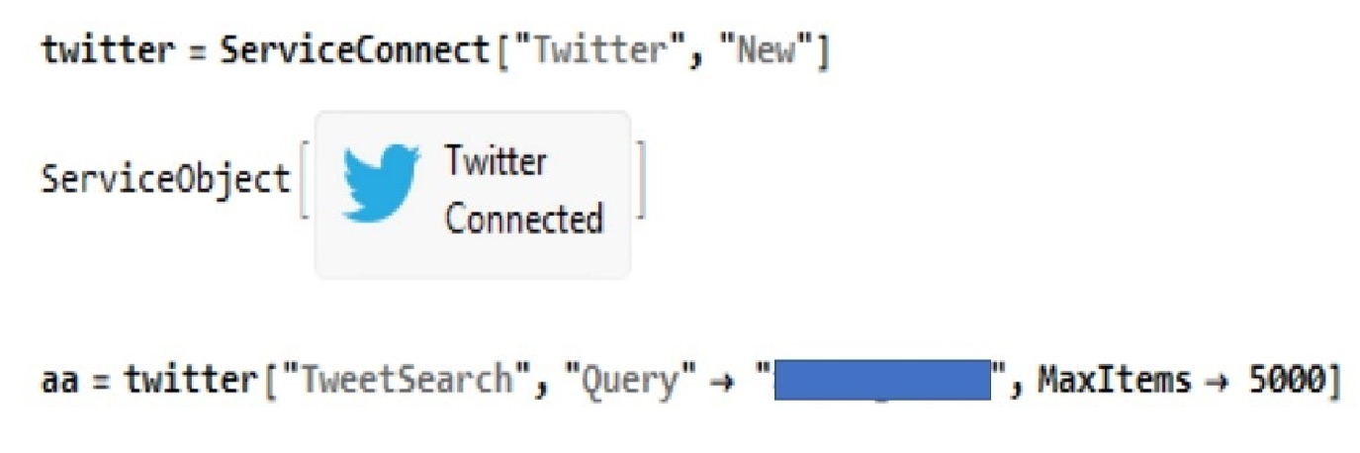

Figure 1: Example of cose used by Wolfram Mathematica software to collect the Tweets (the name of the retailer as been covered for privacy purposes).

Mathematica software create a database with the full text of the tweet and other meta-data including the date of publications and language.

**3.3 Twitter and sentiment analysis**

Sentiment analysis has started acquiring the attention of scholars who adopt the methodology to deeply understand consumers’ online reviews (Homburg *et al*., 2015; Liang *et al*., 2015; Mostafa, 2013; Shayaa *et al*., 2017). Indeed, sentiment analysis is becoming a popular method to mine consumers’ opinions shared online, which require systematic and automatized procedures (Xu et al., 2011). This methodology can collect data on consumers almost in real time and is less costly than traditional techniques based on structured questionnaires (Xu et al., 2011; Shayaa *et al*., 2017). However, most of these studies conducted the sentiment analysis through a semi-manual approach, which needed the researcher text segmentation, speech tagging, and extraction of the sentiment words, which have been further coded and analyzed through traditional regression models (Liang *et al*., 2015; Mostafa, 2013).

Machine learning algorithms consist of a set of tools for classification and prediction using structured and unstructured multimedia data (text, image, video and sound) in a variety of application domains. They employ several methods and tools to reduce the complexity of data and search for hidden patterns among a huge quantity of clustered data. Machine learning for big data analytics consists of extracting a small set of items that occur together in many clusters, and these recurrent sets of items represent the aimed-for classification of the data.

Machine learning is generally based on supervised (supervised machine) or unsupervised algorithms (unsupervised machine). The supervised machines need a training set to train the system, assigning each object a reference category. Unsupervised machines tend to cluster the objects they consider into clusters, learning from data without a reference model. The unsupervised classification systems relate to the discovery of patterns. Unsupervised classification systems are K-Means, Spectral methods and Gaussian Mixture, nonlinear fitting methods, Gradient, Newton, and N-minimize methods. Wolfram Mathematica software allows to build machine learning algorithms and conduct subsequent sentiment analyses.

Wolfram Mathematica software provides several pre-trained (supervised) classification machines for specific tasks in various fields of application such as computer vision and natural language processing applications. These classifiers have been previously trained on large amounts of data, and their parameters have been defined in order to achieve an optimal performance. The pre-processing procedures are organized as pre-processors and processors, and they are applied in sequence to the data and sent to the model unit (Wolfram, 2017). The present study uses an unsupervised machine learning already available in Wolfram Mathematica to perform the sentiment analysis of the collected tweets. To achieve this task, we choose the Classify function. This function is a pre-trained function that has taught various kinds of categorization. The pre-trained models employ several methods such as Logistic Regression that uses probabilities from linear combinations of features, Markov method applying a Markov series on the sequence of features, generally for text, and Support Vector Machine classify function to support vector machine (SVM). The latter is a binary classifier, based on a kernel function used to extract features, in other words its aim is finding the maximum-margin hyperplane that distinguishes the classes, while reducing the multi-class classification problem to a set of binary classification problems (Wolfram, 2017).

Classify function tries to find the model that has the highest likelihood on unseen data (that is on test sets). First, possible candidates are selected (based on the features of data). Second, the models compete against each other using cross validation techniques (Kohavi, 1995; Wolfram, 2017). Finally, the best model is selected in order to identify the sentiment that a snippet of text conveys. The input is typically one or a few sentences and the output conveys only one sentiment. In particular, the software assigns the label positive, negative and neutral to each tweet as the nature of the “sentiment” through the Classify function.

In particular, *Classify* is a function already available in Wolfram Mathematica allowing classification of the data included in the data set in different categories. It is based on a pre-trained machine (algorithm) that is trained in order to learn how to identify for each data a certain category. In this case, the classifying process aims at assigning to each datum (tweet) the category of positive, neutral or negative (corresponding to a positive, neutral or negative sentiment). During the classifying process (that adopts artificial neural networks), the machine is trained through a massive amount of data in order to increase the efficiency of the category assignment. The training step runs until the machine reaches a sufficient level of performance. Wolfram Mathematica employs different neural networks according to the particular analysis. The software, according the quality of output data and the time, automatically chose the best algorithm to adopt based on the available models built and trained through the Repository Net Neural. In the present study, the software used the Markov method to identify the sentiment (Figure 2), which is the main method used for Mathmatica text analysis.

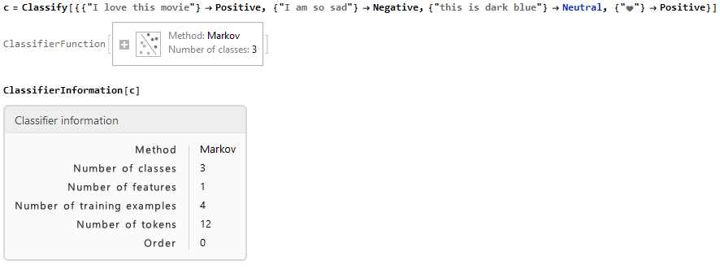

Figure 2: The adoption of Markov method for the classifying function in Wolfram Mathematica.

Given a certain category or class (in the present case positive, neutral or negative), Markov’s classifier of order 0 assumes that tokens are generated independently and adopts Bayes’ theorem (which provides the probability of an event, drawing upon the prior knowledge of conditions that might be related to the event) to predict the category. This procedure is also called unigram model or naive Bayes model.

**4. Findings and Discussion**

The three retailers under investigation adopted different marketing strategies, with different results according to consumers e-word of mouth communications and online generated contents. Although there is a default maximum number of tweets that can be analyzed simultaneously based on computer performance capacity, none of the fast fashion retailers has reached this number. In particular, 2,552 tweets have been collected for retailer A, 4,900 for retailer B, and 2,200 for retailer C (Figure 3).

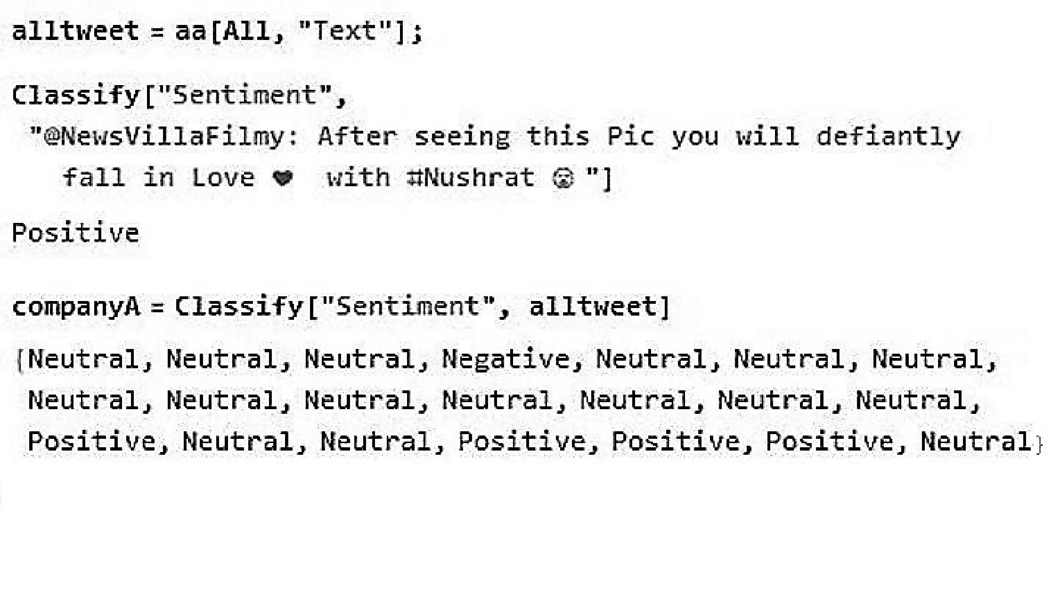

Figure 3. Classify function applied to the data set per company.

The number of tweets per retailer provides a preliminary measure of the quantity of e-word of mouth communication per each retailer, defining the basis for the definition of retailer’s popularity index in Twitter. Indeed, for retailer A, Wolfram Mathematica identified 1,944 neutral tweets, 559 positive (22% of the total tweets), and 49 negative (2% of the total). For retailer B, the sentiment analysis identified 3,900 neutral tweets, 700 positive (14% of the total), and 300 negative (6% of the total). For retailer C, the sentiment analysis identified 1,650 neutral tweets, 550 positive, and no negative tweets, thus the positive tweets are the 25% of the total. Figure 4 summarizes the results (Tally is the command included in Wolfram Mathematica to list the elements).

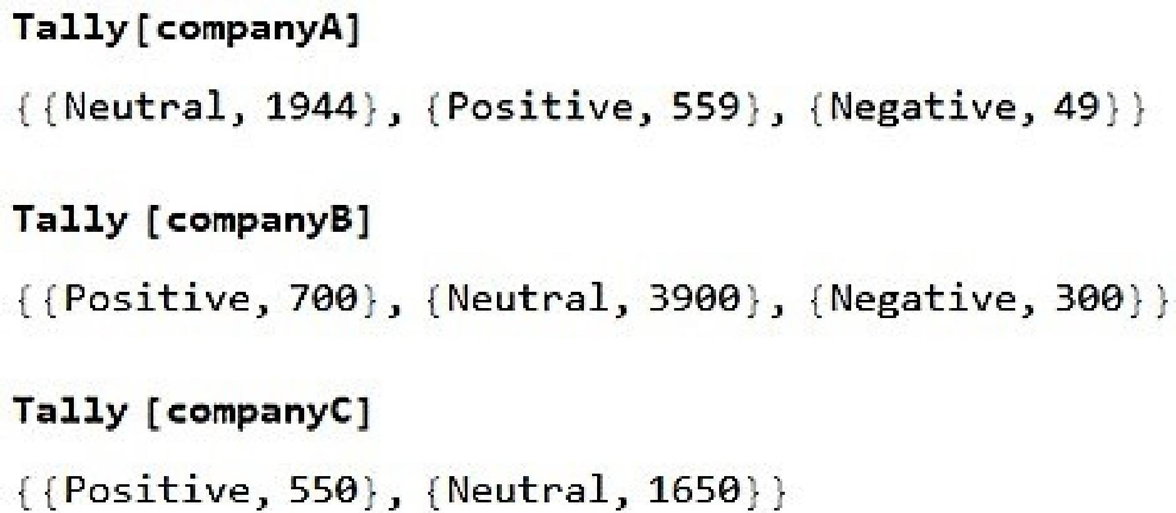

Figure 4. Wolfram Mathematica sentiment analysis outcomes (through Tally command to visualize the outcomes as a list).

Figure 5 compares and contrasts the results per each case research.

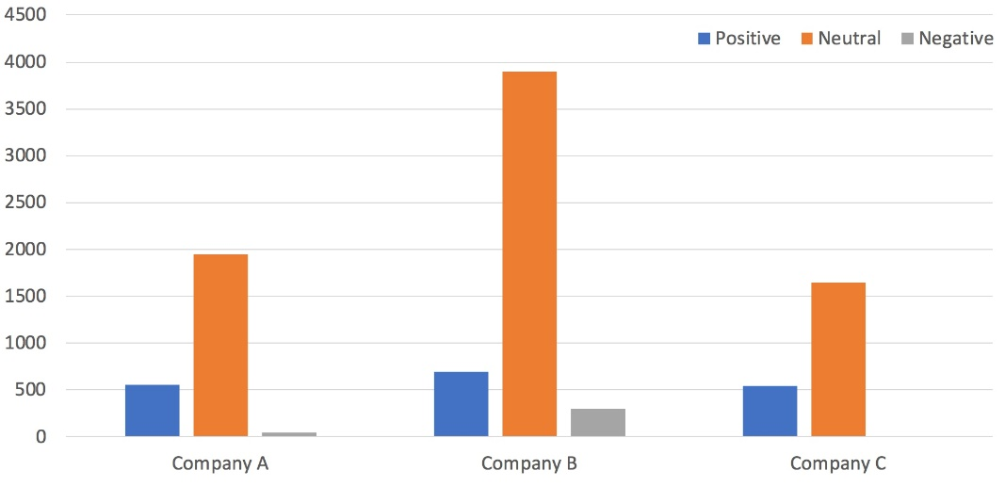

Figure 5: Comparison of the sentiment analysis results for each case research.

When comparing the detected sentiments, retailer C emerges as the one with no negative tweets, resulting as the one which solicited in consumers only positive “sentiments”. Thus, the analysis provides a sort of “sentiment index”, composed by a positive and negative part, consisting of the positive or negative perception of consumers for a certain retailer based on the sentiments detected on the Tweets. This sort of index can be easily compared with the competitors. In the tree case retailers, retailer C has the highest value of positive tweets (25% of the total ones), implying that the products, services, and marketing campaigns of the retailers are perceived as the most successful ones if compared with the main competitors. On the other hand, retailer B shows the highest number of negative tweets (14%), implying that a huge number of consumers are not satisfied with the retailer, by expressing negative feelings towards the retailer. This might have negative consequences for e-word of mouth communication, by soliciting other consumers to share (similar) negative comments.

Moreover, if we limit attention only to the positive and negative tweets, results further demonstrate that consumers shared more positive opinions/experiences about the brand, encouraging other consumers to do the same.

Summarizing, findings illuminate consumers’ evaluations of retail tactics for the three fast fashion retailers, revealing that big data analytics, with emphasis on sentiment analysis can be an efficient tool for marketers that can be integrated into strategies.

**5. Conclusion**

The aim of this research was to gain understanding of how to build value from these consumers’ online generated contents in terms of tweets to increase marketing intelligence.

Since the online contents generated by consumers reflect the product quality and popularity of a certain product, brand or service (Li *et al*., 2013; Liang *et al*., 2015; Tsekouras, 2017), our sentiment analysis provides measures of the actual consumers’ e-word of mouth communications related to the three different fast fashion retailers, in a sort of measure of the both number of messages shared among consumers related to the particular fast fashion retailer, and consumers’ perception (sentiment) of the retailers’ itself (sentiment index), and of what consumers say in terms of positive, negative and neutral comments (tweets). In this way, our study extends the previous works on the importance of big data analytics to achieve a systematic knowledge of consumers evaluation of the most or less appealing elements of a certain retailer (Fan *et al*., 2015; Gensler *et al*., 2015; Pantano *et al*., 2017), by providing a supporting approach to actually do it. To best of our knowledge, while other authors tried to identify the effects of positive or negative online comments/posts/reviews (Hornik *et al*., 2015; Li *et al*., 2013; Pang and Qiu, 2016; Yang *et al*., 2015), the present study is the first one to show how to systematically detect the positive or negative sentiments of shared tweets in aggregate way for improving the marketing intelligence of fast fashion retailers.

Since the e- word-of-mouth communication might positively influence the building and maintenance of brand-customer relationships for fast fashion brands in terms of long-lasting relationships between consumers and fast fashion brands (Chang and Fan, 2017), our findings provide a measure of these relationships, while the high number of positive tweets indicates positive comments-experiences-opinions.

Our findings also have practical implications for the fast fashion industry, which is characterized by the need to reply quickly to consumers’ demands for new products with the help of superior decision support systems (Choi *et al*., 2014; Cook and Yurchisin, 2017), by helping retailers in this sector in access in real time information on consumers’ trends and respond rapidly. Since Twitter is a valuable resource providing information at different levels (Dindar and Yaman, 2018), the real-time flow of data available in Twitter can be used by retailers to collect information about consumers’ experience. To this end, previous studies adopted semi-manual approach, which needed the researcher to manually conduct text segmentation and extraction of certain words to be further coded and analyzed through traditional regression models (Liang *et al*., 2015; Mostafa, 2013). However, there are some limitations on the ability to analyze the massive amount of data emerging from online consumer behavior (Bradlow *et al*., 2017). In other words, to what extent can employees or researchers manually extract words from texts based on millions of tweets? How much time does a human consumer need to read 5,000 tweets and extract words from them? How often can employees check the tweets and make real-time analyses? Past research considered the mining of consumers’ online contents as a non-trivial task due to the amount of contents and the informal style (Xu et al., 2011).

Our research replies to these questions and extends the study by providing an effective and systemic approach to (i) access the rich data set on consumers’ experiences based the massive number of contents that consumers generate and share online, and (ii) investigate this massive amount of data to achieve insights able to impact on retailers’ marketing intelligence, efficiently working with massive amounts of data. In particular, our analysis demonstrates to what extent an information system like ours can make systematic the procedure of detecting the negative comments (as well as positive ones), which is time and cost consuming to perform manually with high volumes of data.

Finally, achieving a quick overview of consumers’ opinions (either positive or negative ones) allows evaluating strengths and weaknesses of products, as well as collecting additional information on competitors’ performance (Xu et al., 2011). Thus, especially fast fashion retailers can benefit from a rapid access to the consumers’ insights in terms of positive and negative comments, which can be compared with the same outcomes from competitors’ analysis. Retailers can understand to what extent consumers share positive or negative evaluations, while comparing the results with the main competitors. Our analysis also shows the extent to which it is possible to collect this kind of data on different retailers, just mentioning the name of the intended company. However, this process can be further implemented if there is the need to understand consumers’ reaction to a specific campaign/service/product/etc., by changing the search terms (see Figure 1). To this end, our study proposes a framework that can be implemented by retailers without access to external service providers (e.g. Google Cloud), due to the advantage of being less expensive than structured questionnaires collection and related analysis, and requiring limited programming skills to run the software.

Summarizing, this study opens a door to the analysis of the rich-consumer-generated data for marketing intelligence.

Despite the theoretical and practical contributions of the present research, it is subject to some limitations. First, the currently-available algorithms consider some comments as “neutral” when they are not able to assign the label “positive” or “negative”, for instance in the case of ironic comments. The actual software is not able to exactly detect the irony in humans’ comments. In our analysis, the algorithms classify a huge number of comments as neutral, which might in reality be either positive or negative. Future developments in artificial intelligence and computer science might facilitate clearer identification of the positive and negative comments, to provide a more precise overview of the proportions of satisfied and dissatisfied consumers. Second, the research collected and evaluated consumers’ generated contents in Twitter, excluding other social media such Facebook or Pinterest where the three fast fashion retailers might be similarly present. Thus, new approaches might extend our study by integrating data from multiple resources for the sentiment analysis. Similarly, new research might include a simultaneous evaluation of posts and pictures. Third, our study does not consider detailed textual analysis in terms of what consumers’ say (in other words, which are the most frequent words, words correlations and networks, main topics, etc.), which might be further included to have a more comprehensive understanding of what exactly consumers say.

**References**

Barnes, L. and Lea-Greenwood, G. (2010), “Fast fashion in the retail store environment”. *International Journal of Retail & Distribution Management*, Vol. 38 No. 10, pp. 760-772.

Baum, D. and Spann, M. (2014), “The interplay between online consumer reviews and recommender systems: an experimental analysis”. *International Journal of Electronic Commerce*, Vol. 19 No. 1, pp. 129-162.

Bilotta, E. and Pantano, P. (2011), “Artificial micro worlds part IV: models of complex self-reproducers”, *International Journal of Bifurcation and Chaos*, Vol. 21 No. 6, pp. 1501-1521.

Chang, S. W. and Fan S. H. (2017), “Cultivating the brand-customer relationship in Facebook fan pages: a study of fast-fashion industry”, *International Journal of Retail and Distribution Management*, Vol. 45 No. 3, pp. 253-270.

Choi, T. M., Hui, C. L., Liu, N., Ng, S. F. and Yu, Y. (2014), “Fast fashion sales forecasting with limited data and time”, *Decision Support Systems,* Vol. 59, pp. 84-92.

Chonacky, N. and Winch, D. (2005), “Maple, mathematics and Matlab: the 3M’s without the tape”, *Computing in Science and Engineering*, Vol. 7 No. 1, pp. 8-16.

Chong, A. Y. L., Chang, E., Liu, M. J. and Li, B. (2017), “Predicting consumer product demands via Big Data: the roles of online promotional marketing and online reviews”, *International Journal of Production Research*, Vol. 55 No. 17, pp. 5142-5156.

Cook, S. C. and Yurchisin, J. (2017), “Fast fashion environments: consumer’s heaven or retailer’s nightmare?”, *International Journal of Retail and Distribution Management*, Vol. 45 No. 2, pp. 143-157.

Demmers, J., Van Dolen, W. M. and Weltevreden, J. W. (2018), “Handling Consumer Messages on Social Networking Sites: Customer Service or Privacy Infringement?”, *International Journal of Electronic Commerce*, Vol. 22 No. 1, pp. 8-35.

Dindar, M. and Yaman, N. D. (2018), “#IUseTwitterBecause: content analytic study of a trending topic in Twitter”, *Information Technology and People*, Vol. 31 No. 1, pp. 256-277.

Ellonen, H.-K., Wikstrom, P. and Jantunen, A. (2009), “Linking dynamic-capabilities portfolios and innovation outcomes”, *Technovation*, Vol. 29, pp. 753-762.

Erkan, I. and Evans, C. (2016), “The influence of eWOM in social media on consumers’ purchase intentions: An extended approach to information adoption”, *Computers in Human Behavior*, Vol. 61, pp. 47-55.

Ersoy, M. and Akbulut Y. (2014), “Cognitive and affective implications of persuasive technology use on mathematics instruction”, *Computers and Education*, Vol. 75, pp. 253-262.

Fan, S., Lau, R. Y. and Zhao, J. L. (2015), “Demystifying big data analytics for business intelligence through the lens of marketing mix”, *Big Data Research*, Vol. 2 No. 1, pp. 28-32.

Fleisher, C. S. (2008), “Using open source data in developing competitive and marketing intelligence”, *European Journal of Marketing,* Vol. 42 No. 7/8, pp. 852-866.

Gensler S., Volckner F., Egger M., Fischbach K. and Schoder D. (2015), “Listen to your customers: insights into brand image using online consumer-generated product reviews”, *International Journal of Electronic Commerce*, Vol. 20 No. 81, pp. 112-141.

Ghiassi M. and Lee S. (2018), “A domain transferable lexicon set for Twitter sentiment analysis using a supervised machine learning approach”, *Expert Systems with Applications*, Vol. 106, pp. 197-216.

Halvorsen, K., Hoffmann, J., Coste-Manière, I. and Stankeviciute, R. (2013), “Can fashion blog function as a marketing tool to influence consumer behavior? Evidence from Norway”, Journal of Global Fashion Marketing, Vol. 4 No. 3, pp. 211-224.

Hennig-Thurau, T., Wiertz, C. and Feldhaus, F. (2015), “Does Twitter matter? The impact of microblogging word of mouth on consumers’ adoption of new movies”, *Journal of the Academy of Marketing Science*, Vol. 43 No. 3, pp. 375-394.

Homburg, C., Ehm, L. and Artz, M. (2015), “Measuring and Managing Consumer Sentiment in an Online Community Environment”, *Journal of Marketing Research*, Vol. 52, No. 5, pp. 629-641.

Hornik, J., Satchi, R. S., Cesareo, L. and Pastore, A. (2015), “Information dissemination via electronic word-of-mouth: Good news travels fast, bad news travels faster!”, *Computers in Human Behavior*, Vol. 45, pp. 273-280.

Joung, H. M. (2014), “Fast-fashion consumers’ post-purchase behaviors”, *International Journal of Retail and Distribution Management*, Vol. 42 No. 8, pp. 688-697.

King, R. A., Racherla, P. and Bush, V. D. (2014), “What we know and don’t know about online word-of-mouth: A review and synthesis of the literature”, *Journal of Interactive Marketing*, Vol. 28 No. 3, pp. 167-183.

Kohavi, R. (1995), “A study of cross-validation and bootstrap for accuracy estimation and model selection”, In *Ijcai*, Vol. 14 No. 2, pp. 1137-1145.

Lau, R. Y., Li, C. and Liao, S. S. (2014), “Social analytics: learning fuzzy products ontologies for aspect-oriented sentiment analysis” *Decision Support Systems*, Vol. 65, pp. 80-94.

Lee, D., Kim, H. S. and Kim, J. K. (2012), “The role of self-construal in consumers’ electronic word of mouth (eWOM) in social networking sites: A social cognitive approach”, *Computers in Human Behavior*, Vol. 28 No. 3, pp. 1054-1062.

Li, M., Huang, L., Tan, C. H. and Wei, K. K. (2013), “Helpfulness of online product reviews as seen by consumers: source and content features”, *International Journal of Electronic Commerce*, Vol. 17 No. 4, pp. 101-136.

Liang, T. P., Li, X., Yang, C. T. and Wang, M. (2015), “What in consumer reviews affects the sales of mobile apps: a multifacet sentiment analysis approach”, *International Journal of Electronic Commerce*, Vol. 20 No. 2, pp. 236-260.

Mostafa, M. M. (2013), “More than words: social networks’ text mining for consumer brand sentiments”. *Expert Systems with Applications,* Vol. 40 No. 10, pp. 4241-4251.

Pang J. and Qiu L. (2016), “Effects of online review chunking on product attitude: the moderating role of motivation to think”, *International Journal of Electronic Commerce*, Vol. 20 No. 3, pp. 355-383.

Pantano, E. and Gandini, A. *(in press),* “From shopping as store experience to network experience: an emerging framework in retail industry”. *International Journal of Retail and Distribution Management.*

Pantano, E. and Gandini, A. (2017), “Exploring the forms of sociality mediated by innovative technologies in retail settings”, *Computers in Human Behavior*, Vol. 77, pp. 367-373.

Pantano, E., Priporas, C. V. and Stylos, N. (2017), “‘You will like it!’ Using open data to predict tourists’ response to a tourist attraction”, *Tourism Management*, Vol. 60, pp. 430-438.

Reimer, T. and Benkenstein, M. (2016), “Altruistic eWOM marketing: More than an alternative to monetary incentives”, *Journal of Retailing and Consumer Services*, Vol. 31, pp. 323-333.

Shayass, S., Al-Garadi M.A., Piprani A.Z., Ashraf M., Sulaiman A. (2017), “Social media sentiment analysis of consumer purchasing behavior VS consumer confidence index”, *in proceedings of the International Conference on Big Data and Internet of Thing*, *London 2017*, ACM series, New York, pp. 32-35.

Shen, B., Choi, T. M. and Chow, P. S. (2017), “Brand loyalties in designer luxury and fast fashion co-branding alliances”, *Journal of Business Research,* Vol. 81, pp. 173-180.

Song, H. and Liu H. (2017), “Predicting Tourist Demand Using Big Data”, in Xiang Z. and Fesenmaier, D. (Ed.), *Analytics in Smart Tourism Design. Tourism on the Verge*, Springer, Cham, pp. 13-29.

Spring, F. (2011), “Exploring process capability with Mathematica”, *Quality and Reliability Engineering International*, Vol. 27 No. 3, pp. 369-387.

Statista (2018), “Number of monthly active Twitter users worldwide from 1st quarter 2010 to 1st quarter 2010 (in millions)”, available at: <https://www.statista.com/statistics/282087/number-of-monthly-active-twitter-users/> (accessed on 7th June 2018).

Su, J., & Chang, A. (2018), “Factors affecting college students’ brand loyalty toward fast fashion: a consumer-based brand equity approach”, *International Journal of Retail and Distribution Management,* Vol. 46 No. 1, pp. 90-107.

Tran, G. A., Strutton, D. and Taylor, D. G. (2012), “Do microblog postings influence consumer perceptions of retailers’e-servicescapes?”, *Management Research Review*, Vol. 35 No. 9, pp. 818-836.

Tsekouras, D. (2017), “The effect of taring scale design on extreme response tendency in consumer product ratings”, *International Journal of Electronic Commerce*, Vol. 21, No. 2, pp. 270-296.

Vazquez, D., Dennis, C. and Zhang, Y. (2017), “Understanding the effect of smart retail brand-consumer communications via mobile instant messaging (MIM) - An empirical study in the Chinese context”, *Computers in Human Behavior,* Vol. 77, pp. 425-436.

Wolfram, S. (2017). *An* elementary introduction to the Wolfram Language. Wolfram Media, Incorporated, Champaign.

Xu, K., Liao S. S., Li, J. And Song, Y. (2011), “Mining comparative opinions from customer reviews for Competitive Intelligence”, *Decision Support Systems*, Vol. 50 No. 4, pp. 743-754.

Yang, K., Li, X., Kim, H. and Kim, Y. H. Social shopping website quality attributes increasing consumer participation, positive eWOM, and co-shopping: The reciprocating role of participation. *Journal of Retailing and Consumer Services*, 24 (2015), 1-9.

Yin, R.K. (2003), *Case Study Research: Design and Methods*. Sage Publications: Newbury Park.

Zhang, J., Onal S. and Das, S. (2017), “Price differentiated channel switching in a fixed period fast fashion supply chain”, *International Journal of Production Economics*, Vo. 193, pp. 31-39.