Submitted to Intellect journal *Drawing: Research, Theory, Practice* 5 Nov 2016

Accepted subject to revision 17 Feb 2017

This version revised March 2017

**Talking the line: inclusive strategies for the teaching of drawing**

*.*

Authors

Qona Rankin (Royal College of Art)

Howard Riley (Swansea College of Art)

Nicola Brunswick (Middlesex University)

Chris McManus (University College London)

Rebecca Chamberlain (Goldsmiths)

**Abstract**

*The article reports on a series of drawing workshops held at the Royal College of Art (RCA), London, which tested an original pedagogical strategy designed to help dyslexic and/or dyspraxic art and design students who had reported difficulties with their abilities to make accurate representational drawings. A group of non-dyslexic/dyspraxic RCA students volunteered as control group, and both cohorts completed three days of workshops in the Drawing Studio of the RCA. Results of recorded interviews eliciting student observations as they drew, and a questionnaire in the form of a Likert scale, administered before and after the workshop indicate positive shifts in both cohorts’ attitudes towards specific aspects of the stages involved in the production of accurate representational drawings of still-life set-ups, the human skeleton, and the clothed life-model. Assessment of the drawings produced indicates positive shifts in the two cohorts in geometric accuracy and other qualitative criteria embedded in the teaching strategy such as control of scale, proportion and illusions of depth. Both cohorts displayed similar positive attitude shifts and both sets of drawings indicated similar positive shifts in visual qualities. An interim conclusion posits that the pedagogical strategy appears to enhance the abilities of both dyslexic/dyspraxic students and non-dyslexic/dyspraxic students to make accurate representational drawings. This result correlates closely with the findings of an earlier, prototype workshop held at the RCA in July 2012. It is suggested that similar pedagogically-inclusive strategies might produce positive results in the context of secondary schools as part of a more inclusive curriculum.*

Keywords:

art students

pedagogy

drawing

dyslexia

inclusivity

**Introduction**

This article is based upon a presentation made by two of the authors (Rankin and Riley) to the *10th International Conference of the British Dyslexia Association,* held in Oxford, March 2016.

We started from the premise that dyslexic readers’ cognitive differences as described by Uta Frith (1997), Margaret Snowling (1997), Amanda Kirby (1999), Tilly Mortimore (2003) and Liz Du Pre, Dorothy Gilroy and Tim Miles (2008), impact on how, and the speed with which they receive, hold, retrieve and structure information. We also understand from interview responses that some dyslexic/dyspraxic art students feel that they cannot draw well, so we set out with the hope of being able to help those students who recognise certain shortcomings in their drawing to improve their observational drawing skills.

Recently, on the BBC Radio 4 programme *The Art of Walking into Doors* (Ledgard 2015), Chris McManus, Professor of Psychology and Medical Education at University College London, and a member of our research group, described drawing from observation as: ‘…taking in visual input, processing it through our eye, through our brain, sending it to another bit of the brain that produces motor outputs and moving our hand in just the right way to make the two look the same, it’s a very complicated process’.

We are interested in how the cognitive differences of dyslexia affect the complications of perceiving (receiving) and structuring the transformation of a three-dimensional object in space into a two-dimensional drawing, and whether teaching strategies developed to help dyslexic readers’ learning in general might be adapted to help their drawing in particular.

**A short explanation of dyslexia/dyspraxia and its relevance to drawing**

It has long been accepted that dyslexia affects the way information is processed, stored and retrieved, with problems of memory, speed of processing, time perception, organisation and sequencing. More recently dyspraxia has been recognized as a condition affecting fine and/or gross motor coordination, which can also have serious negative impacts on daily life, including social, emotional difficulties as well as problems with time management, planning and organization. Moreover, there has been a lot of debate amongst researchers in this field addressing the notion of a lack of automaticity contributing to the reading deficit in dyslexic children and fine and/or gross motor coordination difficulties often seen in dyspraxic individuals (Nicolson and Fawcett 1990)

Most observational drawing involves looking at an object and then looking away to the drawing. This inevitably requires a short-term storage of the visual information so that corresponding marks can be made on the paper. In the same way that short term memory problems can negatively affect the reader we suggest that the drawer may be similarly affected. In addition, since drawing is in part a symbolic act of representing the visual world by arbitrary marks, then dyslexic readers may also have specific problems with making marks in drawings. A paucity of planning and organisational skills and visual perceptual confusion between field and ground could adversely affect the composition of a drawing. The inability to accurately control a pen or pencil due to motor co-ordination difficulties may present additional difficulties to the dyspraxic drawer.

Although we have not been able to provide empirical evidence to suggest that dyslexic and dyspraxic processing difficulties should be a consideration when teaching drawing, we have shown that there is a subset of dyslexics with mathematical problems who are particularly poor at drawing (McManus *et al.,* 2010) and some of our previous research findings (eg Chamberlain *et al.,* 2015) raised several possibilities: firstly, it would appear that motivational and personality factors are important in being able to draw well, and one possibility is that increasing both motivation and the opportunity to practise drawing will improve performance (as with any complex skill); secondly, it has been well documented that specific teaching strategies1 can have enormous benefit on the learning of both dyslexic and dyspraxic students. (Mortimore 2003; Fleming and Kleinhenz 2007)

Therefore we wish to test the possibility that art students with dyslexia may benefit from the explicit teaching of techniques for carrying out basic skills such as accurately representing angles and proportions, judging figure/field relationships, and re-conceptualising their processes of perception by ‘looking without language’: this phrase relates to the idea that when we are able to label what we see with a particular word, then we tend to use that filter of language to the detriment of the actual information received in the structure of the arrays of light arriving at the eyes. One simple way of by-passing the filter of language is to concentrate attention on those areas of the visual field which have no language-label; these areas are referred to as ‘negative spaces’ - the spaces between objects - or ‘shapes of tones’, defined by the contrast boundaries between areas of tone or texture which together make up the overall layouts of the objects within the visual field.

In addition, we are interested to explore whether the students’ verbal articulation of their drawing processes whilst drawing could also be of benefit: that by changing the internal dialogue from what is *known* to what is *perceived* would impact upon how, and the speed with which the visual information from the primary geometry of the scene (i.e. the arrangement in space of lines of projection from the three-dimensional objects to the plane of projection) is translated into the secondary geometry of the drawings (the relationships between points, lines and shapes of tone). Students’ verbal reflections recorded whilst drawing are transcribed at appropriate places in the article.

**The drawing workshops: description of teaching strategies**

The workshops are structured upon a teaching strategy designed to consolidate the student’s learning through repetitive procedures adapted from Nist and Kirby (1986) and reported in Nist and Mealey (1991) and Mortimore (2003). This type of learning follows an eight-step process:

1 Focus attention

2 Give a general overview

3 Introduce new terms

4 Go through the procedure step by step

5 Model the process - think aloud - introduce new frameworks of thought; the students also discuss the process and teach each other

6 Guide the practice- students repeat the instructor’s strategy with support

7 Independent practice

8 Re-demonstrate the practice, if necessary, to reinforce

The eight-step process outlined above has been adapted to a strategy of teaching drawing in a traditional drawing studio, where the student is encouraged:

1 To focus attention upon the subject-matter and its relationship with the surroundings (figure/field relations): relationships of format, scale and positioning of the drawing within the picture-plane (the drawing sheet itself) relevant to the main axes of the drawing sheet.

2 To construct a general structure, or *scaffolding*: in terms of life-drawing, this would relate to the main axes of the model’s pose, using, for example, the ‘invisible grid’ of lines running across the figure that connect salient points such as nose, nipples, navel, knees, and knuckles. These axes might be the vehicle by which students hone their skills of accuracy in drawing angles and lengths in proportion so that the repetitive, low-level exercise is perceived to have contextual meaning for the student.

3 To explore visual concepts such as *contrast boundary* in place of the common term ‘outline’. This immediately engages the student with the variety of tonal values across the whole subject-matter and, in particular, allows the student to notice how the contrast boundary fluctuates at the edges between figure and field. The concept of *negative space* (spaces between those items in the visual field normally labelled with language), can also aid students to look without language, to apply specifically non-verbal methods in the process of drawing. Thirdly, to draw attention to the visual vertices, simply described as *T and Y junctions* apparent as edges where two surfaces are occluded by a third. (Biederman 1987; Ostrofsky and Kozbelt 2012)

4 Tutor demonstrates Steps 1-3. Students repeat these first three steps at the beginning of every new drawing.

5 To discuss with the tutor the process under way on the drawing board.

6 To repeat the recommended strategies with support from the tutor.

7 To draw independently at unsupervised open-access drawing sessions.

8 Tutor re-demonstrates the practices and strategies in order to reinforce them.

**The drawing workshops: details of participants**

Thirteen students, all with extensive experience in drawing, volunteered to spend three days drawing as part of the *AcrossRCA* programm*e* in October 2015*.* This isa series of cross-curricular projects that takes place each October at the Royal College of Art. A follow-up workshop was held in January 2016. (There had also been a prior, prototype workshop held at the RCA, July 2012.)

Of the 5 male and 8 female participants with an age range between 23 and 67, 2 were statemented as dyspraxic, 3 dyslexic, 3 were dyslexic and dyspraxic, and 5 had no assessment. Only one student was left-handed. Students came from a wide range of College departments: Jewellery & Metalwork, Industrial Design Engineering, Ceramics & Glass, Global Innovation Design, Design Products, Textiles, Visual Communication, Curating Contemporary Art, Printmaking, and Painting. The common basis of all these practices has been described as an ‘intelligence of seeing’ (Riley 2008). Drawing nurtures the development of such intelligence.

Throughout the workshops, participants were also encouraged to verbalise any thoughts that came to mind whilst they were being filmed. They were given guidelines on how to make a concurrent verbal report, taken from Perkins, (in Fayena-Tawil, Kozbelt and Sitaris 2011: 138). A *Sony Handycam* digital video recorder was initially attached to a tripod and positioned over the participants’ right shoulder to record action and verbalised thoughts. However, due to lack of space in the drawing studio the camera was hand-held. Every two minutes throughout the sessions the camera was moved to a different participant.The camera operator prompted the participant if he or she fell silent for more than a few seconds. Prompts were questions like ‘What are you thinking about now?’ ‘What’s on your mind now?’ Selected comments by the students are included in the discussion below. (All students gave written consent to their comments being transcribed for the purpose of publication).

**The drawing workshops: detailed description of content and procedure over the 3 days**

A pre-workshop questionnaire was completed prior to first drawing. The questionnaire, in the form of a 7-point Likert scale ranging from ‘Strongly Disagree’ (1) through to ‘Strongly Agree’ (7) is designed to elicit students’ self-assessment of their awareness and understanding of the fundamental concepts and strategies for constructing a 2-D representation of the 3-D visual field, and also a self-assessment of their competencies in applying those strategies.

Participants were given A2 and A3 sheets of cartridge paper and could choose to use pencil, charcoal or chalk pastel. (This variety of media enabled students to explore the maxim that the medium dictates the scale of the drawing.) The objects to be drawn were selected for their range of organic/geometric qualities, lending the compositions a range of possibilities for combining lengths, angles, edges, a variety of scales, and arranged so as to emphasise negative spaces and contrast boundaries within the structure of the primary geometry of the observed scene.

***Day 1 only:*** For the first drawing of the day, a still-life set-up, no tuition advice was offered, so that the drawings serve as the baseline for judging any improvements across the three days. A copy of an article ((Rankin et al., 2012) outlining the structure of the specific strategies to be employed in the teaching of dyslexic students, an 8-step model[1] adapted from Sherrie Nist and Kate Kirby (1986 in Nist and Mealey 1991: 60-61) was handed out after this first drawing.

***All Days:***

***10am-11.30am Three drawings of half an hour each***

A still-life comprising a mix of organic and inorganic objects was set up.

*Drawing 1:* Students were advised to make decisions on format (portrait/landscape/square) relative to the overall proportions of the subject-matter, and also to consider figure/field relationships in terms of scale, balance, symmetry with regard to the major axes of the drawing paper: the centre vertical, the centre horizontal, the two diagonals. Students were encouraged to concentrate upon the linear and angular relationships between the edges of the objects within the set-up.

*Drawing 2:* Students’ attention was drawn to the negative spaces between the objects on display, those spaces unlabelled with words. The phrase *looking without language* was introduced as the topic.

*Drawing 3:* Students were encouraged to focus on contrast boundaries within the set-up: information about surfaces and edges contained in the structured light arriving at our eyes, with an emphasis on using tone and texture. No ‘outlines’ were allowed!

***12noon -1pm One drawing***

A full-sized human skeleton was set up. The tutor’s initial advice focussed upon proportion between parts of the skeleton, and the judgement of length and angle. In this way, a ‘scaffolding’ of lines connecting salient points in the skeleton itself was produced. Switching attention from solid forms to the negative spaces between was encouraged as a means of controlling accuracy of shapes, and the concept of contrast boundaries between tonal and textural properties of the set-up was reiterated in one-to-one discussions with students.

***2pm- 3pm One drawing***

Drawing from clothed life model. Tutorial advice emphasised the topics already covered in the earlier drawing exercises, but with additional tuition about primary geometry and secondary geometry (i.e. how the arrangement in space of lines of projection from the three-dimensional objects to the plane of projection is translated into the secondary geometry of the drawings: the relationships between points, lines and shapes of tone and texture).

***3.30pm-4pm Continue life drawing prior to display and group discussion.***

Day 3 ended with participants completing the Post-workshop questionnaire, identical to the Pre-workshop one.

**Discussion and analysis of drawings produced in the workshops**

There have been growing suggestions that the style of drawings of dyslexic and non-dyslexic art students may be different, with Grant (2008) suggesting that in dyslexic students ‘…the brain is thinking faster than the hand can execute an idea’, their drawings having smaller strokes, lines that overlap, fainter marks, and a 'wooden feel'. Such observations correlate with the taxonomy of indicators of dyslexia developed by Rankin, Riley and Davies (2007).

Professor John Stein of Oxford University (in Ledgard 2015) recently observed ‘The dyslexic brain works slower but will see all sorts of alternative routes and often sees the correct result without going through the linear steps often resulting in very creative solutions to a problem. 2-D drawing requires the ability to go from A to B to C linear thinking, whereas in fact the dyslexic (*sic)* may have seen the 3-D structure in its entirety and it’s very difficult for them then to go into this linear way of putting it down on paper*.’*

There was a noticeable improvement in the confidence displayed in the drawings made across the October 2015 workshops and the January 2016 follow-up workshop, where the tentative wispy marks in the first drawings, exemplified in Figure 1(L), develop into drawn marks indicating confidence through their robustness and boldness, for example Figure 1 (R). This visual assessment of confidence is corroborated by the questionnaire results.

‘I was just thinking this particular, what you call hairy lines it’s almost like how my short-term memory is working, it’s like a bit strobe lighting going down like that rather than a nice you know, sort of fractured impression in my mind. I can feel confident about one line and then when it comes to matching it up with another line then suddenly it’s all wrong’. (Student comment)

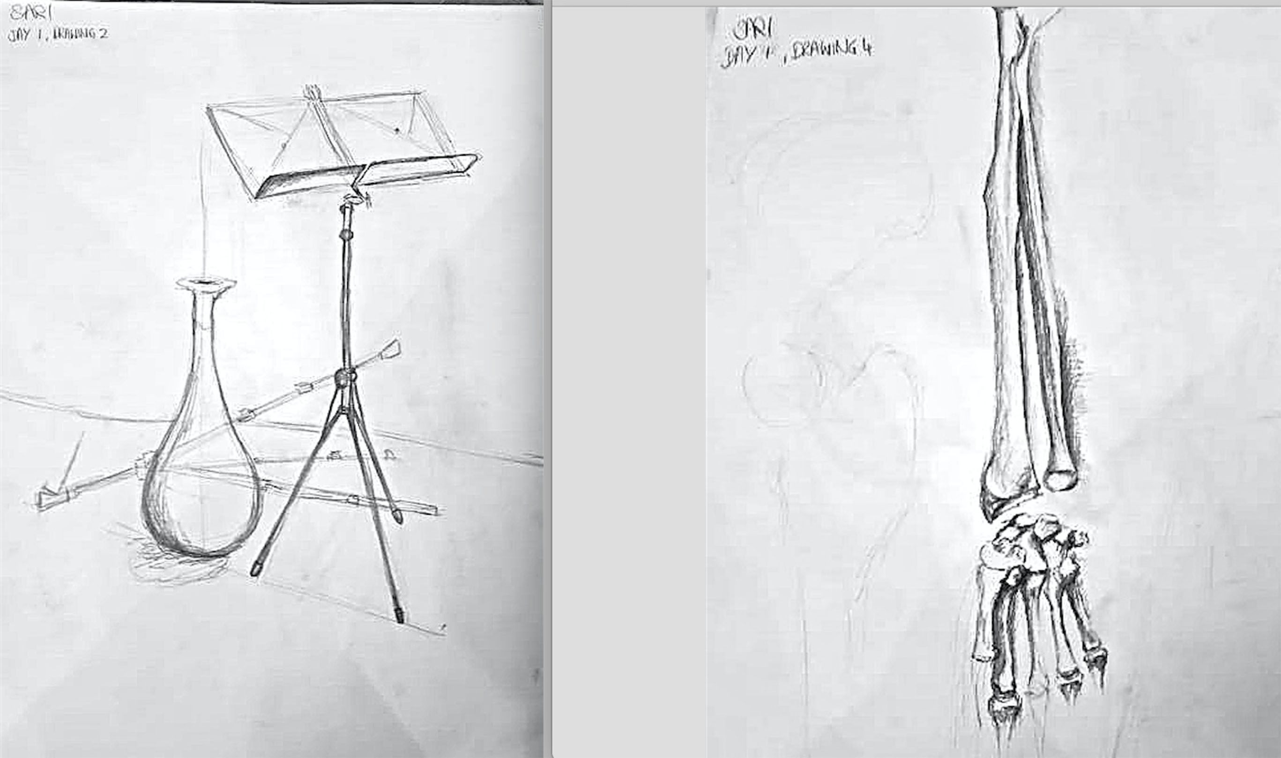

Figure 1 (L):Student A (dyspraxic) Day 1 Drawing 1. (R): Student A (dyspraxic) Day 1 Drawing 4.

‘I’m trying to not do lots of strokes just do definite single strokes so I’m thinking about trying to get the geometry right by having crisp, definite, confident lines’. (Student comment)

It was salutary to hear a dyspraxic student articulate what the teaching strategy had specifically identified as a prime reason for students’ disappointment with their drawings: her inability to plan and organise the detailed parts of her drawing so that it ‘…fitted onto the paper’.

‘I’m trying to place everything on the page in a geometric form. I’m trying to find the geometry, the shapes, just to get the proportion of how everything is related.’ (Student comment).

This particular problem is one recognised and addressed in the earliest stage of the workshops. The observations made by students about losing their place in the drawing, for example forgetting which of the skeleton’s ribs they were working on and sometimes correcting the wrong rib, can be compared to the typical eye-tracking difficulties many dyslexic children encounter when reading. As Angela Fawcett (2001) states ‘… in dyslexics (*sic)* development of the visual magnocellular system is often impaired. Clearly this could interfere both with the reliable direction of visual attention and of eye movements’.

Once the student is able to control the scale and positioning of the drawing using the scaffolding of the major axes relative to the scale and format of the drawing paper, (Figure 2 L), confidence is established to elaborate on the next stages of drawing construction. The metaphor of ‘scaffolding’ resonates with Mortimore’s (2003:118) observations about dyslexic students’ tendencies to be wholist thinkers, who often have trouble organising details in order to support an overall argument in written form: ‘…strategies to help wholists will include…scaffolding frames to support the oral or written expression of information.’

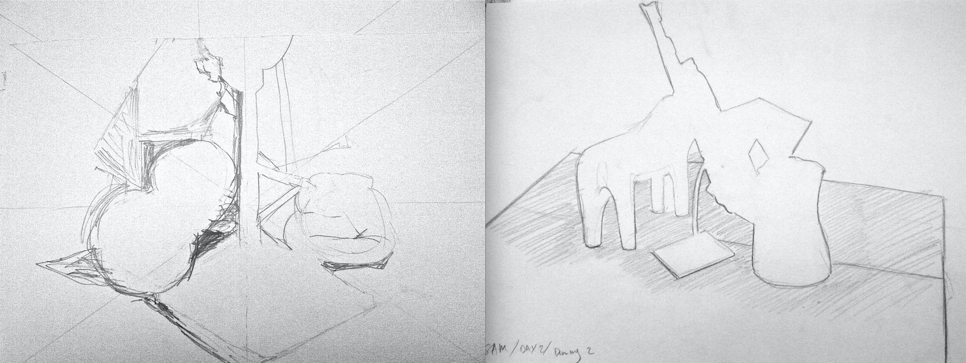

Figure 2 (L):Student B (dyslexic) Day 1 Drawing 3. Use of axes to control details of *scale* and *figure/field relationships*. (R):Student C (dyspraxic) Day 2 Drawing 2. Focus upon *negative spaces* controls proportion and figure/field relationship.

The concept of *negative space* is familiar to most teachers and experienced practitioners of drawing. However, the concentrated and repeated observation of such spaces, unlabelled by language, appears to improve control of a drawing’s proportional relationships between negative and positive shapes making up the figure/field composition. (Figure 2 R).

‘I’m just listening to what Howard said about going over your negative space against the line, so I’m trying to look again at the negative space and see if that helps me. I think negative space is helpful with the fingers cause I think there’s a tendency to feel like they're sort of sausages. For me anyway I need to count them one, two, three, four’. (Student comment)

Similarly, the concept of *contrast boundaries,* relating to the edges between areas of tone and/or texture in the visual field, is recognised by many teachers of drawing as being a more direct way of producing illusions of depth within a drawing (Figure 3 L) much more direct than the practice common to many students of drawing of trying to ‘walk the tightrope of the outline’.

‘I’m thinking about, I’ve made it so flat that I cannot distinguish what is what any more so I’m trying to make it stand out a bit more by blurring the edges and introducing the back ground instead of doing it the other way around’. (Student comment)

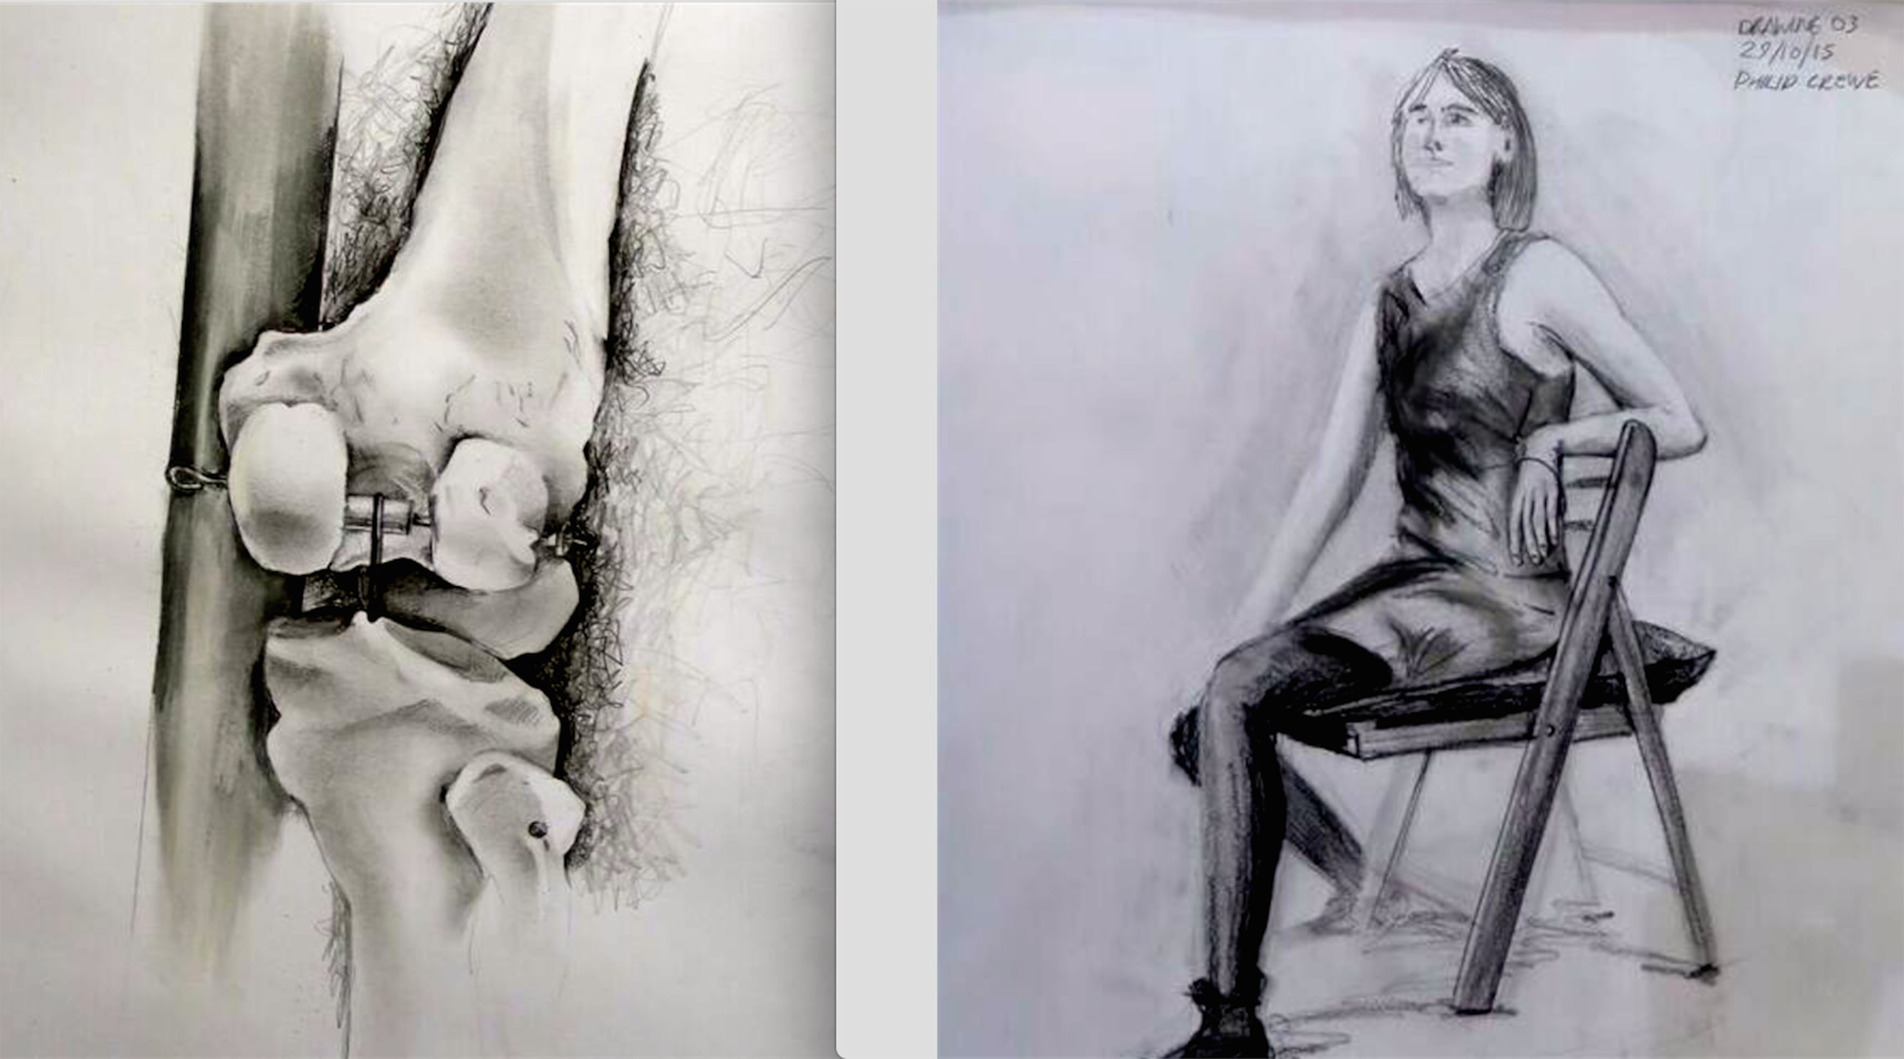

Figure 3 (L):Student D (non-dyslexic) Day 3 Drawing 2. Use of *contrast boundaries* produces illusions of depth. (R):Student E (dyslexic) Day 3 Drawing 3. Observation of *‘T and Y junctions’* the pattern of edges made where one surface occludes another, and both occlude a third. For example, at the junction where the model’s left wrist occludes the rib-cage and background.

The repeated strategy of observing edges rather than outlines also aids the awareness of the ‘T and Y junctions’, produced whenever one tonal or textured surface occludes another, against the background of a third surface. Figure 3 R)

Finally, a couple of examples illustrating the full range of the teaching strategies in drawings made in the latter stages of the workshops: Figure 4.

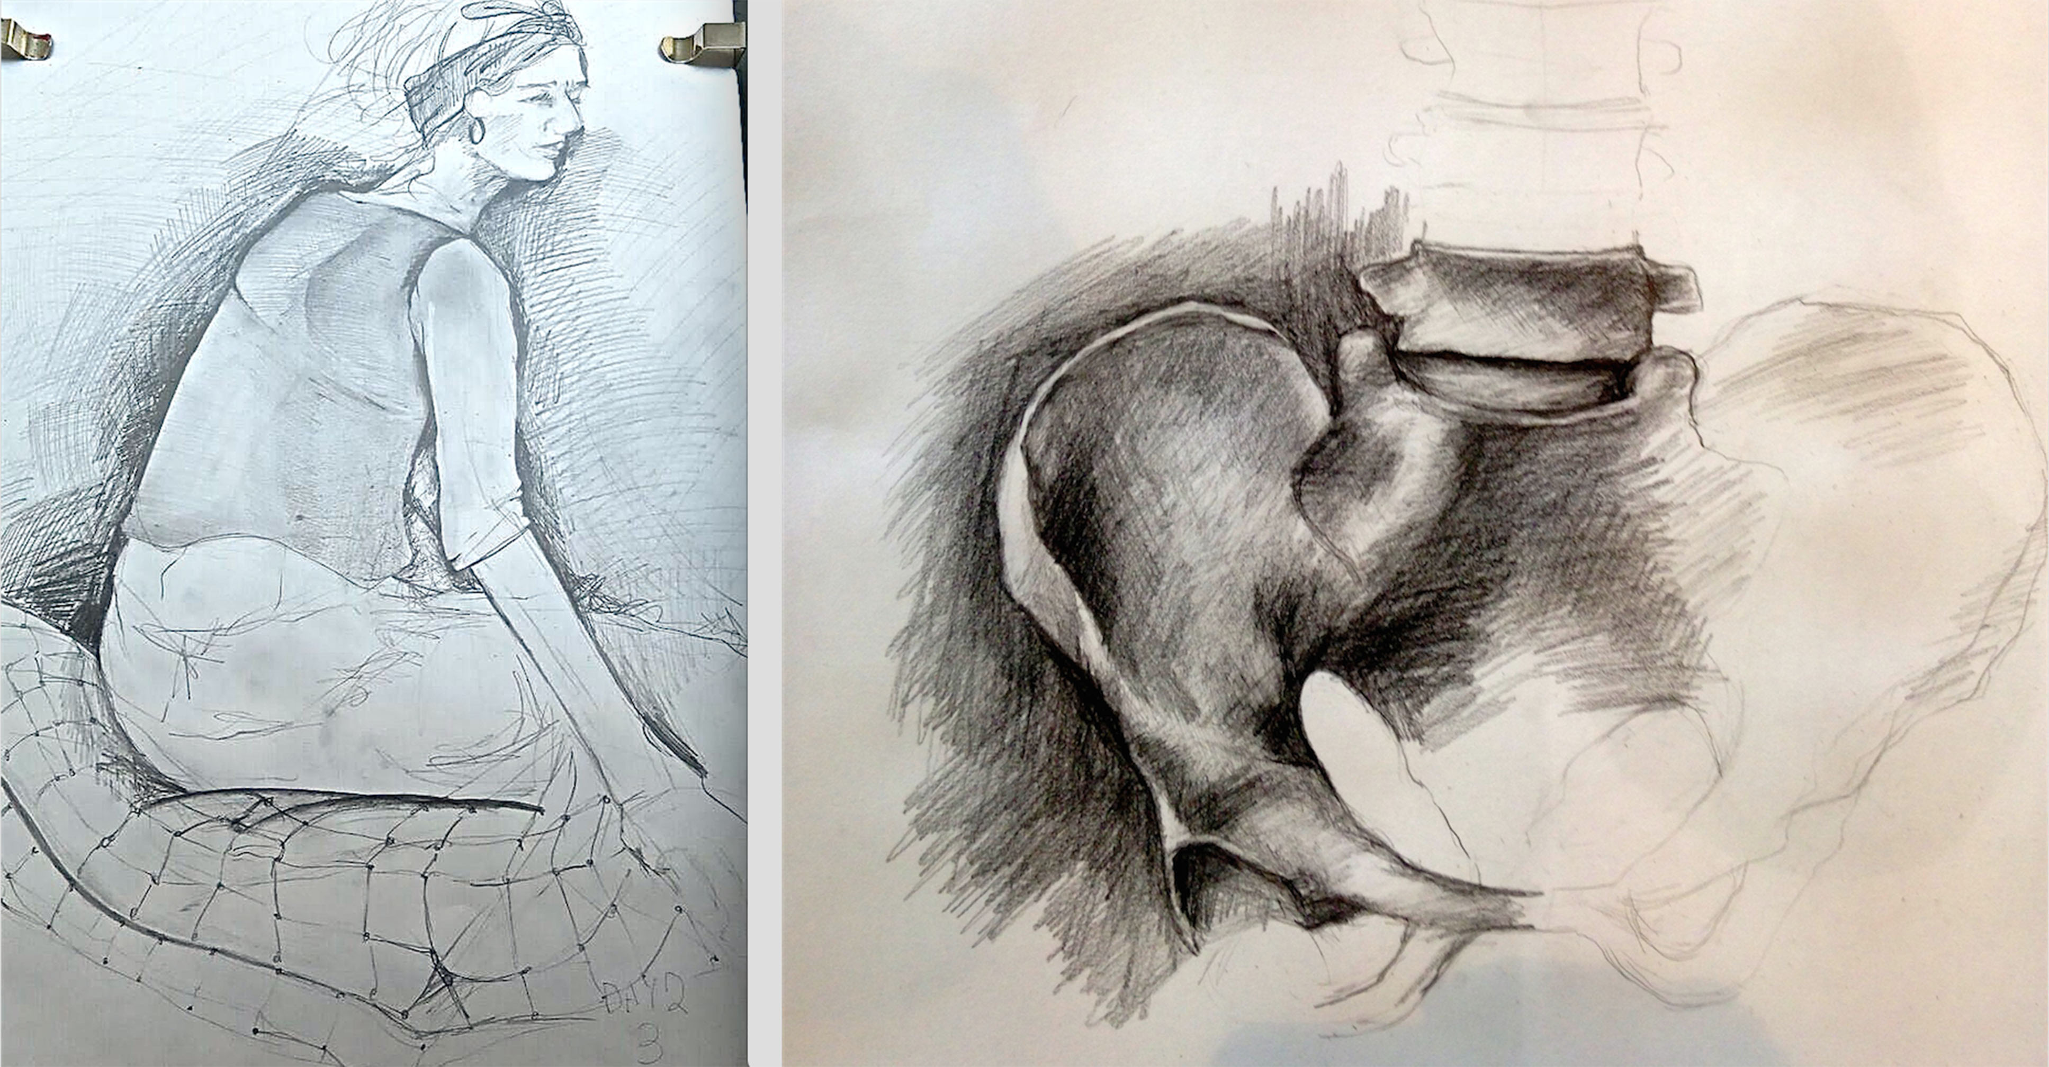

Figure 4 (L):Student F (dyslexic) Day 2 Drawing 3. (R):Student G (non-dyslexic) January 2016 follow-up workshop.

**Conclusions**

Analysis of the Likert Scale questionnaire administered before and after the workshops indicates a positive shift in students’ attitudes over the period of the workshops towards the awareness and understanding of the fundamental concepts and strategies covered. (Table 1) This correlates with an increase in confidence towards the construction of drawings. There appears to be similar positive shifts in both dyslexic/dyspraxic students and non-statemented students: this could be construed as evidence of the teaching strategies’ potential to address the issue of inclusivity within the pedagogy of the art school.

|  |  |  |  |  |
| --- | --- | --- | --- | --- |
|  | Dyslexic/dyspraxic students | | Non-dyslexic/dyspraxic students | |
|  | Pre- workshop | Post- workshop | Pre- workshop | Post-workshop |
| Seeing ‘Negative Spaces’ is easy | 5.00 | 5.63 | 4.60 | 5.60 |
| Seeing ‘Contrast Boundaries’ is easy | 3.00 | 4.13 | 2.00 | 3.80 |
| Controlling Proportion is easy | 2.88 | 3.50 | 4.00 | 5.00 |
| Judging Length and Angle is easy | 4.25 | 5.13 | 2.80 | 4.80 |
| Fitting drawings into the sheet is easy | 2.38 | 4.38 | 4.20 | 5.60 |
| I am aware of ‘Main Axes’ of the drawing sheet | 3.13 | 5.63 | 3.40 | 5.60 |
| I understand the ‘Invisible Grid’ connecting salient points in the scene | 3.00 | 6.00 | 3.20 | 5.40 |
| I understand ‘Primary’ and ‘Secondary’ geometries | 2.38 | 5.88 | 3.20 | 6.20 |
|  |  |  |  |  |

Table 1: Mean group responses on each questionnaire item pre- and post-workshop. Items are

rated on a scale from ‘Strongly Disagree’ (rated as 1) to ‘Strongly Agree (rated as 7).

These results correlate closely with the results of an earlier experimental workshop held at the RCA in July 2012.

Table 2: Mean change in response for each group pre- and post-workshop across the eight questionnaire items.

Having established that both dyslexic/dyspraxic students and non-dyslexic students indicate positive attitude shifts towards the key concepts and strategies related to the accurate construction of drawing and the related indications of an increase in confidence towards the application of those concepts and strategies, (Table 1), we would like to extend the research (by increasing the size of the student cohorts) to explore any indications of qualitative differences between the two cohorts’ drawings. For example, Table 2 indicates that the dyslexic/dyspraxic students are more confident than the control cohort on those items dealing with relationships involving the overall pattern of the drawing within its sheet, whilst the control cohort appears to do better on the items dealing with individual details within the drawing: individual shape, length, angle and contrast boundary. Research is underway to find out more about the possible correlation between global processing skills and dyslexia.

It would appear from a close observation of the limited number of drawings produced in the four days of workshops (three in October 2015, one in January 2016) that the drawings of both cohorts display improvements in terms of the application of the concepts and strategies employed in the workshops. As an example, Figure 5 represents late-workshop drawings by a dyslexic/dyspraxic student (L), and a non-dyslexic student (R). It is accepted that a more in-depth comparison is required before a more authoritative conclusion can be posited.

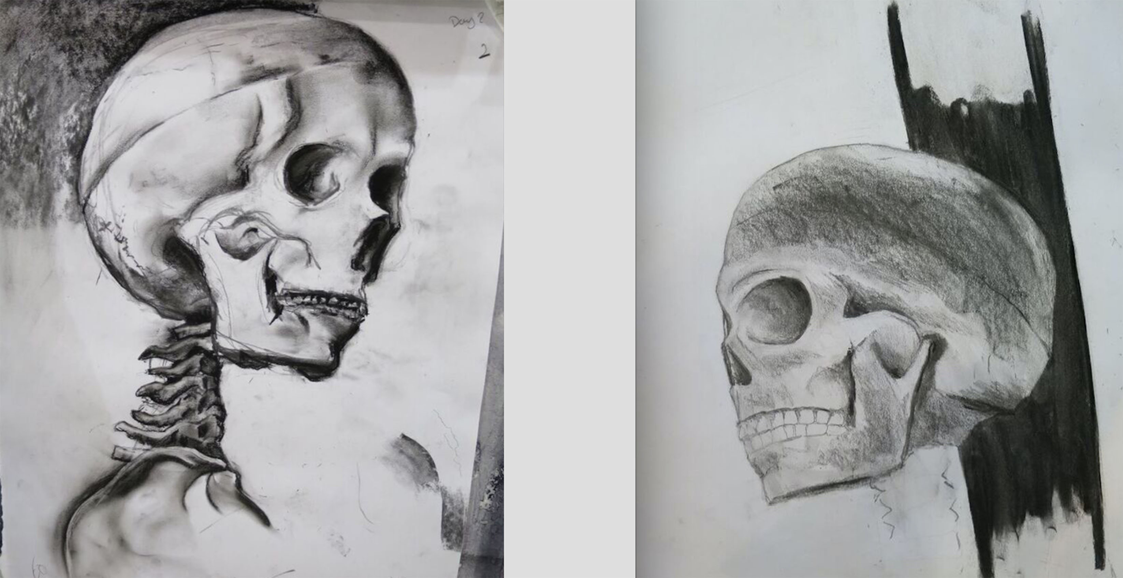

Figure 5 (L):Student H (dyslexic/dyspraxic). (R):Student J (non-dyslexic).

Further analysis also needs to be carried out in order to assess if the recorded student comments changed throughout the workshops, but first impressions suggest that the language became more about what the participants were seeing, and less about their preconceptions.. The use of video interaction analysis will enable a deeper understanding of behavioural traits, which will hopefully reveal new evidence useful to professionals in the field. However, observing the behaviour as it unfolded in time, informed the insight that led to the questions: are there behaviours that encourage accurate drawing? How can we use this information to augment the efficacy of the teaching strategies described in this article in order to help students improve their drawing ability so that they no longer feel professionally disadvantaged?

At the *10th International Conference of the British Dyslexia Association* held in Oxford, March 2016, it was clear that the profile of dyslexia is dynamic and the more we discover the less helpful very specific definitions seem. We would agree that there needs to be a menu of interventions that can be matched to individual children’s needs and we would like our drawing strategy to be included in this. Tom Nicholson (2016) showed a Venn diagram of co-occurrences of areas of deficit; namely vocabulary, reading and maths. It is tempting to include *drawing* in his Venn diagram:

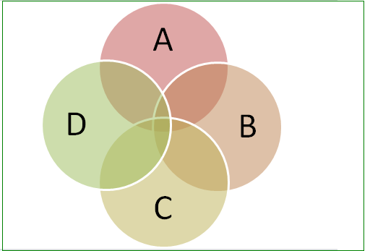

A Vocabulary

B Reading

C maths

D drawing

We have shown that our interventions have achieved successful outcomes in the series of RCA drawing workshops, and we also believe that they could dramatically help some early secondary school children with a profile of learning difficulties, to improve their learning experiences and outcomes at school. This is research yet to be undertaken.

**Endnote**

1In the early 1970s with the emergence of cognitive psychology, a strong emphasis was placed on the reading process of dyslexic students, and there was recognition for the important role that direct instruction played. Following on from this, there was considerable research into teacher-directed comprehension strategies. In 1986 Sherrie Nist and Kate Kirby developed a generic teaching strategy where the instructor guides the learner through an eight-step process. Nist and Mealey (1991) provided a review of the efficacy of direct instruction strategies, but also acknowledged the role metacognition had to play. Thus without the abilities to detect errors, to separate important from unimportant information, and the individual’s ability to self-regulate their actions during reading, these strategies would fail. The metacognitive component also enabled the student to build up confidence and so continue with the task once direct instruction had been withdrawn. Today the eight-step process is often quoted within good practice guidelines and remedial programmes for supporting dyslexic children (Mortimore 2003) where an exceptionally structured, explicit, systematic and comprehensive approach is needed. It seemed entirely appropriate to the present authors to adapt this eight-step process for the purposes of teaching drawing from observation to students with dyslexia.

**References**

BIEDERMAN, I. (1987), ‘Recognition-by-Components: A Theory of Human Image

Understanding’. *Psychological Review* 94 (2): pp115-147.

CHAMBERLAIN, R., MCMANUS, I. C., BRUNSWICK, N., RANKIN, Q. & RILEY, H.

(2015), 'Scratching the Surface: Learning Styles, Training and the Acquisition of High-level

Representational Drawing Ability'. *Psychology of Aesthetics, Creativity and the Arts.* Advance

online publication. http://dx.doi.org/10.1037/aca0000011

DU PRE, L., GILROY, D. and MILES, T. (2008), *Dyslexia at College.* 3rd ed.London:

Routledge.

FAWCETT, A.J. (ed.) (2001),  *Dyslexia: Theory & Good Practice*. Vol.6. London: Wiley.

FAYENA-TAWIL, F., KOZBELT, A. and SITARIS, L. (2011), 'Think Global, Act Local: A

Protocol Analysis Comparison of Artists' and Nonartists' Cognitions, Metacognitions, and

Evaluations While Drawing'. *Psychology of Aesthetics, Creativity, and the Arts.* 5 (2): pp135-145.

FLEMING, J. and KLEINHENZ, E. (2007), *Towards a Moving School: Developing a*

*Professional Learning and Performance Culture.* Melbourne: ACER Press.

FRITH, U. (2002), *Understanding Dyslexia.* Milton Keynes: Open University.

GRANT, D. (2010), *That's the Way I Think: Dyslexia, Dyspraxia and ADHD Explained.*

Abingdon: Routledge.

KIRBY, A. (1999), *Dyspraxia. The Hidden Handicap.* London: Souvenir Press.

LEDGARD, C. (Producer) (2015), *The Art of Walking into Doors*. BBC Radio 4 broadcast 28

September 2015. Accessible at: bbc.in/KujXPD

NICHOLSON, T. (2016), 'Phonological Awareness and Reading Difficulties'*.* Keynote address

at the *10th International Conference of the British Dyslexia Association.* Oxford, March 2016.

Proceedings forthcoming.

NICOLSON, R.I. and FAWCETT, A.J. (1990), 'Automaticity: A New Framework for Dyslexia

Research?', *Cognition. 35(2): pp159-182.*

NIST, S.L., and KIRBY, K. (1986), 'Teaching Comprehension and Study Strategies through Modeling and Thinking Aloud'. *Reading Research and Instruction.* 25 (4): pp254-264.

NIST, S. L. and MEALEY, D. L. **(**1991), ‘Teacher Directed Comprehension Strategies’. In *Teaching Reading and Study Strategies at the College Level* edited by Flippo, R. F. & Caverly, D. C. Newark DE: International Reading Association. pp42-85.

MCMANUS, I. C., CHAMBERLAIN, R., LOO, P.-W., RANKIN, Q., RILEY, H. &

BRUNSWICK, N. (2010), ‘Art Students Who Cannot Draw: Exploring the Relations

Between Drawing Ability, Visual Memory, Accuracy of Copying and Dyslexia’. *Psychology of*

*Aesthetics, Creativity and the Arts,* 4(1): pp18-30.

MORTIMORE, T. (2003), *Dyslexia and Learning Style. A Practitioner’s Handbook*. London:

Whurr.

OSTROFSKY, J. and KOZBELT, A. (2012), ‘A Multi-Stage Attention Hypothesis of Drawing Ability’. In *Thinking Through Drawing: Practice into Knowledge* edited byKantrowitz, A., Brew, A. and Fava, M. New York: Columbia University. pp61-66.

RANKIN, Q., RILEY, H. and DAVIES, M. (2007), ‘Including Dyslexics: Indicators of Dyslexia in Art Students' Drawings’. *Proceedings of the Include 07 Conference.* London: Royal College of Art.

RANKIN, Q., RILEY, H., CHAMBERLAIN, R., McMANUS, C. and BRUNSWICK, N. (2012), ‘Learning to Perceive: Informing Pedagogical Practice through the Empirical Study of Drawing’. *Tracey. The Online Journal of Drawing Research.* Available at: <http://www.lboro.ac.uk/microsites/sota/tracey/journal/thin/2014/rankin.html>

RILEY, H. (2008), ‘Drawing: towards an Intelligence of Seeing’, in Garner, S. (ed.) *Writing on Drawing*.Bristol/Chicago: Intellect/Univ. of Chicago. pp153-167.

SNOWLING, M. J. (2000), *Dyslexia.* 2nd ed. Oxford: Blackwell.

SNOWLING, M. J. (2016), ‘Development of Literacy in Children at High Risk of Dyslexia: Implications for Intervention’*.* Keynote address at the *10th International Conference of the British Dyslexia Association.* Oxford, March 2016.

1.