The Limited Scope of Sea Cargo Liability Regime:

New Political-Economic Environments in the 21st Century

Lijun Zhao*

Abstract
The scope of uniformity of seaborne cargo regimes under the UN’s conventional approach seems to be more extensive than is desirable. The new business pattern of shipping subsectors, the rising influence of developing countries, and containerisation, are creating new shipping environments. These environments show that imperfect competition is only found in parts of the shipping markets nowadays, unlike that in/under the conventional approach to uniformity. Thus, these new economic and political realities call for innovative modifications to the conventional approach and a refocusing of international uniformity towards a limited degree of restriction [limited number of restrictions] of freedom of contract in legal shipping regimes.

Introduction
The international shipping market was unified before 1870. Since 1870, the unified shipping market has broken up into two important sub-sectors, liner and tramp shipping, gradually adapting to the two main types of needs in cargo flows. Cargo liners operate on regular scheduled services; they are versatile, multi-deck vessels with installed cargo-handling cranes or gear, carrying mostly finished or semi-finished manufactured goods, often accompanied by refrigerated products, together with some bulk cargo. The tramp/bulk sector primarily handles two categories of bulk cargoes: dry bulk cargoes (e.g. ore, bauxite, coal, phosphates, and grain) by tramp vessels, and wet bulk cargo (e.g. oil or oil products) by specialised vessels. In the subsequent century up to the 1970s, liner and tramp shipping continued to be run more or less on the same pattern, and thus many vessels were interchangeable between liner and bulk sectors.

The significant transformation in international shipping markets over the past 50 years

II.A Interchangeability between Liners and Tramp Vessels before the 1940s
The distinction between cargo needs and shipping patterns among the two sectors between the 1870s and the 1970s can be further divided into two sub-periods. Besides the general effects of globalisation on the two sub-sectors, the markets for both sectors reflect their own specific characteristics (e.g. entry and exit of carrier companies, and the information between carriers and the cargo interests). They function as the market place both for ship owners seeking cargo spaces to fulfil transport services and assignments, and for the cargo interests, as well as new entrant carriers when they decide to enter the shipping market. These players’ activities increased the liquidity of the oceanborne transport service markets, and thus they ensured better allocation of vessels (cargo spaces) to different routes, among shipowners or liner conferences, servicing international seaborne trade (See Figures 1 and 2).
During the first sub-period, from the 1870s to the 1940s (see Figure 1), tramps and liners were similar in size and specification, and their roles were often interchangeable. Cargoes carried by liner and tramp shipping were not always absolutely defined: liner ships could carry tramp cargoes, and vice versa. However, although these two sectors could substitute for each other, their main structures were diametrically different: oligopoly and protectionism within the liner sector (e.g. liner conferences from the 1870s to the 1970s), and virtually perfect competition in the tramp sector. The Hague Rules (1924) originated from this period, in which the tramps and liners were interchangeable substitutes. Thus, these Rules did not give proper consideration to the unprecedented changes after the 1940s.

Figure 1: Shipping Markets during the 1870s-1940s (The Interchangeability between the liner and bulk sectors)
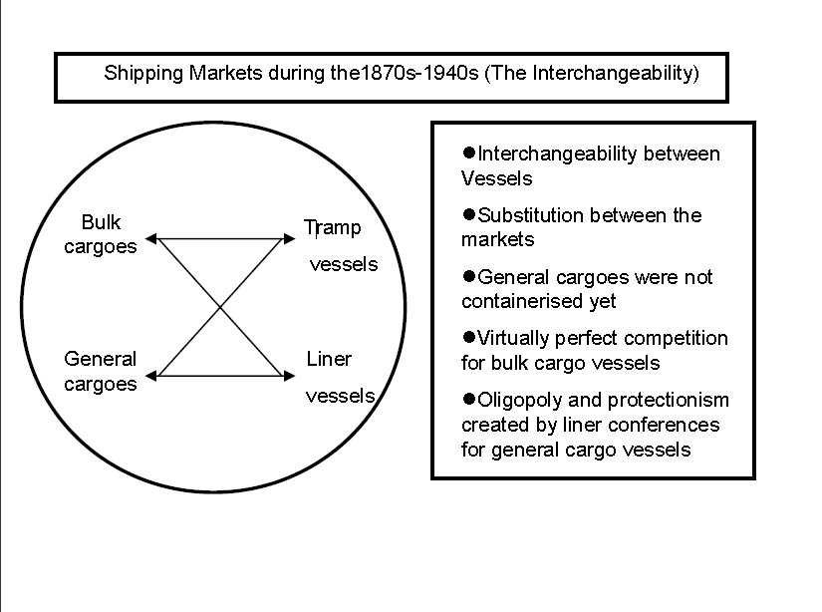
Figure drawn up by the author.

II.B. Transformation: the clear division (non-interchangeability) between liners and tramps after the 1940s
The second sub-period which the international shipping markets experienced was from the 1940s to the 1970s (see Figure 2). The 1970s was another period of revolutionary developments for the liner industry. Introduced in the 1960s, containers became widely used in the 1970s, as a means of unitisation of cargoes, and they revolutionised the transport system for industrial goods.

Figure 2: Shipping Markets during the 1940s-1970s
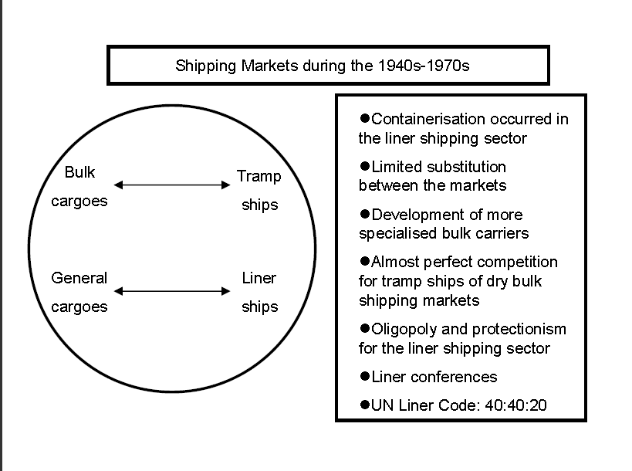
Figure drawn up by the author.
Unlike the structure of the shipping market in the first sub-period, liners and tramps have become clearly divided since the 1940s. The unprecedented increase in world production and international trade after World War II led to a gradual decrease in substitution between these two sectors. In bulk/tramp shipping, both the categories and the volume of cargoes were unprecedented. Wet/liquid bulk cargoes (oil and oil-made products) were introduced on a massive scale into the bulk cargo market, and huge tankers were built. Dry bulk cargoes nurtured specialised bulk cargo markets (e.g. coal, ore of bauxite and phosphates, fertilisers, and grain), and specialised ships were constructed to carry these bulk cargoes. On the other hand, in liner shipping, although liner conferences faced increased competition (e.g. from developing and socialist countries), their anti-competitive markets continued to develop along the same pattern of oligopoly as before World War II.

Increasing containerisation and transformation of pattern of business of shipping companies

III.A. Increasing containerisation
Containerisation significantly boosted the further development of liner carriers. According to UNCTAD (see Figure 3), goods have been increasingly carried within containers since the 1970s. First, it has made different goods more homogenous owing to the same packaging in containers. Second, containerisation has speeded up the time for loading and uploading, which has made regular scheduled services of liners possible. Unfortunately, the importance of containerisation had been considered neither by the Hague Rules (1924), nor the Visby Rules (1968). Although the Hamburg Rules (1978) were concluded after this change, these Rules were not widely ratified.

Figure 3: International Seaborne Trade for Selected Decades (tonnes and percentage of tonnage)
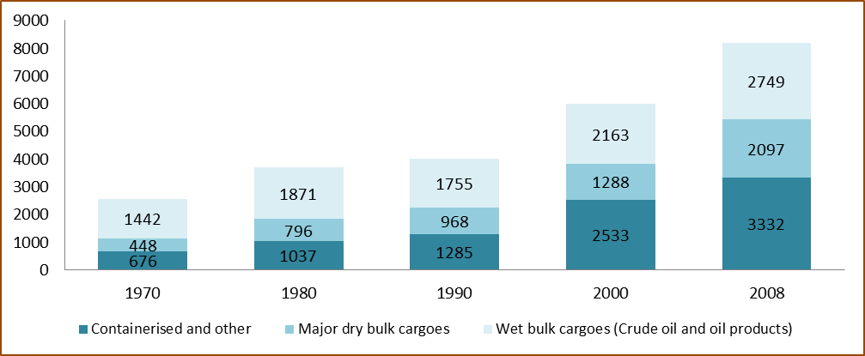
Figure drawn up by the author.

Contained and other cargoes (break bulk) were calculated as one category statistically in the UNCTAD sources cited, so the author cannot identify the accurate percentages of the containerised cargoes. However, according to the author’s conversation with Richard Scott who practices shipping business for over 30 years, the percentage of containerised cargoes within this category is increasing decade by decade, compared with the decreasing percentage of break bulk. In short, now containerised cargoes account for a substantial percentage in the liner shipping sector.

II.B. Clear different business patterns of shipping companies: liners and tramps
Containerisation also boosted new designs of vessels and cargo-handling infrastructure, global door-to-door transport (i.e. multimodal transport), early use of information technology, and structural changes in shipping markets. In order to meet customers’ needs to operate worldwide, containerisation and liner companies’ concentration led to a fundamental transformation of liner shipping companies into the archetype of a globalised transnational shipping company.
In order to meet the new needs created by containerisation, liner companies started to establish their global logistics networks from the 1970s onwards. Their worldwide coverage was achieved through the formation of alliances and transnational megamergers. On the one hand, the formation of global alliances or mergers fulfilled the aim of geographical worldwide coverage. For instance, as previously mentioned, the Grand Alliance had as its members Hapag-Lloyd, NYK, NOL, and P&O in 1995; later, MISC entered this Alliance while NOL left to enter the New World Alliance; recently MISC withdrew and the Grand Alliance now consists of Hapag-Lloyd (Germany, 5th), NYK (Japan, 12th), and OOCL (HK, 11th) (See Appendix: Table on Top 20 Liner Shipping Companies).
On the other hand, large liner shipping companies built their global networks by transnational concentration. For instance, as mentioned above, the three major mergers and acquisitions in the 1990s were: P&O (UK) with Nedlloyd (Netherlands), Maersk (Denmark) with Sea Land (US), and Neptune Orient Line (Singapore) with American President Lines (US). Consequently, the enlargement of these liner companies and their alliances nurtured strategic alliances; their relationships evolved from past competitors towards a number of new forms of cooperation (alliances/consortia and international megamergers) in the globalisation era.
By using these two methods of cooperation (alliances and transnational megamergers), a number of large liner shipping companies now have global networks and can provide global services for their clients through overseas hubs and transnational networks. These large liner companies handle the global services, but small liner companies deal with the regional network. Consequently, the relationship between the large and small liner companies is not one of absolute competition but complementation (cooperation).
Figure 4: Globalised Liner Market (1970 - )
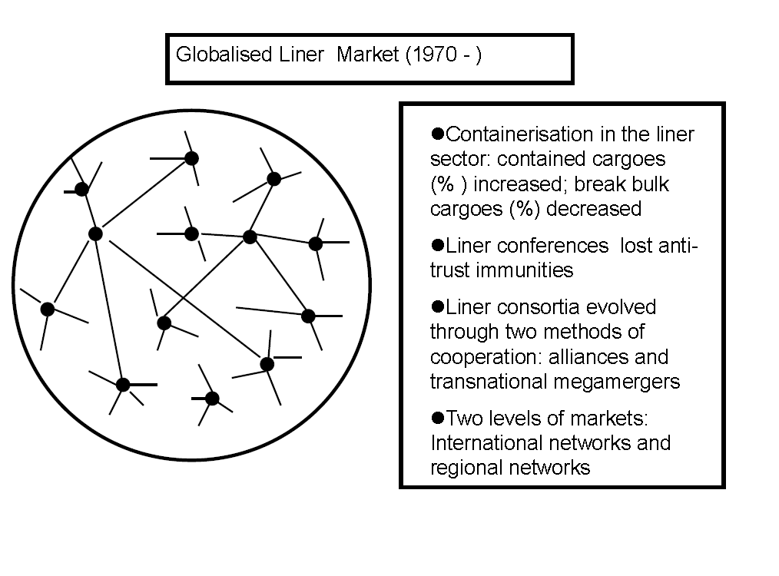
Figure drawn up by the author.
In contrast, tramp shipping did not experience such a large degree of innovative technical developments as the liner sector, and no significant transformation occurred in the structure of markets or the organisation of tramp companies. Although specialised vessels, such as tankers have been built for the tramp shipping (see Table 4), the general pattern of tramp companies has not changed significantly over the past one hundred years. The size of many tramp companies has not changed much. For instance, a tramp company may own either a number of tramps or a single vessel. However, some companies have become significantly larger. Secondly, the relationship of tramp members within the same network is competition on the basis of cost, unlike the cooperation within the liner sector.
Globalised tramp/bulk shipping today operates to a much less globalised extent than the liner sector. Globalised bulk shipping is based on national networks, including trust, and common national or family cultures. Tramp companies establish multinational networks on the basis of the common national cultures of traditional maritime countries, such as the UK, Greece, Norway, and Japan (see Figure 5).
Unlike cooperation by liner companies, tramps compete with one another even as members of the same network. Regardless of the size of tramp companies, their organisation, structure and strategies are similar, and they compete on the basis of cost. Hence, liners run at both regional and global levels, but tramps are almost always run at regional levels. Therefore, global uniform rules on seaborne cargo regime should focus mainly on the globalised liner business rather than regional-based tramps.

Figure 5: Globalised Bulk Shipping - Sum of National Networks
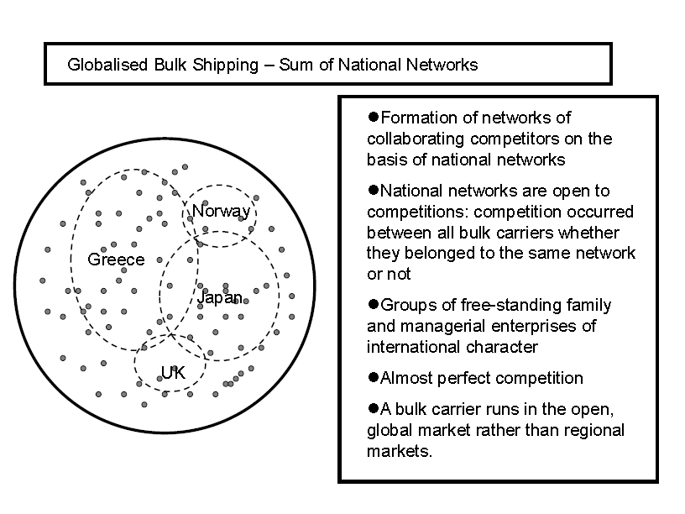
Figure drawn up by the author.

Abolition of anti-competition exemption following the 1970s: increasingly competitive markets for doth tramps and liners
Traditionally, the whole shipping sector was immune from competition law.But the US Ocean Shipping Reform Act (OSRA) 1998 challenged the special treatment of liner conferences under American antitrust law, significantly diminishing the capacity of conferences to regulate their members. Ten years later, in October 2008, EC regulation 4056/86, which guaranteed conferences being exempt from EU competition law, was abolished.
Before October 2006 tramp shipping and cabotage were exempted from the legal regime established to implement the “Treaty on the Functioning of the European Union” (TFEU) Articles 101, 102 and 104 (previously numbered as EC Treaty Articles 81, 82 and 84); international liner conferences were historically immune from antitrust law.
The picture of regulations for international shipping is much more perplexing than that of other modes of transport. Since 1974, the UN “Convention on a Code of Conduct for Liner Conferences” (Liner Code) has granted antitrust exemptions to liner conferences. In 1979, EC Regulation 954/79 supported the EC Member States in ratifying the UN Liner Code. Finally the EC antitrust regime for international shipping provided Regulation 4056/86, which was consistent with the UN Liner Code, prescribed a special antitrust regime for liner shipping and established a block exemption for liner conferences (e.g. price-fixing cartels) without time limitation.
In 2006, the EC implemented a different maritime policy by reconsideration of the application of competition rules to shipping, again through the enactment of EU Regulation 1419/2006. Since October 2006, tramp shipping and cabotage have been covered by EU Regulation 1/2003, subject to competition rules under TFEU Article 101 and 102 (former Articles 81 and 82 of the EC Treaty); on 18 October 2008, the exemptions of liner conferences were abolished through EU Regulation 1490/2007. Thereafter, all joint price fixing activity for services to or from the EU has been illegal. Whereas elsewhere liner conferences are authorised under limited, increasingly strict, anti-competitive exemptions, the EU is the only jurisdiction, until now, in which liner conferences have been prohibited.
These waves of abolition of monopolistic exemptions made the tramp and liner sectors differ further from their counterparts at the times of the Hague Rules (1924), Visby Rules (1968, and 1979), and Hamburg Rules (1978). The shipping markets are evolving toward more competitiveness, and thus the scope of uniformity should be smaller, rather than larger as under the Rotterdam Rules (2008).

Rising influences of non-traditional maritime countries in world shipping markets with political implications
As seen in UNCTAD data, a significant number of vessels are registered in countries with an open registry policy, such as Panama and Liberia. On the basis of the true nationality of vessels, a fleet recorded as being owned and controlled (beneficially owned) by a particular country is comprised of ships owned by companies or individuals which are, or who are, nationals of that country. These could be state-owned in some countries, or they could be privately owned: both forms of ownership are included. In many new trading and developing countries, ship-owners are inclined to register their ship in their home countries. For example, the largest nationally controlled merchant fleets which are also registered under the national flags include oil tankers from Kuwait, Brazil, India and Thailand, dry bulk cargoes carriers from Hong Kong (China), India, Thailand, Turkey, Vietnam and the Republic of Korea, and general cargo ships from Indonesia, Russia, and Thailand. However, there is a precipitous decline reflected in the shipping fleets registered in developed countries, most of which also fall within the traditional maritime powers category. Hoffmann argues that nowadays four out of every five merchant ships are registered either under an open registry flag or in a developing country, and ship-owners from developed countries are more likely to choose a foreign flag than those from countries with a lower GDP per capita. Alternatively, some ship-owners chose second registers of traditional maritime countries.

Table 1: The Largest Fleets of the 20th Century (Fleets in Millions of Gross Registered Tonnage)
Country/Territory | 1914 |  | 1937 |  | 1963 |  | 1992 |  | 2008
 | grt | % | grt | % | grt | % | grt | % | grt | %
Great Britain (UK) | 21.0 | 43% | 20.6 | 31% | 21.6 | 15% | 23.6 | 3.4% | 26.0 | 2.5%
Germany | 5.5 | 11% | 3.9 | 6% | 5.0 |  | 16.9 | 2.4% | 94.2 | 9.1%
USA | 5.4 | 11% | 12.4 | 18% | 23.1 | 16% | 59.1 | 8.5% | 39.8 | 3.8%
Norway | 2.5 | 5% | 4.3 | 6% | 13.7 | 9% | 54.1 | 7.8% | 46.9 | 4.5%
France | 2.3 | 5% | 2.8 | 4% |  | 4% | 7.0 | 1.0% | 6.5 | 0.6%
Japan | 1.7 | 4% | 4.5 | 7% |  | 7% | 90.2 | 12.3% | 161.7 | 15.6%
Italy | 1.7 | 3% | 3.2 | 5% | 5.6 | 4% | 11.7 | 1.7% | 17.7 | 1.7%
Netherlands(Holland) | 1.5 | 3% | 2.6 | 4% | 5.2 | 4% |  |  | 8.6 | 0.8%
Sweden | 1.1 | 2% | 1.5 | 2% | 4.2 |  | 12.2 | 0.3% | 6.9 | 0.7%
Russia (USSR) | 1.0 | 2% | 1.3 | 2% | 5.4 | 4% | 19.2 | 2.8% | 18.0 | 1.7%
Spain | 0.9 | 2% | 1.0 | 1% | 2.0 |  | 5.1 | 0.7% | 4.5 | 0.4%
Greece | 0.8 | 2% | 1.9 | 3% | 15.0 | 10% | 100.6 | 14.5% | 174.6 | 16.8%
Hong Kong |  |  | 0.3 |  | 0.8 |  | 31.6 | 4.5% | 33.4 | 3.2%
China |  |  | 0.6 |  | 0.5 |  | 27.5 | 3.9% | 84.9 | 8.2%
Republic of Korea |  |  |  |  | 0.1 |  | 18.2 | 2.6% | 37.7 | 3.6%
Above-listed total | 45.4 | 93% | 60.9 | 89% | 102.2 | 73% | 477.0 | 66.4% | 761.4 | 73.2%
World total | 49.1 | 100% | 66.7 | 100% | 145.9 | 100% | 718.4 | 100% | 1040.164 | 100%
1. “grt” = “Gross Registered Tonnage”.
2. 1992 and 2008 data include real ownership (or in control) including all registered flags. Data for 2008 include ships of 1000 grt and above.
3. The flag of convenience (open registry) was not widely used before the 1960s, and thus the data for 1914 and 1937 does not take into consideration registered tonnage under foreign flags.

At the macro level (countries), up to the 1960s the main carriers of the world fleet remained the same with Great Britain and the US (which held a decreasing share in world shipping in the following decades), followed by the continual rise of Greece, Norway and Japan (see Table 5, 1963 columns). Flags of convenience (open registry) enabled the ship-owners of traditional maritime countries to maintain control of their fleets while benefiting from low-cost labour of open registered countries; after the 1980s, flags of convenience were extensively used by all western and eastern maritime countries.
The 1970s marked a new era, in which the European maritime countries (except Greece) lost their final pre-dominance in international shipping. In the 1990s and 2000s, Greece ranked in the first position, and Japan has remained steadily in the second position (Table 5, 1992 and 2008 columns). In the 1990s, the rise of new maritime territories from Asia was evident; in the 1990s and 2000s, China, Taiwan (China), Hong Kong (China), and the Republic of Korea became noticeable competitors to their European counterparts (see Table 5 and its 1992 columns, and Tables on top liner and bulk carriers including Asian carrier companies in the Appendix).
At the micro level (carrier companies), the trend towards transnational concentration also resulted in a major reshuffle in the ranking of the leading ocean shipping liner companies and the increasing size of vessels. For example, P&O Nedlloyd (3rd in 1997, UK/Netherlands), Sea Land (4th 1997, US), CP Ships (16th in 1997, Canada) and American President Line (18th in 1997, US) have been overtaken by their competitors and disappeared from the 2009 rankings; Cho Yang (20th in 1997, the Republic of Korea) went bankrupt and also disappeared from the rankings.

Figure 6: Traditional Maritime Powers and Their Maritime Levels of Engagement on 1 January 2009
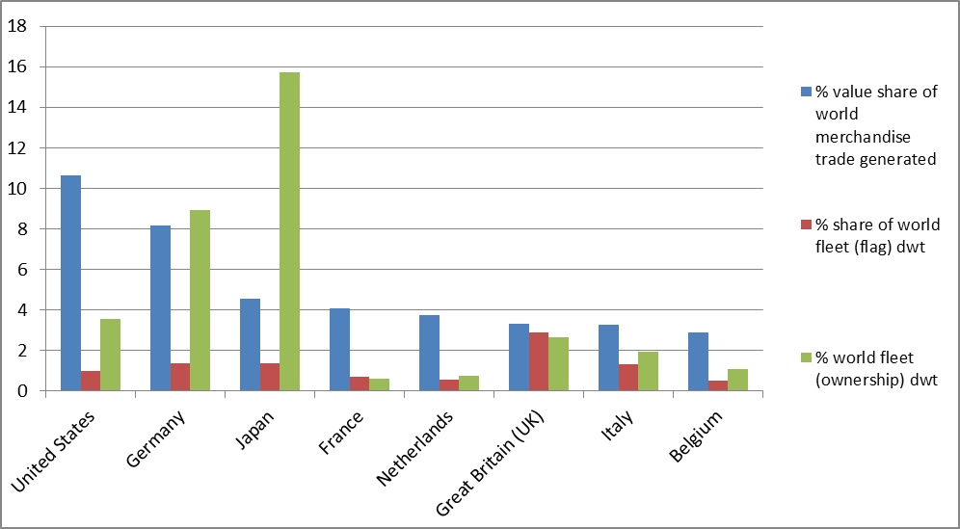
Figure dawn by the author; dwt = deadweight tonnage.

Figure 6 illustrates the maritime levels of engagement of traditional maritime nations on 1 January 2009. It is seen that all the traditional maritime powers, except Germany and Japan, have a greater share of world trade in value than their percentage share of world fleet in deadweight (Figure 6). Compared with the rankings in 2008, those of UK and Italy are reversed.
In the negotiating decades of the Hague Rules, developed countries were more or less only representing the carriers’ interests. However, nowadays some developed countries, such as the US and Germany, represent the cargo interests as well as the carriers’ interests. As Mendelsohn points out, it is shipper interests alone that have effectively prevented the ratification of the Visby Rules in the US, since the ratification of the Visby Rules would ultimately delay the ratification of the Hamburg Rules, favoured by the cargo interests.

Figure 7 : Maritime Levels of Engagement of Newly-emerging Trade Countries and Territories on 1 January 2009
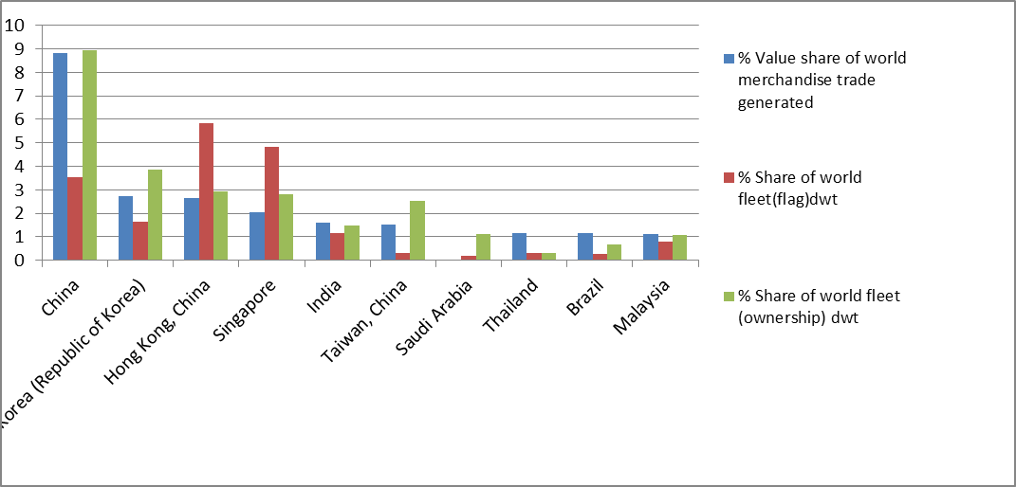 1. “Dwt” = deadweight tonnage.
2. “The country of ownership indicates where the true controlling interest (that is the parent company) of the fleet is located. In several cases, determining this has required several judgements [...]”
Chart drawn by the author.

However, Figure 7 indicates a contrary trend of development for the newly-emerging trading nations: the majority of the ranked territories possess a higher percentage of owned fleets than their share of value in international commerce, and the only exceptions to the trend are India (which is 5th, and not far from the general principle with a slightly lower percentage of fleet ownership than that of trade) and the last three ranked territories, Thailand, Brazil and Malaysia.
In short, the commercial reality in world shipping today is markedly different from the times when the Hague and Hamburg Rules were negotiated. First, there is a significantly increasing number of shipping powers, mainly among the newly-emerged and developed non-European countries (e.g. Japan, the US, the Republic of Korea, and China), but meanwhile it seems that the influence of traditional European shipping countries such as UK has shrunk (see Table 5 above for the decreasing percentage of world fleet ownership). Secondly, the balance of power has clearly swung from the hull-dominated market to the cargo interests. The traditional maritime powers such as Great Britain have lost their supremacy in the shipping sector (see Table 5). Meanwhile, cargo interests have become more developed than they were in the 1920s, for example in the US, and China (see Figure 6, Table 1 and Appendix).
- Conclusion
Government regulations in shipping have a long history (e.g. the US Harter Act of 1893), and they seem to expand their scope of application on uniform seaborne cargo rules. However, a rational set of uniform regimes of sea carriage rules in the future should adjust to the changing business pattern of shipping companies, legal competition policies and today’s new politically influential countries in shipping. Thus, this article looked at the new shipping realities from two perspectives.
Firstly, from the micro-level perspective (shipping sectors and companies), three fundamental transformations in the past 50 years differ from what happened at the time of the Hague-Visby Rules negotiations. In terms of shipping companies, vessels had inter-changeability between liner and bulk sectors during the Hague-Visby period. However, tramps and liners reduced their inter-changeability after the 1940s, and then they were clearly divided. Tramps and liners now carry different types of cargoes, and have different scales of business. The liner shipping companies have both global and local logistical networks. They also work as alliances (or consortia) or transnational megamergers, with both cooperative and competitive motives among individual liners. The scale of many, but not all, tramp companies remains similar to those of the Hague-Visby times: regional networks and non-cooperation between tramps. Therefore, the uniform international sea regime should be limited in scope, focusing on globalised liner shipping realities rather than being further extended.
The reasons for this transformation in international shipping markets are the increasing containerisation and the abolition of anti-competition exemptions for shipping companies after the 1970s. These changes have made the shipping market more globalised and more competitive, which is different from what happened at the time of the previous conventions. On the one hand, globalisation calls for uniform rules of sea carriage. On the other hand, abolition of anti-competition immunity of tramp and liner companies after the 1970s induced more competition than at the time of the Hague, Visby and Hamburg Rules. Competition in the shipping markets will bring about adjustment to freight rates and benefit cargo interests, and the need for mandatory rules within the international sea cargo uniform regimes will be reduced to a certain extent. Therefore, the scope of uniformity should be reduced, rather than increased under the Rotterdam Rules.
Secondly, from the macro-perspective (countries or territories), the political balances in the next round of uniform sea carriage rules will also be significantly different from the previous conventions. Western countries lost their absolute authority when a global convention on uniform rules of sea cargo carriage was introduced. Today, the global “[c]argo geography does not exactly match carrier geography.”
In a potential, forthcoming round of negotiations on uniform sea carriage regimes, with reference to the different ratios between cargo and carriers and the generated volumes of international trade, the influential political and economic negotiators will be divided into three categories. The first group of countries or territories are those which generate and/or accept a large number of cargoes but do not own strong national-flag fleets or even control fleets proportional to the magnitude of their foreign trade (e.g. Canada, see Table 5). The second group are maritime powers without significant hinterlands which have historically developed a comparative advantage in international maritime transport (i.e. third-party shipments, namely carriers which are not the producing or recipient country). These play a significant role in this category of countries, and they became new members of the hull interest groups after World War II; the Hague-Visby regimes had not reflected their interests, and the new members of this category called for further amendments of current international uniform legal regimes for shipping. The third group lie between these two extremes mentioned above, and consist of numerous countries and territories which have a significant amount of international trade and also control fleets (or national-flag fleets) which are used not only for domestic trade, but also for overseas liner and bulk traffic (e.g. China and the US, see Appenxi). For cost reasons, controlled fleets may be registered under “open registries”, to use a euphemism, or “flags of convenience”, to use a more common, but pejorative term.
These three categories of countries will negotiate and bargain at the negotiating tables of the next uniform sea cargo regime. The political influence of these countries is now much greater than it was at the time when the western countries introduced the Hague and Visby Rules. Therefore, the conventional approach to uniformity should be modified to accommodate these newly-emerging countries or territories.

Appendix: Shipping countries and shipping companies

Table 2: Top 20 Liner Shipping Companies (1997-2009)

Table 3: Leading Bulk Cargo Shipping Lines (2007)

Table 4: Leading Bulk Cargo Shipping Lines (2007)
“LNG” = Liquefied Natural Gas.

Table 5: Countries/territories of Ownership

Table 6: Table: The 35 leading maritime countries and territories (1996-2008)

* Dr Lijun Zhao, Lecturer in Middlesex University School of Law, l.zhao@mdx.ac.uk; research interests: maritime and commercial law. An early draft of this article combined with economic justification for the unification of transport law has been accepted for presentation at the 2015 annual conference of the Society of Legal Scholars. I am indebted to Professor Dr. Wei Shi, Mr. Richard Scott, anonymous reviewers and the editorial board for their enlightening comments for this article. ? Gelina Harlaftis and Ioannis Theotokas, ‘Maritime Business during the Twentieth Century: Continuity and Change’ in Costas Th. Grammenos (ed), The Handbook of Maritime Economics and Business (2nd edn, Informa, 2010), 8.
Richard Scott , Greenwich Maritime Institute, ‘A Magnificent Transformation: World Shipping 50 Years Ago and Today’, 12 September2013.
Harlaftis and Theotokas, ‘Maritime Business during the Twentieth Century: Continuity and Change’ , 7-8.
Harlaftis and Theotokas, ‘Maritime Business during the Twentieth Century: Continuity and Change’ , 8-12.
Harlaftis and Theotokas, ‘Maritime Business during the Twentieth Century: Continuity and Change’ , 7-12. Cf. Richard Scott who has profound shipping practical experience points out some counterexamples contradicting Harlaftis and Theotokas’s theoretical models in his conversation with the Author.
Scott, ‘A Magnificent Transformation: World Shipping 50 Years Ago and Today’ .
See the previous section on “Liner Shipping Sector with Anti-competitive Practices”.
Harlaftis and Theotokas, ‘Maritime Business during the Twentieth Century: Continuity and Change’ , 8, 17-18, (stating that tramp shipping involves traditional maritime powers as carriers and economically powerful international companies, such as oil companies. Tramp shipping is under virtually perfect competition, for example Norwegian tramps. See details on tramps in e.g. Stig Tenold, Crisis? What Crisis?: the Expansion of Norwegian Shipping in the Interwar Period, 2005(illustrating that Norway as a traditional shipping power has become a major tramps shipping country since the 1920s and been subject to perfect competition).
Harlaftis and Theotokas, ‘Maritime Business during the Twentieth Century: Continuity and Change’ , 9. D. K. Ryoo and H. A. Thanopoulou, ‘Liner Alliances in the Globalization Era: a Strategic Tool for Asian Container Carriers’ (1999) 26 Maritime Policy & Management 349–367.
Harlaftis and Theotokas, ‘Maritime Business during the Twentieth Century: Continuity and Change’ , 7.
Harlaftis and Theotokas, ‘Maritime Business during the Twentieth Century: Continuity and Change’ , 9. Ryoo and Thanopoulou, ‘Liner Alliances in the Globalization Era: a Strategic Tool for Asian Container Carriers’ .
For more details on the substitution relationship of the liner with the tramp, refer to Basil N. Metaxas, The Economics of Tramp Shipping (2nd edn, Athlone Press ,1971), 111-116.
Harlaftis and Theotokas, ‘Maritime Business during the Twentieth Century: Continuity and Change’ , 8-12.
Marc Levinson, The Box: How the Shipping Container Made the World Smaller and the World Economy Bigger (Princeton University Press, 2010).
Harlaftis and Theotokas, ‘Maritime Business during the Twentieth Century: Continuity and Change’ , 8-12.
See data and chart of 2008 in Jan Hoffmann and Shashi Kumar, Chapter 2: ‘Globalisation - the Maritime Nexus’, in Costas Th. Grammenos (ed), The Handbook of Maritime Economics and Business (2nd edn, Informa 2010), 39.Source: Jan Hoffmann and Shashi Kumar, based on data from the UNCTAD Review of Maritime Transport (2009). See data and charts of 2008 in Jan Hoffmann and Shashi Kumar, Chapter 2: ‘Globalisation - the Maritime Nexus’, in Grammenos, The Handbook of Maritime Economics and Business , 39. Source: UNCTAD, Review of Maritime Transport (2009).
Containerised trade has become a significant factor in the international shipping industry, with an average annual growth rate of nearly ten per cent (global container trade was estimated at 137 million TEUs in the 1990s). UNCTAD, Review of Maritime Transport 2009, (UNCTAD, Geneva, 2009).
More details of analysis in Frank Broeze, The Globalisation of the Oceans, Containerisation from the 1950s to the Present (International Maritime Economic History Association, 2002), 160.
Harlaftis and Theotokas, ‘Maritime Business during the Twentieth Century: Continuity and Change’ , 8-12.
Broeze, The Globalisation of the Oceans, Containerisation from the 1950s to the Present .
The Grand Alliance, http://www.grandalliance.com/, accessed 23 September 2013.
WTO, S/C/W/315, 14, 16, paragraphs 36 and 43. Cf. before the 1980s, mergers and acquisitions mainly took place within national borders and remained confined to the liner sector, but hitherto the bulk sector is traditionally less heavily concentrated because it is frequently organized on the basis of one-ship companies.
Ryoo and Thanopoulou, ‘Liner Alliances in the Globalization Era: a Strategic Tool for Asian Container Carriers’ .
WTO Doc. S/C/W/315, 15, paragraph 39.
Harlaftis and Theotokas, ‘Maritime Business during the Twentieth Century: Continuity and Change’ , 11.
Harlaftis and Theotokas, ‘Maritime Business during the Twentieth Century: Continuity and Change’ , 10. Broeze, The Globalisation of the Oceans, Containerisation from the 1950s to the Present , 138-139.
Harlaftis and Theotokas, ‘Maritime Business during the Twentieth Century: Continuity and Change’ , 11.
WTO, S/C/W/315, 14, paragraph 38 (stating that the share of capacity of the top twenty liner operators increased from 48 percent in 1998 to 69 percent in 2009.
Richard Scott, experienced global shipping market analyst, mentioned to the author that there were some large tramp shipping companies.
Harlaftis and Theotokas, ‘Maritime Business during the Twentieth Century: Continuity and Change’ , 12.
Harlaftis and Theotokas, ‘Maritime Business during the Twentieth Century: Continuity and Change’ , 8-12.
Harlaftis and Theotokas, ‘Maritime Business during the Twentieth Century: Continuity and Change’ , 12.
Harlaftis and Theotokas, ‘Maritime Business during the Twentieth Century: Continuity and Change’ , 8-12.
Cf. Harlaftis and Theotokas, ‘Maritime Business during the Twentieth Century: Continuity and Change’ , 10. A similar figure was named “regional markets in the bulk shipping”, but the word “regional” is a misleading or inaccurate, because the bulk shipping market is run on globally scope. The bulk cargo industry culture is trust on the basis of “national networking” instead of regional networking. Sources: UNCTAD, Review of Maritime Transport, 1998 and 2009. WTO Doc. S/C/W/315, 15, Table 7: Top 20 liner shipping companies (1997-2009). Broeze, The Globalisation of the Oceans, Containerisation from the 1950s to the Present, 138-139.
Antōnios M Antapasēs, Lia I Athanassiou, and Erik Røsæg, Competition and Regulation in Shipping and Shipping Related Industries (Brill 2009), 7.
See also US Federal Maritime Commission, The Impact of The Ocean Shipping Reform Act 1998, September 2001, http://www.fmc.gov/assets/1/Page/OSRA_Study.pdf, http://www.dartmaritime.com/Ocean%20Shipping%20Reform%20Act%20of%201998.html or http://www.gpo.gov/fdsys/pkg/PLAW-105publ258/pdf/PLAW-105publ258.pdf, accessed 27 April 2012.
EC Regulation 4056/86.
For example, in Norway, the relevant competition articles in the EEA Agreement are Articles 53 and 54 corresponding to Articles 85 and 86 in the EU Treaty, and EU Regulations 954/79 and 4056/86. See WTO, Communication From Norway, S/NGMTS/W/2/Add.6/Supp.1, (23 March 1995), 1-2. In 1994 and 1995, the WTO Negotiating Groups on Maritime Transport Services conducted a comprehensive questionnaire among participants and observers; in the end, the participating countries and the Group provided as much information as they could on bulk shipping, liner shipping and multimodal transport. See WTO - NGMTS, ‘NOTE ON THE MEETING OF 13 JULY 1994’, 1994 (4 August 1994), 2 (pointing out that the WTO NGMTS conducted this questionnaire on the economic structure of the shipping sector, including trade flows, and on regulatory structures). WTO, Questionnaire on Maritime Transport Services, Doc. S/NGMTS/W/2, (21 October 1994). WTO - NGMTS, ‘NOTE ON THE MEETING OF 13 AND 16 FEBRUARY 1996’, 1996, Doc. S/NGMTS/W/9, (8 March 1996).
Antapasēs, Athanassiou, and Røsæg, Competition and Regulation in Shipping and Shipping Related Industries, 7.
UNCTAD, ‘Convention on a Code of Conduct for Liner Conferences (Geneva, 6 April 1974)’, no date, http://treaties.un.org/pages/ViewDetails.aspx?src=TREATY&mtdsg_no=XII-6&chapter=12&lang=en , accessed 18 June 2013.
Council Regulation (EC) [1979]OJ L121/1.
Council Regulation (EC) [1986]OJ L378/5.
Council Regulation (EC) [1986]OJ L378/5.
Council Regulation (EC) No 1419/2006 of 25 September 2006 repealing Regulation (EEC) No 4056/86 laying down detailed rules for the application of Articles 85 and 86 of the EC Treaty to maritime transport, and amending Regulation (EC) No 1/2003 as regards the extension of its scope to include cabotage and international tramp services [2006] OJ L269/1.
Council Regulation (EC) [2007]OJ L 332/1.
WTO, ‘MARITIME TRANSPORT SERVICES: Background Note by the Secretariat’, 2010 , Doc. S/C/W/315, (7 June 2010), 23-24, paragraphs 76 and 78.
UNCTAD, Review of Maritime Transport 2008, (Geneva, 2008), Figure: True Nationality of Major Shipping Powers under Open Registry (Ownership or Controlled under Open-registry Fleets).
See True Nationality of Major Shipping Powers (Ownership or Controlled under Open-registry Fleets), as of 1 January 2012 (deadweight) in WTO Doc. S/C/W/315, 13, Table 6; UNCTAD, Review of Maritime Transport, 2009.
See UNCTAD, Maritime Transport Review (2008), 41.
See Jan Hoffmann, Determinants of Vessel Flat, in Kevin Culliane, Shipping Economics, Research in Transportation Economics, (Volume 12, Elsevier, UK, 2005).
Sources: Lloyd’s Register of Shipping 1914, Lloyd’s Statistical Tables 1990, 1992; Gelina Harlaftis, A History of Greek-owned Shipping, 1830 to the Present Day (Routledge, 1993), Table 6.3; UNCTAD, Review of Maritime Transport (2008). Geneva. Harlaftis and Theotokas, ‘Maritime Business during the Twentieth Century: Continuity and Change’ , 5, Table 1.
Gunnar K. Sletmo, ‘Shipping’s Fourth Wave: Ship Management and Vernon's Trade Cycles’ (1989) 16 Maritime Policy & Management 293–303.
Harlaftis and Theotokas, ‘Maritime Business during the Twentieth Century: Continuity and Change’ , 7.
Harlaftis and Theotokas, ‘Maritime Business during the Twentieth Century: Continuity and Change’ , 7-8.
WTO Doc. S/C/W/315, 15, paragraphs 39-40 and Table 7 Top 20 liner shipping companies (1997-2009). The fact that the growth rate of overall capacity exceeds that of the number of vessels for the two 20 liner companies indicates the size of vessels increased.
See details in WTO, S/C/W/315, 16, footnote 21 with reference to Table 7.
Source: UNCTAD, Review of Maritime Transport 2010, (UNCTAD, Geneva, 2010), Table 3.6, 70. Data from the UNCTAD for 2011 are lacking in Review of Maritime Transport 2011, but see also the former date of 2008 in Table 28, UNCTAD, Review of Maritime Transport 2009, (UNCTAD, Geneva, 2009), 83.
UNCTAD, Review of Maritime Transport 2010, (UNCTAD, Geneva, 2010), Table 3.6, 70; Review of Maritime Transport 2009, (UNCTAD, Geneva, 2009), Table 28, 83.
Allan I. Mendelsohn, ‘Why The U.S. Did Not Ratify The Visby Amendments’ (1992) 29 Journal of Maritime Law and Commerce 29–53, 30.
Source: UNCTAD, Review of Maritime Transport (2010). See UNCTAD, Table 3.6, Review of Maritime Transport 2010, (UNCTAD, Geneva, 2010), 70. Data of 2011 from the UNCTAD are absent in Review of Maritime Transport 2011, but see previous data of 2008 in UNCTAD, Review of Maritime Transport 2009, (Geneva, 2009), 83, Table 28.
UNCTAD, Review of Maritime Transport 2012, 41.
UNCTAD, Review of Maritime Transport 2009 and 2010, (Geneva, 2009 and 2010), Table 28.Thailand first became one of top 25 trading nations in 2009.
UNCTAD, Review of Maritime Transport 2009 and 2010, (Geneva, 2009 and 2010), Table 28. In addition, Brazil and Malaysia switched their rankings in 2009, compared to 2008.
The US Shipping Act of 1984, 46 U.S.C. app. §1701-1703. Shashi Kumar, The U.S. Shipping Act of 1984: A Scrutiny of Controversial Provisions (Castine, Marne Maritime Press, 1987);
See Bruce Farthing, International Shipping: An Introduction to the Policies, Politics and Institutions of the Maritime World (2nd edn, Lloyd’s 1993), 21-25.
WTO, ‘MARITIME TRANSPORT SERVICES: Background Note by the Secretariat’ , S/C/W/315, 11, paragraph 27.
WTO, ‘MARITIME TRANSPORT SERVICES: Background Note by the Secretariat’ , S/C/W/315, 11, paragraph 27.
They control fleets the capacity of which far exceeds their foreign trade volume. Greece and Norway (Tables 4 and 5) (as well as Demark) are typical of these countries; they represented the hull interests and had been highly engaged in the negotiation of the most influential current regimes under the Hague Rules (1924). In addition, Japan, Hong Kong (China), Singapore, and Taiwan (China) also belong to the second category, as shown in Appendix. See more in WTO, ‘MARITIME TRANSPORT SERVICES: Background Note by the Secretariat’ , S/C/W/315, 11, paragraph 27.
Even though Panama, Liberia, Marshall Islands, and Chinese Hong Kong are the largest four flag (of registration) states (territories), they do not directly represent the hull interests (Tables 3 and 4). See more in WTO, ‘MARITIME TRANSPORT SERVICES: Background Note by the Secretariat’ , S/C/W/315, 11, 13, paragraph 27, Table 6 True nationality of major open-registry fleets, as at 1 January 2009 (number of ships).
UNCTAD, Review of Maritime Transport (UNCTAD/RMT/2012).
UNCTAD, Review of Maritime Transport (UNCTAD/RMT/2012).
Source: ISEMAR/Le Marin, special issue, 31 October 2008, Shipping 2008: Les clés du transport maritime mondial. WTO Doc. S/C/W/315, 16, Table 8 Leaking bulk cargo shipping lines (2007); Source: ISEMAR/Le Marin, special issue, 31 October 2008, Shipping 2008: Les clés du transport maritime mondial, <www.nxtbook.fr/lemarin/lemarin/DSSHIPPING081031/index.php#/0>, accessed 3 March 2013.
UNCTAD, Review of Maritime Transport 2012, p.42, Table 2.5.
WTO, S/C/W/315, 11-12, paragraphs 28-30, Table 5 (these 35 countries control over 95 percent of the world fleet, half of which are developing countries; the ranking over 1996/2008 period remained more or less stable, because most listed countries/territories move over two or so ranks); UNCTAD, Review of Maritime Transport,1997 and 2009.

