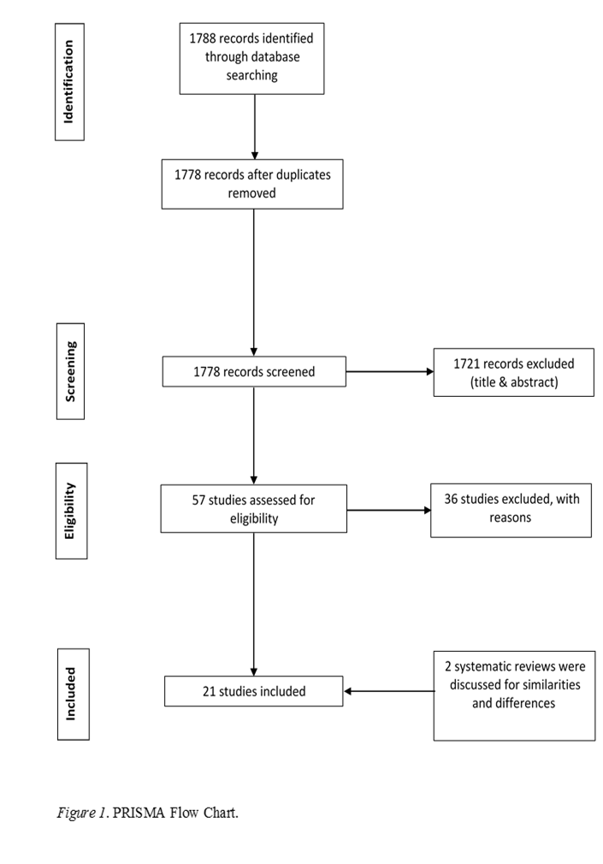

**Figure A.1**, PRISMA flow chart



**Figure A.2**, Synthesis of Results