Service failure research in the hospitality and tourism industry: A synopsis of past, present and future dynamics from 2001 to 2020

Tugra Nazli Akarsu (PhD, FHEA) is a Lecturer in Marketing at the Southampton Business School, University of Southampton, UK. Tugra’s research interests are in the fields of sensory marketing, tourism, branding, and consumer psychology. Her research has been published in journals including the Journal of Business Research, Industrial Marketing Management, European Journal of Marketing, and International Journal of Hospitality Management. She has contributed chapters to edited books on various topics and presented her research at various conferences belonging to reputable bodies.

Reza Marvi (PhD, MSc) is a Lecturer at Middlesex University, London. His research appears in the British Journal of Management, International Journal of Hospitality Management, European Journal of Marketing, and European Journal of International Management, among others.

Pantea Foroudi (PhD, SFHEA, MSc (Honor), MA, BA (Honor) is a business manager and solution architect at Foroudi Consultancy as well as a member of marketing, branding, and tourism, Middlesex University, London. Pantea has published widely in international academic journals such as the British Journal of Management, Journal of Business Research, European Journal of Marketing, and International Journal of Hospitality Management, among other leading academic journals.

Service failure research in the hospitality and tourism industry: A synopsis of past, present and future dynamics from 2001 to 2020

Abstract
Purpose - When service failure occurs, it leads to dissatisfaction, lack of trust and avoidance behaviour among customers, and it can also be seen as a threat to the survival of the business. This paper investigates the current and potential dynamics of service failure research within the tourism and hospitality area.
Design/methodology/approach - By adopting qualitative, quantitative (citation and text mining) and science-mapping tools (descriptive, conceptual, and intellectual), we analyse 99 key papers on service failure in 18 major hospitality and tourism journals over a 20-year span.
Findings - The research on service recovery strategies, recovery efforts, pre-, and post-failure, and post-recovery in the service encounter, and the impacts of justice on post-recovery and post-complaint behaviour are identified as the major streams of service failure research. While emotional labour, rumination, and satisfaction recovery were identified as emerging themes, service failure perceptions and social media were found as the developed and substantial trends.
Practical implications - We present a comprehensive understanding of service failure research development in the hospitality and tourism industry. We propose three areas – circumstantial cues, interactional cues, and crisis management – that practitioners need to understand in order to minimise service failure during the service interaction.
Originality – To the best of our knowledge, no prior bibliometric study has investigated the current and future dynamics of service failure in the hospitality and tourism industry and offered a research agenda based on this gap in the literature.

Keywords Service failure, bibliometrics, text mining, hospitality and tourism, service recovery, recovery management

- Introduction
Service failure (SF) refers to any form of actual or perceived mishap, error, or problem that occurs during the experience phase (Palmer et al., 2000). Service failure can vary based on the severity of the failure frequency or duration, or it can simply occur at the moment that the customer’s expectation is higher than the service received (Ha and Jang, 2009). If a service failure occurs, it can break the silent bond between customer and service provider and trigger customers to react or act at the various stages of service failure. For example, as a negative behavioural outcome, service failure might prompt customers’ complaints (Kim et al., 2009) or negative word-of-mouth (WOM) (Bae et al., 2021, Kim et al., 2009, Heung and Lam, 2003). Customers can also exit from the service silently as a reaction to the perceived service failure (Kim et al., 2009, Namkung and Jang, 2010), or simply be left dissatisfied by the incident (Wan et al., 2011).
When it comes to the hospitality and tourism (hereafter H&T) industry, service failure may be inevitable due to the human involvement in every step of the service process (Susskind, 2002) and the unpredictable nature of the service (Bae et al., 2021). A service failure can have a detrimental effect not only on the H&T industry but also on the global economy, as many countries are dependent on the stable influx of tourism revenue, according to the World Travel and Tourism Council (WTTC) (2021). Worldwide, 330 million jobs are supported by the H&T industry which contributes 10% to the total global GDP, an equivalent of 8.9 trillion dollars in 2019 (WTTC, 2020). In this regard, to provide effective responses to a service failure, service recovery strategies have been frequently studied within the industry. Previous studies have indicated that if service recovery strategies are successfully executed, this not only restores customers’ trust, emotions (Sanchez-Garcia and Curras-Perez, 2011), satisfaction and fairness perceptions (Hwang et al., 2020) but also leads to customers being more satisfied compared to the previous experience of service failure. This was later termed the service recovery paradox (McCollough et al., 2000). In this regard, due to its continually increasing importance, there is a growing body of literature on service failure, service recovery strategies, and managerial alternatives to the recovery efforts following the service failure that occurred: however, as the scope of the research published is wide and diversified, a study that consolidates the current state of service failure is timely.
The literature revealed different attempts to review service failure; for example, Ennew and Schoefer (2003) reviewed the existing literature on service failure in relation to travel and tourism whereas Colgate and Norris (2001) conducted a literature review and qualitative study to produce a model of how customers react to service failure by investigating the antecedents and consequences of service failure. Khamitov et al. (2020) systematically reviewed 236 studies on brand transgression, service failure recovery, and product harm crisis over a 21-year period. On the other hand, Foroudi et al. (2020) investigated service failure and recovery in 416 business-related articles from 1993 to 2019. Together these studies have portrayed a diverse and complex picture of service failure. However, these studies seem to have developed independently with limited opportunities for confluence and interaction. Furthermore, the majority of these studies are focused on a specific subset of a service failure within a particular research stream, highlighted in Table 1. In contrast, our research tries to address the various gaps in service failure literature in the H&T context by identifying the main foci of multiple research streams. Last, review studies integrate and summarise the body of knowledge but, because of their nature, they tend to confer equal weight to all contributions. However, the impact of published work on a research field can vary significantly. Although there are some metrics available to assess the contribution made by prior researchers (e.g., opinion leaders in the field) the most direct and objective assessment of a scholarly work contribution is accumulated citations over time.

<<< Insert Table 1>>>

Against this background, our study differs from the previous reviews in several ways. First, it allows us to include all the relevant literature to systematically paint a detailed and comprehensive picture of service failure and to explore different points of intersection between findings. This helps the researcher to sketch out the research agenda in service failure in the H&T industry. Analysing this large volume of bibliographic data allows researchers to identify specific clusters of research and to examine the strength between different subsets of published articles. Furthermore, and of importance – as proposed in this research – such analysis allows researchers to create a timeline of key developments within different research streams across the last two decades. To the best of our knowledge, to date, no prior bibliometric study has investigated the current and future dynamics of service failure and offered a research agenda based on this gap in the literature.
To fill this research gap, our study undertakes a comprehensive bibliometric, performance and text-mining analysis to identify the conceptual and intellectual structures of the service failure research in H&T. Our performance analysis of the publication and citation data reveals the scientific productivity and scientific actors involved (Narin and Hamilton, 1996, Moral-Muñoz et al., 2020). Through text mining and co-occurrence analysis, our aim is to identify the conceptual structure of the service failure research field within H&T. Considering the adoption of the Internet of Things (IoT), Augmented Reality and Artificial Intelligence by the H&T industry by reviewing the recent highly cited research on service failure in H&T, we also reveal the emergent topics that can act as guidelines to the decision-makers and scholars within the field.
We aim to highlight the emerging and developing notions of service failure in H&T that need substantial consideration to minimise the detrimental effect of pre-post effects of service failure and improve service effectiveness. We also call on policymakers, stakeholders, and destination management organisations (DMOs) to form a partnership to revisit the agenda of service interactions and service failure management in the H&T industry.

- Literature review
H&T is far from providing an ‘error-free’ service due to the high levels of human interaction, perceived expectations of customers, human error, and the inconsistent nature of the service (Namkung and Jang, 2010, Kim and Jang, 2016). Even though any error-caused or inadequate service failure has detrimental consequences on the expectations and satisfaction of customers (Wu et al., 2018), such as loss of confidence (Gohary et al., 2016) or switching service provider (Keaveney, 1995), the impact, nature and severity of the service failure can vary in different contexts. For example, in a restaurant, improperly cooked food (or other food-related issue) or slow service can be considered some of the most common failures (Susskind and Viccari, 2011), whereas delayed or cancelled flights, lost luggage, and any booking-related issues are the most common failures in the airline industry (Migacz et al., 2018). The expectation of customers in different contexts related to the ‘promised’ experience can impact the perceived strength of the service failure. For example, a customer is likely to have higher expectations from the service in a fine dining restaurant compared to a fast-food chain; therefore, any service failure might generate a stronger negative behavioural outcome for those customers who have higher expectations (Cho et al., 2017, Namkung and Jang, 2010).

2.1 Failure types
Different service failure typologies have been identified and classified in various ways including, but not limited to (i) core, interpersonal and procedural failures (Kim and Jang, 2016); (ii) core and interactional failure (Yang and Mattila, 2012); (iii) outcome and process failures (Keaveney, 1995); (v) service provider- or customer-related failures (Lewis and McCann, 2004); and (iv) monetary- and non-monetary-related failures (Gelbrich and Roschk, 2011). Even though different typologies of service failure are identified, the most commonly used category is the core-process failure classification, due to its applicability and generalisability (Smith et al., 1999, Kelley et al., 1993, Huang et al., 2020). In this regard, outcome failure occurs when a service provider does not (or fails to) fulfil the customer’s core and basic service or product that is supposed to be delivered (e.g., unavailable product/service, overcooked food, overbooking). On the other hand, process failure occurs when there is a mismatch between customer expectations and how the real delivery of the service or product is done (e.g., slow service delivery or inattentive staff).

2.2. Service failure attributions
When a failure occurs, customers tend to seek plausible reasons for the causes of such failure (Nikbin et al., 2012, Bitner et al., 1990) and try to make attributions to find the causality of the events. This is explained by the attribution theory (Weiner, 2000, Folkes, 1984). Weiner (2000) classified the causes of failure along three dimensions: controllability, stability, and locus of control. The locus of control refers to whether the service failure originates from the service provider (external) or the customer (internal). Stability refers to the customer’s determination of service failure’s longevity: whether it is temporal (unstable) or permanent (stable) (Swanson and Hsu, 2011, Folkes, 1984). Controllability on the other hand refers to the degree of the customer’s belief about whether the service failure could have been prevented by the service provider or not (Weiner, 2000). In the worst-case scenario, if the customer thinks that the service failure could be controllable, stable, and that it originated within the service provider, this can lead the customer to exhibit anger, dissatisfaction, regret, and disappointment, which are among the widely recognised emotional responses as a consequence of service failure (Xie and Heung, 2012, Hwang et al., 2020, Choi and Mattila, 2008).

2.3. Previous literature review studies on service failure
We believe that an overview of the previous literature reviews is necessary to shed light on the common focus and developing streams within the service failure field. Ennew and Schoefer (2003) attempted to set out an overview of service failure types, complaint handling and service recovery strategies in the context of tourism and hospitality. The aim of Ennew and Schoefer’s (2003) paper is to provide an understanding of how to manage service failure and how to address complaints by identifying how customers react to service failure and how they respond to the different service recovery strategies. The paper highlights three types of failure: (1) service delivery failures; (2) failures related to employee responses to implicit or explicit customer needs and requests; and (3) failures that arise from employee behaviour that is not expected by the customer. Service delivery failures are conceptualised as unavailable service (e.g., overbookings or cancellations), slow service (e.g., delays, lengthy queues), and other core service failures that are industry-specific. Baggage handling or cabin hygiene are examples of core system delivery failures in the airline industry, while in the restaurant setting poor food service might be an example.
Failures related to employee responses to customer needs and requests were conceptualised under two types of customers’ needs: implicit and explicit. Implicit needs refer to those needs that are not directly stated by customers whereas explicit needs are directly stated. Some examples of the explicit customer needs’ failure can be failing to fulfil customers’ stated dietary needs or failure to satisfy customers’ non-smoking restaurant table bookings. Failures that arise from employee behaviour that is not expected by the customer can be categorised under five groups: (1) violation of cultural norms (e.g., dishonesty, unfairness, inequality); (2) level of attention (e.g., poor attention, lack of attention, too much attention); (3) unexpected actions (e.g., rudeness, abusiveness); (4) negative behaviour under adverse conditions; and (5) gestalt (i.e., holistic negative perception of customers towards employees) (Ennew and Schoefer, 2003).
When it comes to customers’ responses to a service failure, scholars have long sought to identify effective strategies for service recovery (Boshoff and Leong, 1998, Tax and Brown, 1998, Tax et al., 1998, Aguilar-Rojas et al., 2015). Following this call, Colgate and Norris (2001), Ennew and Schoefer (2003) and Foroudi et al. (2020) provided overviews of customers’ reactions towards service failure where they highlighted loyalty, voice, and stay or exit (Hirschman, 1980, Singh, 1990). Loyalty has been conceptualised as one of the customer responses to failure, where customers can have behavioural loyalty with a low level of attitudinal loyalty. This situation might occur as customers might not have any substitutes or alternatives. Another response might be a voice, associated with complaining behaviour (Blodgett et al., 1997).
There are several reasons highlighted in the previous literature as drivers of voice, such as personality factors (e.g., assertiveness), gender (Aguilar-Rojas et al., 2015), emotional involvement (Colgate and Norris, 2001), or attribution (Folkes and Kotsos, 1986). Over time, ‘voice’ has been re-conceptualised and expanded from various angles; for example, negative complaints have been diversified with the increased use of the Internet of Things both by individuals and service providers within the settings such as online firestorms or negative reviews (Herhausen et al., 2019, Khamitov et al., 2020). The stay or exit response, on the other hand, refers to the final decision taken by the customer after service failure occurs, where they have to invest effort, time, and motivation (Keaveney, 1995, Singh, 1990).

2.4. Service recovery models
The review of the above stream of literature stated that service failure and recovery are considered ‘inseparable'. Therefore, several service recovery models have been identified; for instance, Bell and Zemke's (1987) five components of service recovery that have been offered to H&T managers as a ‘recipe’: (1) apology; (2) urgent reinstatement; (3) empathy; (4) symbolic atonement; and (5) follow-up. Stewart (1998) offered a simplified model based on an empirical study for managers on customers’ exit processes in the banking sector. The model illustrates at what stage customers engage with the managers prior to exit and their emotional transitions during the process.
Based on the customer satisfaction/dissatisfaction and disconfirmation paradigm, Boshoff (1997) investigated international travellers to identify customers’ reactions towards possible dissatisfaction and disconfirmation situations (e.g., missing flights due to delay) and the possible successful strategies in responding to customers’ (negative) reactions. Level of atonement (the amount of refund/compensation), time (the response time of the recovery), and the organisational level of the employee involved in the service recovery were found as the three most important components in service recovery efforts.

- Methodology
The systematic literature review requires a process where the information needs to be explored in a transparent, systematic, and reproducible way so that it can contribute to and substantiate the research domain (Verma and Yadav, 2021). We followed PRISMA (Preferred Reporting Items for Systematic Reviews and Meta-Analysis Statement) during the process of identification of the keywords, data screening, and inclusion (Page et al., 2021). Figure 1 presents the flowchart used in this study.

<<<Insert Figure 1>>>

3.1. Search strategy and selection of database
We have chosen Web of Science as a bibliographic database which is widely accepted as one of the most comprehensive bibliographic databases for multiple disciplines (Pranckute, 2021). In order to gather the most representative keywords for service failure, we consulted five experts in the field and asked them about the primary and synonym keywords that can be used for searching the literature within the particular domain. By using Boolean operators AND or OR, we tried to be as comprehensive as possible. The keywords that are used to retrieve the studies are as follows: service failure, firm failure, customer service failure, brand failure, online service failure, consumer service failure, and corporation failure.

3.2. Publication outlets
Along with the research aims, only hospitality and tourism journals are included to limit the range of publications and to reduce internal researcher bias (Zupic and Cater, 2015). The H&T journals that are in the ABS list were included in the sample and, subsequently, we limited the scope of the WOS category to ‘Hospitality, Leisure, Sport, Tourism’. We searched for our keywords in the titles, abstracts, and keywords of existing articles in the Web of Science (WoS) database. The WOS findings showed that the first article was published in 2001; therefore, we included the articles that were published after 2001. We filtered the journals included in the ABS list, leading to a sample of 99 central papers. Based on the suggestion by Zupic and Carter (2015), three independent researchers reviewed the papers to increase the validity and rigour of our study. All selected H&T journals for this study and the number of articles on service failure published are listed in Figure 2. Table 2 shows the most frequently cited service failure publications in the H&T domain along with the total citation frequencies.

<<<Insert Figure 2>>>
<<<Insert Table 2>>>

Bibliometrics is referred to as qualitative-driven quantitative analysis and assessment of a research domain (Chabowski et al., 2011, Verma and Yadav, 2021). It includes a range of different sets of analyses that have been developed for different assessments of the research domain outputs. It can be divided into two areas: performance mapping analysis and science mapping analysis. Performance mapping analysis aims to present the scientific actors in terms of researchers and countries, while science mapping aims to present the changing landscape and intellectual structure of the research domain through co-citation analysis (Small, 1973).
This study employed a combination of performance, science mapping, and text-mining approaches to carry out a comprehensive systematic review of the service failure domain. In addition, using the three methods reduced research bias (Podsakoff et al., 2005). For the performance analysis and thematic evolution, we used the R language. While thematic evolution primarily came through the co-word analysis, which is a content analysis to determine the co-occurrence of the terms that are available in documents (van Eck and Waltman, 2010), the intellectual structure was revealed through the co-citation analysis. By employing co-citation analysis, we identified the knowledge structure through the most cited articles and understood how the service failure concept (grouping of words which characteristically travel collectively throughout the text – Leximancer manual) has been incorporated with other study streams. To classify the fundamental concepts and themes of service failure in existing studies and recognise the difference between early and current development of the concept, we employed the text mining (Wilden et al., 2017).

4. Discussion
4.1 Performance analysis
Descriptive analysis of the data
The number of publications on service failure research in 18 leading H&T journals from 2001 to 2020 is presented in Figure 3. The results indicated that the number of articles published increased substantially over the last 20 years. The most productive journal was found to be the International Journal of Hospitality Management (36), followed by the International Journal of Contemporary Hospitality Management (21), and the Cornell Hospitality Quarterly (12) where the annual growth rate was 25.32%. The exponential growth of published articles is evident in Figure 4.

<<<Insert Figure 3>>>
<<<Insert Figure 4>>>

4.2. Thematic analysis
Text data mining
This research employed Leximancer, which is a Computer Assisted Qualitative Data Analysis Software (CAQDAS) and ACA (Automated Content Analysis), known as a “lexico-graphic tool” to illustrate the information visually (Mathies and Burford, 2011), to analyse a large amount of literature rapidly in a quantitative manner, and to re-arrange it by using different ontologies when needs change. Leximancer produces textual documents based on relationships of words through co-occurrence of verbs and term occurrence information (e.g., positions, nouns, and frequencies). We recognised higher levels of complexity within the hidden concept hierarchies, syntax, or thematic structures which helped us to interpret textual data via a different visual perspective (Campbell et al., 2011). In addition, we conducted both thematic (conceptual) and semantic (relational) assessments in text passages. Leximancer develops a high level of relationships between themes (groupings of revealed concepts) and concepts (common text elements) and connected terms that perform close to each other in the text through concept maps (Rooney, 2005). It develops a co-occurrence matrix with the co-occurrence frequencies (the nearest cells with peak values – i.e. nearest local maxima) of all concept seeds (Stockwell et al., 2009). Based on our research objectives, we focused on the associations among themes/concepts and the proximity with the concepts and words appearing in a specific paper. We found Leximancer to be the most appropriate tool for this study (Campbell et al., 2011).

The text-mining procedures
We used “keyword searching by discovering and extracting thesaurus-based concepts from the text data, with no requirement for a prior dictionary, although one can be used if desired” (Wilden et al., 2017, p. 348). The software helps to mitigate human bias, and uses algorithms and Bayesian statistics to mechanically categorise themes and concepts. Although Leximancer uses an unsupervised learning algorithm, we modified the manner in the procedures. We followed the eight steps of Leximancer processes as load data → pre-process → concept seeds identification → edit emergent concept seeds → develop concept thesaurus → create compound concepts → code concepts into text → generate outputs. At each step, based on the suggestion by Wilden et al. (2017), we edited the data to demonstrate the reliability of results across measuring procedures and validity as the “Leximancer algorithm generates fairly stable patterns of meaning when cross-validated in multiple styles and genres of text” (p. 348).
This research reveals the nature of the service failure study, and the results of textual assessment illustrate that ‘service’, ‘negative’ and ‘satisfaction’ are the main themes from prior studies (Figure 5). By looking at the black dots in Figure 5 we can identify the themes that are close to each other – ‘compensations’, ‘service’ ‘recovery’, ‘employees’, experience, ‘airline’ and ‘customers’ – meaning that, when customers experienced a service failure, empathetic response and genuine apology may represent sufficient compensation, resulting in customers’ psychological recovery to varying extents. However, tangible recovery provides physical compensation (e.g., discounts, coupons) for customers’ negative experiences.
The ‘negative’ theme encompasses concepts such as ‘intentions’, ‘positive’, ‘behaviour’, ‘emotions’, ‘complaint’, and ‘emotional’. These themes illustrate that complaint intention can be a measure of consumers’ responses to a service failure. In addition, the papers confirmed that, in group service failure, the majority of consumers show their negative emotions and progressively converge emotionally via group emotional contagion.
The ‘satisfaction’ theme comprised ‘justice’ and ‘compensation’, and overlapped with ‘recovery’ themes, demonstrating that terms connected to these themes are frequently stated together in the text. Studies extend knowledge on service recovery severity and show how the size of monetary compensation and prompt complaint handling may impact consumers’ satisfaction. The consumers’ recovery satisfaction is connected to the perceived procedural justice of the recovery causes, the distributive justice of the precise recovery, and the interactive justice of the recovery process. Even though perceived justice is essential, it is not adequate to assure consumer satisfaction and does not always mean that customers will forgive companies’ faults. Satisfaction incrementally forms attitudes towards services/products which contain negative or positive evaluations and feelings that can be divided into (i) primary satisfaction (perceived service) which is related to customers’ perceptions of the consumption experience and their emotional status; and (ii) secondary satisfaction which refers to customers’ emotional and cognitive judgements of the recovery effort after a complaint. In summary, our assessment of the service failure literature shows that the perceived justice theory is the main theory to assess the underlying mechanism of recovery.

<<<Insert Figure 5 Here>>

Thematic evolution
To understand the thematic evolution of service failure literature within H&T research between 2001 and 2020, we divided the period into four time periods based on the annual production growth (2001-2010, 2011-2015, 2016-2018, and 2019-2020). The research themes were represented in two-dimensional space into four groups which are (i) motor themes: the themes in that area are well developed and considered important for the structure of the field; (ii) basic themes: the important yet not well-developed themes; (iii) niche themes: specialised but well-developed themes, and finally (iv) emergent and declining themes that are not central and tend to be weakly developed (Moral-Munoz et al., 2018). Figure 6 represents the thematic evolution of service failure research in the H&T literature.
Customer satisfaction first appeared as a motor theme in the first time period: well developed and important for the research field and continually evolved and appeared in different areas. For example, between 2011 and 2015, customer satisfaction attribution was revealed as a niche theme, whereas customer satisfaction quality appeared as a niche theme in 2015-2018, and customer satisfaction recovery was a key theme in 2018-2020, which implies its ongoing importance for service failure. Compared to 2001-2010, the number of niches and basic themes in the final time period (2018-2020) has substantially increased (e.g., strategy identification, perceived justice quality, satisfaction recovery). In the final period, it can be seen that marginal but not yet well-developed themes are emerging such as emotional labour, rumination, and satisfaction recovery, whereas service failure perceptions and social media presence are emerging as well-developed and substantial themes.

<<<Insert Figure 6>>>

4.3. Intellectual structure of the service failure
Multi-dimensional scaling (MDS)
The collected data from WoS were transferred to BibExcel for bibliometric analysis. Based on highly-cited articles, a co-citation matrix such as MDS was developed for additional examination (Chabowski and Mena, 2017). We employed the proximity of the co-citation groups to map and visualise the association among the 25 most cited papers following suggestions by previous studies (Ramos-Rodríguez and Ruiz-Navarro, 2004, Chabowski et al., 2013). By employing SPSS, a maximum standardised distance of 0.25 yielded a good model fit and produced five dissimilar groups (Hair et al., 1998).

Hierarchal cluster analysis (HCA)
In addition to MDS, we used HCA which emphasises the connections between appropriate studies and increases the robustness and rigour of our study. HCA is a quantitative method that determines the intellectual streams and subgroups of the study domain based on the similarities among the papers. By employing Ward’s method, we produced a dendrogram for a visual determination of the ‘cut-off’, and five clusters were developed.
Cluster 1 emphasises apology as a recovery method to upsurge interpersonal fairness, as illustrated in Figure 7. Within the context of process failures, consumers may feel a social loss and should be interested to receive social resources signalling interactional justice. Cluster 1 contains a research chain consisting of manifold research groups (Groups 2, 3, 4, and 5). Group 2 (V15, V2) focuses on pre-failure, post-failure and post-recovery in the service encounter. Group 3 (V16, V2) provides an intensive discussion on the impact of justice dimensions (distributive, procedural, and interactional) and post-recovery in the service encounter. Similarly, Group 4 (V17, V3, V16) reflects on the application of fairness theory to justice dimensions, service recovery, and post-complaint behaviour. Group 5 (V19, V3) identifies the effects of the recovery tactic on justice dimensions and service recovery.
Cluster 2 focuses on justice theory (comprising dimensions of distributive, procedural, and interactional justice) as the most fundamental theory to explain the consumer perceptions originating from the service failure. Articles in this cluster recommended that the higher the degree of the service failure the greater the dissatisfaction related to the early service transaction and confidence in the service provider, which may lead to a deterioration and weakening of repurchases along with negative advocacy. So, this creates greater pressure on the service provider to perform an efficacious atonement and service recovery. Cluster 2, consisting of Group 1, consists of two articles (V12, V6): Ha and Jang (2009) and Kim et al. (2009). Their articles focused on recovery efforts and behavioural intention. Based on justice theory, both studies examined the three-justice dimensions (distributive, procedural, and interactional) on customers’ future behavioural intentions.
Cluster 3 (V11 and V13) is centred on service recovery strategies. This cluster includes articles by Kelley et al. (1993) and Lewis and McCann (2004). By employing critical incident techniques from consumers’ perceptions, they found that service failure characterises the interruption throughout a service distribution procedure, resulting in inferior consumer satisfaction. Due to an organisation’s service recovery efforts, this may satisfy consumers who request apologies, exchanges, replacements, reparations, refunds, or any further complaint-allied requests.
Cluster 4 (V4, V5, and V20) illustrates customer reactions following service failure through attribution theory to scrutinise consumers’ responses to recovery compensation after service failures with varying levels of stability and controllability. Articles in this cluster attempt to address how attributions affect negative customer emotions, such as anger, and how consumers’ views may lead to anger and lower intention to repurchase as the key factors for negative emotions.
Cluster 5 (V1, V10, and V18) mainly relies on service-switching behaviour and attribution theory, which play essential roles in shaping customers’ satisfaction (McCollough et al., 2000, Keaveney, 1995). The published papers in this cluster recognised the key antecedents of customer switching in service interactions. Based on the service recovery paradox, the deteriorating service delivery – which is a strong enrichment to switch affective loyalty – can become susceptible to dissatisfaction at the cognitive level. The research groups and clusters delivered an indication of the service failure knowledge structure. A detailed overview of the most highly cited papers on service failure is in Table 2.

<<<Insert Figure 7 Here>>

Based on the sample, which includes 99 papers, it is unmanageable to address all references in the examination. According to the process of bibliometric research, this study set high and low threshold numbers of citations for the graphical investigation as suggested by previous scholars (Zupic and Cater, 2015, Wilden et al., 2017). The main aim was to eliminate articles which were not focal to the network, although they suggested a significant demonstration of the concept. Also, the clusters were assessed for their consistency and support for the identification of service failure research.

What we already know
To expand the previous literature and to overcome the lack of rigour and subject-specific literature reviews, we aimed to provide a qualitative-driven quantitative literature review by utilising bibliometric analysis. The studies were assessed based on multi-dimensional scaling and hierarchical cluster analysis to identify the intellectual structure of the service failure field within the H&T industry. The research findings of MDS illustrated that the research groups within service failure are much more diverse and linked with service recovery, unlike the other literature review paper findings. Similar to the previous literature streams, service recovery efforts and behavioural intention (Group 1) constitute one of the research groups within the H&T field.
Due to the increasing importance of service recovery in the service encounter, pre-failure, post-failure and post-recovery in the service encounter constitute the second research group (Group 2). Related to service recovery and customers’ reaction toward failure, the concept of justice has been a topic of interest for over 40 years by considering consumers’ evaluation of whether their needs have been fulfilled in service recovery and post-complaint behaviour (Liao, 2007). Therefore, the impact of justice dimensions and post-recovery in service encounters (Group 3), the effects of recovery tactics on justice dimensions (Group 5), and post-complaint behaviour (Group 4) are identified as the other research streams in H&T.
5. Future directions

The purpose of this research was to review the service failure research in the hospitality and tourism domain. We adopted a multi-method approach to bibliometric analysis and performed science mapping and text-mining techniques to identify (1) the intellectual structure of service failure research in H&T, (2) the knowledge structure through the most cited articles as well as understand how the service failure concept (grouping of words which characteristically travel collectively throughout the text – Leximancer manual), (3) the thematic evolution of the topics within the service failure in H&T and, finally, (4) the future research opportunities and issues that need collectivistic consideration for the operational success of the service and its management in H&T industry.
To identify future directions and opportunities, through citation analysis we have identified the 15 most-cited papers between 2018 and 2020, which are presented in Table 3. We have identified two important cues – interactional and circumstantial – that might help future researchers to contribute potential insights to reveal the denominators of service failure in different contexts. These cues might also help the H&T industry to provide a more nuanced service approach to minimise the potential service failure. Consistent with this we also identified crisis management as one of the key topics for researchers, which is less discussed in the previous literature, but is highlighted by the recent research – this warrants further examination. Thus, in the next section, we focus our discussion on the aforementioned emergent topics. We also present future research questions and research opportunities in Table 4.

<<<Insert Table 3>>>
<<<Insert Table 4>>>

5.1. Emergent topic 1: Circumstantial cues
The contextual-based service failures (e.g., restaurant, airline, hotel) and their impact on behavioural outcomes have long been investigated by H&T scholars (Bitner et al., 1990, Stewart, 1998, Keaveney, 1995, Kelley et al., 1993, Tax et al., 1998, Smith and Bolton, 1998, McCollough et al., 2000). However, design-related cues or cues related to the specific circumstances at the service settings (e.g., closed vs open kitchen) become increasingly relevant to service failure, even though this type of research has been investigated in retail-related settings for many years (Krishna, 2012, Wang et al., 2011). One of the most recent works in this context was conducted by Byun and Jang (2018), where circumstantial cues are defined as the direct or circumstantial information that might be seen as the reason for the service failure by the customers.
Even though the open vs closed kitchen setting (as a circumstantial cue) has been investigated by Byun and Jang (2018), many other circumstantial cues, such as employee outfits, decoration, music choice, or other design-related cues have not been investigated in depth, mainly due to the challenges in the identification of the cause of the service related to the circumstantial cues chosen. However, researchers have examined circumstantial cues in retail contexts (both brick and mortar and online); their findings on how the availability of such cues can influence consumers’ decision processing, emotions, judgements, and in-store experience have been validated across two decades (Ahmed and Ting, 2020, Turley and Milliman, 2000, Krishna and Morrin, 2007).
Our research indicates that circumstantial, interactional, and situational cues were less discussed and have emerged as the key topics of interest in recent years. The reason might simply be as follows: when service failure occurs, customers might be able to identify the cause of the incident if there is a direct causal relationship (e.g., slow service, unavailable ticket, loud music). However, at times, the cause of the incident can be complex, or there can be multiple variables, particularly if setting a direct causal relationship is not possible between the service failure and the cause of the incident (Byun and Jang, 2018). In this regard, a customer who encounters a service failure might respond differently depending on the information conveyed through the circumstantial cue available (Byun and Jang, 2018, Iglesias, 2009), which needs a warrant examination, to inform managers in particular. For example, an open kitchen setting in a restaurant as a circumstantial cue allows customers to collect more information than a closed kitchen setting does.
Therefore, if a customer encounters a service failure, they can be more informed on the cause and hence they are likely to attribute it to the service provider (Byun and Jang, 2018). [As our paper was undergoing the review process, emerging articles are supporting our future research direction (Terres et al., 2020).] Terres et al. (2020) investigated the service design cues and how sophisticated service design (compared to modest design) can minimise consumers’ negative emotional responses after service failure occurs. Reflecting our findings in clusters and research groups, circumstantial cues can be one of the emerging service recovery strategies, where managers should continuously observe and work on the combinations of the cues to improve their quality as this might mitigate the adverse impact of service failure (Bitner, 1992, Jiang and Wen, 2020)].

5.2. Emergent topic 2: Interactional cues
The servicescapes are complex settings, and the evaluations of the settings are not derived from one attribute; rather, the evaluation needs to be derived from the interplay of various factors (Kim and Baker, 2019). Not only is the interaction of a customer to physical circumstance important – the customer-customer interaction can also be part of the circumstantial cue, as a natural setting of the service interactions (Henkel et al., 2017). A cue that can be part of the interactional cue, customer incivility, has been recently investigated as a part of the complex servicescape (Kim and Baker, 2019). Even though the core interaction between customers-employees and its effect on observant customers has been investigated, less attention has been paid to how customers can influence each other, particularly during service failure. No matter what the core relationship between customer and service provider is, circumstantial cues, such as customers’ disruptive behaviour or incivility, can also influence how other customers perceive and what they attribute to the cause-effect of service failure.
The study by Kim and Baker (2019) particularly revealed that customers who show uncivil behaviour severely disturb the service interactions, even when the customers are not directly interacting. This interesting study offered substantial food for thought for scholars and managers on how they understand other interactional aspects in the service environment that have never been considered as a trigger for the cause-effect of service failure. Therefore, further investigations on that front can consider other aspects of customer-customer interactions as it is not only critical to manage employee-customer interactions: customer-customer interactions also have a substantial cause-effect on service failure.
One also needs to keep in mind the major strategy changes in H&T from standardised service management to personalised experience (Kirillova and Chan, 2018). As such, automated technologies such as service robots or AI-powered interfaces are now becoming a part of H&T in various processes of the service, with the adoption of technology by the H&T industry from delivery of the service to check-in, or dealing with the more complex situations and tasks such as handling customers’ inquiries (Ho et al., 2020, Choi et al., 2019). Ho et al. (2020) defined service robots as “an automated technology in a physical embodiment with adaptable interfaces that interact, communicate and deliver services to customers” (p.1). It is not news that the service robots in the H&T industry are becoming more prevalent and, at times, are seen as technological disruptions since they are replacing the human staff (Buhalis et al., 2019). The role of service robots during service recovery has been investigated recently (Wirtz et al., 2018); however, it is possible that the technology-generated service encounters can play a substantial role in service failure recovery, since different interactions with different actors (service robots vs staff) during the service failure incident can be perceived by customers differently (Ho et al., 2020).
When it comes to personalised experience and service management, the concept of personalisation also created a shift in other factors such as servers’ aesthetics management (Wu et al., 2019). In terms of interactional cues, Wu et al. (2019) investigated how employees’ conspicuous consumption cues influence customers’ service evaluation at the time-of-service failure in the luxury dining restaurant context. Their study found that customers perceive employees with conspicuous consumption cues (e.g., wearing a conspicuous watch) as more competent. In a different research context, customers’ interaction with any technology-generated service encounters during service failure or any other interactional cue could lead customers to exhibit different emotional or behavioural reactions. Additionally, with the adaptation of new technologies in the H&T industry, the technological interactions as well as other interactional cues related to the employee (e.g., employee competence, employee’s perceived warmth) at the time-of-service failure demand further attention from academics as well as practitioners (Wu et al., 2019, Ho et al., 2020).

5.3. Emergent topic 3: Crisis management

At the time-of-service failure, the direct causal relationship between the incident and cognitive and behavioural outcomes of customers has been investigated frequently (Wang et al., 2021). Through the attribution theory, customers tend to explain the cause of events and try to create a cause-and-effect relationship based on three causal layers – stability, controllability, and locus of control (Weiner, 2000). According to situational crisis theory, which is an antecedent to the attribution theory (Coombs, 2007), individuals experience various emotions when a crisis occurs and the attribution of blame and responsibility for the crisis that occurred falls to the responsible entities involved. In the hospitality and tourism industry, when an imminent crisis occurs, ‘who is responsible’ cannot be answered immediately, which makes crisis management vital to minimise the detrimental impact on the reputation of the company. When it comes to a service failure, contextual failure scenarios have been frequently explored and relevant strategies have been formulated to minimise the adverse outcome of the failure on customers’ behaviour, brand image, and reputation. However, with the introduction of online platforms, particularly social media, there is a nascent understanding of how the appropriate crisis management actions can be taken to minimise or prevent a service failure (Su et al., 2019).
There is also a nascent understanding of how personal characteristics (e.g., values, beliefs) interplay with customers’ attribution during the service failure. According to Min and Kim (2019), when customers cannot find an external reason for the service failure and attribute it to personal reasons (e.g., an intentional delay due to personal beliefs), that might lead consumers to think that the service failure occurred due to discrimination. This can engender anger and frustration in these customers, and they raise their voices concerning the failure to express their dissatisfaction. To be able to determine why customers feel mistreated at times of service failure can provide valuable information to service providers to correct their mistakes and allow them to be better informed for times when crisis management is required, particularly considering the complex nature of the service itself. That makes crisis management an area that warrants examination.

6. Conclusion

It is an undeniable fact that hospitality and tourism researchers have made considerable progress in the last two decades. Considering the complex servicescapes, how the traditional service encounters are strengthened with the technology and service recovery efforts were investigated for different industries. As service is becoming more ‘experiential’, and the consumers are more inclined to share their experiences in virtual communities than ever before (Verma and Yadav, 2021), the effect of service failure can be echoed, and create a domino effect on other customers, which may cause them to switch their service provider in H&T. Therefore, service failure has drawn considerable attention from scholars and practitioners globally, which makes the service failure domain multi-faceted, ever-growing, and extensive due to the differences in the multitude of service providers in the H&T industry.
Despite the previous attempts, to the best of our knowledge, no previous study investigates service failure within the H&T industry from multiple angles (e.g., conceptual, intellectual structure, as well as thematics). Our study attempted to go beyond the service failure and recovery efforts debate, demonstrated the research productivity, influential journals, and emerging themes, and revealed the intellectual structure as well as emerging trends within the hospitality and tourism area.

7. Limitations and future research
This study has some limitations. First, our analysis was restricted to a specific time period, between 2001 to 2020, and we examined the papers published in 18 journals. Having a broader set of journals could enrich the results. Future researchers are also encouraged to consider different timeframes for a comparison. Investigating different timeframes is not only important for comparison but can also provide a continuation to understand the service failure in a longitudinal manner and can serve up potential new insights into the intellectual development of the research domain. Second, we have used a specific set of keywords to identify the service failure research based on our search strategy; therefore, different keywords might increase the number of documents to be included in the analysis.
Web of Science was chosen as a primary database; therefore, exploring the service failure domain in different databases such as SCOPUS can generate new supplementary insights on the research results. Third, based on the studies included in the research, our study revealed various themes related to behavioural aspects of service failure through the analysis. However, process, procedural, and timing-related aspects of service recovery and its impact on service recovery strategies could also be investigated. Last, but not least, future researchers might consider a further contextual/localised approach to service failure, as this might condense the results of the current study by providing additional insights.

Author contributions

All three authors have been involved in all the research processes from the conceptual development of the paper to the writing-up stage.

References

Aguilar-Rojas, O., Fandos-Herrera, C. and Flavian-Blanco, C. (2015), "What may lead you to recommend and revisit a hotel after a service failure instead of complaining?", International Journal of Contemporary Hospitality Management, Vol. 27 No. 2, pp. 214-235.
Ahmed, S. and Ting, D. H. (2020), "Shopping cues: Conceptualization, scale development, and validation", International Journal of Market Research, Vol. 62 No. 1, pp. 95-112.
Bae, G., Lee, S. and Kim, D.-Y. (2021), "Interactions between Service Recovery Efforts and Customer Characteristics: Apology, Compensation, and Empowerment", Journal of Quality Assurance in Hospitality & Tourism, Vol. 22 No. 2, pp. 218-244.
Bell, C. R. and Zemke, R. E. (1987), "Service Breakdown: The Road to Recovery", Management Review, Vol. 76 No. 10, p. 32.
Bitner, M. J. (1992), "Servicescapes: The impact of physical surroundings on customers and employees", Journal of marketing, Vol. 56 No. 2, pp. 57-71.
Bitner, M. J., Booms, B. H. and Tetreault, M. S. (1990), "The Service Encounter - Diagnosing Favorable and Unfavorable Incidents", Journal of Marketing, Vol. 54 No. 1, pp. 71-84.
Blodgett, J. G., Hill, D. J. and Tax, S. S. (1997), "The effects of distributive, procedural, and interactional justice on postcomplaint behavior", Journal of Retailing, Vol. 73 No. 2, pp. 185-210.
Boshoff, C. (1997), "An experimental study of service recovery options", International Journal of Service Industry Management, Vol. 8 No. 2, pp. 110-130.
Boshoff, C. and Leong, J. (1998), "Empowerment, attribution and apologising as dimensions of service recovery - An experimental study", International Journal of Service Industry Management, Vol. 9 No. 1, pp. 24-+.
Buhalis, D., Harwood, T., Bogicevic, V., Viglia, G., Beldona, S. and Hofacker, C. (2019), "Technological disruptions in services: lessons from tourism and hospitality", Journal of Service Management, Vol. 30 No. 4, pp. 484-506.
Byun, J. and Jang, S. (2018), "Open kitchen vs closed kitchen: Does kitchen design affect customers' causal attributions of the blame for service failures?", International Journal of Contemporary Hospitality Management, Vol. 30 No. 5, pp. 2214-2229.
Campbell, C., Pitt, L. F., Parent, M. and Berthon, P. R. (2011), "Understanding Consumer Conversations around Ads in a Web 2.0 World", Journal of Advertising, Vol. 40 No. 1, pp. 87-102.
Chabowski, B. R. and Mena, J. A. (2017), "A Review of Global Competitiveness Research: Past Advances and Future Directions", Journal of International Marketing, Vol. 25 No. 4, pp. 1-24.
Chabowski, B. R., Mena, J. A. and Gonzalez-Padron, T. L. (2011), "The structure of sustainability research in marketing, 1958-2008: a basis for future research opportunities", Journal of the Academy of Marketing Science, Vol. 39 No. 1, pp. 55-70.
Chabowski, B. R., Samiee, S. and Hult, G. T. M. (2013), "A bibliometric analysis of the global branding literature and a research agenda", Journal of International Business Studies, Vol. 44 No. 6, pp. 622-634.
Cho, S. B., Jang, Y. J. and Kim, W. G. (2017), "The Moderating Role of Severity of Service Failure in the Relationship among Regret/Disappointment, Dissatisfaction, and Behavioral Intention", Journal of Quality Assurance in Hospitality & Tourism, Vol. 18 No. 1, pp. 69-85.
Choi, S., Liu, S. Q. and Mattila, A. S. (2019), ""How may i help you?" Says a robot: Examining language styles in the service encounter", International Journal of Hospitality Management, Vol. 82, pp. 32-38.
Choi, S. and Mattila, A. S. (2008), "Perceived controllability and service expectations: Influences on customer reactions following service failure", Journal of Business Research, Vol. 61 No. 1, pp. 24-30.
Colgate, M. and Norris, M. (2001), "Developing a comprehensive picture of service failure", International Journal of Service Industry Management, Vol. 12 No. 3, pp. 215-233.
Ennew, C. and Schoefer, K. (2003), "Service failure and service recovery in tourism: A review", Discussion papers (Christel DeHaan Tourism and Travel Research Institute), 2003/6., Christel DeHaan Tourism and Travel Research Institute, Nottingham University Business School, Christel DeHaan Tourism and Travel Research Institute, Nottingham University … pp. 1-16.
Folkes, V. S. (1984), "Consumer Reactions to Product Failure - an Attributional Approach", Journal of Consumer Research, Vol. 10 No. 4, pp. 398-409.
Folkes, V. S., Koletsky, S. and Graham, J. L. (1987), "A Field-Study of Causal Inferences and Consumer Reaction - the View from the Airport", Journal of Consumer Research, Vol. 13 No. 4, pp. 534-539.
Folkes, V. S. and Kotsos, B. (1986), "Buyers and Sellers Explanations for Product Failure - Who Done It", Journal of Marketing, Vol. 50 No. 2, pp. 74-80.
Foroudi, P., Kitchen, P. J., Marvi, R., Akarsu, T. N. and Uddin, H. (2020), "A bibliometric investigation of service failure literature and a research agenda", European Journal of Marketing, Vol. 54 No. 10, pp. 2575-2619.
Gelbrich, K. and Roschk, H. (2011), "A Meta-Analysis of Organizational Complaint Handling and Customer Responses", Journal of Service Research, Vol. 14 No. 1, pp. 24-43.
Gohary, A., Hamzelu, B. and Pourazizi, L. (2016), "A little bit more value creation and a lot of less value destruction! Exploring service recovery paradox in value context: A study in travel industry", Journal of Hospitality and Tourism Management, Vol. 29, pp. 189-203.
Guchait, P., Han, R., Wang, X. Y., Abbott, J. and Liu, Y. T. (2019), "Examining stealing thunder as a new service recovery strategy: impact on customer loyalty", International Journal of Contemporary Hospitality Management, Vol. 31 No. 2, pp. 931-952.
Ha, J. and Jang, S. (2009), "Perceived justice in service recovery and behavioral intentions: The role of relationship quality", International Journal of Hospitality Management, Vol. 28 No. 3, pp. 319-327.
Hart, C. W. L., Heskett, J. L. and Sasser, W. E. (1990), "The Profitable Art of Service Recovery", Harvard Business Review, Vol. 68 No. 4, pp. 148-156.
Henkel, A. P., Boegershausen, J., Rafaeli, A. and Lemmink, J. (2017), "The Social Dimension of Service Interactions: Observer Reactions to Customer Incivility", Journal of Service Research, Vol. 20 No. 2, pp. 120-134.
Herhausen, D., Ludwig, S., Grewal, D., Wulf, J. and Schoegel, M. (2019), "Detecting, Preventing, and Mitigating Online Firestorms in Brand Communities", Journal of Marketing, Vol. 83 No. 3, pp. 1-21.
Hess, R. L., Ganesan, S. and Klein, N. M. (2003), "Service failure and recovery: The impact of relationship factors on customer satisfaction", Journal of the Academy of Marketing Science, Vol. 31 No. 2, pp. 127-145.
Heung, V. and Lam, T. (2003), "Customer complaint behaviour towards hotel restaurant services", International Journal of Contemporary Hospitality Management, Vol. 15, pp. 283-289.
Hirschman, A. O. (1980), ""Exit, Voice, and Loyalty": Further Reflections and a Survey of Recent Contributions", The Milbank Memorial Fund Quarterly. Health and Society, Vol. 58 No. 3, pp. 430-453.
Ho, T. H., Tojib, D. and Tsarenko, Y. (2020), "Human staff vs. service robot vs. fellow customer: Does it matter who helps your customer following a service failure incident?", International Journal of Hospitality Management, Vol. 87.
Hoffman, K. D., Kelley, S. W. and Rotalsky, H. M. (2016), "Retrospective: tracking service failures and employee recovery efforts", Journal of Services Marketing, Vol. 30 No. 1, pp. 7-10.
Huang, Y. Y., Zhang, M., Gursoy, O. G. and Shi, S. (2020), "An examination of interactive effects of employees' warmth and competence and service failure types on customer's service recovery cooperation intention", International Journal of Contemporary Hospitality Management, Vol. 32 No. 7, pp. 2429-2451.
Hwang, Y., Gao, L. S. and Mattila, A. S. (2020), "What recovery options to offer for loyalty reward program members: Dollars vs. Miles?", International Journal of Hospitality Management, Vol. 87.
Iglesias, V. (2009), "The attribution of service failures: effects on consumer satisfaction", Service Industries Journal, Vol. 29 No. 2, pp. 127-141.
Jiang, Y. and Wen, J. (2020), "Effects of COVID-19 on hotel marketing and management: a perspective article", International Journal of Contemporary Hospitality Management, Vol. 32 No. 8, pp. 2563-2573.
Keaveney, S. M. (1995), "Customer Switching Behavior in-Service Industries - an Exploratory-Study", Journal of Marketing, Vol. 59 No. 2, pp. 71-82.
Kelley, S. W., Hoffman, K. D. and Davis, M. A. (1993), "A Typology of Retail Failures and Recoveries", Journal of Retailing, Vol. 69 No. 4, pp. 429-452.
Khamitov, M., Grégoire, Y. and Suri, A. (2020), "A systematic review of brand transgression, service failure recovery and product-harm crisis: integration and guiding insights", Journal of the Academy of Marketing Science, Vol. 48 No. 3, pp. 519-542.
Kim, J. H. and Jang, S. (2016), "Factors affecting memorability of service failures: a longitudinal analysis", International Journal of Contemporary Hospitality Management, Vol. 28 No. 8, pp. 1676-1701.
Kim, T., Kim, W. G. and Kim, H.-B. (2009), "The effects of perceived justice on recovery satisfaction, trust, word-of-mouth, and revisit intention in upscale hotels", Tourism Management, Vol. 30 No. 1, pp. 51-62.
Kim, Y. S. and Baker, M. A. (2019), "Observer reactions to other customer incivility: Emotional labor, gratitude, loyalty to employee and tipping intention", International Journal of Contemporary Hospitality Management, Vol. 31 No. 3, pp. 1292-1308.
Kirillova, K. and Chan, J. (2018), ""What is beautiful we book": hotel visual appeal and expected service quality", International Journal of Contemporary Hospitality Management, Vol. 30 No. 3, pp. 1788-1807.
Krishna, A. (2012), "An integrative review of sensory marketing: Engaging the senses to affect perception, judgment and behavior", Journal of Consumer Psychology, Vol. 22 No. 3, pp. 332-351.
Krishna, A. and Morrin, M. (2007), "Does Touch Affect Taste? The Perceptual Transfer of Product Container Haptic Cues", Journal of Consumer Research, Vol. 34 No. 6, pp. 807-818.
Lewis, B. R. and McCann, P. (2004), "Service failure and recovery: evidence from the hotel industry", International Journal of Contemporary Hospitality Management, Vol. 16 No. 1, pp. 6-17.
Liao, H. (2007), "Do it right this time: The role of employee service recovery performance in customer-perceived justice and customer loyalty after service failures", Journal of Applied Psychology, Vol. 92 No. 2, pp. 475-489.
Liu, H. F., Jayawardhena, C., Dibb, S. and Ranaweera, C. (2019), "Examining the trade-off between compensation and promptness in eWOM-triggered service recovery: A restorative justice perspective", Tourism Management, Vol. 75, pp. 381-392.
Mathies, C. and Burford, M. (2011), "Customer service understanding: gender differences of frontline employees", Managing Service Quality, Vol. 21 No. 6, pp. 636-648.
Maxham, J. G. (2001), "Service recovery's influence on consumer satisfaction, positive word-of-mouth, and purchase intentions", Journal of Business Research, Vol. 54 No. 1, pp. 11-24.
Maxham, J. G. and Netemeyer, R. G. (2002a), "A longitudinal study of complaining customers' evaluations of multiple service failures and recovery efforts", Journal of Marketing, Vol. 66 No. 4, pp. 57-71.
Maxham, J. G. and Netemeyer, R. G. (2002b), "Modeling customer perceptions of complaint handling over time: the effects of perceived justice on satisfaction and intent", Journal of Retailing, Vol. 78 No. 4, pp. 239-252.
McColl-Kennedy, J. R. and Sparks, B. A. (2003), "Application of Fairness Theory to Service Failures and Service Recovery", Journal of Service Research, Vol. 5 No. 3, pp. 251-266.
McCollough, M. A., Berry, L. L. and Yadav, M. S. (2000), "An Empirical Investigation of Customer Satisfaction after Service Failure and Recovery", Journal of Service Research, Vol. 3 No. 2, pp. 121-137.
Migacz, S. J., Zou, S. W. and Petrick, J. F. (2018), "The "Terminal" Effects of Service Failure on Airlines: Examining Service Recovery with Justice Theory", Journal of Travel Research, Vol. 57 No. 1, pp. 83-98.
Min, H. and Kim, H. J. (2019), "When service failure is interpreted as discrimination: Emotion, power, and voice", International Journal of Hospitality Management, Vol. 82, pp. 59-67.
Mody, M. A., Lu, L. and Hanks, L. (2020), ""It's not worth the effort"! Examining service recovery in Airbnb and other homesharing platforms", International Journal of Contemporary Hospitality Management, Vol. 32 No. 9, pp. 2991-3014.
Moral-Munoz, J. A., Arroyo-Morales, M., Herrera-Viedma, E. and Cobo, M. J. (2018), "An Overview of Thematic Evolution of Physical Therapy Research Area From 1951 to 2013", Frontiers in Research Metrics and Analytics, Vol. 3 No. 13.
Moral-Muñoz, J. A., Herrera-Viedma, E., Santisteban-Espejo, A. and Cobo, M. J. (2020), "Software tools for conducting bibliometric analysis in science: An up-to-date review", Profesional de la Información, Vol. 29 No. 1.
Namkung, Y. and Jang, S. (2010), "Service Failures in Restaurants:Which Stage of Service Failure Is the Most Critical?", Cornell Hospitality Quarterly, Vol. 51 No. 3, pp. 323-343.
Narin, F. and Hamilton, K. S. (1996), "Bibliometric performance measures", Scientometrics, Vol. 36 No. 3, pp. 293-310.
Nikbin, D., Ismail, I., Marimuthu, M. and Salarzehi, H. (2012), "The Relationship of Service Failure Attributions, Service Recovery Justice and Recovery Satisfaction in the Context of Airlines", Scandinavian Journal of Hospitality and Tourism, Vol. 12 No. 3, pp. 232-254.
Page, M. J., McKenzie, J. E., Bossuyt, P. M., Boutron, I., Hoffmann, T. C., Mulrow, C. D., Shamseer, L., Tetzlaff, J. M., Akl, E. A., Brennan, S. E., Chou, R., Glanville, J., Grimshaw, J. M., Hrobjartsson, A., Lalu, M. M., Li, T. J., Loder, E. W., Mayo-Wilson, E., McDonald, S., McGuinness, L. A., Stewart, L. A., Thomas, J., Tricco, A. C., Welch, V. A., Whiting, P. and Moher, D. (2021), "The PRISMA 2020 statement: an updated guideline for reporting systematic reviews", Systematic Reviews, Vol. 10 No. 1.
Palmer, A., Beggs, R. and Keown‐McMullan, C. (2000), "Equity and repurchase intention following service failure", Journal of Services Marketing, Vol. 14 No. 6, pp. 513-528.
Podsakoff, P. M., Mackenzie, S. B., Bachrach, D. G. and Podsakoff, N. P. (2005), "The influence of management journals in the 1980s and 1990s", Strategic Management Journal, Vol. 26 No. 5, pp. 473-488.
Pranckute, R. (2021), "Web of Science (WoS) and Scopus: The Titans of Bibliographic Information in Today's Academic World", Publications, Vol. 9 No. 1.
Qiu, S. Z., Li, M. M., Mattila, A. S. and Yang, W. (2018), "Managing the face in service failure: the moderation effect of social presence", International Journal of Contemporary Hospitality Management, Vol. 30 No. 3, pp. 1314-1331.
Ramos-Rodríguez, A. and Ruiz-Navarro, J. (2004), "Changes in The Intellectual Structure of Strategic Management Research", Strategic Management Journal - STRATEG MANAGE J, Vol. 25, pp. 981-1004.
Rooney, D. (2005), "Knowledge, economy, technology and society: the politics of discourse", Telemat. Inf., Vol. 22 No. 4, pp. 405–422.
Sanchez-Garcia, I. and Curras-Perez, R. (2011), "Effects of dissatisfaction in tourist services: The role of anger and regret", Tourism Management, Vol. 32 No. 6, pp. 1397-1406.
Singh, J. (1990), "Voice, exit, and negative word-of-mouth behaviors: An investigation across three service categories", Journal of the Academy of Marketing Science, Vol. 18 No. 1, pp. 1-15.
Small, H. (1973), "Co-citation in the scientific literature: A new measure of the relationship between two documents", Journal of the American Society for Information Science, Vol. 24 No. 4, pp. 265-269.
Smith, A. K. and Bolton, R. N. (1998), "An Experimental Investigation of Customer Reactions to Service Failure and Recovery Encounters:Paradox or Peril?", Journal of Service Research, Vol. 1 No. 1, pp. 65-81.
Smith, A. K., Bolton, R. N. and Wagner, J. (1999), "A model of customer satisfaction with service encounters involving failure and recovery", Journal of Marketing Research, Vol. 36 No. 3, pp. 356-372.
Smith, M. D. (2002), "The impact of shopbots on electronic markets", Journal of the Academy of Marketing Science, Vol. 30 No. 4, pp. 446-454.
Stewart, K. (1998), "An exploration of customer exit in retail banking", International Journal of Bank Marketing, Vol. 16 No. 1, pp. 6-14.
Stockwell, P., Colomb, R. M., Smith, A. E. and Wiles, J. (2009), "Use of an automatic content analysis tool: A technique for seeing both local and global scope", International Journal of Human-Computer Studies, Vol. 67 No. 5, pp. 424-436.
Su, L. J., Stepchenkova, S. and Kirilenko, A. P. (2019), "Online public response to a service failure incident: Implications for crisis communications", Tourism Management, Vol. 73, pp. 1-12.
Susskind, A. and Viccari, A. (2011), "A Look at the Relationship between Service Failures, Guest Satisfaction, and Repeat-Patronage Intentions of Casual Dining Guests", Cornell Hospitality Quarterly, Vol. 52 No. 4, pp. 438-444.
Susskind, A. M. (2002), "I Told You So!:Restaurant Customers' Word-of-mouth Communication Patterns", Cornell Hotel and Restaurant Administration Quarterly, Vol. 43 No. 2, pp. 75-85.
Swanson, S. R. and Hsu, M. K. (2011), "The Effect of Recovery Locus Attributions and Service Failure Severity on Word-of-Mouth and Repurchase Behaviors in the Hospitality Industry", Journal of Hospitality & Tourism Research, Vol. 35 No. 4, pp. 511-529.
Tax, S. S. and Brown, S. W. (1998), "Recovering and learning from service failure", Sloan Management Review, Vol. 40 No. 1, pp. 75-+.
Tax, S. S., Brown, S. W. and Chandrashekaran, M. (1998), "Customer evaluations of service complaint experiences: Implications for relationship marketing", Journal of Marketing, Vol. 62 No. 2, pp. 60-76.
Terres, M. D., Herter, M. M., Pinto, D. C. and Mazzon, J. A. (2020), "The power of sophistication: How service design cues help in service failures", Journal of Consumer Behaviour, Vol. 19 No. 3, pp. 277-290.
Tsao, W. C. (2018), "Star power: the effect of star rating on service recovery in the hotel industry", International Journal of Contemporary Hospitality Management, Vol. 30 No. 2, pp. 1092-1111.
Turley, L. W. and Milliman, R. E. (2000), "Atmospheric Effects on Shopping Behavior: A Review of the Experimental Evidence", Journal of Business Research, Vol. 49 No. 2, pp. 193-211.
van Eck, N. J. and Waltman, L. (2010), "Software survey: VOSviewer, a computer program for bibliometric mapping", Scientometrics, Vol. 84 No. 2, pp. 523-538.
Verma, S. and Yadav, N. (2021), "Past, Present, and Future of Electronic Word of Mouth (EWOM)", Journal of Interactive Marketing, Vol. 53, pp. 111-128.
Wan, L. C., Chan, E. K. Y. and Su, L. (2011), "When will customers care about service failures that happened to strangers? The role of personal similarity and regulatory focus and its implication on service evaluation", International Journal of Hospitality Management, Vol. 30 No. 1, pp. 213-220.
Wang, X., Guchait, P., Khoa, D. T. and Paşamehmetoğlu, A. (2021), "Experience of shame in service failure context among restaurant frontline employees: does industry tenure matter?", International Journal of Contemporary Hospitality Management, Vol. 33 No. 8, pp. 2817-2838.
Wang, Y. J., Minor, M. S. and Wei, J. (2011), "Aesthetics and the online shopping environment: Understanding consumer responses", Journal of Retailing, Vol. 87 No. 1, pp. 46-58.
Weiner, B. (2000), "Attributional thoughts about consumer behavior", Journal of Consumer Research, Vol. 27 No. 3, pp. 382-387.
Wilden, R., Akaka, M. A., Karpen, I. O. and Hohberger, J. (2017), "The Evolution and Prospects of Service-Dominant Logic: An Investigation of Past, Present, and Future Research", Journal of Service Research, Vol. 20 No. 4, pp. 345-361.
Wirtz, J. and Mattila, A. S. (2004), "Consumer responses to compensation, speed of recovery and apology after a service failure", International Journal of Service Industry Management, Vol. 15 No. 2, pp. 150-166.
Wirtz, J., Patterson, P. G., Kunz, W. H., Gruber, T., Lu, V. N., Paluch, S. and Martins, A. (2018), "Brave new world: service robots in the frontline", Journal of Service Management, Vol. 29 No. 5, pp. 907-931.
Wu, L., So, K. K. F., Xiong, L. N. and King, C. (2019), "The impact of employee conspicuous consumption cue and physical attractiveness on consumers' behavioral responses to service failures", International Journal of Contemporary Hospitality Management, Vol. 31 No. 1, pp. 21-40.
Wu, W. Y., Qomariyah, A., Sa, N. T. T. and Liao, Y. K. (2018), "The Integration between Service Value and Service Recovery in the Hospitality Industry: An Application of QFD and ANP", International Journal of Hospitality Management, Vol. 75, pp. 48-57.
Xie, D. H. and Heung, V. C. S. (2012), "The effects of brand relationship quality on responses to service failure of hotel consumers", International Journal of Hospitality Management, Vol. 31 No. 3, pp. 735-744.
Xu, X., Liu, W. H. and Gursoy, D. (2019), "The Impacts of Service Failure and Recovery Efforts on Airline Customers' Emotions and Satisfaction", Journal of Travel Research, Vol. 58 No. 6, pp. 1034-1051.
Yang, W. and Mattila, A. S. (2012), "The role of tie strength on consumer dissatisfaction responses", International Journal of Hospitality Management, Vol. 31 No. 2, pp. 399-404.
Yim, B. H. and Byon, K. K. (2018), "The Influence of Emotions on Game and Service Satisfaction and Behavioral Intention in Winning and Losing Situations: Moderating Effect of Indentification with the Team", Sport Marketing Quarterly, Vol. 27 No. 2, pp. 93-107.
Zupic, I. and Cater, T. (2015), "Bibliometric Methods in Management and Organization", Organizational Research Methods, Vol. 18 No. 3, pp. 429-472.

Table 1. Comparison of previous studies on service failure and our study
Article | Aim of the study | The focus of the study | Time period | Methodology | Keywords
Ennew and Schoefer (2003) | Review of the existing literature on the service failure in relation to travel and tourism | To identify the strategies that organisations can use to manage the outcomes of service failure | Not specified | Literature review | Not specified
Colgate and Norris (2001) | To produce a model of how customers react to service failure by investigating the antecedents and consequences of service failure | To create a model for the potential outcomes from the service failure | Not specified | Literature review + Qualitative study | Not specified
Foroudi et al. (2020) | To investigate service failure in business associated research | To assess the knowledge structure of the service failure and propose a future framework | 1993 to 2019 | Bibliometric | Service failure
Khamitov et al. (2020) | To systematically review studies on brand transgression, service failure recovery and product harm crisis | To provide major themes on three important fields as well as reveal the contribute of fields in each other | 1998-2019 | Systematic literature review | Comprehensive list of keywords that covers on brand transgression, service failure recovery and product harm crisis
Our study | To identify the current and emergent dynamics of service failure within hospitality and tourism research | To present the thematic, conceptual and intellectual landscape evolution of service failure research in H&T. To present the emergent topics of service failure research in H&T | 2001-2020 | Bibliometric analysis (performance mapping, evaluation of conceptual and intellectual structure with a series of analysis) | A comprehensive keyword list (primary synonym) that covers service failure

Table 2: The overview of the most frequently cited service failure publications
Authors | Motivation | Journal | Theories | Methodology | Total citations
Smith et al. (1999) | …develops and tests a model of customer satisfaction with service failure recovery encounters, using an exchange framework | Journal of Marketing Research | -Resource exchange  -Prospect theory  -Mental accounting | -Mixed-design experiment: Survey | 58
Bitner et al. (1990) | ...explores the understanding of the particular events and related behaviours of contacts employees that cause customers to distinguish (dis)satisfactory services | Journal of Marketing | N/A | -Critical incident technique  -Interview | 41
Tax et al. (1998) | …provides a comprehensive understanding of service complaint handling evaluations | Journal of Marketing | Justice theory | -Survey | 34
Blodgett et al. (1997) | …explores the effects of distributive, interactional, and procedural justice on complainants’ repatronage and negative word-of-mouth intentions | Journal of Retailing | Complaining  behaviour theory | -Experimental study | 33
McCollough et al. (2000) | … explores the recovery paradox and whether customers who experience a failure followed by superior recovery might rate their satisfaction as high as or even higher than they would have had no failure occurred | Journal of Service Research | Attribution theory | -Experimental study | 30
Hess et al. (2003) | ...explores how customers’ relationships with a service organization affect their reactions to service failure and recovery | Journal of the Academy of Marketing Science | Equity theory | -Experimental study | 29
Wirtz and Mattila (2004) | …identifies how the three dimensions of fairness influence consumers’ attributional processes, their post-recovery satisfaction and behavioural responses in a service failure context | International Journal of Service Industry Management | Justice theory | -Experimental study | 25
Smith (2002) | …explores whether the presence of shop-bots significantly alter consumer search behaviour | Journal of the Academy of Marketing Science | N /A | N/A | 22
Bitner et al. (1990) | ...answers what are the antecedents and consequences of customer dis/satisfaction in service encounters | Journal of Marketing | Attribution theory | -Experimental study | 21
McColl-Kennedy and Sparks (2003) | …explores how a service failure event triggers an emotional response in the consumer (e.g. assessment of the situation, considering justice element, while engaging in counterfactual thinking and apportioning accountability) | Journal of Service Research | Fairness theory | -Focus groups | 20
Maxham and Netemeyer (2002a) | …explores between-subject mean variations over time, depending on whether customers report satisfactory or unsatisfactory recoveries | Journal of Marketing | Attribution theory | -Survey | 19
Ha and Jang (2009) | …examined restaurant customers’ perceptions of justice according to service recovery effort levels and whether perceived justice influences customers’ future behavioural intentions. | International Journal of Contemporary Hospitality Management | Justice theory | Survey | 19
Kim, Kim, & Kim | …assess the relative influences of justices on customer satisfaction with service recovery and examines the relationship between recovery satisfaction and subsequent customer relationships | Tourism Management | Justice theory | Survey | 19
Hoffman et al. (2016) | ...examines service failures and recovery strategies in service industries and provides a typology of service failures and recoveries commonly occurring in the restaurant industry | Journal of Services Marketing | N/A | Critical incident technique | 18
Keaveney (1995) | …understands what actions of service firms, or their employees, cause customers to switch from one service provider to another | Journal of Marketing | N/A | Grounded events/actual  incidents | 18
Choi & Mattila | ...examines the notion of perceived controllability and its impact on customer responses | Journal of Business Research | Attribution theory | Experimental design | 17
Hart et al. (1990) | ...explores how the best companies turn complaining customers into loyal ones | Harvard Business Review | N/A | N/A | 16
Kelley et al. (1993) | ...develops classification schemes of retail failures and recovery strategies | Journal of Retailing | Attribution theory;  Dissonance theory;  Equity theory | Critical incident technique | 16
Lewis & McCann (2004) | ...assesses the types and magnitude of service failures experienced by hotel guests; evaluate the service recovery strategies used by hotels and their effectiveness | International Journal of Contemporary Hospitality Management | Justice theory | Scenario cases; The cumulative encounter approach; Critical incident technique | 16
Weiner (2000) | …explores why attribution theory endured so long and outlived its theoretical peers | Journal of Consumer Research | Attribution theory | N/A | 15
Folkes et al. (1987) | …examines the relationships among attributions, affects, and behavioural responses of consumers experiencing a product failure | Journal of Consumer Research | Attribution theory | Interview | 15
Maxham (2001) | …examines the effects that different levels of service recovery have on satisfaction, purchase intentions, and one’s propensity to spread positive WOM | Journal of Business Research | Equity theory | Experimental study; Field study | 14
Maxham and Netemeyer (2002b) | ...explores the effects of perceived justice on customer satisfaction and intent following a service or product failure and a recovery attempt | Journal of Retailing | Social exchange theory | Survey | 14
Smith and Bolton (1998) | ...addresses how does a customer’s satisfaction with a service failure and recovery encounter affect cumulative satisfaction judgments and repatronage intentions. | Journal of Service Research | N/A | Experimental study | 14
Tax and Brown (1998) | ...explores whether a company doing its best to address customer complaints and learn from mistakes? | MIT Sloan Management Review | N/A | N/A | 14

Table 3: The highly cited recent papers
Rank | Authors | Year | Publication title | Source | Total citations
1 | Migacz et al. (2018) | 2018 | The Terminal Effects of Service Failure on Airlines: Examining Service Recovery with Justice Theory | Journal of Travel Research | 34
2 | Xu et al. (2019) | 2019 | The Impacts of Service Failure and Recovery Efforts on Airline Customers' Emotions and Satisfaction | Journal of Travel Research | 17
3 | Kim and Baker (2019) | 2019 | Observer reactions to other customer incivility: Emotional labor, gratitude, loyalty to employee and tipping intention | International Journal of Contemporary Hospitality Management | 11
4 | Byun and Jang (2018) | 2018 | Open kitchen vs closed kitchen: Does kitchen design affect customers' causal attributions of the blame for service failures? | International Journal of Contemporary Hospitality Management | 14
5 | Wu et al. (2018) | 2018 | The Integration between Service Value and Service Recovery in the Hospitality Industry: An Application of QFD and ANP | International Journal of Hospitality Management | 12
6 | Yim and Byon (2018) | 2018 | The Influence of Emotions on Game and Service Satisfaction and Behavioral Intention in Winning and Losing Situations: Moderating Effect of Identification with the Team | Sport Marketing Quarterly | 12
7 | Ho et al. (2020) | 2020 | Human staff vs. service robot vs. fellow customer: Does it matter who helps your customer following a service failure incident? | International Journal of Hospitality Management | 4
8 | Mody et al. (2020) | 2020 | Exploring guest response towards service failure in home-sharing: service presence and consumption motivation | International Journal of Hospitality Management | 4
9 | Wu et al. (2019) | 2019 | The impact of employee conspicuous consumption cue and physical attractiveness on consumers' behavioral responses to service failures | International Journal of Contemporary Hospitality Management | 6
10 | Liu et al. (2019) | 2019 | Examining the trade-off between compensation and promptness in eWOM-triggered service recovery: A restorative justice perspective | Tourism Management | 5
11 | Su et al. (2019) | 2019 | Online public response to a service failure incident: Implications for crisis communications | Tourism Management | 5
12 | Guchait et al. (2019) | 2019 | Examining stealing thunder as a new service recovery strategy: impact on customer loyalty | International Journal of Contemporary Hospitality Management | 5
13 | Qiu et al. (2018) | 2018 | Managing the face in service failure: the moderation effect of social presence | International Journal of Contemporary Hospitality Management | 7
14 | Min and Kim (2019) | 2019 | When service failure is interpreted as discrimination: Emotion, power, and voice | International Journal of Hospitality Management | 4
15 | Tsao (2018) | 2018 | Star power: the effect of star rating on service recovery in the hotel industry | International Journal of Contemporary Hospitality Management | 5

Table 4. Recommendations for the future research in service failure
Macro level themes | Sub categories | Future research questions
Circumstantial cues | Design related settings (open vs closed kitchen) | How can circumstantial cues contribute to service failure?
 | Employee outfits | How are different circumstantial cues are perceived and attribute to the cause-effect of service failure?
 | Hygiene settings and situations | What are the key circumstantial cues in different settings (i.e., hotel, restaurant etc.) and how are they disrupting service management?
 | Music-related choices (type, frequency, genre) | What are the cultural determinants of circumstantial cues and how do consumers perceive them in different cultural settings?
Interactional cues | Customer-customer interactions | How have societal norms changed/shaped interactional cues?
 | Different levels of customer-customer interactions (active vs passive) | To what extend do customer-customer interactions triggers service failure?
 | Different interactional situations (emotional outbursts, disruptive outbursts) | How can different customer-customer interactions (disruptive behavioural outcomes) be regulated/minimised to prevent service failure?
 | Customer- AI-powered interfaces | How does technology generated service encounters influence consumers’ service experience?
Crisis management | Social media and crisis communication | How can social media be used for effective crisis communication strategies?
 | Personal values and crisis management | How can personal values (values, beliefs) interplay in crisis communication?
 |  | How do individuals perceive crisis communication in the post- failure stage?

Figure 1: Review Methodology Flowchart

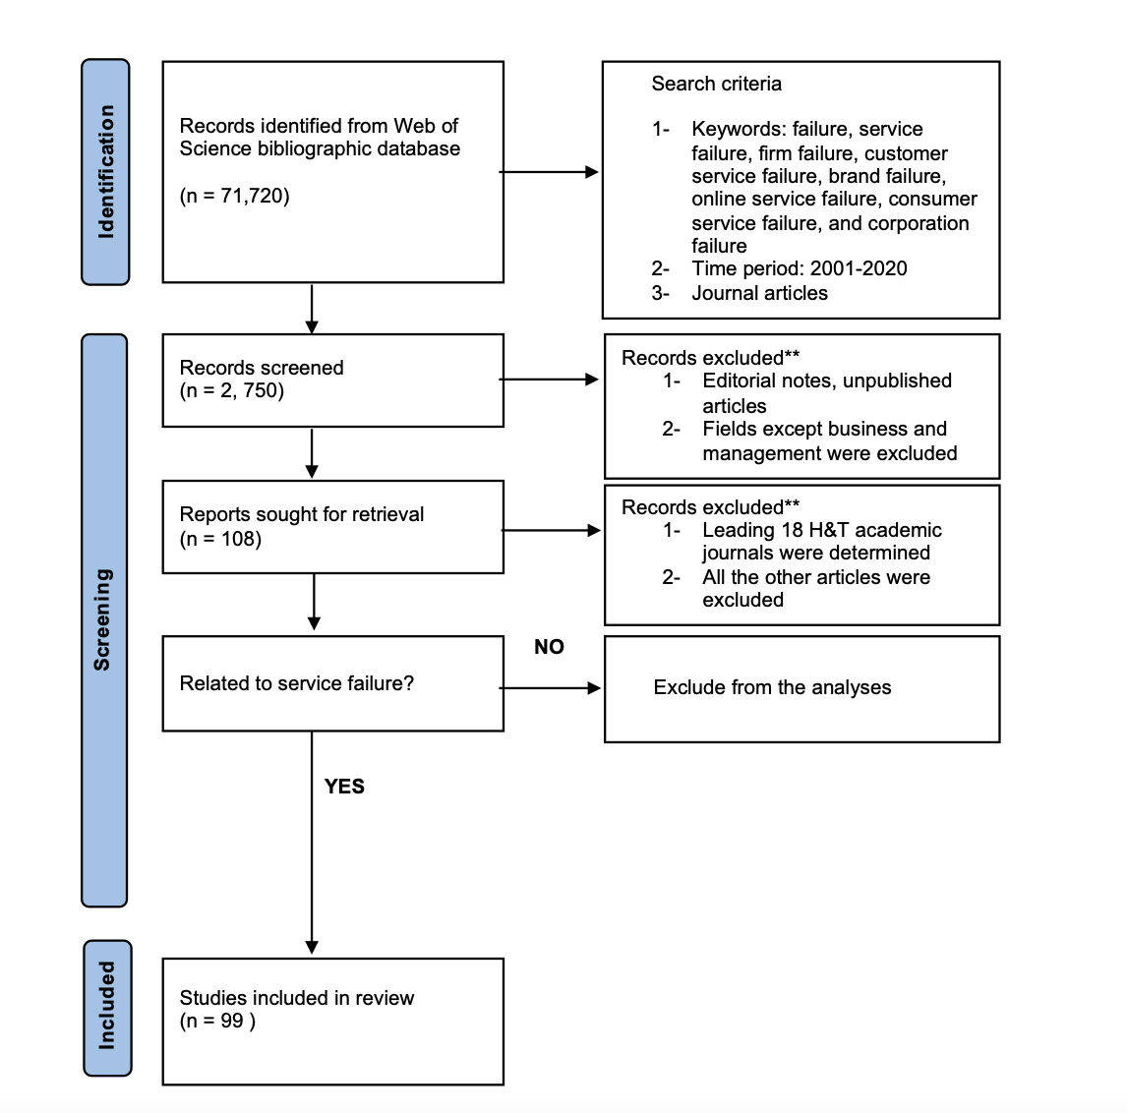

Figure 2: Journals selected for the study and the number of service failure articles published in the selected journals

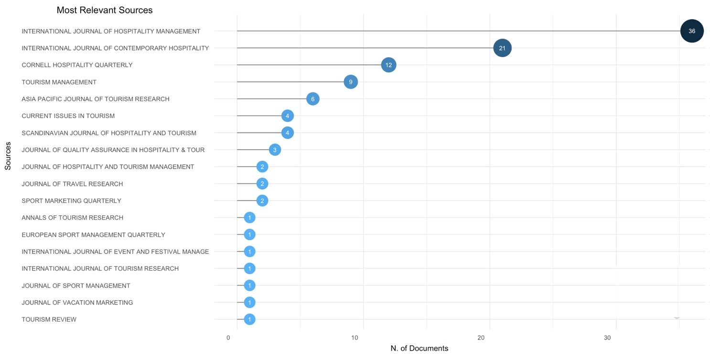

Figure 3: Source growth

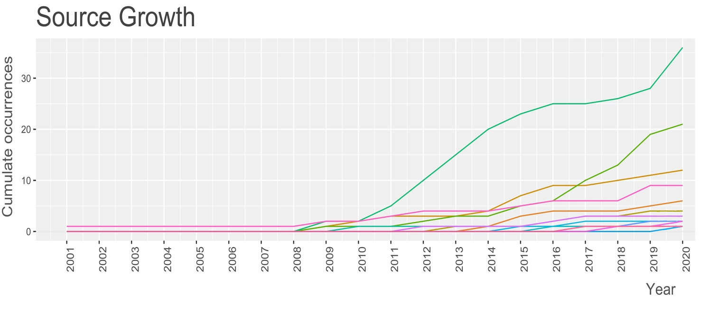

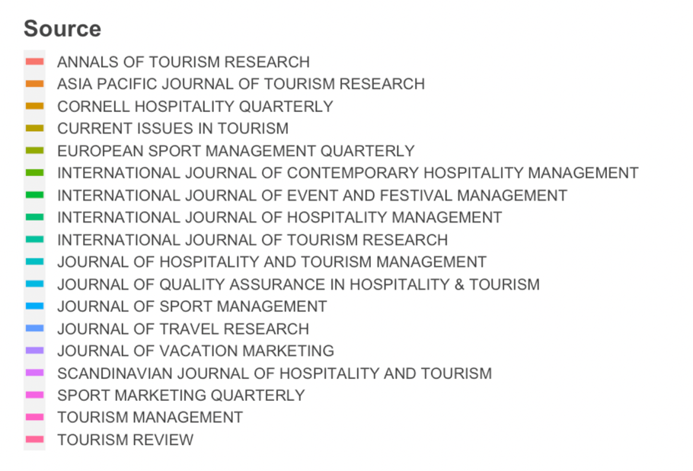

Figure 4: Annual Scientific Production

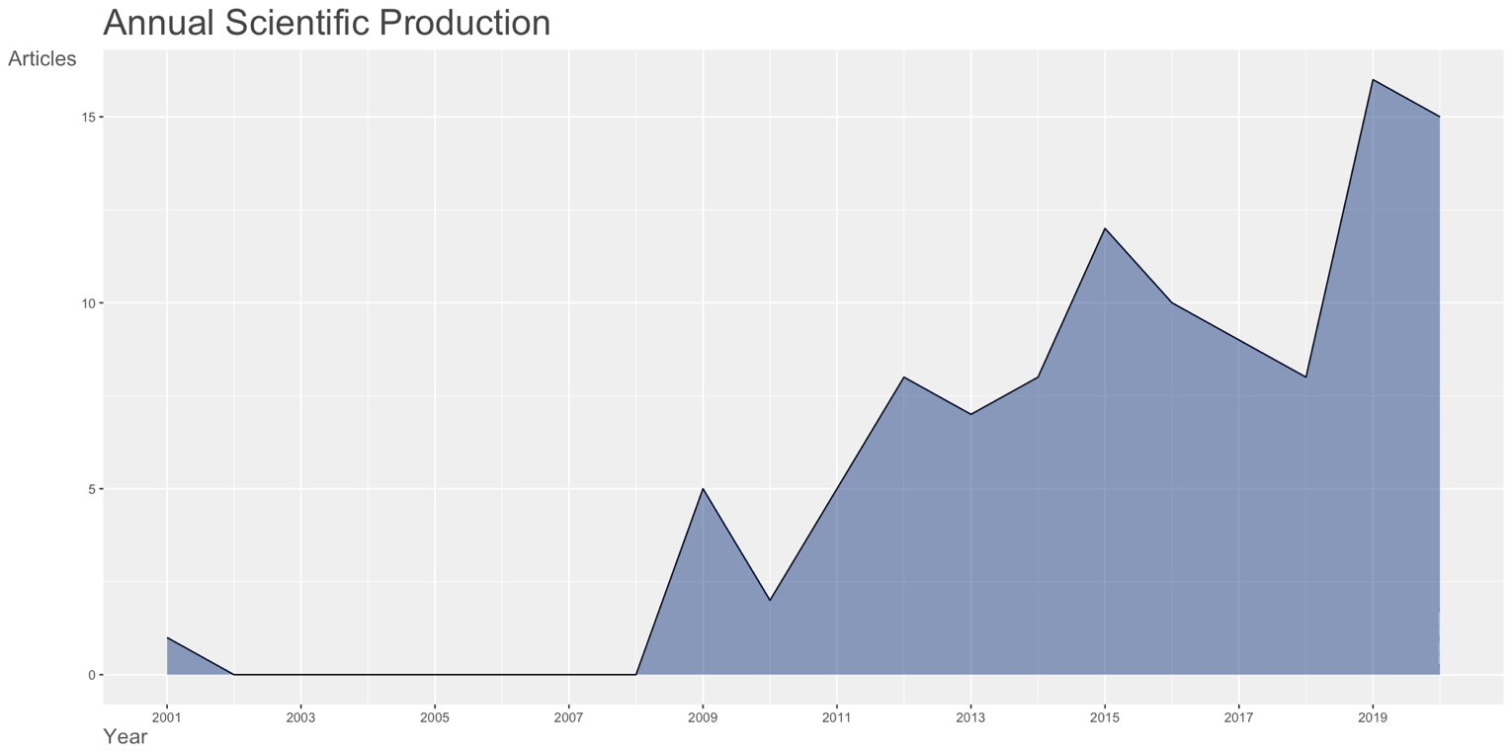

Figure 5: Theme and concept based on text-mining
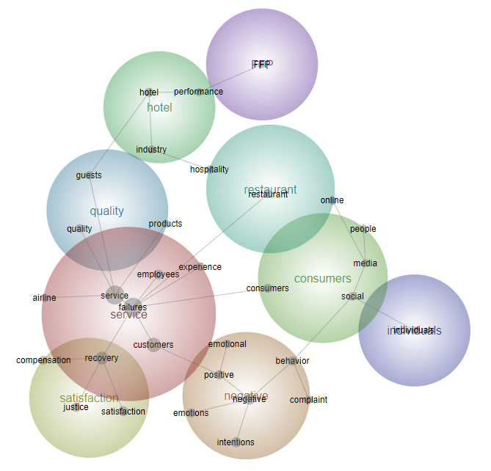

Figure 6: Thematic evolution of service failure in H&T over 2001-2020

Figure 7: Multidimensional scaling and hierarchical cluster analysis: Service failure knowledge structure

