**EXERCISE TECHNIQUE: THE PUSH PRESS**

**AUTHORS:**

Chris Bishop (MSc), Shyam Chavda (MSc, CSCS) and Anthony Turner (PhD, CSCS*D)

**AFFILIATIONS:**

London Sports Institute, Department of Science and Technology, Middlesex University, Allianz Park, Greenlands Lane, NW4 1RL

**CORRESPONDENCE:**

**Email:** [C.Bishop@mdx.ac.uk](mailto:C.Bishop@mdx.ac.uk)

**Tel No:** (+44)20 8411 4775

**Address:** London Sports Institute,Middlesex University, Allianz Park, Greenlands Lane, NW4 1RL

**INTRODUCTION**

Optimising power is considered an integral part of an athlete’s overall physical development, and strength and conditioning (S&C) coaches are continually searching for methods to enhance this physical attribute. Common methods include Olympic weightlifting and its derivatives (i.e., clean or snatch pulls, hang high pulls, jump shrugs) (14), plyometric training (12), and ballistic strength training (3), which collectively helps to target various points on the force-velocity curve. This mixed methods approach to athletic development has been deemed one of the most effective strategies for athletes, by virtue of ‘shifting the entire curve’ up and to the right as opposed to focusing solely on one part of it (8).

As with the majority of weight room exercises, this approach can also be applied to overhead lifting tasks (Table 1). Many athletes may not require a thorough competency for overhead movement patterns in their sport (such as outfield soccer players), and some coaches may consider associated exercises as ‘low priority’. However, there may be a case for developing such competency in these exercises; particularly the push press. Firstly, the lower body is characterised by an explosive triple extension of the hip, knee, and ankle joints (14) during this lift; the importance of which has been noted in athletic tasks such as sprinting, jumping, and changing direction. With such movements common, in both individual and team sport athletes, any exercise that develops this pattern may offer the chance for power to be improved. Accordingly, the push press has been shown to generate comparable lower body power outputs to other commonly used ballistic exercises such as the jump squat (11), and is most likely easier to coach and master compared to an exercise like the jerk. Therefore, regardless of whether an athlete’s sport requires such movement patterns, providing a sound rationale for understanding its benefit (particularly for power development) is the aim of this article. Consequently, the authors have provided descriptive instructions and pictures for different variations of the push press exercise.

*** INSERT TABLE 1 ABOUT HERE ***

**USING THE PUSH PRESS TO ENHANCE POWER DEVELOPMENT**

With optimal shoulder flexion range of motion reported to be 180° (10), it is important that coaches ensure that their athletes have adequate mobility prior to embarking on ballistic exercises, such as the push press. Typically, joint range of motion can be measured via goniometry, although it should be highlighted that there is likely to be some degree of error when coaches are familiarising themselves with the associated technique. It is suggested that all coaches undertake extensive practice with such methods to ensure results are consistent across multiple trials, as per regular data collection techniques (15). Assuming that optimal mobility is present, there is some emerging evidence to suggest that this exercise could be considered by practitioners as a useful tool for enhancing power output (11).

Lake et al. (11) investigated how power and impulse compared between the push press and jump squat exercises across loads of 10-90% (with 10% increment increases) of push press and back squat 1RM’s. Peak power and impulse were not significantly different between exercises; however, push press mean power (across loads) was significantly greater (~9.5%; *p* = 0.03) than the jump squat exercise. Similarly, Cushion et al. (4) investigated whether the jump squat and push jerk held biomechanical similarities to the countermovement jump (CMJ) under a variety of loads. It is acknowledged that the push press and push jerk are not the same exercise. However, they do hold biomechanical similarities by virtue of incorporating a dip and drive phase from the lower body to aid with both momentum and velocity during an overhead lifting task. Jump squat loads were once again determined as a percentage of 1RM back squat load and were performed at 10, 25, 35, and 50%. Push jerks were performed at 30, 50, 65, and 75% 1RM push jerk load. When analysed against the CMJ, few significant relationships existed between joint moments and joint impulse for either the jump squat or push jerk; although, more were present for the push jerk in terms of dynamic correspondence at the knee joint.

Although two different exercises are being compared in these studies (push press and push jerk), the underlying message showed some similarities. Cushion et al. (4) suggested that although load dependent, a greater mechanical similarity was observed between the push jerk and the CMJ (when compared to the jump squat exercise). Lake et al. (11) proposed that the mechanical demand during the push press was comparable to the jump squat. In addition, it was advocated that the push press may be a time efficient method for developing both lower body power and upper body/trunk strength competencies. Such improvements would be considered highly desirable by all S&C coaches.

Furthermore, the idea that the push press can promote trunk strength is an idea worth expanding on with future research. The trunk can be defined as the muscles of the abdominals, gluteal complex, lumbar and thoracic spine, and serve to connect movements from the lower body to the upper body (9). Aspe and Swinton, (1) observed greater abdominal muscle activation (2-7%) during an overhead squat, compared to the back squat under comparable loads. During overhead lifting tasks, it has been suggested that the abdominal muscles must work harder to maintain desired pelvic alignment; essentially contracting against the latissimus dorsi which is put on a stretch during bilateral overhead patterns (2). Thus, overhead ballistic tasks may be an alternative method for gaining additional conditioning of the trunk, which has been noted elsewhere in the literature (13).

In addition, and although anecdotal, there is undoubtedly a lower level of impact from the push press when compared to the jump squat exercise, potentially making it the preferred option. Factors such as joint/tendon health (especially at the knee) will be reduced, indirectly aiding as an injury prevention strategy by virtue of ‘safer exercise selection’. Finally, the notion of sequential force transference must also be considered. The ability of a single exercise to promote efficient transfer of force through the kinetic chain (whilst simultaneously improving an athlete’s power capabilities) facilitates advantages to total body conditioning. Considering numerous sports require effective transfer of force from the ground up (i.e., boxing, field hockey, tennis), the associated triple extension pattern seen with this ballistic overhead lifting task could prove to be a very useful tool for enhanced force and power properties. Therefore, it is the advice of the authors that this exercise be considered regardless of whether an athlete is exposed to overhead movement patterns in their sport or not.

**PERFORMING THE PUSH PRESS**

The push press is a ballistic strength exercise that can be divided into 3 phases: the dip, the drive, and the extension at the elbows. Whilst commonly used with a barbell from the ‘front position’ across the shoulders (Figures 1-3), variations exist including performing from behind the neck (Figures 4-6) and with the use of 2 dumbbells (Figures 7-9). Instructions on how to perform each phase have been provided in Table 2. Whilst dumbbells can be used as a viable alternative, the larger amount of instability when using two objects instead of one is likely to result in lower power output.

*** INSERT TABLE 2 ABOUT HERE ***

*** INSERT FIGURES 1-9 ABOUT HERE ***

**PRACTICAL APPLICATION**

By virtue of being considered a strength-speed exercise, the push press can likely be prescribed in both strength and power-orientated training blocks. With a key goal of enhancing lower body power output, it is advised that the number of repetitions be limited to ~4 per set to avoid large intra-set drop-offs in power (6). In addition, perfecting the push press holds advantages for further power development. The push jerk may be the logical ‘next step’ in further developing speed qualities by virtue of requiring increased speed to ‘drop under the bar’ during the catch phase. Where the push press can be seen to utilise momentum from the lower body to ‘drive the bar up’, the push jerk requires athletes to drop under the bar for the catch phase; thus, the speed component of the lift is greater. Whilst both the push press and push jerk require an explosive triple extension pattern, the drop underneath the bar characterises the key difference for the push jerk, resulting in reduced vertical bar displacement overhead. This reduced displacement may sound favourable (by virtue of having to ‘press the bar’ less); however, dropping under the bar provides an increased technical challenge, and athletes will likely require greater familiarisation with such a technique. Finally, adding the split component to the catch in the jerk can be seen as a further progression, and as such, provides a logical and holistic approach to developing power in overhead lifts.

It should be acknowledged that some variations of the push press may not be appropriate for all athlete populations. The behind the neck version places the shoulder joint in the ‘high five’ position (5), which has been suggested to potentially put the shoulder joint at risk of injury. Therefore, athletes with reduced shoulder flexion mobility (which would have been previously determined) or recent injuries to the shoulder complex, should avoid this variation. Whilst performing the exercise either from the front position or with dumbbells is likely favourable; in reality, optimal shoulder mobility should be achieved before any variation is attempted. Furthermore, understanding that improving mobility is a process that can take time, alternative options such as the jump shrug may provide a comparable alternative until optimal shoulder mobility has been achieved.

In summary, there is a paucity of literature pertaining to the push press exercise which would suggest that further research is warranted on this exercise in respect to power development. Early indications would suggest that it is comparable to commonly used exercises such as the jump squat for enhancing this physical attribute. However, to the authors’ knowledge, no research has investigated how the push press compares to Olympic lifts and its derivatives for power output; thus, this could be considered an area for future research. Despite the minimal literature associated with this exercise, the push press will likely improve an athlete’s power output, enhance conditioning of the trunk, provide a means of sequential force transference through the kinetic chain (which will also aid in upper body conditioning), and provide reduced impact on the knee joint in comparison to an exercise like the jump squat. With that in mind, regardless of whether a sport requires any overhead movement patterns, such benefits are all advantageous to any athlete’s overall physical development. The distinct lack of empirical data make it difficult to prescribe optimal training parameters for this exercise; however, the authors propose using between 3-5 sets, 2-5 repetitions, and 75-85% 1RM when trying to develop acyclical power. If trying to develop cyclical power, coaches can utilize 2-5 sets, 5-10 repetitions, with 60-80% 1RM. If being programmed as part of a strength training block, it is suggested that the push press is performed at the start of the programme, so as to optimize speed and power development. If programmed alongside additional speed/power lifts, its order is likely dependent on which other lifts are being conducted in the same session and the specified training goal at that time.

**REFERENCES**

1. Aspe R and Swinton, P. Electromyographic and kinetic comparison of the back squat and overhead squat. *J Strength Cond Res* 28: 2827-2836, 2014.
2. Bishop C, Villiere A, and Turner A. Addressing movement patterns by using the overhead squat. *Prof Strength Cond J* 40: 7-12, 2016.
3. Cormie P, McGuigan M, and Newton R. Adaptations in athletic performance after ballistic power versus strength training. *Med Sci Sports Ex* 42: 1582-1598, 2010.
4. Cushion E, Goodwin J, and Cleather D. Relative intensity influences the degree of correspondence of jump squats and push jerks to countermovement jumps. *J Strength Cond Res* 30: 1255-1264, 2016.
5. Escalante G. Exercise modification strategies to prevent and train around shoulder pain. *Strength Cond J* Post Author Corrections: 21 December, 2016.
6. Fleck S and Kraemer W. Advanced training strategies. In: *Designing resistance training programmes*. Anonymous, 4th Edition. Champaign, IL: Human Kinetics, 209-239, 2014.
7. Flores F, Sedano S, and Redondo J. Optimal load and power spectrum during the jerk and back jerk in competitive weightlifters. *J Strength Cond Res* 31: 809-816, 2017.
8. Haff G and Nimphius S. Training principles for power. *Strength Cond J* 34: 2-12, 2012.
9. Hedrick A. Training the trunk for improved athletic performance. *Strength Cond J* 22: 50-61, 2000.
10. Howe L and Blagrove R. Shoulder function during overhead lifting tasks: Implications for screening athletes. *Strength Cond J* 37: 84-96, 2015.
11. Lake J, Mundy P, and Comfort P. Power and impulse applied during push press exercise. *J Strength Cond Res* 28: 2552-2559, 2014.
12. McNeely E. Introduction to plyometrics: Converting strength to power. *NSCA’s Perf Train J* 6: 19-22, 2005.
13. Saeterbakken A and Fimland M. Muscle activity of the core during bilateral, unilateral, seated and standing resistance exercise. *Eur J Appl Physiol* 112: 1671-1678, 2011.
14. Suchomel T, Comfort P, and Stone M. Weightlifting pulling derivatives: Rationale for implementation and application. *Sports Med* 45: 823-839, 2015.
15. Turner A, Brazier J, Bishop C, Chavda S, Cree J, and Read P. Data analysis for strength and conditioning coaches: Using excel to analyse reliability, differences, and relationships. *Strength Cond J* 37: 76-83, 2015.

Table 1: Example overhead lifting exercises for different points on the force-velocity curve

|  |  |  |  |
| --- | --- | --- | --- |
| **STR** | **STR-SPD** | **SPD-STR** | **SPD** |
| Shoulder Press | Push Press | Push Jerk | M/B Overhead Toss |
| STR = Strength, STR-SPD = Strength-speed, SPD-STR = Speed-strength, SPD = Speed  M/B = Medicine Ball | | | |

Table 2: Instruction for the three phases of the push press exercise

|  |  |
| --- | --- |
| **PHASE** | **INSTRUCTIONS** |
| Dip | The dip is characterised by a countermovement involving simultaneous flexion of the hips, knees, and ankles. Total joint displacement should be small and performed under control at all times, ensuring that the bar is moving vertically down. Horizontal deviation of the bar during this phase is undesirable, and may be indicative of reduced force application vertically. Coaches should also be wary of athletes who ‘dip’ through their toes – feet should remain flat throughout this phase. Finally, a minimal amount of time should occur between the end of the dip and the start of the drive phase; thus, optimising the pre-loading strategy in preparation for vertical force application. |
| Drive | Initially, an explosive triple extension of the hips, knees, and ankles occurs vertically. Upon successful extension of the lower extremity joints, the momentum is used to accelerate the bar or dumbbells above the head as explosively as possible. It should be noted that the bar path may not be ‘strictly vertical’ when performed from the front position as the head must retract to allow for the accelerating bar path. However, if performed from behind the neck, it may be easier for the bar to travel in a completely vertical direction. In turn, this may facilitate higher levels of power which have been noted in comparable exercises such as the split jerk (6). |
| Extension of the Elbows | Full extension at the elbow joints is required to complete the lift and how easily that is achieved is dependent on load. Lake et al. (9) noted that peak power occurred at 81.3% of 1RM which is likely to elicit a faster elbow extension than loads of 95-100% 1RM. Coaches should be mindful of athletes who struggle to fully extend their elbows (due to fatigue within sets or mobility issues), which may result in increased risk of injury if the bar cannot be held in a safe position overhead. |

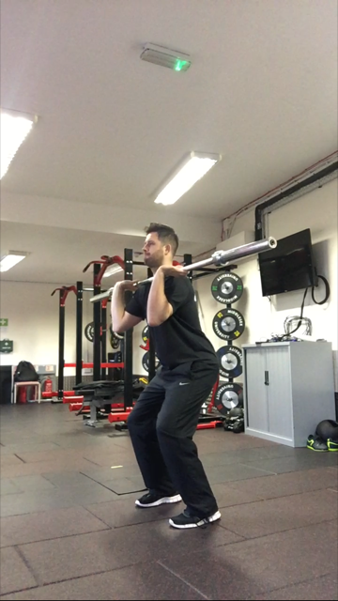 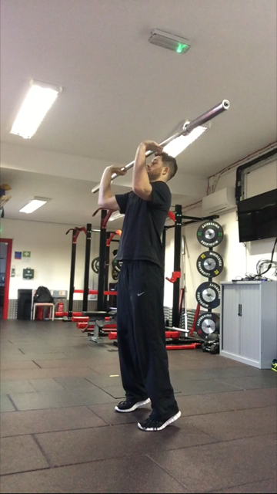 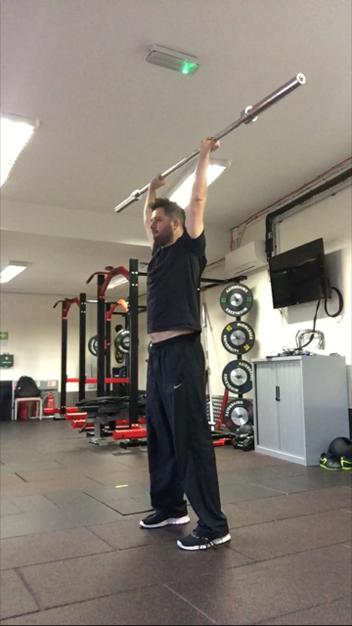

Figures 1-3: Example pictures of the dip, the drive, and the extension phases of the push press from the front position. The reader should note that the head must retract back during the drive phase (Figure 2) in order to facilitate a vertical bar path. In addition, Figure 3 demonstrates that the head returns to a neutral position once the elbows have been fully extended overhead.

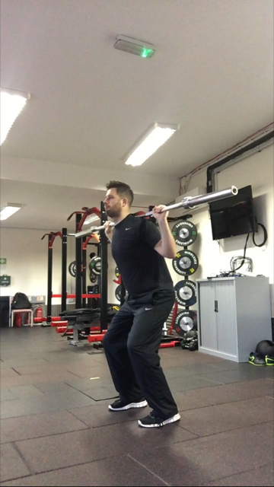 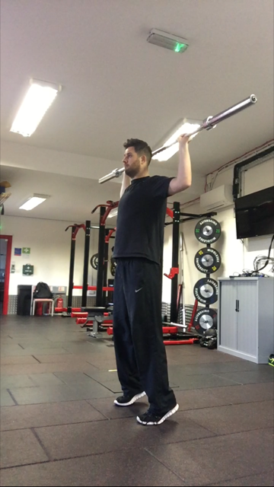 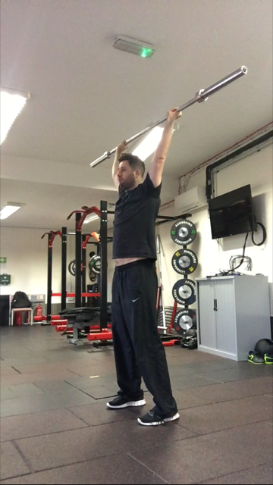

Figures 4-6: Example pictures of the dip, the drive, and the extension phases of the push press from the behind neck position. The reader should note the ‘high five’ position at the shoulder joint in Figure 5, which should be avoided for athletes with reduced shoulder flexion mobility or injuries.

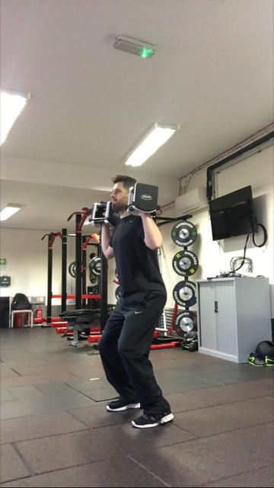 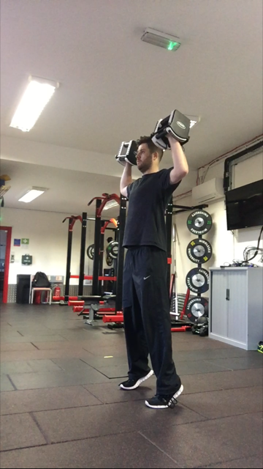 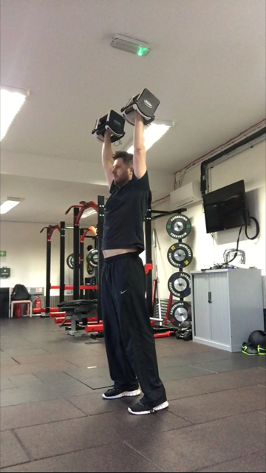

Figures 7-9: Example pictures of the dip, the drive, and the extension phases of the push press when using dumbbells. Readers are encouraged to try this variation regardless of whether a barbell is the preferred option. Performing the push press with two separate objects provides greater instability at the shoulder joint, which in turn may offer athletes some useful proprioceptive feedback when learning the exercise.