Factors influencing the infiltration of pharmaceuticals through soils

Tamas Balogh, Michael Revitt*, Huw Jones and Lian Lundy

Urban Pollution Research Centre, Middlesex University, The Burroughs, Hendon, London NW4 4BT, UK
*Corresponding author, e-mail m.revitt@mdx.ac.uk

ABSTRACT
Pharmaceuticals and personal care products (PPCPs) are emerging environmental contaminants but studies of their environmental fate have focused on their behaviour during wastewater treatment processes. Little is known about the behaviour of PPCPs in soils and this is important to provide an understanding of how these compounds will be distributed during the infiltration processes which occur both naturally and under a number of treatment procedures. In this study four PPCP compounds (bezafibrate, carbamazepine, chloramphenicol and diclofenac) have been selected for investigation to determine their mobility and leaching behaviour in two types of soils. Under experimental conditions, chloramphenicol showed the highest potential to leach through the soils followed by carbamazepine, bezafibrate and diclofenac, which mirrors the order of their increasing organic carbon adsorption coefficients (K_{oc}). The results suggest that ionic strength, pH and soil organic matter (SOM) are notable factors affecting the sorption and therefore the overall fate of pharmaceutical compounds in the soil environment.

KEYWORDS
Pharmaceuticals and personal care products (PPCPs), Soil, Sorption, Column leaching

INTRODUCTION
Pharmaceutical drugs and the ingredients in cosmetics, food supplements, and other personal care products, together with their respective metabolites and transformation products, are collectively referred to as PPCPs. The occurrence of PPCPs in the environment is increasingly causing concern and a number of significant scientific reviews have now been published (e.g. Halling-Sorensen et al. 1998; Daughton and Ternes, 1999; Kümmerer 2001; 2009a,b; Kasprzyk-Hordern et al 2009a,b). Non-point sources such as the effluents from sewage treatment plants, waste, landfill effluent and the veterinary treatment of animals have been shown to lead to low concentrations (ng/l to µg/l) of PPCPs in environmental samples such as surface waters (Kasprzyk-Hordern et al., 2009c) and groundwaters (Holm et al., 1995; Heberer and Stan, 1997; Sacher et al., 2001; Ternes et al., 2007). There is only limited information on their behaviour in soils although a range of veterinary medicines, including hormones, antibiotics, and parasiticides, have been detected at low concentrations in this environment. Soil and soil water can also be exposed to human pharmaceuticals through the use of digested sewage sludge as an agricultural fertilizer and through the irrigation of fields with treated wastewater (Oppel et al., 2004; Kay et al., 2005). Other contamination routes include the possible contact between soils and leakages from sewers and sewage treatment plants as well as inundation with receiving waters already polluted with PPCPs (Ellis and Revitt, 2002; Ellis 2006).

In this paper the fates of selected PPCPs in different types of soils have been investigated through a study of their sorption and transport processes using leaching column experiments. Infiltration plays an important role in both agricultural and urban water cycles and therefore an understanding of the interactions and fate of PPCPs in soil systems is important. In addition to furthering scientific knowledge the results from this study will provide advice to regulators on how to achieve the successful implementation of the EU Water Framework Directive, particularly with respect to controlling the environmental levels of a relatively new group of xenobiotics.

METHODOLOGY
The chemical structures, medical uses, some relevant physico-chemical parameters and environmental occurrences for the four selected PPCPs (bezafibrate, carbamazepine, chloramphenicol and diclofenac) are presented in Table 1. Bezafibrate is used world-wide as a lipid regulating drug. Carbamazepine is used in the treatment of epilepsy and has been detected at low µg/l levels in sewage treatment plant effluents. Chloramphenicol has been extensively used as an antimicrobial agent both in human and animal treatments. Diclofenac is a non-steroidal anti-inflammatory drug which is not completely removed by the sewage treatment process.

Table 1: Properties and environmental occurrence of selected PPCPs
Compound | Structure and CAS name | CAS RN  Molecular Weight  Formula | Use | pKa  Solubility  logK_{ow}  logK_{oc}* | Environmental Occurrence †
Bezafibrate | 2-(4-{2-[(4-chlorobenzoyl)amino]ethyl}phenoxy)-2-methylpropanoic acid | 41859-67-0  361.819 g/mol  C₁₉H₂₀ClNO₄ | Lipid regulator | 3.61  500 mg/l  4.25  2.5 | 3100 ng/l in surface water ^{(a)}  4600 ng/l sewage effluent ^{(b)}  53% removal efficiency in STP ^{(c )}
Carbamazepine | 5H-dibenzo[b,f]azepine-5-carboxamide | 298-46-4  236.269 g/mol  C₁₅H₁₂N₂O | Analgesic; antiepileptic | 13.4  112 mg/l  2.45  2.2-3.1 | 1100 ng/l in surface water ^{(a)}  6300 ng/l sewage effluent ^{(b)}  3% removal efficiency in STP ^{(c )}
Chloramphenicol | 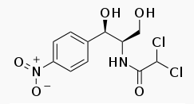  2,2-dichloro-N-[(1R,2R)-2-hydroxy-1-(hydroxymethyl)-2-(4-nitrophenyl)ethyl]acetamide | 56-75-7  323.132 g/mol  C₁₁H₁₂Cl₂N₂O₅ | Antibiotic; antimicrobial | 11.03  2500 mg/l  1.14  1 | 355 ng/l in surface water ^{(a)}  560 ng/l sewage effluent ^{(d )}  5-12% removal efficiency in STP ^{(c )}
Diclofenac | 2-(2-(2,6-dichlorophenylamino)phenyl)acetic acid | 15307-86-5  296.148 g/mol  C₁₄H₁₁Cl₂NO₂ | Analgesic/anti-inflammatory | 4.0±0.2  1113 mg/l  4.51  2.6 | 1200 ng/l in surface water ^{(a)}  2100 ng/l sewage effluent ^{(b)}  5-10% removal efficiency in STP ^{(c )}

*Reference: EPI Suite 2008
† maximum detected concentrations, Reference: a) Daughton and Ternes, (1999); b) Ternes (1998); c) Kasprzyk-Hordern et al., 2009c; d) Hirsch et al. (1999);

Soil samples for use in the column leaching experiments were collected from a site where there is a long term historical record of the soil types present and their key characteristics. One of the tested soils (Soil A) is an arable soil belonging to the Rowland Series and has been classified by Kay et al. (1936) as a medium clay loam with a mean pH of 7.2. Soil B is a lighter textured and more acidic soil (mean pH of 4.2) with a higher organic content and constitutes an acidic version of the Sonning Series. Table 2 identifies the important characteristic properties and the particle size distributions of soils A and B.

Table 2: Measured characteristic properties of soils A and B.
Soil | pH | MWHC (%) | LOI (g/100g soil) | TOC (ppm) | Particle size distribution (%)*
A | 7.22 (± 0.05) | 44.3 (± 3.8) | 2.53 (± 0.02) | 8285 (± 331) | Sand (2-0.02 mm)  Silt (<0.02-0.002 mm)  Clay (<0.002 mm) | 73  23  4
B | 4.22 (± 0.01) | 12.0 (± 1.0) | 8.26 (± 0.06) | 36494 (± 2686) | Sand (2-0.02 mm)  Silt (<0.02-0.002 mm)  Clay (<0.002 mm) | 82  16  2
MWHC: Maximum Water Holding Capacity, LOI: Loss on Ignition, TOC: Total Organic Carbon content. Each experiment carried out in replicates, values in brackets show the standard deviation.
* Soil size fractions used are defined according to the International Soil Science Society

The vertical soil column leaching experiments were designed according to the OECD guidelines (OECD, 2004). Glass columns (length 200 mm; diameter 50 mm) were carefully packed with 200 g of sieved soil (< 2 mm). Glass wool and glass beads (50 g, 3.5 mm) were placed in the bottom of each column to prevent soil loss and to filter the leachate samples. The soil was saturated from below and pre-equilibrated overnight with artificial rainwater (0.01 M CaCl₂). 20 µg of each pharmaceutical was applied as an aqueous solution to the top of each column and allowed to diffuse into the upper soil layer. A layer of glass wool and glass beads (25 g) was placed on top of each column to protect the soil columns from disturbance by the incoming eluent.

The complete leaching experiment was performed twice and on each occasion repeated 3 times for each soil with an extra soil column acting as a control. Leachate samples were collected daily over a period of 12 days after the application of 100 ml of eluent. The leaching solution for two of the columns was maintained as 0.01 M CaCl₂ but for the remaining column and the control column the eluent was changed to a higher ionic strength solution (0.1 M NaCl) after 7 days. Leachate samples from two consecutive days were combined prior to TOC analysis (20 ml subsample) and determination of the PPCP concentrations following solid phase extraction. At the end of the leaching process, the soil columns were carefully removed and divided into soil depths of 0-1 cm, >1-2 cm, >2-3 cm, >3-5 cm, >5-7 cm and >7 cm. After air drying, the PPCPs were extracted ultrasonically using methanol. All extracted samples were concentrated prior to analysis using liquid chromatography/mass spectrometry.

Chromatographic separation of the PPCPs was achieved using reverse phase chromatography on a Kinetex 2.6u C18 (50 mm x 2.1 mm) analytical column. The mobile phases were 0.1% formic acid in water (Solvent A) and 0.2 % formic acid in acetonitrile (Solvent B). The flow rate was 0.3 ml/min and the column temperature was set to 35ºC. The sample injection volume was 10 µl. The applied solvent gradient started at 2% B where it was held for 1.6 minutes followed by a gradual increase to 75% B over 10.4 minutes and held for 1 minute before reduction to 2% B maintained until the end of the 16 minute analysis.

RESULTS AND DISCUSSION
The mass balance for each PPCP was calculated by summarising all measured data from both soil and leachate samples for each column. Then the average values for both soil A and soil B columns were determined and compared to the originally applied 20 µg of each pharmaceutical compound to calculate the recovery percentages. The results are presented in Table 3 and show that a recovery of over 90% was achieved for carbamazepine compared with around 50% for bezafibrate and diclofenac and less than 30% for chloramphenicol. The presence of moisture and microorganisms are possible reasons for the losses identified for chloramphenicol, bezafibrate and diclofenac.

Table 3: Recoveries of PPCPs at the conclusion of the leaching experiments.
 | Column A (µg) | Column A (%)* | Column B (µg) | Column B (%)*
Bezafibrate | 11.36 ± 2.0 | 56.8 | 8.47 ± 4.3 | 42.4
Carbamazepine | 18.11 ± 3.5 | 90.5 | 21.40 ± 1.2 | 107.0
Chloramphenicol | 4.19 ± 1.2 | 20.9 | 6.17 ± 1.2 | 30.8
Diclofenac | 11.82 ± 2.0 | 59.1 | 10.68 ± 3.9 | 53.4
Mean +/- standard deviation for recoveries;
* Percentage of the 20 µg originally applied.

The total organic carbon (TOC) content of the leachates was determined as soil organic matter is an important factor affecting the sorption of organic compounds and thus the ultimate fate of pharmaceuticals in the soil matrix. Green et al. (2009) have examined the effect of salt and dissolved organic carbon on the sorption characteristics of compounds in soil and found that enhanced mobilization of organic matter can occur in soils due to the presence of sodium chloride which, in turn, can lead to the release of PPCPs. The impact of changing the leaching solution to 0.1M NaCl on the mobilization of organic matter in soils A and B is clearly shown in Figure 1. With CaCl₂ as the leaching solution there is a progressive decrease in organic carbon leaving the column but an increase in the mobilisation of organic carbon is clearly evident for both soils when NaCl is introduced after day 7-8. This phenomenon has an enhancing effect on the leaching rate of PPCPs and is particularly noticeable for soil A.

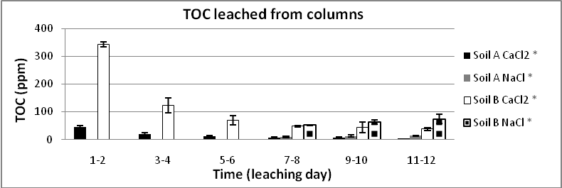
Up to day 7, each bar represents the mean of results from six columns; from day 7 each bar is the average of three results; Error bars represent +/- standard deviation; *CaCl₂ indicates that only 0.01M CaCl₂ was used for leaching; * NaCl means that from leaching day 7, artificial rainwater was changed for 0.1M NaCl solution

Figure 1: TOC concentrations in soil column leachates over 12 days

Figures 2 and 3 illustrate the leaching behaviours in the two soils of four PPCPs (bezafibrate, carbamazepine, chloramphenicol and diclofenac) over the 12 day experiments. In both figures, the grey bars represent the situation when the columns were percolated with only 0.01 M CaCl₂ and the white bars indicate the impact of switching to 0.1 M NaCl. Figure 2 shows the average percentage of the PPCP that leached through the soil column; only grey bars are shown during the first six days as only artificial rainwater was used during this time. Figure 3 identifies the average percentage distributions of the PPCPs remaining in the soil columns at the end of the 12 day leaching period.

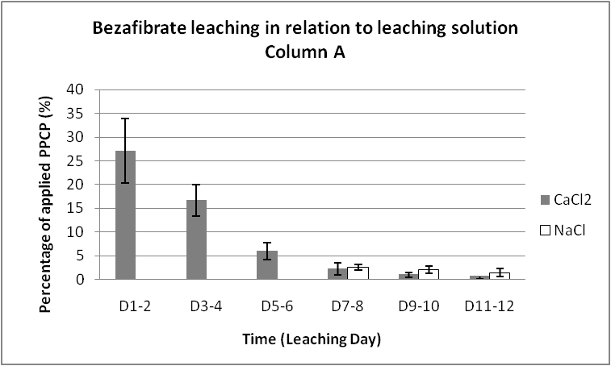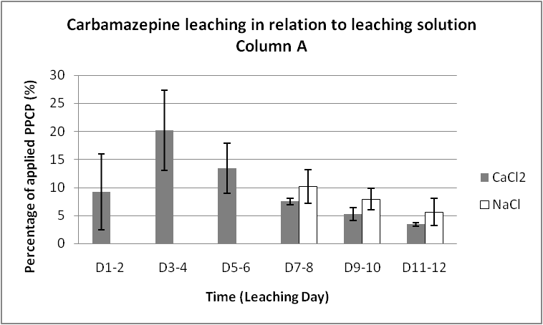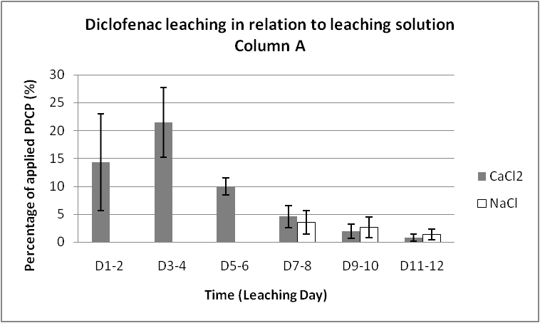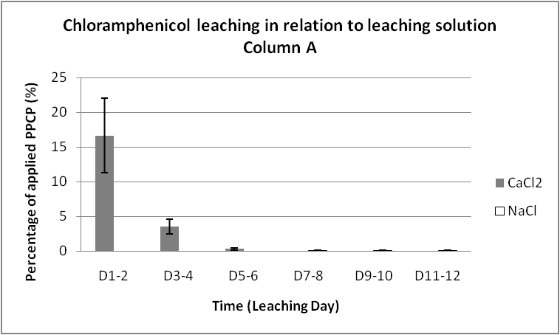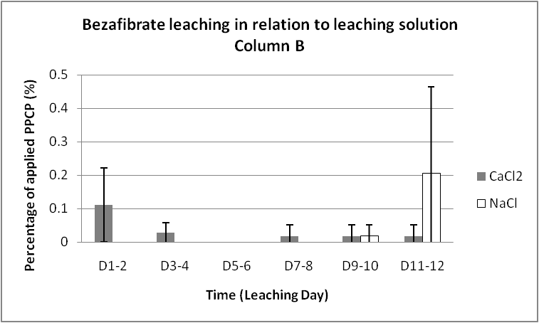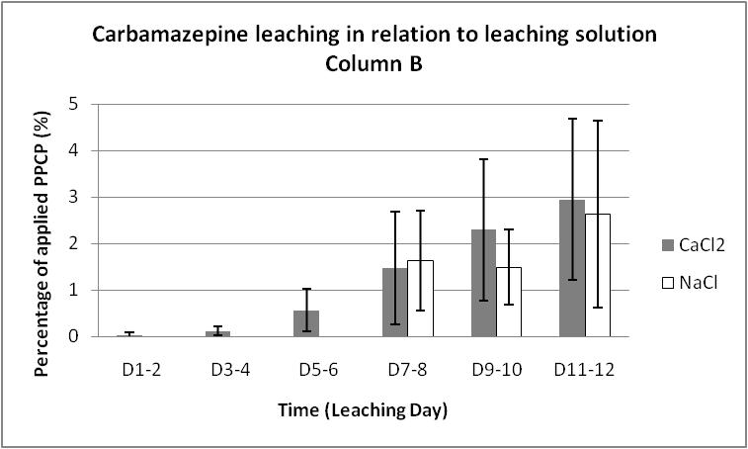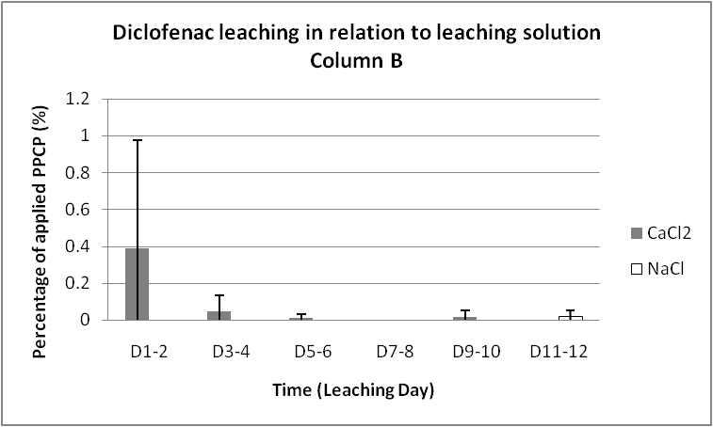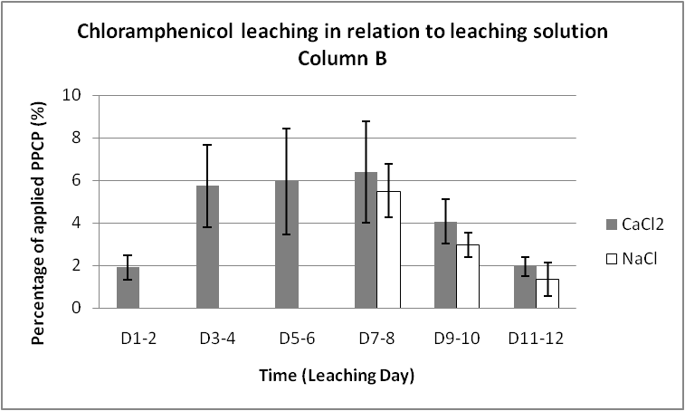

Error bars are plotted on each histogram representing +/- standard deviation.

Figure 2: The percentage of PPCPs in the leachate from soils A and B over 12 days.

The detected amounts of each PPCP compound in both solid and aqueous phases with regard to the leaching experiment are summarised in Table 4. Each value represents an average percentage of the originally applied 20 µg of each PPCP to triplicate columns. The behaviours of bezafibrate, carbamazepine and diclofenac in the soil A columns indicate a clear preference for the leachate whereas in soil B they were more strongly retained by the solid phase. The retention of chloramphenicol was less affected by the soil type, although there was a marginally greater affinity for the solid phase for soil B. The results clearly show different behaviours for the PPCPs in the two soils with soil A facilitating a greater mobility than soil B. The latter retains the majority of the applied PPCPs except chloramphenicol, which demonstrates only minimal retention.

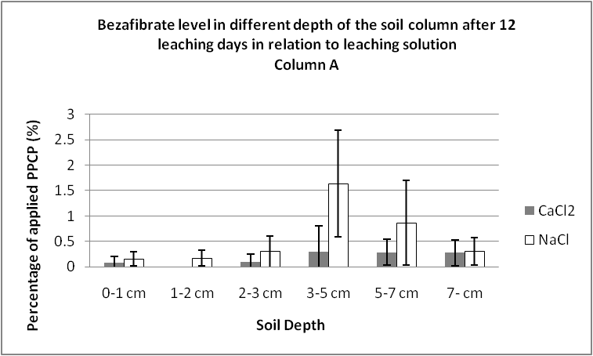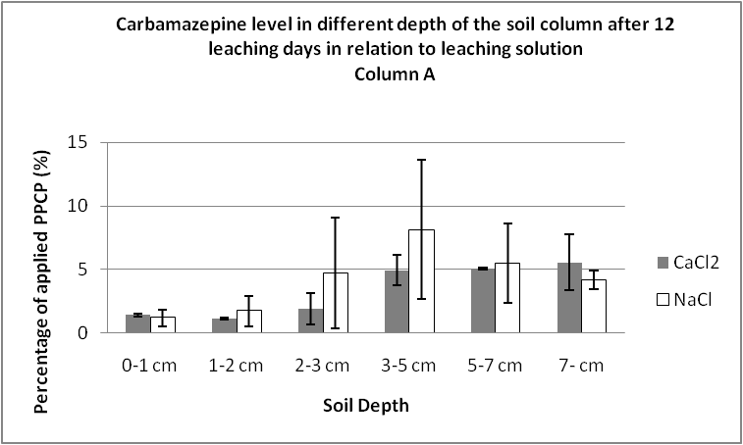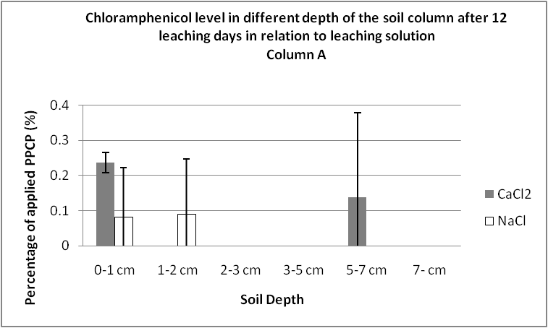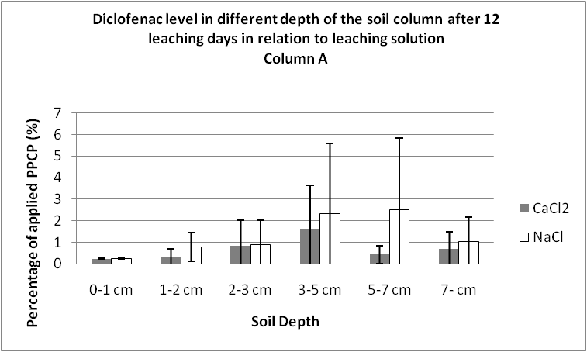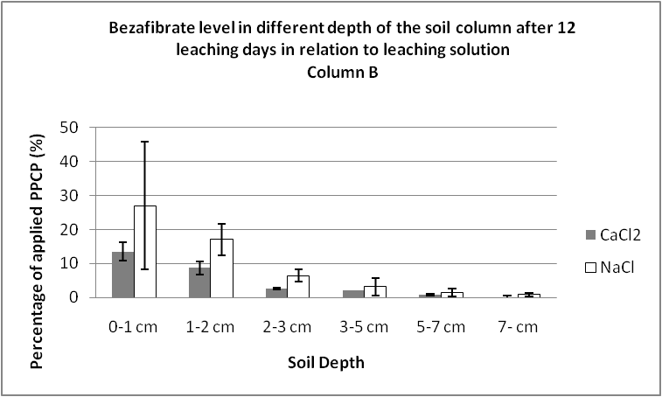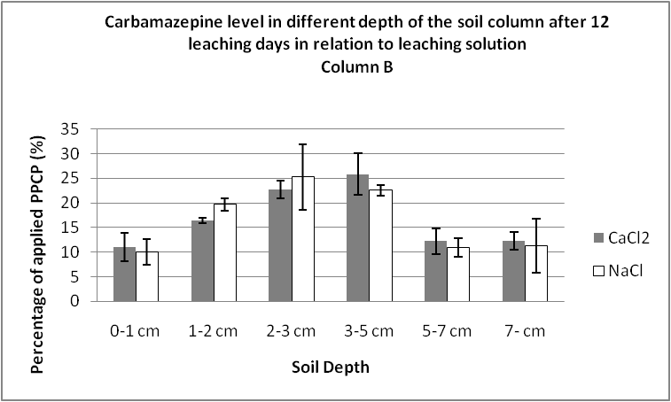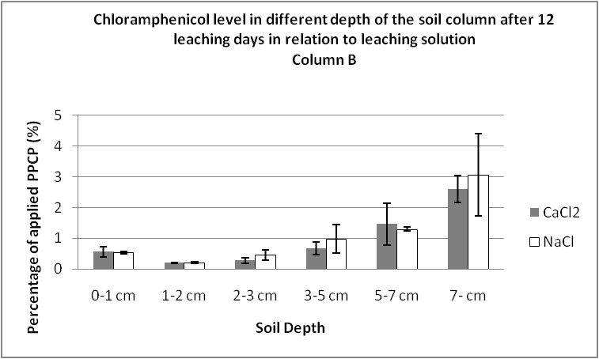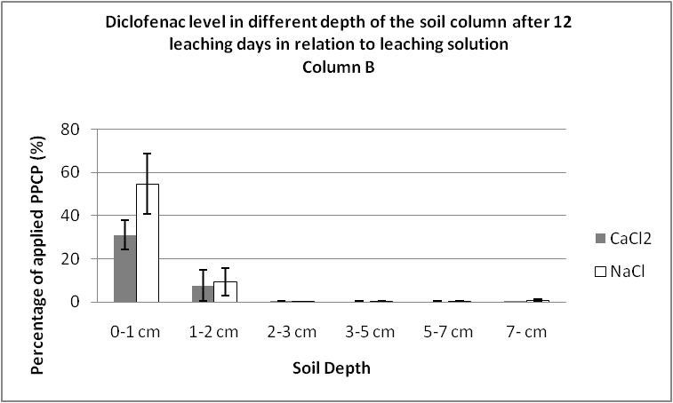

Each bar represents the average percentage (together with +/- standard deviation) for triplicate columns

Figure 3: The percentage of the PPCPs remaining in soils A and B at different depths after leaching for 12 days.

Table 4: The average percentage distributions of four PPCPs between leachate and two different soils
PPCP | Leachate |  |  |  | Soil
PPCP | A CaCl₂ | A NaCl | B CaCl₂ | B NaCl | A CaCl₂ | A NaCl | B CaCl₂ | B NaCl
Bezafibrate | 50.98 ± 9.94 | 58.21 ± 7.73 | 0.17 ± 0.20 | 0.39 ± 0.39 | 1.02 ± 0.77 | 3.43 ± 2.19 | 28.09 ± 3.90 | 56.07 ± 22.45
Carbamazepine | 50.53 ± 4.64 | 75.00 ± 29.98 | 7.37 ± 4.96 | 6.53 ± 4.47 | 30.04 ± 17.29 | 25.49 ± 15.47 | 100.42 ± 4.96 | 99.67 ± 0.77
Chloramphenicol | 18.51 ± 2.67 | 22.81 ± 8.75 | 26.94 ± 9.05 | 22.44 ± 3.85 | 0.38 ± 0.23 | 0.17 ± 0.15 | 5.77 ± 1.26 | 6.54 ± 1.71
Diclofenac | 47.35 ± 6.94 | 58.90 ± 15.66 | 0.20 ± 0.31 | 0.72± 0.78 | 4.12 ± 4.00 | 7.79 ± 8.57 | 40.28 ± 10.34 | 65.62 ± 18.90
Mean values ± standard deviation of triplicate samples

The sorption behaviour of organic compounds to soils is governed by properties such as water-solubility, acidity, molecular size and shape, the acidity/basicity of the functional groups, and the polarity and charge of the molecules. The K_{oc} coefficients for the selected PPCPs increase in the order: chloramphenicol < carbamazepine < bezafibrate < diclofenac (see Table 1) and these values mirror their observed behaviour during the leaching experiments particularly for soil B. Also factors such as soil particle size, pH-value (see Table 2), water holding capacity and speed of drainage will control the soil transport process, but these variables were regulated as thoroughly as possible throughout the leaching experiments. For example, soil size fractions of less than 2 mm were used and the flow rate of the leaching solution was controlled to approximately 40 ml/hour.

Both of the soils contain over 70 % in the sand fraction and soil B has a slightly lighter texture. However, the main difference between soils A and B is the higher organic content and lower pH of the latter. It seems that these factors are responsible for the greater retention of the PPCP compounds. This is in agreement with the studies carried out by Williams and Adamsen (2006), Ternes et al. (2007), Chefetz et al. (2008), Yu et al. (2009) and Xu et al. (2009), among others who suggest that ionic strength, pH and SOM are notable factors affecting the sorption and therefore the overall fate of pharmaceutical compounds in the soil environment. Soil pH influences the adsorption of weak acids and bases such that at low pH-values, weak bases in the cationic form are adsorbed to a higher extent than free bases. This is demonstrated by chloramphenicol with regard to its greater retention by soil B. Also weak acids like bezafibrate and diclofenac have stronger sorption at low pH. However soil properties such as the pH-value and the type and amount of clay content have only a small effect on the sorption process except in soils with low organic matter content. In soil B the organic matter content is over 3.6% and this appears to be the strongest factor influencing the behaviour of the PPCP compounds. An additional important factor in soils is biodegradation and this is currently being further investigated with preliminary results suggesting that it appears to be an important mechanism for the removal of chloramphenicol.

CONCLUSIONS
The fate of selected PPCPs in the soil environment has been investigated in soil column leaching experiments. Four PPCP compounds (bezafibrate, carbamazepine, chloramphenicol and diclofenac) were selected for investigation to determine their mobility in two types of soils. The measured recoveries suggest that there are additional factors influencing the behaviour of PPCPs in the soil environment and biodegradation is currently being investigated. The results suggest that ionic strength, pH and SOM are notable factors affecting the sorption and therefore the overall fate of pharmaceutical compounds in the soil environment. Chloramphenicol demonstrated the highest mobility in both soils followed by carbamazepine, bezafibrate and diclofenac, which corresponds to the order of their increasing K_{oc} coefficients. Soil A showed less retention for the compounds than soil B. The higher acidity and organic content associated with soil B contribute to a greater retention of PPCPs compared to soil A. Hence it possesses a greater soil filtering capacity and the potential to remove selected PPCPs in processes related to water quality protection, wastewater treatment and stormwater management.

REFERENCES
Chefetz B, Mualem T, and Ben-Ari J. (2008). Sorption and mobility of pharmaceutical compounds in soil irrigated with reclaimed wastewater. Chemosphere, 73(8),1335–43.
Daughton, C.G. and Ternes, T.A. (1999). Pharmaceuticals and personal care products in the environment: agents of subtle change? Environ Health Persp, 107, 907–938.
Ellis, J.B. (2006) Pharmaceutical and personal care products (PPCPs) in urban receiving waters, Environ Pollut 144, 184-189
Ellis, J.B. and Revitt, D.M. (2002). Sewer losses and interactions with groundwater quality. Wat Sci Technol 45 (3), 195-202
EPI Suite (2008). US EPA Ecological Structure Activity Relationships program (ECOSAR). Downloaded from the www page: http://www.epa.gov/oppt/newchems/21ecosar.htm; visited 3 August 2009.
Green, S. M., Machin, R., Cresser, M. S. (2009). Does road salting induce or ameliorate DOC mobilisation from roadside soils to surface waters in the long term? Environ Monit Assess 153, 435–448
Halling-Sorensen, B., Nors Nielsen, S., Lanzky, P.F., Ingerslev, F., Holten Lutzhoft, H.C., Jorgensen, S.E. (1998). Occurrence, fate and effects of pharmaceutical substances in the environment—a review. Chemosphere 36 (2), 357–393.
Heberer, T.and Stan, H.J. (1997). Determination of clofibric acid and N-(phenylsulfonyl)-sarcosine in sewage, river and drinking water. Int. J. Environ. Anal. Chem. 67 (1–4), 113–123.
Hirsch, R., Ternes, T., Haberer, K. and Kratz, K.L. (1999). Occurrence of antibiotics in the aquatic environment. Sci. Total Environ. 225 (1/2), 109–118.
Holm, J.V., Rugge, K., Bjerg, P.L. and Christensen, T.H. (1995). Occurrence and distribution of pharmaceutical organic-compounds in the groundwater downgradient of a landfill (Grindsted, Denmark). Environ. Sci. Technol. 29 (5), 1415–1420.
Kasprzyk-Hordern, B., Dinsdale, R.M. and Guwy, A.J. (2009a), Illicit drugs and pharmaceuticals in the environment – Forensic applications of environmental data. Part 1: Estimation of the usage of drugs in local communities, Environ Pollut 157, 1773-1777
Kasprzyk-Hordern, B, Dinsdale, R.M. and Guwy, A.J. (2009b). Illicit drugs and pharmaceuticals in the environment – Forensic applications of environmental data, Part 2: Pharmaceuticals as chemical markers of faecal water contamination, Environ Pollut 157, 1778-1786
Kasprzyk-Hordern, B, Dinsdale, R.M. and Guwy, A.J. (2009c). The removal of pharmaceuticals, personal care products, endocrine disruptors and illicit drugs during wastewater treatment and its impact on the quality of receiving waters, Water Res 43, 363 – 380
Kay, F.F. (1936) A soil survey of the University Farm, Sonning, Berkshire. University of Reading
Kay, P, Blackwell, P.A. and Boxall, A.B.A. (2005). Column studies to investigate the fate of veterinary antibiotics in clay soils following slurry application to agricultural land. Chemosphere 60, 497–507
Kummerer, K. (2001). Drugs in the environment: emission of drugs, diagnostic aids and disinfectants into wastewater by hospitals in relation to other sources—a review. Chemosphere 45 (6/7), 957–969.
Kummerer, K. (2009a). Antibiotics in the aquatic environment – A review – Part 1. Chemosphere, 75(4), 417-434.
Kummerer, K. (2009b). Antibiotics in the aquatic environment – A review – Part II. Chemosphere, 75(4), 435-441.
OECD (2004) Guidelines for the Testing of Chemicals, Test No.312, Leaching in Soil Columns.
Oppel J, Broll G, Löffler D, Meller M, Römbke J, Ternes T. (2004). Leaching behaviour of pharmaceuticals in soil-testing-systems: a part of an environmental risk assessment for groundwater protection. Sci Total Environ; 328(1-3):265-73.
Sacher, F., Lange, F.T., Brauch, H.-J., Blankenhorn, I. (2001). Pharmaceuticals in groundwaters: analytical methods and results of a monitoring program in Baden-Wurttemberg, Germany. J. Chromatogr. A 938 (1/2), pp. 199–210.
Ternes, T.A. (1998). Occurrence of drugs in German sewage treatment plants and rivers, Water Res., 32 (11), 3245–3260.
Ternes, T.A., Bonerz, M., Herrmann, N., Teiser, B., Andersen, H.R. (2007). Irrigation of treated wastewater in Braunschweig, Germany: An option to remove pharmaceuticals and musk fragrances, Chemosphere 66, 894–904
Williams C.F.and Adamsen, F.J. (2006). Sorption-desorption of carbamazepine from irrigated soils. J Environ Qual, 35(5), 1779-1783
Xu, J., Wu, L. and Chang, A.C. (2009). Degradation and adsorption of selected pharmaceuticals and personal care products (PPCPs) in agricultural soils, Chemosphere 77, 1299-1305
Yu L, Fink G, Wintgens T, Melin T and Ternes T. (2009). Sorption behavior of potential organic wastewater indicators with soils. Water Res, 43(4):951–60.

