Is baseline aerobic ﬁtness associated with illness and attrition rate in military training? ***1Dimitriou L, 2Lockey J W, 2Castell LM London Sports Institute, Middlesex University, UK; Green Templeton College, University of Oxford, UK***

**Middlesex University, London, UK 2Green Templeton College, University of Oxford, Oxford, Oxon, UK**

**Correspondence to Dr Lygeri Dimitriou, London Sport Institute, Middlesex University, London, NW4 1RL, UK;** [**L.Dimitriou@mdx.ac.uk**](mailto:L.Dimitriou@mdx.ac.uk)

**ABSTRACT**

Respiratory illnesses are a leading cause of morbidity and medical discharge in the military. This study aimed to investigate the effects of baseline aerobic ﬁtness on haematological, salivary and mood variables, and simultaneously, in a novel approach, to identify factors precipitating illness and attrition rate in recruits during military training.

Thirty-ﬁve healthy male recruits from an Army Training Regiment undertaking 12 weeks of training were prospectively investigated. Their 2.4 km run time (RT) was used as a surrogate of baseline aerobic ﬁtness. Saliva and venous blood samples were analysed for secretory IgA, full blood counts and cell cytokine production (interleukin (IL) 6 and IL-8), respectively. Each recruit completed questionnaires on mood proﬁle, and gastrointestinal and upper respiratory tract symptoms (URTS).

Signiﬁcant salivary and haematological perturbations were observed and coincided with increased duration of URTS/week and mood disturbance over this military training period. From Start to End: leucocyte count decreased by 28% (p<0.001); neutrophil percentage (%) decreased by 13% (p<0.01); lymphocyte % increased by 17% (p<0.05); the neutrophil:lymphocyte ratio decreased by 22% (p<0.01); eosinophil% increased by 71% (p<0.01). From Start to Mid to End: monocyte% increased by 68% at Mid (p<0.01) but only by 30% at End (p<0.01); IL-6 increased by 39% at Mid (p<0.01) and a further 61% by End. The 2.4 km RT was signiﬁcantly associated with URTS duration (p<0.01). In addition, a 1-min increase in 2.4 km RT increased a recruit’s risk 9.8-fold of developing URTS lasting, on average, 3.36 days/week. In recruits ranked with high-URTS duration their RT was 48 s slower (p<0.01) than those with low-URTS, and their attrition rate reached 45%.

The least ﬁt recruits may have found training more physically demanding as reﬂected in the higher URTS duration, which may have led to a high attrition rate from the Army. It is worth considering that baseline aerobic ﬁtness might be an important factor in illness development and attrition rate in recruits during this type of military training.

**INTRODUCTION**

Both historically and currently, respiratory illnesses are a leading cause of morbidity and medical discharge in the military. The increased incidence of infectious disease, illness and particularly upper respiratory tract illness in military personnel during operations and training is well documented.1–9 Military training may include strenuous and prolonged physical exercise, psychological stress, sleep deprivation, insufﬁcient energy intake and recovery times. The synergism of these stressors combined with close contact and exposure to challenging environments may impair immune function, leading to increased illness, disease epidemics, medical discharge and subsequent attrition.1–8

In 1951 Sartwell9 suggested that recruits may be more susceptible to illness compared with ‘seasoned’ personnel. Subsequent studies have identiﬁed an increased incidence of upper respiratory tract illness, haematological and endocrinological changes in military personnel during training, and increased dropout rates.1 2 4 –7 However, there is little consistency between studies on military personnel and trainees. Discrepancies include duration and intensity of training, biochemical methods, baseline ﬁtness levels, psychological state, subject variability and diet. Identifying precipitating factors involved in the large intraindividual and/or interindividual variability of susceptibility to infection and of the immune response to physical training10 11 might help to minimise attrition rates and promote successful military training.

Strenuous, prolonged exercise is linked with changes in plasma volume,12 cell numbers and function, including transient immunodepression, as well as transient changes in plasma cytokine concentrations such as interleukins 6 and 8 (IL-6 and IL-8).13 14 A high incidence of upper respiratory tract illness has also been reported after endurance events such as marathons,15–18 but Spence et al19 observed that only a third of athletes displaying respiratory symptoms had an illness of pathogenic origin. Other pathophysiological mechanisms to be considered include exercise-induced hyperpnoea possibly leading to airway dehydration injury,20 subsequent airway inﬂammation,21 22 allergy,18 psychological impacts of exertion on immunity,23 limitations of pathogen detection techniques or as yet unknown pathogens.20

After strenuous exercise, IgA decreases in both blood and oronasal mucosa10 24 25 and low secretory IgA (sIgA) in saliva is associated with increased upper respiratory tract illness.11 26 In football players during training, the illnesses reported were consistently preceded by decreased sIgA which coincided with increased training load.27 28 Interestingly, 82% of the illnesses reported were associated with a preceding decrease in sIgA.27 In contrast, no such associations were observed during basic military training.29 Saliva ﬂow rate (Salfr) and sIgA are inversely correlated30 which may partly explain observed discrepancies in the association between sIgA and infections.

Finally, mood disturbance is associated with increases in training load, haematological and biochemical changes, insufﬁcient recovery, fatigue, illness, depression and underperformance in athletes23 31 32 and soldiers.33 A higher level of mental toughness in combat controller trainees with high aerobic and anaerobic ﬁtness has been reported.34

Military personnel involved in training or operations routinely experience sleep and eating pattern disruptions, and extreme stress,7 compared with athletes who are often well rested, receive sport-speciﬁc diets and psychological support. In training and combat simulations, military personnel also suffer injuries and abrasions which may contribute to increased illness and infections. The aims of this study were therefore to investigate the effects of baseline aerobic ﬁtness on haematological, salivary and mood variables, and simultaneously to identify factors precipitating illness and attrition rate for the ﬁrst time, in recruits during military training.

**METHODS**

**Participants**

Thirty-ﬁve healthy male army recruits from two separate cohorts at an Army Training Regiment (ATR) gave written, informed consent to participate in this investigation. Ethical permission was obtained from the University of Oxford. Inclusion criteria were male recruits aged >18 years with no previous medical disorders, as conﬁrmed by military doctors. Participants were familiarised with all test procedures before monitoring sessions.

**Experimental design**

Three monitoring sessions were conducted during a 12-week training programme of the Common Military Syllabus for Recruits35 on induction day of Week 1 (Start), in Week 6 (Mid) and at the end of training Week 12. Participants were asked to refrain from intense physical activity, dietary supplements or medications for 24 h before early morning testing; they were also asked to avoid sex, tobacco, alcohol and caffeine for 12 h before, and not to eat or drink (except water) for 8 h before early morning testing. Drinking water, chewing gum or mints and teeth brushing were prohibited for 30 min before testing.36 Participants were requested, if possible, to maintain normal sleep patterns and dietary regimens on the day preceding testing. Unstimulated saliva collections were timed for sIgA analysis. Venous blood samples were taken at the same monitoring session, seated, and drawn into EDTAvacutainers using venestasis. Plasma was extracted by centrifugation; both, saliva and plasma were stored at −70°C immediately after collection. All measurements were taken at the same time of day (±1 h). Participants also completed questionnaires.

**Incidence of illness and attrition rate**

Recruits were asked to report the occurrence and duration of upper respiratory tract symptoms (URTS) which included cold, cough, sore throat, nasal symptoms (congestion and/or discharge) and inﬂuenza-like illness, gastrointestinal symptoms (GIS) of vomiting, diarrhoea or abdominal pain, each week, including the week preceding Start (Week 0). The rate of attrition (N/12 weeks) in this study was deﬁned as those who were subsequently back-squadded and/or discharged from the Army by the end of the study, as provided from the ATR’s ofﬁcial records.

**Proﬁle of mood states**

Mood was assessed preceding venepuncture, via a modiﬁed proﬁle of mood states (POMS) questionnaire37 measuring Tension, Fatigue, Vigour, Depression, Anger, Happiness and Calmness, rated on a 5-point response scale from 0 (‘not at all’) to 4 (‘extremely’). Scores were calculated by adding up responses for each mood state (three questions per mood) to score out of 12.

**Physical skills assessment**

The representative military task (RMT) assessed physical skills of a 2.4 km run time (RT), number of sit-ups in 2 min and carrying loads of 40–45 kg for 90–120 m, respectively. The RMT was performed at Weeks 1, 7 and end of Week 11. Time taken to complete the 2.4 km run at Start, using maximal effort, was used here as a surrogate measure of baseline aerobic ﬁtness.38 A signiﬁcant association (p<0.01) between 2.4 km RT and %_VO2 max during Week 1 of military training for recruits was reported previously.35 The change in recruits’ aerobic ﬁtness was assessed by difference in RT between Weeks 1 and 11.

**Physical training programme**

Physical training programme data were obtained from the cohort training instructor and the training syllabus that applied at the time. Training volume was expressed as duration (hours/ week). Training lesson intensities were estimated and rated by the training instructor from very light (1) to very hard (5) based on the standard classiﬁcation system of physical activity intensity.39 Logistical difﬁculties precluded the measurement of heart rate and/or session rate of perceived exertion (sRPE) to quantify training load on a daily basis.40

Collectively, all physical training duration ranged from approximately 3.6–24.8 h/week excluding time spent transiting around the camp (90 min). Intensity ranged from very light (1) to very hard (5) between and within training sessions. Generally, each day consisted of two to three different physical training sessions (Figure 1). Recruits were physically active for 12 h/day including domestic cleaning, and cleaning helmets, boots, weapons, etc.

**Assays Blood samples**

Venous blood samples were measured for full blood count (FBC), and in vitro cell production of IL-6 and IL-8. FBC was determined with a Coulter counter.

**Cytokines**

In vitro whole blood cytokine production assay was performed with the mitogenic stimulant concanavalin A.41 Supernatant cytokine levels were measured via high sensitivity ELISA (R&D Systems, UK).

**Secretory IgA**

sIgA was measured using an indirect enzyme immunoassay kit (Salimetrics). sIgA secretion rate (sIgAsr), or total amount of sIgA appearing on the oral surface/unit time, was calculated as the product of absolute sIgA concentration (mg/mL) and Salfr (mL/min).

**Statistical analyses**

Statistical analyses were performed using SPSS V.19.0. Values are reported as means±SEM with statistical signiﬁcance set at p<0.05. Three different statistical approaches were used to analyse the data of this study:

1. The 32 recruits were ranked for ﬁtness into three tertiles (Fast/Medium/Slow-RTs (F/M/S-RTs)) based on their 2.4 km RT at Start (Table 1). One-factor univariate analyses of variances (ANOVAs) examined the effect of RT on mean number of days with URTS per week during military training and the effect of RT on the difference between Start and Mid on the independent variables of FBC, cell cytokine production (IL-6, IL-8), salivary (sIgA) and mood states.

2. To further investigate RT and URTS, recruits were categorised into two groups (high-URTS and low-URTS) based on days/week with URTS. The high-URTS group included recruits in the highest tertile of URTS (N=11, range, mean SEM, 2.08–6.00, 3.36±0.38 days/week, respectively); the low-URTS group included those in the two lowest tertiles (N=21, range, mean SEM, 0.00–2.00, 0.79±1.59 days/ week, respectively). Logistic regression analysis was performed.

3. Data of all independent variables including illness (URTS, GIS) were analysed using a one-way ANOVA with three within-participant factors (time: Start, Mid, End of training). POMS was analysed with multivariate ANOVA. Post hoc multiple comparisons identiﬁed the location of pairwise signiﬁcant differences between training phases (Start, Mid, End) corrected using the Bonferroni adjustment. Mauchly’s sphericity test was used to assess homogeneity of variance for all above analyses. Violations of the sphericity assumption were corrected using Greenhouse-Geisser.

**RESULTS**

The anthropometric characteristics of the recruits are summarised in Table 2. Out of the initial cohort of 35 recruits, 32 provided data on all independent variables at Start and Mid, and 17 at Start, Mid and End. Nine recruits reported sick culminating in them being back-squadded (ie, restarting training from Week 1); nine others dropped out of the study for personal reasons.

**Training volume, intensity and running performance**

Mean volume and intensity over 12 weeks were 9.8±6.5 h/week and 3.5±0.3 respectively. Training volume increased considerably from Start by 2.1-fold at Week 2 and 6.9-fold at Week 3 followed by a decrease reaching similar levels as Week 2 which remained at similar levels up to Week 6 (Figure 2). At Week 1, RT ranged from 8.7–11.3 min, improving to 7.9–11.3 min at Week 11, representing an increase in aerobic ﬁtness of 6.2% (p<0.05) in the 17 recruits who successfully completed 12 weeks of military training.

**Haematological parameters**

The main training effect on most of the haematological parameters was statistically signiﬁcant, except for platelets and eosinophils (Figure 2). Red blood cell count (RBC), haematocrit (Hct), haemoglobin concentration (Hb) and mean cell haemoglobin concentration (MCHC) were signiﬁcantly decreased from Start at Mid and End whereas mean cell volume (MCV) signiﬁcantly increased at Mid and End (Figure 2).

From Start to End: WBC count decreased by 28% (p<0.001); neutrophil (%neu) decreased by 13% (p<0.01); lymphocyte (%lym) increased by 17% (p<0.05); the neutrophil:lymphocyte ratio decreased by 22% (p<0.01); eosinophils (%eos) increased by 71% (p<0.01).

From Start to Mid to End: (%neu) and (%lym) decreased by 6% (NS), then %neu by a further 8% (p<0.01); monocytes increased by 68% at Mid (p<0.01) but only by 30% at End (p<0.01).

**Haematological parameters**

The main training effect on most of the haematological parameters was statistically signiﬁcant, except for platelets and eosinophils (Figure 2). Red blood cell count (RBC), haematocrit (Hct), haemoglobin concentration (Hb) and mean cell haemoglobin concentration (MCHC) were signiﬁcantly decreased from Start at Mid and End whereas mean cell volume (MCV) signiﬁcantly increased at Mid and End (Figure 2).

From Start to End: WBC count decreased by 28% (p<0.001); neutrophil (%neu) decreased by 13% (p<0.01); lymphocyte (%lym) increased by 17% (p<0.05); the neutrophil:lymphocyte ratio decreased by 22% (p<0.01); eosinophils (%eos) increased by 71% (p<0.01).

From Start to Mid to End: (%neu) and (%lym) decreased by 6% (NS), then %neu by a further 8% (p<0.01); monocytes increased by 68% at Mid (p<0.01) but only by 30% at End (p<0.01).

**In vitro IL-6 and IL-8 production to Con-A stimulation**

The coefﬁcient of variation (CV) between duplicate samples was <10% for IL-6, IL-8. IL-6 and IL-8 production increased from Start by 39% (p<0.001) and 7% (NS), respectively, at Mid, with a further increase of 15% and 45% at End (p<0.05, Figure 3).

**sIgA concentration, sIgA secretion rate and saliva ﬂow rate**

The CV between duplicate samples was <8%. sIgA increased from Start by 55% at Mid, whereas at End it decreased by 14% (NS). sIgAsr decreased from Start by 14% at Mid and by 16% at End (NS). Despite high interindividual variability, the training effect on sIgA and saliva ﬂow rate (Salfr) was signiﬁcant (p<0.05, Figure 3).

**Proﬁle of mood states**

There was no training effect on overall mood but only on Fatigue and Anger; both increased signiﬁcantly from Start at Mid (Fatigue, p<0.01; Anger, p<0.02), whereas at End only the increase in Fatigue was signiﬁcant (p<0.02). Vigour and Happiness decreased (NS) at End of training compared with Start (Figure 4).

**Incidence of illness**

The number of recruits completing questionnaires varied each week (Figure 4). The self-reported incidence of illness in recruits was 23% (URTS) and 0% (GIS) at Week 0. From Weeks 4–6, 65% reported URTS; 8% reported GIS (Figure 4A). URTS duration at Mid was increased >fourfold (p<0.05) compared with Week 0. The duration of GIS duration increased from zero days to approximately half a day/week at Mid (NS) compared with Week 0 (Figure 4B).

**RT association with URTS duration, attrition rate, and haematological, salivary and mood variables**

There was a signiﬁcant inverse association with RTs and URTS duration (F=6.535, p<0.01 Figure 5), and signiﬁcantly higher URTS duration (2.8±0.5 days/week) in the Slow-RT group compared with both Medium-RT (1.31±0.39 days/week, p<0.05) and High-RT groups (0.79±0.29 days/week, p<0.01).

A 1 min increase in 2.4 km RT increased a recruit’s risk 9.8-fold of developing URTS lasting, on average, 3.36 days/ week. The mean 2.4 km RT of the recruits categorised in the high-URTS (based on days/week of URTS) was 10.7±0.58 min which was signiﬁcantly slower (p<0.01) than that of the low-URTS group (9.9±0.60 min). These high-URTS recruits experienced respiratory symptoms for signiﬁcantly longer than those categorised as low-URTS, and their attrition rate reached 45%: they were back-squadded.

The difference of independent variables between Start and Mid between the RT groups was not signiﬁcant. However, in response to training, RBC, Hct, Hb and WBC were reduced from Start to Mid on average by 60% (NS) more in Slow-RT versus Fast-RT groups. Negative and positive mood state scores at Start were respectively higher by 58% and lower by 10% in the Slow-RT group compared with the Fast-RT group, and were even higher (133%) and lower (26%), respectively, at Mid in Slow-RT versus Fast-RT.

**DISCUSSION**

The present study aimed to identify factors associated with illness development and attrition rates during military training. The physical and psychological demands of a 12-week military training programme in army recruits resulted in haematological, salivary and cell cytokine production changes that coincided with increased incidence and duration of URTS, GIS, mood disturbance and military attrition rates, especially in the least ﬁt recruits (Slow-RT).

The depression in cell numbers observed cannot be attributed to training-induced haemodilution12 because MCHC also decreased, which is unaffected by haemodilution.42 The respective signiﬁcant decrease and increase seen in RBC, MCHC and MCV might suggest footstrike haemolysis as previously reported in rigorous military training.43

**Training volume, intensity and RT**

The recruits’ RT decreased signiﬁcantly by Week 11 which suggests a signiﬁcant improvement in aerobic ﬁtness.35 Training volume, intensity and physical strain all increased considerably and intermittently throughout the 12 weeks; the increase in training volume during the ﬁrst 6 weeks of training was concomitant with an increase in URTS duration (Figure 4) and other signiﬁcant haematological perturbations such as decreased RBC, HCT and MCHC and increased MCV, monocytes and eosinophils and mood disturbance. This suggests that the increase seen in the training load might not have been sufﬁcient to allow for a progression of cardiovascular strain and recovery which supports previous ﬁndings, from the same military base,35 that showed that the training load did not increase progressively to allow for sufﬁcient cardiovascular progression. In the present study logistical difﬁculties precluded measurement of heart rate and/or sRPE to quantify training load on a daily basis.40

**Neutrophils and lymphocytes**

The decrease in neutrophil and lymphocyte percentages seen at the midpoint of training suggests exercise-induced depression of innate and adaptive immunity, and that training volume might have depressed speciﬁc aspects/functions of immunity. A reduction in circulating neutrophils and lymphocytes leaves the host more susceptible to viral, bacterial and fungal infections.44 Furthermore the signiﬁcantly higher duration of URTS at Mid concomitant with neutrophil and lymphocyte reduction appears to support this association. The importance of metabolism and its effects on exercise-induced immunodepression in lymphocytes is discussed in Newsholme and Leech.45

**Monocytes and eosinophils**

The respective signiﬁcant increase (68%) and (30%) in monocytes seen at Mid and End, respectively, of training supports previous military training ﬁndings44 and suggests a monocyte activation which would counteract the concurrent decrease in neutrophils observed in this study, and possibly due to exercise-induced inﬂammation along with the signiﬁcant increased duration of URTS seen at Mid.44 46 The increase in eosinophils (80%) and monocytes(68%) seen at Mid coincided with the increase in URTS duration and in vitro IL-6 and IL-8 production. IL-8 in the respiratory tract might conceivably activate eosinophils, thus participating in local immune modulation via degranulation. Eosinophil activation is important in upper and lower respiratory inﬂammation,47 and IL-8 is important for eosinophil attraction and function.48 Exercise-induced recruitment and degranulation of eosinophils and basophils to the respiratory tract due to airway inﬂammation might explain the exercise-induced URTS increase seen in this study and others.

Another pathophysiological mechanism to consider includes allergies.18 21

**In vitro IL-6 and IL-8 production**

In vitro production of IL-8 was signiﬁcantly increased at End, and IL-6 was enhanced signiﬁcantly at Mid and End of training. These changes indicated a stimulated immune function, despite the signiﬁcant increase in duration of URTS at Mid. Baum et al49 also showed that 12 weeks of moderate endurance training increased in vitro IL-1 and IL-6 production after stimulation. However, impaired cell function after prolonged exercise may compromise cytokine production.50

The WBC and neutrophil counts of seven recruits in whom in vitro IL-8 production decreased at Mid (p=0.083 and p=0.051, respectively) appeared lower than other recruits; furthermore, their URTS duration was 1.5-fold higher at Mid than the other recruits.

IL-8 is a major neutrophil chemoattractant and such results reﬂect an impaired chemotactic response, possibly hampering the ability of immune cells to mount a defence,13 leading in turn to increased susceptibility to opportunistic infections. In this subset of recruits, it is tempting to speculate that the neutrophils might have already been stimulated due to in vivo infections and were thus simply unable to respond further to added stimulation. Prasad et al51 reported that, after exposure to bacterial stimulation, neutrophil response to further stimulation is decreased.

**sIgA concentration, sIgA secretion rate and saliva ﬂow rate**

The lowest values of sIgAsr and Salfr combined were recorded at Mid, when URTS and GIS duration was highest; this supports that decreased sIgA might be a risk factor for upper respiratory infections52 and the role of saliva in maintaining respiratory, gastrointestinal, oral and systemic health.53 54 Salfr decreased markedly at Mid, suggesting dehydration.55 Indeed, airway dehydration injury caused by hyperpnoea during exercise20 could lead to airway inﬂammation21 and URTS.

The increased sIgA at Mid may be attributable to the decreased Salfr also observed at Mid as a result of hypohydration,30 55 increased occurrence and duration of URTS,56 increased mood disturbance57 as reﬂected in the POMS score, or a synergism of all three.

Previous studies have shown sIgA to decrease with exercise training over 12 weeks in swimmers58 and military recruits29 while others found no change in sIgA in elite swimmers during a competitive season26 and military recruits during training.5 The inconsistent sIgA response to physical training among studies can be explained by high interindividual and intraindividual variability consistently reported.10 11 52 Future studies should consider infection onset and expressing sIgA data as secretion rate and/or IgA:osmolality ratio.

**Proﬁle of mood states**

Military training affected the overall mood of recruits negatively, indicating increased mood disturbance. Most negative mood states (Anger, Depression and Fatigue) increased during training and Vigour and Happiness decreased at End compared with Start; similar mood changes have been observed in athletes undertaking increased training loads.31 32 In this study there was an abrupt increase in training volume between Weeks 1 and 2–5, coinciding with increased URTS. Changed social structure and environment, personal or emotional problems and fear of failure may have also contributed to this increase in mood disturbance.59 60

**RT association with URTS duration, attrition rate, haematological, salivary and mood variables**

The signiﬁcant association between RT and mean duration of URTS/week suggested that baseline aerobic ﬁtness plays an important role in military training. Although all recruits studied performed similar amounts of physical activity, the ﬁttest recruits probably worked at lower aerobic physical intensities, while the least ﬁt recruits worked harder which supports previous research.35 The least ﬁt recruits might have had an increased likelihood of developing illnesses which could have led to recruits experiencing delays in training and possibly increasing attrition rate. Previously it was shown that a slow 3-mile RT has been associated with increased injury risk in military training.38 Furthermore, the recruits categorised in the high-URTS group were 48 s slower (p<0.01) in the 2.4 km run compared with the low-URTS group, and their attrition rate reached 45%.

The Fast-RT recruits’ POMS resembled those of the ‘Iceberg Proﬁle’, where successful athletes have lower negative mood states, higher vigour and ﬁtness compared with unsuccessful peers.34 59 In the present study, the Slow-RT group had signiﬁcantly higher duration of URTS than the Fast-RT group, suggesting that higher stress levels increase the likelihood of illness development.23 These results suggest that using POMS to monitor physical and psychological stressors during military training is promising and might assist with predicting predisposition to illness and attrition rate and reﬁning selection criteria.34 This is the ﬁrst study to have investigated the effects of baseline aerobic ﬁtness on haematological, salivary and mood variables, and to have identiﬁed factors associated with illness and attrition rate during military training. Furthermore, it suggests that baseline aerobic ﬁtness might be important in successful longterm military training.

A clear and consistent trend in most independent variables was observed between the Fast-RT and Slow-RT groups. The least ﬁt recruits generally had a larger reduction from Start to Mid in most haematological and salivary variables compared with the ﬁttest recruits. Markers associated with illness development, either previously reported or within this study, do not guarantee whether a person will stay healthy or develop illness. This reinforces the multifactorial nature of immunity and the high interindividual and intraindividual variability of response to exercise. The small sample size tends to limit generalisations for military recruits, however, a paucity of research has examined these variables in military personnel and trainees while undertaking training. Additional research, with a larger sample of military recruits and an appropriate control group (eg, consisting of civilian personnel at the same base, but not undertaking military training) is recommended to further substantiate the ﬁndings of this study.

Future research should focus on quantifying the training load, recovery and sleep,61 preferably on a daily basis, measuring the recruit’s overall ﬁtness, immune and respiratory function, illness and its aetiology. It would also be of interest to train some of the least ﬁt recruits separately to a baseline ﬁtness level before starting the training programme. Recruits trained in this way might help to determine whether or not physiological adaptations could potentially have a beneﬁcial effect of reducing the likelihood of the incidence of URTS development.

**CONCLUSIONS**

In this study, the physical and psychological demands of a 12-week military training programme resulted in several haematological, salivary and cytokine alterations together with increased occurrence and duration of URTS, GIS, mood disturbance and military attrition rates. The least ﬁt recruits may have found training more physically demanding as reﬂected in higher URTS duration, which may have led to a high attrition rate from the Army. It is worth considering that baseline aerobic ﬁtness might be an important factor in illness development and attrition rate in recruits during this military training.

**Key Messages**

* **Military training resulted in several salivary, haematological and cell cytokine production perturbations.**
* **The 2.4 km run time (RT) was signiﬁcantly associated with upper respiratory tract symptoms (URTS) duration.**
* **A 1 min increase in 2.4 km RT increased a recruit’s risk 9.8-fold of developing URTS lasting, on average, 3.36 days/week.**
* **In recruits ranked as high-URTS RTs were 48 s slower than in the low-URTS group, and their attrition rate reached 45%.**
* **It is worth considering that baseline aerobic ﬁtness might be an important factor in illness development and attrition rate in recruits during this military training.**

**REFERENCES**

1 Bernton EE, Hoover DD, Galloway RR, et al. Adaptation to chronic stress in military trainees. Adrenal androgens, testosterone, glucocorticoids, IGF-1, and immune function. Ann N Y Acad Sci 1995;774:217–31.

2 Gray GC, Callahan JD, Hawksworth AW, et al. Respiratory diseases among U.S. military personnel: countering emerging threats. Emerg Infect Dis 1999;5:379–85.

3 Harwood GE, Rayson MP, Nevill AM. Fitness, performance, and risk of injury in British Army ofﬁcer cadets. Mil Med 1999;164:428–34.

4 Gomez-Merino D, Drogou C, Chennaoui M, et al. Effects of combined stress during intense training on cellular immunity, hormones and respiratory infections. Neuroimmunomodulation 2005;12:164–72.

5 Whitham M, Laing SJ, Dorrington M, et al. The inﬂuence of an arduous military training program on immune function and upper respiratory tract infection incidence. Mil Med 2006;171:703–9.

6 Smith B, Wong CA, Smith TC, et al. Newly reported respiratory symptoms and conditions among military personnel deployed to Iraq and Afghanistan: a prospective population-based study. Am J Epidemiol 2009;170:1433–42.

7 Castell LM, Thake CD, Ensign W. Biochemical markers of possible immunodepression in military training in harsh environments. Mil Med 2010;175:158–65.

8 Korzeniewski K, Nitsch-Osuch A, Cjcialowski A. Environmental factors, immune changes and respiratory diseases in troops during military activities. Resp Physiol Neurobiol 2013;187:118–22.

9 Sartwell PE. Common respiratory disease in recruits. Am J Hyg 1951;53:224–35.

10 Dimitriou L, Sharp NCC, Doherty M. Circadian effects on the acute responses of salivary cortisol and IgA in well trained swimmers. Br J Sports Med 2002;36:260–4.

11 Francis JL, Gleeson M, Pyne DB, et al. Variation of salivary immunoglobulins in exercising and sedentary populations. Med Sci Sports Exerc 2005;37:571–8.

12 Sawka MN, Convertino VA, Eichner ER, et al. Blood volume: importance and adaptations to exercise training, environmental stresses, and trauma/sickness. Med Sci Sports Exerc 2000;32:332–48.

13 Weinstock C, König D, Harnischmacher R, et al. Effect of exhaustive exercise stress on the cytokine response. Med Sci Sports Exerc 1997;29:345–54.

14 Castell LM, Poortmans JR, Newsholme EA. Some aspects of the acute phase response after a marathon race, and the effects of glutamine supplementation. Eur J Appl Physiol 1997;75:47–53.

15 Peters EM, Bateman ED. Ultramarathon running and upper respiratory tract infections. An epidemiological survey. S Afr Med J 1983;64:582–4.

16 Nieman DC, Johanssen LM, Lee JW. Infectious episodes in runners before and after the Los Angeles Marathon. J Sports Med Phys Fitness 1990;30:316–28.

17 Castell LM, Poortmans JR, Newsholme EA. Does glutamine have a role in reducing infections in athletes? Eur J Appl Physiol 1996;73:488–90.

18 Robson-Ansley P, Howatson G, Tallent J, et al. Prevalence of allergy and upper respiratory tract symptoms in runners of the London marathon. Med Sci Sports Exerc 2012;44:999–1004.

19 Spence L, Brown WJ, Pyne DB, et al. Incidence, etiology, and symptomatology of upper respiratory illness in elite athletes. Med Sci Sports Exerc 2007;39:577–86.

20 Bermon S. Airway inﬂammation and upper respiratory tract infection in athletes: is there a link? Exerc Immunol Rev 2007;13:6–14.

21 Helenius I, Lumme A, Haahtela T. Asthma, airway inﬂammation and treatment in elite athletes. Sports Med 2005;35:565–74.

22 Bjermer L, Anderson SD. Bronchial hyperresponsiveness in athletes: mechanisms for development. Eur Respir Monogr 2005;33:19–34.

23 Cohen S, Tyrrell DA, Smith AP. Psychological stress and susceptibility to the common cold. N Engl J Med 1991;325:606–12.

24 Müns G, Singer P, Wolf F, et al. Impaired nasal mucociliary clearance in long-distance runners. Int J Sports Med 1995;16:209–13.

25 Gleeson M. Mucosal immunity and respiratory illness in elite athletes. Int J Sports Med 2000;21(Suppl 1):S33–43.

26 Pyne DB, McDonald WA, Gleeson M, et al. Mucosal immunity, respiratory illness, and competitive performance in elite swimmers. Med Sci Sports Exerc 2001;33:348–53.

27 Putlur P, Foster C, Miskowski JA, et al. Alteration of immune function in women collegiate soccer players and college students. J Sports Sci Med 2004;1:234–43.

28 Yamauchi R, Shimizu K, Kimura F, et al. Virus activation and immune function during intense training in rugby football players. Int J Sports Med 2011;32:393–8.

29 Brenner IK, Severs YD, Rhind SG, et al. Immune function and incidence of infection during basic infantry training. Mil Med 2000;165:878–83.

30 Mandel ID, Khurana HS. The relation of human salivary gamma A globulin and albumin to ﬂow rate. Arch Oral Biol 1969;14:1433–5.

31 Garatachea N, Hernández-García R, Villaverde C, et al. Effects of 7-weeks competitive training period on physiological and mental condition of top level judoists. J Sports Med Phys Fitness 2012;52:1–10.

32 Umeda T, Suzukawa K, Takahashi I, et al. Effects of intense exercise on the physiological and mental condition of female university judoists during a training camp. J Sports Sci 2008;26:897–904.

33 Knapik J, Staab J, Bahrke M, et al. Soldier performance and mood states following a strenuous road March. Mil Med 1991;156:197–200.

34 Walker TB, Lennemann LM, McGregor JN, et al. Physiological and psychological characteristics of successful combat controller trainees. J Spec Oper Med 2011;11:39–47.

35 Rayson MP, Wilkinson DM. The physical demands of CMS (R): An ergonomic assessment. Optimal Performance Ltd report, 2002.

36 Navazesh MM. Methods for collecting saliva. Ann N Y Acad Sci 1993;694:72–7.

37 Terry PC, Lane AM, Lane HJ, et al. Development and validation of a mood measure for adolescents. J Sports Sci 1999;17:861–72.

38 Lisman P, O’Connor FG, Deuster PA, et al. Functional movement screen and aerobic ﬁtness predict injuries in military training. Med Sci Sport Exerc 2013;45:636–43.

39 Pollock ML, Gaesser GA, Butcher JD, et al. ACSM Position Stand: The recommended quantity and quality of exercise for developing and maintaining cardiorespiratory and muscular ﬁtness, and Flexibility in healthy adults. Med Sci Sports Exerc 1998;30:975–91.

40 Foster C. Monitoring training in athletes with reference to overtraining syndrome. Med Sci Sports Exerc 1998;30:1164–8.

41 Licastro F, Davis LJ, Morini MC. Lectins and superantigens: membrane interactions of these compounds with T lymphocytes affect immune responses. Int J Biochem 1993;25:845–52.

42 Dang C. Runner’s anaemia. JAMA 2001;286:714–16.

43 Kehat T, Shupak A, Goldenberg I, et al. Long-term hematological effects in special forces trainess. Mil Med 2001;168:116–19.

44 Bøyum A, Wiik P, Gustavsson E, et al. The effect of strenuous exercise, calorie deﬁciency and sleep deprivation on white blood cells, plasma immunoglobulins and cytokines. Scand J Immunol 1996;43:228–35.

45 Newsholme EA, Leech A. Functional biochemistry in health and disease. Chichester: Wiley, 2010.

46 Nguyen D, Diamond L. Diagnostic hematology. London: Arnold, 2003.

47 Choi GS, Kim JH, Shin YS, et al. Eosinophil activation and novel mediators in the aspirin-induced nasal response in AERD. Clin Exp Allergy 2013;43:730–40.

48 Filep JG, Beauchamp M, Baron C, et al. Peroxynitrite mediates IL-8 gene expression and production in lipopolysaccharide-stimulated human whole blood. J Immunol 1998;161:5656–62.

49 Baum M, Klöpping-Menke K, Müller-Steinhardt M, et al. Increased concentrations of interleukin 1-beta in whole blood cultures supernatants after 12 weeks of moderate endurance exercise. Eur J Appl Physiol 1999;79:500–3.

50 Pedersen BK. Inﬂuence of physical activity on the cellular immune system: mechanisms of action. Int J Sports Med 1991;12(Suppl):S23–9.

51 Prasad KK, Chaudhary AKA, Kalra JJ. Oxygen-derived free radicals producing activity and survival of activated polymorphonuclear leukocytes. Mol Cell Biochem 1991;103:51–62.

52 Neville V, Gleeson M, Folland JP. Salivary IgA as a risk factor for upper respiratory infections in elite professional athletes. Med Sci Sports Exerc 2008;40:1228–36.

53 Amerongen AVN, Veerman ECI. Saliva the defender of the oral cavity. Oral Dis 2002;8:12–22.

54 Tenovuo J. Antimicrobial agents in saliva—protection for the whole body. J Dent Res 2002;81:807–9.

55 Walsh NP, Montague JC, Callow N, et al. Saliva ﬂow rate, total protein concentration and osmolality as potential markers of whole body hydration status during progressive acute dehydration in humans. Arch Oral Biol 2004;49:149–54. 56 Gleeson M, Dobson AJ, Firman DW, et al. The variability of immunoglobulins and albumin in salivary secretions of children. Scand J Immunol 1991;33:533–41.

57 Graham NM, Bartholomeusz RC, Taboonpong N, et al. Does anxiety reduce the secretion rate of secretory IgA in saliva? Med J Aust 1988;148:131–3.

58 Gleeson M, McDonald WA, Pyne DB, et al. Salivary IgA levels and infection risk in elite swimmers. Med Sci Sports Exerc 1999;31:67–73.

59 Morgan W. Prediction of performance in athletes. In: Klavora P, Daniel JV, eds. Coach athlete and the sports psychologist. Champaign, Ill: Human Kinetics, 1979:60.

60 Algoe SB, Fredrickson BL. Emotional ﬁtness and the movement of affective science from lab to ﬁeld. Am Psychol 2011;66:35–42.

61 Kraemer WJ, Szivak TK. Strength training for the warﬁghter. J Strength Cond Res 2012;26(Suppl 2):S107–18.

Acknowledgements

The authors thank the recruits for their willing participation. The authors also thank the staff at Sir John Moores Army Barracks, in particular the Practice Manager; Dr James Bilzon, Professor Philip Calder and Dr Liz Miles, for their help. LD thanks Professors Greg Whyte and Craig Sharp. The study was supported by the MOD (ARTD).

Contributors

LD and LC conceived the idea for the study, prepared the methods, collected the data and drafted the initial version of the manuscript. LD completed both the biochemical and statistical analyses. JL contributed with further critical drafting. All authors critically revised and approved the ﬁnal version of the manuscript.



3.0

4.0

4.0

3.5

3.5

3.3

3.7

3.4

3.3

3.2

3.0

3.7

**Figure 1. Volume and intensity of physical training lessons during 12-week military training. Values on top of columns signify the average weekly training intensity according to classiﬁcation system of physical activity intensity. RMT, representative military task.**

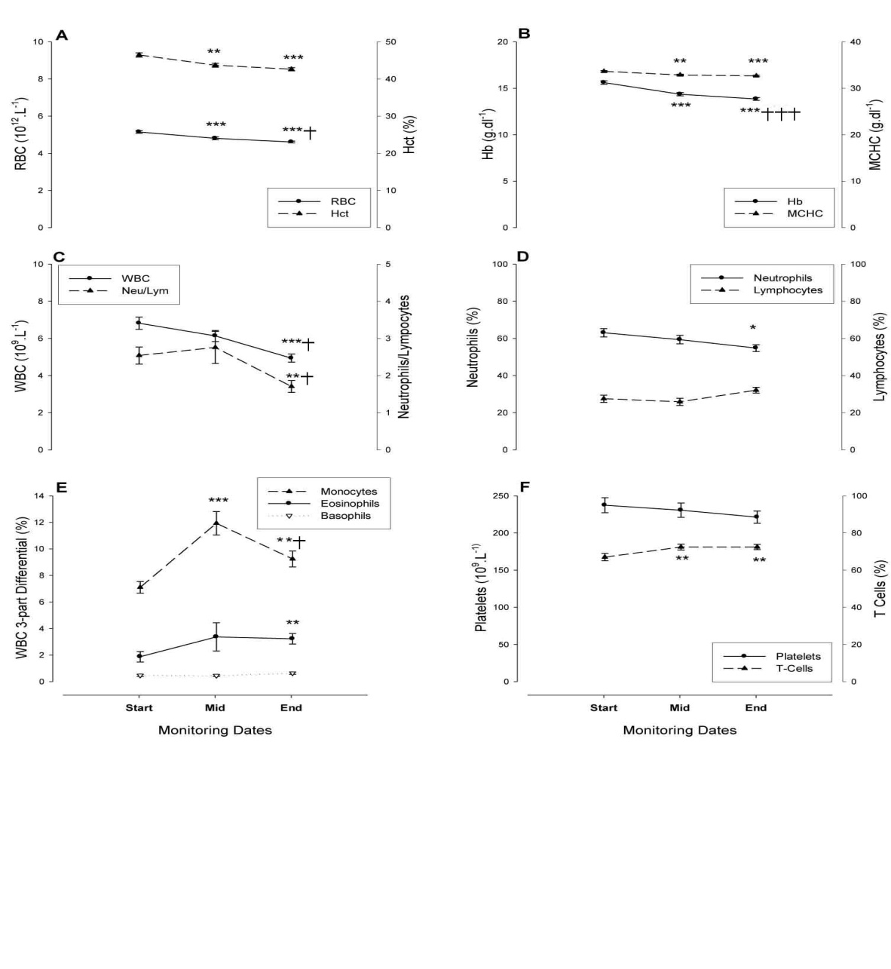

Figure 2 **Selected haematological parameters during 12-week military training (mean±SEM). Erythrocyte count (red blood cell, RBC) and haematocrit (Hct), (A); haemoglobin concentration (Hb) and mean cell haemoglobin concentration (MCHC) (B); Leucocyte count and neutrophil/ lymphocyte ratio (C); neutrophils (neu%) and lympocytes (lym%) (D); Percentage of monocytes, basophils, eosinophils (E); Platelet count (F). Within-group differences (repeated measures): signiﬁcant differences between Start and Mid, Start and End are indicated by *p<0.05, ** p<0.01, ***p<0.001; between Mid and End by †p<0.05, ††p<0.01, †††p<0.001.**

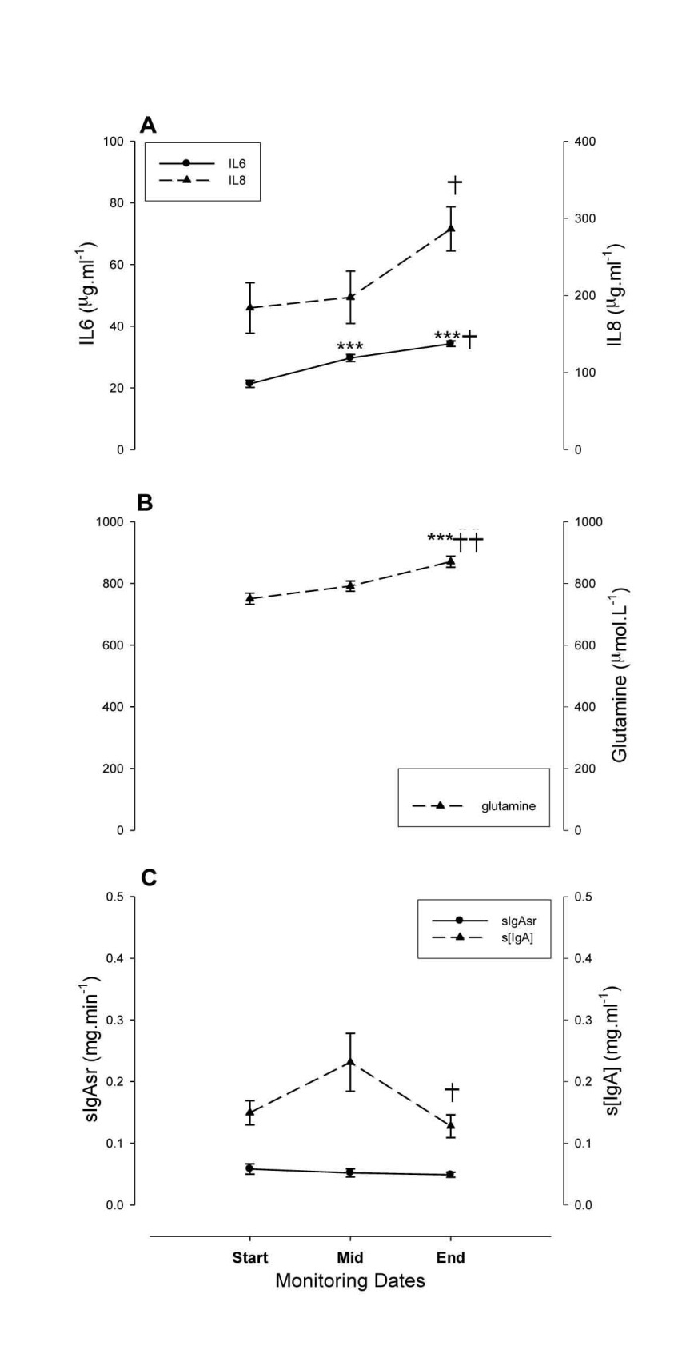

Figure 3 Selected plasma and saliva parameters during 12-week military training (mean±SEM). IL-6 and IL-8 production (A), secretory IgA (sIgA) and sIgA secretion rate (sIgAsr), (B) Within-group differences (repeated measures): signiﬁcant differences between Start and Mid, Start and End are indicated by *p<0.05, **p<0.01, ***p<0.001. Signiﬁcant differences between Mid and End are indicated by †p<0.05, ††p<0.01, †††p<0.001.

metabolites army 2007

Figure 4 Occurrence and duration of illness and proﬁle of mood states (POMS) during 12-week military training (mean±SEM). Upper respiratory tract symptom and gastrointestinal symptoms: percentage of occurrence in recruits (A); duration (B); mood states: negative (C), positive (D). Data for A and B were obtained from recruits present in all monitoring sessions; 13 matched responses were used for repeat measures of analyses of variance. Error bars are omitted from C and D for clarity. Anger: Start versus Mid p<0.02, Fatigue: Start versus Mid p<0.01, Start versus End p<0.02.

Run Time groups

Slow-RT

Medium-RT

Fast-RT

0

1

2

3

4

*††

Mean number of days with URTS/week

(Days.week-1)

Figure 5 **Number of days with upper respiratory tract symptom (URTS)/week in Fast, Medium and Slow-run time (RT) groups. Between-group differences: (analyses of variance): Signiﬁcance between Slow-RT and Medium-RT, and Slow-RT and Fast-RT groups indicated by *p<0.05, *††p<0.01, respectively.**

|  |  |  |  |
| --- | --- | --- | --- |
| Groups | N | Mean SEM | Min Max |
| Fast-Run Time (min)  Lowest Tertile | 10 | 9.5 +0.1 | 8.7 9.7 |
| Medium-Run Time(min)  Medium Tertile | 11 | 10.1 +0.07 | 9.8 10.4 |
| Slow-Run Time (min)  Highest Tertile | 11 | 10.9 +0.14 | 10.5 12.0 |

**Table 1: Fast Medium and Slow run time group categorised based on 2.4km run time (min) recorded at wk-1**